Review on Pharmacognostical & Pharmacological Properties of Pyrostegia venusta: An Ornamental Plant

Authors: Mrs. Shital Revan Kalekar^{1*}, Dr. Sunil L. Harer¹, Ms. Harshita Rajeev Agarwal², Mr. Ganesh Shamrao More^{2*}, Mr. Manas Mahesh Joshi³

Designation:
1*: Assistant Professor, Department of Pharmacognosy, D.Y. PATIL UNIVERSITY School Of Pharmacy, Sr. No. 124 & 126, A/p Ambi MIDC Road, Tal Maval, Talegaon Dabhade, Maharashtra 410506
1:Principal, Department of Pharmacognosy, D.Y. PATIL UNIVERSITY School Of Pharmacy, Sr. No. 124 & 126, A/p Ambi MIDC Road, Tal Maval, Talegaon Dabhade, Maharashtra 410506
2: Undergraduate Student, Department of Pharmacognosy, D.Y. PATIL UNIVERSITY School Of Pharmacy, Sr. No. 124 & 126, A/p Ambi MIDC Road, Tal Maval, Talegaon Dabhade, Maharashtra 410506
2*: Assistant Professor, Department of Pharmacology, D.Y. PATIL UNIVERSITY, School Of Pharmacy, Sr. No. 124 & 126, A/p Ambi MIDC Road, Tal Maval, Talegaon Dabhade, Maharashtra 410506
3: Undergraduate Student, Department of Pharmacognosy, D.Y. PATIL UNIVERSITY School Of Pharmacy, Sr. No. 124 & 126, A/p Ambi MIDC Road, Tal Maval, Talegaon Dabhade, Maharashtra 410506

Corresponding author:
Mrs. Shital Revan Kalekar
Assistant Professor, Department of Pharmacognosy, D.Y. PATIL UNIVERSITY, School Of Pharmacy, Sr. No. 124 & 126, A/p Ambi MIDC Road, Tal Maval, Talegaon Dabhade, Maharashtra 410506.

ABSTRACT:
Herbal and natural folk remedies have been used in all cultures of the world for centuries. Plants are undoubtedly a reservoir of potentially useful chemical compounds that act as medicines and provide new clues and clues for modern synthetic design. The flowering plant species Pyrostegia venusta, often known as flaming vine or orange trumpet vine, is a member of the Bignoniaceae genus and is indigenous to southern Brazil, Bolivia, northeastern Argentina, and Paraguay. Today, it is a well-liked garden species. In traditional Brazilian medicine, it has been widely used as a tonic to treat certain skin infections such as leukoderma, vitiligo, etc., as well as to treat diarrhea, coughing, and common respiratory conditions including bronchitis, colds, and the flu that are brought on by infections. Sterols, triterpenes, flavonoids, fatty acids, n-alkanes, nitrogen compounds including allantoin, and carbohydrates were discovered in Pyrostegia venusta phytochemical research. Pyrostegia venusta crude extracts exhibit a variety of pharmacological actions, including anti-inflammatory, analgesic, antinociceptive, wound healing, and antibacterial effects. They are also effective in the treatment of pathological illnesses including the common cold and flu. Additionally used to boost melanogenesis and reduce menopausal symptoms.
KEYWORDS: Pyrostegia venusta, Flamevine, orange trumpet vine.
INTRODUCTION:
The flowering plant species Pyrostegia venusta, often known as flaming vine or orange trumpet vine, is a member of the Bignoniaceae genus and is indigenous to southern Brazil, Bolivia, northeastern Argentina, and Paraguay. Today, it is a well-liked garden species. John Miers first described this species in 1863. This evergreen, vigorous climber is a fast grower and can spread like wildfire if left unattended. The height can be up to 5 meters. Foliage consists of two or three opposite leaflets, 4–8 cm across, pinnate leaves and a three-pronged tendril protruding from the end of the petiole. The orange flowers are 5–9 cm long and densely clustered and appear from winter through spring. Hummingbirds pollinate plants. The fruits are brown capsules that are smooth and 3 cm long. The plant is sensitive to cold winds and prefers sun and shelter. It tolerates the salinity of the soil. The plant's branching tentacles will cling to any hard surface, including brick walls. Bignoniaceae is a dicotyledon family that has between 100 and 125 genera and 700 and 800 species. Lapacol-type naphthoquinones, iridoid glycosides, flavones, triterpenes, alkaloids, polyphenols, tannins, and fixed oils from seeds are a few of the chemical substances connected to this species. Pyrostegia venusta's aerial parts and flowers have both been isolated for their oleanolic acid content. A lot of biological significance for oleanolic acid has been demonstrated. It has properties that are anti-cancer, anti-tumor, antioxidant, anti-inflammatory, acetylcholinesterase, alpha-glucosidase, antimicrobial, hepatoprotective, anti-inflammatory, antipruritic, antispasmodic, and anti-allergic.
PLANT DESCRIPTION:
Biological Source: Pyrostegia venusta, also known as flame vine or orange trumpet vine, is a plant species in the Bignoniaceae family Pyrostegia.

“Fig. 1 – Whole Plant of Pyrostegia venusta”
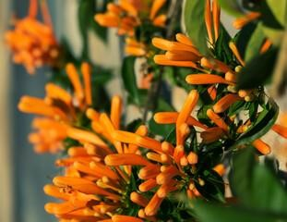

“Fig 2 – Flower of the plant”
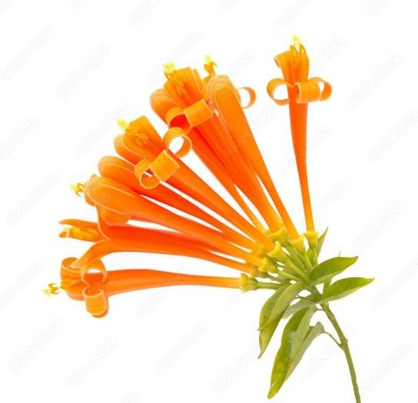

“Fig 3 – Different seeding phases of Pyrostegia venusta”
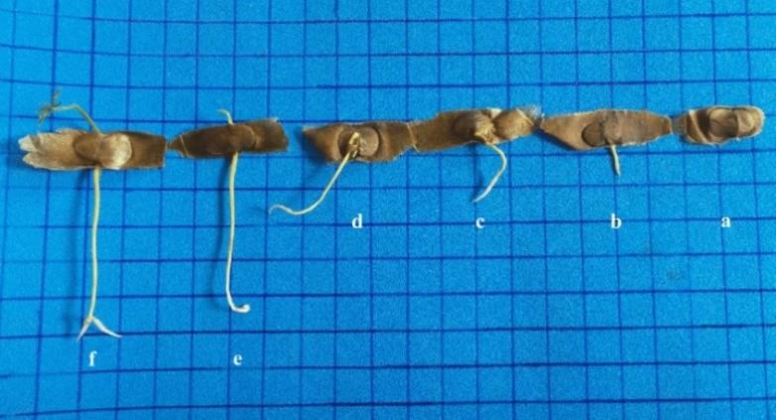

Taxonomy of Pyrostegia venusta:
Class: Equisetopsida
Subclass: Magnoliidae
Superorder: Asteranae
Order: Lamiales
Family: Bignoniaceae
Genus: Pyrostegia

Synonyms:
Flame flower, flame vine, flaming trumpet vine, orange creeper, orange trumpet vine, Flaming trumpet, Golden shower trumpet, Orange Bignonia, flame creeper

Distribution:
Argentina Northeast, Bolivia, Brazil North, Brazil Northeast, Brazil South, Brazil Southeast,
Brazil West-Central, Colombia, Costa Rica, Ecuador, El Salvador, Guatemala, Guyana, Honduras, Mexico Central, Mexico Gulf, Mexico Northwest, Mexico Southeast, Mexico Southwest, Panamá, Paraguay, Peru, Suriname, Venezuela

Macroscopic Description:
Leaves
Bipinnate, frequently with an apically trifid terminal tendril (occasionally with bifid or trifid branches again), or trifoliate leaves; thickly hairy, tributary pilose, or glabrous petioles; Leaflets ovate (rarely lanceolate), slightly subinequilateral, chartaceous (rarely membranous), 3 to 5 pairs of lateral veins protruding below, densely pubescent to glabrous, transparent, abaxially often particularly conspicuous, with large axillary glands of the lower lateral veins, base rounded or obtuse (rarely cordate), tip shortly acuminate-slimy or acuminate -mucronulate (blunt-mucronulate or acuminate).
Staminode
Located 1.2-1.6 cm higher than the placement of the anthers.
Fruit:
Capsule glabrous; Drying with an olive sheen, central vein visible but not prominent; base acute; Apex Aristate.
Inflorescence:
a terminal or axillary panicle that is usually dense or subcorymbous, unbranched, or one, two, or three times (rarely three times) branched; trichomes are initially perpendicular to the surface and are found on the stem, leaf rachis, and bracteoles; glabrous to densely hairy to hairy, ciliated at tip; calyx without teeth at apex; lepidoptera scales sparse; lobes are long, apical, and hairy on the margin; the crown is narrowly tubular-infundibular, orange or reddish-orange (occasionally yellow); the tube is serious within at and below the base of the stamens and staminodes. Stamens are 1.3–3.5 cm away from the corolla tube's base, and stigma lobes can be broadly oval, elliptical, orbicular, or broadly oblong.
Flowers:
The flowers of Pyrostegia venusta are typical of hummingbird pollinators: odorless and petals mostly bright red-orange, quite thick in structure, with narrow tube and wide opening and more or less naked inside.
Phytochemical and Pharmacological activities:
Genus of Pyrostegia that belongs to the Bignoniaceae family. There are four native South American species in this family. In Brazil, members of this family of plants are utilized for customary uses. A survey of the literature revealed that the Pyrostegia genus has historically been used to treat conditions like diarrhea, cough, vitiligo, jaundice, and respiratory illnesses like colds, coughs, and bronchitis. The phytochemical constituents of the genus Pyrostegia include phenolic compounds, triterpenes, phenylpropanoids, phenylethanoid glycosides, and flavonoids. Pyrostegia extract has a wide range of pharmacological effects, including anti-inflammatory, wound healing, antinociceptive, analgesic, vascular relaxant, cytotoxic, antitumor, antitussive, anthelmintic, hyperpigmentation, and disease treatment. The Pyrostegia genus is extensively utilized in conventional medicine and demonstrates a broad spectrum of pharmacological effects. The majority of Pyrostegia species, nevertheless, However, most Pyrostegia species require further research on their chemical components and pharmacological effects. Pyrostegia venusta is a plant that contains phytochemicals such as terpenoids, alkaloids, tannins, steroids, and saponins found in flower and root extracts.
According to the literature review, flowers of Pyrostegia venusta, from which the compounds β-sitosterol, n-hentriacontane, acacetin-7-O- β-glucopyranoside and mesoinositol have been isolated. Other studies have indicated the presence of carotenoids in the flowers and rutin in the leaves. Gas Chromatography Mass spectropscopy (Gc-MS) analysis of flower extract has showed the presence of Acetophenone; alpha.-l-Mannopyranoside, methyl 6-deoxy-2,3,4- tris-O-(trimethylsilyl)-;3H-3a,7-Methanoazulene, 2,4,5,6,7,8- hexahydro-1,4,9,9-tetramethyl-, (3aR (3a.alpha.,4.beta.,7.alpha.))- (Synonym Cyperene); trans-3-Hexenedioic acid, bis(trimethylsilyl) ester; beta.-DL-Arabino pyranose, 1,2,3,4-tetrakis- O- (trimethylsilyl)- (Synonym- B Arabipyranos); Ethyl malonate, ethyl trimethylsilyl ester; Propionic acid, pentamethyldidilanyl ester; Glycoside, .alpha.-methyl-trtrakis-O-(trimethylsilyl);Hexadecenoic acid, methyl ester (Synonym-Palmitic Acid; D-Xylose, tetrakis(trimethylsilyl)-;Glycoside,. Alpha.-methyl-trtrakis-O- (trimethylsilyl)-;Gluconic acid, 2-methoxime, tetra(trimethylsilyl)-, trimethylsilyl ester; 12-Octadecadienoic acid, methyl ester (Synonym Linoleic acid); 9-Octadecenoic acid (Z)-, methyl ester (Synonym Oleic Acid) ;Myo-Inositol, 1, 2, 3, 4, 5, 6-hexakis-O- (trimethylsilyl)-; Docosanoic acid, methyl ester; 1,2-Benzenedicarboxylic acid, mono(2-ethylhexyl) ester; Methyl 10-methyl-undecanoate; (1,2,4)Triazolo(1,5-a)pyrimidine-6carboxylic acid, 4, 7-dihydro-7- imino-, ethyl ester; Dotriacontane; Silicic acid, diethyl bis(trimethylsilyl) ester; Tetracosanoic acid, methyl ester; Di-ndecylsulfone; Dodecahydropyrido(1,2-b)isoquinolin-6-one; Heptacosane; Tetra siloxane, decamethyl-;
Tetra decanoic acid, 12- methyl-, methyl ester; Stigmasteryltosylate; 2-p-Nitrophenyloxadiazol-1, 3, 4-one-5; 2-Methyl-6-(5-methyl-2-thiazolin-2- ylamino)pyridine; Diazo progesterone; 1, 6-Dibromo-2- cyclohexyl pentane; Cyclotrisiloxane, hexamethyl-; cis2-Hexen-1- ol, trimethylsilyl ether.
It has been demonstrated that the compounds acacetin-7-O-β glucopyranoside and βsitosterol showed anti-inflammatory activity. The Dr. Dukes phytochemical and ethnobotanical database has mentioned some of these compounds to be useful in various medicinal complications. Database has mentioned that Acetophenone are useful Antibacterial, fungicide, pesticide, hypnotic, perfumery, soporific; 3H-3a,7-Methanoazulene, 2, 4, 5, 6, 7, 8hexahydro-1, 4, 9, 9-tetramethyl-, (3aR-(3a.alpha.,4.beta., 7.alpha.))-(Cyperene) is an Antimalarial and Anti-plasmodial; Hexadecenoic acid, methyl ester (Synonym-Palmitic Acid) is an Antioxidant, hypo-cholesterolemic-nematicide, pesticide, antiandrogenic flavour, haemolytic, 5- Alpha reductase inhibitor; 9, 12- Octadecadienoic acid, methyl ester (Synonym - Linoleic acid) is an Anti-inflammatory, hypo-cholesterolemic cancer preventive, hepatoprotective, nematicide, insectifuge, anti-histaminic antieczemic, anti-acne, 5-Alpha reductase inhibitor, anti-androgenic, anti-arthritic, anti-coronary, insectifuge; 1,2-Benzenedicarboxylic acid, mono (2-ethylhexyl) ester (Phthalic acid) is useful in preparation of perfumes and cosmetics, and as plasticized vinyl seats on furniture and in cars, and clothing including jackets, raincoats and boots, as well as in textiles, as dye stuffs, cosmetics and glass making; Myo-Inositol, 1, 2, 3, 4, 5, 6-hexakis-O- (trimethylsilyl)- is useful in anti-depression, liver problems, panic disorders and diabetes; 9-Octadecenoic acid (Z)-, methyl ester is a 5-alpha-reductase-inhibitor, allergenic, alpha-reductase-inhibitor, anemiagenic, anti-alopecic, anti-androgenic, anti-inflammatory, anti-leukotriene-D4 (antiplatelet activating factor), dermatitigenic, insectifuge, perfumery, propecic cancer-preventive, choleretic, flavour, hypocholesterolaemia, irritant, percutaneostimulant; Stigmasteryltosylate is used as anti-hepatotoxic, anti-inflammatory, anti-ophidic, anti-oxidant, estrogenic, sedative.

Acetophenone; alpha.-Mannopyranoside | 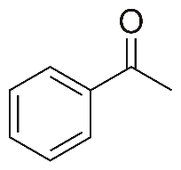
Diethyl malonate | 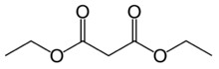
Docosanoic acid | 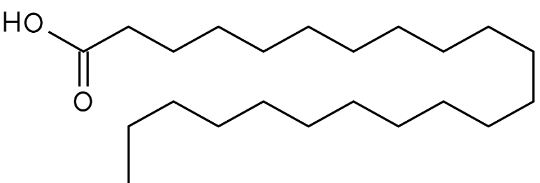
octadecadienoic acid | 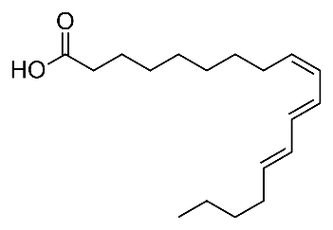
Benzenedicarboxylic acid | 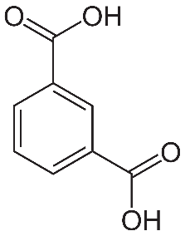
Tetracosanoic acid | 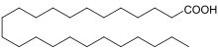
Tetra decanoic acid | 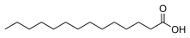
Stigmasteryl Tosylate | 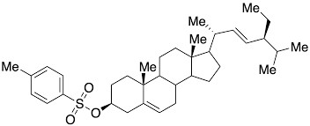
Di-n decylsulfone | 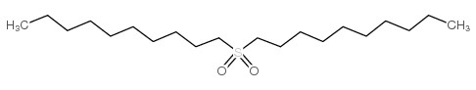
myo-inositol | 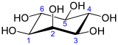
Nitrophenyloxadiazol | 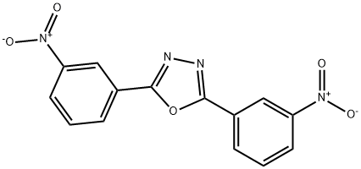
Cyclotrisiloxane | 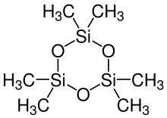
Linoleic acid | 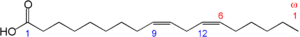
Ethyl malonate
DL-Arabinose pyranose | 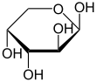
Table 1.1: Structures of Pyrostegia venusta phytoconstituents

TRADITIONAL USE:
Traditional Brazilian medicine uses Pyrostegia venusta's flowers, leaves, and seeds as an infusion or decoction as a tonic and to cure conditions including diarrhea, leukoderma, coughing, and common respiratory infections like bronchitis. Traditional Brazilian medicine uses the aerial portions of Pyrostegia venusta as an infusion or decoction as a tonic and to cure a variety of ailments, including diarrhea, vitiligo, coughing, and common respiratory infections including bronchitis, the flu, and colds. Pyrostegia venusta's aerial parts and flowers have been used to isolate oleanolic acid, according to published research. Oleanolic acid is demonstrated to be crucial to biology. It possesses actions that are antibacterial, hepatoprotective, anti-inflammatory, anti-pruritic, anti-spasmodic, antiangiogenic, antiallergic, antiviral, and immunomodulatory. From the flowers, acetin7-glucopyranoside and -sitosterol were extracted.
BIOLOGICAL STUDIES:
Antioxidant activity:
Utilizing the 1,1-diphenyl-2-picrylhydrazyl (DPPH), 2,2'-azinobis-3-ethylbenzothiazoline-6-sulfonic acid (ABTS), and Ferric reducing antioxidant capacity (FRAP) assays, the antioxidant capacity of Pyrostegia venusta flowers, seeds, leaves, and roots was examined.
Treatment of unhealthy/ sickness behavior:
The study investigated the effects of a hydroalcoholic extract of Pyrostegia venusta flowers on lipopolysaccharide-induced sick behavior in mice. Pyrostegia venusta extract reduced lipopolysaccharide-induced depression-like and exploratory behaviours. These findings support previous claims about the usefulness of these plants in traditional medicine and suggest that they may be useful in the treatment of sick behavior disorders such as the flu and the common cold.
Estrogen activity:
A tea derived from the Pyrostegia venusta plant has recently been used to ease menopause symptoms. The concentrations of the extract's active components are, however, somewhat low. For the generation of plant extracts with greater metabolite concentrations, plant tissue culture is an alternative.

Genotoxic activity:
Mice were used to test Pyrostegia venusta extracts for genotoxicity using the chromosomal aberration assay and the micronucleus assay. The test groups were given oral doses of 50, 100, and 200 mg/kg body weight, respectively. The frequency of micronucleated polychromatic erythrocytes in the experimental controls was significantly and statistically lower than in the positive control group that received cyclophosphamide compared to the negative control group that got water. No genotoxic activity was detected in Pyrostegia venusta.
Antimicrobial activity:
Pyrostegia venusta leaves and flowers were used in this study to examine the hydroalcoholic extracts' melanogenic activity on B16F10 murine melanoma cells. After a 4-day incubation period, both extracts—leaves (0.1; 0.3; 1 and 3 g/ml) and flowers (0.03 and 0.1 g/ml)—increased the melanin content in a concentration-dependent manner. Using the MTT assay (3-(4,5-dimethylthiazol-2-yl)-2,5-diphenyltetrazolium bromide), cell viability was also examined in murine B16F10 cells, and it was found that neither extract caused any cell death at the measured doses. The in vitro activity of fungal tyrosinase was also examined in both extracts. In actuality, tyrosinase activity was unaffected by neither extract.
Melanogenic activity:
The melanogenic activity of hydroalcoholic extracts from leaves and flowers of Pyrostegia venusta on B16F10 murine melanoma cells was recently studied; Both extracts, leaves (0.1; 0.3; 1 and 3 g/ml) and flowers (0.03 and 0.1 g/ml) increased the melanin content in a concentration-dependent manner after 4-day incubation on melanoma cells. Cell viability was also tested in murine B16F10 cells using the MTT assay (3-(4,5-dimethylthiazol-2-yl)-2,5-diphenyltetrazolium bromide) which revealed that no cell death was detected at the same tested concentrations of both extracts. Both extracts were also tested for fungal tyrosinase activity in vitro. In fact, neither extract was able to alter tyrosinase activity.
Antitumor activity:
Significant anticancer activity and moderate cytotoxicity are both present in Pyrostegia venusta hydroalcoholic extract.
Hyperpigmentant activity:
Low concentration of hydroalcoholic extracts of leaves and flower of Pyrostegia venusta indicated anti vitiligo (hyperpigmentant) activity
CONCLUSION:
For millennia, traditional medicine has made extensive use of plant-based arts. Pyrostegia venusta has great pharmacological potential and a favorable effect, particularly in the areas of tropical disorders, skin conditions, and respiratory illnesses. Therefore, the Pyrostegia venusta described in this review may be a significant source of naturally occurring, bioactive medications, and it has the potential to be of great interest for further study.
REFERENCES:
- Montandon A, Zuza E, Toledo BE. Prevalence and reasons for tooth loss in a sample from a dental clinic in Brazil. Int J Dent. 2012;2012:719750.
- Shivakumar KM, Vidya SK, Chandu GN. Dental caries vaccine. Indian J Dent

Res. 2009;20:99–106.
- Sasaki EY, Ito LA, Canteli VC, Ushirobira TM, Ueda-Nakamura T, Dias Filho BP, et al. Antioxidant capacity and in vitro prevention of dental plaque formation by extracts and condensed tannins of Paullinia cupana. Molecules. 2007;12:1950–63.
- Argimón S, Alekseyenko AV, De Salle R, Caufield PW. Phylogenetic analysis of glucosyltransferases and implications for the coevolution of mutans streptococci with their mammalian hosts. PLoS One. 2013;8
- Kolenbrander PE, London J. Adhere today, here tomorrow: Oral bacterial adherence. J Bacteriol. 1993;175:3247–52.
- Palomer LR. Dental caries in children: a contagious disease. Rev Chil Pediatr. 2006;77:50– 6.
- Coronado-Castellote L, Jiménez-Soriano Y. Clinical and microbiological diagnosis of oral candidiasis. J Clin Exp Dent. 2013;5:279–86.
- Campisi G, Pizzo G, Milici ME, Mancuso S, Margiotta V. Candidal carriage in the oral cavity of human immunodeficiency virus-infected subjects. Oral Surg Oral Med Oral Pathol Oral Radiol Endod. 2002;93:281–6.
- Kumamoto CA. A contact-activated kinase signals Candida albicans invasive growth and biofilm development. Proc Natl Acad Sci U S A. 2005;102:5576–81.
- Socransky SS, Haffajee AD. Dental biofilms: Difficult therapeutic targets. Periodontology. 2012;28:12–55.
- Paquette DW, Williams RC. Modulation of host inflammatory mediators as a treatment strategy for periodontal diseases. Periodontol. 2000;2000(24):239–52. [
- Shetty S, Bose A, Sridharan S, Satyanarayana A, Rahul A. A clinico-biochemical evaluation of the role of a herbal (Ayurvedic) immunomodulator in chronic periodontal disease: A pilot study. Oral Health Dent Manag. 2013;12:95–104.
- Ferreira DT, Alvarez PS, Houghton PJ, Braz-Fillho R. Chemical isolated compounds from roots of Pyrostegia venusta and considerations about its medicinal importance. Quim Nova. 2000;23:42–6.
- Scalon SP, Vieira MC, Lima AA, Souza CM, Mussury RM. Pregerminative treatments and incubation temperatures on the germination of “cipó-de-São-João” [Pyrostegia venusta (Ker Gawl.) Miers]-Bignoniaceae. Rev Bras Plant Med. 2008;10:37–42.
- Veloso CC, Bitencourt AD, Cabral LD, Franqui LS, Dias DF, dos Santos MH, et al.
Pyrostegia venusta attenuate the sickness behavior induced by lipopolysaccharide in mice. J Ethnopharmacol. 2010;132:355–8.
- Roy P, Amdekar S, Kumar A, Singh V. Preliminary study of the antioxidant properties of flowers and roots of Pyrostegia venusta (Ker Gawl) Miers. BMC Complement Altern Med. 2011;11:69.
- Moreira CG, Horinouchi CD, Souza-Filho CS, Campos FR, Barison A, Cabrini DA, et al. Hyperpigmentant activity of leaves and flowers extracts of Pyrostegia venusta on murine B16F10 melanoma. J Ethnopharmacol. 2012;141:1005–11.
- Silva RM, Rodrigues DT, Augustos FS, Valadares F, Neto PO, Santos L, et al. Antitumor and cytotoxic activity of Kielmeyeracoriacea mart. Zucc. And Pyrostegia venusta (Ker Gawl.) Miers extracts. J Med Plants Res. 2012;6:4142–8.
- Nisha PV, Shruti N, Swamy KS, Kumari M, Vedamurthy AB, Krishna V, et al. Anthelmintic activity of Pyrostegia venusta using Pheretimaposthuma. Int J Pharm Sci Drug Res. 2012;4:205–8.
- Veloso CC, Bitencourt AD, Cabral LD, Franqui LS, Santa-Cecília FV, Dias DF, et al. Anti-inflammatory and antinociceptive effects of the hydroethanolic extract of the flowers of Pyrostegia venusta in mice. Rev Bras Farmacognosia. 2012;22:162–8.
- Roy P, Amdekar S, Kumar A, Singh R, Sharma P, Singh V. In vivo antioxidative property, antimicrobial and wound healing activity of flower extracts of Pyrostegia venusta (Ker Gawl) Miers. J Ethnopharmacol. 2012;140:186–92.
- CLSI. Clinical and Laboratory Standards Institute, Reference Method for Broth Dilution Antifungal Susceptibility Testing of Yeasts: Approved Standard M27-A2. NCCLS. Villanova, PA, USA: CLSI; 2002.
- Bauer AW, Kirby WM, Sherris JC, Turck M. Antibiotic susceptibility testing by a standardized single disk method. Am J Clin Pathol. 1966;45:493–6.
- Holetz FB, Pessini GL, Sanches NR, Cortez DA, Nakamura CV, Filho BP. Screening of some plants used in the Brazilian folk medicine for the treatment of infectious diseases. Mem Inst Oswaldo Cruz. 2002;97:1027–31.
- Hamada S, Torii M, Kotani S, Tsuchitani Y. Adherence of Streptococcus sanguis clinical isolates to smooth surfaces and interaction of the isolates with Streptococcus mutans glucosyltransferase. Infect Immun. 1981;32:364–72.
- Ooshima T, Osaka Y, Sasaki H, Osawa K, Yasuda H, Matsumura M, et al. Caries inhibitory activity of cacao bean husk extract in in-vitro and animal experiments. Arch Oral Biol. 2000;45:639–45.
- Ishida K, de Mello JC, Cortez DA, Filho BP, Ueda-Nakamura T, Nakamura CV. Influence of tannins from Stryphnodendron adstringens on growth and virulence factors of Candida albicans. J Antimicrob Chemother. 2006;58:942–9.
- Tada H, Shiho O, Kuroshima K, Koyama M, Tsukamoto K. An improved colorimetric assay for interleukin 2. J Immunol Methods. 1986;93:157–65.
- Aligiannis N, Kalpoutzakis E, Mitaku S, Chinou IB. Composition and antimicrobial activity of the essential oils of two Origanum species. J Agric Food Chem. 2001;49:4168
- Duarte MC, Figueira GM, Sartoratto A, Rehder VL, Delarmelina C. Anti-Candida activity of Brazilian medicinal plants. J Ethnopharmacol. 2005;97:305–11.
- Ower PC, Ciantar M, Newman HN, Wilson M, Bulman JS. The effects on chronic periodontitis of a subgingivally-placed redox agent in a slow release device. J Clin Periodontol. 1995;22:494–500.
- Marsh PD. Are dental diseases examples of ecological
catastrophes? Microbiology. 2003;149:279–94.
- Calderone RA, Fonzi WA. Virulence factors of Candida albicans. Trends

Microbiol. 2001;9:327–35.

Lohinai Z, Benedek P, Fehér E, Györfi A, Rosivall L, Fazekas A, et al. Protective effects of mercaptoethylguanidine, a selective inhibitor of inducible nitric oxide synthase, in ligature-induced periodontitis in the rat. Br J Pharmacol. 1998;123:353–60.
- Ugar-Cankal D, Ozmeric N. A multifaceted molecule, nitric oxide in oral and periodontal diseases. Clin Chim Acta. 2006;366:90–100.
- de Almeida MV, Teixeira FM, de Souza MV, Amarante GW, Alves CC, Cardoso SH, et al. Thalidomide analogs from diamines: Synthesis and evaluation as inhibitors of TNF-alpha production. Chem Pharm Bull (Tokyo) 2007;55:223–6.
- Ferreira DT, Alvares PS, Houghton PJ, Braz-Filho R.Chemical constituents from roots of Pyrostegia venusta and considerations about its medicinal importance. Quím Nova. 2000;23:42-46.
- Scalon SP, Vieira MC, Lima AA, Souza CM, Mussury RM. Pregerminative treatments and incubation temperatures on the germination of „cipóde- São-João‰ (Pyrostegia venusta (Ker Gawl) Miers)-Bignoniaceae. Rev Bras Plantas Med. 2008;10:37-42.
- Veloso CC, Bitencourta AD, Cabral LD, Franqui LS, Dias DF, dos Santos MH, Soncini R, Giusti-Paiva A. Pyrostegia venusta attenuate the sickness behavior induced by lipopolysaccharide in mice. J Ethnopharmacol. 2010;132:355-358.
- Singh S, Rana A and Chauhan SVS. Impact of environmental changes on the reproductive biology in Pyrostegia venusta Presl. J Environ Biol. 2009;30(2): 271-273.
- Ndayisenga I. Pyrostegia venusta ker Gwal Miers. In Thesis: Butare city ornamental plant taxonomy and phytogeography; Submitted for the award of BachelorÊs degree in Biology in University of Rwanda
- URL:http://www.biology.nur.ac.rw/IMG/pdf/Ndayisenga_I_2011.pdf Dubey R, Misra KJ. Chemical components of Pyrostegia venusta flowers. J Indn Chem Soc. 1976;53: 378381.
- Harbone JB. Comparative biochemistry of the flavonoids VI Flavonoid patterns in the Bignoniaceae and Gesneriaceae. Phytochem. 1967;6: 1646-1651
- Blatt CTT, Santos MD, Salatino A. Flavonoids of Bignoniaceae from "cerrado" and their possible taxonomic significance. Plant Syst Evol. 1998;210: 289-292.
- Roy P, Amdekar S, Kumar A, and Singh V. Preliminary study of the antioxidant properties of flowers and roots of Pyrostegia venusta (Ker Gawl) Miers. BMC Complement Altern Med. 2011;11: article 69.
- Gupta MB, Nath R, Srivastava N, Shanker K, Kishor K, Bhargava KP. Anti-inflammatory and antipyretic activities of beta-sitosterol. Planta Med. 1980;39: 157-163.
- Shen KH, Hung SH, Yin LT, Huang CS, Chao CH, Liu CL, Shih YW. Acacetin, a flavonoid, inhibits the invasion and migration of human prostate cancer DU145 cells via inactivation of the p38 MAPK signaling pathway. Mol Cell Biol. 2010;333: 279-291
- URL for Dukes phytochemical and ethnobotanical databases- http://www.arsgrin.gov/cgi-bin/duke/listChemicals.pl
- Pan MH, Lai CS, Wang YJ, Ho CT. Acacetin suppressed LPS-induced up expression of iNOS and COX-2 in murine macrophages and TPA-induced tumor promotion in mice. Biochem Pharmacol. 2006;72:1293-1303.
- Pan MH, Hsieh MC, Hsu PC, Ho SY, Lai CS, Wu H, Sang S, Ho CT. 6-Shogaol suppressed lipopolysaccharide-induced up-expression of iNOS and COX-2 in murine macrophages. Mol Nutr Food Res. 2008;52(12):1467-77.

