Perspectives of Ventricular assist device (VAD) in heart failure patients
Mr. Murthi S, Department of Perfusion Technology
School of Allied Health Sciences, Vinayaka Mission’s Research Foundation – DU
AVMC & H, Puducherry, India

ABSTRACT
Congestive heart failure is a major cause of mortality and morbidity around the world. Heart failure affects more than 64 million people around the world. Despite many medical therapies available for heart failures like heart transplant ventricular assist devices offers an alternative when the heart transplant is limited by donor availability. And it also provides both pulsatile flow and non-pulsatile flow and depending upon the choice of temporary or permanent supportive device. The advancement in VAD helps in extended support, overall patient outcomes This article describes the ventricular assist device and pump types, components, indications, complication, hemodynamic criteria and evolution and current trends
Keyword: Ventricular assist device, pulsatile and non-pulsatile flow indications, complication,
- INTRODUCTION

Ventricular Assist Device Ventricular assist device (VAD) is a mechanical pump which is surgically implanted to one or both ventricles of the heart, to augment or replace ventricular function. It is designed to support heart function partially (either the right "RVAD" or left "LVAD" ventricle) or completely (both at once "BiVAD") in people who have heart Failure.[1] VAD is implanted either as a bridge to transplantation or as a bridge to recovery or as an alternative to heart transplantation (called destination therapy, a patient who will never get a heart transplant). [2]
- WORKING PRINCIPLE
Ventricular assist device takes blood from a lower chamber (ventricle) of the heart and helps pump it to the body or to the lungs, that decrease the workload of the heart thereby reducing myocardial oxygen demand, while maintaining adequate systemic perfusion. The increase in systemic perfusion improves myocardial oxygen supply.[3] That reduction in myocardial oxygen demand and improvement in myocardial oxygen supply helps in ventricular recovery.[4]

- Components
The basic parts of a ventricular assist device include an inflow tube that carries blood out of heart , outflow tube that returns blood to ascending aorta or the main pulmonary artery, Driveline (A cord passes through the skin and holds the control and power wires, that connects the device to an external portable driver), Portable driver consisting of a control unit (that monitors the VAD functions) A power source (that may be worn around the waist, carried in a shoulder bag, or contained within a small bedside monitor). [5]
- Pump flow types
Pulsatile and non-pulsatile (continuous flow) pumps are the two primary groups into which the pumps utilized in ventricular assist devices fall. Pumps with Pulsatile Flow: The majority of extracorporeal pulsatile devices have valves, an air chamber with a compressor-operated membrane, and a blood chamber. Blood enters by an inflow cannula, fills the blood chamber, and is subsequently expelled into the systemic circulation via an outflow cannula by a pneumatic pump that collapses the blood chamber by pumping air at a high pressure into it. As the ventricle empties into the blood chamber during native ventricular systole, pulsatile devices consecutively fill and empty. Pulsatile Flow Pumps imitate the heart's normal rhythmic pounding. The patients will therefore have measured blood pressure and palpable pulses. [6] [7]
- CLINICAL APPLICATION
Ventricular assist devices can be used for a wide spectrum based on the therapeutic goals of circulatory support as well as the duration of treatment. They can be used for short term as well long-term duration. The indications are: bridge to recovery, bridge to transplantation, destination therapy, bridge to decision, post cardiotomy cardiogenic shock, and end stage cardiomyopathy [8]

- CLINICAL COMPLICATION
The most common complications of VADs implanted include: Haemorrhage including pericardial tamponade, right ventricular failure, sepsis, device thrombosis, cable malfunction, mechanical device failure, neurologic dysfunction, and infection.[9]

- CURRENT TRENDS AND EVOLUTION
LVAD technology evolved from first-generation pulsatile pumps (Novacor®, and HeartMate VE®) to the continuous flow of second and third-generation).[10] Second-generation pumps have an axial design with a turbine system that provides a parallel flow to its rotation axis. Heart mate II is very small] in size then heart mate I and significantly better survival [11]The final group, third-generation LVAD, is the most widely used. HeartWare® (HVAD), with the hybrid centrifugal flow, was not inferior to HeartMate II® at the ENDURANCE trial , being the exchange feasible in practice[12]There were no clinical trials that compared long-term morbidity and mortality between both centrifugal DT-LVAD devices. However, some descriptive data showed fewer complications and mortality with HeartMate III® than with HeartWare®[13]
Nevertheless, HeartMate III® signaled a revolution in medicine. It is a totally magnetically levitated robust LVAD that improves hemocompatibility by reducing bloodstream friction and presenting broader route gaps. Overall heart mate III is not improved in overall survival rate than heart mate II but heart mate III lower rates of gastrointestinal bleeding as well as aortic insufficiency. [14]
Even though there were no changes in the incidence of right heart failure, arrhythmia, or infections, hemocompatibility-related events (bleeding, stroke, and device thrombosis) occurred at reduced rates in the HeartMate III® group.[15] But if biventricular assistance is required, negative effects are far more common, with bleeding and infection occurring on more than [16] Despite the use of HeartMate III, there was only one reported case of both and 25%, respectively. [17] Long-term morbidity and mortality between the two centrifugal DT-LVAD devices were not evaluated in clinical trials. Nevertheless, some illustrative data revealed fewer. HeartMate III® has fewer side effects and lower fatality rates than HeartWare® [18]. Perhaps there will be another choice in the near future.

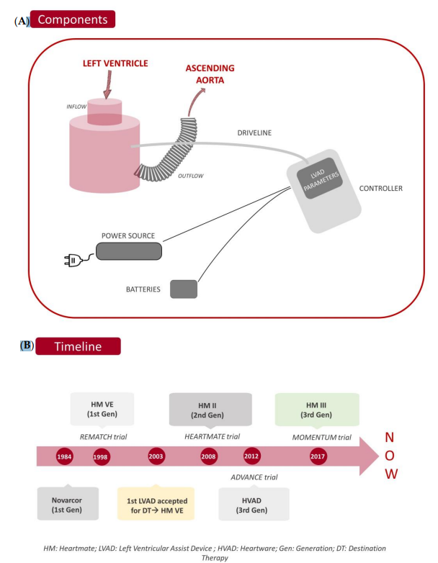

Figure 1: Components and timeline of VAD

- CONCLUSION
In the care of severe heart failure patients who are ineligible for transplantation, mechanical circulatory support is a highly sensible alternative that increases their functional ability. Implantable pumps increased exponentially in terms of event-free survival as they became more sophisticated. Additionally, highly specialized non-transplant LVAD centres came to be. At two and five years, the predicted survival rate is currently greater than 70% and 50%, respectively.
However, meticulous preimplant patient selection determines the short- and medium-term prognosis. Evaluation of the baseline situation is crucial, paying close attention to factors including frailty, the psychosocial environment, renal function, hemodynamic indicators that can assist determine prognosis and RVF, and ultimately, the surgical strategy used for the heart. A multidisciplinary shared decision process is particularly pertinent in these cases, particularly in patients who have several conditions and under uncertain circumstances.

REFERENCE
- Lloyd-Jones D, Adams RJ, Brown TM, et al. Heart disease and stroke statistics—2010 update: a report from the American Heart Associat ion. Circulation. 2010;121(7): e46–e215.
- Maybaum S, Mancini D, Xydas S, et al. Cardiac improvement during mechanical circulatory support: a prospective multicenter study of the LVAD working group.Circulation. 2007;115:2497–2505.
- Slaughter MS, Rogers JG, Milano CA, et al. Advanced heart failure treated with continuous flow left ventricular assist device. N Engl J Med. 2009;361:2241–2251.
- Slaughter MS, Pagani FD, Rogers JG, et al. Clinical management of continuous left ventricular assist devices in advanced heart failure. J Heart Lung Transplant. 2010;29:S1–S39.
- Goldstein DJ. Worldwide experience with the MicroMed DeBakey Ventricular Assist Device as a bridge to transplantation. Circulation 2003;108 Suppl 1:II272–7.16. Myers TJ, Bolmers M, Gregoric ID, Kar B, Frazier OH. Assessment of arterial blood pressure during support with an axial flow left ventricular assist device. J Heart Lung Transplant. 2009;28(5):423–427.
- Miller LW, Pagani FD, Russell SD, et al. Use of a continuous-flow device in patients awaiting heart transplantation. N Engl J Med 2007;357:885–96.
- Klotz S, Stypmann J, Welp H, et al. Does continuous flow left ventricular assist device technology have a positive impact on outcome pretransplant and posttransplant? Ann Thorac Surg 2006;82:1774–8.
- Thalmann M, Schima H, Wieselthaler G, Wolner E. Physiology of continuous blood flow in recipients of rotary cardiac assist devices. J Heart Lung Transplant 2005;24:237– 45.
- Haft J, Armstrong W, Dyke DB, et al. Hemodynamic and exercise performance with pulsatile and continuous-flow left ventricular assist devices. Circulation 2007;116:I8 –15.
- Starling, R.C.; Estep, J.D.; Horstmanshof, D.A.; Milano, C.A.; Stehlik, J.; Shah, K.B.; Bruckner, B.A.; Lee, S.; Long, J.W.; Selzman, C.H.; et al. Risk Assessment and Comparative Effectiveness of Left Ventricular Assist Device and Medical Management in Ambulatory Heart Failure Patients: The ROADMAP Study 2-Year Results. JACC Heart Fail. 2017, 5, 518–527. [CrossRef] [PubMed]
- Cassina, A.M. Dispositivos de asistencia ventricular de tipo axial. Cirugía Cardiovasc. 2009, 16, 131–137. [CrossRef]
- Slaughter, M.S.; Rogers, J.G.; Milano, C.A.; Russell, S.D.; Conte, J.V.; Feldman, D.; Sun, B.; Tatooles, A.J.; Delgado, R.M.; Long, J.W.; et al. Advanced Heart Failure Treated with Continuous-Flow Left Ventricular Assist Device. N. Engl. J. Med. 2009, 361, 2241–2251. [CrossRef
- Wasilewski, G.; K ˛edziora, A.; Wi´sniowska-Smiałek, S.; Tomsia, P.; Kaleta, M.; Wierzbicki, K. Outcomes in Patients with HeartMate3 ´ Versus HeartWare Ventricular Assist Device Implanted as Destination Therapy. Transplant. Proc. 2022, 54, 1049–1053. [CrossRef] [PubMed]
- Mehra, M.R.; Uriel, N.; Naka, Y.; Cleveland, J.C.; Yuzefpolskaya, M.; Salerno, C.T.; Walsh, M.N.; Milano, C.A.; Patel, C.B.; Hutchins, S.W.; et al. A Fully Magnetically Levitated Left Ventricular Assist Device—Final Report. N. Engl. J. Med. 2019, 380, 1618–1627. [CrossRef]
- Mehra, M.R.; Goldstein, D.J.; Cleveland, J.C.; Cowger, J.A.; Hall, S.; Salerno, C.T.; Naka, Y.; Horstmanshof, D.; Chuang, J.; Wang, A.; et al. Five-Year Outcomes in Patients with Fully Magnetically Levitated vs. Axial-Flow Left Ventricular Assist Devices in the MOMENTUM 3 Randomized Trial. JAMA 2022, 328, 1233–1242. [CrossRef] [PubMed]
- Marasco, S.; Simon, A.R.; Tsui, S.; Schramm, R.; Eifert, S.; Hagl, C.M.; Paç, M.; Kervan, Ü.; Fiane, A.E.; Wagner, F.M.; et al. International experience using a durable, centrifugal-flow ventricular assist device for biventricular support. J. Heart Lung Transplant. 2020, 39, 1372–1379. [CrossRef] [PubMed]
- Wasilewski, G.; K ˛edziora, A.; Wi´sniowska-Smiałek, S.; Tomsia, P.; Kaleta, M.; Wierzbicki, K. Outcomes in Patients with HeartMate3 ´ Versus HeartWare Ventricular Assist Device Implanted as Destination Therapy. Transplant. Proc. 2022, 54, 1049–1053. [CrossRef] [PubMed]
- Allen, S.R.; Slaughter, M.S.; Ahmed, M.M.; Bartoli, C.R.; Dhingra, R.; Egnaczyk, G.F.; Gulati, S.K.; Kiernan, M.S.; Mahr, C.; Meyer, D.M.; et al. COMPETENCE Trial: The EVAHEART 2 continuous flow left ventricular assist device. J. Heart Lung Transplant. 2023, 42, 33–39. [CrossRef]

