Food Microstructure Analysis Techniques: Unraveling the Hidden World of Food
Soumya C Meti¹, Udaykumar Nidoni², Sharanagouda Hiregoudar³ and Pramod Katti⁴
¹Research scholar, Department of Processing and Food Engineering, College of Agricultural Engineering, University of Agricultural Sciences, Raichur-584104.
²Professor and University Head, Department of Processing and Food Engineering, College of Agricultural Engineering, University of Agricultural Sciences, Raichur-584104.
³Professor and Head, Department of Processing and Food Engineering, College of Agricultural Engineering, University of Agricultural Sciences, Raichur-584104.
⁴Professor, Department of Agricultural Entomology, University of Agricultural Sciences, Raichur-584104.
Corresponding author: Soumya C Meti; Email: soumyacm97@gmail.com
Abstarct

This book chapter delves into the intricacies of food microstructure, defined as the spatial arrangement of cells, intercellular spaces, and the interaction of food constituents within the matrix. This all-encompassing concept extends to diverse food items, encompassing bakery products, fruits, vegetables, and meat, exerting profound influence on their quality, texture, and nutritional attributes. Although imperceptible to the unaided eye, microstructure plays an indispensable role in shaping characteristics such as sponginess, crispness, firmness, and emulsion stability. An enlightened comprehension of food microstructure and its dynamic metamorphosis during processing is indispensable in crafting superlative foodstuffs with optimized nutritional availability. Employing an array of microscopic analysis techniques such as optical microscopy, fluorescence microscopy, scanning electron microscopy, and others, researchers gain invaluable insights into food composition, quality control, and the discernment of unwelcome substances. As discerning consumers demand augmented nutritional excellence, heightened sensory properties, and utmost safety, the unexplored realm of microstructural engineering emerges as a captivating avenue to tailor food microstructure for targeted functional efficacy. This chapter accentuates the significance of food microstructure analysis techniques and underscores their boundless potential for pioneering food applications and transformative innovations.
Keywords: Food microstructure, imaging, microscopy

Food Microstructure Analysis Techniques: Unraveling the Hidden World of Food

Introduction
Food microstructure can be defined as the intricate arrangement and interplay of food constituents, leading to distinct and observable spatial divisions of different material phases at the microscopic level. Moreover, food microstructure may encompass not only the physical and chemical organization of constituents but also the interactions of individual molecules within the microstructural matrix (1).
The primary role of food is to offer pleasure through its delightful flavors, enticing aromas, and pleasing textures, while also providing essential nutrition and energy. Additionally, consumers seek food with other functionalities, such as extended shelf life, enhanced health benefits, and transparent labeling. An emerging trend in food research is the aspiration to create and manufacture food products with tailored functionalities to meet specific consumer demands. Achieving this goal involves diverse approaches pursued by researchers and food manufacturers, with a prominent focus on comprehending and controlling food structures, particularly at the microscopic level. The study of food microstructures encompasses three essential aspects: visualization, identification, and quantification, each necessitating distinct tools and techniques to gain valuable insights into the intricate nature of food compositions (41).
Food is a complex and heterogeneous system, encompassing both fresh products characterized by cellular structures and processed items with microscopic domains formed by a blend of ingredients. These structures are often beyond the direct observation of the naked eye. While human vision can perceive objects down to approximately 1 μm with adequate lighting, many biological cells and food components fall within this scale but remain imperceptible due to lighting limitations. Nevertheless, they become distinctly visible and clear under the magnification of a regular light microscope. For instance, some salad dressing emulsions contain oil or water droplets well below 1 μm in diameter, while elemental plant fibers possess a diameter in the range of a few nanometers, necessitating the use of higher-resolution microscopes such as scanning electron microscopes to investigate and discern their intricate characteristics (11).
Microscopes help determine food morphology, but a complete understanding of microstructure requires chemical imaging tools (Fourier transform infrared, Raman, fluorescence, or confocal laser scanning microscope) for ingredient distribution and physical structural tools (x-ray diffractometer) for molecular arrangement and crystallinity analysis. Combining these techniques enables researchers to unravel the complexity of food microstructures, aiding in product development and consumer appeal.
Modern microscopy and chemical imaging tools have revolutionized the study of food microstructure, enabling researchers to not only determine food morphology and ingredient distribution but also quantify crucial parameters like dimension, concentrations, fractions, and kinetic constants. With the advent of x-ray computed tomography, quantification can now be performed in three dimensions through non-destructive imaging, offering invaluable insights into food structures. Furthermore, these advanced techniques allow for the probing of microscale interactions and forces among food ingredients, facilitated by instruments such as the atomic force microscope. This enhanced understanding of food microstructure and interactions paves the way for more precise food product development and optimization, addressing consumer demands and enhancing the overall quality and appeal of food products (11).
Quantitative measurements serve as the conclusive element in deciphering food microstructures. Though initially not intended for food applications, diverse microstructure techniques have been adopted by food researchers to establish correlations between structure and functionality. A wide range of unexplored methods for analyzing food microstructure hold promise. Targeted microstructure imaging facilitates the identification of specific molecules within the food matrix, providing valuable insights. Understanding and modeling microstructure present opportunities for pioneering microstructural engineering, enabling purposeful manipulation to achieve targeted material properties. Continuous exploration of microstructure analysis propels advancements in food science and engineering, paving the way for novel and superior food products that precisely align with consumer preferences.2. Milestones in microscopic techniques (11).
2. Milestones in microscopic techniques
The milestones in food microscopic techniques have unfolded over centuries, driven by the groundbreaking work of visionary scientists. It all began with the invention of the light microscope by Antonie van Leeuwenhoek in the late 16th to early 17th century, paving the way for the observation of cellular structures in foods. In 1931, Ernst Ruska and Max Knoll introduced electron microscopy, granting researchers the ability to visualize nanoscale food microstructures. The 1950s witnessed two key advancements: the introduction of Fourier Transform Infrared (FTIR) spectroscopy by Peter Fellgett and Rudolf Kompfner for chemical analysis of food components, and the development of confocal laser scanning microscopy by Marvin Minsky and Kohei Shimada, allowing three-dimensional imaging. Sir C. V. Raman's discovery of Raman scattering in 1928 led to the application of Raman spectroscopy in food microstructure analysis. In 1972, Godfrey Hounsfield and Allan M. Cormack's work resulted in X-ray computed tomography, revolutionizing non-destructive 3D imaging of food samples. The 1986 invention of atomic force microscopy by Gerd Binnig and Heinrich Rohrer enabled nanoscale surface characterization of food materials, while Cryogenic Electron Microscopy (Cryo-EM) provided insights into near-atomic level structures. In the early 2000s, super-resolution microscopy techniques pioneered by Eric Betzig, Stefan W. Hell, and William E. Moerner, surpassed diffraction limits, offering subcellular insights. In 2021, continued advancements in all microscopy techniques, including 3D imaging, high-speed imaging, label-free imaging, and correlative microscopy, have further deepened our knowledge of food microstructures and their significance in food science and technology.

3. Magnification and resolution
The concept of magnification in microscopy is the ability of the microscope to generate an image of a sample or object at a larger scale than its actual size. It is simply a measure of how much the image is enlarged. Two methods to increase the magnifying power of a microscope are (i) using lenses with smaller focal lengths and (ii) decreasing the object distance from the objective lens. An illustration of this can be seen in Fig. 1, which shows scanning electron microscopy images of lipid nanoparticles at magnifications of ×20,000 and ×50,000 (19). These techniques in magnification enable scientists to explore minute details and structures, leading to advancements in various scientific domains.
Resolution is the ability to distinguish or resolve two small points, which are very close together, as two separate entities as it can be seen in the Fig. 2. Radiolarian under (C) light microscope and (D) scanning electron microscope. Surface texture of Radiolarian can be seen clearly in scanning electron microscope which has a higher resolution than light microscope (19).
Factors that affect a microscope’s resolution include the properties of the imaging agent (wavelength of the light) and the focusing power of the instrument (numerical aperture of the objective for light microscope). These are considered with a simple equation to calculate the theoretical resolution limit for a given microscope’s primary or objective lens (11):
R = λ/2NA
Where,
R = resolution (theoretical resolution limit, minimum distance of the two adjacent objects)
λ = wavelength of the visualizing agent
NA = numerical aperture of the lens

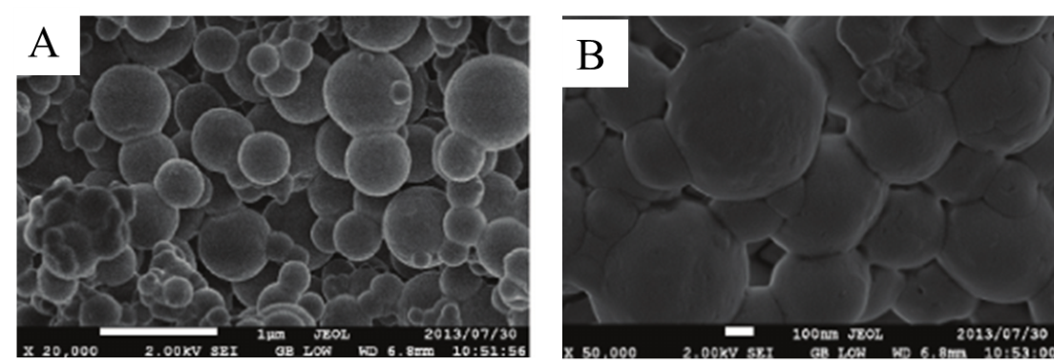
Fig. 1. Scanning electron microscopy images of lipid nanoparticles at (A) ×20,000 and (B) ×50,000 magnification
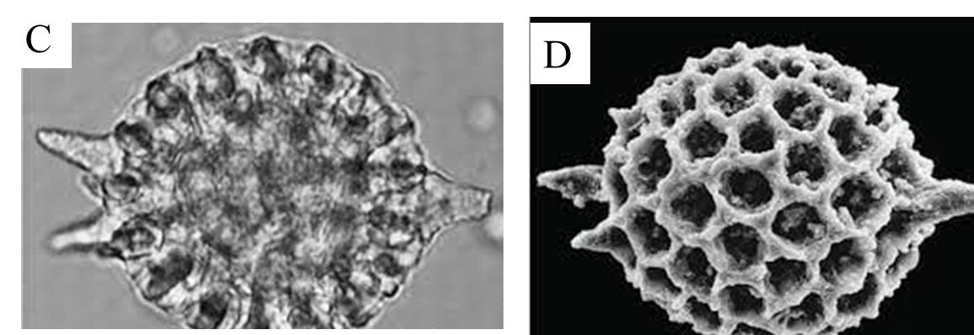

Fig. 2. Radiolarian under (C) light microscope and (D) scanning electron microscope

4. Food microstructure analysis techniques
Imaging has emerged as a preeminent and indispensable family of instrumental techniques for the analysis of foods and food microstructures. Traditionally known as microscopy, imaging has transcended its prior confines, encompassing a broader and more diverse domain. Microscopy, encompassing both an artistic and scientific pursuit, has experienced remarkable advancements, resulting in an enhanced ability to achieve higher magnification and improved feature contrast. Various imaging agents, such as photons (light), high-energy photons (x-rays), and electrons, play distinctive roles in this multifaceted field. For food analysis, a myriad of imaging tools is harnessed, including optical microscopy, fluorescence microscopy, Raman microscopy, transmission electron microscopy, scanning electron microscopy, X-ray computed tomography, atomic force microscopy, nuclear magnetic resonance imaging, field emission scanning electron microscope, confocal laser scanning microscopy, cryo-electron microscopy (Dong and Joer, 2017) and super-resolution stimulated emission depletion microscopy (5). These sophisticated techniques bestow valuable insights into the intricate microstructure of food, enhancing comprehension of food properties and overall quality.

4.1. Optical microscopy
Optical or light microscopy, pioneered by Antonie van Leeuwenhoek in the 17th century, has become a fundamental technique for visualizing microstructures. This approach employs lenses to magnify specimens, enabling detailed observation. In its basic form, bright field light microscopy involves passing white light through the specimen, resulting in a 2D contrast image that highlights differences in absorbance among microstructural phases. Adequate preparation of the specimen is crucial, involving careful slicing, staining, and fixing to ensure compatibility with the microscope stage and enhance contrast. However, these procedures can introduce artifacts. To address these challenges, advanced optical methods like dark field and phase contrast microscopy have been developed. These techniques exploit differences in scattering behavior or refractive index to enhance contrast, eliminating the need for extensive sample pretreatment (3).

The optical microscope offers a magnification range of 10 to 1000× and a resolution of 0.2 μm or 200 nm, facilitating the visualization of size, shape, and internal structure of individual particles and cells. Specific stains are utilized to color distinct components in food, aiding in the identification of protein, fat, starch, and sugar. Starch is revealed using iodine, fats with osmium tetroxide, proteins with hematoxylin, and carbohydrates with periodic acid-schiff staining (34).
Blaszczak and Lewandowicz (2020) observed that at room temperature, potato starch granules remained unchanged and appeared as black spots in the micrographs (Fig. 3A). In LM images, the swollen granules exhibited red-blue-mazarine ovals (Figure 3B). The red color indicated the presence of amylopectin-iodine complexes, while the blue color represented amylose complexes, with darker regions denoting non-gelatinized areas. The transparency of these shapes depended on the extent of gelatinization among different granules. Additionally, the micrographs unveiled the presence of the hydrated amylose phase, which leaked out from the starch granules, contributing to the paste milieu (Fig. 3B). Upon heating the potato starch granules at 90°C, a more advanced gelatinization stage was observed (Fig. 3C). A substantial portion of the released amylose formed droplets, and in conjunction with solubilized amylopectin, constituted a bicontinous network to some extent.
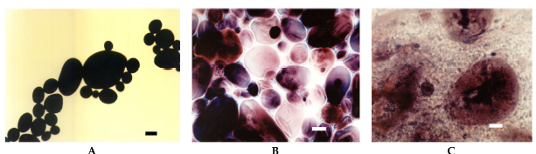
Figure 3: light microscopy (LM) micrographs at 20× magnification of native potato starch dispersions subjected to various incubation temperatures for 15 minutes: (A) at 25°C, (B) at 68°C, and (C) at 90°C. The scale bar indicates 20 µm.
Borem et al. (2008) investigated the impact of different drying temperatures (40, 50, and 60°C) on the structural changes of coffee seeds using a tray dryer until they reached a final moisture content of 11% w.b. To visualize oil globules within the coffee seeds, Sudan IV staining was employed. Drying at 40°C preserved the plasma membrane integrity, resulting in oil globules displaying a globular shape within the cells. At 50°C, oil was concentrated at the endosperm tissue's extremities. Conversely, drying at 60°C caused the oil to disperse across the cellular surface, forming large droplets in intercellular spaces. The rupture of membranes due to higher temperatures exposed the oils to oxidation, leading to the formation of undesirable compounds that significantly impacted the coffee's aroma and flavor.
Phothiset and Charoenrein (2014) conducted a study to assess the impact of freezing and thawing on the microstructure of papaya tissues. Toluidine blue was utilized to visualize the substructures of cells. Papaya cubes were subjected to freezing at -40°C until the temperature reached -25°C, followed by thawing at 4°C for a duration of 4 hours. The freeze-thaw cycles induced the depolymerization of pectin and hemicellulose within the cell walls, along with the loss of vacuoles. Consequently, the cells underwent shrinkage, leading to decreased firmness and an increased drip volume in the papaya tissue.
The advantages of an optical microscope include being inexpensive, relatively compact and easy to set up and use, whereas its disadvantages include (i) only has 1,000 times magnification (ii) Specimens may become deformed while being prepared for microscopy (iii) only has a 0.2 m resolution (iv) Working with various stains is challenging (18).

4.2. Fluorescence microscopy
A fluorescence microscope is an optical instrument that employs fluorescence, along with scattering, reflection, attenuation, or absorption, to investigate the properties of organic and inorganic substances. The term "fluorescence microscope" encompasses a range of setups, from simple configurations like epifluorescence microscopes to more complex designs like confocal microscopes, which utilize optical sectioning to enhance the resolution of fluorescence images. With a magnification range spanning from 120 to 14400× and a resolution of 177 nm, fluorescence microscopy offers high-resolution imaging capabilities (43).
Fluorescence involves the emission of light from atoms, molecules, or materials that have been excited to an electronically active state. The wavelength or energy of the excitation light indicates the molecular chemical bonds or the physical state of the material. Optical filters are integrated into a bright light source to selectively target the excitation wavelength, and fluorescence filters are positioned after the sample to capture the emission spectrum. Fluorescent stains, containing molecules that fluoresce upon excitation (known as fluorochromes), can also be introduced to the sample to highlight components with which they strongly interact. Staining can take a positive form (targeting specific structures) or a negative form (highlighting non-target structures). Many food materials naturally contain fluorochromes. By carefully selecting an appropriate excitation wavelength, the vivid colors emitted through fluorescence become readily observable under a light microscope.
Fig.4. shows the aleurone layer within a wheat kernel that auto-fluoresces bright blue, making that particular layer of cells become obvious to the viewer, over any other cell types within the wheat kernel (5).
Fig. 4. Particles of wheat fiber demonstrating various colors of auto-fluorescence
Tsai et al. (2010) evaluated the contribution of phenol-pectin crosslink in strengthening the texture of guava slices during thermal processing. Guava slice (2 cm) was treated with ferulic acid (0.5 g/kg) and dehydrated at 30°C for 36 h with air convectional drier. Excitation wavelength of 488 nm was used. Ferulic acid treated guava slice exhibited higher hardness (4.2 kg) than control (2.5 kg) which strengthened the texture of guava. Autofluorescence was observed at the borders of the cell wall (Fig. 10.). Evident that the accumulated phenolic compounds around the cell wall might link with pectin and prevent the detachment of cells during processing.

4.3. Confocal laser scanning microscopy
Confocal microscopy, known as confocal laser scanning microscopy (CLSM) or laser confocal scanning microscopy (LCSM), is an advanced optical imaging technique that enhances micrograph resolution and contrast. It achieves this by utilizing a spatial pinhole to eliminate out-of-focus light during image formation. By capturing a series of two-dimensional images at varying depths within a specimen, it enables the creation of three-dimensional reconstructions of internal structures. This method finds diverse applications in fields like life sciences, semiconductor analysis, and materials science (31).
The concept of confocal imaging, patented by Marvin Minsky in 1957, aimed to address limitations of traditional wide-field fluorescence microscopes. In conventional fluorescence microscopy, uniform illumination leads to simultaneous excitation of all parts of the sample, resulting in significant unfocused background signals. In contrast, a confocal microscope employs point illumination and incorporates a pinhole ahead of the detector. This design eliminates out-of-focus signals, giving rise to the term "confocal." Only fluorescence produced very close to the focal plane is detected in a confocal microscope, greatly improving optical resolution, particularly in the depth direction. However, this comes with a trade-off: due to the pinhole's blocking effect, a substantial portion of emitted fluorescence is not detected, leading to reduced signal intensity. This often necessitates longer exposure times. To mitigate signal reduction, sensitive detectors like photomultiplier tubes (PMT) or avalanche photodiodes convert the optical signal into an electrical one for further processing (30).
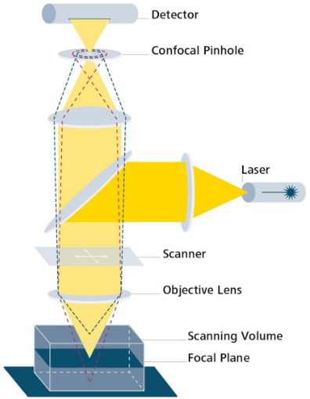
Fig. 5. Schematic view of a confocal laser scanning microscope
In confocal microscopy, only a single point within the sample is illuminated at a time. To achieve 2D or 3D imaging, scanning occurs over a regular raster pattern across the specimen. The scanning is done horizontally by employing one or more servo-controlled oscillating mirrors. This scanning technique offers low reaction latency and adjustable scan speeds, with slower scans yielding better signal-to-noise ratios and improved contrast. The focal plane's achievable thickness primarily depends on the wavelength of the light used divided by the numerical aperture of the objective lens. Additionally, the optical properties of the specimen also play a role. The ability to create thin optical sections makes confocal microscopes well-suited for 3D imaging and surface profiling of samples. These successive slices compose a 'z-stack,' which can be processed to generate a 3D image or merged into a 2D stack, often by selecting the maximum pixel intensity, though other methods like using the standard deviation or summing the pixels are also common (30).
Krebs et al. (2022) studied the effect of UHP homogenization on the microstructure of buttermilk. 1% Fast Green (proteins) and 1% Nile Red (fat) were used as flurochromes. The sample was excited with 488- and 638-nm lasers and collected at 590 nm and 755 nm, respectively. Results found that with increasing pressure from 0 to 300 MPa, the particles became much smaller, more homogeneous protein distribution in aggregates associated together into a filamentous manner which gave stable structure to buttermilk.
Limitations of fluroscence microscope are as follows (i) It has a lower resolution than SEM and TEM, (ii) Fluorophores lose their capacity to fluorescence due to photobleaching when a short wavelength is used, (iii) Low light sensitivity and (iv) High complexity and cost (24).

4.4. Stimulated emission depletion microscopy
Stimulated Emission Depletion (STED) microscopy is a crucial component of super-resolution microscopy techniques, offering the ability to generate super-resolution images through targeted fluorophore deactivation. This technique narrows down the area of illumination at the focal point, leading to enhanced achievable resolution for a given system (see Fig. 6) (4).
STED operates by extinguishing fluorescence within specific regions of the sample, while maintaining an active center focal spot for fluorescence emission. The configuration of this focal area can be manipulated by modifying the characteristics of the pupil plane in the objective lens. An early example of these diffractive optical elements (DOEs) is a torus shape utilized for two-dimensional lateral confinement, as illustrated below. The red zone is depleted of fluorescence, while the green spot remains active. This DOE is created by circular polarization of the depletion laser combined with an optical vortex. The lateral resolution of this DOE typically falls within the range of 30 to 80 nm, although even smaller values, such as 2.4 nm, have been reported (38).
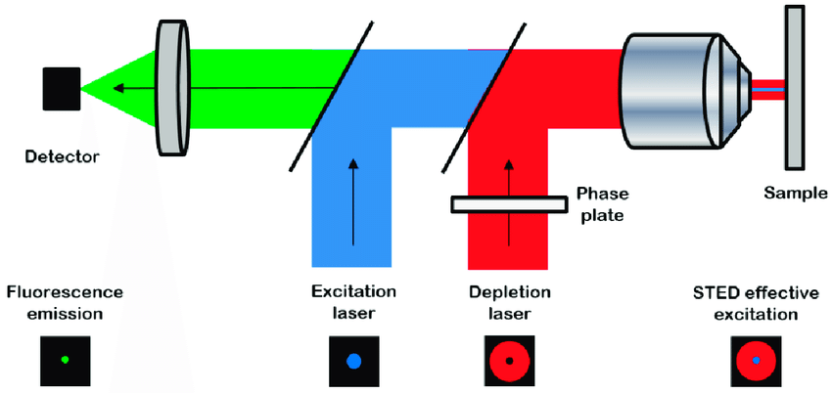

Fig. 6. Stimulated emission depletion microscopy principle
Jose et al. (2022) compared super-resolution microscopy technique and conventional confocal microscopy for visualizing protein microstructural organization in egg white protein and its relation to rheology. STED microscopy achieved a 5-fold resolution enhancement over confocal microscopy, enabling precise visualization of protein microstructures. This improved resolution facilitated a more accurate structure quantification, revealing 7–13 times more particles within solid areas compared to confocal imaging. Furthermore, the observed increase in particle count and density in STED images directly correlated with the logarithmic rise in elastic modulus across egg-white samples cooked at various temperatures.

4.5. Raman microscopy
Raman imaging integrates a confocal microscope with a spectrometer to capture a Raman spectrum at each sample point. Optical microscope objective lenses both facilitate sample observation and transmit Raman scatter to the spectrograph. This technique allows for the mapping of constituents within intricate food matrices, encompassing details like chemical distribution, quantities, and structural layouts. However, Raman spectroscopy faces limitations, primarily concerning signal detection. Insufficient detection may stem from a material's lack of Raman activity or its emission of a weak Raman signal (9).
Lohumi et al. (2018) studied detection of adulterants (Sudan-I and Congo Red dyes) in paprika powder using excitation wavelength of 785 nm and Raman shifts of 763 to 2837 cm⁻¹. Results found that adulterants could be detected at the level of 0.1, 0.25 and 0.5%.

4.6. Transmission electron microscopy
Transmission electron microscopy (TEM) involves passing an electron beam through a thin specimen, interacting with its constituents to form an image. Specimens are often ultra-thin sections or suspensions on a grid, typically under 100 nanometers thick. The resultant image is magnified and directed onto an imaging device, such as photographic film or a sensor coupled with a scintillator (20).
Transmission Electron Microscopes (TEM) offer diverse modes including imaging, STEM, diffraction, and spectroscopy, providing detailed nanometer and atomic-scale information. Its ability to reveal atomic arrangement, composition, and bonding makes TEM crucial in nanoscience for both biological and materials research (20).
The transmission electron microscope (TEM) is composed of key components arranged from top to bottom. These include an emission source or cathode, which can be made of materials like tungsten filament or lanthanum hexaboride (LaB6), connected to a high voltage source (typically 100–300 kV). Electrons are emitted into the vacuum through thermionic or field electron emission methods. In thermionic emission, a Wehnelt cylinder focuses emitted electrons into a coherent beam, stabilizing the electron current. Field emission uses electrostatic electrodes—extractor, suppressor, and gun lens—with different voltages to control the electric field's shape near the emission tip. This assembly, along with the cathode, forms the "electron gun." The electron beam then moves to the condenser lens system, where upper lenses refine the focus for precise beam size and sample positioning (refer to Fig. 7).
Fig. 7. Schematic view of a transmission electron microscope

4.7. Scanning electron microscopy
A scanning electron microscope (SEM) is a specialized electron microscope variant designed for generating images of a sample's surface. This is achieved by directing a focused beam of electrons onto the sample's surface. As the electrons engage with the atoms in the sample, diverse signals are produced that carry information about the surface's topography and composition. The electron beam follows a pattern of scanning known as a raster scan, where the beam's position and the strength of the detected signal are combined to construct an image. In the primary mode of operation for most SEMs, secondary electrons that are emitted from atoms that the electron beam excites are collected using a secondary electron detector. The count of secondary electrons that can be gathered, and consequently the signal strength, varies based on factors such as the topography of the specimen. Certain SEMs can achieve astonishing resolutions finer than 1 nanometer. Sample observation in a conventional SEM occurs within a high vacuum environment. Alternatively, in a variable pressure or environmental SEM, samples can be examined under conditions of low vacuum or even in wet conditions. Furthermore, specialized instruments enable SEM imaging across a broad range of temperatures, from cryogenic to elevated levels (23).
A scanning electron microscope (SEM) utilizes interactions between the electron beam and sample atoms to generate signals like secondary electrons (SE) and back-scattered electrons (BSE), with characteristic X-rays providing element information. SEs, with limited energy, produce high-resolution images of surface structures, while BSEs offer insight into element distribution. Characteristic X-rays result from inner-shell electron displacement and are used to identify elements via spectroscopy. SEM micrographs display depth of field, enhancing 3D appearance. With magnification from 10x to over 500,000x, SEM surpasses light microscopy's limits, enabling comprehensive exploration of microscale and nanoscale features.
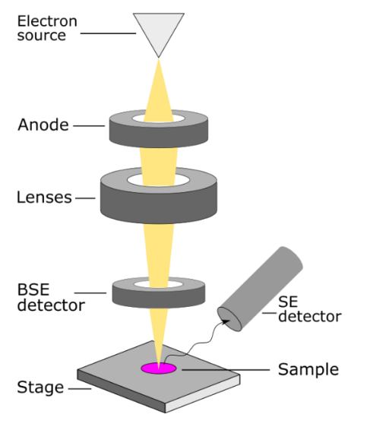
Fig. 8. Schematic view of a scanning electron microscope
Sharma et al. (2017) conducted a study to explore the emulsifying potential of sodium caseinate and pectin as a combination for encapsulating clove oil in nanoemulsion form. The researchers prepared a mixture of clove oil, NaCas (5%), and pectin (1%) using a high-speed magnetic stirrer at 25°C for 20 minutes, with stirring speeds ranging from 15,000 to 24,000 rpm. The prepared mixture was then stored at 25°C for one month. The analysis was performed using scanning electron microscopy (SEM) at 15 kV and transmission electron microscopy (TEM) at 70 kV. The results indicated that the formulation maintained stability against phase separation for a period of 20 days during storage. Morphological examinations through SEM and TEM confirmed that the core material, clove oil, was fully encapsulated within the coating material.

The electron microscope comes with several limitations: (a) Images are monochromatic, lacking color representation, (b) The instruments are large and costly, demanding significant investment, (c) Specialized facilities are essential for housing and maintenance due to their sensitivity to vibrations and electromagnetic fluctuations, (d) Preparing samples from bulk materials is often time-intensive, (e) Possible artifacts may arise from sample preparation procedures, (f) Proficiency in tool operation and data analysis necessitates specialized training, (g) Samples are constrained to those compatible with the vacuum chamber and suitable in size and solidity for chamber accommodation, and (h) The maximum size in horizontal dimensions is typically around 10 cm, while vertical dimensions are more restricted, rarely surpassing 40 mm.

4.8. Cryo-electron microscopy
Cryogenic electron microscopy (cryo-EM) is a specialized technique that involves cooling samples to extremely low temperatures to preserve their structure. This is achieved by embedding biological specimens in a vitreous ice matrix. The process includes applying an aqueous sample solution onto a mesh grid, followed by rapid freezing in liquid ethane or a mixture of ethane and propane. While cryo-EM's foundations were laid in the 1970s, recent strides in detector technology and software algorithms have brought about a transformative shift, enabling the determination of biomolecule structures at nearly atomic resolution.
Cryo-EM involves capturing images of radiation-sensitive samples under conditions of extreme cold, enabling the study of biomolecule structures within their natural cellular contexts. By analyzing frozen slices of suspensions, researchers gain insights into particle morphology in their dispersed state while minimizing beam-induced heating and material damage. With magnification from 50 to 500 million times and an exceptional 1.22 Ångström resolution, molecular details are examined at an unprecedented level. Trejo et al. (2021) employed Cryo-EM at 200 kV with a magnification of 38,000× to investigate native casein micelles in bovine milk frozen at –182°C. Their findings revealed interconnected water-filled cavities and channels within the micelle's interior, offering insight into its dynamic nature and the retention and release mechanisms of β-casein macromolecules.

4.9. X-ray computed tomography
A computed tomography scan (CT scan), formerly known as computed axial tomography (CAT scan), is a medical imaging method that provides detailed internal images of the body. Radiographers or radiology technologists perform CT scans using rotating X-ray tubes and detectors positioned in a gantry to measure X-ray attenuations across different body tissues. These measurements, taken from various angles, are then processed using tomographic reconstruction algorithms on a computer to create cross-sectional images (known as "slices") of the body. CT scans are valuable for patients with metallic implants or pacemakers, for whom magnetic resonance imaging (MRI) is unsuitable. Since its inception in the 1970s, CT scanning has demonstrated its versatility in medical diagnosis and imaging of non-living objects. The 1979 Nobel Prize in Physiology or Medicine was jointly awarded to South African-American physicist Allan MacLeod Cormack and British electrical engineer Godfrey Hounsfield for their pioneering work in computer-assisted tomography.
X-ray computed tomography, depicted in Figure 9, is a technique leveraging variations in X-ray radiation attenuation to create transmission images (radiographs) of samples. By capturing multiple radiographs from various angles around the sample, a 3D image, or tomograph, is reconstructed. This method proves invaluable in revealing internal content and microstructures of food products, including distribution of components like fat, protein, and air bubbles, as illustrated in Figures 23 and 24. The brighter regions signify higher X-ray absorption, indicating dense materials, while darker regions denote lower absorption, representing air voids or gas phases. With a resolution of 1 μm and magnification ranging from 1000 to 2000×, X-ray computed tomography offers detailed insights into the structural characteristics of diverse samples (42).
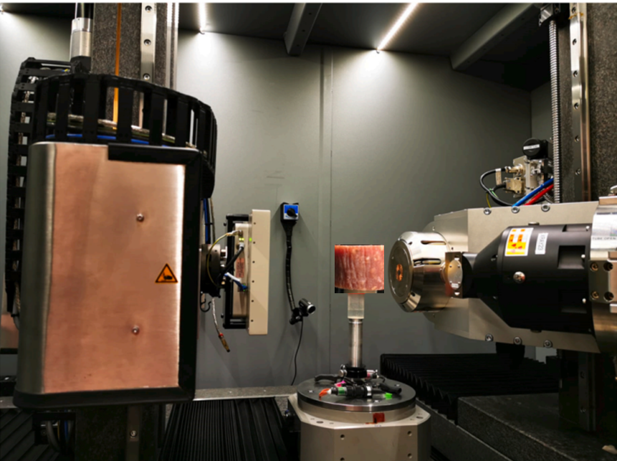
Fig. 9. Experimental setup for X- ray CT for Salami
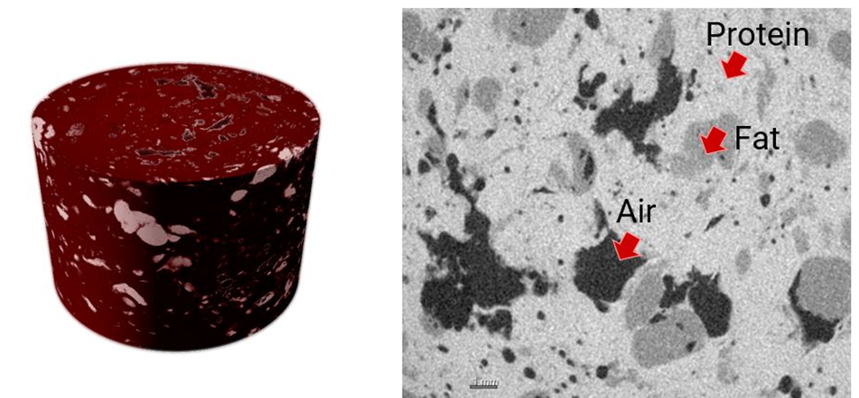
Fig. 10. 3D rendered scan is shown on the left and a cross-section is shown on the right
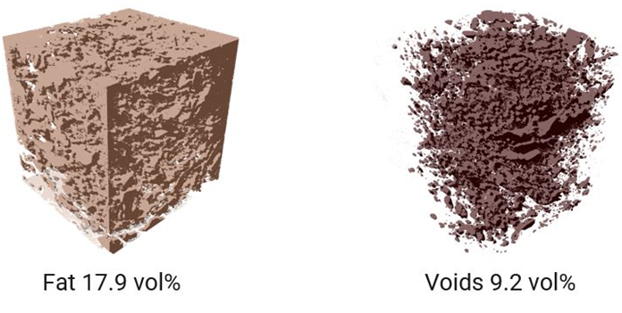
Fig.11. Distribution and volume fraction analysis
X-ray CT scanning comes with its share of limitations. The finite resolution of the technique can lead to blurring of material boundaries, and not all features possess significant enough attenuation contrasts for effective imaging. Image artifacts are another challenge that can complicate both data acquisition and interpretation. Additionally, handling large data volumes generated during the process may demand substantial computational resources for visualization and analysis. Furthermore, it's worth noting that X-ray imaging is primarily geared towards detecting macro-sized particles and structures, lacking the capability to detect the presence of nano-sized materials (42).

4.10. Nuclear magnetic resonance imaging
Nuclear Magnetic Resonance (NMR) is a nondestructive imaging technique that allows for the acquisition of both two-dimensional and three-dimensional images of biological samples. It operates by measuring the physical properties of the sample, such as proton density and relaxation times. The relaxation time in NMR serves as a parameter for quantifying attributes like water or fat content, and it can provide insights into changes in the microstructure of the sample. This method focuses on the study of magnetic nuclei, such as protons, which are aligned with a constant magnetic field and subsequently manipulated by an alternating magnetic field, as illustrated in Figure 12 (21).
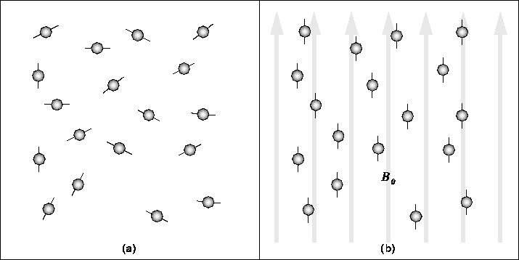

Fig. 25. Basic principle of MRI
NMR relaxation is a technique that tracks changes in the NMR signal due to nuclear magnetization or alignment fluctuations over time. After excitation, the NMR signal weakens as nuclei lose alignment. This process yields distinct time constants linked to nuclear population return to thermodynamic equilibrium post electromagnetic pulse. These constants are tied to factors like magnetic nucleus concentrations and mobility.
The advent of advanced data analysis algorithms in the early 2000s introduced 2D NMR relaxometry, yielding "relaxation spectra." These spectra exhibit peaks for water within diverse microstructural pores and compartments. Peaks correspond to proton longitudinal and transverse relaxation times (T1 and T2) contingent on pore size and water content. Peaks from solutes and biopolymers offer insights into dynamic behavior and sample composition.
Various 2D relaxation and diffusion experiments provide insights into localized water transport in food microstructures (e.g., tomatoes, mangoes) affected by processing. Notably, NMR doesn't inherently offer spatial images, but specialized sequences in MRI have started addressing this. MRI combines spectroscopy and relaxometry data, expanding food product inspection capabilities. MRI has been applied to assess internal quality in avocados, cherries, olives, apples, pears, citrus, and meats, notably demonstrating potential for quantitative fat assessment in beef using image analysis, showing strong correlation (R2 = 0.98) between MRI-detected and chemically measured intramuscular fat percentages across different quality grades (Fig. 12 and 13) (25).
Fig. 12. Main steps involved in extraction of fat pixels from the MRI image and application of ImageJ image processing. (a) Original MRI image of beef meat, (b) Selected total beef slice image, (c) Selected fat region image, (d) Extracted total beef slice image from background and (e) Extracted fat region image from muscle and background
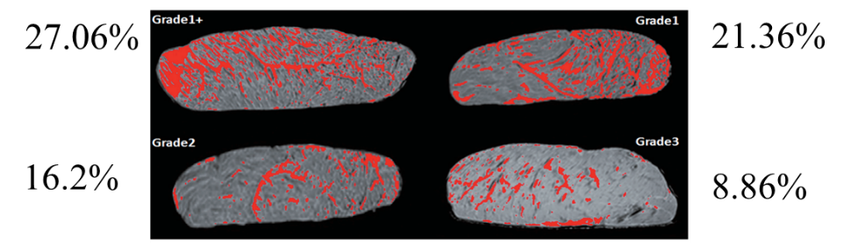
Fig. 13. MRI images of different grades of beef samples. Fat is in red

4.11. Atomic force microscopy
Atomic force microscopy (AFM), or scanning force microscopy (SFM), is a specialized form of scanning probe microscopy (SPM) that achieves unparalleled resolution, overcoming optical diffraction limits by more than 1000 times. AFM involves physically probing a surface to gather data, enabled by piezoelectric elements that guide precise movements based on electronic instructions. For imaging, the probe's response to sample forces constructs a high-resolution 3D topographical image by systematically scanning the sample's position relative to the probe while recording the constant probe-sample interaction height. In manipulation, probe-sample forces are leveraged to intentionally modify properties, enabling atomic manipulation, scanning probe lithography, and localized cell stimulation. Alongside topographical imaging, AFM measures various properties like stiffness, adhesion strength, conductivity, and surface potential with comparable high resolution. Many SPM techniques extend from AFM principles, expanding its applications (37). In their research, Tiwari et al. (2018) explored microwave-assisted alkali pretreatment for extracting sugars from banana fruit peel waste. Atomic force microscopy (AFM) analysis revealed altered surface characteristics, likely due to disrupted cell wall structures. This disruption potentially contributed to reduced hemicelluloses and lignin content, resulting in a significant increase in sugar production (0.561 g/g of dry biomass waste).

5. Microscopic techniques followed by FSSAI and CODEX for food analysis
- Determination of light filth in whole wheat flour- This technique is suitable for both whole wheat flour (atta) and refined flour. A test portion undergoes digestion through boiling in a 3% HCl solution, followed by sieving. The resulting residue is then rendered free of fat by boiling in isopropanol, with subsequent sieving. To capture any impurities, a mixture of Tween 80 and Na4EDTA in 40% isopropanol is employed, which traps them alongside mineral oil. The separated oil phase is isolated, filtered, and subjected to microscopic examination to identify any impurities present. Notably, the examined sample should not reveal any visible impurities under the microscope. In the context of wheat flour, the presence of light filth is required to be absent as per the specified standards (14).
- Test for the presence of animal body fat in vegetable fat- Animal body fats, such as beef tallow and lard, have been found to contain trisaturated glycerides. Upon crystallization, these glycerides exhibit a distinctive crystalline pattern when observed under a microscope. Upon examination under both x 160 and x 400 magnifications, the unique characteristics of these crystals become evident. Beef tallow typically crystallizes into recognizable fan-like tufts, featuring ends that are more or less pointed. On the other hand, lard crystals exhibit a chisel-shaped appearance. In the case of hydrogenated fats, the deposited crystals are of a smaller size. It's important to note that the size and shape of these crystals are influenced by factors such as solution strength, the quantity of fat used, and the duration of the crystallization process (16).
- Microscopic examination of spices- To achieve transparency, the spice is subjected to a boiling process with Chloral hydrate. This compound serves a dual purpose: firstly, it eliminates starch content, resulting in the concentration of other plant tissues, and secondly, it effectively removes colorants from these tissues. As a result, the outlines of the tissues become significantly more distinct and observable. In addition, Phloroglucinol is employed as a staining agent specifically for Sclerenchymatous matter (13).
- Test for chicory in coffee- To perform the test, start by boiling approximately 1 gram of the sample with 50 ml of a 2% sodium hydroxide solution for a duration of about 2 to 3 minutes. Following this, dilute the mixture, filter it, and thoroughly wash the residue with water until the filtrate no longer contains any traces of alkali. Repeat this process until the residue exhibits no color when in contact with water. In case there is still some residual coloration, you may employ treatment with calcium chloride solution, followed by further washing with water. Place a small drop of the residue material in glycerine onto a clear microscopic slide for observation.
Coffee can be identified by the presence of both longitudinal and transverse schlerenchymatous fibers (derived from the pericarp). On the other hand, chicory exhibits large vessels, some of which can be up to 115 microns wide and possess short pits. Additionally, roasted cereals like barley, oats, and wheat, along with soy, might be mixed with coffee or coffee-chicory blends as substitutes. A meticulous microscopic examination will enable the identification of these adulterants (15).
- Method for distinguishing type of peas- This technique relies on distinguishing between starch granules found in wrinkled-seeded and smooth-seeded varieties. Starch granules in smooth-seeded types (such as round, early, and Continental) appear as shapeless masses lacking distinct geometric forms. Conversely, starch granules in wrinkled-seeded types (such as garden peas and sweet peas) exhibit well-defined, clear-cut, and generally spherical particles (10).

6. Key characteristics of tools to examine food microstructure

Table 1. Key characteristics of tools to examine food microstructure (11)
Tool | Imaging agent | Resolution | Information
Optical microscopy | Visible light | ̴200 nm | Morphology, composition with staining
Fluorescence microscopy | Visible light | 177 nm | Composition
Confocal laser scanning microscopy | Laser | 120 nm | Ingredient localisation, 3D information
Raman microscopy | Laser | 0.2 μm | Chemical distribution and its quantitative assessment
Stimulated emission depletion microscopy | Laser | 20 nm | To visualize and quantify protein, fat, starch microstructural organization
Transmission electron microscopy | Electron | 0.1 nm | Fine structural detail, macromolecular interactions
Scanning electron microscopy | Electron | 0.5 nm | Surface topography and composition of the sample
Electron tomography | Electron | 1.22 Å | Surface topography and composition of the sample in their native state
X-ray computed tomography | X- rays | 1 μm | Non-destructive 3D structure based on atomic contrast
Nuclear magnetic resonance imaging | Protons | 1 μm | Quantification of water or fat
Atomic force microscopy | Electron | 0.1 nm | Surface topology

7. Limitations of food microstructure analysis techniques
While Food Microstructure Analysis Techniques offer valuable insights into the hidden world of food, they also come with certain limitations that researchers and food scientists should be aware of. Some of the limitations include:
- Sample preparation complexity: Many microscopy techniques require meticulous sample preparation, which can be time-consuming and labor-intensive. Preparing samples for analysis may involve delicate cutting, staining, and fixation procedures, which can introduce artifacts and alter the original microstructure.
- Destructive analysis: Some microscopy methods, such as transmission electron microscopy and scanning electron microscopy, often require the destruction of the sample or its portion during the preparation process. This limitation restricts the ability to analyze the same sample multiple times or perform additional tests on it.
- Limited depth of field: Traditional microscopy techniques often have a limited depth of field, which means that only a thin slice of the sample is in focus at a time. This may hinder the complete visualization and understanding of the three-dimensional microstructure of complex food systems.
- Resolution limitations: The resolution of light microscopy, although significantly improved over the years, is still limited when compared to advanced imaging techniques like super-resolution microscopy or electron microscopy. This limitation may affect the ability to visualize nanoscale structures and interactions within the food matrix.
- Accessibility: Sophisticated microscopy equipment, such as transmission electron microscopes and confocal laser scanning microscopes, can be expensive to acquire and maintain. This cost may restrict the accessibility of these techniques to certain research facilities and limit their wider application.
- Sample size requirements: Some microstructure analysis techniques require a certain minimum sample size for accurate analysis. This could be challenging when dealing with limited or precious food samples, especially in research involving rare or valuable food materials.
- Data analysis complexity: Microscopy generates large volumes of image data that need to be meticulously analyzed and interpreted. The complexity of data analysis and the need for specialized software and expertise can be a challenge for researchers, especially in multidimensional imaging studies.
Despite these drawbacks, Food Microstructure Analysis Techniques remain indispensable tools for understanding the intricate composition and functionality of food materials. Being cognizant of these limitations allows researchers to employ these techniques judiciously and seek complementary methods to obtain comprehensive insights into food microstructures.

8. Conclusion
In conclusion, Food Microstructure Analysis Techniques present numerous opportunities for advancing our understanding of food materials. These techniques, ranging from traditional microscopy to advanced imaging and spectroscopy, have allowed us to visualize and analyze the intricate microstructures of food, leading to valuable insights into their composition, organization, and functionality. By harnessing this knowledge, researchers and food manufacturers can design and produce food products with tailored properties to meet specific consumer demands. These techniques also hold great potential for improving food safety by enabling the identification and characterization of additives, contaminants, and undesirable substances, ensuring the production of safer and high-quality food.
However, alongside these opportunities, there are certain drawbacks to consider. The complexity and diversity of food materials pose challenges in selecting the most appropriate microstructure analysis technique for each specific application. Some techniques may require extensive sample preparation, which could alter the natural microstructure, leading to potential artifacts. Additionally, the high cost and specialized expertise needed to operate certain advanced imaging equipment may limit accessibility for smaller food businesses and research laboratories.
Despite these drawbacks, the continual advancements in Food Microstructure Analysis Techniques offer a promising future for the food industry. As researchers continue to explore and refine these methods, addressing current limitations and improving efficiency, the potential benefits for food product development, quality control, and safety are expected to significantly outweigh the challenges. By leveraging these powerful tools, we can uncover the hidden world of food, leading to innovative and sustainable solutions that enhance the overall food experience for consumers worldwide.

9. References
- Aguilera, J. M., 2005, Why food microstructure?. Journal of Food Engineering, 67(2): 3-11.
- Adriaensen, H., Musse, M., Quellec, S., Vignaud, A., Cambert, M. and Mariette, F., 2013, MSEMRI sequence optimisation for measurement of bi- and tri-exponential T2 relaxation in a phantom and fruit. Magnetic Resonance Imaging, 31(2): 1677-1689.
- Błaszczak, W. and Lewandowicz, G., 2020, Light microscopy as a tool to evaluate the functionality of starch in food. Foods, 9(5): 670-676.
- Blom, H. and Brismar, H., 2014, STED microscopy: Increased resolution for medical research?. Journal of Internal Medicine, 276(6): 560–578.
- Bonilla, J. C. and Clausen, M. P., 2022, Super-resolution microscopy to visualize and quantify protein microstructural organization in food materials and its relation to rheology: Egg white proteins. Food Hydrocolloids, 124(3): 107281-107290.
- Borém, F. M., Marques, E. R. and Alves, E., 2008, Ultrastructural analysis of drying damage in parchment Arabica coffee endosperm cells. Biosystems Engineering, 99(1):62-66.
- Chaple, S., Sarangapani, C., Dickson, S. and Bourke, P., 2023, Product development and X-Ray microtomography of a traditional white pan bread from plasma functionalized flour. LWT-Food Science and Technology, 174(1): 114326-114337.
- Chargot, M., Chylińska, M., Pieczywek, P.M., Rösch, P., Schmitt, M., Popp, J. and Zdunek, A., 2016, Raman imaging of changes in the polysaccharides distribution in the cell wall during apple fruit development and senescence. Planta, 243(2): 935-945.
- Chawanji, A., Holroyd, S.E. and Nickless, E., 2022, Raman confocal microscopy to assess changes in cheddar cheese during maturation. International Journal of Dairy Technology, 75(4): 882-891.
- CODEX STAN 297-2009, Codex Standards in the WHO South-East Asia Region.
- Dong, J. and St. Jeor, V. L., 2017, Food microstructure techniques. Food Analysis, pp. 557-570.
- Dyba, M. and Hell, S. W., 2003, Photostability of a Fluorescent Marker Under Pulsed Excited-State Depletion through Stimulated Emission. Applied Optics, 42(25): 5123–5129.
- FSSAI, 2021. Manual For Analysis of Spices, Herbs and Condiments. Pp. 92.
- FSSAI, 2015. Manual of Methods of Analysis of Foods: Cereals and Cereal Products. Pp. 14-17.
- FSSAI, 2015. Manual of Methods of Analysis of Foods: Beverages (Coffee, Tea, Cocoa, Chicory) Sugar and Sugar Products & Confectionery Products. Pp. 16-19.
- FSSAI, 2015. Manual of Methods of Analysis of Foods: Oils and Fats. Pp. 50-52.
- Garud, S. R., Lamdande, A. G., Tavanandi, H. A., Mohite, N. K. and Nidoni, U., 2022, Effect of physicochemical properties on popping characteristics of selected pearl millet varieties. Journal of the Science of Food and Agriculture, 102(15): 7370-7378.
- Gunning, P. A., 2013, Light microscopy: principles and applications to food microstructures. Food Microstructures, 62–95. doi:10.1533/9780857098894.1.62 .
- Heintzmann, R. and Ficz, G., 2007, Breaking the resolution limit in light microscopy. Methods in cell biology, 81(1): 561-580.
- Jonge, N. and Ross, F. M., 2011, Electron microscopy of specimens in liquid. Nature Nanotechnology, 6(8): 695–704.
- Kirtil, E. and Oztop, M.H., 2016, 1 H nuclear magnetic resonance relaxometry and magnetic resonance imaging and applications in food science and processing. Food Engineering Reviews, 8(1): 1-22.
- Kirtil, E., Oztop, M.H., Sirijariyawat, A., Ngamchuachit, P., Barrett, D.M. and McCarthy, M.J., 2014. Effect of pectin methyl esterase (PME) and CaCl2 infusion on the cell integrity of fresh-cut and frozen-thawed mangoes: An NMR relaxometry study. Food research international, 66(1): 409-416.
- Klein, T., Buhr, E. and Frase, C. G., 2012, TSEM: A review of scanning electron microscopy in transmission mode and its applications. Advances in imaging and electron physics, 171(1): 297-356.
- Krebs, L., Pouliot, Y., Doyen, A., Venema, K. and Brisson, G., 2023. Effect of reverse osmosis and ultra-high-pressure homogenization on the composition and microstructure of sweet buttermilk. Journal of Dairy Science, 106(3): 1596-1610.
- Lee, S., Lohumi, S., Lim, H.S., Gotoh, T., Goto, T., Cho, B.K. and Jung, S., 2015, Determination of intramuscular fat content in beef using magnetic resonance imaging. Applied Magnetic Resonance, 60(1): 157–162.
- Liu, Q., Wu, J., Lim, Z. Y., Aggarwal, A., Yang, H., & Wang, S. (2017b). Evaluation of the metabolic response of Escherichia coli to electrolysed water by 1H NMR spectroscopy. LWT-Food Science and Technology, 79(4): 428–436.
- Lohumi, S., Lee, H., Kim, M.S., Qin, J. and Cho, B.K., 2018, Through-packaging analysis of butter adulteration using line-scan spatially offset Raman spectroscopy. Analytical and bioanalytical chemistry, 410(2): 5663-5673.
- Marigheto, N. A., Moates, G. K., Furfaro, M. E., Waldron, K. W. and Hills, B. P., 2009, Characterisation of ripening and pressure-induced changes in tomato pericarp using NMR relaxometry. Applied Magnetic Resonance, 36(9): 35-47.
- Musse, M., Cambert, M. and Mariette, F., 2010, NMR study of water distribution inside tomato cells: effects of water stress. Applied Magnetic Resonance, 38(2): 455-469.
- Patel, D. V. and McGhee, C. N., 2007, Contemporary in vivo confocal microscopy of the living human cornea using white light and laser scanning techniques: a major review. Clinical and Experimental Ophthalmology, 35(1): 71-88.
- Pawley, J. B., ed. 2006, Handbook of Biological Confocal Microscopy (3rd ed.). Berlin: Springer. ISBN 0-387-25921-X.
- Phothiset, S. and Charoenrein, S., 2014, Effects of freezing and thawing on texture, microstructure and cell wall composition changes in papaya tissues. Journal of the Science of Food and Agriculture, 94(2): 189-196.
- Sharma, M., Mann, B., Sharma, R., Bajaj, R., Athira, S., Sarkar, P. and Pothuraju, R., 2017. Sodium caseinate stabilized clove oil nanoemulsion: physicochemical properties. Journal of food engineering, 212(2): 38-46.
- Stephens, D. J. and Allan, V. J., 2003, Light microscopy techniques for live cell imaging. Science, 300(5616): 82-86.
- Sugumar, S., Nirmala, J., Ghosh, V., Anjali, H., Mukherjee, A. and Chandrasekaran, N., 2013. Bio‐based nanoemulsion formulation, characterization and antibacterial activity against food‐borne pathogens. Journal of basic microbiology, 53(8): 677-685.
- Sunil, C. K., Chidanand, D. V., Manoj, D., Choudhary, P. and Rawson, A., 2019, Effect of ultrasound treatment on dehulling efficiency of blackgram. Journal of Food Science and Technology, 55(7): 2504–2513.
- Tiwari, G., Sharma, A., Kumar, A. and Sharma, S., 2019. Assessment of microwave-assisted alkali pretreatment for the production of sugars from banana fruit peel waste. Biofuels, 10(1): 3-10.
- Torok, P. and Munro, P. R. T., 2004, The use of Gauss-Laguerre vector beams in STED microscopy. Optics Express, 12(15): 3605–3617.
- Trejo, R., Dokland, T., Jurat-Fuentes, J. and Harte, F., 2011, Cryo-transmission electron tomography of native casein micelles from bovine milk. Journal of dairy science, 94(12): 5770-5775.
- Tsai, P.J., Sun, Y.F. and Hsiao, S.M., 2010. Strengthening the texture of dried guava slice by infiltration of phenolic compounds. Food research international, 43(3): 825-830.
- Verboven, P., Defraeye, T. and Nicolai, B., 2018, Measurement and visualization of food microstructure: Fundamentals and recent advances. Food Microstructure and its Relationship with Quality and Stability, 2(3): 3-28.
- Vidhya, M., Varadharaju, N., John Kennedy, Z., Amirtham, D. and Manohar Jesudas, D., 2017, Applications of X-Ray Computed Tomography in Food Processing. Food research international, 2(8): 673-679.
- White, N.S. and Errington, R.J., 2005. Fluorescence techniques for drug delivery research: theory and practice. Advanced drug delivery reviews, 57(1): 17-42.

