Techniques of Extraction

Assist. Prof. Dr. Fadime SEYREKOĞLU
Department of Food Processing
Amasya University, Suluova Vocational School,
Amasya, Türkiye
fadime.tokatli@amasya.edu.tr
Assist. Prof. Dr. Sultan ACUN
Department of Food Processing
Amasya University, Suluova Vocational School,
Amasya, Türkiye
sultan.acun@amasya.edu.tr

ABSTRACT
Extraction methods play a crucial role in the food industry for obtaining bioactive compounds, flavors and aromas from various plant and animal sources. This study aims to highlight the importance of both conventional and modern extraction methods in food applications. Conventional methods, such as maceration, percolation, infusion, decoction, digestion and Soxhlet extraction, have been widely employed for centuries. However, they often suffer from limitations such as prolonged extraction times and high solvent consumption.
On the other hand, modern extraction techniques have emerged as promising alternatives due to their improved efficiency and eco-friendly nature. The utilization of conventional and modern extraction methods is dependent on the desired compounds and the characteristics of the raw materials. Various food applications, including the production of functional foods, nutraceuticals, natural food additives and food flavors, greatly benefit from these extraction techniques. Moreover, these methods contribute to sustainable practices by minimizing waste generation and solvent consumption.
In conclusion, the selection of appropriate extraction methods is of utmost importance in the food industry to obtain high-quality extracts and meet consumer demands. The advancements in modern extraction techniques provide more efficient and sustainable approaches compared to conventional methods. Further research and optimization of these methods will continue to shape the future of food extraction processes, facilitating the development of innovative food products with enhanced nutritional and sensory attributes.

Keywords: Extraction, conventional, modern.

I. INTRODUCTION

The process of extracting desired chemicals from plant or animal tissues is essential. It is widely used in many industries, including pharmaceuticals, nutraceuticals, traditional medicine, dietary supplements and alternative and modern medicine. Since plants naturally contain beneficial phytochemicals, albeit in small amounts, they are the main source for medicinal component extraction. To get the desired component, the extraction procedure effectiveness is crucial.
Due to their therapeutic and preventive qualities, plants have been used in traditional and alternative medicine for ages. Plants provide for 25% of all natural sources used in the creation of therapeutic pharmaceuticals, which accounts for about 50% of all sources [1, 2]. Plant-based products are frequently utilized for medical purposes in developing nations, whereas natural medicines have become more common in wealthy nations as a result of growing healthcare expenses [3]. The secondary metabolites produced by plants are largely responsible for their therapeutic effects and wide range of biological activities. In addition to phenols, flavonoids, tannins, alkaloids, fixed oils, volatile oils, steroids, glycosides and resins, various plant parts like roots, fruits, seeds, leaves, flowers and stems also include these bioactive substances [4]. These advantageous phytochemicals have therapeutic benefits and have been used in the management of cardiovascular, malignant and chronic disorders. However, according to Zhang et al. (2018), plants naturally only have a small number of active natural compounds. This highlights the significance of choosing the best extraction method, solvent and extraction duration for the desired molecule. Conventional extraction techniques are still often utilized by academics, despite current interest in newer, more sustainable technology. These methods are affordable, straightforward and simple to include into regular activities. To ascertain the most effective method for extraction, we therefore analyze traditional extraction procedures in this chapter, together with their benefits and drawbacks [5].

II. CONVENTIONAL EXTRACTION METHODS

Conventional extraction procedures consist of maceration, filtration, digestion, hydrodistillation, heat assisted extraction and Soxhlet extraction [6,7,8]. In these methods extraction time is longer than other methods and a large amount of solvent is consumed.

A. Maceration
In this method, the solid material is first pulverized and mixed with the appropriate solvent and for a certain period of time kept at room temperature. After the extraction process is finished, the mixture is filtered. The resulting filtrates are combined and filtered again to obtain a flowing extract [9,10,11]. This method is usually used in the presence of components such as gum, balm, resin, soap. It is used to overcome possible difficulties that may be encountered in filtration processes. Water, aqueous and non-aqueous solvents can be used in the method. Polarity of the compound depends on the solvent used [5].
Maceration is a method that can provide the preservation of phenolic substances and aroma compounds. It minimizes the loss of aroma compounds and helps the extraction of phenolic substances by altering plant cell walls [12]. Maceration is a solid-liquid extraction method in which the shredded plant and the appropriate solvent are involved.
Diffusion continues until the intracellular and extracellular concentrations of the active substance are equalized. In this process the equilibrium is disturbed by the intense mixing carried out throughout the entire extraction process and extraction time is shortened by 10-30 minutes. So that intense agitation the concentration gradient in the solvent increases and an increase in extraction efficiency is achieved. In order to obtain a higher grade of herbal extract, double the maceration process is applied to the larger particles of the vegetative matrix. So already the extracted component is exposed to a fresh solvent so that the concentration the gradient is re-established [13]. Figure 1 shows that maceration process of Hypericum species.

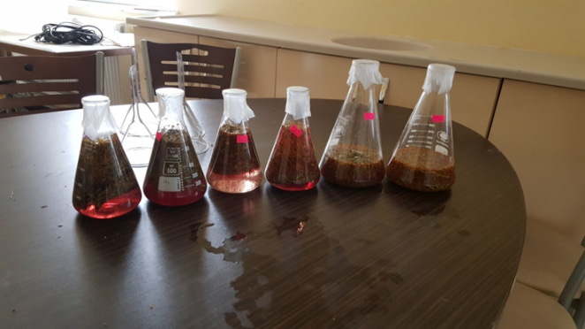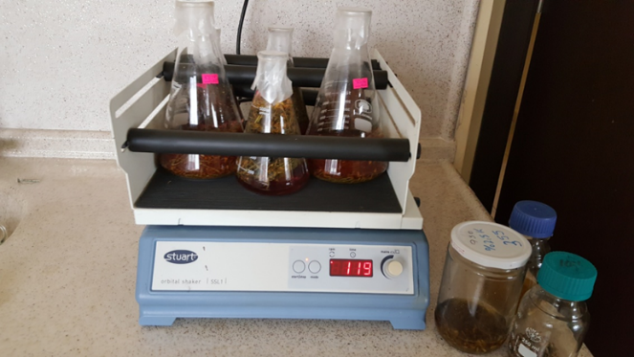
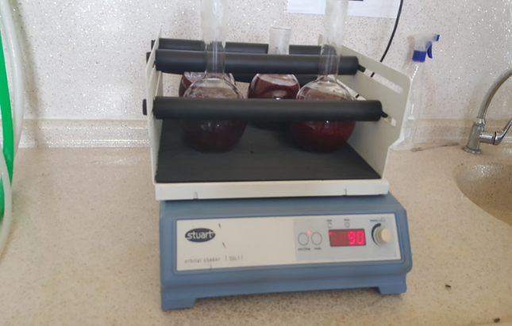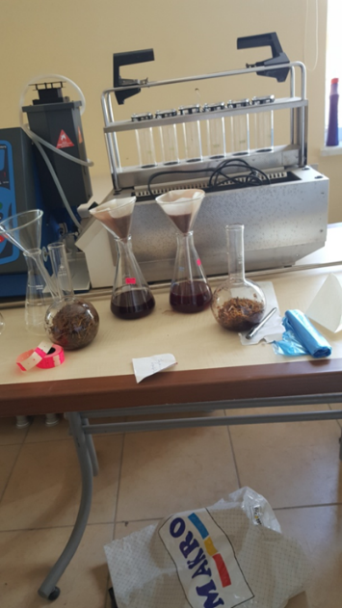

Figure 1: Schematic diagram of maceration process

B. Percolation
Extraction of active compounds with a percolator made of glass, porcelain, enamel or stainless steel is performed. The plant material is first dried and powdered and used in a suitable solvent placed in the filtration tank. Sufficient amount of solvent is added and the mixture is left for about 4 hours [14]. Percolation replaces the saturated solvent with the fresh solvent and therefore it is more efficient than the maceration method (Figure 2). It is a continuous extraction method [5]. Adding solvent is continued until the amount of solvent reaches 75% of the total volume. Afterwards, filtration and evaporation processes are applied and the crude extract is obtained. This method is used in materials science, physics, epidemiology,geology and other fields are also applied. It is also applied for brewing coffee in daily life.

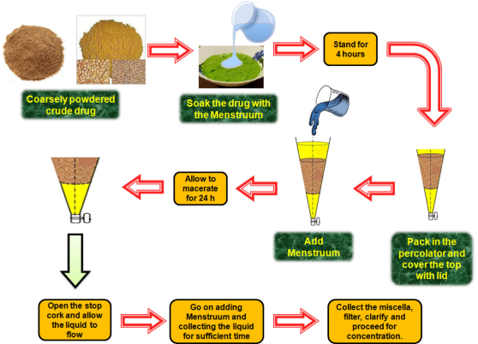

Figure 2: Percolation process [15].
Many factors affect the percolation process. These factors are; the selectivity of the solvent, the amount of flow of the solvent (falling rate), temperature, changes in the overall leaching process. The selectivity of the solvent affects both the yield and the qualitative and quantitative composition of the separated components. The mixed drip rate determines the flow rate of the solvent. Thus, it determines the contact time between the plant and the solvent. Although heat important in filtration, it is rarely used as a control factor. While some phytocomponents require higher temperatures for extraction, some sensitive components may be destroyed at these temperatures. For these reasons, temperature should always be taken into account [15]. There are some limitations of the conventional percolation procedure for separating thermolabile substances and hydroalcoholic mixtures, which can cause problems [16].

C. Infusion
The infusion method is an extraction method with similar properties to the maceration method. It is possible to extract flavor and aroma substances and other chemical compounds from plants in this method. Alcohol, water or oil can be used as solvent. The dried and shrunken plant material is placed in a container. Then cold or hot solvent is added to it and left to incubate for a certain time [10]. Methods of maceration or percolation to obtain infusions of the desired concentration is a modified method. In this method, a 1:10 plant material/water ratio is generally used (Figure 3a).
Infusions are a period of time in which the drug is briefly softened in cold or boiling water, then filtered. Next is the process of concentrating. The infusion obtained by this process is diluted with water and made ready for use. According to official prescriptions, the infusion water ratio should be 1/10 [17]. Prepared preparations should be consumed within 24 hours as they are sensitive to microbial contamination.

D. Decoction
In the decoction method water is added to the plant and heated for 20-30 minutes (Figure 3b). After the mixture is cooled to 40°C, pressed and then filtered. The prepared mixture can also be used in concentrated form or diluted [18]. This method is suitable for hard plant materials such as roots, stems, bark and wood. The plant material is cut into small pieces, water is added as a solvent and boiled for the specified time. Water soluble compounds and heat resistant components can be extracted by this method.
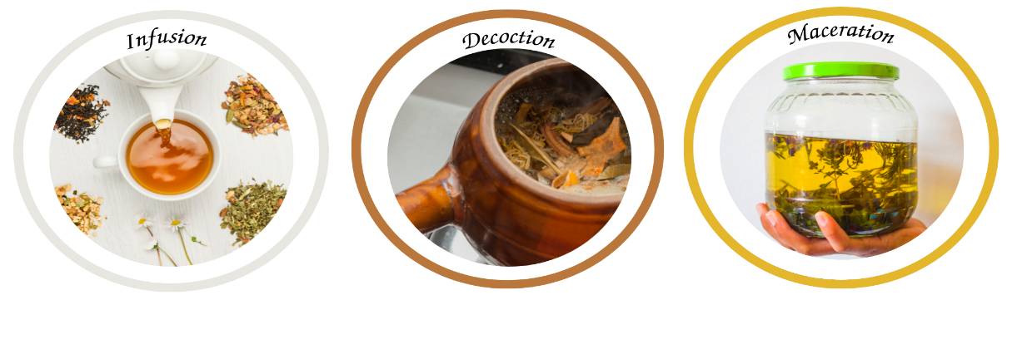
a) Infusion b) Decoction c) Maceration

Figure 3: Conventional extraction techniques

This method which used in preparation of ayurvedic extracts known as "quath" or "kwath". The prepared mixture is concentrated and then filtered [19]. Compounds to be extracted are usually oil-soluble in boiling [9]. In addition, in the study in which Teucrium polium L was boiled and infused; Higher amount of phenolic compounds from Lamiaceae family and higher antioxidant activity was observed [20]. The time required for boiling or the lack of desired flavor and aroma are among the disadvantages of the method. There may be problems with transportation and storage. Water is not a suitable solvent for the extraction of active components of plants [18]. The applicability of the method is simple; however, more amounts of solvent are required [9].

E. Digestion
The method is quite similar to the maceration technique. The difference is used is the extraction temperature. Higher temperatures are used than the maceration method [21]. This method is used in the extraction and purification of plant parts or polyphenolic compounds that are difficult to dissolve [19]. The extraction uses solvent or ethanol and the process continues for about 24 hours. The solvent softens the cell wall and it ensures the diffusion of the extract across the membrane. The heating process increases the extraction efficiency can be increased. If the desired bioactive compounds are heat stable, high temperature is applied, otherwise the desired extract may not be present in the target compound [17].

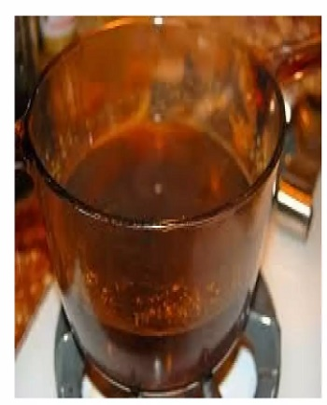

Figure 4: Digestion techniques
F. Reflux Extraction
The plant parts are placed in a round-bottomed flask containing the solvent. Round bottom bottle, it is surrounded by a cover, which is combined with a capacitor (Figure 3). With the system warming up the solvent reaches its boiling point. At this stage, successive evaporation and condensation processes take place. Condensation of extraction solvent without loss of solvent performs the extraction process [22]. In addition, reflux extraction is an effective extraction method in terms of bioactive composition and antioxidant activity of compounds and process efficiency. It is similar to the method of boiling hot water used in traditional medicine [23].

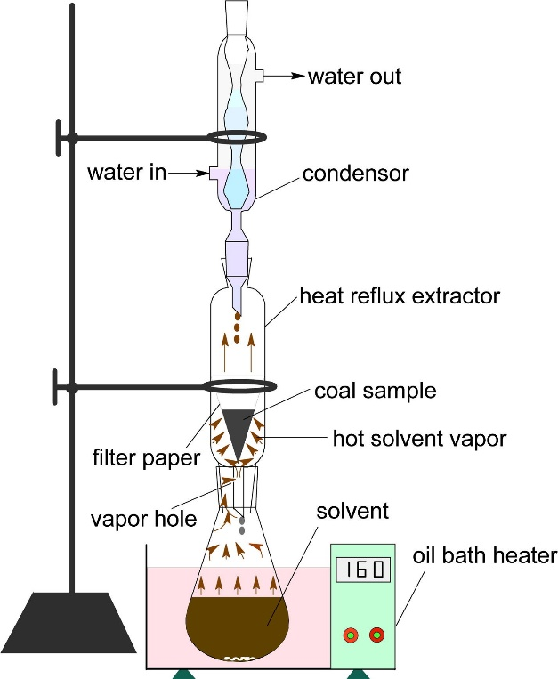

Figure 5: Schematic diagram of reflux extraction [24].

G. Soxhlet Extraction
Soxhlet extraction is a closed system, simple and one of the oldest extraction methods. Soxhlet extraction consists of the heating system, chiller system, soxlet extractor. Sections of the soxlet assembly is shown in Figure 6 [25].

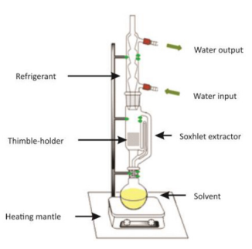

Figure 6: Soxhlet equipment [26].

Soxlet is suitable for solid-liquid extraction. Solvent that evaporates with heat drop by drop wets the solid. Siphoning when it reaches a certain liquid level comes into play. Reconstituted with solvent extractives filtered through the solid returns to the glass bubble. Extraction is in circulation in this way. Since only the solvent evaporates while the extractive substances are in the solvent balloon, always continues to drip cleanly. Extraction process usually continues 3-24 h. Soxlet siphoning number and extraction duration should be taken into account [27].
The following steps are carried out in the extraction of herbal materials. The shredded plant material is placed in the thimble. The Soxhlet extractor connected to the condenser is placed in the solvent bottle and is heated. As the solvent heats up, the steam moves and flows towards the distillation arm. The solvent are added to plant material and then soluble compounds are dissolved in the extraction solvent. The siphon tube is filled with solvent and then extract (solvent and insoluble compounds) away from the Soxhlet extractor. In the final stage syphons comes back down to the distillation flask [28]. Finally, the solvent is removed by a rotary evaporator to obtain the extract.

Table 1: Advantages and disadvantages of the conventional methods

Extraction methods | Advantages | Disadvantages | References
Maceration | Simple method | Long extraction time | [29,30,  5,31,  32,33,  34, 19,  35,17,  36,37,  38].
 | Low investment cost | Low Extraction efficiency
 | No equipment required | Slow process
 | Active at room temperature | Large volume of solvent
Percolation | High extraction efficiency | Long extraction time
 | Easy process | Large volume of solvent
 | Suitable for expensive drugs | High energy consumption
Infusion | Short extraction time | Large amounts of solvent
 | Preparation of fresh extracts | Susceptibility to microbial
 | Obtaining to well soluble bioactive compounds | contamination
Decoction | Simple method | Large volume of solvent
 | Convenient and inexpensive equipment | More filtration processes necessary
Digestion | High extraction efficiency  with heating | Long extraction time  More filtration processes
 | Efficiency of solvent increases | necessary
Reflux extraction | Less extraction time and solvent | Loss of some components due to heat treatment
 | Efficient extraction | Long extraction time
Soxhlet extraction | Applicability at high | Poor extraction efficiency
 | temperatures  Simple process | Large volume of solvent  Long extraction time
 | Does not require filtering

III. MODERN EXTRACTION METHODS

Today, with the rapid progress of science and technology, new and advanced methods have emerged in many industries. These developments have also shown their effect in the field of food engineering and have led to significant changes in the extraction methods used for obtaining and separating food compounds. The technology of extraction, which has diverse applications in industries such as perfumery, food, medicine and cosmetics, has been utilized by civilizations such as the Egyptians, Greeks, Chinese and Aztecs for a variety of purposes throughout history. The need for alternative extraction techniques arose as a result of the drawbacks associated with conventional methods, such as their prolonged duration. The utilization of reduced solvent in modern extraction techniques is commonly acknowledged as an eco-friendly approach. Furthermore, the utilization of low temperature in modern extraction techniques facilitates the retrieval of delicate constituents [39].
Extraction refers to the methodical separation of specific compounds from a given substance. Extraction techniques are commonly employed in the food sector to procure a multitude of significant substances, including vegetable oils, flavors, colorants, antioxidants, vitamins and other bioactive compounds [40]. Although conventional extraction techniques have been extensively employed over the years, modern extraction methods present superior and more efficient alternatives that are also environmentally sustainable. The utilization of these techniques holds significant significance in the food industry as they serve to enhance the quality of products, augment their nutritional value and facilitate the creation of novel products [40,39]. There is a pressing need for alternative selective extraction techniques owing to several factors, including the substantial quantity of oil that remains in the seed, the non-ecological nature of the chemical solvents employed, the degradation of cell structure resulting from elevated temperatures and the protracted duration of the extraction process [41]. Several contemporary techniques have been identified as modern methods, including ultrasound assisted extraction, microwave assisted extraction, low frequency electrical processing assisted extraction, supercritical fluid extraction, enzyme assisted extraction and fermentation assisted extraction methods [42,43,39].
Microwave assisted extraction involves heating a material with microwaves, which are high-frequency electromagnetic waves (300-300000 MHz) and movement of ionic components as a result of the applied electric field strength. The movement of the ions increases the solvent penetration into the matrix and thus the dissolution of the components becomes easier [44,43]. Ultrasonic assisted extraction, on the other hand, is a relatively inexpensive extraction method and the extraction process is carried out by applying acoustic vibrations and frequencies above 20 kHz to the sample. This method is used for both solid and liquid sample preparation. It supports the extraction, digestion and slurry formation of solid samples. In liquid samples, liquid-liquid extraction is used to support the formation of emulsion or homogenization [45,46]. Supercritical fluid extraction is a technique in which supercritical fluids are used as a solvent under high pressure and high temperature. Supercritical fluid extraction is recognized as an effective method for the extraction of various food components. It is widely used especially in the extraction of vegetable oils and in the separation of compounds such as caffeine and antioxidants [47,48].
Enzyme assisted extraction is an important research area in food engineering and offers the advantage of fast, selective and efficient extraction. This method offers a more sustainable approach in terms of energy and environmental impact, with factors such as lower processing temperatures and the use of environmentally friendly solvents [49,50]. In this method, the extraction and separation of targeted compounds is achieved by using the special properties and abilities of enzymes. It is used as an effective technique to obtain various compounds such as vegetable oils, proteins, phenolic compounds, vitamins and flavorings. In enzyme assisted extraction, first of all, it is necessary to add enzymes to the substrate and ensure their interaction. Enzymes initiate specific reactions by binding to substrate molecules and release targeted compounds. At this stage, appropriate pH, temperature and other processing conditions are controlled to optimize enzyme activity [51,52].
While there may be variances in the application techniques of contemporary extraction methods, the majority of them are more cost-effective and ecologically sustainable than traditional methods, particularly in the acquisition of bioactive constituents. Furthermore, the extracted substances are of higher purity and exhibit greater yield. Table 2 presents a summary of the benefits associated with contemporary extraction techniques.

Table 2: Advantages of some modern extraction methods

Method | Advantages | References
Enzyme asisted-extraction | It is recommended to implement more stringent environmental laws and regulations pertaining to the industrial extraction of bioactive plant compounds.  The absence of flammable and volatile solvents in the process ensures that there is no environmental hazard.  The extraction process does not generate any undesired residues in proximity to the extracted bioactive constituents.  This task does not necessitate a significant number of operations or extensive setup.  This technology offers the advantage of operating at low temperatures and for shorter durations.  The cost of production is relatively inexpensive.  Greater efficiency can be achieved due to its ability to access cellular spaces. | [53,54,55,51].
Fermantation-assisted extraction | The extraction of bioactive components from agricultural or industrial by-products can be achieved through a biological process.  The utilization of enzymes secreted by fungi or microorganisms during extraction leads to a more efficient process.  The process exhibits a high degree of efficacy in the extraction of polyphenolic compounds.  This activity necessitates minimal equipment.  The economic aspect is evident.  The process of applying is straightforward.  The system setup and processing cost are minimal. | [56,57,58].
Supercritical fluid extraction | The phenomenon under consideration exhibits a degree of selectivity.  The extraction process carried out at low temperatures results in a reduction of heat-soluble constituents, namely, a decrease in the amount of residual components.  Due to the ease of solvent recovery, the system exhibits greater economic efficiency.  The production process is environmentally sustainable as it does not involve the use of any hazardous solvents.  The efficiency of extraction is high.  Functions within the low pressure spectrum. | [59,60,61,62].
Microwave assisted extraction | Enables the utilization of a reduced amount of solvent.  The processing time is reduced due to the efficient accessibility of the cells.  The preservation of antioxidant activity is ensured by the avoidance of high temperature and brief exposure.  The extraction efficiency is notably high.  The conversion of electromagnetic energy into heat results in energy conservation.  The uniform dispersion of thermal energy precludes the utilization of excessive heat and mitigates issues pertaining to the degradation of delicate molecular structures. | [63,58,64,39].
Ultrasound assisted extraction | The method in question is characterized by its rapidity.  The concept of high efficiency.  This can be implemented at a reduced temperature. As a result, the prevention of thermal damage to extracts is achieved.  The preservation of the structural and molecular composition of bioactive constituents is maintained.  Selective extraction is a process of extracting specific components or substances from a mixture or solution.  The method in question is ecologically sustainable.  Demands a reduced amount of solvent.  Extraction does not involve any temperature or concentration gradients.  This method offers consistent extraction.  Reduced form factor devices are capable of being utilized. | [65,66,41].
Ohmic heating assisted extraction | Processing the product with a smooth and rapid temperature increase ensures that the applied heat treatment is more effective and that the nutritional composition and sensory properties of the product are preserved.  Heat energy is produced directly in the product without the need for a heat transfer surface.  It also makes it possible to use in the processing of foodstuffs sensitive to temperature increase.  The desired temperature is reached in a short time  No mixing is required due to mass heating.  It is a silent and environmentally friendly system  Ohmic heating process enables simultaneous solid and liquid phase heating  As the heat transfer ends as soon as the current is cut off, the process is easily controlled.  In ohmic heating systems, 90% of electrical energy is converted into heat energy due to the formation of thermal energy in the product, thus providing energy efficiency.  Allows better and simpler process control with less maintenance | [67,68,69,70].

Modern extraction techniques have enabled expedited and optimized extraction procedures. Whilst the operational procedures of each approach may vary, it is noteworthy that all of them exhibit a greater degree of environmental sustainability. This section will provide information regarding the disparities between various methodologies and their respective applications in recent times.

A. Microwave assisted extraction
Microwaves, which are situated within the electromagnetic spectrum ranging from 300 MHz to 300 GHz and 1 mm to 1 m, utilize either ion transmission or dipole rotation mechanisms for the purpose of heating. The heating of the solution occurs due to the resistance of the solution to the ion flow during the displacement of electrons in the magnetic field. Dipole rotation involves the forced rearrangement of molecules. Currently, the solution undergoes an increase in temperature. The utilization of solvents is not mandatory in the microwave assisted extraction technique. Extraction can be performed either in the presence of a solvent or through a solvent-free process. The primary objective is to elevate the temperature of the solvent or sample. As demonstrated referans by [71,72,73], extraction can be achieved through various means such as the application of microwave radiation to cause damage or by altering the transport properties of solvents and solutes.
Frequency, microwave power, temperature, amount of material to be extracted and humidity are effective on microwave assisted extraction process. The increased frequency reduces its penetration into the food and prolongs the processing time [74]. Increasing the microwave power helps to increase the generated heat and thus increase the extraction efficiency [75]. However, the use of high microwave power may lead to the deterioration of components as well as increased cost [76]. Used in a controlled manner, high temperature can increase extraction efficiency by reducing surface tension and viscosity. Higher mass materials have a higher absorbance efficiency because they can absorb more microwave power; For materials with low mass, batch processing should be preferred [77]. Since microwave energy activates water molecules while performing the extraction process, the amount of water in the substance increases the microwave absorbance. If the amount of free water in the food is high, the extraction efficiency increases [78].
Solvent selection is also an important factor in microwave assisted extraction. Solvents that can be mixed with water increase the extraction efficiency. However, solvents must be able to absorb microwave energy and dissolve the substance. Solvents with polar properties such as ethanol and methanol are widely used [79,73,80]. When non-polar solvents such as toluene and hexane are preferred, it is recommended to mix them with solvents with high dipole moment such as acetone, methanol and water [80].
The extraction of macromolecules such as carbohydrates, proteins, fats, as well as minor components such as essential oils or phenolic substances from foods can be performed by microwave assisted method. Especially phenolic compounds are perishable substances and they are easily affected by environmental factors. Therefore, it is of great importance to meticulously control the parameters during the extraction process [80].
The studies carried out with the application of microwave assisted extraction method are presented in Table 3.

Table 3: Recent studies with the microwave assisted extraction method

Sample | Target substance | Parameter | References
Blueberries | Anthocyanin | 30-100°C, 2-14 minutes, 0-100% ethanol, 1:10-1:50 solids ratio | [81].
Pitaya fruit | Betalain | 100 W, 8 min, 35°C | [75].
Peach pulp | Phenolic content | 90 sec., 900 W | [43].
Hot pepper sauce | Β-caroten  Capsaisin  Phenolic content | 60 °C 10 min  40 °C 15 min  50 °C 20 min  80W | [82].
Hawthorn fruit | Phenolic content | 5% solid ratio, 270 W and 20 min | [83].
Black pepper | Essential oil | 350 and 500 W, temperature below 10 °C | [84].

B. Ultrasound assisted extraction
Ultrasonic sound waves are characterized by a frequency range that exceeds the upper limit of human auditory perception, typically exceeding 16-18 kHz. These waves propagate as mechanical vibrations through either solid or fluid media. Mason and Lorimer's (2002) research indicates that the minimum accepted ultrasonic frequency is 20 kHz, whereas the maximum limit is established at 5 MHz for gases and 500 MHz for liquids and solids [85]. In the course of the extraction procedure, acoustic waves are propagated within the liquid medium, inducing vertical displacement of the constituent particles. The transmission of mechanical vibrations to the material in contact with it results in the phenomenon of cavitation, as reported by referans [86,87]. The splitting of particles and subsequent recovery of analyte is facilitated by the presence of voids. This methodology is applicable to both solid and liquid specimens. In the course of the extraction procedure, the selection of sonication probes or ultrasonic baths may be favored based on their respective characteristics. The achievement of a uniform energy distribution in solid-liquid extractions results in a more efficient extraction process that can be executed within a reduced timeframe. However, probes have some downsides, such as low sample processing capacity, expensive tips and short lifetime [86]. In the food industry, the amount of energy calculated by factors such as sound intensity (W/m²), sound power (W), sound energy density (W.s/m³) is effective in determining the ultrasonic sound application method. These methods are called "low energy" for frequencies lower than 1 W/cm² and higher than 100 kHz, while those with sound intensity higher than 1 W/cm² and in the 18-100 kHz range are called "high energy". can be used in industry. While low-energy systems are used to determine the physicochemical properties of foods, processes such as homogenization, extraction and crystallization are performed in high-energy systems [65].
The appropriate selection of various factors, including time, frequency, temperature, solvent and ultrasonic power, is crucial for achieving an efficient extraction process, as noted by referans [87].The utilization of ultrasonic assisted extraction has gained significant popularity in recent times, owing to its benefits such as decreased reliance on organic solvents, heightened extraction efficacy and energy conservation [88]. The integration of ultrasonically assisted extraction equipment into pre-existing technological systems is a feasible option and its cost-effectiveness is a significant benefit, as noted by referans [89]. Studies have demonstrated that ultrasonic aided extraction uses less solvent (10-15 ml) and takes less time (2–30 minutes) than traditional procedures or certain other contemporary systems [65; 90; 87]. Ultrasound-assisted extraction has the potential to reduce the reliance on organic solvents, as it allows for the use of an ethanol-water mixture or even just water. In lieu of solvents such as methanol and hexane, organic alternatives may be deemed preferable. This protects heat-degraded components, which contributes to environmental protection and increases efficiency [88].
According to Tavman et al. (2009), the utilization of ultrasound can perform multiple functions, including but not limited to sugar crystallization, foam disruption, degassing, maturation of spirits and meats, waste management, enzyme suppression, sterilization, freezing, filtration and microbial inhibition [91].
The studies carried out with the application of the ultrasound assisted extraction method are presented in Table 4.

Table 4: Recent studies with the ultrasound assisted extraction method

Sample | Target substance | Parameter | References
Sugar beet molasses | Phenolic compounds | 20-60°C  30-90 min. | [92].
Mandarin leaf | Phenolic compounds | Water, pH:2, solvent:fruit ratio 1:20, 54 min, 53°C | [93].
Rosehip | Phenolic compounds | Solvent is methanol  Time 3-15min., amplitude %25-100, temperature 20-30-40°C, solid:solvent ratio 5-15% | [86].
Green walnut | Phenolic compounds | 25, 50, 75 and 100%, amplitude; 10, 20, 30, 40, 50 and 60 min | [94].

C. Ohmic heating assisted extraction
The ohmic heating technique involves the application of alternating current to the food product, with the objective of generating heat within the product through resistance-based mechanisms. The term "ohmic heating," "joule heating," and "electrical resistance heating" are commonly used in academic literature. Numerous studies have highlighted the efficacy of ohmic heating as a rapid, uniform and notably efficient method of heating. Ohmic heating has been studied and applied in various food processing methods, including pasteurization, sterilization, boiling, thawing, cooking, distillation, extraction and evaporation. The utilization of this technique has also been observed in various pre-treatment applications, such as ohmic heating, extraction, osmotic drying and drying processes, as reported by referans [70,95].
Ohmic heating presents certain advantages over traditional methods due to the lack of elevated surface temperatures and the capacity to regulate heat transfer coefficients. Furthermore, it is noteworthy that there are advantages associated with this method, including the retention of both the color and nutritional content of the food, as well as a brief processing period and a high yield, as indicated by referans [96]. The ohmic heating system exhibits low maintenance costs. According to referans [97] , the suitability of ohmic heating for temperature-sensitive products lies in its capacity to swiftly elevate the temperature of even the most frigid points. Nevertheless, the preliminary capital expenditure associated with ohmic heating systems utilized in industrial settings is considerably elevated. An additional drawback pertains to the non-conductive nature of fat globules, thereby posing challenges in achieving efficient heating through ohmic heating [98]. Moreover, with an increase in temperature, there is a corresponding increase in electrical conductivity due to the acceleration of electron movement. There exists a direct relationship between the temperature and the rate of accumulation of dirt in the system, whereby an increase in temperature results in a corresponding increase in the rate of dirt accumulation. Inadequate cleaning of the ohmic heating system can result in operational issues caused by the accumulation of protein deposits on the electrodes, as noted by referans [99].
The studies carried out today with the application of ohmic heating assisted extraction method are presented in Table 5.

Table 5: Recent studies with the ohmic heating assisted extraction method

Sample | Target substance | Parameter | References
Black rice bran | Anthocyanin | 50, 100, 150 ve 200 V/cm |  | [100].
Stevia | Glycoside and phenolic compounds | EtOH consantration (0 – 100%) and solvent percentage (10 – 120 mL/g); time (1 – 25 min.), temperature (20 – 55 °C), power (700 W) |  | [101].
Cranberry | Phenolic compounds | Power supply at a frequency of 50 Hz, a maximum voltage of 1000 V |  | [99].
Grape juice | Phenolic compounds | 13 V/cm at 20 °C to 90 °C and 0, 20, 40 and 60 min. |  | [95].

D. Enzyme-assisted extraction
Enzyme-assisted extraction method is becoming increasingly popular due to its ability to reduce the use of solvents. This method particularly shortens the extraction time of raw materials and enables extraction at lower temperatures [50]. Some phytochemicals are absorbed in plant matrices and distributed in the cytoplasm, or they interact with the polysaccharide-lignin network through ester, hydrogen, or hydrophobic bonds. These matrices can sometimes be inaccessible to solvents during the extraction process. To enhance the release of polyphenols, enzymatic treatment is recommended before the extraction process to allow the solvents to reach these compounds. Enzymes such as cellulases, pectinases, hemicellulases and α-amylases facilitate the breakdown of plant cell walls and enable solvents to enter the cells. As a result, the yield of polyphenols obtained increases [102].
Despite being one of the green extraction methods, the use of expensive enzymes increases the cost of extraction. Additionally, enzymes are unable to fully disrupt the cell wall, thereby restricting solvent extraction. The fluctuation of enzyme activity due to environmental factors poses challenges in optimizing the method at an industrial scale. This situation makes it difficult to implement the technique on an industrial level [102,88].
Today, the studies carried out with the application of the enzyme assisted extraction method are presented in Table 6.

Table 6: Recent studies with enzyme assisted extraction method.

Sample | Target substance | Parameter | References
Tomato | Lycopene | The enzymatic reaction was carried out at a temperature of 40°C for a duration of 5 hours, using an enzyme-to-substrate ratio of 0.2 ml/g. The solvent-to-substrate ratio was 5 ml/g and the extraction process lasted for 1 hour. The enzyme-to-enzyme ratio used was 1. | [103].
Olive pomace | Phenolic compounds | Cellulase, pectinase and tannase are used. 17 min | [104].
Grape pomace | Phenolic compounds | pH 5, solid:liquid 1:8, 32 °C | [105].
Cherry pulp | Phenolic compounds | pectinase, 18 min, 2µL/g, 70 °C, pH 10.0 | [106].

F. Fermentation assisted extraction (Solid-state fermentation)
Solid-state fermentation (SSF) is a bioprocess that offers potential for extracting bioactive compounds from agro-industrial by-products [56,107]. The enzymes released during SSF act as biocatalysts, facilitating the release and extraction of bioactive agents [108]. This economical and easily implementable biotechnological process requires small equipment, has lower capital requirements and reduced operating costs [56]. However, there is a need for further research on SSF for the production and extraction of antioxidants and other bioactive compounds.
SSF utilizes natural and environmentally friendly enzymes for the extraction of phenolic compounds. It employs inexpensive substrates like agricultural and industrial waste for enzyme production, making it a cost-effective approach. This method generates less wastewater and consumes lower energy. By mimicking the natural habitat of fungi, SSF allows for the growth of microorganisms and the production of value-added products [109].
Various microorganisms, including Aspergillus niger, GH1, Aspergillus niger PSH, Aspergillus niger SLH 6, Leuconostoc, Lactobacillus, Oenococcus and Candida utilis, are employed in SSF. These microorganisms produce different carbohydrases that aid in converting bound phenolics into soluble forms. Enzymes such as β-glucosidases play a crucial role in mobilizing soluble phenolics, while cellulases and xylanases break down plant biomass cell walls, releasing insoluble phenolics [109,110].
In summary, SSF offers a promising approach for extracting bioactive compounds from agro-industrial by-products. It utilizes natural enzymes, low-cost substrates and has environmental benefits. However, further research is required to optimize fermentation parameters, select suitable microorganisms and substrates and develop efficient methods for the recovery and purification of desired products.
Today, the studies carried out with the application of the fermantation assisted extraction method are presented in Table 7.

Table 7: Recent studies with fermentation assisted extraction method

Sample | Target substance | Parameter | References
Coffe pulp | Chlorogenic acid | 35 °C, 30 min, 2.5 g yeast/kg coffee pulp | [111].
Castilla Rose (Purshia plicata) | Phenolic compounds | 25 °C, 2 × 106 spores/g, extraction time of polyphenols was 24 h | [112].
Avocado seed | Bioactive compounds | particle size of 2.5 mm, 60 % of humidity and 120 h | [57].
Pea | Protein | 4 °C and pH 7.5 | [113].

CONCLUSION

Conventional extraction methods typically involve the use of solvents, which results in longer processing times and increased solvent consumption. However, conventional methods are still widely used and yield effective results in many industrial applications.
Modern extraction methods offer several advantages compared to conventional methods. Microwave-assisted extraction allows for rapid and efficient extraction, saving time. Ultrasound-assisted extraction enhances the breakdown of cell walls through the use of sound waves, thereby improving extraction efficiency. Ohmic-assisted extraction employs electric current to increase cell wall permeability, speeding up the extraction process. Pulsed electric field-assisted extraction facilitates the entry of substances into cells through the use of an electric field. High-pressure-assisted extraction achieves high efficiency by performing extractions under high pressure. Supercritical fluid extraction combines the properties of liquid and gas phases to achieve highly efficient extraction.
In conclusion, extraction methods are continuously evolving to have less adverse environmental impact. Recent studies have shown the effectiveness of alternative methods such as microwave-assisted, ultrasound-assisted, ohmic-assisted, pulsed electric field-assisted, high-pressure-assisted and supercritical fluid extraction. These alternative methods can also be combined with conventional methods, leading to time savings, reduced solvent consumption and high-quality product yields. Further development of these alternative methods in industrial settings will provide better understanding of their effects.

REFERENCES
[1] A.S. Van Wyk and G. Prinsloo, “Medicinal plant harvesting, sustainability and cultivation in South Africa.” Biol. Conserv., vol. 227, pp.335-342, 2018.
[2] S. Hayta, N. Tasar, U. Cakilcioglu, O. Gedik, “Morphological, karyological features and pollen morphology of endemic Ebenus haussknechtii Bornm. ex Hub.-Mor. from Turkey: A traditional medicinal herb,” J. Herb. Med., vol. 4(3), pp. 141-146, 2014.
[3] World Health Organization. “WHO traditional medicine strategy: 2014-2023” World Health Organization, 2013.
[4] J.X. Li and Z.Y. Yu “Cimicifugae rhizoma: from origins, bioactive constituents to clinical outcomes.” Curr. Med. Chem., vol 13(24), pp. 2927-2951, 2006.
[5] Q.W. Zhang, L.G. Lin, W.C. Ye, “Techniques for extraction and isolation of natural products: A comprehensive review.” Chin. Med., vol. 13(1), pp. 1-26, 2018.
[6] A. Jovanović, V. Đorđević, G. Zdunić, D. Pljevljakušić, К. Šavikin, D. Gođevac and B. Bugarski, “Optimization of the extraction process of polyphenols from Thymus serpyllum L. herb using maceration, heat- and ultrasound-assisted techniques.” Sep. Purif. Technol., vol. 179, pp. 369–380, 2017.
[7] G. Vuleta, J. Milić, S. Savić, FarmaceutskaTehnologija, Faculty of Pharmacy, University of Belgrade, Belgrade, Serbia (in Serbian), 2012.
[8] L. Wang and C. Weller, “Recent advances in extraction of nutraceuticals from plants”, Trends Food Sci Technol, vol. 17, pp.300–312, 2006.
[9] N.N. Azwanida, “A review on the extraction methods use in medicinal plants, principle, strength and limitation”, Medical and Aromatic Plants, vol. 4(196), pp. 2167-0412, 2015.
[10] K.P., Ingle, A.G., Deshmukh, D.A., Padole, M.S. Dudhare, M.P. Moharil, V.C. Khelurkar, “Phytochemicals: Extraction methods, identification and detection of bioactive compounds from plant extracts.” Journal of Pharmacognosy and Phytochemistry, vol. 6(1), pp. 32-36. 2017.
[11] S.O. Majekodunmi, “Review of extraction of medicinal plants for pharmaceutical research.” MRJMMS, vol. 3, pp. 521-527, 2015.
[12] K.J. Olejar, B. Fedrizzi, P.A. Kilmartin, “Antioxidant activity and phenolic profiles of S auvignon B lanc wines made by various maceration techniques.” Aust. J. Grape Wine Res., vol. 21(1), pp. 57-68, 2015.
[14] A.R. Abubakar and M. Haque, “Preparation of medicinal plants: Basic extraction and fractionation procedures for experimental purposes.” J. Pharm. Bioallied Sci., vol. 12(1), pp. 1, 2020.
[15] P.K. Mukherjee, “Quality control of herbal drugs: an approach to evaluation of botanicals.” Bus. Horiz., 2002.
[16] P.K. Mukherjee, “Extraction and other downstream procedures for evaluation of herbal drugs. Quality Control and Evaluation of Herbal Drugs: Evaluating Natural Products and Traditional Medicine, Elviser, pp. 195-236, 2019.
[17] S.S. Handa, “An overview of extraction techniques for medicinal and aromatic plants.” Ext. Technol. Med. Aromatic Plants, vol. 1(1), pp. 21-40, 2008.
[18] A. Nagalingam, “Drug delivery aspects of herbal medicines.” Jpn Kampo Med Treat Common Dis Focus Inflammation, vol. 17, pp. 143, 2017.
[19] M. Kamil Hussain, M. Saquib, M. Faheem Khan, “Techniques for extraction, isolation and standardization of bio-active compounds from medicinal plants.” Natural Bio-Active Compounds, Springer, Singapore, 2019, pp. 179-200.
[20] Z. Özer, T. Kılıç, S. Çarıkçı, H. Yılmaz, “Investigation of phenolic compounds and antioxidant activity of Teucrium polium L. decoction and infusion.” Balıkesir Üniversitesi Fen Bilimleri Enstitüsü Dergisi, vol. 20(1), pp. 212-218, 2018.
[21] Mehta, R. M. Pharmaceutics 1, Extraction processes, C.B.S. publishers, pp. 145-159. 2003.
[22] S.K. Aditha, A.D. Kurdekar, L.A. Chunduri, S. Patnaik, V. Kamisetti, “Aqueous based reflux method for green synthesis of nanostructures: Application in CZTS synthesis.” MethodsX, vol. 3, pp. 35-42, 2016.
[23] Y. F. Shang, S.X., Chen, J.H. Miao, Y.G. Zhang, H.Z. Cai, X.Y. Bu, ... , Z.J. Wei, “Autoclaving hyphenated with reflux extraction for gaining bioactive components from Chaenomeles fruits.” Sep Sci Technol, vol. 56(7), pp. 1225-1230, 2021.
[24] B. Tian, Y.Y. Qiao, Y.Y. Tian, K.C. Xie, D.W. Li, “Effect of heat reflux extraction on the structure and composition of a high-volatile bituminous coal.” Appl. Therm. Eng., vol. 109, pp. 560-568, 2016.
[25] C.H. Kuo, B.Y. Chen, Y.C. Liu, C.M. Chang, T.S. Deng, J.H. Chen, C.J. Shieh, “Optimized Ultrasound-Assisted Extraction of Phenolic Compounds from Polygonum cuspidatum,” Molecules, vol. 19, pp. 67-77, 2014.
[26] V.A. Guntero, P.M. Mancini, M.N. Kneeteman, “Introducing Organic Chemistry Students to the Extraction of Natural Products Found in Vegetal Species,” World J. Chem. Educ., 5, 142-147, 2017.
[27] A. Kellner, M. Otto, H.M. Widmer, Sample Preparation, in Analytical Chemistry: Modern Approach to Analytical Science. Weinheim: Wiley-Vch., 2004, pp. 506-508.
[28] D. Raynie, “Looking at the Past to Understand the Future: Soxhlet Extraction.” LCGC North America, vol. 37(8), pp. 510-513, 2019.
[29] W.Y. Wang, H.B. Qu, X.C. Gong, Research progress on percolation extraction process of traditional Chinese medicines.” Journal of Chinese Materia Medica, vol. 45(5), pp. 1039-1046, 2020.
[30] M.G. Rasul, “Conventional extraction methods use in medicinal plants, their advantages and disadvantages.” Int. J. Basic Sci. Appl. Comput. vol. 2, pp. 10-14, 2018.
[31] M. Devgun, A. Nanda, S.H. Ansari, S.K. Swamy, “Recent techniques for extraction of natural products.” Res J Pharm Technol., vol. 3(3), pp. 644-649, 2010.
[32] Z. Khan, J. Troquet, C. Vachelard, “Sample preparation and analytical techniques for determination of polyaromatic hydrocarbons in soils.” Int J Environ Sci Technol, vol. 2(3), pp. 275-286, 2005.
[33] Renard, C. “Bioactives in Fruit and Vegetables and their Extraction Processes: State of the Art and Perspectives.” Bio2actives, np., 2017.
[34] M.B. Soquetta, L.D.M. Terra, C.P. Bastos, “Green technologies for the extraction of bioactive compounds in fruits and vegetables.” CyTA-Journal of Food, vol. 16(1), pp. 400-412, 2018.
[35] N. Harbourne, E. Marete, J. Christophe, 17 Conventional Extraction Techniques For Phytochemicals. Handbook of Plant Food Phytochemicals, 2013, pp. 399.
[36] C. Tubtimdee, A. Shotipruk, Extraction of phenolics from Terminalia chebula Retz with water–ethanol and water–propylene glycol and sugaring-out concentration of extracts. Sep. Purif. Technol, vol. 77(3), pp. 339-346, 2011.
[37] D. Grigonis, P.R. Venskutonis, B. Sivik, M. Sandahl C.S. Eskilsson, “Comparison of different extraction techniques for isolation of antioxidants from sweet grass (Hierochloe odorata).” J. Supercrit. Fluids, vol. 33(3), pp. 223-233, 2005.
[38] W. Xiao, L. Han, B. Shi, “Microwave-assisted extraction of flavonoids from Radix Astragali.” Sep. Purif. Technol, vol. 62(3), pp. 614-618, 2008.
[39] S. Acun, Gıdalardaki Fenolik Bileşenlerin Modern Ekstraksiyon Yöntemleri. Gıda Mühendisliğinde Alanında Yeni Yaklaşımlar (Ed. Hülya GÜL, Fatma HAYIT), 2022, İksad yayınevi, Ankara.
[40] H. Asil, E. Göktürk, Uçucu Yağ Elde Etmede Modern Ekstraksiyon Yöntemleri, Güncel Fitoterapi ve Geleneksel Tıbbi Bitkiler. Nobel Tıp Kitabevleri, 2020, pp. 97-104.
[41] T. Dedebaş, T.D. Capar, L. Ekici, H. Yalçın, “Yağlı Tohumlarda Ultrasonik-Destekli Ekstraksiyon Yöntemi ve Avantajları.” Avrupa Bilim ve Teknoloji Dergisi, vol. 21, pp. 313-322, 2021.
[42] P. Tarke, M. Rajan, “Comparison of conventional and novel extraction techniques for the extraction of Scopoletin from Convolvulus pluricaulis.” Indian J. Pharm. Educ. Res., vol. 48, pp. 27–31, 2014.
[43] H. Baltacıoğlu, E.M. Şahin, E.D. Karadağ, “Şeftali Posasından Ultrason ve Mikrodalga Destekli Ekstraksiyon Yöntemleriyle Fenolik Bileşiklerin Eldesi.” Niğde Ömer Halisdemir Üniversitesi Mühendislik Bilimleri Dergisi, vol. 8(2), pp. 875-881, 2019.
[44] B. Kaufmann, P. Chrısten, “Recent Extraction Techniques for Natural Products: Microwaveassisted Extraction and Pressurised Solvent Extraction” Phytochem. Anal., vol. 13, pp105–113, 2002.
[45] J.L. Tadeo, C. Sanchez-Brunete, B. Albero, A.I. Garcia-Valcarcel, “Application of ultrasound- assisted extraction to the determination of contaminants in food and soil samples.” Journal of Chromatography A, vol. 1217(16), pp. 2415, 2010.
[46] B. Atılgan, Kızıçam (Pinus brutia) kabuk taneni eldesinde ekstraksiyon yöntemlerinin verim ve kimyasal bileşim üzerine etkisi (Master's thesis, Bursa Teknik Üniversitesi), 2018.
[47] M. Türk, E.S. Giray, “Yıllık Pelinotunun (Artemissia annua L.) Kimyasal Kompozisyonu ve Antioksidan Kapasitesinin Belirlenmesinde Sub ve Süperkritik Akışkanların Etkisi.” Çukurova Üniversitesi Mühendislik-Mimarlık Fakültesi Dergisi, vol. 35(3), pp. 631-646, 2020.
[48] U. Değirmenci, “Geleneksel Tıpta Kullanılan Tıbbi ve Aromatik Bitkilerden Süperkritik Akışkan (CO2) Ekstraksiyon Yöntemiyle Ekstre Eldesinin Avantajları.” Mersin Üniversitesi Tıp Fakültesi Lokman Hekim Tıp Tarihi ve Folklorik Tıp Dergisi, vol. 12(1), pp. 1-2, 2022.
[49] D.B. Muñiz-Márquez, G.C. Martínez-Ávila, J.E. Wong-Paz, R. Belmares-Cerda, R. Rodríguez-Herrera, C.N. Aguilar, “Ultrasound-assisted extraction of phenolic compounds from Laurus nobilis L. and their antioxidant activity.” Ultrason. Sonochem., vol. 20(5), pp. 1149-1154, 2013.
[50] R.A. Carciochi, L.G. D’Alessandro, P. Vauchel, M.M. Rodriguez, S.M. Nolasco, K. Dimitrov, Valorization of Agrifood By-Products by Extracting Valuable Bioactive Compounds Using Green Processes, Ingredients Extraction by Physicochemical Methods in Food, Alexandru Mihai Grumezescu, Alina Maria Holban, Elviser, United Kingdom, 2017, pp. 191-228.
[51] O. Gligor, A. Mocan, C. Moldovan, M. Locatelli, G. Crișan, I.C. Ferreira, “Enzyme-assisted extractions of polyphenols–A comprehensive review.” Trends Food Sci Technol, vol. 88, pp. 302-315, 2019.
[52] A. Akyüz, S. Ersus, “Optimization of enzyme assisted extraction of protein from the sugar beet (Beta vulgaris L.) leaves for alternative plant protein concentrcate production.” Food Chem, vol. 335, 127673, 2021.
[53] S.U. Kadam, C. Álvarez, B.K. Tiwari, C.P. O’Donnell, “Extraction of biomolecules from seaweeds.” In Seaweed Sustainability, Academic Press, 2015, pp. 243-269.
[54] J. Banerjee, R. Singh, R. Vijayaraghavan, D. MacFarlane, A.F. Patti, A. Arora, “Bioactives from fruit processing wastes: Green approaches to valuable chemicals.” Food chem, vol. 225, pp.10-22, 2017.
[55] T. Belwal, S.M. Ezzat, L. Rastrelli, I.D. Bhatt, M. Daglia, A. Baldi, ... A.G. Atanasov, “A critical analysis of extraction techniques used for botanicals: Trends, priorities, industrial uses and optimization strategies.” TrAC Trends in Analytical Chemistry, vol., 100, pp. 82-102, 2018.
[56] C. Torres-León, N. Ramírez-Guzmán, J. Ascacio-Valdes, L. Serna-Cock, M.T. dos Santos Correia, J.C. Contreras-Esquivel, C.N. Aguilar, “Solid-state fermentation with Aspergillus niger to enhance the phenolic contents and antioxidative activity of Mexican mango seed: A promising source of natural antioxidants.” Lwt, vol. 112, 108236, 2019.
[57] D.P. Yepes-Betancur, C.J. Márquez-Cardozo, E.M. Cadena-Chamorro, J. Martinez-Saldarriaga, C. Torres-León, A. Ascacio-Valdes, C.N. Aguilar, “Solid-state fermentation–assisted extraction of bioactive compounds from hass avocado seeds.” Food Bioprod. Process., vol. 126, pp. 155-163, 2021.
[58] C. Torres-León, L. Serna-Cock, S. L. Paz-Arteaga, N. Ramírez-Guzmán, C. N., Aguilar, Microwave-assisted extraction (MAE) and fermentation-assisted extraction (FAE) of polyphenols from mango seeds. In Technologies to Recover Polyphenols from AgroFood By-products and Wastes, Academic Press., 2022, pp. 189-199.
[59] S.M. Wang, Y.C. Ling, Y.S. Giang, “Forensic applications of supercritical fluid extraction and chromatography.” Forensic Sci. J, vol. 2(5)., 2003
[60] L. Wang, Z. Wang, H. Zhang, X. Li, X., H. Zhang, “Ultrasonic nebulization extraction coupled with headspace single drop microextraction and gas chromatography–mass spectrometry for analysis of the essential oil in Cuminum cyminum L.” Analytica chimica acta, vol. 647(1), pp.72-77, 2009.
[61] S. Mahdi Pourmortazavi, M. Rahimi-Nasrabadi, S. Somayyeh Hajimirsadeghic, “Supercritical fluid technology in analytical chemistry-review.” Current Analytical Chemistry, vol. 10(1), pp. 3-28, 2014.
[62] M. Yousefi, M. Rahimi-Nasrabadi, S.M. Pourmortazavi, M., Wysokowski, T. Jesionowski, H. Ehrlich, S. Mirsadeghi, “Supercritical fluid extraction of essential oils.” TrAC Trends in Analytical Chemistry, vol. 118, pp. 182-193, 2019.
[63] C. Torres-León, R. Rojas, L. Serna-Cock, R. Belmares-Cerda, C.N. Aguilar, “Extraction of antioxidants from mango seed kernel: Optimization assisted by microwave.” Food Bioprod. Process., vol. 105, pp. 188-196, 2017.
[64] A. Álvarez, J. Poejo, A.A. Matias, C.M. Duarte, M.J. Cocero, R.B. Mato, “Microwave pretreatment to improve extraction efficiency and polyphenol extract richness from grape pomace. Effect on antioxidant bioactivity.” Food Bioprod. Process., vol. 106, pp. 162-170, 2017.
[65] Ö.A. Cavuldak, N. Vural, R.E. Anlı, “Bitki Kaynaklı Fenolik Bileşiklerin Ultrasonik Dalga Destekli Ekstraksiyonu.” Gıda, vol. 41(1), pp. 53-61, 2016.
[66] O. Ketenoğlu, “Yer Fıstığı (Arachis Hypogaea L.) yağının farklı çözücüler kullanılarak değişken güç ve frekanslarda ultrason destekli ekstraksiyonu.” Gıda, vol. 45(1), pp.61-71, 2020.
[67] Ö.F Çokgezme and F. İçier, “Dondurulmuş Gıdaların Çözündürülmesinde Alternatif Bir Yöntem: Ohmik Çözündürme.” Akademik Gıda, vol. 14(2), pp. 166-171, 2016.
[68] N. Kaur and A.K. Singh, “Ohmic Heating: Concept and Applications-A Review.” Crit. Rev. Food Sci. Nutr., vol. 56(14), pp. 2338-2351, 2016.
[69] L.P. Cappato, M.V.S. Ferreira, J.T. Guimaraes, J.B. Portela, M.Q. Costa, A.L.R. Freitas, R.L. Cunha, C.A.F. Oliveria, G.D. Mercali, L.D.F. Marzack, A.G. Cruz, “Ohmic heating in dairy processing: Relevant aspects for safety and quality.” Trends Food Sci Technol, vol. 62, pp. 104-112, 2017.
[70] B. İncedayı, B. Seyhan, Ö.U. Çopur, “Ohmik Isıtma Destekli İşlemlerin Gıdalarda Kullanımı ve Kalite Üzerine Etkisi.” Bursa Uludağ Üniversitesi Ziraat Fakültesi Dergisi, vol. 33(2), pp. 341-354, 2019.
[71] İ. Tunç F. Çalışkan, G. Özkan, E. Karacabey, “Mikrodalga destekli soxhlet cihazı ile fındık yağı ekstraksiyonunun yanıt yüzey yöntemi ile optimizasyonu.” Akademik Gıda, vol. 12(1), pp. 20-28, 2014
[72] P.R. Seoane, N. Flórez-Fernández, E.C. Piñeiro, H.D. González, Microwave-assisted Water Extraction. In Water Extraction of Bioactive Compounds, 2017, Elsevier, pp. 163-198.
[73] G.Ç. Dülger, Ü. Geçgel, E. Culpan, "Mikrodalga ekstraksiyon yöntemiyle uçucu yağ eldesi. International Eurasian Congress on Natural Nutrition and Healthy Life, 12-15 July 2018, Ankara, Turkey, pp. 525-530.
[74] A.K. Chaturvedi, “Extraction of neutraceuticals from plants by microwave assisted extraction.” Sys Rev Pharm., vol. 9(1), pp. 31-35, 2018.
[75] K. Thirugnanasambandham, V. Sivakumar, J.P. Maran, “Microwave-assisted extraction of polysaccharides from mulberry leaves.” Int. J. Biol. Macromol., vol. 72, pp. 1–5, 2015.
[76] V.M. Simić, K.M. Rajković, S.S. Stojičević, D.T. Veličković, N.Č. Nikolić, M.L. Lazić, I.T. Karabegović, “Optimization of microwave-assisted extraction of total polyphenolic compounds from chokeberries by response surface methodology and artificial neural network.” Sep Purif Technol, vol. 160, pp. 89-97, 2016.
[77] W. Routray, V. Orsat, Preparative Extraction And Separation of Phenolic Compounds. Natural Products: Phytochemistry, Botany and Metabolism of Alkaloids, Phenolics and Terpenes. Ramawat, G.K., Mérillon, J.-M., 2013, Springer, Berlin, Heidelberg, pp. 2013–2045.
[78] K. Chandrasekaran, D. Karunasagar, J. Arunachalam, J. “Dispersive liquid–liquid micro extraction of boron as tetrafluoroborate ion (BF 4−) from natural waters, wastewater and seawater samples and determination using a micro-flow nebulizer in inductively coupled plasma-quadrupole mass spectrometry.” J. Anal. At. Spectrom., vol. 28(1), pp. 142-149, 2013.
[79] K. Kumar, A.N. Yadav, V. Kumar, P. Vyas, H.S. Dhaliwal, H.S. “Food waste: A potential bioresource for extraction of nutraceuticals and bioactive compounds.” Bioresources and Bioprocessing, vol. 4(1), pp. 1-14, 2017.
[80] P. Özer, A. Görgüç, F.M. Yılmaz, “Mikrodalga teknolojisinin bitkisel dokulardan makro ve mikro bileşenlerin özütlenmesinde kullanımı.” Gıda, vol. 43(5), pp. 765-776, 2018.
[81] X. Zheng, X. Xu, C. Liu, Y. Sun, Z. Lin, H. Liu, H. “Extraction characteristics and optimal parameters of anthocyanin from blueberry powder under microwave-assisted extraction conditions.” Sep Purif Technol, vol. 104, pp. 17-25, 2013.
[82] M. Civan, S. Kumcuoğlu, Ş. Tavman, “Acı biber salçası atıklarından ultrason destekli ekstraksiyon işlemiyle karotenoid ekstraksiyonu.” Akademik Gıda, vol. 17 (3), pp. 351-361, 2019.
[83] M.S. Yılmaz, N. Kutlu, G.M. Erdem, Ö. Şakıyan, A. İşçi, “Fenolik bileşiklerin alıç meyvesinden (Creategus monogyna) mikrodalga ve ultrases destekli yöntemler ile ekstraksiyonu.” Gıda, vol. 46(4), pp. 1002-1015, 2021.
[84] T. Dedebaş, “Farklı renk karabiber esansiyel yağların karakteristik özellikleri: ön işlem mikrodalga uygulamasının etkisi.” Kahramanmaraş Sütçü İmam Üniversitesi Mühendislik Bilimleri Dergisi, vol. 25(3), pp. 212-221, 2022.
[85] T.J. Mason J.P. Lorimer, Applied Sonochemistry: Uses of Power Ultrasound in Chemistry and Processing. Wiley-VCH, Weeinheim, 2002.
[86] E. Büyüktuncel, “Gelişmiş ekstraksiyon teknikleri I.” Hacettepe University Journal of the Faculty of Pharmacy vol. 2, pp. 209-242, 2012.
[87] S. Turan, D. Atalay, R. Solak, M. Özoğul, M. Demirtaş, “Ultrasonik destekli ekstraksiyon parametrelerinin kuşburnu (Rosa canina L.) Meyvesinin toplam fenolik ve karotenoid miktarları ile antioksidan aktivitesi üzerine etkisi.” Gıda, vol. 46 (3), pp. 726-738, 2021.
[88] S. Kumcuoğlu, T. Yılmaz, Ş. Tavman, “Salça üretim atıklarından ultrason destekli ekstraksiyon işlemiyle likopen ekstraksiyonu.” Akademik Gıda, vol. 9(6), pp. 23-28, 2011.
[89] J.E. Wong-Paz, D.B. Muñiz-Márquez, P. Aguilar-Zárate, J. A. Ascacio-Valdés, K. Cruz, C. Reyes-Luna, R. Rodríguez, C.N. Aguilar, Extraction of Bioactive Phenolic Compounds by Alternative Technologies, Ingredients Extraction by Physicochemical Methods in Food, Alexandru Mihai Grumezescu, Alina Maria Holban Elviser, United Kingdom, 2017, pp.229-254.
[90] S. Arslan Tontul, C. Mutlu, A. Koç, M. Erbaş, “Çiya tohumundan ultrason destekli yağ ekstraksiyonunun optimizasyonu.” Gıda, vol. 43 (3), pp. 393-402, 2018.
[91] Ş. Tavman, S. Kumcuoğlu, Z. Akkaya, “Bitkisel ürünlerin atıklarından antioksidan maddelerin ultrason destekli ekstraksiyonu.” Gıda, vol. 34(3), pp. 175-182, 2009.
[92] M. Chen, Y. Zhao, S. Yu, “Optimisation of ultrasonic-assisted extraction of phenolic compounds, antioxidants and anthocyanins from sugar beet molasses.” Food Chem, vol. 172, pp. 543-550, 2015.
[93] Z. Ciğeroğlu, Ş.İ. Kırbaşlar, S. Şahin, G. Köprücü, “Optimization and kinetic studies of ultrasound-assisted extraction on polyphenols from Satsuma Mandarin (Citrus Unshiu Marc.) leaves.” Iran. J. Chem. Chem. Eng., vol. 36(5), pp. 163-171, 2017.
[94] S. Uğurlu, E. Bakkalbaşı, E. “Yeşil Cevizlerden Ultrason Destekli Ekstraksiyon Yöntemiyle Fenolik Bileşiklerin Eldesi.” Yüzüncü Yıl Üniversitesi Fen Bilimleri Enstitüsü Dergisi, vol. 28(1), pp. 185-191, 2023.
[95] S. Sabancı, “Üzüm Suyunun Isıtılmasında Güncel Elektriksel Isıtma Uygulaması; Ohmik Isıtma.” Avrupa Bilim ve Teknoloji Dergisi, vol. 20, pp. 466-471, 2020.
[96] P.J. Cullen, B.K. Tiwari and V. Valdramidis, Novel Thermal and Non-Thermal Technologies for Fluid Foods. Chapter 11: Ohmic Heating of Fluid Foods. Academic Press, Londan UK., 2012.
[97] D.L. Parrott, “Use of ohmic heating for aseptic processing of food particulates.” Food Technol, pp. 68-72, 1992.
[98] M.S. Rahman, Handbook of food preservation 2nd edition Taylor & Francis Group, LLC, 2007, pp. 741-750.
[99] N.K. Kantar, Kızılcık meyvesinden (Cornus mas) ohmik destekli mikrodalga ve ultrasonik yöntemler ile fenolik bileşiklerin ekstraksiyonu. Doktora Tezi, Ankara Üniversitesi Fen Bilimleri Enstitüsü, Ankara, 2019.
[100] P. Loypimai, A. Moongngarm, P. Chottanom, T. Moontree, “Ohmic heating-assisted extraction of anthocyanins from black rice bran to prepare a natural food colourant.” Innov. Food Sci. Emerg. Technol., vol. 27, pp. 102-110, 2015.
[101] Ö. Uygun, Şeker Otundan (Stevia Rebaudiana) Steviol Glikozitlerin ve Fenolik Maddelerin Ekstraksiyonunda Mikrodalga ve Ultrases Uygulamalarının Optimizasyonu, Master's thesis, Fen Bilimleri Enstitüsü, 2019.
[102] M. Puri, D. Sharma, C.J. Barrow, “Enzyme-assisted extraction of bioactives from plants.” Trends Biotechnol, vol. 30(1), pp. 37-44, 2012.
[103] G. Catalkaya and D. Kahveci, “Optimization of enzyme assisted extraction of lycopene from industrial tomato waste.” Sep. Purif. Technol., vol. 219, pp. 55-63, 2019.
[104] G.A. Macedo, Á.L. Santana, L.M. Crawford, S.C. Wang, F.F. Dias, J.M. de Moura Bell, “Integrated microwave-and enzyme-assisted extraction of phenolic compounds from olive pomace.” Lwt, vol. 138, 110621, 2021.
[105] A.S.C. Teles, D.W.H. Chávez, M.A.Z. Coelho, A. Rosenthal, L.M.F. Gottschalk, R.V. Tonon, “Combination of enzyme-assisted extraction and high hydrostatic pressure for phenolic compounds recovery from grape pomace.” J. Food Eng. vol. 288, 110128, 2021.
[106] G. Domínguez-Rodríguez, M.L. Marina, M. Plaza, “Enzyme-assisted extraction of bioactive non-extractable polyphenols from sweet cherry (Prunus avium L.) pomace.” Food Chem, vol. 339, 128086, 2021.
[107] D.A. Vattem, Y.T. Lin, R.G. Labbe, K. Shetty, “Phenolic antioxidant mobilization in cranberry pomace by solid-state bioprocessing using food grade fungus Lentinus edodes and effect on antimicrobial activity against select food borne pathogens.” Innov. Food Sci. Emerg. Technol vol. 5(1), pp. 81-91, 2004.
[108] R.J. Soares, “Production and biochemical properties of proteases secreted by Aspergillus niger under solid state fermentation in response to different agroindustrial substrates.” Biocatal. Agric. Biotechnol., vol. 3(4), pp. 236-245. 2014.
[109] P. Leite, C. Silva, J.M. Salgado, I. Belo, “Simultaneous production of lignocellulolytic enzymes and extraction of antioxidant compounds by solid-state fermentation of agro-industrial wastes.” Ind Crops Prod, vol. 137, pp. 315-322, 2019.
[110] Q. Bei, G. Chen, F. Lu, S. Wu, Z. Wu, “Enzymatic action mechanism of phenolic mobilization in oats (Avena sativa L.) during solid-state fermentation with Monascus anka.” Food Chem, vol. 245, pp. 297-304, 2018.
[111] J.S. da Silveira, N. Durand, S. Lacour, M.P. Belleville, A. Perez, G. Loiseau, M. Dornier, “Solid-state fermentation as a sustainable method for coffee pulp treatment and production of an extract rich in chlorogenic acids.” Food Bioprod. Process., vol. 115, pp. 175-184, 2019.
[112] S. Leonardo, M.C. Jesús, M.R. Paola, Z.C. Alejandro, A.V. Juan, A. Cristóbal Noé, “Solid-state fermentation with Aspergillus niger GH1 to enhance polyphenolic content and antioxidative activity of Castilla Rose (Purshia plicata).” Plants, vol. 9(11), pp. 1518, 2020.
[113] M. Emkani, B. Oliete, R. Saurel, “Pea protein extraction assisted by lactic fermentation: Impact on protein profile and thermal properties.” Foods, vol. 10(3), pp. 549, 2021.

