Data Analysis and Visualization: Unveiling Insights through Numbers and Graphics

Arun Agrawal
Assistant Professor
Department of CSE
Institute of Technology and Management Gwalior- India
arun.agarwal@itmgoi.in

Yogendra Singh Rathore
Assistant Professor
Department of CSE
Institute of Technology and Management Gwalior- India
yogendrasingh.rathore@itmgoi.in

Archana Tomar
Assistant Professor
Department of CSE
Institute of Technology and Management Gwalior- India
archana.tomar@itmgoi.in

Abstract
In today's world, we have lots of information, and understanding it is like solving a puzzle. First, we clean and organize the information, which is data analysis. Then, we make pictures or charts to show the patterns and stories hidden in the data – that's data visualization. These pictures help us understand the information better. Sometimes, we can even click on these pictures to explore more details. Choosing the right type of picture and using colors and labels correctly makes the pictures clearer. Learning how to do these things helps us uncover secrets in the data and make smarter decisions. It's like turning numbers into pictures that tell us important stories.

Keywords: Data Analysis, Data Visualization, Insights

- Introduction
Data analysis is the cornerstone of understanding and deriving meaningful insights from the vast and complex sea of information that defines our modern world. In its essence, data analysis is the systematic process of examining, cleaning, transforming, and interpreting data to uncover patterns, extract useful information, and support decision-making ^{[1]}. As we navigate through a landscape inundated with data generated by various sources, ranging from online transactions and social media interactions to scientific experiments and industrial processes, the ability to harness the power of data analysis has become indispensable ^{[2]}.

At its inception, data analysis involves the collection of raw data, often diverse and unstructured, from numerous sources. This raw data might seem like an enigmatic jumble, but through a meticulous process of cleaning and organizing, it is refined into a coherent and structured format ^{[3]}. This step is crucial, as accurate and reliable data form the bedrock upon which the entire analysis rests. Once the data is cleaned and organized, the exploratory phase begins. Exploratory Data Analysis (EDA) involves employing various statistical techniques and visualization tools to uncover initial insights, trends, and potential outliers within the data ^{[4]}.
The true power of data analysis emerges when we delve into the realm of statistical inference and modeling. Statistical techniques, ranging from simple calculations like averages and percentages to more complex methods such as regression analysis and machine learning algorithms, allow us to make informed predictions and decisions based on the data's inherent patterns and relationships ^{[5]}. Through hypothesis testing and inferential statistics, data analysis provides a means of not only describing the past but also making educated guesses about the future ^{[6]}.

Data analysis isn't merely confined to its numeric aspect; it extends its reach into the visual realm through data visualization. Visualization transforms data into intuitive charts, graphs, and plots, providing a dynamic and accessible way to communicate complex findings ^{[7]}. This visual representation of data not only aids in conveying information but also facilitates deeper understanding, enabling patterns and outliers to be recognized at a glance. From pie charts that depict proportions to line graphs illustrating trends over time, the visual language of data adds a layer of clarity and context that text alone cannot convey ^{[8]}.

- Insights and Decisions through Analysis and Visualization

Discovering insights and making decisions involves looking at data, cleaning it, finding patterns, and making clear pictures. This helps us understand and choose better. These are the phases of data visualization. ^{[9]}

- Examining Data: Data analysis starts with looking closely at the information you have. It's like investigating a treasure map to figure out where the hidden gems might be. You want to see what kind of data you have, how it's organized, and if there are any problems or mistakes ^{[10]}.
- Cleaning Data: Imagine you're preparing to bake a cake, but some of your ingredients are a bit dirty. You'd clean them before using, right? Similarly, in data analysis, you clean up your data by getting rid of mistakes, errors, or anything that doesn't belong. This ensures your analysis is based on accurate and reliable information ^{[11]}.

- Transforming Data: Now, think about crafting something beautiful out of clay. You mold and shape it into the desired form. In data analysis, you transform your data to make it more suitable for your goals. You might rearrange it, calculate new values, or group things together to make it easier to work with ^{[12]}.
- Modeling Data: Think of data modeling as creating a simplified version of something complex. It's like making a miniature model of a building before constructing the real thing. In data analysis, you create models or representations that capture the essence of your data. These models can help you understand trends, relationships, and predictions ^{[13]}.
- Discovering Useful Information: Just like a detective searches for clues to solve a case, data analysis helps you find valuable information hidden within the data. You might discover trends, patterns, or interesting facts that you didn't know before. This newfound knowledge can be incredibly helpful in making informed decisions ^{[14]}.
- Drawing Conclusions: Imagine you're reading a mystery book, and you gather all the clues to figure out who the culprit is. In data analysis, you gather evidence from your data to draw conclusions ^{[15]}. You make sense of what the numbers are telling you and use this understanding to make informed judgments ^{[16]}.
- Supporting Decision-Making: Think of data analysis as a toolkit that provides you with insights to make better decisions ^{[17]}. Just like a carpenter uses tools to build something, decision-makers use the insights from data analysis to build strategies, plans, and choices that are more likely to succeed.

In a nutshell, data analysis is like being a detective, scientist, and artist all at once. It involves carefully looking at data, cleaning it up, changing it to make it more useful, and creating models to understand and explain real-world situations. This process helps us uncover valuable information, draw meaningful conclusions, and make smarter decisions in various aspects of life.

- The Power of Data Visualization

While data analysis provides the foundation, data visualization adds a dynamic layer by presenting insights in a visual format. Visualizations make complex data more understandable and accessible to a wider audience ^{[18]}. Here's why data visualization matters:

- Clarity and Interpretation: Visualizations possess a remarkable ability to distill intricate numerical data into accessible forms, such as charts, graphs, and maps. Through this transformative process, what was once abstract and overwhelming becomes tangible and understandable ^{[19]}. Patterns that may have been concealed within the raw data come to life, and trends are illuminated with a single glance. The power of visualizations lies in their capacity to expedite interpretation ^{[20]}. Instead of poring over rows of numbers, individuals can absorb information rapidly, allowing for timely insights. Whether it's the upward trajectory of sales over time, the geographic spread of a phenomenon, or the proportional breakdown of data, visualizations grant an immediate grasp of the underlying message ^{[21]}. This swiftness of comprehension has wide-reaching implications. Decision-makers can swiftly identify areas that require attention or investment, researchers can pinpoint anomalies to explore further, and audiences can engage with complex concepts without being overwhelmed. Visualizations create a shared language through which diverse groups can collectively understand and discuss data-driven insights. In a fast-paced world where information overload is a constant challenge, visualizations stand as beacons of clarity. They empower individuals to unravel the significance of data without getting lost in the details, amplifying understanding, communication, and the capacity to make informed choices.
- Effective Communication: Visualizations are like storytellers that help us share important information ^{[22]}. When we have lots of numbers, it can be hard to understand, like reading a long list. But a good graph or picture can show the same information in a simple way. It's like showing a picture of how things are changing over time or how big parts are compared to the whole. This makes it much easier for everyone to understand, whether they're experts or not. So, visualizations make it simple to share what we've found and help others see the important points quickly ^{[21][22]}.
- Exploration and Discovery: Interactive visualizations are like a treasure map for data adventurers. They let you explore and play with information, just like an explorer in a new land ^{[23]}. You can zoom in, click around, and ask your own questions, revealing hidden gems that might have stayed hidden. It's like having a magic tool that helps you discover things others might miss. You become the investigator, solving puzzles and finding valuable clues within the data. This hands-on experience empowers you to make amazing discoveries, helping you understand the world in a whole new way. Just as a curious explorer uncovers hidden treasures, interactive visualizations enable you to uncover the hidden treasures of data insights ^{[24]}.

- Choosing the Right Visualization Tools

Choosing the right visualization tools is crucial for effectively communicating insights from your data ^{[25]}. Different types of data and the nature of the insights you want to convey require specific visualization techniques. Here are explanations for the common types of visualizations mentioned:

- Bar Charts and Histograms: These visualizations are well-suited for displaying categorical data or data that can be divided into discrete bins as shown in figure 1. Bar charts use rectangular bars to represent data, with the length of each bar corresponding to the value of the category it represents. Histograms are a type of bar chart that displays the frequency distribution of continuous or discrete data in intervals (bins) ^{[26]}.

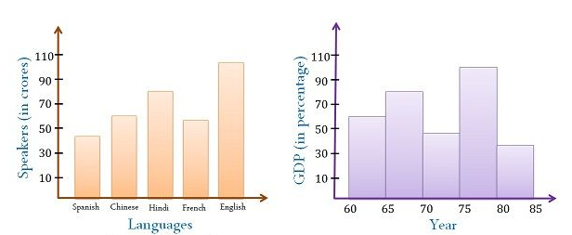
Figure 1: Example of Bar Graph and Histogram

- Line Charts: Line charts are used to show trends and patterns in data over time or along a continuous scale as shown in figure 2. They are particularly useful for displaying relationships between variables that change systematically or gradually ^{[27]}.

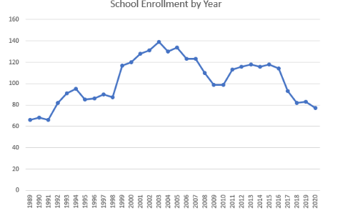
Figure 2: Example of Line Chart

- Scatter Plots: Scatter plots are used to visualize the relationship between two variables. Each data point is represented by a dot on the graph, with one variable plotted on the x-axis and the other on the y-axis as shown in figure 3. Scatter plots help identify correlations, clusters, and outliers in the data ^{[28]}.

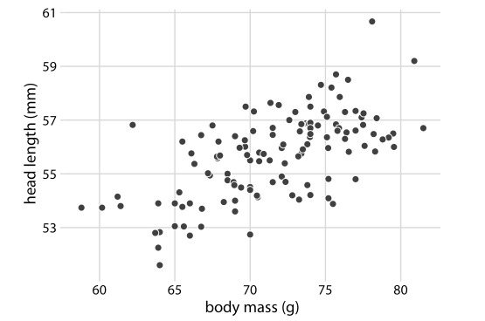
Figure 3: Example of Scatter Plots

- Pie Charts: Pie charts are effective for illustrating proportions and percentages within a whole. The circle is divided into slices, with each slice representing a category or component of the whole as shown in figure 4. Pie charts are best used when you want to highlight the relative sizes of different parts of a dataset ^{[29]}.

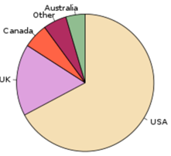
Figure 4: Example of Pie Chart

- Maps and Geospatial Visualizations: Maps and geospatial visualizations are used to display data with a geographical component as shown in figure 5. They can show how data varies across different locations, regions, or countries. Geospatial visualizations are useful for understanding spatial patterns and distributions ^{[30]}.

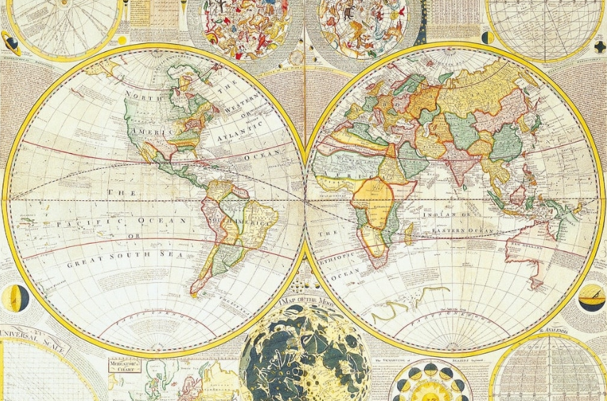

Figure 5: Example of Maps and Geospatial Visualizations

- Heatmaps: Heatmaps are used to represent data density and patterns in a two-dimensional space. They use color gradients to show the intensity of values at different points on a grid ^{[31]}. Heatmaps are often used in areas such as biology, data analysis, and web analytics to visualize large datasets and identify trends.

When choosing a visualization tool, consider the following factors:

- Data Type: Different visualization types are suitable for different types of data (categorical, numerical, time-series, geospatial, etc.).
- Insights: Determine what insights you want to convey. Are you highlighting trends, comparing data, showing distribution, or emphasizing proportions?
- Audience: Consider the audience who will be viewing the visualization. Choose a format that is most intuitive and understandable for them.
- Context: Think about the context in which the visualization will be used. Is it for a presentation, a report, a website, or some other medium?
- Complexity: Choose a visualization that matches the complexity of the data and the message you're trying to convey. Some types of visualizations are better at handling intricate relationships or patterns.

- Best Practices for Effective Visualization

Creating compelling visualizations requires attention to detail and design principles:

- Simplicity: Keep visualizations simple and uncluttered to avoid confusion.
- Labeling: Clearly label axes, data points, and other relevant elements for easy understanding.
- Color and Contrast: Use colors purposefully to highlight important information and create contrast.
- Consistency: Maintain a consistent style throughout your visualizations for a cohesive presentation.
- Interactivity: When appropriate, add interactivity to allow users to explore the data on their own.
- Accuracy and Integrity: Ensure that your visualizations accurately represent the data and do not distort information. Avoid using techniques that might exaggerate differences or mislead viewers.
- Storytelling: Use your visualizations to tell a story or convey a clear message. Arrange the elements in a logical sequence that guides the viewer through the data insights.
- Contextualization: Provide context for the data being presented. Use annotations, captions, and titles to explain the significance of the visualization and any relevant trends or patterns.
- Data-Ink Ratio: Minimize non-essential elements in the visualization to maximize the data-ink ratio—the proportion of ink (or pixels) used to represent data versus the total ink used in the visualization. This helps reduce clutter and improve clarity.
- Choosing the Right Visualization Type: Select the appropriate type of visualization (e.g., bar chart, line chart, scatter plot, etc.) based on the data and the insights you want to convey. Different visualization types are suited for different types of data relationships.

- Avoiding Chartjunk: Chartjunk refers to unnecessary decorative elements in a visualization that do not contribute to understanding the data. Eliminate unnecessary gridlines, background colors, and other distractions that don't add value.
- Accessibility: Design your visualizations to be accessible to a wide range of users, including those with visual impairments. Ensure that color choices, font sizes, and other design elements are accessible and conform to accessibility standards.
- Hierarchy and Emphasis: Use visual cues such as size, color, and position to emphasize important data points or trends. Create a clear hierarchy that guides the viewer's attention.
- Testing and Iteration: Before finalizing your visualization, test it with a diverse audience to gather feedback. Iterate based on the feedback received to improve clarity and effectiveness.
- Data Source and Attribution: Clearly indicate the source of your data and provide appropriate attribution. This adds credibility to your visualization and allows viewers to verify the information.
- Responsive Design: If your visualizations will be viewed on different devices and screen sizes, ensure they are responsive and can adapt to various screen dimensions without losing clarity or functionality.
- Whitespace and Layout: Effective use of whitespace (empty space) can enhance the readability and visual appeal of your visualization. Carefully consider the layout and spacing of elements to achieve a balanced and organized appearance.
- Color Blindness Consideration: Be mindful of color choices, as some viewers may have color vision deficiencies. Avoid relying solely on color to convey information and use patterns or labels as alternatives.

- Conclusion

Data Analysis and Visualization is a dynamic approach that harmonizes analytical precision and creative design to extract meaning from complex datasets ^{[32]}. Emphasizing simplicity, clear labeling, and strategic color usage, it ensures clarity and avoids misrepresentation ^{[33]}. Consistency and context-driven storytelling guide viewers through data's narrative, while interactive elements empower exploration. Chart selection, data-ink optimization, and accessibility considerations foster effective communication ^{[34]}. It advocates for responsive design, accommodating diverse devices, and user needs. Thoughtful integration of color, layout, and whitespace optimizes comprehension. By uniting accurate data representation with engaging visuals, it unveils hidden patterns, enabling informed decision-making. This methodology embodies the synergy of art and science, illuminating insights and propelling data analysis into a powerful tool for understanding and innovation.

References
- Torre‐Bastida, Ana Isabel, et al. "Big Data for transportation and mobility: recent advances, trends and challenges." IET Intelligent Transport Systems 12.8 (2018): 742-755.
- Burke, Jason. Health analytics: gaining the insights to transform health care. John Wiley & Sons, 2013.
- Whitney, Hunter. Data insights: new ways to visualize and make sense of data. Newnes, 2012.
- Larose, Daniel T., and Chantal D. Larose. Discovering knowledge in data: an introduction to data mining. Vol. 4. John Wiley & Sons, 2014.
- Ratner, Bruce. Statistical and machine-learning data mining:: Techniques for better predictive modeling and analysis of big data. CRC Press, 2017.
- York, Jonathan L., and Jeffrey E. Danes. "Customer development, innovation, and decision-making biases int he lean startup." Journal of Small Business Strategy (archive only) 24.2 (2014): 21-40.
- Murray, Scott. Interactive data visualization for the web: an introduction to designing with D3. " O'Reilly Media, Inc.", 2017.
- Bailey, Jefferson, and Lily Pregill. "Speak to the eyes: The history and practice of information visualization." Art Documentation: Journal of the Art Libraries Society of North America 33.2 (2014): 168-191.
- Soukup, Tom, and Ian Davidson. Visual data mining: Techniques and tools for data visualization and mining. John Wiley & Sons, 2002.
- Miles, Matthew B., and A. Michael Huberman. Qualitative data analysis: An expanded sourcebook. sage, 1994.
- Chai, Christine P. "The importance of data cleaning: Three visualization examples." Chance 33.1 (2020): 4-9.
- Weissgerber, Tracey L., et al. "Reveal, don’t conceal: transforming data visualization to improve transparency." Circulation 140.18 (2019): 1506-1518.
- Patil, Indrajeet. "Visualizations with statistical details: The'ggstatsplot'approach." Journal of Open Source Software 6.61 (2021): 3167.
- Qin, Xuedi, et al. "Making data visualization more efficient and effective: a survey." The VLDB Journal 29 (2020): 93-117.
- Tracy, Sarah J. Qualitative research methods: Collecting evidence, crafting analysis, communicating impact. John Wiley & Sons, 2019.
- Gigerenzer, Gerd, et al. "Helping doctors and patients make sense of health statistics." Psychological science in the public interest 8.2 (2007): 53-96.
- LaValle, Steve, et al. "Big data, analytics and the path from insights to value." MIT sloan management review (2010).
- Sinar, Evan F. "Data visualization." Big Data at Work. Routledge, 2015. 115-157.
- Grant, Robert. Data visualization: Charts, maps, and interactive graphics. Crc Press, 2018.
- Sinar, Evan F. "Data visualization." Big Data at Work. Routledge, 2015. 115-157.
- Pang, Alex T., Craig M. Wittenbrink, and Suresh K. Lodha. "Approaches to uncertainty visualization." The Visual Computer 13.8 (1997): 370-390.
- Knaflic, Cole Nussbaumer. Storytelling with data: A data visualization guide for business professionals. John Wiley & Sons, 2015.
- Medler, Ben, and Brian Magerko. "Analytics of play: Using information visualization and gameplay practices for visualizing video game data." Parsons Journal for Information Mapping 3.1 (2011): 1-12.
- Pousman, Zachary, John Stasko, and Michael Mateas. "Casual information visualization: Depictions of data in everyday life." IEEE transactions on visualization and computer graphics 13.6 (2007): 1145-1152.
- Zakaria, Mahmoud Sherif. "Data visualization as a research support service in academic libraries: An investigation of world-class universities." The Journal of Academic Librarianship 47.5 (2021): 102397.
- Kosara, Robert, Fabian Bendix, and Helwig Hauser. "Parallel sets: Interactive exploration and visual analysis of categorical data." IEEE transactions on visualization and computer graphics 12.4 (2006): 558-568.
- Eppler, Martin J., and Ken W. Platts. "Visual strategizing: the systematic use of visualization in the strategic-planning process." Long Range Planning 42.1 (2009): 42-74.
- Matejka, Justin, Fraser Anderson, and George Fitzmaurice. "Dynamic opacity optimization for scatter plots." Proceedings of the 33rd Annual ACM Conference on Human Factors in Computing Systems. 2015.
- Spence, Ian, and Stephan Lewandowsky. "Displaying proportions and percentages." Applied Cognitive Psychology 5.1 (1991): 61-77.
- Kraak, Menno-Jan, and Ferjan Ormeling. Cartography: visualization of geospatial data. CRC Press, 2020.
- Trame, Johannes, and Carsten Keßler. "Exploring the lineage of volunteered geographic information with heat maps." GeoViz, Hamburg, Germany (2011).
- Keim, Daniel, et al. Visual analytics: Definition, process, and challenges. Springer Berlin Heidelberg, 2008.
- Kharakhash, Oleksandr. "DATA VISUALIZATION: TRANSFORMING COMPLEX DATA INTO ACTIONABLE INSIGHTS." Automation of Technological & Business Processes/Avtomatizaciâ Tehnologiceskih i Biznes-Processov 15.2 (2023).
- Lipkus, Isaac M., and Justin G. Hollands. "The visual communication of risk." JNCI monographs 1999.25 (1999): 149-163.

