THE MICROBIAL DIVERSITY AND PHYSIO-CHEMICAL ANALYSIS OF VERMICOMPOST AND BIOCOMPOST SOIL AND THEIR EFFECT ON GROWTH AND YIELD OF Phaseolus mungo
DR.R.KRISHNAVENI¹, G.RAMYA¹,M.ASHEERA ASHRIN¹, H.ASIYA NACHIYA¹, J.HASLIN NIHAR¹
*Dr.R.Krishnaveni, Assistant Professor and Head, PG and Research Department of Microbiology. Idhaya College for Women, Kumbakonam.
M.Asheera ashrin¹, H.Asiya nachiya¹, J.Haslin nihar¹Research Students Department of Microbiology. Idhaya College for Women, Kumbakonam
G.Ramya ,Reaearch scholar, Idhaya College for Women, Kumbakonam.

Corresponding Author;*R.KRISHNAVENI¹
Mail ID : krishnavenimicro@gmail.com
Introduction:
Vermocompost is a biological process where Earthworm play a important role on decomposing of waste materials like dried leaf and soil. It is a bio-oxidative process The earthworms interact intensively with microbes and accelerating the organic matter and modifying its biochemical properties. Vermicomposting systems ia a Biotic interactions between decomposers. The functional diversity and subsrate quality are the main Effect of these systems(sampedro and Domeiguez, 2008)
The primary consumers of the vermicomposting are the bacteria,fungi and ciliates. microoraganism are the most numerically abundant and diverse members of the vermicomposting food web .Endosymbiotic microbes in soil produce extracellular enzymes .It decomposwe cellulose and phenolic compounds.In addition, carbon resourse is a limiting factor for earthworm growth.(Tiunov and Schen 2004) The secondary metabolites which act against numerous co-exizting phytopathogenic fungi and human pathogenic bacteria (Pathma et al.2011b) .Through earthworms the large soil particles and leaf litters degraded and it transformed in to organic wastes. (Maboeta and van Rensburg 2003).
The present study carried on the following topics;
1.Analyzing the soil microbial diversity on vermicompost and biocompost soil
2.Analysis of Physio-chemical parameters of the vermicompost and Biocompost soil.
3.Analyzing the growth and yield effect of vermicompost and Biocompost soils on Phaseolus mungo.

.
MATERIALS AND METHODS
SITE OF COLLECTION:
For the present study was carried out in two different soil samples were collected from Idhaya college for women and saradha nursery at sakkotai, Kumbakonam , Thanjavur district,Tamilnadu .The study period between Dec 2017 to march 2018.The samples are normal soil, compost soil, vermicompost soil.(figure:1 A)The seed of Phaseolus mungo were collected from Kavery fertilizers ,at Kumbakonam.(figure : 1 B)

LACTOPHENOL COTTON BLUE MOUNT:
By using this technique fungal species and spores are identified.

METHODS USED FOR PHYSIO-CHEMICAL ANALYSIS:
a)Walkely-black method(organic carbon)
b)Kjeldhal method (organic nitrogen)
c)Olsen’method (organic phosphorus)

RESULT
The microbial diversity and growth effect of vermicompost and biocompost soil on Phaseolus mungowere studied. And their physio-chemical parameters were measured. According to study result,Table -1 shows the microbial diversity on compost soil, the bacterial species were isolated such as Bacillus sp, Actinomycetes sp,Pseudomonas sp(Figure:3A ,B).The fungal species also isolated they are ,Penicillium sp ,Aspergillus sp, Pythiumsp,Candida sp.
Table -2 shows microbial diversity on vermicopost soil,the bacterial species were isolated such as ,Bacilius sp, Rhizobium sp, Azotobacter sp, and Micrococcus sp. The fugal species were isolated such as Penicillium sp, Aspergillus sp,Euopenicillium sp. The pathogenic fungus Fusarium sp and Pythium sp were absence in vermicompost soil.(Figure : 2 A,B)
Table-3 shows the total microbial count on vermicompost and biocompost soil samples .In biocompost soil the total count at various dilution rates respectively 2.1×10⁻⁴,3.5×10⁻⁵,18×10⁻⁶ and averagely 20×10⁻⁶ were counted.In vermicompost soil the total countat various dilution rates respectively 1.43×10⁻⁴×10⁻⁵,24×10⁻⁶ and averagely 25.2×10⁻⁶were counted.
Table-4 shows the morphological characteristics of bacterial isolates from both soil samples on Nutrient Agar Medium.On vermicompost plate white mucoid,gram negative,rod-shaped,motile colonies were identified.On biocompost plate white mucoid ,cocci shaped,Non-motile colonies were identified.(Figure :4 A,B).
Table -5 shows the morphological characteristics of fungal isolates from both soil samples on Sabouraud Dextrose Agar Medium.On vermicompost plate pale yellowish creamy,rod –shaped ,Non-motile colonies were identified.
Table-6 shows the methods used for the analysis of physiochemical parameters of soil samples.Organic content of the soil is analyzed by Walkey and Black method.Nitrogen content analyzed by Kjeldahl method.Phosphorus content analyzed by Olsens method.
Table-7 shows the physiochemical values of both soil samples.On vermicompost soil the p^{H} 6.2-7,Temperature 16⁰C-24⁰C,Organic contents 11.2%,nitrogen 1.44%, phosphorus 1.42%. But in biocompost soil the p^{H} 5.5-6.5, Temperature 15⁰C-25⁰C,Organic contents 10.3, Nitrogen 1.6%, phosphorus 1.2% were analyzed.
Table-8 shows the growth effect on both soil samples on Phaseolus mungo.The vermiplant shows 11cm plant, 3cm length and 0.7cm width of leaf on 4 days; 18.7 cm plant, 6.7cm length ,1.8cm width of leaf on 15th day ;26.2cm plant ,9.2 cm and 2.7 cm width of leaf,1-5gm of yield on day 30.40cm plant ,8.5cm and 3.5cm width of leaf ,8-10 gm of yield on day 60.But in the Biocompost plant 8.2cm plant,2.2 cm length and 0.4cm width of leaf on day 4;17.8cm plant , 3.5cm length and 1.5 cm of width on day 15;23.5cm plant, 5.2 cm length and 2.3 cm width of leaf ,1-2.5 gm of yield on day 30;34cm plant ,7cm length and 2.9cm width of leaf ,6-8 gm of yield on day 60.(Figure:7 A,B,C,D,E.F.G.H).

TABLE:1 MICROBIAL DIVERSITY ON COMPOST SOIL:
S.NO | COMPOST SOIL
 | BACTERIA |  | FUNGI
1 | Bacillus sp | Fusarium sp
2 | Pseudomonas sp | Penicillium sp
3 | Actinomycetes sp | Aspergillus sp
 |  | Pythium sp
 |  | Candida sp

TABLE :2 MICROBIAL DIVERSITY ON VERMICOMPOST SOIL
S.NO | VERMICOMPOST SOIL
 | BACTERIA | FUNGI
1 | Pseudomonas sp | Penicillium sp
2 | Bacillus sp | Eupenicillus sp
3 | Micrococcus sp | Aspergillus sp
4 | Azotobacter sp
5 | Rhizobium sp

TABLE -3 TOTAL CFU\ml COUNT FOR VERMICOMPOST AND BIOCOMPOST
DILUTION RATE | 10⁻⁴ | 10⁻⁵ | 10⁻⁶ | Average
Compost soil cfu/ml | 2.1×10⁴ | 3.5×10⁵ | 18×10⁶ | 20.1×10⁶
Vermicompost cfu/ml | 1.43×10⁴ | 8×10⁵ | 24×10⁶ | 25.2×10⁶

TABLE:4 THE PHYSICOCHEMICAL PARAMETERS OF VERMICOMPOST AND BIOCOMPOST
PARAMETERS ANALYSED | VALUES
 | VERMICOMPOST | BIOCOMPOST
Ph | 6.2-7 | 5.5-6.5
Temperature | 16⁰C-24⁰C | 15⁰C-22⁰C
Organic contents% | 11.2 | 10.3
N% | 1.44 | 1.6
P% | 1.42 | 1.2

TOTAL PLANT GROWTH
SAMPLE | VERMICOMPOST  SOIL |  |  | COMPOST  SOIL
 | PLANT | LEAF | YIELD | PLANT | LEAF | YIELD
DAY 4 | 11cm | 3cm length  0.7cm  width | 0 | 8.2cm | 2.2cm  Length  0.4cm width | 0
DAY 15 | 18.7cm | 4.2cm  Length  1.8cm  width | 0 | 17.8cm | 3.5cm  Length  1.5cm  width | 0
DAY 30 | 26.2cm | 6cm  Length  2.7cm  width | 1-5cm | 23.5cm | 5.2cm  Length  2.3cm  width | 1-2.5  Cm
DAY 60 | 40cm | 8.5cm  Lengh  3.5cm  width | 8-10  cm | 34cm | 7cm  Length  2.9cm width | 6-8cm
TABLE:5 PLANT GROWTH ON SOIL SAMPLES
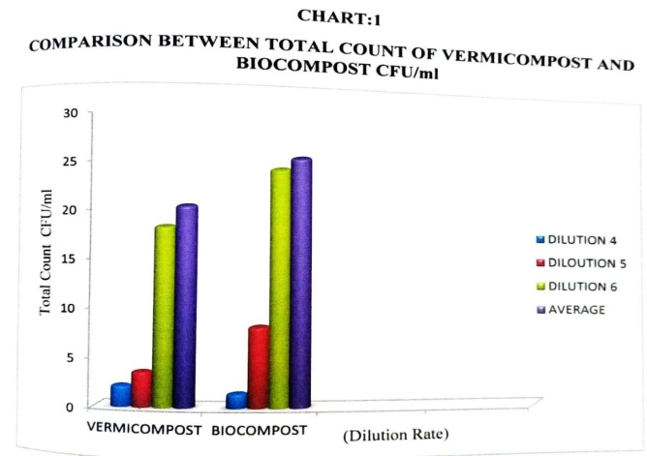

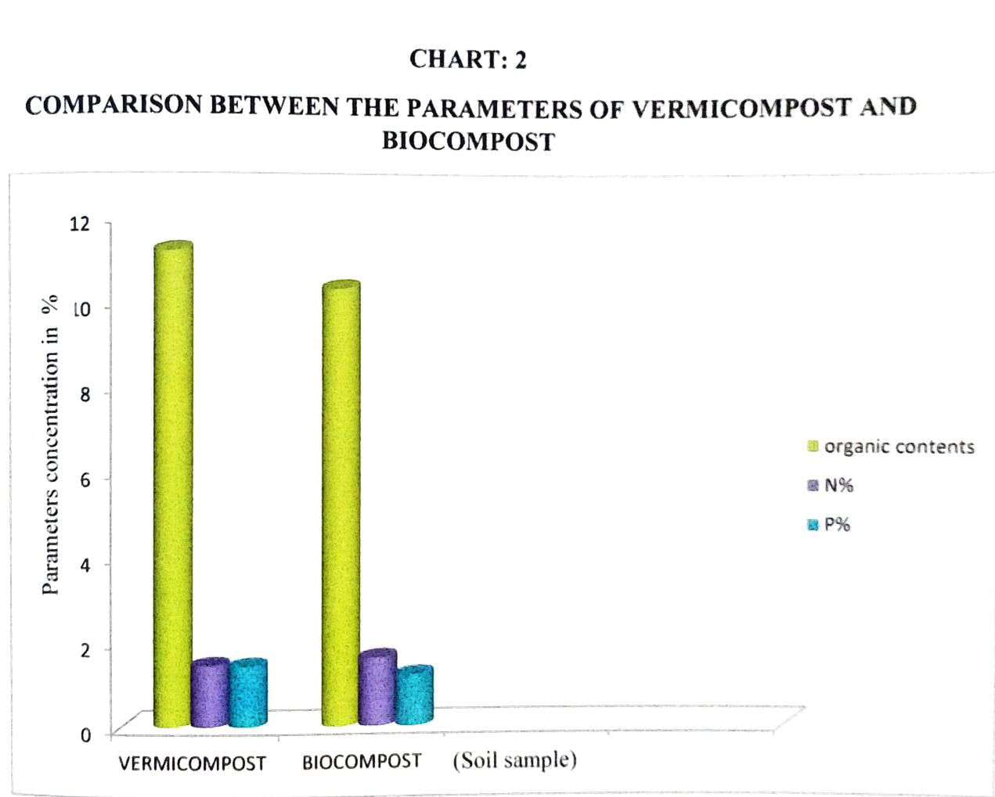

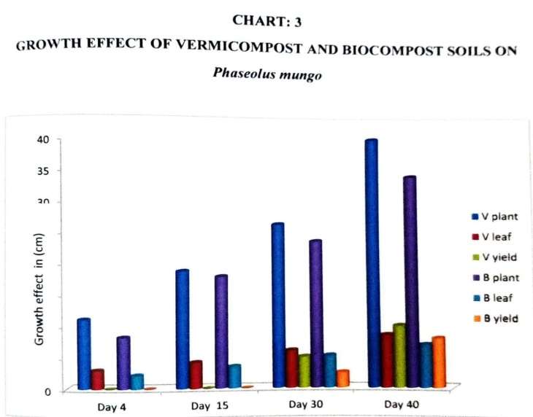

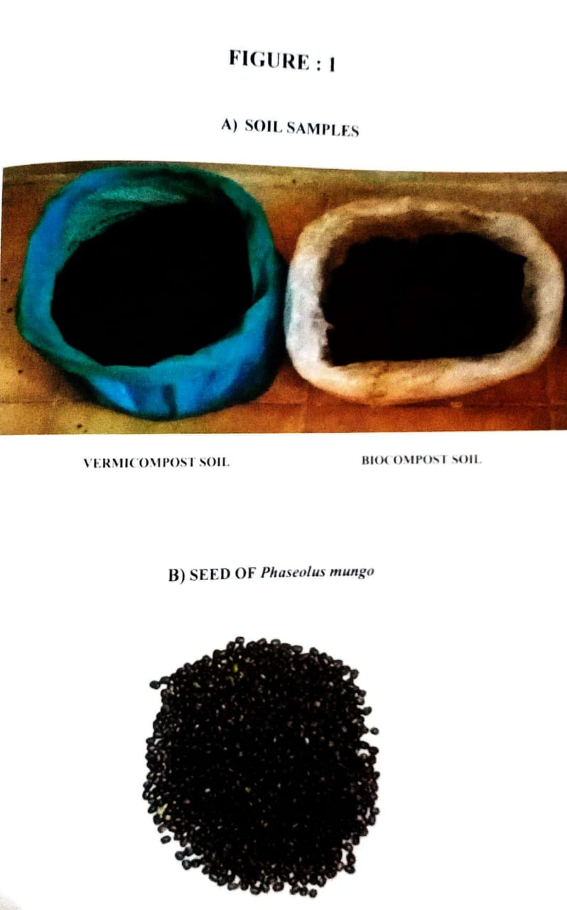

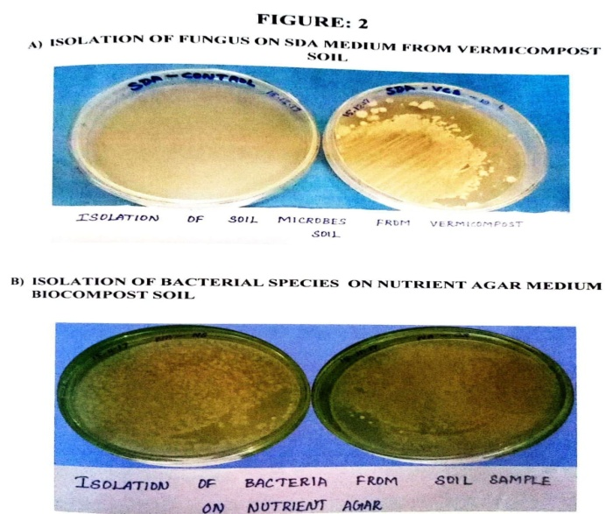

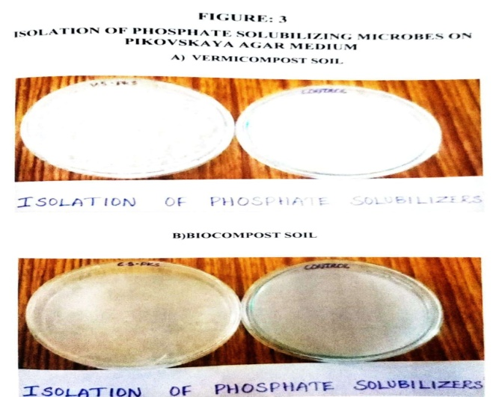
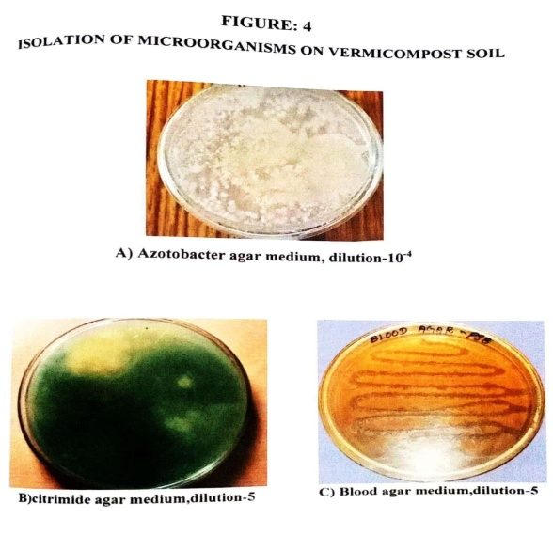

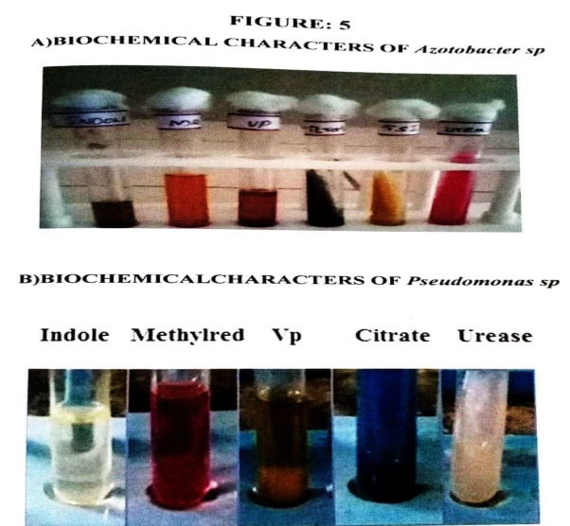

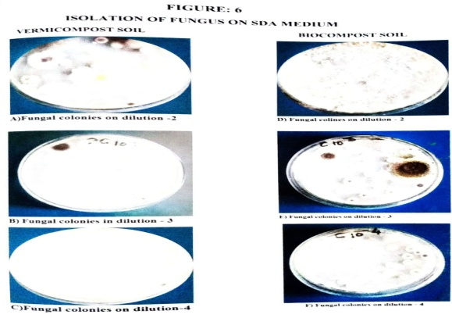

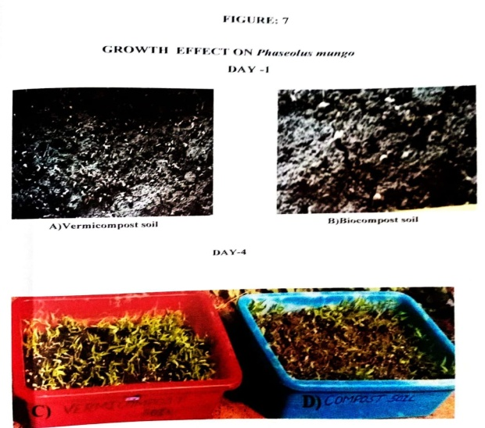

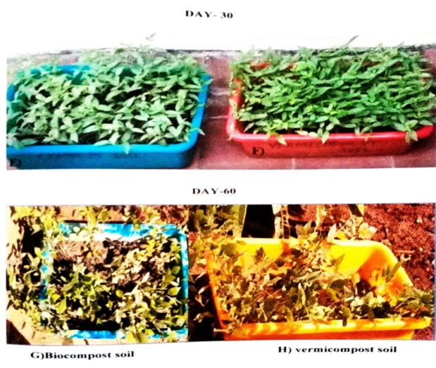

DISCUSSION
In this study the vermicompost the plant Phaseolus mungo which were cultivated in the vermicompost soil shows the maximum total plant length (40cm) and leaf length (8.5cm ) and width (3.5cm) on 60th day when compared to biocompost soil of its total plant length ( 34cm ),leaf length (7cm) and width (2.9cm).The study result was supported by vermicompost addition to soil –less bedding plant media enhanced germination ,growth,flowering and fruiting of a wide range of green house vegetablesand ornamentals(Atiyeh et al.2000a,b,c), marigolds (Atieh et el.2001), pepper (Arancon et al.2003a),strawberries (Arancon et el.2004b)and petunias(Chamani et al 2008).Vermicompost application in the ratio of 20:1 resulted in a significant and consistent increase in plant growth in both field and greenhouse conditions (Edward et el.2004),thus providing a substantial evidence that biological growth promoting factors play a key role in seed germination and plant growth (Edward and Burrows 1988;Edward 1998).Investigations revealed that plant hormones and plant-growth regulating substances (PGRs) such as auxins,gibberlines,cytokinins,ethylene and abscicic acid are produced by microorganisms (Barea et al.1976;Arshad and Frankenberger 1993).
In this strudy the vermicompost soil pH(6.2-7),temperature(16⁰C-24⁰C),organic carbon (11.2%), nitrogen (1.44%),phosphorus (1.42%) was higher than biocompost soil pH(5.5-6.5),temperature (15⁰C-22⁰C),organic carbon (10.3%),organic nitrogen(1.6%) and organic phosphorus (1.2%).This work was supported by Uptake of nitrogen (N),phosphorous (P),potassium (K),and magnesium (Mg) by rice (Oryza sativa)plant was hightest when fertilizer was applied in combination with vermicompost (Jadhav et al,1997).Nuptake by ridge gourd (Luffaacutangula) was higher when the fertilizer mix contained 50% vermicompost (sreenivas et el.2000).Aprt from providing mineralogical nutrients,vermicomposts also contribute to the biological fertility by adding beneficial microbes to soil.

SUMMARY
- The present study was carried out on microbial diversity and growth effect of vermicompost and biocompost soil.
- Vermicompost is a cost-effective and ecofriendly waste management technology which takes the privilige of both earthworms and the associated microbes and has many advantages over traditional thermophilic composting.
- Vermicompost are excellent sources of biofertilizers and their addition improves the physiochemical and biological properties of agriculture soil.
- Vermicomposting amplifies diversity and population of beneficial microbial communities .Although there are some reports indicating that few harmful microbes such as spores of Pythium spand Fusarium sp are dispersed by earthworms(Edwards and Fletcher 1988).
- The microbes like Bacillus sp, Psedomonas sp, Azotobacter sp, Micrococcus sp ,Rhizobium sp were isolated on vermicompost soil; Bacillus sp, Pseudomonas sp, Actinomycetes sp were isolated from biocompost soil.
- The total count average (25.2×10⁶ cfu/ml) isolated in vermicompost soil was higher than in (20.2×10⁶ cfu/ml) in biocompost soil.
- The physio-chemical parameters such as pH(6.2-7),Temperature (16⁰C-24⁰C),Organic carbon(11.2%),Nitrogen (1.44%),Phosphorus (1.42%) were higher in vermicompost soil than biocompost soil.
- The growth yield on 60 days (40cm)length,(8cm)leaf length were observed higher in vermicompost soil than biocompost soil.
- Vermicomposting used as a ulternative media for the plant growth at low cost,excellent nutrient status, physiological charactristics, considerable improvement in plant growth have been attributed to physiological and biological properties of vermicompost.
- So,in future the farmers adviced to use of vermicompost soil for their plant growth and fertility.

REFERENCE

- Aira M, .Monroy F,Dominguez J (2008).Changes in density of nematodes protozoa and total coliforms after transit through the gut of four epigeic earthworm
- Munnoli PM, Da Silva JAT, Saroj B (2010) Dinaics of the soil-earthworm-plant relationship: A review. Dynamic soil, Dynamic plant:1-21
- Pathma J,Rahul GR, Kamaraj kenady R, Subashri R,Sakthivel N (2001 b) secondary metabolite production by bacterial antagonist. Journal of biological control.
- Maboeta MS, Van Rensburg L(2003) Vermicomposting of industrially producer wood chips and sewagw sludge utilizing Cisenia foetida.Ecotoxicol Environ Saf.

