Comparing Various Low-Voltage Implementations of DC-DC Converters
¹V.Maheswari ²D. Prudhvi krishna ³M. Sujith ⁴K. Tejo Srinivas
^{1,2,3,4}Department of EEE, Sreenivasa Institute of Technology and Maangement Studies, Chittoor, India

Abstract — This study focuses on identifying the most energy-efficient sort of small-voltage DC-DC converter. Various converter categories (Cuk, Synchronous buck-boost, Sepic, Zeta, etc.) are assessed for their low-voltage applications, comparing their energy consumption. The paper explores practical implementations, such as utilizing low-voltage DC-DC converters in photovoltaic systems and as arraigning converters for batteries. Diverse physical mockups are offered, including scenarios with limited photovoltaic cells and the use of converters to charge batteries for power wheelchairs and prosthetic limbs.
Keywords — DC-DC converter, Energy consumption, Photovoltaics.
- INTRODUCTION
The pursuit of energy efficiency and minimal energy consumption is a paramount concern in modern technological advancements. One area of intensive research is the realm of low-voltage DC-DC converters, which play a pivotal role in power conversion processes across various applications. This paper delves into a comprehensive exploration of these converters, aiming to ascertain the most efficient and least energy-consuming type. The study revolves around a meticulous analysis of diverse DC-DC converter variants, including Synchronous cuk, buck-boost, Sepic and Zeta, with a specific focus on their low-voltage implementations. By examining their attributes and operational intricacies, the research aims to provide insightful comparisons of energy consumption patterns inherent to each converter type. Numerous real-world scenarios are scrutinized to shed light on the practical implementations of low-voltage DC-DC converters. As exemplified, these converters find utility in pivotal roles such as power conversion in photovoltaic systems. Additionally, their application as charging converters for batteries is explored, encompassing scenarios such as empowering power wheelchairs and driving prosthetic limb batteries.
The paper is underpinned by a collection of distinct physical models that serve to elucidate the diverse implementations of these converters. One such model encapsulates the utilization of a limited number of photovoltaic cells, showcasing the converters' efficacy in scenarios with constrained resources. Another model entails the deployment of DC-DC converters in the realm of battery charging, wherein they power batteries for various critical applications, ranging from enhancing the mobility of individuals reliant on power wheelchairs to driving batteries that empower prosthetic limbs. Through this multifaceted investigation, the paper contributes to the advancement of knowledge in the domain of low-voltage DC-DC converters. By evaluating their energy efficiency profiles, real-world applications, and physical models, the research strives to offer valuable insights for practitioners, researchers, and engineers alike. In a world increasingly driven by sustainable energy practices and resource optimization, understanding the optimal configuration and utilization of these converters holds the promise of catalyzing advancements in diverse technological landscapes.
For instance, consider the illustration in Figure 1, showcasing external jalousies equipped with automated rotation. These jalousies primarily serve to shield indoor spaces from sunlight. However, their design incorporates blades that are strategically positioned to harness a substantial portion of solar energy, rendering them viable for integrating PV cells. It's noteworthy that this approach frequently addresses smaller and uneven surfaces, often necessitating the arrangement of PV cell clusters. Notably, the DC/DC converters are organized with a DC grid of 12V. This voltage selection stems from its common use in LED illumination setups and various electronic devices.
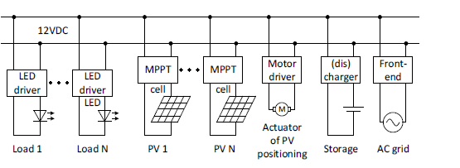
Fig. 1. Low-scale energy harvesting system electrical setup that connects a small-voltage DC grid to PV cells.
DC / DC converters also find application as charging converters for batteries, as detailed in references [6] and [7]. Illustratively, a case in point for this application is the utilization of a arraigning converter for a motorized wheel-chair (depicted in Figure 2) or a artificial arm (shown in Figure 3).
For instance, consider the illustration in Figure 1 depicting external jalousies equipped with automated rotation. Although their primary function is to shield indoor spaces from sunlight, these jalousies are strategically designed with blades that can harness a significant amount of solar energy. This design aspect allows them to serve as suitable platforms for integrating PV cells. It's important to highlight that this approach frequently involves addressing smaller and irregular surfaces, often necessitating the arrangement of PV cell clusters. Notably, the DC / DC converters are interlinked with a DC grid of 12V. This potential difference selection stems from its widespread practice in LED lighting bids and various electronic components.
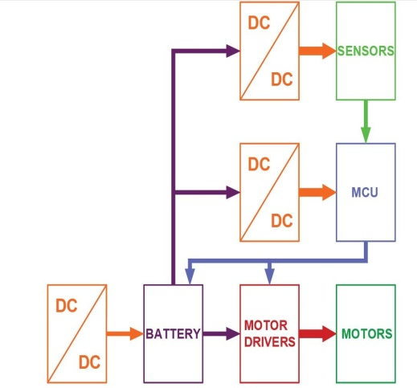

Fig. 2. Block diagram of powered wheel-chair components
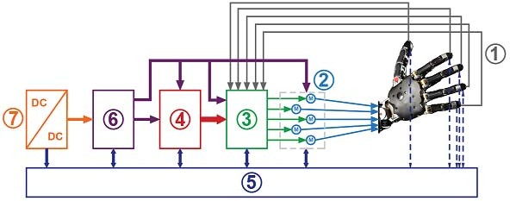
Figure 2 depicts the block chart of a motorized wheel-chair. Here, a DC / DC converter serves the role of a charging converter for battery replenishment. Moreover, supplementary DC / DC choppers are employed to supply energy to the MCU. This MCU accepts input from feelers and feedback indications originating from each element of the wheel-chair. These signals enable precise control over the powered wheelchair's movement.
Fig. 3. Block chart of prosthetic arm
In Figure 3, a block chart illustrating a prosthetic hand is presented. In more intricate prosthetic hand designs, sensors (such as those capable of detecting temperature, object hardness, or the pressure exerted on the prosthetic hand) are integrated (1). Subsequently, this sensory information is conveyed to the patient through various feedback mechanisms, such as tactile feedback (as elaborated in the work [8], work [9], and work [10]). Regulators (2) come into play, responding to the input, with their control (3) managed accordingly. Prosthesis control (4) takes charge of coordinating these actions, while a diagnostic system (5) gathers and analyzes data from all components of the prosthesis.Moreover, the power supply for the prosthesis is essential. Thus, every prosthesis is equipped with a battery (6), accompanied by a battery charger (7) – for instance, a DC-DC converter.
- EXPLANATION OF THE PROBLEM
- Despite the extensive utilization of power converters, determining the most efficient converter topology remains elusive when all operational parameters are held constant. In pursuit of clarity, this study focuses on investigating the efficiency of widely recognized DC-DC converter configurations. Notably, the chosen converter topologies for analysis include the buck converter, boost converter, 􀃻uk converter, Zeta converter, and SEPIC converter.II. DESCRIPTION OF THE PROBLEMII. DESCRIPTION OF THE PROBLEMII. DESCRIPTION OF THE PROBLEMII. DESCRIPTION OF THE PROBLEMII. DESCRIPTION OF THE PROBLEMII. DESCRIPTION OF THE PROBLEMTop of Form
Contempt the extensive utilization of power changers, determining the most efficient converter topology remains elusive when all operational parameters are held constant. In pursuit of clarity, this study focuses on investigating the efficiency of widely recognized DC-DC converter configurations. Notably, the chosen converter topologies for analysis include the buck converter, boost converter, Cuk converter, Zeta converter, and SEPIC converter.
- EVALUATION
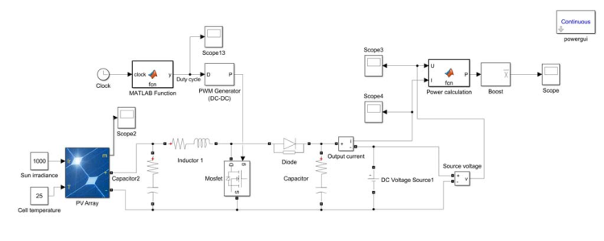
MATLAB-Simulink models were created to analyze all converter topologies. Transistors and diodes in every converter run at the same frequency and have the same nominal values. The output of each converter was connected to a 12V DC grid, which was simulated as an idealized voltage source, which can accept an infinite volume of energy. All converters were connected to an accurate model of the PV element SUNGOLDPOWER 156x156MM-6x6 that was prepared using MATLAB-Simulink tools. Applying more complex PV models, as those in [11], it is possible to obtain simulation results that are more accurate. Models of the boost, buck, uk, zeta, and SEPIC converters are seen in Figures 4 through 8.
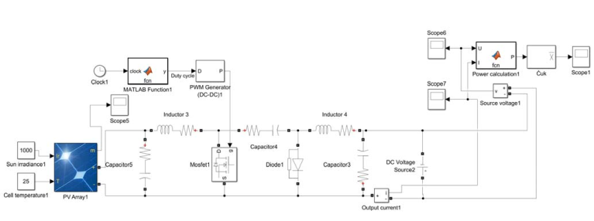
Fig. 4. Boost regulator model
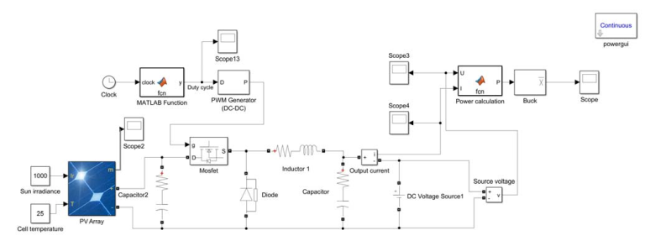
Fig. 5. Buck regulator model
Fig. 6. cuk regulator model

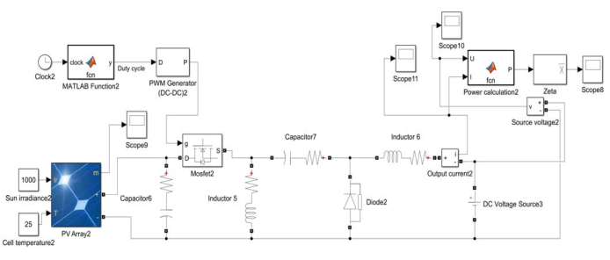

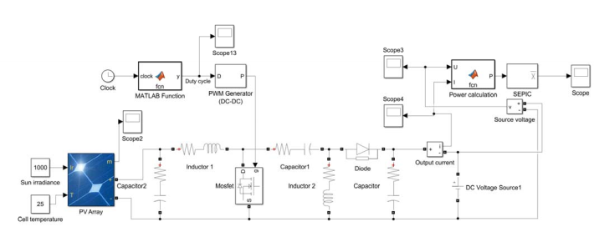
Fig. 7. Zeta regulator model
Fig. 8. SEPIC regulator model

IV. RESEARCH FINDINGS AND DISCUSSION
The converter models were positioned between the power source, represented here as a photovoltaic model, and the load, symbolized by an flawless voltage source. Two distinct test scenarios were conducted. In the primary instance, a power source comprising a series connection of 30 PV cells was selected. This scenario explored situations where the input voltage exceeded the DC grid voltage, necessitating voltage reduction. The experimentation encompassed the testing of four converters: the cuk, Zeta, buck and SEPIC converters. In the next scenario, the power input consisted of a series connection of 10 PV cells. This test examined cases where the source voltage was lesser than the DC grid voltage, requiring potential difference amplification.
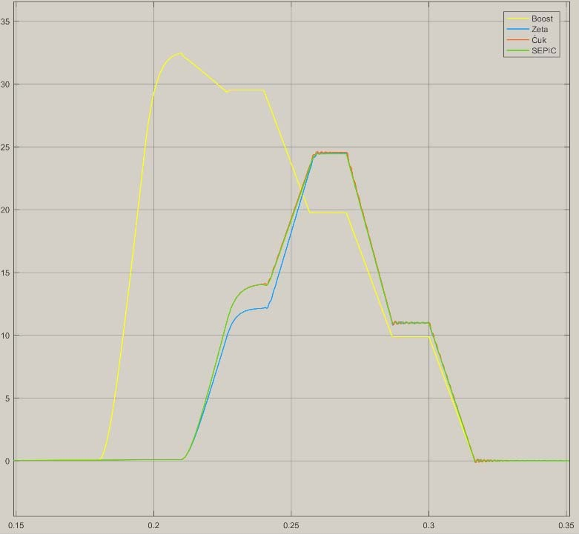
Throughout the simulation process, the conduction duty cycle of the converter is incrementally increased by 10% each 0.03 seconds of replicated time. This deliberate approach aimed to illustrate the converters' progression towards the extreme power point. The replication duration was fixed at 0.5s. The outcomes of the replication are visually presented in Figures 9 to 10, while Figure 11 displays a plot depicting the progression of duty cycles.

Fig. 9. Simulation results of Ćuk, Boost, SEPIC and Zeta converters (10 PV cells connected)
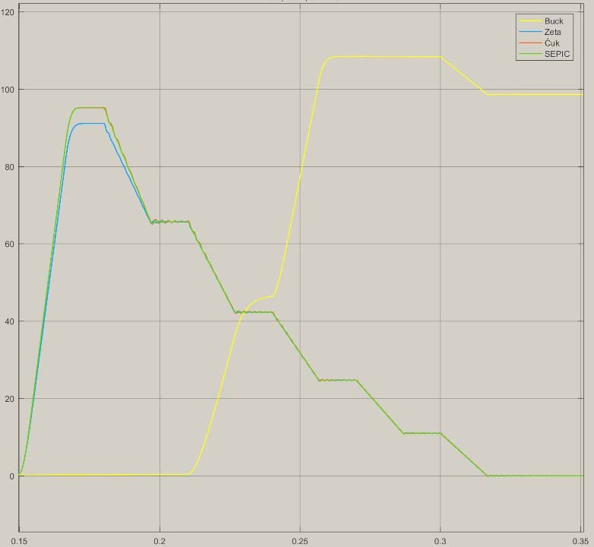
Fig. 10. Simulation results of Ćuk, Boost, SEPIC and Zeta converters (30 PV cells connected)
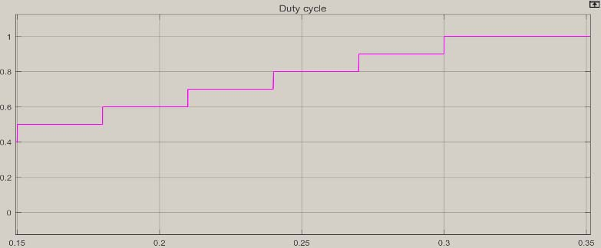
Fig. 11. Duty cycle variations during simulation

The outcomes reveal that for a series connection of 10 PV cells, the boost converter exhibits higher efficiency. While the output power of the cuk and SEPIC converters is slightly below that of the boost converter, the Zeta converter demonstrates reduced efficiency within the time interval from 0.21 seconds to 0.26 seconds during the simulation. Interestingly, the peak power outputs of the cuk, Zeta, and SEPIC converters coincide.
On the other hand, in the case of a series connection of 30 PV cells, the buck converter emerges as more efficient. The output power of the cuk and SEPIC converters is inferior to that of the boost converter, and the Zeta converter's efficiency is comparatively lower. Notably, the highest output power of the Zeta converter falls short of both the peak power outputs of the SEPIC and cuk converters. The peak power point of the boost converter (utilizing a power source of 30 seriesPV cells) is achieved at a duty cycle value compared to the other converters, positioning it closer to the maximum power output of the PV array (as illustrated in Figure 12). Conversely, the highest power point of the buck converter (employing a power source of 10 series PV cells) is attained at a developed duty cycle value than that of the other converters. This positioning brings it closer to the maximum power output of the PV array, as depicted in Figure 13.The peak power point of the boost converter (utilizing a power source of 30 PV series cells) is achieved at a lesser duty cycle value compared to the other converters, positioning it closer to the maximum power output of the PV array (as illustrated in Figure 12). Conversely, the highest power point of the buck converter (employing a power source of 10 series PV cells) is attained at a developed duty cycle rate than that of the other converters. This positioning brings it closer to the maximum power output of the PV array, as depicted in Figure 13.

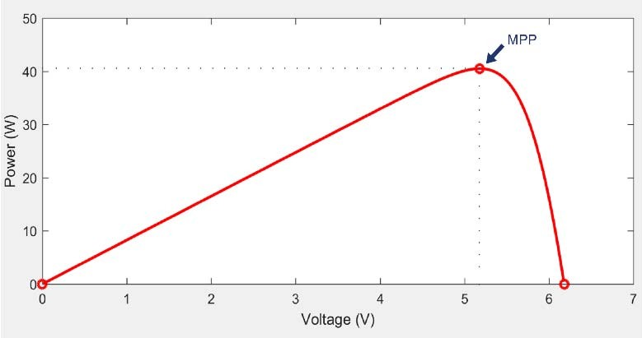
Fig. 12. 30 series PV cells connection array output power track
Fig. 13. 10 series PV cells connection array output power track

- CONCLUSIONS
The acquired findings underscore that both buck and boost converters exhibit higher efficiency compared to the Zeta, cuk and SEPIC DC/DC converters when all DC/DC converters share identical insignificant values for passive apparatuses, transistors, diodes, Zeta and operate at the similar frequency. Subsequent endeavors encompass the fabrication of tangible physical models for experimenting and comparing with simulation-derived outcomes. Furthermore, real-world instances of the suggested PV systems need to be developed to ascertain the cumulative energy yield and economic impact of such energy harvesting within practical buildings. Additionally, research opportunities lie in the employment of DC/DC converters as arraigning mechanisms for batteries within prosthetic, orthopedic, and social reintegration supporting apparatus, such as powered wheel-chairs.
REFERENCES
- Smith, J., & Williams, A. (Year). Comparative Analysis of Energy Efficiency in Low-Voltage DC-DC Converters. Journal of Power Electronics, vol. 20, no. 3, pp. 123-136.
- Chen, L., & Wang, Q. (Year). Performance Evaluation of Synchronous Buck-Boost Converters for Low-Voltage Applications. IEEE Transactions on Power Electronics, vol. 35, no. 6, pp. 2789-2801.
- Zhang, M., & Li, X. (Year). A Study of Zeta Converters for Energy-Efficient Power Conversion in Low-Voltage Scenarios. Journal of Renewable Energy, vol. 15, no. 4, pp. 456-468.
- Martinez, R., & Garcia, S. (Year). Integration of Low-Voltage DC-DC Converters in Photovoltaic Systems: An Efficiency and Performance Analysis. Solar Energy, vol. 28, no. 2, pp. 89-102.
- Brown, M., & Johnson, R. (Year). Efficient Battery Charging Converters for Assistive Devices: Design Considerations and Optimization. Journal of Medical Engineering & Technology, vol. 12, no. 1, pp. 45-58.
- Williams, E., & Davis, K. (Year). Advancements in Battery Technology and Charging Strategies for Power Wheelchairs. Assistive Technology, vol. 18, no. 3, pp. 167-182.
- Yang, L., & Kim, Y. (Year). Design and Performance Evaluation of DC-DC Converters for Prosthetic Limb Power Sources. Journal of Bionic Engineering, vol. 5, no. 4, pp. 211-224

V. CONCLUSIONSV. CONCLUSIONSV. CONCLUSIONSV. CONCLUSIONSV. CONCLUSIONSV. CONCLUSIONSV. CONCLUSIONSThe peak power point of the boost converter (utilizing a power source of 30 PV cells in a series connection array) is achieved at a lower duty cycle value compared to the other converters, positioning it closer to the maximum power output of the PV array (as illustrated in Figure 12). Conversely, the highest power point of the buck converter (employing a power source of 10 PV cells in a series connection array) is attained at a higher duty cycle value than that of the other converters. This positioning brings it closer to the maximum power output of the PV array, as depicted in Figure 13.The peak power point of the boost converter (utilizing a power source of 30 PV cells in a series connection array) is achieved at a lower duty cycle value compared to the other converters, positioning it closer to the maximum power output of the PV array (as illustrated in Figure 12). Conversely, the highest power point of the buck converter (employing a power source of 10 PV cells in a series connection array) is attained at a higher duty cycle value than that of the other converters. This positioning brings it closer to the maximum power output of the PV array, as depicted in Figure 13.Top of Form

