Three Hericium Pers. from Ratanmahal Wildlife Sanctuary of Gujarat, India.
Praveen Kumar Nagadesi^{1*} Shraddha Olpadkar²
¹Department of Botany, School of Life Sciences, St. Joseph’s University, 36, Lalbagh Road, Bengaluru, Karnataka, India.
²Department of Botany, J. M. Shah Science College, Ring Rd, Lilotri Bazar, Jambusar, Gujarat 392150, India.
*Corresponding Author E-mail: nagadesipraveenkumar@yahoo.com
Abstract
A survey was undertaken during 2010-2011 to detect the various white rot fungi in Ratanmahal wildlife sanctuary of Gujarat. Detailed macroscopic and microscopic study of fungal samples was identified as Hericium abietis (Weir ex Hubert) K. Harrison, Hericium cirrhatum (Pers.) Nikol. Hericium erinaceus (Bull. ex Fr.) Pers. The two species of Hericium was reported for the first time from the Eco-regions of Gujarat. For the first time Hericium abietis was reported from India. All the three species of Hericium was used as food by tribal of Gujarat, so the conservation was done.
Introduction
The edible mushroom Hericium was first described as genus by Persoon (1794). it is a part of the Hydnum genus due to the hydnoid nature of hymenophore (Fries 1822, Miller 1933). It belong to the order Hericiales and Hericiaceae family (Donk 1964), but according to Index Fungorum the Hericiales was merged with the Russulales order (Kirk et al. 2001). it comprises 34 species with 66 taxon names was listed in Index Fungorum (Index Fungorum 2021), 71 species names was listed in Mycobank (2022) and 23 species records in Notes of Genera in Basidiomycota (He et al. 2019). The mega-diverse country of the world is India, being underexplored for Hericium macro-fungi, except some sporadic noteworthy mycologists’ contributions (Berkeley 1851; Bagchee et al. 1954;, Thind & Khara 1975; Das & Sharma 2010; Das et al. 2011, 2013; Zutshi & Gupta 2013, Semwal et al. 2014, Karun & Sridhar 2016). The genus Hericium shows a peculiar morphology in fruit body like woolly surface. So they are commonly called as bear's head mushroom (H. americanum), monkey's head mushroom (H. cirrhatum) and lion's mane or goat's beard mushroom (H. erinaceus) and based on the nature of spines they are also called coral-spine mushroom (H. coralloides), spine-face or tiered-tooth mushroom (H. cirrhatum) (Karun & Sridhar 2016). The basidiomata is white and fleshy, growing on dead trees or dried woods, the basidiomata are similar to fragile iced thorns which either hang from a branch, supporting the framework or as a tough unbranched cushion of tissue (Kuo 2014). In the present study the distribution, identification and conservation of some species of Hericium from Rathanmahal wildlife Sanctuary, Gujarat, India was reported.
Materials and Methods
Study area
Ratanmahal Wildlife Sanctuary is an area of 55.65 Sq. Km consisting of dry deciduous forest. The total existing sanctuary area lies between the river panama and orsang. It’s location is Panchmahals district, Limkheda taluka. Ratanmahal is 45 km from Baria. It is situated between 74º 37' to 70º 11' East longitude and between 22º 32' to 22º 35' North latitude. The flora of Ratanmahal forest is 543 species of plants, out of which 119 species are trees, 40 species are shrubs, 238 species are herbs, 48 species are grasses, 87 species are climbers, 2 species are partial parasites and 9 species are orchids. Amongst all tree species, Teak was found to have the maximum density and comprised 19.6 % of the total trees cover composition. The next dominant species is the Badaro, constituting 15.7 % of the total composition. The climate is subtropical arid, which turns to humid during the monsoon, i e during July to October. Gradually it becomes exceedingly dry and cold during November to February followed by a long hot summer the hottest month being May and June. Mean annual temperature of the sanctuary is 25.3 ºC with a maximum of 44.9 ºC and minimum of 6.1 ºC. annual rain fall is about 980 mm and rain fall occurs between June and September
Collection and Phenotypical identification
The sporophore was collected from Eco-regions of Gujarat like, India, during the rainy season (July–September) of the years 2015 to 2019. Field characters like habit, host, name of locality and other macro-morphological characteristics were recorded for sample specimens. For Phenotypical identification of sporophore, different Macroscopic features like abhymenial, hymenial surfaces, context, and pore tubes of species were examined. Microscopic features like hyphae, basidiospores and pilear crust were observed by preparing crush mounts and free-hand sections in water, 5% KOH solution, and staining was done with cotton blue (1%, in lactophenol), Congo red (1%, in distilled water), phloxine (1%, in distilled water), and Melzer’s reagent (Arya et al., 2008, Nagadesi and Arya,2012, 2016, Nagadesi 2019,Nagadesi et al 2014).
Results and Discussion
Hericium abietis (Weir ex Hubert) K. Harrison. Canad. Jour. Bot. 42: 1208. 1964. Plate 1 Fig. C,D
Sporophore up to 5 x 2.5 cm, solid tubercle; white to yellowish, buff when young, yellowish when bruised. sessile large, solid, massive, tubercle attached laterally to the wood by rooting strands, context firm, pallid; spines up to 1.2 cm long, very short and stout when young, pointed on ends in tufts. The basal mycelium is interwoven with rhizomorphic strands; hyphae on surface of basal tubercle nonamyloid, clamped, 2.65-3.75 µm wide, cells long, walls thin. No KOH reaction when dried; Melzer's reagent gave amyloid reaction to tramal context, branches, and spines. Hymenium and subhymenium nonamyloid, dull yellow in Melzer's; subhymenium compact, 20.85-30.65µm thick, consisting of a layer of thin-walled generative hypha 3.65-4.75 µm in diameter. Hyphae in basidiocarp amyloid, flexuous, often bifurcating broadly, interwoven, variable in width, clamped at the septa, thick-walled, with wider lumen. Spores 4.65-5.56 x 4.25 - 4.75µm, subglobose, white, smooth, amyloid with thickwalls, dextrinoid; Basidia 5-7 x 25-30 µm, with walls irregular wavy; cystidia flexuous, clavate. Gloeocystidia 8-12 µm; oleiferous hyphae 200 µm, thick-walled, exposed in hymenium, moniliform, usually burst in Melzer's reagent and exuding oily contents. Odor and taste mild.
Specimen examination
India, Gujarat state, Ratanmahal wildlife sanctuary, on dead bamboo wood causing a white rot, 15th August 2010, coll. N. Praveen Kumar, (Acc no: MSUB Bot 120),
This fungus causes a white pocket rot in Abies grandis (Dougl.) Lindl., A. lasiocarpa (Hook.) Nutt., A. procera Rehd., Picea engelmannii Parry ex Engelm., Tsuga heterophylla (Raf.) Sarg., Pseudotsuga menziesii (Mirb) Franco in the Pacific Northwest. In Alaska, it is causing a rot in western hemlock, and Picea sitchensis (Bong.) Carr.(Englerth 1947). In Canada of British Columbia it causing a long pitted trunk rots in western hemlock and true fir (Bier 1949). Foster and Foster (1951) also reported it as a cause of a rot of western hemlock. In the present study it is causing white rot on dead Bamboo.
Hericium cirrhatum (Pers.) Nikol. Acta Inst. Bot. Acad. Sci. USSR Plant Crypt., Fasc. II 6, 343 (1950) Plate 1 Fig. E
Sporophore: Large white bracket-like caps with hairy-bristly upper surface and fertile flattened tiered teeth underneath. Solitary or in tufts (Plate I Fig. E), annual, lignicolous, rare, odor almond-like, taste not distinctive, edible and measures 2.2–10.9 cm diam. × 0.5–3.3 cm thick. Basidiomata at first small pinkish-white eruption with fine hairs, on ageing becomes irregular to bracket-shaped, hairy and on maturity irregularly semicircular to lobed or bracket-like to shell-shaped with wavy margin (Plate I Fig. E). Upper surface sterile, light-brown to white, hairy-bristly and on ageing short-spined to warty (hairs get trimmed off due to heavy showers) (Plate I Fig. E). The lower pinkish-white fertile hymenium bears deadaleoid to lamellate, deeply incised, pointed, flattened teeth 5-18 mm tall, surface finely sulcate, tiered, crowded, spread over (Plate I Fig. E) and sometimes decurrent directly onto substrate. Sessile and laterally attached to substrate. Flesh whitish and soft. Basidia elongated, club-shaped and 2-4 spored. Spores whitish, smooth, oval and measures 9.8–11.2 × 7.2–8.2 µm (Plate I Fig. E).
Specimen examination
India, Gujarat state, Ratanmahal wildlife sanctuary, on dead and living tree of Madhuca indica wood causing a white rot, 15th August 2010, coll. N. Praveen Kumar, (Acc no: MSUB Bot 125),
Hericium erinaceus (Bull. ex Fr.) Pers. Mycol. Europ. 2: 153. 1825. Plate 1 Fig. A,B,
Basidiocarp an ovoid, solid, up to 5 cm wide, attached laterally; upper surface a tangle of coarse agglutinated strands of mycelium; white becoming yellowish and finally brownish. Margin of pileus indefinite, but marked by the bases of long pendent spines. Context fleshy, tough, watery, concolorous; Spines 1.5-4.2 cm long, pendent, beard-like, covering the sides. These are formed in a line as though the rows of spines originated in sequence during the enlargement of the tubercle. Stipe represented by a tough rooting attachment arising within the woody substrate. When KOH was applied to dried material there was no reaction; with Melzer's reagent, context surface and spores were amyloid, context usually amyloid but may not show any darkening in some sections. Spores 5.5-6.8 x 4.5-5.6 µm, subglobose, finely roughened to smooth; basidia 25-40 x 5.25-7.65 µm, 4-spored; gloeocystidia arising in subhymenium, up to 7.75 µm wide, with dense contents exuding as oily appearing droplets in KOH. Hyphae of the trama 3.65-20 µm in diameter, inflated or not, thick-walled, at times the lumen almost closed, interwoven, giving rise to gloeocystidia in the spines. Interweaving hyphae 3.65-10 µm thick with some clamps, branched and thick-walled. odor and taste mild.
Specimen examination
India, Gujarat state, Rajpipla forest, on dead wood causing a white rot, 15th September 2011, coll. N. Praveen Kumar, (Acc no: MSUB Bot 128),
Hericium erinaceus is a rare species native to North America, commonly found in East Asia and India (Das et al. 2011), rarely found in Europe. It is considered as being associated with a heart rot of oaks, occasionally on other frondose species, and is usually found growing from knotholes or cracks on living trees. It is recorded on Fagus in a number of states, on Acer spp. (Washington), Eucalyptus (California) and Platanus (Virginia). In 2003, it was red-listed in 13 of the 23 European countries because its natural habitats are beginning to disappear (Thongbai et al. 2015). In the present study it is causing white rot in dead wood of Rajpipla forest area.
Distribution – Eidgt species of Hericium have been reported from the Indian Subcontinent on woody substrates mainly from the Himalayan region (Thind & Khara 1975, Das & Sharma 2009, Das et al. 2011, 2013, Zutshi & Gupta 2013, Semwal et al. 2014, Das et al. 2013) (Table 2). Hericium erinaceus was also known from the reserve forest of the Western Ghats during July 2012 (Karun & Sridhar 2016). In the present study it is reported from reserved forest of Rajpipla area of Gujarat. Hericium cirrhatum, H. coralloides and H. erinaceus were recorded from Asia, North America and Europe (Boddy et al. 2011). In the present study it was recorded from the India country of Asian continent

Plate I
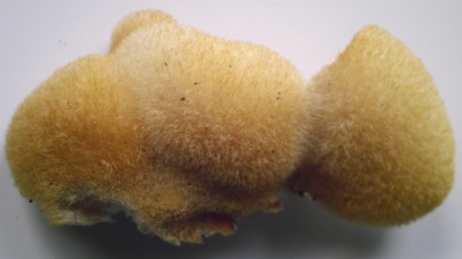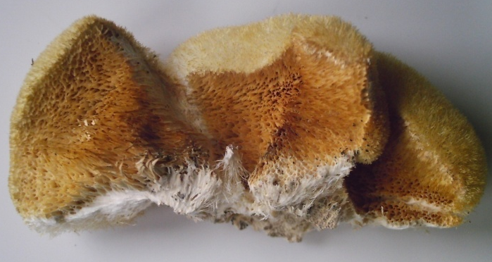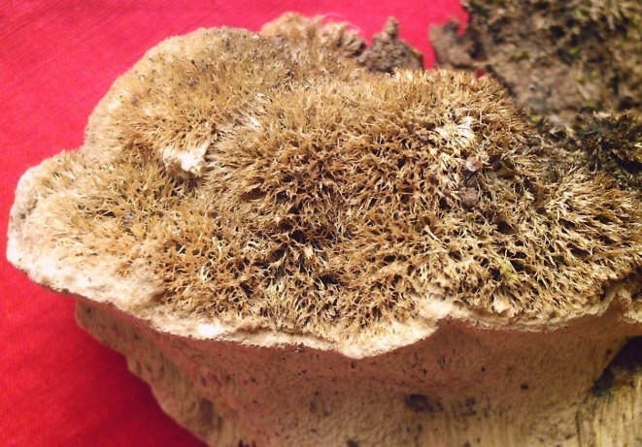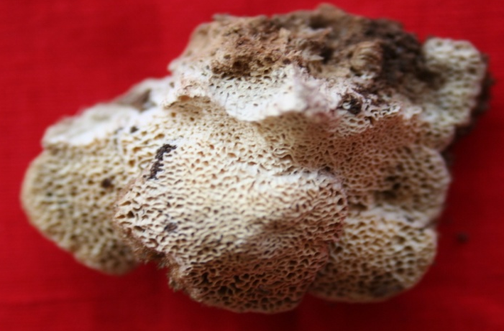
E
A
D
C
B
Table 2 Distribution and substrate preference of Hericium spp. in India
S.No | Species | Location | Habitat | Reference
1 | Hericium abietis | Rathanmahal, Gujarat | Bamboo | Present study
2 | Hericium bharengense | Upper Bhareng, Sikkim | Logs of Tsuga dumosa | Das et al. (2011)
3 | H. cirrhatum. | Yuksom, Sikkim | Wood of Alnus nepalensis; Trunk of Quercus sp | Das & Sharma (2010)
 |  | Makutta, Western Ghats of Karnataka | Crevices of endemic tree Euodia lunuankenda | Karun and Sridhar (2016)
 |  | Rthanmahal, Gujarat | Living tree of Madhuca indica | Present study
4 | H. clathroides | Chamba, Himachal Pradesh | Dead tree of Quercus incane | Thind & Khara (1975)
5 | H. coralloides | Darjeeling; West Bengal | unknown | Berkeley (1851)
 |  | Mussoorie Hills, Uttarakhand ? | unknown | Bagchee et al. (1954)
 |  | Pahalgam, Jammu-Kashmir | Log in coniferous forest | Thind & Khara (1975)
 |  | Doda, Jammu- Kashmir | Dead wood of Quercus leucotrichophora | Zutshi & Gupta (2013)
6 | H. erinaceus | Sikkim | Unknown | Berkeley (1851)
 |  | Mussoorie Hills, Uttarakhand | Unknown | Bagchee et al. (1954)
 |  | Narkanda, Simla | Log of coniferous tree | Thind & Khara (1975)
 |  | Nainital, Uttarakhand | Base of Quercus incane | Thind & Khara (1975)
 |  | Pauri, Uttarakhand; | Cracks of live but decaying | Semwal et al. (2014)
 |  | Shimla, Himachal Pradesh | On wood of Quercus leucotrichophora | Semwal et al. (2014)
 |  | Western Ghats of Karnataka | Unknown tree canopy | Karun & Sridhar (2016)
 |  | Rajpipla, Gujarat | Imported wood log | Present study
7 | Hericium rajendrae | Himalayan, Jammu- Kashmir | Unlnown wood | Upendra Singh and Kanad Das in 2019
8 | H. yumthangense | Yumthang, Sikkim | Wood of Abies densa | Das et al. (2013)

Conservation – Hericium coralloides and H. erinaceus are designated under ‘vulnerable’ (VU) category of Red List in many European countries (Boddy et al. 2011). Most of the Hericium spp. are edible and needs conservation measures during mass collection from wild. Being edible and medicinally versatile, several strategies and priorities of conservation of Hericium spp. have been offered by Boddy et al. (2011). In the present study also the Hericium sp was used by tribal of Gujarat as food so it is edible. In the Western Ghats, H. cirrhatum was found on the dead wood of endemic live trees of Euodia lunuankenda and this host is extensively used to manufacture plywood and matchsticks. Besides, H. cirrhatum was recovered on the tree canopy of unknown tree during July 2012 (Karun & Sridhar 2016). It is likely Western Ghats harbor some more Hericium spp. warrants further exploration (Karun & Sridhar 2016) in the present work the H. cirrhatum was dead and living tree of Madhuca indica and this plant is used for making tribal drink alcohol in Gujarat
Medicinal uses - Most of the young Hericium spp. are edible, Hericium spp. are also known for their therapeutic potential especially in stimulation or synthesis of nerve growth factor (NGF) and several health-promoting principles including those used in treatment of dementia (e.g. metabolites of H. erinaceus: Kawagishi and Zhuang 2008, Ma et al. 2010, Friedman 2015, Thongbai et al. 2015). It is also known that H. erinaceus possess polysaccharide belonging to beta-glucan group showing potent antitumor activities (Seok et al. 2009).
References
Arya A, Albert S and Nagadesi P K.. New and Interesting Records of Basidiomycetous Fungi from Ratanmahal Wildlife Sanctuary, Gujarat, India. Journal of Mycolology and Plant Pathology 2008, 38 (2), 221–226
Bagchee K, Puri YN, Bakshi BK. 1954 - Principal diseases and decays of oaks and other hard woods in India - II. Indian Phytopathology 7, 18-42.
Berkeley MJ. 1851. Decades of Fungi, Deca 35 (# 341-350), Sikkim-Himalayan Fungi collected by Dr. Hooker. Hooker Journal of Botany 3, 167-172.
Boddy L, Crockatt ME, Ainsworth AM. 2011 - Ecology of Hericium cirrhatum, H. coralloides and H. erinaceus in the UK. Fungal Ecology 4, 163-173.
Das K, Sharma JR. 2010 - Hericium cirrhatum (Pers.) Nikol. A new record to Indian mycoflora. Kavaka 37–38, 17–19.
Das K, Stalpers J, Eberhardt U. 2011 - A new species of Hericium from Sikkim Himalaya (India). Cryptogamie, Mycologie 32, 285-293.
Das K, Stalpers JA, Stielow JB. 2013 - Two new species of hydnoid fungi from India. IMA Fungus 4, 359–369.
Donk MA. 1964. A conspectus of the families of Aphyllophorales. Persoonia. 3(2):199–324
Friedman M. 2015 - Chemistry, Nutrition, and health-promoting properties of Hericium erinaceus (Lion’s Mane) mushroom fruiting bodies and mycelia and their bioactive compounds. Journal of Agricultural and Food Chemistry 63, 7108-7123.
Fries EM. 1822. Systema Mycologicum, sistens fungorum ordines, genera et species, huc usque cognitas. Vol.II. 1re partie. Gryphiswaldiae: Ernesti Mauritii.
He MQ, Zhao RL, Hyde KD, Begerow D et al. 2019 – Notes, outline and divergence times of Basidiomycota. Fungal Diversity 99, 105–367.
He MQ, Zhao RL, Hyde KD, Begerow D et al. 2019 – Notes, outline and divergence times of Basidiomycota. Fungal Diversity 99, 105–367.
Index Fungorum 2021 – http://www.indexfungorum.org/ (Accessed on July 6, 2021).
Index Fungorum 2021 – http://www.indexfungorum.org/ (Accessed on July 6, 2021).
Karun NC, Sridhar KR 2016 – Two new records of hydnoid fungi from the Western Ghats of India. Studies in Fungi 1(1), 135–141, Doi 10.5943/sif/1/1/14
Karun NC, Sridhar KR. 2016 - Spatial and temporal diversity of macrofungi in the Western Ghat forests of India. Applied Ecology and Environmental Research 14, 1-21.
Kawagishi H, Zhuang C. 2008 - Compounds for dementia from Hericium erinaceum. Drugs of the Future 33, 149155.
Kirk PM, Cannon PM, David JC, Stalpers JA. 2001. Ainsworth and Bisby’s dictionary of the fungi. 9th ed. Wallingford: CAB International.
Kokni F. K. and Solanki H. A. 2019. Wood Inhibiting Basidiomycetes Fungi found in the different parts of South Gujarat, India. International Journal of Research and Analytical Reviews 6(2):119-127.
Kuo M. 2014 – The Genus Hericium. http://mushroomexpert.com/hericium.html (Accessed October 6, 2020).
Kuo M. 2014 – The Genus Hericium. http://mushroomexpert.com/hericium.html (Accessed October 6, 2022).
Ma B-J, Shen J-W, Yu H-Y, Ruan Y, Wu T-T, Zhao X, 2010 - Hericenones and erinacines: stimulators of nerve growth factor (NGF) biosynthesis in Hericium erinaceus. Mycology 1, 92-98.
Miller LW. 1933. The genera of Hydnaceae. Mycologia. 25(4):286–302.
MycoBank (2022). https://www.mycobank.org/page/Simple%20names%20search (Accessed December 6, 2022).
Nagadesi PK, and Arya A. Lignicolous Macro Fungi from Gujarat, India. World Scientific News, 2016, 45 (2): 307-330.
Nagadesi PK, and Arya A. New records of lignicolous fungi deteriorating wood in India. Mycosphere 2012, 3(6), 997–1004, Doi 10.5943 /mycosphere/3/6/13
Nagadesi PK, Bhavani J, and Arya A. New records of Lignicolous fungi from Krishna District, Andhra Pradesh, India. Int Lett Nat Sci 2014, 12(1):55–69
Nagadesi PK. Phenotypical studies of lignicolous fungi from Kondapalli hill Central Eastern Ghats, South India. Indian Phytopathology. 2018, 71(4):589-597. https://doi.org/10.1007/s42360-018-0090-3,
Nikolajeva TL. 1950 - Acta Inst. Bod. Acad. Sci. USSR Plant. Crypt., Fasc. II 6, 222.
Persoon CH. 1794 - Neuer Versuch einer systematischen Einteilung der Schwämme.Neues Magazine fȕr der Botanik 1, 63–138.
Semwal KC, Stephenson SL, Bhatt VK, Bhatt RP. 2014 - Edible mushrooms of the Northwestern Himalaya, India: a study of indigenous knowledge, distribution and diversity. Mycosphere 5, 440-461.
Seok LJ, Min KM, Cho JY, Hong EK. 2009 - Study of macrophage activation and structural characteristics of purified polysaccharides from the fruiting body of Hericium erinaceus. Journal of Microbiology and Biotechnology 19, 951-959.
Singh, Upendra; Das, Kanad (2019). "Hericium rajendrae sp. nov. (Hericiaceae, Russulales): an edible mushroom from Indian Himalaya". Nova Hedwigia. 108 (3–4): 505–515. doi:10.1127/nova_hedwigia/2019/0527.
Thind KS, Khara HS. 1975 - The Hydnaceae of the North Western Himalayas–II. Indian Phytopathology 28, 57–65
Thongbai B, Rapior S, Hyde KD, Wittstein K, Stadler M 2015 - Hericium erinaceus, an amazing medicinal mushroom. Mycological Progress 14, 1-23.
Thongbai B, Rapior S, Hyde KD, Wittstein K, Stadler M. 2015. Hericium erinaceus, an amazing medicinal mushroom. Mycol Prog. 14(91):1–23.
Zutshi SK, Gupta V. 2013 - Occurrence and characterization of Hericium coralloides: a rare wild edible mushroom from Doda region of J & K, India. Journal of Mycopathological Research 51, 361-363.

