BRAIN & COMPUTER INTERFACE
AUTHORS :
ANTARIKSHA RAMAN
UnderGraduate
Vicky29raman@gmail.com
Department of Computer Science and Engineering
Sapthagiri College Of Enigneering Bangalore,India
ARYAN VAIDYA
UnderGraduate
Department of Computer Science and Engineering
JEEVAN H
UnderGraduate
Department of Computer Science and Engineering
ANINDITA GOSWAMI
UnderGraduate
Department of Computer Science and Engineering
Dr. Soumya C Mahadev
Associate Professor

soumyamadhu31@gmail.com
Department of Bio-Technology
Sapthagiri College Of Enigneering Bangalore,India

ABSTRACT :
A Ground breaking technology called a brain-computer interface (BCI) makes it possible for the human brain To talk without delay with different objectslike computers or prosthetic limbs. BCIs are incredibly promising for use in interactive, assistive, and medical usage since they can record and analyse brain signals. The ideas, applications, difficulties, and potential applications of BCI are succinctly summarised in this abstract.
BCIs work by identifying and interpreting brain activity, frequently with the use of EEG or neural implants. These signals are subsequently translated into commands by machine learning algorithms, allowing users to operate equipment mentally. Medical uses include helping those who are paralysed or have neurological conditions, giving them an opportunity to regain motor function and enhance quality of life. BCIs also make it possible for virtual experiences to be more immersive and improve human-computer interaction.
However, there remain few issues. On-going difficulties involve properly and safely decoding complex brain impulses, addressing ethical issues with cognitive augmentation, and dealing with data privacy. Potential advantages and risks must be considered as the sector develops. For ethical BCI development, partnerships between neuroscientists, engineers, ethicists, and regulators are essential.
BCIs have amazing potential in the future. BCIs may become more portable and user-friendly thanks to advancements in miniaturisation, wireless technology, and signal processing. With more study, even broader applications could be found, ranging from new ways to express oneself to improving cognitive function. BCIs have the potential to fundamentally alter how the world communicate with technology and one another, but serious thought must still be given to their consequences for science, ethics, and society.

INTRODUCTION :
The term "brain-computer interface" was first used by University of California, Los Angeles professor Jacques Vidal in the 1970s, when he showed how one could mentally direct a cursor around a straightforward virtual maze.
The Brain-Computer Interface (BCI), an innovative development that has helped advance human-machine connection, is the product of the fusion of neuroscience and technology. A BCI enables a direct connection between the exquisite complex nature of the human brain and the immense potential of external devices, signifying an extraordinary leap in the area of communication and control. This introduction offers a summary of the key ideas and importance of BCIs, emphasizing their revolutionary effects across a range of fields.
At its essence, a BCI acts as a link that crosses the conventional barriers between the human mind and a machine. It uses the neurological signals sent by the brain to translate our thoughts, intentions, and emotions into concrete actions in the physical or digital world. This revolution is made achievable by complex signal processing methods and cutting-edge algorithms that interpret neural patterns and open up new avenues for human empowerment and expression.
BCIs have far-reaching effects that go beyond traditional human-computer connection. They provide people having disabilities new hope in the realm of medical rehabilitation, where they show remarkable potential. Patients who are paralysed, for example, may experience a resurgence of autonomy when BCIs allow them to use prosthetic limbs or conduct text- or speech-synthesis-based communication. Now that BCIs offer channels for neuro feedback and focused therapy interventions, neurological problems that formerly kept people on the perimeter of interaction may be lessened.Additionally, BCIs have an opportunity to redefine the limits of cognitive enhancement and sensory perception. BCIs can open up new vistas of productivity, creativity, and comprehension by seamlessly connecting our cognitive processes with external systems. They cause us to be thrust into immersive surroundings that react to our neurological impulses, blurring the distinction between reality and virtuality.

However, while BCIs present limitless potential, they also present a variety of moral, practical, and social issues. Careful thought must be given to protecting individual privacy, safeguarding neuronal data security, and navigating the unanticipated effects of fusing humans and technology.
BCIs might be viewed from a different perspective as a novel and interesting kind of communication that people without disabilities could also employ. BCIs may be utilised in addition to more conventional modalities, such as the auditory and visual modalities, in the fields of multimedia communication and human-computer interaction, for instance. The communication bandwidth between people and machines could be increased via multimodal communication with the aid of a BCI. Other BCI applications incorporating multimedia are also possible, in addition to communication. One can envision (multiplayer) games that use BCIs as the control system, for instance. The visualisation of brain activity, or conversion to sound, may be another intriguing application field.

- TYPES OF BCI
1. Invasive BCIs :
These BCIs require the implantation of electrodes right into the brain. This method, which provides high-quality signal resolution, is frequently applied in academic contexts. It can provide precise control of prosthetic limbs or computers and are particularly built for those who are suffering with severe motor limitations, such as paralysis.
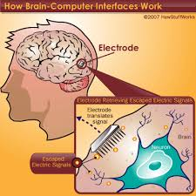
FIG : REPRESENTS HOW BRAIN COMPUTER INTERFACE WORKS [6]

2. PARTIALLY INVASIVE :
Partially invasive Brain-Computer Interfaces (BCIs) offer a promising way to strike a balance between signal quality and user comfort between fully invasive and non-invasive techniques. These BCIs entail the insertion of electrodes or sensors into zones that are partially invasive but not directly inside the brain tissue, usually beneath the skull.
By reducing some of the hazards involved with completely invasive treatments, this strategy hopes to capitalise on the advantages of invasive BCIs, such as improved signal resolution and stability. Compared to non-invasive techniques like EEG, partially invasive BCIs can record neural activity with higher fidelity by placing electrodes closer to the surface of the brain.
Applications which call for precise control, such sophisticated prostheses or fine-grained motor activities, may benefit from partially invasive BCIs. They also provide chances for long-term monitoring and neuro feedback, advancing both the therapeutic and scientific fields.
Even though partially invasive BCIs have benefits, there are some flaws that should be taken into account, including implantation procedures, infection concerns, and long-term biocompatibility. Research is still focused on finding a balance between these worries and the potential advantages. Partially invasive BCIs may become increasingly important as technology develops and our understanding of brain-electrode interfaces grows, opening up new possibilities for human-machine connection while reducing quite of few drawbacks of completely invasive approaches.
3. Non-Invasive BCIs:
- Electroencephalography (EEG): EEG BCIs use electrodes placed on the scalp to record electrical activity produced by the brain's neurons. These BCIs are non-invasive and offer real-time monitoring and helps in neuro- feedback, basic communication, and controlling simple devices.
- Functional Near-Infrared Spectroscopy (fNIRS): This technology measures changes in blood oxygenation in the brain's cortex, providing a non-invasive method to infer brain activity. While less direct than EEG, fNIRS is portable and also comes in handy for cognitive monitoring and basic communication.
- Magneto encephalography (MEG): MEG measures the magnetic fields generated by neural activity and provides high spatial and temporal resolution. It's primarily used for research due to its complex setup and cost.
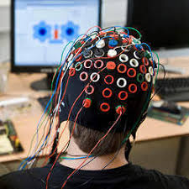
FIG: REPRESENTING NON - INAVSIVE BRAIN COMPUTER INTERFACE
EEG :
A non-invasive neurophysiological test called an electroencephalogram (EEG) is used for evaluating and recording the electrical activity of the brain. It helps to comprehending how the brain works, identifying neurological problems, and keeping track of brain health.
Electrodes are positioned on the scalp during an EEG in order to detect the minute electrical impulses produced by the firing of brain neurons. These signals, often referred to as brainwaves, are divided into many frequency bands, each of which is connected to certain mental states and activities. Delta (0.5–4 Hz), Theta (0.8–13 Hz), Alpha (8–13 Hz), Beta (13–30 Hz), and Gamma (30–100 Hz) are the principal frequency bands.
EEGs are frequently used to diagnose illnesses like epilepsy, sleep problems, and brain traumas in clinical settings. Additionally, they are employed in studies of cognitive functions, emotional reactions, and anomalies of the nervous system. Event-related potentials (ERPs), a sophisticated approach, aid in the analysis of the brain's reactions to particular stimuli or events.
The EEG method is risk-free and painless, making it appropriate for persons of all ages. Recent developments have produced ambulatory portable EEG equipment that improve the research of brain activity in real-world contexts. EEG is still essential to improving our understanding of the brain's complex functions.
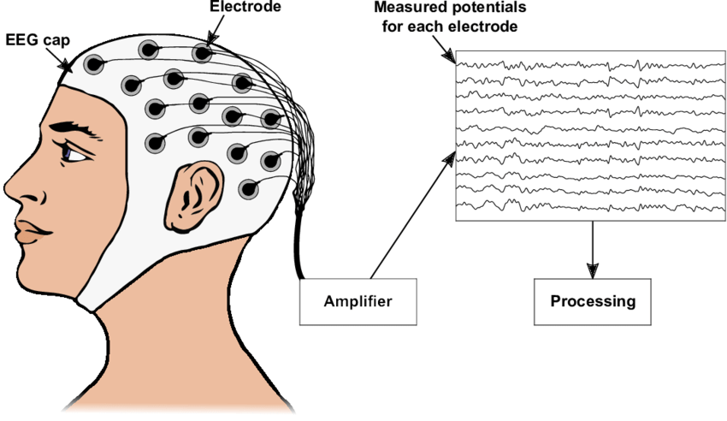
FIG: REPRESNETING EEG [9]
fNIRS :
A non-invasive neuroimaging technique called functional near-infrared spectroscopy (fNIRS) is used to track and quantify changes in cerebral blood flow and oxygenation levels. By using near-infrared light to enter the skull and interact with haemoglobin, it provides important details about neural function and provides insights into brain activity.
Based on the idea that oxygenated and deoxygenated haemoglobin have differing near-infrared light absorption characteristics, fNIRS operates. The relative concentration of oxygenated and deoxygenated haemoglobin can be calculated using fNIRS by detecting the intensity of light that is absorbed by the brain tissue and then reflected back. Researchers and physicians can examine the parts of the brain that are involved in tasks, cognitive processes, and responses thanks to these variations in haemoglobin concentration, which operate as an indirect signal of neuronal activity.The advantages of fNIRS over other neuroimaging techniques like fMRI and PET are portability, a minimal amount of motion artefacts, and compatibility for ecologically sound situations. To examine illnesses including autism, stroke, and mental problems, it is frequently utilised in cognitive neuroscience, neurorehabilitation, and clinical research. However, it is constrained in terms of spatial resolution and depth penetration.With growing technology, fNIRS has contributed to our understanding of brain function and dysfunction and has opened up new opportunities for both scientific and clinical research.
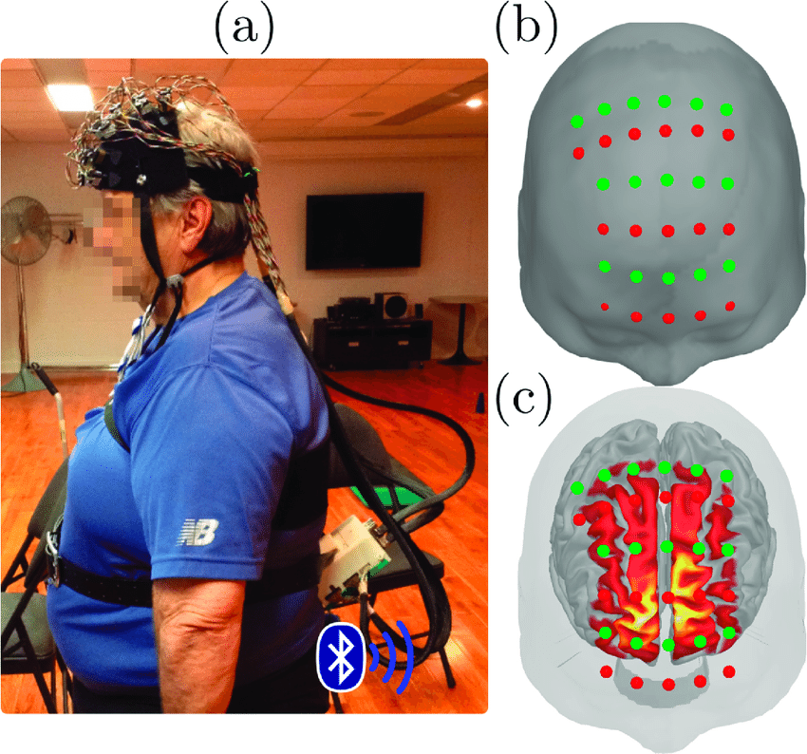
FIG:REPRESENTING FNIRS [7]
Magneto encephalography :
A non-invasive neuroimaging technique called magneto encephalography (MEG) examines the magnetic fields produced by the electrical activity of brain neurons. It offers insightful information about high temporal resolution real-time brain processes. The foundation of MEG is the idea that because of the mobility of ions in the brain, neuronal activity generates weak but measurable magnetic fields.
To detect these magnetic fields during MEG, a ring of superconducting sensors is placed around the head. Researchers can identify the locations of neuronal activity by projecting the observed magnetic fields onto a three-dimensional brain model. Millisecond-scale temporal resolution and the capacity to record both deep and surface-level brain activity are two benefits of MEG.
MEG is particularly helpful for researching how the brain interprets sensory information, speaks, moves, and thinks. It is also used to identify crucial functional areas and reduce post-operative impairments in patients with epilepsy and brain tumours during pre-surgical mapping. However, some of its drawbacks is that it is quite expensive and sensitive to environmental intervention.
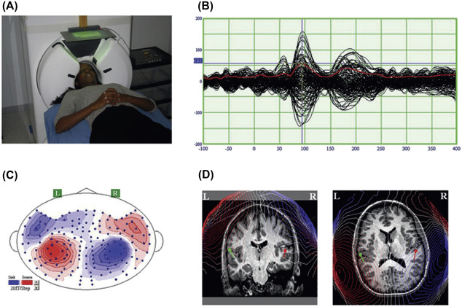
FIG: REPRESENTING MEG [8]
How BCI works ?
A brain-computer interface (BCI), also referred to as a brain-machine interface (BMI) or a direct neural interface (DNI), is a technology that creates a direct line of communication between the brain and outside objects, allowing users to interact with or control those objects using brain signals. BCIs operate by taking the following steps:

1.Signal acquisitions: BCIs capture brain signals via invasive techniques like implanted electrodes or a variety of neuroimaging techniques like electroencephalography (EEG) and magnetoencephalography (MEG). The most popular non-invasive technique is EEG, which uses electrodes on the scalp to record electrical brain activity.
2.Signal preprocessing: Unprocessed brain signals may contain noise and artefacts. To improve the quality of the data, signal preprocessing uses filtering, amplification, and artefact removal.
3.Feature extraction: Relevant features are recovered from preprocessed brain signals via feature extraction. These characteristics may be particular patterns, frequency ranges, or statistical metrics that reveal the intention or state of mind of the user.
4.Feature classification: Machine learning algorithms are trained to recognise patterns in the extracted features that correlate to various mental states or commands. This process is known as feature classification. This often involves the use of classification methods like neural networks or support vector machines.
5. User training: While their brain signals are being recorded, users engage in mental activities or actions during the training phase. The system links the observed brain activity to the desired states or activities.
6.Real time operation: After the classifier has been trained, users can carry out the cognitive processes related to particular activities. The real-time brain impulses are processed by the BCI system, which then categorises them using learned patterns and converts them into commands for external devices.
7.Device control: Using the decoded commands, external devices like computers, robotic arms, prosthetic limbs, or assistive technology can be managed. To communicate or interact with the environment, the system turns the user's intentions into actions.
BCIs can be used for a variety of things, such as communication aids for patients who are imprisoned, assistive technology for those with motor disabilities, tools for improving cognitive function, and even interfaces for amusement and video games. The accuracy, speed, and usability of BCIs are still being worked on in order to make them more practical and available for many applications.
BCI applications :
Brain computer interfaces played an important role in many areas of research. They are involved in Neuromarketing and advertising, medicine, neureorgonsoenomics And the Smart Environment Education and governance, games and entertainment, security and authentication fields.

Medical applications :
Healthcare field has a variety of applications that uses brain signals in all associated phases including prevention, detection, diagnosis, rehabilitation and restoration
Healthcare has plenty of opportunities for brain-computer interfaces (BCIs), which provide cutting-edge methods for the diagnosis, treatment, and monitoring of a variety of neurological and psychiatric diseases. BCIs have several medical uses, such as:
- Management of epilepsy: By using changes in brain activity patterns to predict epileptic episodes, BCIs enable early intervention and individualised treatment plans.
- Neuromodulation for Disorders: By stimulating particular brain regions through neurofeedback, BCIs can be used to treat disorders like anxiety, depression, and obsessive-compulsive disorder.
- Stroke Rehabilitation: BCIs make it easier for stroke victims to recover motor function and relearn motions through tailored rehabilitation activities. These techniques include neurofeedback and motor imagery training.
- Pain management: Real-time feedback on brain activity related to pain perception can be obtained through BCIs, enabling the development of individualised pain management plans and minimising dependency on medicine.
- Rehabilitation for Spinal Cord Injuries: By enabling persons with spinal cord injuries to operate robotic exoskeletons and external devices, BCIs support the recovery of mobility and communication.
- Management of Parkinson's disease: BCIs can help with Parkinson's disease management by tracking brain activity linked to motor symptoms and providing feedback to adjust drug dosages.
- BCIs offer neurofeedback training to help people with attention deficit hyperactivity disorder (ADHD) improve their ability to focus and pay attention.
- Communication for Patients with Locked-In Syndrome: Patients with locked-in syndrome who are unable to move or talk can communicate thanks to BCIs, allowing them to convey their preferences and thoughts.
- Detecting Early Signs of Neurological illnesses: BCIs can continually track brain activity to find early indications of neurological illnesses, allowing for prompt treatments and individualised treatment strategies.
10.Deep Brain Stimulation (DBS): BCIs aid in optimizing DBS procedures for conditions like Parkinson's disease and essential tremor by providing real-time feedback to adjust stimulation parameters.

11.Neurofeedback for Anxiety:Offer neurofeedback Deep Brain Stimulation (DBS): BCIs aid in optimizing DBS procedures for conditions like Parkinson's disease and essential tremor by providing real-time feedback to adjust stimulation parameters.

Conclusion:
An revolutionary technique called a brain computer interface bypasses the typical neuromuscular system by using brain impulses to operate an external device. This enables a person with a disability to interact with their surroundings. Recent developments in neurosciences, such as BCI technology, have drawn researchers from a wide range of fields, including entertainment & games, security, and marketing.
Although brain computer interface technology is currently at the experimental stage, it has a lot of potential and could soon become clinically useful for everyday medical practise. Given the range of disciplines it covers, including neurosciences, doctors of all specialties, nurses, engineers, hospital managers, and administration, it will undoubtedly alter how we provide neurosurgical services to our patients and assist us in making the desired advancements in neurosciences laboratories. While current BCI technology seems to be at a standstill in the lab, the way we treat patients with traumatic brain injury in the future will be very different from the way we do it today. This review offers the chance for various healthcare professionals, such as physicians, nurses, biomedical engineers, and hospital managers, to get more informed about this cutting-edge neurotechnological development.
Research work
- Conformal in-ear bioelectronics for visual and auditory brain-computer interfaces
Design and overview of SpiralE
Because the shape and size of the ear canal varies from person to person, and the internal structure is also different. winding, SpiralE was introduced into the ear canal in a temporary compression (one spiral) (Figure 1a, upper left inset). Then by applying Joule heating generated by a The electric field activates the shape-memory effect, causing the SpiralE to expand within a certain area. spiral with larger radius (bottom left box of Figure 1a). . For SpiralE to comply inner wall of the ear canal, the radius of the given helix is ​​larger than the radius of the ear channel. During the rehabilitation process, SpiralE is obstructed by the wall of the ear canal This allows SpiralE to conform to the shape of the ear canal and effectively deal with the variations and complexity of each user's ear canal. Additionally, once the stimulus is removed and cooled At body temperature, SpiralE automatically adheres to the inner wall of the ear canal, providing a sensation suitable and ensures the stability and reliability of the EEG detection of the ear (Figure 1b on the left). THE The shape of SpiralE in the ear imaged with a medical endoscope (OLYMPUS Visera Elite), as shown in the upper right box of Figure 1b. You can see that the hollow shape of SpiralE well adapted to the inner wall of the ear canal. Also, when SpiralE is gradually being phased out of the ear after measuring the EEG in the ear, it was found that SpiralE has an irregular shape three-dimensional structure conforms to the shape of the ear canal and has a variable radius along Axial. (at the bottom right). box in Figure 1b). After thermoelectric activation, SpiralE continues to deform until it returns to the fixed large spiral configuration (Additional Movie 1). This further indicates that SpiralE adapts to the inner wall of the ear canal. rather than fully returning to the intended uniform radius in the ear after stimulation.
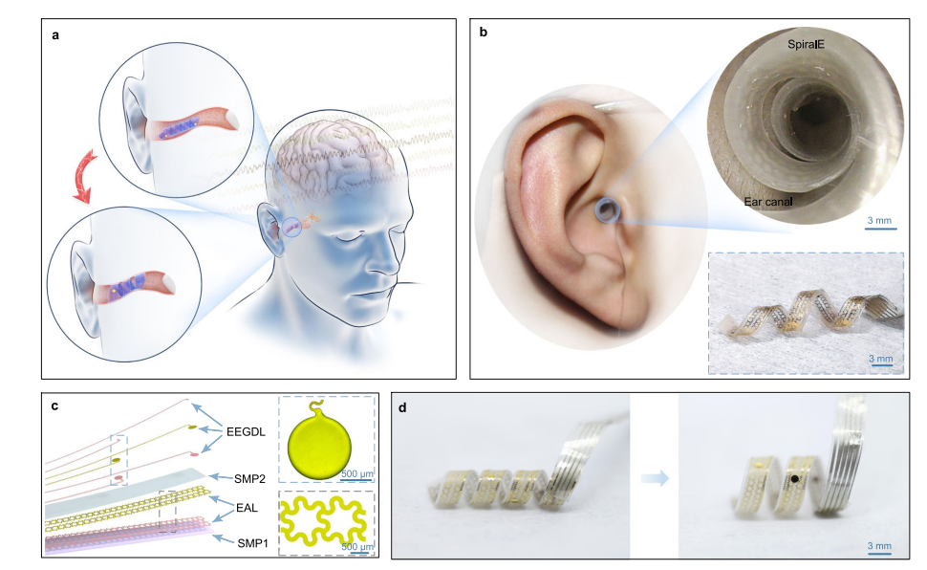
Figure 1:[5]
Validation and characterization of SpiralE
To validate the fatigue properties of SpiralE, dynamic dynamics of the weakest component, i.e., a tensile electrode (consisting of EAL and EEGDL), exposed to 400 cycles at 10% tensile strain, as shown in Supplementary Fig. 5 Study resistance modulation. Our analysis confirms the efficacy of SpiralE, as evidenced by the consistent resistance changes observed during the stretching process and negligible changes in resistance after stretching. These results support the feasibility of using SpiralE for repetitive or short-term applications such as small numbers of measurements. The electrical impedance of electronic devices is important to increase the recorded signal-to-noise ratio (SNR). Impedance spectroscopy of the electrode is obtained in four different states according to electrochemical impedance spectroscopy (EIS). H. Initial Flattened State, Permanently Reconstructed Spiral State, Temporary Spiral State, and Recovered Spiral State. The results show that the values ​​of all channels in these four states are almost unchanged (Fig. 2a). Furthermore, we find that the impedance magnitude of SpiralE (the electrodes are circular with a diameter of 1 mm) is less than 1 kilo Ohm at 50 Hz. This finding is comparable to the results of previous reports33,34 and suggests that SpiralE is suitable for use in EEG detection. The figure also shows the impedance values ​​of his five channels as the deformation is repeated until the final large spiral state is reached. 2b confirms the electrochemical stability of SpiralE.
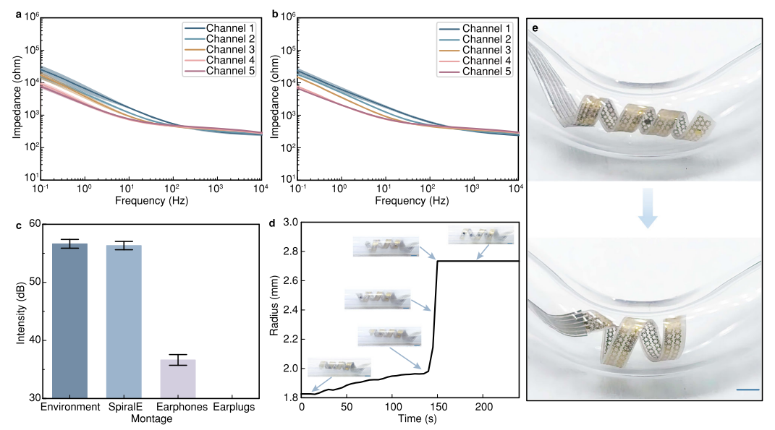
Figure 2:[5]

REFERENCE :
[1] www.sciencedirect.com
J. van Erp, F. Lotte, M. Tangermann Brain-computer interfaces:
beyond medical applications Computer, 45 (4) (2012), pp. 26-34
View in Scopus Google Scholar

[2] R. Rao, R. Scherer
Brain-computer interfacing [in the spotlight]
Signal Process Mag, IEEE, 27 (4) (2010) 152-150
Google Scholar
[3] https://www.slideshare.net/bhadragowdra/brain-computer-interface-documentation
[4] https://doi.org/10.1038/s41467-023-39814-6
Conformal in-ear bioelectronics for visual and auditory brain-computer interfaces pdf

[5] https://doi.org/10.1038/s41586-023-06094-5
Walking naturally after spinal cord injury using a brain–spine interface pdf
[6]https://encrypted-tbn0.gstatic.com/images?q=tbn:ANd9GcRDs_fhyPpQ5-U0zUUO7V7XBOL2Rp46B2gNFA&usqp=CAU
https://encryptedtbn0.gstatic.com/images?q=tbn:ANd9GcTysYLjYsO22F5YQPXLuV4Fw98VAOZJNc4OhA&usqp=CAU
[7]https://www.researchgate.net/profile/Deborah-Talamonti2/publication/349038977/figure/fig1/AS:987505973284865@1612451179436/Functional-Near-Infrared-Spectroscopy-fNIRS-experimental-setup-a-Participant-wearing.png
[8]https://ars.els-cdn.com/content/image/3-s2.0-B9780128038130000039-f03-38-9780128038130.jpg
[9]https://www.researchgate.net/profile/Sebastian-Nagel-4/publication/338423585/figure/fig1/AS:844668573073409@1578396089381/Sketch-of-how-to-record-an-Electroencephalogram-An-EEG-allows-measuring-the-electrical.png

