Sheep tail fat: A cure for multiple diseases

Tanjima Tarique Laskarª, Monica Arora^{b},
ªDepartment of Pharmaceutical Chemistry, Al-Ameen College of Pharmacy, Bengaluru, India
^{b}Department of Pharmaceutical Chemistry, Al-Ameen College of Pharmacy, Bengaluru, India

Email- tanjimatarique.12@gmail.com

INTRODUCTION
Since ancient times sheep or lamb fat of tail has been an important element in the diets of people living in many tropical regions of the world due to the presence of important fatty acids. Asian peoples have been using lambs and sheep fat of tail for various medicinal purposes. The desert sheep survive mostly on natural herbs and that’s why it is a rich source of omega3-fatty acids from which around 700 medicines are produced. The beneficial fats the sheep or lamb obtained from these herbs are stored mainly in its tail [1]. Fat-tailed sheep are hardy and adaptable and they are capable of enduring and withstanding the tough challenges of desert life. When the sources of food are plentiful and parasites or microbes are not a major factor, the fat-tailed sheep can be large in size and growth. The tails fat represents up to 15% of the total carcass weight of the sheep. Increasing evidence suggests that numerous edible fats of tail may function as adjuvant dietary therapies to treat a wide range of cancer diseases. Sheep fat of tail are also found to significantly prevent expression of proinflammatory cytokines such as IL-1β, TNF-α and COX-2 [2,3]. The fatty acids of tail are also reported to possess antioxidant activity and relieve joint pain and varicose veins. Use of sheep fat tail leads to normalization of hormonal levels and improves hormone synthesis thereby minimizing the risk of developing infertility and menopause in women. The fatty acid of tail slows down the process of aging of the body and the development of atherosclerosis, while improving the functioning of the heart as well as brain. The fatty acids of tail contain exactly those substances that are required for growth and development of fetus so scientists have established that it is imperative to consume the tail fats during pregnancy when the organs of the unborn baby are being laid [4,5]. It is beneficial to serve sheep tail fat to young children at the stage of their growth as it accelerates the mental development and academic performance of children. Men who eat tail fat will never suffer from impotence and infertility issues. It has protective action against alcohol intoxication so it can be served along with strong alcoholic drinks to minimize the risk of developing toxicities. This product can be consumed as food in winters because it provides energy needed for thermoregulation and heat production. The fatty acids are useful for smokers as well because it removes tar and other harmful substances from the lungs and works as a remedy for pneumonia as well. Doctors prescribe treatment with sheep tail fat for dystrophy and exhaustion. Fat tail fat is an irreplaceable product for various viral diseases. This product has a beneficial effect on the Gastrointestinal tract as a piece of fat protects the stomach from excess gastric juice, eliminates constipation, and normalizes the peristaltic movement of the intestinal walls and prevents the development of ulcers and gastritis [6]. Melted fat tail acts as a remedy for tumor of skin tissues including adipose tissue. The melted mass of fat is applied to the inflammation and rubbed for about 15-20 minutes. This massage has a beneficial impact on the inflammation and noticeable results can be obtained within a few weeks. Lamb fat is used as a medicine for cough and bronchitis for children and adults. One teaspoon of lamb fat along with a glass of boiled milk consumed on empty stomach improves the elimination of phlegm and toxins from body. Thus, the sheep tail fat may be considered as more advantageous compared to the other medicines as it is an inexpensive and easily available natural product [7,8].
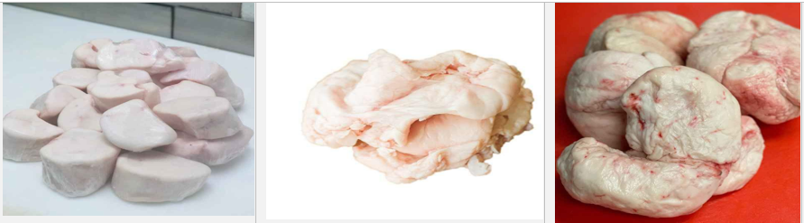
Figure 1: Fats of sheep extracted from the tail region
CHEMICAL COMPOSITION
Tail fat of sheep has a snow-white colour and when melted it becomes transparent in colour and does not freeze at normal room temperature. It is composed of proteins, fats (saturated & unsaturated), Vitamins (Vitamin B12, B1, B3, B2, B5, B6, K2, E, B9) and minerals (Zinc, Selenium, Phosphorus, Iron, Potassium, Copper, Magnesium, Sodium, Calcium & Manganese). The fat product contains fifteen fatty acids in measurable amounts such as oleic acid (39.6-53.5%), linoleic acid (2.1-3.7), linolenic acid (2.2-2.9%), margaric acid (0.9-2.3%), palmitic acid (18.2-23.6%, palmitoleic acid (1.4-3.6%), myristic acid (2.4-5.5%), myristoleic acid (0.3-2.1%), stearic acid (7.1-22.1%) pentadecanoic acid (0.6-1.0%), and arachidic acid (0.1-0.3%) [9,10].
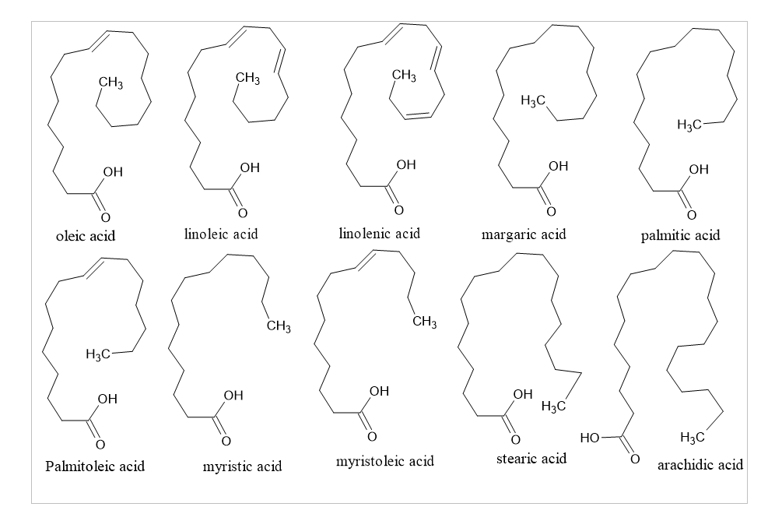Figure 2: Structures of different types of fatty acids present in sheep tail
PHARMACOLOGICAL REVIEW
Sciatica
Sciatica is a condition characterized by considerable pain and disability in which the pain radiates in legs with or without associated neurological deficits. It is a condition where the pain radiates along the sciatic nerve starting from the hips down the lower back to the leg and possibly to foot [11]. The longer it persists the more it moves down the leg and the leg becomes thinner accompanied with weakness and numbness of leg. The symptoms may include a lower back pain caused due to sciatic nerve which is accompanied by bladder and bowel incontinence. Sciatica has several causes among which the most common causes are due to herniated disc that leads to compression of roots of sciatic nerve and in some cases it may develop due to infection caused by some Enterobacteria which causes inflammation of sciatic nerve. The pathophysiology behind sciatica is the presence of high levels of phospholipase A2 (PLA2) which is an important enzyme in the inflammatory process [12]. PLA2 acts on cell membrane and releases arachidonic acid, a precursor of the proinflammatory mediators such as leukotriene and thromboxane. The presence of proinflammatory cytokines such as interleukin-1a (IL-1a), IL-1b, IL-6, tumor necrosis factor-α(TNF-α), high levels of IL-6, IL-8 and prostaglandin E2 (PGE2) are responsible for triggering the pain of sciatic nerve [13]. The schematic diagram for pathophysiology of sciatica is given below:
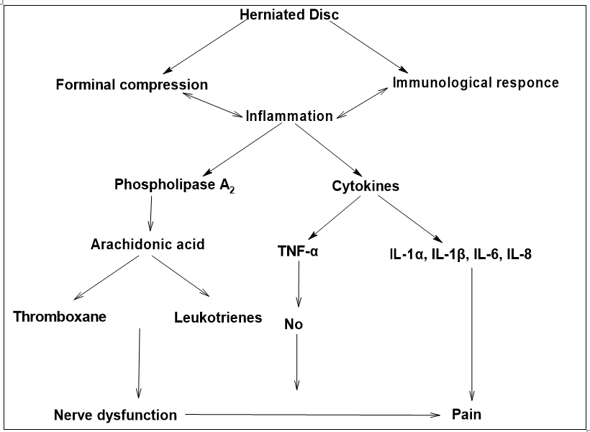
Figure 3: An overview of the pathogenesis of Sciatica due to herniated disc
Science has proved that Omega three fat group has important role in treating the inflammation of nervous tissues as in the case of a herniated disk which is among one of the main principal causes of Sciatica. The desert sheep is a rich source of omega 3 fats which are mainly stored in its tail. For using it as a medication for sciatica the tail fat should be melted first so that the harmful bacteria and germs are killed by the heat. It should also be consumed in three days on empty stomach to so that no other lipids of the body can compete with the lipids of the tail for absorption in the gastrointestinal tract at the vesicle, pancreas level and cellular level [14]. The enzymes acting at the membrane of digestive tract converts those lipids of the omega 3 group to the beneficial type 3 prostaglandin which is responsible for reducing the inflammation and pain caused by Sciatica. Type 3 prostaglandins are well known for their calming effect on the pains and inflammations which are formed mainly from Alpha Linoleic Acid (ALA) [15,16].
Lung cancer
Lung cancer is a fatal disease prevalent worldwide and among which the most prevalent subtype of lung cancer is h non-small-cell lung cancer (NSCLC). Patients with NSCLC have often a poor 5-years survival rate due to acquired resistance to therapeutic drugs. Several mechanisms are expected to contribute to drug resistance for lung cancer therefore is an urgent need of novel to synergistically treat lung cancer [17,18]. Dietary lipid is currently considered as useful adjuvant approach for playing an important role in cancer development. Abnormal metabolism of lipids is thought to be a key characteristic of cancer cells and approaches targeting lipid metabolism has been proved to be a promising approach for cancer therapy. Food rich in heptadecanoic acid (C17:0) has the potential for use in the context of NSCLC. Increasing evidence suggests that odd-chain saturated fatty acid such as heptadecanoic acid (C17:0), profoundly inhibits non-small-cell lung cancer (NSCLC) cell proliferation. Sheep tail fat (STF) is a dietary lipid rich in C17:0 fatty acid, also known as margaric acid and its production increases in sheep with age. It is unique in its ability to inhibit NSCLC cell proliferation compared to other common dietary lipids and exhibits the greatest inhibitory effect against three NSCLC cell lines (A549, PC-9, and PC-9/GR). Mechanistic studies showed that STF suppresses growth of NSCLC cells by downregulating the Akt/S6K signalling pathway and it also suppresses tumour growth and expression of the proliferative marker Ki-67. Therefore, three types of Sheep fatty acids (SFAs) namely C16:0, C17:0, and C18:0 exerts a much more potent cytotoxic effect on NSCLC cells, of which C17:0 has the lowest IC₅₀ value [19].
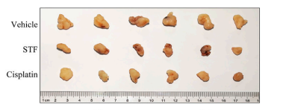
Figure 4: In-vivo Inhibition of NSCLC tumor growth in comparison vehicle and standard anticancer drug Cisplatin
Knee joint pain/Osteoarthritis
Cartilage tissue is the most damaged tissue in osteoarthritis which is characterized by the progressive degeneration of cartilage tissue and local inflammatory manifestations. Proinflammatory cytokines such as interleukin-1 (IL-1β) and tumor necrosis factor alpha (TNF-α) are reported to lead to the oxidative stress reactions in the cartilage tissue and also play a crucial role in the pathogenesis of osteoarthritis. In addition, these proinflammatory cytokines are reported to cause articular damage by increasing the synthesis of plasminogen and metalloproteinases and inhibits type 2 collagen synthesis and chondrocyte replication in the matrix. Medical treatment for this is limited due to the gastric, cardiovascular other side effects and many patients reject the surgical treatment option. Therefore, there is a need for more effective, reliable and inexpensive drugs are needed [20]. Recent studies have focused more on the natural products for treatment of rheumatoid arthritis and knee joint pain. Sheep tail fat (STF) can be used on the damage of knee articular joint as it significantly prevents the increase of IL-1β, TNF-α and COX-2 gene expressions in the knee cartilage tissue after damage or due to osteoporosis. Nevertheless, fatty acids in the STF contents such as such as oleic, linoleic, palmitic, stearic and myristic acids have been reported to inhibit proinflammatory cytokines like IL-1β, TNF-α and cyclooxygenase-2 (COX-2). STF is also reported to exhibit chondroprotective activity and improves the histopathological disturbances in the cartilage tissue of knee joints. Since Sheep Tail Fat is an inexpensive and easily available natural product so it could be useful in clinical practice along with the other medicines to prevent cartilage damage of knee joints [21].
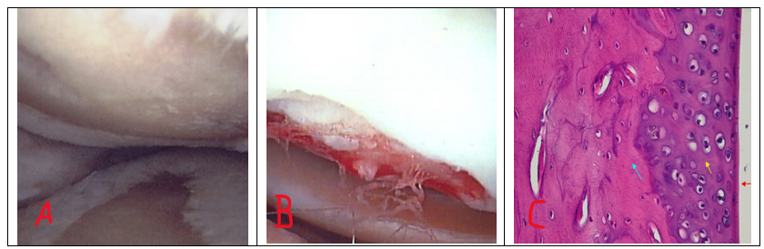
Figure 5: Comparison of healthy knee joint(A), Osteoarthritic joint (B) and STF treated cartilage tissue of damaged knee(C)
CONCLUSION
Despite having immense therapeutic potential, fat-tailed sheep have long been neglected as a subject of research due to lack of productive performance and its genetics are poorly known and, in most cases, it is uncharacterized. The fatty acids present in the tail fat of these sheep is distinctive, bio-active and contains unusual branched-chain fatty acids that are beneficial to human health and improves various health implications including sciatica. The nutritional value of fat tailed sheep is impressive as it contains a range of beneficial nutrients including healthy fatty acids, proteins, vitamins and minerals. Therefore, research on STF should be upraised as it can be a better alternative in near future as a bioactive product in clinical practices because of its inexpensiveness and easy availability.
REFERENCE
[1] Mahachi LN, Rudman M, Arnaud E, Muchenje V, Hoffman LC. Application of fat-tailed sheep tail and backfat to develop novel warthog cabanossi with distinct sensory attributes. Foods. 2020 Dec 8;9(12):1822.
[2] Udo HM, Budisatria IG. Fat-tailed sheep in Indonesia; an essential resource for smallholders. Tropical animal health and production. 2011 Oct;43:1411-8.
[3] Zhang T, Gao H, Sahana G, Zan Y, Fan H, Liu J, Shi L, Wang H, Du L, Wang L, Zhao F. Genome‐wide association studies revealed candidate genes for tail fat deposition and body size in the Hulun Buir sheep. Journal of Animal Breeding and Genetics. 2019 Sep;136(5):362-70.
[4] Yousefi AR, Kohram H, Shahneh AZ, Nik-Khah A, Campbell AW. Comparison of the meat quality and fatty acid composition of traditional fat-tailed (Chall) and tailed (Zel) Iranian sheep breeds. Meat Science. 2012 Dec 1;92(4):417-22.
[5] Maleki E, Kafilzadeh F, Meng GY, Rajion MA, Ebrahimi M. The effect of breed on fatty acid composition of subcutaneous adipose tissues in fat-tailed sheep under identical feeding conditions. South African Journal of Animal Science. 2015;45(1):12-9.
[6] Khachadurian AK, Adrouni B, Yacoubian H. Metabolism of adipose tissue in the fat tail of the sheep in vivo. Journal of lipid research. 1966 May 1;7(3):427-36.
[7] Alipanah M, Kashan NE. Fatty acid composition of fat tail, visceral and meat fat of three Iranian sheep breeds. Journal of Food, Agriculture & Environment. 2011;9(2 part 1):416-8.
[8] Mehran M, Filsoof M. Fatty acid composition of sheep tail‐fats from five Iranian native breeds. Fette, Seifen, Anstrichmittel. 1976;78(5):187-9.
[7] Biswas P, Datta C, Rathi P, Bhattacharjee A. Fatty acids and their lipid mediators in the induction of cellular apoptosis in cancer cells. Prostaglandins & Other Lipid Mediators. 2022 Jun 1;160:106637.
[8] Kim HS, Mendiratta S, Kim J, Pecot CV, Larsen JE, Zubovych I, Seo BY, Kim J, Eskiocak B, Chung H, McMillan E. Systematic identification of molecular subtype-selective vulnerabilities in non-small-cell lung cancer. Cell. 2013 Oct 24;155(3):552-66.
[9]] Ünsal M, Yanlic KO. Fractionation and characterization of tail fats from Morkaraman lambs fed with diets containing Rosa canina L. seed at different levels. International Journal of Food Properties. 2005 May 1;8(2):301-12
[10] Cimen FK, Kockara N, Turkoglu M, Dundar C, Cetin N, Suleyman B, Coban A, Yarali O, Malkoc I, Suleyman H. Effect of sheep tail fat on the knee joint cartilage injury induced in rats with formalin. International Journal of Clinical and Experimental Medicine. 2017 Jan 1;10(5):7573-81.
[11] Savastano LE, Laurito SR, Fitt MR, Rasmussen JA, Polo VG, Patterson SI. Sciatic nerve injury: a simple and subtle model for investigating many aspects of nervous system damage and recovery. Journal of neuroscience methods. 2014 Apr 30;227:166-80.
[11] Moshref S, Jamal Y, Hummdi LA, Kaki AM, Al-Hibshi A. Intra-articular injection of autologous fat micro graft in sheep hind knee joints. Life Science Journal. 2013;10(4):2115-20.
[12] Savastano LE, Laurito SR, Fitt MR, Rasmussen JA, Polo VG, Patterson SI. Sciatic nerve injury: a simple and subtle model for investigating many aspects of nervous system damage and recovery. Journal of neuroscience methods. 2014 Apr 30;227:166-80.
[13] Unda SR, Villegas EA, Toledo ME, Asis Onell G, Laino CH. Beneficial effects of fish oil enriched in omega-3 fatty acids on the development and maintenance of neuropathic pain. Journal of Pharmacy and Pharmacology. 2020 Mar;72(3):437-47.
[14] Lockett MJ, Tomlinson DR. The effects of dietary treatment with essential fatty acids on sciatic nerve conduction and activity of the Na+/K+ pump in streptozotocin-diabetic rats. British journal of pharmacology. 1992 Feb;105(2):355.
[15] Pérez J, Ware MA, Chevalier S, Gougeon R, Shir Y. Dietary omega-3 fatty acids may be associated with increased neuropathic pain in nerve-injured rats. Anesthesia & Analgesia. 2005 Aug 1;101(2):444-8.
[16] Bourre JM, Youyou A, Durand G, Pascal G. Slow recovery of the fatty acid composition of sciatic nerve in rats fed a diet initially low in n− 3 fatty acids. Lipids. 1987 Jul;22(7):535-8.
[17] Wootton SK, Metzger MJ, Hudkins KL, Alpers CE, York D, DeMartini JC, Miller A. Lung cancer induced in mice by the envelope protein of jaagsiekte sheep retrovirus (JSRV) closely resembles lung cancer in sheep infected with JSRV. Retrovirology. 2006 Dec;3(1):1-5.
[18] Kim HS, Mendiratta S, Kim J, Pecot CV, Larsen JE, Zubovych I, Seo BY, Kim J, Eskiocak B, Chung H, McMillan E. Systematic identification of molecular subtype-selective vulnerabilities in non-small-cell lung cancer. Cell. 2013 Oct 24;155(3):552-66.
[19] Xu C, Zhang L, He H, Liu X, Pei X, Ma T, Ma B, Lin W, Zhang B. Sheep tail fat inhibits the proliferation of non-small-cell lung cancer cells in vitro and in vivo. Frontiers in Pharmacology. 2022 Aug 11;13:917513
[20] Ude CC, Ng MH, Chen CH, Htwe O, Amaramalar NS, Hassan S, Djordjevic I, Rani RA, Ahmad J, Yahya NM, Saim AB. Improved functional assessment of osteoarthritic knee joint after chondrogenically induced cell treatment. Osteoarthritis and cartilage. 2015 Aug 1;23(8):1294-306.
[21] Ude CC, Shamsul BS, Ng MH, Chen HC, Ohnmar H, Amaramalar SN, Rizal AR, Johan A, Norhamdan MY, Azizi M, Aminuddin BS. Long-term evaluation of osteoarthritis sheep knee, treated with TGF-β3 and BMP-6 induced multipotent stem cells. Experimental gerontology. 2018 Apr 1;104:43-51.

