Chapter 04

Entrepreneurship and Innovation for Sustainability*

Pushpendra Singh
Dept. of Electrical Engineering
Govt. Women Engineering College Ajmer, India
pushpendragweca@gmail.com

ABSTRACT
This chapter describes the importance of role played by industries for supporting environmental growth. The chapter includes topic: Sustainable habitat; Green buildings; green materials; material selection; Methods of increasing energy efficiency of building; Sustainable cities and transport. Renewable energy sources

Keywords—sustainable habitate; green building, green matrials,sustanibale transports and energy sources
- Sustainable Habitat:
A sustainable habitat refer as an ecosystem that is capable to produce food and shelter for human and other leaving beans in plants, without depletion of resources and in a manner that NO external waste is generated. This sustainable habitat evolves naturally or can be built under influence of mankind. This is basically an attempt to replicate the Mother Nature that is well connected with all the creatures existing in environment to enrich the ecosystem. While designing sustainable habitats the stakeholders must consider the waste of one process as raw material for another. This cascaded material management system will enhance more sustainable society and reduces the pollution level.

The salient features of sustainable habitat include:
- Appropriate waste management
- Affordable housing
- Waste water treatment and recycling facility
- Green transportation methods
- Green Buildings
It expected that the population of cities will be nearly double by next 20 yrs. So, this generate a challenge for the governing authorities to build and manage buildings and social communities that are environmental friendly and endorses quality of life in terms of energy independence, reduction in carbon consumption and conservation of natural system.
Green buildings are high geared buildings whose architected and operational time assures the growth in environment by curtaining the carbon footprint and endorsing sustainable energy sources. It conserves the maximum possible energy reservoirs and improves the health and efficiency of its stakeholders. The Fig. 4.1 presents the concept of sustainable architecture. That considers the pre-building, building and post building phases of green building.

Construction
Operation & Maintenance
Disposal
Energy Dispatch
Efficiency
Renewable
Water Management
Curtail
Recycle
Blue print
Materials & Operations
Reduce
Select
Waste Management
Reuse
Recycle
Pre-Construction phase
Construction phase
Post-Construction phase
Architects
Contractors
Customers

Fig. 4.1 Representational of sustainable architecture

  - Challenges related to green buildings
- Utilize more in few resources.
- Economics (budget) related to endorsement of sustainable resources and environmental conservation.
- Market flow special in building developer (real estate industry) sector play an important role. As return on investment is a prime goal of any business sector.
- The direct benefits of a green building are not instantly visible. This may divert the attention of its stakeholders. Further, due to lack of awareness about the upcoming benefits the potential consumers may not be attracted.
  - Processing of green building
- This concept requires out of box thinking. As, this is not similar to conventional and easy to copy blueprint.
- Assembling of correct and high quality material is required. In this process elements of architect are initially optimized and further assembled as part of complete building solution.
- A correct and accurate mix of technology and cost has to be framed to make project cost effective.
- Those technologies are endorsed that adopt correct building engineering with low cost estimation. An effective understanding of engineering methods of building operation should be done that further helps in avoiding deployment of sophisticated technologies.

  - Difference between a green and conventional building

- New technologies and material are deployed as compare to conventional
- More intelligent architect in terms of cost and material compare to conventional design. (pollution control, waste management, energy management)
- The overall benefits of green building are dependent on the degree to that sustainable features are considered during its design and construction.

The awareness to the emerging concept is a major challenges for green building development in developing country like India. The potential stakeholders should be made aware about the concept and its related benefits. Further, government bodies should promote the concept by supplying financial aid as well as implementing the supporting rules and regulation. As this is a combined responsibility of the society for the society.

- Green Materials of Building Construction
Green materials are eco-friendly materials deployed for construction of green building. They are selected for the reason that they have low negative impact on the environment. These are basically operating on renewable energy resources. The basic expectation from these materials is that they should not be spoil from heat cold and humidity.
Some of the green materials building are as follows.
- Wood
- Bamboo
- Cordwood
- Natural fibre
- Composites
- Polyurethane
- Cork
- Natural Clay
- Non-VOC paints
- Stone

- Material Selection Sustainable Design

The sustainable product or design has a low impact on the environment during its complete cycle. The sustainable aspect of these assets include extraction of ore its production, operation and further final recycling. The Fig. 4.2 presents a six rings of sustainability chain collaborated with each other.
Raw Material
Resources

Economics
Waste Management
Recycling and Reuses
Consumption of Energy
Production
Process

Fig. 4.2 .Cycle of product material sustainability

For develop sustainable products and designs, few important principles should be considered:
1. Deploying products with less pollution and low energy consumption.
2. Minimize deployment of scare/rare materials.
3. Avoid uses of toxic products.
4. Select clean production process.
5. Endorse easy recycling products.
Further, some evaluation indicators should be carefully considered while selecting a suitable design. As the conventional material and design basically consider only the cost and mechanical properties. These material and design should primarily focus on the environmental aspects.

- Green Building Certification

This is a rating system and a tool that is deploys to assess the performance of a construction project or building with environmental and sustainability perspective. The major aim of this system is to improve the overall quality of infrastructure and its design as per the set parameters of United Nation (UN) sustainable development goals. It is considered that the building that received this certification is deemed to meet the benchmark performance and quality.
  - Goal and beliefs of building certificates
The main goal of these certification systems is to provide tools and techniques to evaluate the environmental and resource adequate performance of a building. The major aim/ objective of such tools include.
- Optimize and adequate performance of building with low impact on environment.
- Providing a method for quantify environmental effects on building.
- To set a benchmark to asses objectives of buildings.
Some of the important benefits for building certification include.
- This can help in creating awareness regarding causes of negative impact of building on the surrounding environment. This further help in reduction of such impacts.
- This will further help in fulfilment of techno-fiscal and social responsibility of the building.
- This increases in monetary value of property.
Green building certification design and construction consider the following five domains.
- Water efficacy
- Sustainable site
- Energy and environment
- Indoor environment
- Quality of material and resources

- Methods of Increasing Energy Efficiency of Building
It is important to enhance the energy efficiency of a green building as these buildings are very less depended on the external energy sources. The three primary methods that improve energy efficiency in public, residential and commercial building includes.
- Improved design and construction that help reduce in cooling, heating and load
- Upgrades the energy consuming equipment
iii) Actively control and manage the energy uses.
- Sustainable Cities
Sustainable cities are designed considering social, economical and environmental impacts. As per the United Nation sustainable development goals the sustainable cities should be dedicate towards the achieving their goal towards green, social and economical sustainability. They should primarily focus towards minimization of input for water, food and energy simultaneously generating low pollution and waste. These cities should endorsed economical growth and match the basic requirement of its inhabitants and provided a suitable and sustainable living culture for all its citizens. Ideally, the sustainable cities should produce an enduring method of life considering the economics, ecology, politics and culture. The priorities of sustainable cities basically consist of self feeding by maximum utilization of renewable energy sources and minimum detonation of surrounding natural environment. This can be accomplished by effective utilization of territory, composition of organic elements, recycling used material, waste to energy models etc. This may lead to reduction in city’s impact on continuous climate change. Further, Fig. 4.3 describes the role of partnership among the government bodies, civil societies and private sectors for form a sustainable city.
Sustainable
Cities
Government
Regulatory Framework;
Tariff Setting; Subsidies & Guarantees
Civil Society
Community willingness to pay; Awareness; Environmental friendly life style
Private Sector
Financial share; Novel technology; local knowledge; Backward/Forward Linkage

Fig. 4.3. Partnership framework for sustainable cities

- Sustainable Transport
Sustainable transport means the methods or means of transportation that are sustainable towards environmental and social impacts. The element for assessment for this includes means of transport for air water and land. The transportation system sustainability is majorly measured by the effectiveness and efficiency of the transportation system as well as its impact on surrounding environment and climate. As per United Nation report, the transportation systems across the globe have significant impact on the surrounding climate an approximate between 20-25%. This is among the fastest pollution producing sector as compare to any other sector. Further, Fig. 4.4 presents the working domain for sustainable transportation. The sustainable transportation system build a positive contribution towards the environment and society as well as it provides economic sustainability to the serving community. The sustainable transportation system creates positive contribution towards society and environment. As they are economical and produces low carbon foot prints. Short-term motion often endorsed incremental enhancement in efficiency of fuel and controls emissions produced by vehicles emissions controls while the long-term goals the renewable energy resources are made alternative to the conventional fossil energy base. The complete life cycle of transport network is subject to adequate optimization and sustainability measurement.

Sustainable
Transportation

Health
Cheap
Accessible
Low Social And environmental effects

Fig. 4.4. Sustainable transportation domain

- Energy Sources
Energy has an important role in human life. It is a crucial part of the economic communications. It is the essential input that is required for sustain economic development. Energy is the potential of a physical coordination to carry out work. The energy exist in various forms i.e. kinetic\potential energy, heat, mechanical energy, light, electricity etc. Energy is the capability to do a work. Further, energy sources can be renewable and non-renewable. Description of some energy sources are a below.
  - Conventional and Non Conventional Energy Sources
The conventional energy sources are basically non-renewable by nature. They can be use only at once and are available in the planet and has limit to its availability i.e. coal, wood, petroleum etc. Further, these energy sources are not environmental friendly and increase the carbon foot print. Not all nations in the world have required number of access to these energy resources.
The non conventional energy sources are basically renewable energy source. That can be uses again and again and has an easy access. They are environmental friendly and have a low carbon foot print. Any nation can access them as per her potential i.e. solar, wind, hydro etc.
- 2 Solar Energy
Sun is the key origin for all energy sources. Sun light received to the earth are clean and renewable energy source. The sun is almost available threw out the day in major areas across the globe. Further, one of the best advantages associated with solar energy is its generation during the peak load hours. Due to its cheap and easier availability it is a popular technology among its stakeholders.
The solar energy is basically radiation received from the sun that is capable of producing heat along electrical power generation and chemical reactions. The total amount of sun radiation received to our planet is quilt large as compare to the energy requirement of the planet. Usually the solar energy is associated with methods to collect Sun light and its transformation into other useful energy form. Some of the commonly deployed forms of solar energies are:
- Solar thermal (for heating)
- Passive solar gain
- Solar photovoltics
- Concentrated solar power
9.2.1 Solar PV Cell
A Solar PV cell or solar cell, is a transducer or device that convert sunlight/ light into electricity (DC power). This PV cell has of 2-3 layers of semi conducting material (silicon). When the light penetrates the cell it generates an electric filed across the semiconductor layer that produces electrical current. The intensity of generated electrical power is proportional to the intensity of penetrating light. The structure of a solar PV cell is presented in Fig. 4.4.
The electrical power produced by solar cell at time (t) is mathematical modelled as:
$P_{pv}^{t}= η_{pv} E^{t}A_{pv}$ (4.1)
Where, $η_{pv}$,$E^{t},A_{pv}$ are efficiency of PV module, incident irradiation and area plate area. Further, for an array the total power produced by a solar array is represented as:

$P_{total}^{t}= N_{s}N_{p}P_{pv}^{t}$ (4.2)
Here,$N_{s}$ and $N_{s}$ are the number of series and parallel PV cell.

9.2.2 Advantages of solar energy
- Unlimited availability
- Low carbon emission
- Suitable for installation in remote area
- Less or No noise due to No moving part
9.2.3 Disadvantages of solar energy
- Requires space
- Operation depends on weather conditions
- Energy storage is expensive.

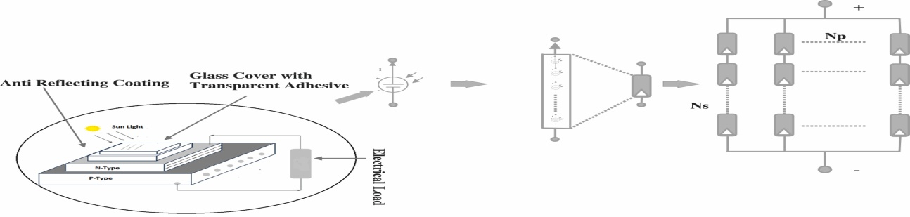
Fig 4.4 Structure of a Solar PV cell

9.3 Fuel Cell
Fuel cell is basically an electrochemical cell that converts the available chemical energy of the cell (hydrogen) into electricity by help oxidizing agent (oxygen) using redox reaction. Fuel cell and batteries are different as fuel cell needs continuous oxygen from atmosphere as a fuel source to sustain the ongoing chemical reactions, while in battery the input to chemical energy are obtain from metal and its ions that already exist in battery. Fuel cell has the potential to supply continuous electrical power till its keep receiving the required fuel.
Normally fuel cell does not have any moving part. Further, the fuel cell is unable to respond quickly to change in load conditions. It has a large booting time due to inbuilt electrochemical reactions. So, fuel cell is endorsed with a battery energy storage system (BESS) that store the excess power during the low load hours and supply it at the peak load hours when the generation is unable to meet the required demand. The construction diagram of a fuel cell is presented below in Fig. 4.5. This can be comfortable observed from the diagram that power flow from the fuel cell is unidirectional and that of BESS is bi directional. That indicate that fuel cell can supply power the system while the BESS can received and deliver power to the system. Further, the electrical power produced by fuel cell is mathematical modelled as:

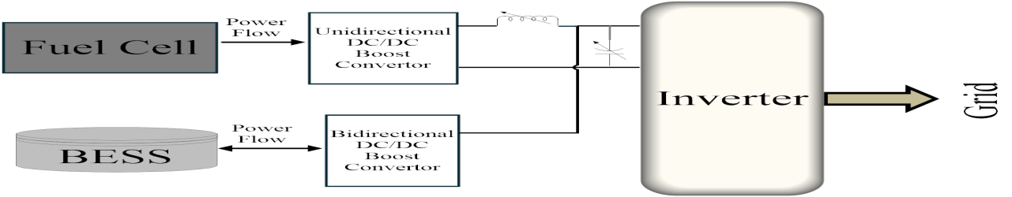

Fig 4.5 Structure of a Fuel Cell
$P_{fc}= E_{fc}I_{fc}-\frac{I_{fc}^{2}R_{fc}}{A_{fc}}$ (4.3)
Where , $E_{fc,}I_{fc}$ , $R_{fc}$ and $A_{fc}$ are potential difference of fuel cell, current flowing in fuel cell, resistance between electrodes and surface are of electrodes respectively.

9.3.1 Advantages of fuel cell
- Unlimited availability
- Low carbon emission
- Suitable for installation in remote area
- Less or No noise due to No moving part
9.3.2 Disadvantages of Fuel cell
- Expensive technology
- Will take time for easier access.

9.4 Wind Energy
The Wind turbines are mostly deployed to convert wind energy into electricity. In earlier days this energy source was deployed for sail, mill and pump purpose. This is a prominent renewable energy source with a high impact. The Fig. 4.6 describe the construction of a wind turbine. The wind flow due to change in pressure zone which is created due to heat and cold effect causes by Sun position.
The power produced by wind turbine is proportional to length of turbine blades and the power output is proportional to the cube of wind velocity.
The electrical power produced by wind turbine at time (t) is mathematical modelled as:

$P_{wt}^{t}= \frac{1}{2}C_{wt} p^{w}A_{wt}({v^{t})}^{3}$ (4.4)

Here, $C_{wt}, p^{w},A_{wt},$ and $({v^{t})}^{3}$ are the wind power coefficient, density of wind, area swept by wind turbine blades and wind velocity at time (t).
However, the major challenges related to wind turbine is that the speed of wind is unpredictable. That means that for a time the wind flow is large and for another its low. This may create a potential challenge. As large wind speed at low load hours may boost the node voltages that may harm the connected equipment.

9.4.1 Advantages of Wind turbine
- Unlimited availability
- Low carbon emission
- Suitable for installation in remote area
- Easy to access technology

9.4.2 Disadvantages of Wind turbine
- More noise with moving part.
- May be dangerous for flying creatures and objects.
- People are still afraid to install it in backward.

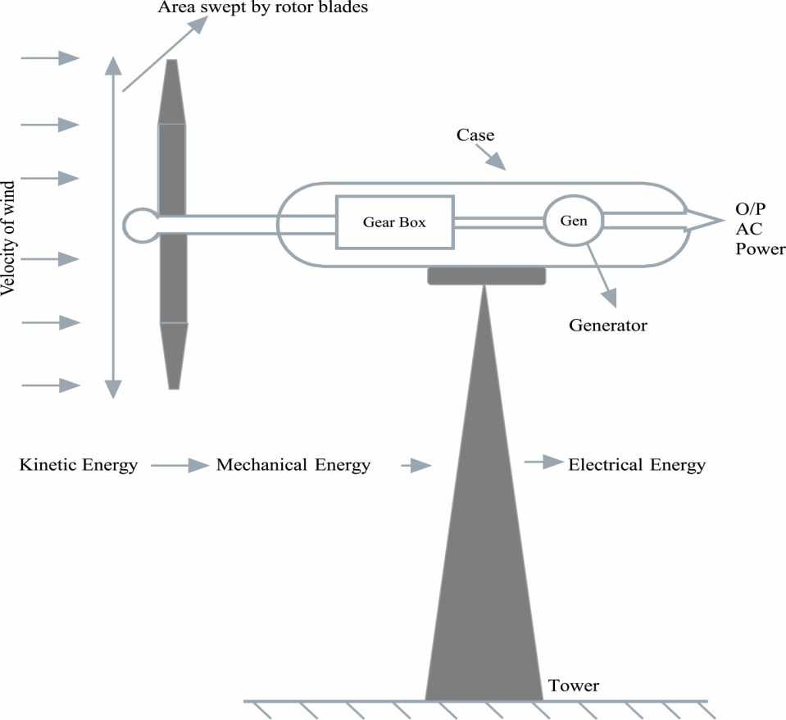
Fig 4.6 Structure of a wind turbine
9.5. Small Hydro Plants
Small hydro plants are constructed near/ on the water body (rivers and cannels) to generate electricity to serve a small industrial plant or commodity. A small hydro plant has a generation capacity upto 25 MW. This is a set upper limit for the plants. Small hydro plant can be sub classified as mini (100 to 1000 kW) and micro (5 to 100kw) plants.
Hydro plants generate power from kinetic energy of water (flow of water). Continuous water flow and high between water inlet and outlet are the two key factors of these plants. In conventional hydro plants, water from the reservoir is sent to the turbine by a pipe (penstoke). This flow of water rotates the blades of turbine connected to vertical generator that generate electricity. The small hydro plants are ideal for the dam that ere initially constructed for water storage purpose. Fig.4.7 presents the layout diagram of a small hydro plant.
The electrical power produced by hydro plants is mathematical modelled as:

$P_{ht}= η_{ht} p^{ht}Q_{ht}gh$ (4.4)

Here, $η_{ht}, p^{ht},Q_{ht},$ g and $h$ are the efficiency of turbine, density of water, volumetric flow rate, gravitational acceleration and high difference between inlet and outlet.

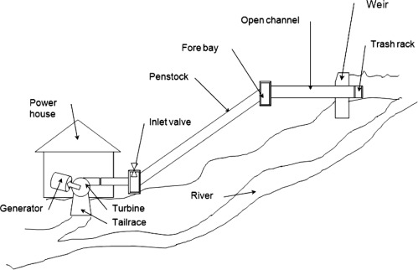

Fig 4.7 Structure of Small hydro plant

9.5.1 Advantages of small hydro plant
- Less construction cost.
- Lower community and environmental and impact.
- Endorse other water related revenues sources.

9.5.2 Disadvantages of small hydro plant
- Requires a water body.
- Largely depends on availability of water.
- Required skill operators.
- Low return to investment

9.6 Bio Fuel
Bio fuel is converted in fuel energy source converted form bio mass. As these feedstock materials can be grown/produced again so these are consider as renewable energy sources. Bio fuel can be generated from biomass in short time span and some time can be used directly. The bio fuels are used for transportation, heating, electricity generation purpose.

Table 4.1 Classification of type of bio fuel
Sno | Name | Methodology
1 | Bio digestion | Bacteria break down in organic material to form bio gas in absence of air. The bio gas is further deployed as fuel or energy sources .
2 | Combustion | Heat is generated by burning organic materials. This heat is further converted into other use full form on energy.
3 | Fermentation | This is a metabolic practices to create chemical changes in an organic materials threw enzymes. This is basically a method of extraction of energy from a carbohydrate without deploying oxygen.
4 | Gasification | - The organic material is reform into hydrogen, carbon dioxide, and carbon monoxide by help of heat without combustion process deploying definite amount of oxygen and steam. The output can be used as fuel source.
5 | Pyrolysis | At high temperature organic material is decomposed at in absence of oxygen. With this reaction organic material is converted in liquid or solid fuel.

9.6.1 Advantages of bio fuel
- Less dependency of fossil fuel
- Endorse carbon neutrality.
- Reduces waste.
- Domestic production.

9.6.2 Disadvantages of bio fuel
- Requires a water and space.
- Not completely clean.
- Underdeveloped technology.

9.7 Energy Derived from Oceans
Ocean energy is energy derived from oceans and is renewable by nature. The ocean has the largest however least explored source of renewable energy on the planet. This energy source has the potential to generate an adequate quantity of reliable renewable energy source across the globe. More than 70% of the planet Earth surface area is covered by ocean. It is largest solar light collector. The sunlight heat the surface of ocean more as compare to the water in depth. This trapped heat can be effectively utilized into useful energy form. The ocean has an important role in maintain the earth temperature constant.
The energy source can be bifurcated into three type i.e. tidal, wave and ocean thermal. These technologies in all forms are under development process and not commercialised at large scale. These technologies required more research and money to build proper utility.

9.7.1 Advantages of Energy Derived from Oceans
- Clean energy source.
- Has potential to meet large energy requirement.

9.7.2 Disadvantages of Energy Derived from Oceans
- May put aquatic life in danger.
- Chances of breakdown during storms.
- Available near costal area.
- Specific site required.
9.8 Geothermal Energy
Geothermal energy means thermal or heat energy within the earth. This is considered as a renewable energy source as this energy source can be extracted again forms the earth. The extracted heat in form of steam or hot water can be use for heating and electricity generation purpose.
The earth core has a very high temperature molten metal inside it that has creeping radioactive decay. As per the research this temperature can be up to 10800 (°F) even more than that of sun. That heat up its above surface by convection, and radiation. When the underground water comes in contact with this hot rock or surface its get converted into steam or hot water and try to come out of the surface. This phenomenon can be natural or manmade. Fig. 4.8 presents the layout of a geothermal plant for electricity generation.

Well
Reinjection
Super-heater
Super-heater
Super-heater
Turbine
Pump
Condenser

Fig 4.8 Structure of Geothermal plant
9.8.1 Advantages of Geothermal energy
- Less dependency of fossil fuel
- Endorse carbon neutrality.
- Reliable.
- Rapid evolution.

9.8.2 Disadvantages of geothermal energy
- Location Restricted.
- High Costs.
- Environmental side effect

Summary
- A sustainable habitat refer as an ecosystem that is capable to produce food and shelter for human and other leaving beans in plants, without depletion of resources and in a manner that NO external waste is generated.
- Green buildings are high geared buildings whose architected and operational time assures the growth in environment by curtaining the carbon footprint and endorsing sustainable energy sources.
- The sustainable product or design has a low impact on the environment during its complete cycle.
- Sustainable transport means the methods or means of transportation that are sustainable towards environmental and social impacts.
- Energy is the potential of a physical coordination to carry out work.
- The conventional energy sources are basically non-renewable by nature. They can be use only at once and are available in the planet and has limit to its availability.
- The non conventional energy sources are basically renewable energy source. That can be uses again and again and has an easy access.

References:
1. K.K. Yadav, Neha Gupta, Vinit Kumar, Sustainable Habitat: A Green Approach, Conference: National Conference on Energy and Environment: Threats and Remedies
2. Green Building Design & Construction - A Developer’s Perspective, https://masterspmc.com/
3. C.C. Zhou, G.F. Yin, X B Hu , Multi-objective optimization of material selection for sustainable products: Artificial neural networks and genetic algorithm approach
4. The Triple Bottom Line: What Is It and How Does It Work? . www.ibrc.indiana.edu.
5. Ecocity Berkeley: Building Cities for a Healthy Future, Register, Richard, North Atlantic Books
6. https://www.unep.org/regions/asia-and-pacific/regional-initiatives/supporting-resource-efficiency/sustainable-cities
7. Pushpendra Singh , et al. , Multi-criteria decision making monarch butterfly optimization for optimal distributed energy resources mix in distribution networks., Applied Energy, 278 (2020): 115723.

