Title:- Wireless sensor based IoT application for protection of agriculture and vehicle protection from wild animal

1. Introduction: Wireless sensor based network acts as the prime block of the Internet of Things (IoT) aspects, it enabling the interoperability of the sensor nodes using the various platforms like internet, which makes useful in daily life of the human being. In today’s scenario, the consumption of electronics causes broad utility of WSN in the home automation gadgets, food processing, and it provides the approximate production of 80%revenue in the telecom sector [8]. Therefore the new invention in the sensor nodes is the demand of today’s telecom.
The operation cost to design such node is assumed to be very low and has normal hardware which enables the wide use of WSN in industry, real time monitoring and various traffic controllers used for remote access. Therefore, WSN provides a potentially low-cost accessible product solution to the world for detecting and tracking any point object in various applications like Robotics enemy detection in the military [3]. Additionally, WSN is broadly used for security application, environmental issues monitoring, weather forecast monitoring, security products, military, civilian, robot surveillance, and health care products [9]. Mostly the constraints associated with WSN are categorized in the processing, capacity, memory and energy [9]. In view of the fact that the the energy becomes a critical factor as battery replacement in the various devices is difficult to retain in the applications specific products [10]. However reducing the energy consumption of the wireless nodes is considered as the very important and prime challenge for expanding network quality in the channel communication. As the far distance transmissions of data consumes much exhausting form of energy as compared to data processing capabilities, so the sensors nodes should be designed in such a manner to transmit data in multi-hop manner for saving their various kind of energy [12]. Therefore extensive and renowned research is being done for designing energy-efficient communication in multiple nodes [13], and further future innovation and advancement is needed in the communication processing.
2. Novelty and Contribution: In the previously reported works, major research has been done on the front end for the implementation of wireless sensor networks for agricultural land. However, the present research proposal will also deal with and investigate the possible energy-efficient early prediction methods for agricultural land and road accident protection. In this proposal, we will analyze various machine learning-based prediction methods and redundant data filtration methods for efficient event detection and early prediction. In the proposed research work, the various prediction methods are analyzed like regression of logistics, undeterministic forest regression, logistic regression, and methods for hybrid regression and further for true event detection. In summary, a machine learning-based hybrid prediction algorithm will be used for the optimal decision. The research proposal will investigate and efficiently analyze the collected data from different types of event monitoring sensors.
3. Methodology: Sensor motes will be used for the collection of data and transfer of data to headquarters (monitoring station). Headquarters analyses the data with the help of efficient machine learning algorithms. Based on the processing of the data at the monitoring station, it transmits the command signals to the sensor motes, which control the actuators in the field. The actuators will be a protection method on the agriculture field or light signals on the road. For protection, we will use unpleasant noise signals to divert wild animals. In addition, the alert signal will be transmitted to
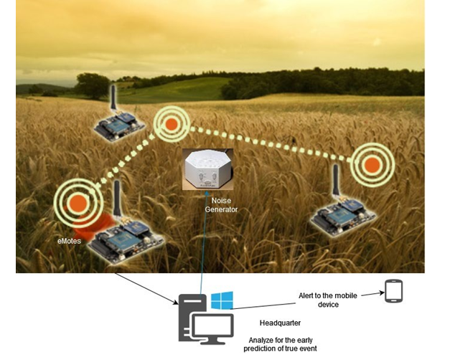
Fig.1 Agriculture land protection system from wild Animals
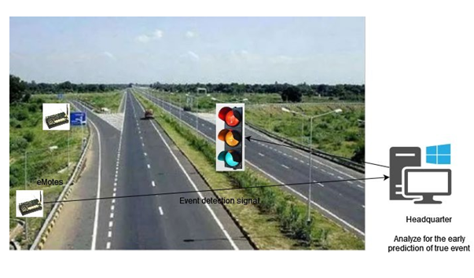
Fig 2 Vehicle protection system from wild Animals

Importance/ Rationale of Investigation-

In today’s scenario Wireless Sensor Network (WSN) is the very effective and innovative emerging field that is widely used in further advanced communication by connecting the tiny sensor nodes [3]. These networks supply the platform for accessing various information in prescribed applications and very popular in application like industrial and commercial .It was planned to design for detecting and tracking any object using the sensor nodes and transmit this vital information to the external resources in the channel hoping with Base Station (BS) [3]. WSN provides this service at a realistic cost without accessing the physical locations of the object needed in daily life for the business purpose [4]. Therefore, effective research is progressive action being performed in the WSN area, where sensor nodes play a critical role in providing such services. Wireless network consists of a large number of tiny sensor nodes; those connected in an ad-hoc manner and transmit corresponding information to BS [5].
This research will propose energy-efficient techniques for better cluster and grid formation adaptively to reduce energy consumption in the various setup processes. The total number of communication clusters affects the energy consumption and lifetime of the network. Therefore to stabilize clustering, our work will add some optimization techniques.
As cluster and grid head selection affects the routing of packets, our research work will contribute some energy-efficient distance-based techniques for improving the CH and GH selection and packet routing in WSN.
For performing better cluster and grid formation as well as CH & GH selection, we will employ the K-means, FCM, Particle Swarm Optimization (PSO), Self Organization Map (MAP) techniques, energy and Euclidean distance of the nodes, and the location of cluster/grid centroid and the BS. We will employ the nodes' energy and their Euclidean distance from cluster/grid centroids, BS, and among them for efficient packet routing
- Result- For performing better cluster and grid formation as well as CH & GH selection, we will employ the K-means, FCM, and Particle Swarm Optimization (PSO), Self Organization Map (MAP) techniques, energy and Euclidean distance of the nodes, and the location of cluster/grid centroid and the BS. We will employ the nodes' energy and their Euclidean distance in the cluster/grid centroids, BS, and among them for efficient packet routing. Investigate the cluster-based routing protocols by simulating them using the MATLAB Tool, and we will find their problems, which increase the network's energy consumption. Once the problems are identified, we will propose energy solutions for enhancing the network lifetime Overall, our work will result in energy-efficient distance-based clustering and routing techniques for extending the network whole lifetime and optimal energy consumption in the wide network.
- References:-
- L. Mainetti, L. Patrono and A. Vilei (2011). Evolution of wireless sensor networks towards the Internet of Things: A survey. 19th Inter. Conf. on Soft., Telecommun. and Comput. Netw. (SoftCOM), Split. Page No 1-6.
- D.S. Deif and Y. Gadallah(2014). Classification of Wireless Sensor Networks Deployment Techniques. IEEE Commun. Surveys & Tutorials, vol. 16, no. 2, Page No. 834-855.
- A.A.A. Ari(2016). Bio-inspired Solutions for Optimal Management in Wireless Sensor Networks, Ph.D. Thesis, University Paris-Saclay, Cameroon.
- D.N.A. Amro(2019). Dynamic Energy-Efficient Routing Protocol for Wireless Sensor Networks. Master of Informatics, Palestine Polytechnic Univ. Palestinian.
- R. Sumathi(2011). Development and Analysis of Distinct Energy-Efficient Routing Protocols for Load Balancing, Service Differentiation, QoS Assurance and Localization in Wireless Sensor Networks. Ph.D. Thesis, Education and Research Institute University, Chennai, India.
- P. Koskela(2018). Energy Efficient Solutions for Wireless Sensor Networks.
Ph.D. Thesis, University of Oulo, Oulo.
- M.O. Oladimeji(2017). Computational Intelligence Algorithms for Optimization of Wireless Sensor Networks. Ph.D. Thesis, School of Engineering, London South Bank University, England.
- A. Attiah(2018). Energy Efficient and Secure Wireless Sensor Networks Design.
Ph.D. Thesis, University of Central Florida, United States.
- S. Sharma(2016). On Energy Efficient Routing Protocols for Wireless Sensor Networks. Ph.D. Thesis, NIT, Rourkela, Odisha, India.
- R. Yan, H. Sun and Y. Qian(2013). Energy-Aware Sensor Node Design With Its Application in Wireless Sensor Networks. IEEE Transactions on Instrumentation and Measurement, vol. 62, no. 5, Page No. 1183-1191.
- G. Anastasi, M. Conti, M. Di Francesco and A. Passarella(2009). Energy conservation in wireless sensor networks: A survey. Ad Hoc Netw., vol. 7, no. 3, Page No. 537-568.
- K. Akkaya and M. Younis(2005). A Survey on Routing Protocols for Wireless Sensor Networks. Ad Hoc Netw., vol. 3, no. 3, Page No. 325-349.
- A.A. Abbasi and M. Younis(2007). A survey on clustering algorithms for wireless sensor networks. Comput. Commun., vol. 30, no. 14, Page No. 2826- 2841.
- P. Kuila and P.K. Jana(2014). Approximation schemes for load balanced clustering in wireless sensor networks. J. of Supercomputing, vol. 68, Page No. 87-105.
- Puneet(2017). Energy Efficient Clustering Algorithm for Wireless Sensor Network. M.Tech Thesis, Lovely Professional University, Punjab, India.

