An Emerging paradigm for topical drug delivery: Emulgels
Simranjeet kaur, Rajni Dhiman*, Pooja Sharma
Faculty of Pharmaceutical sciences, PCTE Group of Institutes
Abstract
Semisolid mixes are the dermatological substances that get used superficially the most frequently. Topical drug delivery has a number of benefits, including the ability to self-medicate, preventing first-pass metabolism, lowering degradation, and enhancing patient compliance. These delivery methods can be found in a variety of solid, semi-solid, and liquid formulations, including powdered materials, creams, ointments, lotions, emulsions, and powders.
The physiochemical characteristics of the carrier and the medication, which affect the release rates of the medications, determine how effective topical formulations are. A medicine that has been topically applied diffuses from the delivery system, travels to the intended site, and is absorbed by the skin. Increasing the drug's release from the dose form can boost skin absorption.
Introduction
Chemicals are substances that have been provided to the human body by a variety of strategies over the years, including oral, sublingual, rectal, parental, etc., to cure illnesses. When regular systems of drug administration fail or when a local skin illness, such as a fungal infection, occurs, a topically applied drug delivery system is typically used. To achieve a drug's localising effect or to directly treat cutaneous problems, a topical drug delivery device applies a formulation or drug containing medicament directly to the skin. Despite there are many numerous kinds of dermatological substances available for use on the skin, the most widely used ones are semisolid mixtures [1]. This approach of distributing medications has a number of benefits included avoiding first-pass metabolism, reducing alimentary and frequent quantity degradation, enhancing patient compliance, and facilitating simple self-medication. These systems include powdered materials, creams, ointments, lotions, emulsions, and other solid, semi-solid, and wet formulations [2]. The physiochemical properties of the carrier and the medicinal product used directly affect the release rates of medicines from topical formulations. When a medicine is delivered topically, it diffuses from the delivery mechanism, travels to its target site, and is then absorbed by the skin. Therefore, accelerating up the drug's release from the dosage form might improve percutaneous absorption. Additionally, topical administrations offer a consistent delivery for a longer period of time and an enhanced bioavailability by avoiding your liver's first pass metabolism action [1].
Structure and physiology of Skin
The epidermis, dermis, and hypodermis are the three separate layers that make up the skin. The epidermis influences how much water is expelled from the body and acts as a barrier against disease invasion. The basement membrane, which holds the dermis and epidermis together, is mostly made of extracellular matrix, which is created by fibroblasts. Papillary dermis and reticular dermis are two independent layers that make up the dermis. Papillary dermis is the superficial layer that lies next to the epidermis. It also has blood vessels, nerves, sweat glands, lymphatic vessels, mechanoreceptors, thermoreceptors, hair follicles, sweat glands, and sebaceous glands. Those blood veins nourish the dermal and epidermal layers with nutrition and evacuate waste [3].
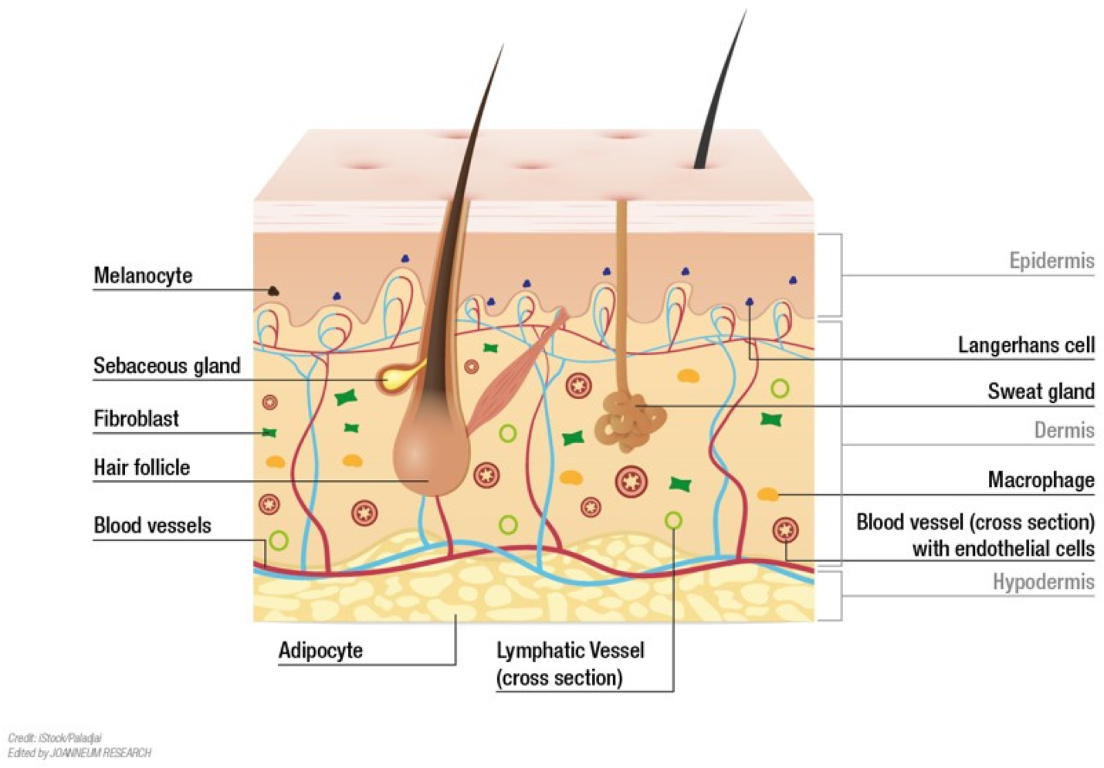

Physiological Factors [4]
- 1. Lipid Content: The stratum corneum of the skin serves as a vital water barrier; when overall lipid content is low, percutaneous penetration is exacerbated.
- 2. Skin Thickness: From the outermost layer of the epidermal layer to the subcutaneous layer, skin thickness varies.
- 3. The thickness of the epidermal layer fluctuates between 100 to 150 m.
- 4. Hair Follicle Density: The infundibulum of the hair follicle has a storage capacity that is around ten times bigger than that of the stratum corneum.
- 5. Skin pH: Increased sweating and fatty acid release at the skin's surface cause a change in skin pH.
- 6. Skin Temperature: Skin flexibility speeds up as the temperature rises.
- 7. Skin Hydration: Promote the drug's ability to pass through the skin.
- Skin Inflammation: Knowing that the stratum corneum is damaged, the permeability rises

Classification of Tropical Dosage form
Introduction to Emulgel
Topical treatments including applications, creams, and cosmetics are widely utilised yet have significant drawbacks. When administered, they are extremely sticky and make the patient uneasy. Additionally, they need to be applied with rubbing because they have a lower spreading coefficient. They also display the stability issue. The usage of transparent gels has increased in both pharmaceutical and cosmetic preparations as a result of all these aspects within the main group of semisolid preparations. The surface tension between a colloid, which is normally 99% by weight liquid, and a macromolecular system of fibres constructed from a little quantity of a gelating goods present immobilises the colloid. Despite the fact that gels have many advantages hydrophobic medication delivery is a significant drawback. An approach based on oil emulsion is therefore being utilised to get beyond this restriction, allowing even a hydrophobic curative moiety to be successfully integrated and given through gels [5]
Due to their extremely versatile physical characteristics that ensure the minimising of the limitations of conventional drug delivery, hydrogels are contemporary, promising, and intelligent drug delivery systems. They typically include up to 90% water and must contain a polymer that, by cross-linking its chains, creates a three-dimensional network structure, making hydrogels porous enough to hold pharmaceuticals. The fundamental drawback of hydrogels is their inability to transport hydrophobic pharmaceuticals, which is problematic given that the majority of potent medication ingredients are hydrophobic. Emulgels, regularly referred to as creamed gels and gelled emulsions, were created to tackle this negative aspect.
Emulgels are completely novel pharmaceutical delivery systems that combine emulsions in gels, enabling the the advantages of both [2] . They are available in both o/w and w/o types. A reliable and superior approach that incorporates subpar water-soluble pharmaceuticals is emulgel. Given that emulgel has both wet and non-aqueous phases, it can distribute the two types of hydrophilic and lipophilic substances. They have been utilised as a control release formulation recently. These biphasic systems are more durable and have an improved drug loading capacity [4].
Delivery of drug through emulgels
Emulgels are revolutionary methods for drug delivery created by marrying emulsions and gels; as a result, they have the characteristics of both. Either the o/w type or the w/o type can be constructed. The technology Emulgel uses to incorporate subpar water-soluble pharmaceuticals is stable and excellent. Due to the existence of both aqueous and non-aqueous phases, emulgel is capable of carrying both hydrophilic and lipophilic prescription drugs. They have been applied lately as a formulation for controlled dispensing. These biphasic systems are more stable and have the ability of loading additional medicines. Thirdly, for the systemic action of drugs by transdermal application can be the aim of the topical therapy. Drug penetrates the stratum corneum by two options: the transepidermal route and the route via pores. The transepidermal route can be divided into the transcellular and the intercellular route. Transcellular route is the direct and the shortesh route where the drug directly passes through both the lipid structures of the stratum corneum and the cytoplasm of the dead keratinocytes, but encounter significant resistance to permeation because they have to cross both lipophilic and hydrophilic structures. Intercellular transportation serves as the primary pathway for drug movement between corneocytes. Initially, skin appendages, comprising a mere 0.1% of the total skin surface, were thought to have a negligible impact on drug permeation through the pores. Nonetheless, in the case of highly lipophilic and large molecules (and certain electrolytes), these appendages and other diffusion shunts may indeed play a significant role. Theoretical vertical pathways for percutaneous penetration have been proposed, involving the follicular apparatus of hair follicles, sweat glands, and microlesions in the interfollicular horny layer. When a lipophilic drug easily traverses the stratum corneum, it encounters slow diffusion upon reaching the hydrophilic epidermis, leading to a temporary deposition known as the reservoir effect.
Substances with a small molecular size and the ability to dissolve in both lipids and water exhibit the most effective permeation. When electrolytes are applied in aqueous solutions, they tend to form a stable hydration field, which hinders absorption by increasing the size of the diffusing component. The drugs' permeability coefficient relies on factors such as the size of the solute, its lipophilicity, and the length of the diffusion path. While Fick's law initially suggests that penetration depends on skin thickness, subsequent research indicates that the lipid composition of the skin plays a more significant role in this process [5].
Formulation ingredients of Emulgels
S. No. | Name of Ingredients | Uses | Examples | References
1 | Aqueous Material | Conversion of emulsion into emulgels in the presence of gelling agent | Water, Alcohol | [6]
2 | Oil | Act as a vehicle, Part of oily phase in emulsion, Solubility of hydrophobic drugs, medicinal value | Liquid paraffin, Propylene glycol, Isopropyl myristate, Isopropyl palmitate, Isopropyl stearate, Castor oil, Olive oil, Balsam oil, Wool wax, Soyabean oil, Cotton seed oil, Oleic acid, Maize oil, Arachis oil, Fish liver oil | [7]
3 | Emulsifiers | Emulsification, Increase stability | Polyethylene glycol stearate, Sorbitan monooleate (Span 80), Polyoxyethylene sorbitan monooleate (Tween 80), Stearic acid and Sodium stearate
4 | Gelling Agents | Act as a thickening agent | Natural materials such as Tragacanth, Carrageen, Pectin, Agar, Xantham gum, Alginic acid and Starch; Synthetic agents are cellulose derivatives such as Methylcellulose, Hydroxyethylcellulose, Hydroxypropylmethylcellulose, Carboxyvinyl polymers, Carboxymethylcellulose and Magnesium aluminium silicates | [6]
5 | Penetration enhancers | Partitioning of the drug into skin structures, or enhance delivery into skin | Menthol, Clove oil, Mentha oil, oleic acid, Eucalyptus oil, Transcutol | [2]
6 | pH adjusting agents | Avoiding the risk of skin irritation during application | Triethanolamine, Sodium hydroxide | [2]
7 | Preservatives | Protect the formulation from spoiling due to stopping or slowing  microbial development | Methyl paraben, Combination of methyl paraben and propyl paraben, Phenoxyethanol, Benzalkonium chloride | [2]

Preparation procedure of Emulgels
Types of Emulgels

Marketed Preparations of Emulgels
S. No. | Product Name | Drug | Manufacturer | Uses
1 | Denacine Emulgel | Clindamycin phosphate | Beit jala pharmaceutical company | Anti-acne
2 | Voltaren Emulgel | Diclofenac diethyl ammonium | Novartis Pharma | Relieve pain and inflammation
3 | Bengay Ultra Strength Pain Relieving | Methyl salicylate and menthol | Johnson & Johnson | Topical pain relief
4 | Flexall 454 | 7% menthol and 10% camphor | Sanofi | Relief from minor aches and pains associated with arthritis, backaches, and muscle strains.
5 | Biofreeze Pain Relief Gel | Menthol | Hygenic Corp. | Relief from muscle and joint pain
6 | Iodex Fast Relief Gel | Diclofenac | GlaxoSmithKline Pharmaceuticals | Relive Minor muscular pain and inflammation.
7 | Miconaz-H-emulgel | Miconazole nitrate, Hydrocortisone | Medical union Pharmaceuticals | fungal infections of the mouth, throat and gullet
8 | Excex gel | Clindamycin, Adapalene | Zee laboratories | Acne treatment
9 | Nadicin cream | Nadifloxacin | Psychoremedies | Skin infections such as boils, impetigo, and infected hair follicles
10 | Dermafeet  Emulgel | Urea 40% | Herbitas | Intense moisturizing and exfoliation activity

Future Scenario of Emulgels
The future outlook for emulgels is promising and diverse, holding great potential across various fields. In advanced drug delivery systems, emulgels are expected to play a vital role, enabling controlled release and targeted administration of medications, ultimately reducing side effects and improving patient outcomes. The cosmetics and skincare industry will likely see continuous evolution of emulgel-based products, incorporating innovative ingredients to address specific skin concerns.[8]
Moreover, the emergence of nanoemulgels could lead to improved drug solubility and bioavailability, creating new opportunities for therapeutic applications. Emulgels are not limited to human healthcare; they also find utility in veterinary medicine and agriculture. As research and technology progress, emulgels are set to contribute significantly to personalized medicine, where tailored formulations meet the unique needs of individual patients.[9]
With researchers delving into novel possibilities and industries acknowledging their adaptability, emulgels are anticipated to be a major driving factor shaping the future of pharmaceuticals, cosmetics, and diverse sectors.

References
- Begum et al., 2019 A Review on Emulgels-A Novel Approach for Topical Drug Delivery. Asian Journal of Pharmaceutical Research and Development. 7(2): 70-77.
- Milutinov, J et al., 2023 Emulgels: Promising Carrier Systems for Food Ingredients and Drugs. Polymers. 15, 2302.
- Hofmann E et al., 2023 Modelling the Complexity of Human Skin In Vitro. Biomedicines. 11(3), 794.
- Patel B. M, Kuchekar A. B, Pawar S. R. 2021. Emulgel Approach to Formulation Development: A Review. Biosci Biotech Res Asia. 18(3).
- Panwar A.S. et al., 2011. EMULGEL: A REVIEW. Asian Journal of Pharmacy and Life Science. Vol. 1 (3):333-343
- Kumar S., Badola A., Nayak B., 2017. Emulgel: Magnifying the application of topical drug delivery. Indian J. Pharm. Biol. Res. 5(1):25-33.
- S. Malavi, P. Kumbhar, A. Manjappa, S. Chopade, O. Patil, Udichi Kataria, J. Dwivedi and J. Disouza., 2022. Topical Emulgel: Basic Considerations in Development and Advanced Research. Indian J Pharm Sci 84(5):1105-1115.
- Ojha A., Ojha M., Madhav
- Hardenia, A., Jayronia, S., Jain, 2014. EMULGEL: AN EMERGENT TOOL IN TOPICAL DRUG DELIVERY. Int. J. Pharm. Sci. Res. Vol. 5(5): 1653-1660.

