SMART CAR PARKING SYSTEM

Yuvasri M
Department of Electronics and Communication Engineering,
Karpagam Institute of Technology,
Coimbatore, Tamilnadu, India.

Mythili Priya R
Department of Electronics and Communication Engineering,
Karpagam Institute of Technology,
Coimbatore, Tamilnadu, India.
Poornima K
Department of Electronics and Communication Engineering,
Karpagam Institute of Technology,
Coimbatore, Tamilnadu, India.

Palanivelavan R
Department of Electronics and Communication Engineering,
Karpagam Institute of Technology,
Coimbatore, Tamilnadu, India.

S. Pragadeswaran*
Department of Electronics and Communication Engineering,
Karpagam Institute of Technology,
Coimbatore, Tamilnadu, India.
praga1994@gmail.com

ABSTRACT
Parking management system is vital in modern cities as it reduces traffic-related air pollution, increases the profitability for companies who are managing parking spaces in malls and in Airports etc. Excessive traffic jams lead to delays in reaching workplace or home, wastage of fuel, wear and tear on vehicles or even a road rage by the stressed and frustrated motorists. We have proposed an algorithm to control traffic congestion and the smart parking system. We have also discussed smart toll tax collection using Internet of things. The implementation of our proposed method is inexpensive. By creating a Parking Management System Using I0T which creates an interface between users and parking lot gives the solution for the problem. As our lives getting modernized we are using new kind of luxurious things such as our automobiles- bikes and cars. So just like us it needs a space in every areas, we have parking lots for them. It may not be free all the time, sometimes it becomes a big stress or us to find a place for the vehicle to be parked. So we are introducing a system that can indicate, book and notify us about our parking space through mobile phones.
When a parking spot is vacant in a garage or parking lot, the guidance systems can also maximize the revenue of a paid parking area by alerting drivers about the open spot. One way to detect whether a parking spot is empty or occupied is through contactless ultrasonic technology, as it is reliable in harsh outdoor environments. Gates to garages can also employ ultrasonic technology to make the ticketing process fully automated. Efficient and smart way to automate the management of the parking system that allocates an efficient parking space using internet of things technology.

The Internet of things (IoT) has the ability to transfer data through networks without involving human interactions. IoT allows users to use affordable wireless technology and also helps the user to transfer the data into the cloud. IoT helps the user to maintain.

Keyword: RFID, Arduino, GSM Module, IR Sensor, cloud database

I. INTRODUCTION
The implementation of our proposed method is inexpensive. By creating a Parking Management System Using I0T which creates an interface between users and parking lot gives the solution for the problem. As our lives getting modernized we are using new kind of luxurious things such as our automobiles- bikes and cars. So just like us it needs a space in every areas, we have parking lots for them. It may not be free all the time, sometimes it becomes a big stress or us to find a place for the vehicle to be parked. So we are introducing a system that can indicate, book and notify us about our parking space through mobile phones.

II. LITERATURE SURVEY
To create an interface with the user and the parking lot using IOT do design a website that shows whether the seats are free/booked/occupied To Use a sensor module to find the availability state of the parking lot. The Internet of things (IOT) describes the network of physical objects—“things” or objects—that are embedded with sensors, software, and other technologies for the purpose of connecting and exchanging data with other devices and systems over the Internet. Things have evolved due to the convergence of multiple technologies, real-time analytics, machine learning, commodity sensors, and embedded systems. Traditional fields of embedded systems, wireless sensor networks, control systems, automation (including home and building automation), and others all contribute to enabling the Internet of things.
In the consumer market, IoT technology is most synonymous with products pertaining to the concept of the "smart home", including devices and appliances (such as lighting fixtures, thermostats, home security systems and cameras, and other home appliances. support one or more common ecosystems, and can be controlled via devices associated with that ecosystem, such as smartphones and smart speakers.
These sensors are used to detect the availability of vacant parking spaces. It also acquires real time information about vacant parking slots through their web applications. But the problem is that it generates a huge amount of data. One of the main limitations of this system is high energy consumption and it also suffers from technical aspects [3]. The E-parking system makes use of the latest technologies to merge the reservation of parking slots and the payment systems.

III. PROPOSED SYSTEM

It consists of three sections: the first section is the parking area which includes Arduino devices along with sensors. The user interacts with the parking area with the help of these devices. The user cannot enter the parking area without the help of an RFID card. The second section contains the cloud-based web services which act as a mediator between the user and parking area. The cloud is updated depending upon the availability of the parking area. The admin administers the cloud services and it can also be viewed by the user for checking the availability. The third section is the user side. The user gets notification on the basis of the availability via SMS through GSM module.

IV. HARDWARE AND DESCRIPTION
The three main hardware components used are GMS module, RFID card, and IR sensors. A user is allowed inside a parking space only if the user has a RFID card. RFID card contains the information of the registered user. As the car enters the parking slot, the reader module scans the registered user’s RFID tag. The data is sent to the arduino for checking the availability of the car parking and simultaneously, the user is notified through SMS about the status of the parking area. The GSM module sends the message according to the availability. IR sensor sends the signals according to the presence of the vehicle.

COMPONENTS:
NODE MCU:
Node MCU is an open source firmware for which open source prototyping board designs are available. The name "Node MCU" combines "node" and "MCU" (micro-controller unit). The term "Node MCU" strictly speaking refers to the firmware rather than the associated development kits.
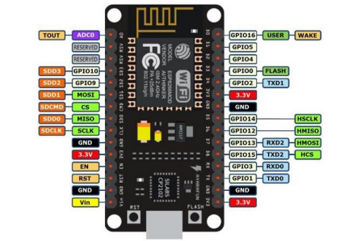
NODE MCU

IR SENSOR:
An infrared sensor is basically an electronic device which is used to detect the presence of objects. Infrared light is emitted by this device. If this device does not detect any IR light reflected back that means there is no object present. If the light is detected by the sensor there is an object present.
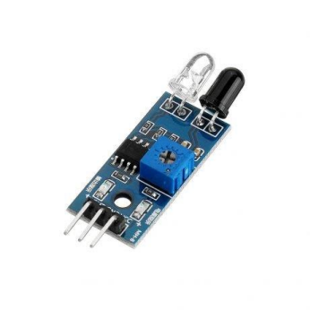
Figure1.IR Sensor

RFID TAGS:
RFID tags are made up of integrated circuit (IC), an antenna, and a substrate. It is an identification badge or credit card that transfers its contents about an object to the reader module. RFID tag transfers data about an object through radio waves. When RFID tags are attached to devices they can also be used for tracking.
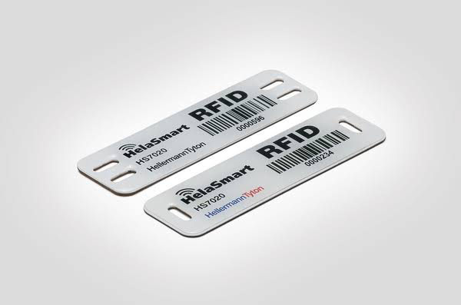
Figure 2.RFID tags

GSM module:
The GSM module is a circuit which is used to setup communication between mobile phones and microcontroller. It is used to send SMS, MMS and voice messages through mobile network. GPRS extension in GSM allows high data transmission. GSM uses time division multiple access approach for transmission.
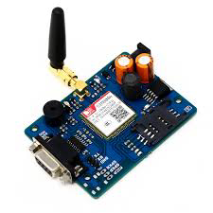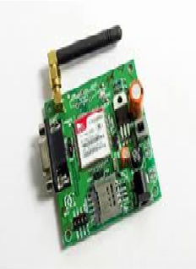
Figure 3.GSM module

Experimental Setup

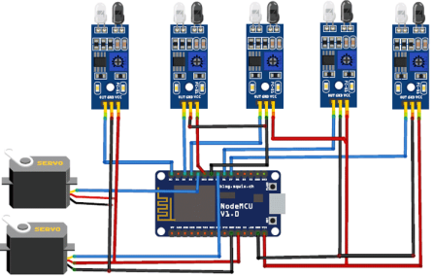

V. SOFTWARE AND DESCRIPTION

APP DEVELOPMENT:
An app is developed which is supported on android, windows and IOS. This app enables the users to register and book slots in advance. Another advantage is that the users can pay through their linked wallets in the app.
Developing a mobile application for engineering project ideas can greatly enhance their accessibility and impact, especially among college students. The process begins by clearly defining the project's scope and objectives, understanding the specific problem it aims to solve, and identifying the target audience, in this case, college students. Choosing the right development platform is crucial; deciding between iOS, Android, or cross-platform development depends on your target audience and resources. Prioritize planning the user interface (UI) and user experience (UX) by creating wireframes and mock ups to ensure an intuitive design.

WEBSITE:
Similar to the application , the users are authenticated and allowed to book through the website also. The programming languages that are used to build the website are PHP, JS, Bootstrap, Jquery and HTML.
Creating a website for a smart car parking system is an excellent initiative to streamline and enhance the parking experience for users. This platform will primarily serve as a registration portal, allowing users to register their vehicles and gain access to the system's smart features. The website will provide a user-friendly interface where vehicle owners can easily input their vehicle information, such as license plate number, vehicle type, and contact details. Once registered, users will have the convenience of accessing real-time information about parking availability, making reservations, and receiving notifications about their parking status.

VI.METHODOLOGY
Every parking slot in the given mall is identified with a unique id(Parking id).The User registers using either the app/website which prompts him to enter the Username and Password. Once he is registered he is given a unique Customer id. This id is used every time he wants to book a parking slot. To book a parking slot he initially needs to select a destination of his choice. The available number of parking slots in that place will be displayed. One constraint we consider is that the user is allowed to book only when he is within 30 minutes from his arrival time.
Case 1:
For parking in public areas:
Parking spaces in public areas are considered registered to this system. Even people who are having unused parking space/garage can register to this system. This will be beneficial during peak hours. If the parking slots are available at the specified time at the desired location, the user is allocated a slot. This slot has a unique id (Parking id) associated with it which notifies the user where he has to exactly park his vehicle. He would receive a confirmation receipt regarding his parking status.
Case 2:
For parking inside malls:
If the parking slots are available at the specified time in that mall, the user is allocated a particular slot. This slot has a unique id (Parking id) associated with it which notifies the user of the slot where he has to park. He would receive a confirmation receipt regarding his parking status.
a) User didn’t arrive at the specified time If the time slot is opened and if the user hasn’t cancelled, whether he arrives at the specified time or at a later time, he will be charged the same amount. The amount deducted is based upon the duration of the slot booked by him.
b) Cancelled before the time slot opens The slot is released into the pool of available slots and the amount will not get deducted from the user’s account.
c) Cancelled after the time slot opens. The slot gets released into the available pool but a small amount (cancellation charges) gets deducted from the user’s account.
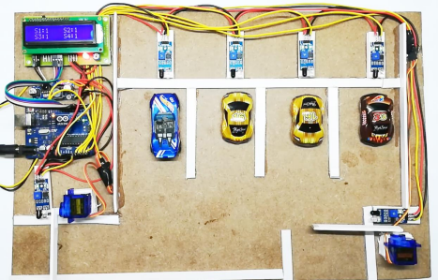

Flow Chart:

Start

|
[User Arrives at Parking Lot]

|
Is a Parking Spot Available?

|
Reserve Parking Spot (Optional)

|
Notify User and Provide Directions

|
User Parks Vehicle

|
Is Vehicle Detected in Spot?

|
Yes

|
Update Parking Availability Status

|

User Leaves Parking Lot

|
End

VI. RESULTS

The increasing demand for smart parking systems provides real-time access to parking space availability, unlike existing systems lacking reservation and slot check features. The current systems rely on vision-based and sensor-based methods, which are time-consuming. This paper aims to create a connected, cost-effective parking solution, reducing theft and vehicle fuel consumption during parking search.

The current state of parking systems predominantly relies on two methods. Firstly, there is the vision-based monitoring system, which estimates available parking slots by counting the number of incoming and outgoing cars. However, this method consumes a significant amount of time and effort and may not provide accurate real-time information. Secondly, there is the sensor-based system, which uses ultrasonic sound waves to detect the presence of vehicles in parking spaces. While this method is more accurate than the vision-based approach, it still has limitations and can be costly to implement.
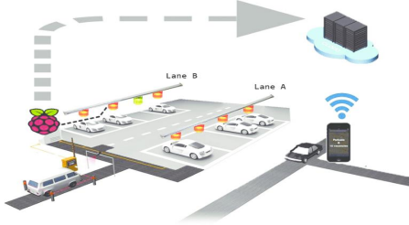

Figure 4. FUTURE MODEL

VII. CONCLUSION AND FUTURE WORK
The concepts of smart cities have always been a dream. There have been advancements made from the past couple years to make a smart city dream into reality. The advancement of internet of things and cloud technologies has given rise to the new possibilities in terms of smart cities. Smart parking facilities have always been the core of constructing smart cities. The system provides a real time process and information of the parking slots.
This paper enhances the performance of saving users time to locate an appropriate parking space. It helps to resolve the growing problem of traffic congestion. As for the future work the users can book a parking space from a remote location. GPS (Global Positioning system), reservation facilities and license plate scanner can be included in the future.

REFERENCES

- Abhirup Khanna, R. A. (2016). IoT based Smart Parking System. International Conference on Internet of Things and Applications (IOTA) (p. 5). Pune: IEEE.
- Rachapol Lookmuang, K. N. (2018). Smart Parking Using IoT Technology . IEEE , 6.
- O. Orrie, B. S. (2015). A Wireless Smart Parking System. IECON (p. 5). Yokohama: IEEE.
- Khaoula Hassoune, W. D. (2016). Smart parking Systems:A Survey . IEEE .
- Wael Alsafery, B. A. (2018). Smart Car Parking System Solution for the Internet of Things in Smart Cities. IEEE .
- IrisNet: Internet -scale Resource-Intensive Sensor Network Service, http://www.intel-iris.net
- Kumar, Rakesh, Naveen K. Chilamkurti, and Ben Soh. "A comparative study of different sensors for smart car park management." In Intelligent Pervasive Computing, 2007. IPC. The 2007 International Conference on, pp. 499-502. IEEE, 2007.
- HappyMinds: SMARTPARKINGhttp://www.happiestminds.com

