Projection of Future Climate Data Using Global Circulation Models
Preeti Sajjan
Dept. of. Soil and water conservation engineering
Dr. NTR College of Agricultural Engineering
Bapatla, Andhra Pradesh, India

Dr. K. Krupavathi
Assistant Professor, Dept. of Irrigation & Drainage Engineering.
Dr. NTR College of Agricultural Engineering
Bapatla, Andhra Pradesh, India

C. Aparna
Dept. of. Soil and water conservation engineering
Dr. NTR College of Agricultural Engineering
Bapatla, Andhra Pradesh, India

ABSTRACT
The accurate prediction of future climate patterns is of paramount importance in understanding and mitigating the impacts of climate change on various ecosystems and human societies. This study focuses on the utilization of Global Circulation Models (GCMs) to project forthcoming climate data. GCMs are indispensable tools that simulate the Earth's atmospheric and oceanic processes, enabling us to gain insights into the complex interactions driving climatic shifts. 2 climate models namely HadGEM2-ES and MIROC-ESM were selected to generate future climate data for the period 2010-2090 from MarkSim daily weather generator and also generated climate data compared with the observed data for the period 2010-2021. By comparing model predictions with observed trends, it helps to validate the performance of GCMs and identify potential areas of improvement. Results reveals that both RCP 4.5 and 8.5 scenarios predicted substantial rise in precipitation and temperature for future years. HadGEM2-ES with RCP 8.5 show very high temperature whereas MIROC-ESM with RCP 4.5 shows very low temperature. There is an increasing trend in prediction of climate data from 2010 to 2090 with highest precipitation and temperature in 2090 and lowest in 2010. From the prediction it is expected to increase in rainfall from 49.75 mm to 1341.66 in the future and maximum and minimum temperature about 32.98-36.84 °C and 24.37-28.58°C. it was also observed that minimum temperature was increasing drastically compared to the maximum temperature. Mean monthly observed and predicted precipitation and temperature was compared for the period 2010-2090. Statistical analysis was done to compare both data. RCP 8.5 scenario is more correlated with observed data. Models had underestimated 1-3°C temperature and 30-49.7 mm rainfall this bias has to be corrected. RCP 8.5 scenario was having highest R² about 0.88 for precipitation and 0.97 for temperature low correlation was observed for RCP 4.5 scenario compared to 8.5. Statistical analysis results confirms that data obtained from MIROC-ESM with RCP 8.5 scenario are in close agreement with the observed data with low bias in data, hence this model and scenario can be used for future projection of climate data. The findings provide crucial insights for policymakers, researchers, and stakeholders working towards a comprehensive understanding of the Earth's changing climate and the formulation of effective strategies to address its far-reaching consequences.
I. INTRODUCTION
In the twenty-first century, climate change (CC) stands out as the foremost environmental challenge. Its effects on food security are already observable, marked by shifts in precipitation patterns, increasing air temperatures, and more frequent occurrences of extreme events. [IPCC (2016)., Islam et al (2021)]. This problem is further complicated by insufficient environmental resource management and constrained adaptive capacity within developing nations. [Groitoru et al (2016), IPCC (2014)]. India, classified as a developing nation, faces significant vulnerability to changing climate conditions. Over the latter part of the twentieth century, India witnessed notable increases in air temperatures, as well as monsoon and post-monsoon rainfall, whereas winter precipitation declined, all due to the impact of climate change. The occurrence of extreme weather events, directly linked to these climatic shifts, has risen in frequency in recent times, resulting in significant economic losses and human casualties. Projections indicate that with ongoing global warming, these trends of intensified extreme weather are anticipated to persist throughout the current century. [Fahad et al (2018), Islam et al (2022), Das et al (2022)]. Therefore, understanding the changes in precipitation and air temperature is crucial for formulating efficient approaches to mitigate climatic risks.
Climate projections play a crucial role in the fields of climate science and policy formulation by offering valuable insights into the potential changes Earth's climate may undergo in diverse scenarios. The primary purpose of climate projections lies in comprehending and anticipating likely climate trends and impacts across various spatial and temporal dimensions. They aid in evaluating how human activities, including actions like altering land use, greenhouse gas emissions, and industrial practices, might shape the planet's climate. These projections supply estimates of forthcoming alterations in temperature, precipitation patterns, sea levels, and occurrences of extreme weather. It's essential to acknowledge that climate projections do not offer absolute predictions; rather, they provide probabilistic estimations rooted in multiple emission scenarios and model uncertainties. They function as invaluable tools for making informed decisions amidst the uncertainty of future climates. Ongoing enhancements in climate models and observational methods contribute to the ongoing improvement and reliability of these projections over time.
To investigate potential consequences of climate change, it is necessary to provide descriptions of climate at both local and regional levels.. The Global Climate Models (GCMs) are the fundamental tool for understanding the potential impacts of climate change [Yue et al (2002), Eyring et al (2016)], and making projections for the future.
Considering the above points, the study was conducted to project future climate data of Bapatla district using two GCMs like, HadGEM2-ES and MIROC-ESM.
II. MATERIAL AND METHODS
- Study area
The research was carried out within Bapatla district, located in the southern Indian state of Andhra Pradesh. Positioned along the eastern coastline of India, Bapatla is situated on the Bay of Bengal at approximately 15.90 degrees North latitude and 80.470 degrees East longitude. This region features a flat landscape with only a few meters of elevation above sea level, experiencing a tropical climate marked by warm and humid summers alongside milder winters. The district's average maximum and minimum temperatures stand at 32.3°C and 18.5°C, respectively, and it witnesses a normal annual rainfall of 925.3 mm. Renowned for its agricultural significance, Bapatla is recognized for rice cultivation and the production of crops such as pulses, cotton, and tobacco. The district's soils are notably fertile, classified primarily as black cotton soil, sandy loamy, and red loamy. In the district, approximately 70% of the area comprises black cotton soil, with the remaining 30% characterized by sandy loamy soil. Bapatla enjoys well-established transportation connections, facilitated by the presence of the Chennai-Kolkata railway line and National Highway 16 (NH 16), enabling efficient travel to neighboring cities and states. The geographical location of the study area is illustrated in Figure 1.

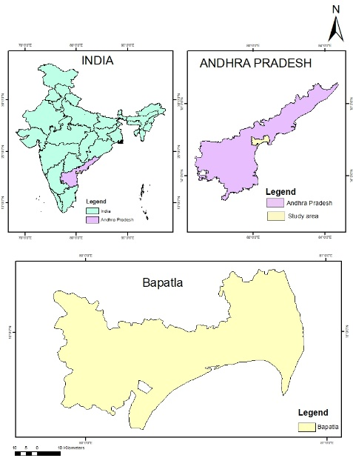
Fig 1 Location map of Study area
- Future Climate data generator
MarkSim serves as a software solution aimed at producing daily weather data through the utilization of a stochastic weather generator. This application employs a third-order Markov process to replicate daily weather patterns and has been fine-tuned using an extensive dataset obtained from over 9200 global weather stations. To organize this dataset, a clustering algorithm grouped the stations into 664 clusters, each holding distinct rainfall model parameters derived from monthly averages of key metrics such as rainfall, air temperature, diurnal temperature range, elevation, and latitude. Employing interpolated climate surfaces with a resolution of 10 minutes of arc (approximately 18 km), the software effectively pinpoints the pertinent cluster for a given location, consequently assessing and adapting the model parameters accordingly. Within the scope of this study, MarkSim was employed to generate detailed daily weather data files for the execution of DSSAT crop models. Within MarkSim's 17 available models, two were meticulously chosen to project forthcoming climate conditions, as per the reference provided by Jones et al. in 2000.
HadGEM2-ES stands as an advanced coupled model, merging Atmosphere-Ocean General Circulation Model (AOGCM) capabilities with high-resolution attributes within both atmospheric and oceanic aspects. The atmospheric dimension boasts N96 resolution (1.875 × 1.25 degrees), comprising 38 vertical levels, while the oceanic sector follows a resolution of 10 degrees (progressing to 1/30 degrees at the equator) with 40 vertical levels. Particularly notable is HadGEM2-ES's incorporation of interactive land and ocean carbon cycles, thereby accommodating dynamic representations of vegetation. It offers the valuable option to prescribe either atmospheric CO2 concentrations or anthropogenic CO2 emissions, consequently enabling the simulation of CO2 concentrations. Additionally, the model introduces an interactive tropospheric chemistry scheme, facilitating the simulation of atmospheric composition evolution and intricate interactions involving atmospheric aerosols. These intrinsic attributes position HadGEM2-ES as a comprehensive and potent instrument for investigating climate mechanisms and the Earth's multifaceted reactions to diverse compelling factors.
The ESM, referred to as "MIROC-ESM," originates from the global climate model MIROC (Model for Interdisciplinary Research on Climate). This variant, known as MIROC-ESM (MIROC-ESMCHEM), is developed from a version that doesn't include the coupled atmospheric chemistry component. It is valuable to assess the influence of interactions between chemistry and climate within the transient climate system.
Climate models are employed to project potential future shifts in climate conditions based on specific scenarios. These models are executed multiple times using diverse future condition scenarios, encompassing factors like population levels and anticipated emissions of carbon dioxide (CO2) or other greenhouse gases. Each Global Climate Model (GCM) possesses unique characteristics and sensitivity to greenhouse gas emissions. The collective range of these models is pivotal for researchers as it offers insight into the uncertainty surrounding potential future outcomes within a given scenario and timeframe. To encompass this diversity and leverage the array of projections, ensembles of multiple simulations from global climate models are commonly utilized. CMIP5, denoting the Coupled Model Intercomparison Project Phase 5, represents the fifth stage of a collaborative global initiative aimed at comparing and assessing climate models. Coordinated by the World Climate Research Programme (WCRP), CMIP5 involves numerous international climate modeling centers. Within the CMIP5 simulations, four future scenarios known as "Representative Concentration Pathways" (RCPs) are included. These scenarios stem from the work of four integrated assessment models (IAMs) and are chosen from a pool of over 300 published greenhouse gas emission scenarios derived from socio-economic and energy-system modeling. These RCPs are designated based on their approximate global radiative forcing levels for 2100, with RCP 8.5 indicating a stabilization phase after 2150, RCP 4.5 and RCP 6 signifying different points of progression, and RCP 3-PD reflecting a "Peak and Decline" pattern of maximal forcing levels. Among the four available scenarios, this study focuses on two for climate projection: RCP 4.5 and RCP 8.5.
Weather data has been generated from MarkSim DSSAT weather generator. Data from 2010-2090 was generated for future projection and data from 2010-2021 for comparison of projected and observed data. For generation of future weather data, latitude and longitude of Bapatla district has been entered. Screenshot depicting the location, model selection and replication selection for generating future climate data is shown in Fig 2.
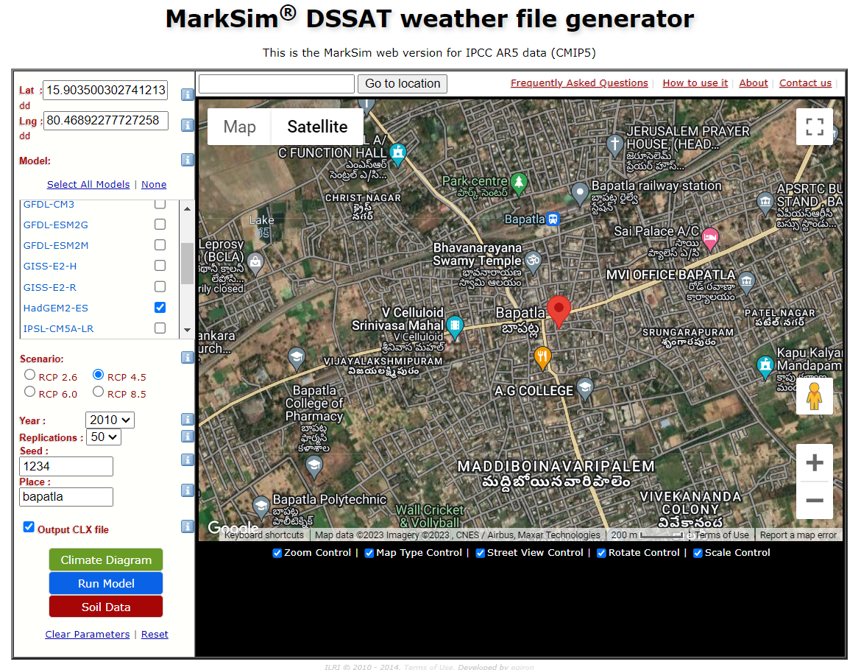
Fig 2 Entering data in the MarkSim DSSAT weather generator
As above mentioned, 2 climate forecast models have been selected from the drop window. The input details have to be entered like location, and models. Two models mainly HADGEM2-ES and MIROC-ESM were identified with scenario 4.5 and 8.5 to generate the future climatic data. The model was run with 50 replications to minimise the errors in simulation. After entering the input details run the model and then click on download CXL file.
The future rainfall maximum temperature and minimum temperature and radiation were generated, and the screenshot displaying the data is shown in Fig 3. The future climate data was generated from 2010 to 2090 using the weather generator and from 2010-2021 for comparison of projected and observed data.
Fig 3. Generation of weather data in MarkSim DSSAT weather generator
- Observed weather data
For the comparison of future projected data and observed data, observed data from 2010-2021 was collected from weather station Dr. NTR College of Agricultural Engineering, Bapatla. Observed data from 2010-2021 is shown in Table 1.

Table 1. Observed Weather parameters
Year | Temperature |  | Rainfall(mm)
 | Maximum | Minimum
2010 | 28.90 | 18.90 | 2254.80
2011 | 30.86 | 18.83 | 838.70
2012 | 30.20 | 19.17 | 1153.10
2013 | 29.95 | 17.92 | 1676.20
2014 | 30.00 | 18.10 | 878.10
2015 | 30.47 | 18.80 | 1050.20
2016 | 30.68 | 18.51 | 1200.80
2017 | 30.52 | 17.65 | 856.20
2018 | 34.42 | 23.14 | 701.00
2019 | 34.45 | 23.76 | 716.60
2020 | 33.93 | 23.49 | 903.70
2021 | 34.00 | 23.49 | 1035.90

III. RESULTS AND DISCUSSIONS
- Generation of future Rainfall data for Bapatla district
MarkSim tool was utilized to project changes in future precipitation data. The climate models, namely HadGEM2-ES and MIROC-ESM with 2 RCP scenarios i.e., RCP 4.5 and RCP 8.5 were used to generate future climate data from 2010-2090.

Fig 4. The variability of projected average annual rainfall from 2010-2090 in HadGEM2-ES and MIROC-ESM in both 4.5 and 8.5 RCP scenarios
The average annual rainfall projection for the period 2010-2090 from different climate with RCP scenario 4.5 and 8.5. from the graph (Fig 4) it can be observed that the rainfall trend is increasing from 2010-2090 with minimum rainfall in the year 2010 and maximum in the year 2090 for all the scenarios and models. In both HadGEM2-ES and MIROC-ESM models with RCP 8.5 rainfall is
increasing drastically compared to 4.5 RCP scenario for the same models where rainfall is gradually increasing and also low rainfall compared to RCP 8.5 scenario.
Similar trend was also observed from previous studies (Thoeun H C 2015, Krishnan et al (2020), Tyagi et al (2022), Kamruzzaman et al (2023) where at the end of century there is highest rainfall.

- Generation of future temperature (Maximum & Minimum) data for Bapatla district
The projected maximum and minimum temperature for future is shown in Fig 5.a &b respectively for all the selected climate models with RCP 4.5 and 8.5. Figures show the temperature for moderate emission scenario (RCP 4.5) and high emission scenario (RCP 8.5) from 2010-2090, as time passes the maximum temperature is projected to rise by 1°C to more than 3°C, whereas the minimum temperature is projected to rise by 1°C to more than 4°C. As per the analysis the minimum temperature is increasing drastically compared to maximum temperature for both models and scenarios the same trend was also reported by Kamruzzaman et al (2023). For the period 2010-2090 the maximum warming is projected to be from 32.98°C to 35.58°C for RCP 4.5 and from 33.12°C to 36.84°C for RCP 8.5 in HadGEM2-ES, and from 32.12°C to 34.12°C for RCP 4.5 and minimum warming is projected to be from 24.32°C to 26.53°C for RCP 4.5 and 24.43°C to 28.58°C for RCP 8.5 in HadGEM2-ES model whereas in MIROC-ESM it is projected to be from 24.39°C to 25.75°C for RCP 4.5 and from 24.37°C to 26.89°C for RCP 8.5 scenario. Both maximum and Minimum temperature generated in HadGEM2-ES for RCP 8.5 is in increasing trend, the potential consequences could pose a significant threat to the entire region.
It strongly agrees with the report submitted by Krishnan et al (2020). Under the RCP8.5 scenario, it is projected that by the end of the twenty-first century, temperatures will increase by around 4.7°C to 5.5°C compared to the average temperatures during the recent past (1976–2005). Tyagi et al (2022) and Krishnan et al (2020) also reported that under RCP 4.5 scenario increase mean temperature is projected to be by 2.1- 4.8°C and under worst case that RCP 8.5 it is projected to be increase by 3.1-5.8°C at the end of 21 century.

Fig 5. The variability of average annual (a)Maximum and (b)Minimum temperatures from 2010-2090 in HadGEM2-ES and MIROC-ESM for both 4.5 and 8.5 RCP scenarios

- Comparison of observed and projected mean monthly climate data
For the validation of data obtained from both the climate models, observed data from 2010-2021 was compared with model data, various statistical analysis was also done. Results obtained from statistical analysis is presented in below (Table 2). Trend analysis and comparison of both data is graphically represented below (Fig 6.a-c).
From the analysis it was observed that there has been an increasing trend in monthly rainfall from January to September and then decreasing trend up to December in both climate models and observed data (Fig 6.a) the results align with earlier research that has similarly forecasted a rise in rainfall during monsoon periods and a decline in winter precipitation (Kwon and Sung, 2019). All the scenarios show increase in precipitation, smallest increase in precipitation is shown by MIROC-ESM 4.5 with lowest R² about 0.77 and R as 0.88, and the error in prediction was MAE 35.66 mm and RMSE 49.74 mm the highest correlation and lowest error was observed for MIROC-ESM 8.5 (Table 2). All the scenarios underestimated the precipitation during rainy season.
The comparison of mean monthly observed maximum and minimum air temperatures for the period 2010-2021 with the maximum and minimum temperatures from HadGEM2-ES and MIROC-ESM for Bapatla region indicated that maximum and minimum temperature were high in summer for both predicted and observed data. From the analysis it can be revealed that models underestimated the temperature data. The maximum temperature was in the range 30.5-38.13°C (Fig 6.b) and minimum temperature was 18-27.9°C (Fig 6.c) Similar trend and results were observed from the previous findings (Thoeun H C 2015.) that a comparison of observed maximum and minimum air temperatures from 1985 to 2008 with the annual maximum and minimum temperatures projected by climate models showed that the maximum temperature range was between 31.5°C and 36.1°C, while the minimum temperature range was between 21.5°C and 26.3°C.
Observed maximum temperature data was more than the predicted data 2-3°C whereas minimum temperature was 1-1.2 °C higher. Statistical results confirms that the MAE and RMSE are in the range 3-3.3°C for maximum temperature and for minimum temperature they are in the range 1-1.2°C (Table 2).
Table 2. Statistical results obtained from the comparison of predicted and observed data for the period 2010-2021
Statistical  Parameters | Maximum temperature °C |  |  |  | Minimum temperature °C |  |  |  | Rainfall (mm)
 | HadGEM2-ES |  | MIROC-ESM |  | HadGEM2-ES |  | MIROC-ESM |  | HadGEM2-ES |  | MIROC-ESM
 | RCP 4.5 | RCP 8.5 | RCP 4.5 | RCP 8.5 | RCP 4.5 | RCP 8.5 | RCP 4.5 | RCP 8.5 | RCP  4.5 | RCP  8.5 | RCP  4.5 | RCP  8.5
R² | 0.97 | 0.96 | 0.97 | 0.97 | 0.96 | 0.96 | 0.97 | 0.97 | 0.84 | 0.84 | 0.77 | 0.88
R | 0.98 | 0.98 | 0.99 | 0.99 | 0.98 | 0.98 | 0.98 | 0.99 | 0.91 | 0.92 | 0.88 | 0.94
MAE | 3.19 | 3.06 | 3.11 | 3.22 | 1.03 | 0.97 | 1.04 | 1.05 | 32.20 | 32.05 | 35.66 | 29.29
RMSE | 3.26 | 3.14 | 3.16 | 3.28 | 1.19 | 1.10 | 1.17 | 1.19 | 47.58 | 47.26 | 49.74 | 41.99

Fig 6. Mean monthly projected and observed climate data for selected climate models with RCP scenario 4.5 and 8.5 (a)Rainfall, (b)Maximum temperature and (c)Minimum temperature

IV. CONCLUSION
Projections of climate data for period 2010 to 2090 from two climate models with selected RCP scenarios showed an increasing trend in average rainfall, maximum temperature and minimum temperature in all the cases. At the end of the twenty-first century i.e., 2090 all the projected climate data reaches the extreme end in RCP 8.5 scenario for both models. The projected results obtained from RCP 8.5 scenario in both GCMs for all the climate parameters agrees with the observed data, this can be considered valid projection models for future. Comparison of observed and predicted data for the period 2010-2021 reveals that RCP 8.5 is having highest correlation lowest error in prediction and there is 2-3°C bias in the model in temperature prediction and also underestimated the precipitation, it should be corrected before prediction.
The ongoing human-induced climate change is projected to persist throughout the twenty-first century. To enhance the precision of future climate projections, especially when considering regional forecasts, it is crucial to adopt strategic methods aimed at advancing our understanding of Earth system processes. Additionally, continuous efforts to improve observation systems and climate models are essential for refining our predictions and addressing the challenges posed by climate change effectively. climate projections from GCMs are indispensable tools for understanding the potential trajectory of earth’s climate. They help the society to prepare for a changing climate, foster sustainable development, and inform actions aimed at safeguarding the environment and future generations and also helps in policy making and implementation related to adoption and mitigation in interest of a larger society.
REFERENCES
- IPCC, S.R. IPCC, Climate Change and Land, an IPCC Special Report on Climate Change, Desertification, Land Degradation, Sustainable Land Management, Food Security, and Greenhouse Gas Fluxes in Terrestrial Ecosystems, 2019.
- H.M.T. Islam, A.R. Md, T. Islam, Md Abdullah-Al-Mahbub, S. Shahid, A. Tasnuva, M. Kamruzzaman, Z. Hu, A. Elbeltagi, M.M. Kabir, M.A. Salam, S.M. Ibrahim, Spatiotemporal changes and modulations of extreme climatic indices in monsoon-dominated climate region linkage with large-scale atmospheric oscillation, Atmos. Res. 264 (2021), 105840, https://doi.org/10.1016/j.atmosres.2021.105840.
- A.E. Croitoru, A. Piticar, D.C. Burada, Changes in precipitation extremes in Romania, Quat. Int. 415 (2016) 325–335, https://doi.org/10.1016/J. QUAINT. 2015.07.028
- IPCC, Climate Change 2014: IPCC Fifth Assessment Synthesis Report-Summary for Policymakers-An Assessment of Inter-governmental Panel on Climate Change, 2014.
- Kamruzzaman, M., Wahid, S., Shahid, S., Alam, E., Mainuddin, M., Islam, H.T., Cho, J., Rahman, M.M., Biswas, J.C. and Thorp, K.R., 2023. Predicted changes in future precipitation and air temperature across Bangladesh using CMIP6 GCMs. Heliyon, 9(5).
- Kwon, M. and Sung, J.H., 2019. Changes in future drought with HadGEM2-AO projections. Water, 11(2), p.312.
- Krishnan, R., Sanjay, J., Gnanaseelan, C., Mujumdar, M., Kulkarni, A. and Chakraborty, S., 2020. Assessment of climate change over the Indian region: a report of the ministry of earth sciences (MOES), government of India (p. 226). Springer Nature.
- M.G.R. Fahad, A.K.M. Saiful Islam, R. Nazari, M. Alfi Hasan, G.M. Tarekul Islam, S.K. Bala, (2018),. Regional changes of precipitation and temperature over Bangladesh using bias-corrected multi-model ensemble projections considering high-emission pathways, Int. J. Climatol. 38 https://doi.org/10.1002/joc.5284.
- H.M.T. Islam, A.R.M.T. Islam, S. Shahid, G.M.M. Alam, J.C. Biswas, M.M. Rahman, D.K. Roy, M. Kamruzzaman, Future precipitation projection in Bangladesh using SimCLIM climate model: a multi-model ensemble approach, Int. J. Climatol. (2022), https://doi.org/10.1002/joc.7605.
- Jones, P.G. and Thornton, P.K., 2000. MarkSim: software to generate daily weather data for Latin America and Africa. Agronomy Journal, 92(3):445-453.
- S. Das, M. Kamruzzaman, A.R. Md, T. Islam, (2022). Assessment of characteristic changes of regional estimation of extreme rainfall under climate change: a case study in a tropical monsoon region with the climate projections from CMIP6 model, J Hydrol (Amst). 610, 128002, https://doi.org/10.1016/J. JHYDROL.2022.128002.
- V. Eyring, S. Bony, G.A. Meehl, C.A. Senior, B. Stevens, R.J. Stouffer, K.E., (2016). Taylor, Overview of the Coupled Model Intercomparison Project Phase 6 (CMIP6) Experimental Design and Organization, Geosci Model Dev., 2016, https://doi.org/10.5194/gmd-9-1937-2016.
- S. Yue, P. Pilon, B. Phinney, G. Cavadias, (2002), The influence of autocorrelation on the ability to detect trend in hydrological series, Hydrol. Process. 16, https://doi.org/10.1002/hyp.1095.
- Thoeun, H.C., 2015. Observed and projected changes in temperature and rainfall in Cambodia. Weather and Climate Extremes, 7:61-71.
- Tyagi, N., Jayal, T., Singh, M., Mandwal, V., Saini, A., Nirbhav, Sahu, N. and Nayak, S., 2022. Evaluation of observed and future climate change projection for Uttarakhand, India, using CORDEX-SA. Atmosphere, 13(6):947.

