Dalk or Mālish (Massage Therapy): Application and benefits in the perspective of Unani Regimenal Therapy

Mohd Afsahul Kalam^{*1} Irfat Ara¹, Tauseef Amin²
¹Research Officer Unani, Regional Research Institute of Unani Medicine, Srinagar. Central Council for Research in Unani Medicine, New Delhi, Ministry of Ayush, Government of India.
²Research Officer Unani, Regional Research Institute of Unani Medicine, Srinagar. Central Council for Research in Unani Medicine, New Delhi, Ministry of Ayush, Government of India.
*Author of correspondence: Research Officer Unani. Department of Ilmul Advia, RRIUM, University of Kashmir, Habak, Naseembagh Campus, Hazratbal, Srinagar, 19006, J&K; Email ID: afsahnium@gmail.com; Mob. No. 7051435488

Abstract
‘Ilāj bi’l Tadbīr (Regimenal therapy) is a type of therapy which is given in the form of various regimes to maintain the health of a person. It has been utilized for preventive as well as therapeutic measures for thousands of years by ancient Unani physicians. The eminent Unani scholars, Ibn Sina, Zakaria Razi, Hakim Akbar Arzani etc. have mentioned various regimes in their classical books, they are Riyāḍat (exercise), Dalk (massage or friction), Takmīd (fomentation), Natūl (liquid dripping therapy), Hammām (Turkish bath), Hijāma (cupping) etc. The purpose to use of these regimes is to maintain cellular homeostasis by regulating various metabolic pathways. Now this therapy is gaining popularity due to its tremendous results. Dalk (Massage) is one of the important regimes utilized for various benefits. It is very useful in promoting immune homeostasis and longevity, and alleviating aging, age-related disorders, and autoimmune disorders. Biological mechanisms, by which this is effective in several diseases is still not completely understood, but it is known that neuro-endocrine and immunological responses are involved, leading to anti-inflammatory, analgesic and antioxidant effects in different pathological conditions. According to various studies Massage therapy is found very effective for treating several ailments, but it is observed that this is much beneficial when used as adjuvant with pharmacotherapy and dietotherapy. In this review Dalk or Massage procedure is mentioned with its definition, aims and objectives, standard operative procedures, therapeutic applications, complication and contraindication etc.

Keywords: Unani Medicine; Ilāj Bi’l Tadbīr; Regimenal Therapy; Dalk; Massage; Analgesic, Antioxidant

- Introduction
Dalk is an Arabic word which means massage. The word “Massage” is also taken from Arabic word “Mass” and some says that it was from the Greek word “Massein” which means “to knead”. The Hebrew word “Mashesh” is also means “to touch, to feel, to grasp”. In Ayurvedic Medicine massage is known as “Champan”, “Mardan”, “Abhayanga” and “Makesh” means “to strike, to press”. (Malik I et al. 2013) In the past, a male massage practitioner might have been called a masseur (ma-SUR), and a female practitioner a masseuse (ma-SOOS). Today, most professionally trained men and women prefer to be called massage practitioners or massage therapists. (Mark FB 2010) Dalk or Massage is a systematic manipulation of body tissue with the hands or tools using oil or without oil. It is widely practiced method used for prevention, restoration and all therapeutic purpose. History of Dalk (massage) is back to the starting of human civilization. Massage was used to expel waste product from the body of patient in Babylon and Assyria. Hippocrates (460BC-370BC) mentioned that massage, exercise, balanced diet, fresh air and rest are essential for maintenance of health. In 1st century, Roman physician Celsus wrote an eight volume book “De Medicine”, in 7th volume he clearly describe the use of rubbing and massage in prevention and therapeutics of some aliments (Ahmad I 1983). Galen mentioned 9 forms of massage and each of which had its own indication. (Sinha 2001) Majusi has mentioned about the preventive and curative aspects of Dalk (Massage) in his book Kamil al-Sana’a. (Majusi AA 1889) According to Ibn Rushd, massage is a type of exercise used for removal of toxins or waste metabolites from the body and is very important regimen for neurological and musculoskeletal disorders. Unani physicians included Dalk in the category of Riyāḍat (Exercise), due to its ability to liquefy Rutūbat-i-badan, liquefy Akhlāt-i-fāsida (morbid humours), create Latīf Harārat (heat) in the body, and strengthen ligaments, tendons and muscles like Riyāḍat (Ibn-Rushd 1987) or it can be say that, Dalk is a special type of Riyāḍat (exercise) or Harkat (movement) which can be applied to a particular organ without involving the whole body, with the same beneficial effects like Riyāḍat.
In 16th century Fabricus-Ab-Aquapendente, the tutor of William Harvey, given the term “Kneading” for the first time in his book on massage in which he warmly recommended the use of massage as a rational therapy for joint affection. The French colonists in India first used the term “massage” during 1761-1763 and included it for the first time in 1812 in a French-German dictionary. The word massage according to Oxford dictionary entered in the English literature in 1879. (Khan AA 2013)
Many definitions of massage have been offered from time to time. Some of the definitions are given bellow:
A massage is described by the American Massage Therapy Association (AMTA) as
"Manual soft tissue manipulation, holding, producing movement, and/or providing pressure to the body." (Anonymous 2013)
Massage is a scientific way of treating some forms of disease by external manipulations, employed in a variety of ways to the soft tissues of the body. (Cook 1998)
"Massage is the systemic mode of curing certain forms of disease by systemic manipulation”-by Murrel; “Massage signifies a group of procedures, which are usually done with hand on the external tissue of the body in a variety of ways either with a curative, palliative or hygienic point of view”-by Graham ; Massage is a healing art (Cassar MP 2006).

1.1 Classification of Dalk (Massage) according to Unani Medicine
Various types of massage recommended in Unani System of Medicine.
According to Ibn-Rushd Dalk (Massage) is classified into 6 types (3 on the basis of Kaifiyat and 3 on the basis of Kammiyat) (Kabiruddin YNM)
- On the basis of Kaifiyat the classification is as follows.
- Dalk Ṣulb (hard massage)
- Dalk Layyin (soft massage)
- Dalk Mo’atadil (Moderate massage)
- On the basis of Kammiyat the classification is as follows.
- Dalk Kathīr (heavy massage)
- Dalk Qalīl (short massage)
- Dalk Mo’atadil (moderate massage)
Murrakab Types of Dalk on the Basis of Kaifiyat (Quality) and Kammiyat (Quantity)
There are 9 types. (Arzani YNMa)
- Dalk Ṣulb-i-Kathīr
- Dalk Layyin-i-Kathīr
- Dalk Mo’atadil Kathīr
- Dalk Ṣulb-i-Qalīl
- Dalk Layyin-i-Qalīl
- Dalk Mo’atadil Qalīl
- Dalk Ṣulb-i-Mo’atadil
- Dalk Layyin-i-Mo’atadil
- Dalk Mo’atadil Mo’atadil
Other types of Dalk
- Dalk Khashin: Here massaging is done with a rough piece of cloth. It draws the blood rapidly to the surface. It should not be done for longer duration otherwise it leads to excessive elimination of Rutūbat from the body.
- Dalk Amlas: It is carried out with soft hand or soft piece of cloth. It increases blood flow in the treated area. The objective of the massage is always to make the body firm, loose, soft.
- Dalk Isti’dād: This special type of massage is done before exercise in order to prepare the body for undergoing different movements during exercise. It is done gently at beginning and gradually towards the finish to make waste product easily expellable when exercising (Ibn-Sina 2007).
Sub-type of Dalk Isti’dād
a. Dalk Qawī, Dalk Ḍa’if, Dalk Mo’atadil
- Dalk Tawīl, Dalk Kathir, Dalk Mo’atadil
- Dalk Istirdād: This Dalk is done at the end of exercise and is also known as Dalk Musakkin. Its purpose is to liquefy and eliminate the waste products, which is retained after exercise in the tissue. This type of massage should be carried out gently and preferably with oil. It should never be done vigorously, roughly or hardly at the end, as it would harden the body (Arzani A YNMa, Arzani A YNMb).

Classification of Therapeutic Massage (Qadir A 2001, Cassar MP, 2006, Hollis M 1998).
A. On the basis of character
- Stroking Manipulation: Superficial and Deep
- Pressure Manipulation
- Kneading: it includes palmar kneading, digital kneading and ironing reinforced kneading.
- Petrissage: it includes, lifting away skin, wringing, Skin rolling.
- Friction: it includes circular friction and transverse friction.
- Percussion/Tapotment Manipulation: It includes clapping, hacking, tapping, beating, pounding, tenting, and contact heel percussion.
- Vibratory Manipulation: It is done by vibrations and shaking.
B. On the basis of depth of Tissue Approached: Light, Deep
C. On the basis of part of Body Massaged: General, Local
D. On the basis of Application of Pressure: Manual, Mechanical massage

1.2 Mechanism of action
The effects of Dalk is based on Tahlīl-i-Mawād (dissolution of morbid humours), Taghziya (Nutrition) and dispersion of Fudlāt (Morbid matters) into tissue spaces. Every diet has some Fuḍlāt after the process of digestion, Tab‘iyat acts upon this and tries to eliminate through nearest possible channel in the form of bawl (urine), barāz (faeces), arq (sweat), balgham (sputum) etc. After Hadm ‘Uḍwi a very Raqīq Fuḍla formed which is not eliminated completely but accumulates into A‘ḍa-i-Rikhw like joint, muscles etc. that may be the predisposing factor for so many diseases. Dalk helps in removal of these fudlāt for promotion or restoration of health. It also increases circulation for better nutrition and function of the organ. Through Imāla-i-Mawād, the morbid material is diverted from important organs like brain, heart, liver etc. to organ of lesser importance to safeguard these important organs from deleterious effects of obnoxious matters. (Ibn-Sina 2010, Kabiruddin YNM, Jurjani 2010)

1.3 Aims and Objectives of Dalk (Massage)
- Tahlīl-i-Mawād: It removes or excretes thick, stagnant, and sticky, viscous, tenacious matters from the body which are not excreted by Mushil (purgative) drugs. (Kabiruddin 2015)
- Tarqīq-i-Mawād (liquefaction of body humours): Massage produces liquefaction in body humours. (Kabiruddin 2015)
- Taskhīn-i-Badan (to warm the body): Massage produces mild to moderate Harārat (heat) in body. (Kabiruddin 2015)
- Tahlīl-i-Riyāh (To resolve the gaseous matters): Massage alleviates Riyah (air) trapped in organs. (Kabiruddin 2015)
- Imāla-i-Mawād (diversion of morbid matter): Massage is applied to divert Mādda (morbid matter) from one point of the body to the other. (Kabiruddin 2015)
- Taskīn-i-Waja’ (Reducing or eliminating pain): Massage alleviates the pain. (Kabiruddin 2015)
- Taskhīn-i-Badan (To warm the body). (Kabiruddin 2015)
- Tal’īn-i-Jild (Moistening of skin): Massage with Roghan produces Rutūbat (moistness) in the body (Arshad MJ & Asjad M 2017) or massaged part and thus helps in treatment of diseases caused by Yubūsat (dryness).
- Taqwiyat-i-Adlāt wa Ribāṭ (strengthening of muscle and ligaments): It strengthens the muscle & ligaments.
- To restore the atrophied organs to their normal size. (Hamdani 2004, Hamdani 2006)
- Taqwiyat-i-A’sab (To strengthen the nerves). (Hamdani 2004, Hamdani 2006)
- Jazb-i-Shahmiyat (To absorb fat into skin and tissues) (Hamdani 2004, Hamdani 2006)
- Tahaffuz-i-Jild (To protect the skin) (Hamdani 2004, Hamdani 2006)
- To Improve joint mobility (Mahmooda B et al. 2016)
- To Improve Circulation (Arshad MJ & Asjad M 2017)
- To Improve lymphatic drainage (Mahmooda B et al. 2016)
- To reduce muscular spasm and cramping (Mahmooda B et al. 2016)
- To regulate weight gain in premature infants. (Mahmooda B et al. 2016)
- Pregnancy and labor support: In females, who were given massage therapy during the delivery, showed less agitation, faster delivery and less postpartum psychosis. (Mahmooda B et al. 2016)
- Post-surgical rehabilitation. (Mahmooda B et al. 2016)

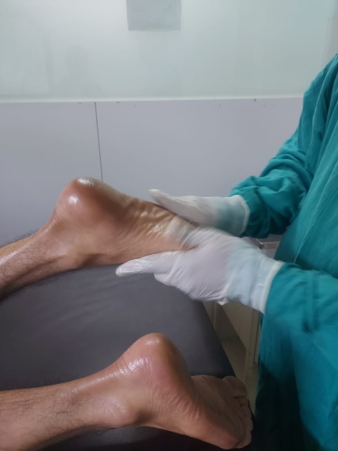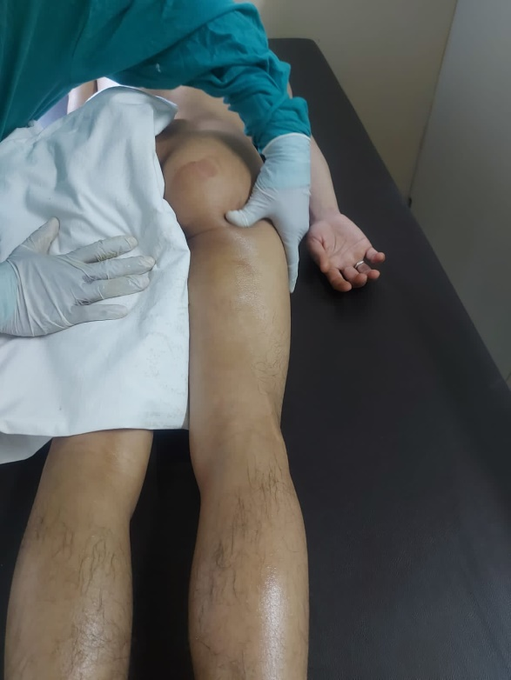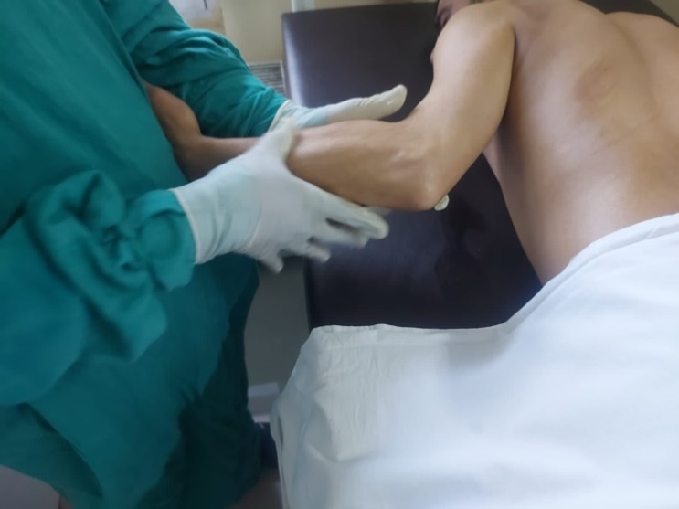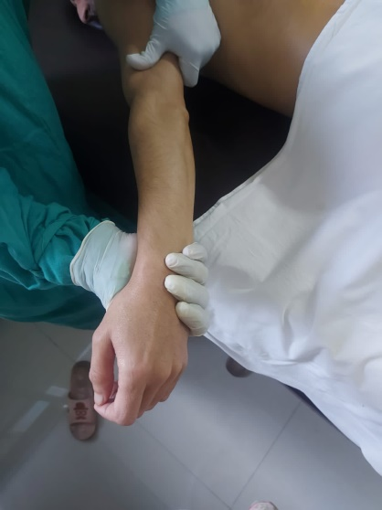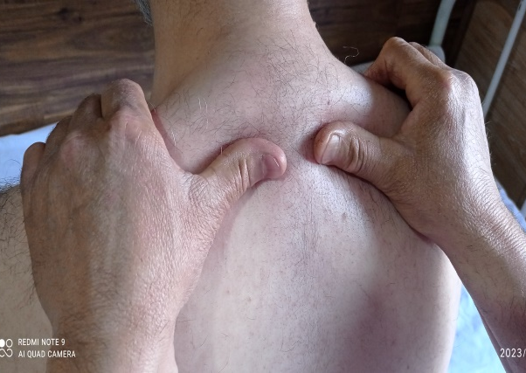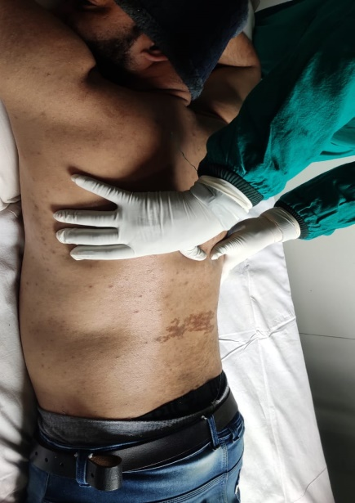
f.
e.
d.
c.
b.
a.
Fig 1. a.,b.,c.,d., Showing massage of different parts of the body

1.4 Materials and equipment required
- Massage place/cabin (maintained with required temperature depending of the season) (Malik Itrat et al. 2013)
- Wooden Massage Table (6-7x 2 feet) (Sinha 2001)
- Oil for massage (Ibn-Sina 2010, Kabiruddin YNM, Jurjani 2010)
- Thick rubber sheet (Sinha 2001)
- Pan and Induction heater for heating the oil.
- Soft wet towel for cleaning the body.
1.5 Standard Operative Procedure of Dalk (Massage)
Pre-procedure
- Check vitals and note it in Case Record Form (CRF)
- Procure suitable oil (either hot or cold as required) for massage
- Select the part to massage
- The oil should be warm not more than 41⁰C
During Procedure
- Ask the patient to lie down on the massage table in supine position. (Johari H 2000)
- Full body Massage should start from the soles of the feet and move towards the heart. (Johari H 2000)
- Massage the legs, arms, chest, abdomen, back and hips in that order. (Johari H 2000)
- Massage of head neck, face, should be done in sitting position. (Johari H 2000)
- Massage is done applying friction or pressure, rubbing, stroking, kneading, pounding, tapping, vibrating or stimulating the external soft part of body with rough cloth or soft cloth or hands without or with medicated oils, creams, ointment till skin becomes red.
- For neck & Shoulder massage- Place a hand on either shoulder in the classic massage position.
  - Knead the thumb deep into the muscle of the shoulders. (Fig. 1.e)
  - Use the finger for grip, but don’t press them into the collar bone as this can be painful. (Fig. 1.e)
  - After finishing shoulder massage use the press and release technique to massage along the neck, all the way to the hairline. Remember to keep your hands on either side of the spine.
  - Now move around to stand in front of your client’s head, so their shoulders are facing you. Make a fist with each hand, and then rub the knuckles gently but firmly across the tops of the shoulders and over the back of the neck.
- For feet Massage-Start Massaging the soles of the feet by wrapping both hands around the foot, (Fig. 1.a) as this area tends to accumulate a lot of tension.
- Toes should be grabbed individually with gentle pull.

Post Procedure
- Clean the oil from body with hot wet towel.
- Stay for some time in massage room.
- Avoid the cold temperature of outer side for some time.
- Check vitals and note it in CRF again.
1.6 Timing and Duration of Massage:
The timing and duration of massage depends on the different types of disease, age of the patient, season, and oil applied.
Timing:
According to Ibn-i-Rushd, the timing for massage is same as for exercise. Thus, according to his concept, the timing is mentioned in respect to Season as follows: (Tanwir et al. 2013)
- Mawsam-i-Rabi' (spring season): Noon
- Mawsam-i-Saif (summer season): Morning
- Mawsam-i-Kharīf (autumn season): Noon
- Mawsam-i-Shita (winter season): After noon
But most suitable time for massage is early in the morning between 5-9 a.m. and in the evening between 4:30-6 p.m.
Duration:
- Massage for about 30-45 minutes. It may differ with the age of patient. (Johari H 2000)
- New Born babies should be massaged 15 minutes daily. (Johari H 2000)
- Children up to 4 years should be massaged for 20 minutes. (Johari H 2000)
- Youth and adults should be massaged for 30 minutes. (Johari H 2000)
- In old people massage should be done for 30 minutes. (Johari H 2000)
- In healthy individuals with no pains, massage for relaxation is typically performed for 30-45 minutes.
- In cases of pains and aches, the duration of massage may be longer.
- In physically weak individuals, the massage may start with 15-20 minutes and gradually increase to 30-35 minutes.
- For individuals who are habitual to massage, daily sessions may last for 25-30 minutes.
1.7 Some beneficial massage oils with their action and uses (Kabiruddin 1935, Anonymous 1993, Amanullah 2011)
S.N. | Name of oils | Action | Used
1 | Roghan Azaraqi | Anti-inflammatory, Nerve stimulant | Arthralgia
2 | Roghan Babuna | Anti-inflammatory | Arthralgia
3 | Roghan Banafsha | Moisturizer | Insomnia
4 | Roghan Chaharbarg | Anti-inflammatory | Arthralgia
5 | Roghan Haftbarg | Analgesic, Nerve tonic | Hemiplegia, Arthralgia
6 | Roghan Kaddu | Moisturizer | Insomnia
7 | Roghan Kahu | Somniferous | Insomnia
8 | Roghan Khashkhash | Analgesic, sedative | Insomnia
 | Roghan Labub Sab’a | Moisturizer | Insomnia
9 | Roghan Mom | Analgesic | Neuralgia
10 | Roghan Malkangani | Nerve Tonic | Hemiplegia, Bell’s palsy,
11 | Roghan Qust | Nerve Tonic | Hemiplegia
12 | Roghan Shibbat | Anti-inflammatory | Cervical spondylosis
13 | Roghan Sir | Anti-inflammatory, Nerve Stimulant | Hemiplegia, Arthralgia
14 | Roghan Surkh | Anti-inflammatory | Sciatica, Hemiplegia, Arthralgia

1.8 Benefits of Dalk (Massage) in various diseases
S.N | Disease | Application of Dalk (Massage)
- Amrāḍ-i-Rās-o-A’sāb wa Dimāgh (Diseases of Head, Nerve and Brain)
1 | Bekhwābī(Insomnia) | 1. Massage of milk mixing with the paste of Tukhm-i-Khashkhash and Cannabis leaves is useful to induce sleep, if applied on sole. (Khan A 1983)  2. Roghan Kahu & Roghan Labub Sab’a mixed in equal quantity is massaged on head to induce sleep (Khan A 1983)  3. Massage with goat milk or Roghan Badam also induces sleep (Khan A 1983)
2 | Dawār (vertigo) | 1. Massage with Roghan Labub Khamsa prepared with Tukhm Kahu, Tukhm Kaddu, Tukhm Kashkhash and Tukhm Tarbuz is done for the treatment of vertigo (Imam G 2001)
3 | Fālij (Hemiplegia) | 1. Massage the affected part with Roghan Qust and Roghan Aqir Qarha (Razi Z 1999, Razi Z 1997)
4 | Ikhtilāj (Fasciculation) | 1. Massage with Roghan Farfiyun and Aqir Qarha (Razi Z 1997)
5 | Istirkha (Flaccidity) | 1. Massage with Roghan-i-Istirkha or Roghan-i-Darchini over affected part. (Khan MA 2011)  2. Massage with Roghan Sosan and Roghan Nargis (Razi Z 1997)
6 | Jamūd wa Shakhūsh (Catalepsy & Apoplexy) | 1. Massage with oil prepared with Roghan Sudab, Roghan Khiri, Roghan Marzanjosh and mixing Jund bedastar a little bit is said to be useful for this condition (Jurjani 2010)
7 | Khadar (Paraesthesia) | 1. Massage the affected part with Roghan-i-Farfiyun/Qust by mixing Jund Bedastar and Aqir Qarha in it. (Jurjani 2010)
8 | Laqwa (Bell’s palsy) | 1. Massage the face with Roghan Qust, Roghan Nardin, Roghan Akhrot or Roghan Aqir Qarha (Razi Z 1997)  2. Massage of oil prepared with Roghan Gul, Roghan Murad and a little bit vinegar (Jurjani 2010)
9 | Malikhuliyya (Melancholia) | 1. Massage the head with goat milk or Murattib Roghaniyat like Roghan Kahu, Roghan Kaddu, Roghan Labub Sab’a etc. (Khan A 1983)
10 | Mirgī (Epilepsy) | 1. Start massage on the temporal bone with the help of rough cloth and gradually move toward lower limb finally to calf muscle. (Khan MA 2011)  2. If it associated with menstrual disorders massage the scalp with Roghan Banafsha or Roghan Sosan (Khan A 1983)
11 | Nisyān (Amnesia, Alzheimer) | 1. Massage the whole head with Roghan Badam, Roghan Khashkhash, Roghan Kahu, Roghan Kaddu one by one (Kabiruddin 1935)  2. Massage with Roghan Badam or Roghan Labub Sab’a (Khan A 1983)
12 | Rā’shā (Tremor) | 1. Massaging with Roghan Biskhapra is very effective in Ra’sha (Ibn-Sina 2010)  2. Mix small amount of vinegar in Roghan Gul and Roghan Mūrad and massage on head (Jurjani 2010)
13 | Sakta (Stroke) | 1. Massage of palm and sole is useful in this condition. Roghan Shifa is also effective for this (Khan A 1983)
14 | Shaqiqa (Migraine) | 1. Massage the lower limb & calf muscle is beneficial  2. Massage with Roghan Kahu and Roghan Khashkhāsh on affected side of head (Majusi AA 1889)  3. Take juice of fresh root of Satāwar, cook it with equal quantity of sesame oil till water evaporate and then massage the oil on scalp (Jurjani 2010)
15 | Suda’ (headache) | 1. Massage with Roghan Babūna is useful, if headache occurs due to external cold causes (Ibn-Zohr 1936)  2. Massage the scalp with hot oil (Tabri R 2002)  3. Headache which occurs due to Du’f-i-Dimāgh can be cured by massage of Roghan-i-Badam and Roghan-i-Khashkhāsh on scalp (Kabiruddin 1935)
16 | Waja’ al-A’sab (Neuralgia) | 1. Massage with Roghan Sosan and Roghan Ghār is effective to alleviate neuralgic pain (Razi Z 1997)
B. Amrāḍ-i-Ri’a wa Qalb (Diseases of lungs and heart)
1 | Dhat al-Janb (Pleurisy) | 1. Add 3g camphor in Roghan Gul 20g and apply it on the chest (Khan A 1983)  2. Add Roghan Gul in warm water and apply it on chest (Jurjani 2010)
2 | Dhat al-Ri’a (Pneumonia) | 1. take 5 g wax and heat it with Roghan Gul 10g and apply on the chest (Kabiruddin 1935)
3 | Dīq al-Nafas (Asthma) | 1. Massage the chest with Roghan Sosan, Roghan Ghār, Roghan Shibbat, Roghan Sudāb or any hot oil (Razi Z 1998)
4 | Fuwāq (Hiccup) | 1. Add Mastagi in Roghan Gul and apply it on epigastric region (Razi 1998)
5 | Nafth al-Dam (Haemoptysis) | 1. Add Murmakkī and Kundur in Roghan As and apply it on the chest (Majusi AA 1889)
6 | Surfa (cough) | 1. If it occurs due to cold then massage with hot oils like Roghan Sosan, Roghan Nargis, Roghan Qust on chest (Tabri R 2002)  2. If it occurs due to dryness then massage with Roghan Gul on chest (Tabri R 2002)
C. Amrāḍ-i-Nizām-i-Hadm Jigar wa Tihāl (Diseases of GIT, Liver and Spleen)
1 | Qūlanj (Colitis) | 1. Massage with Roghan Qust on abdomen shows good result (Khan A 1983)  1. Soft massage on calf muscle also provides good result in Qūlanj Bārid.
2 | Qurūh-i-Mi’da (Gastric ulcer) | 1. Add Zardī Baida Murgh in Roghan Gul and apply on abdomen (Kabiruddin 1935)
3 | Su’-i-Hadm (Indigestion) | 1. Massage with Roghan Nārdīn on umbilicus (Razi Z 1999)
4 | Waram-i-Mi’da (Gastritis) | 1. Massage with Roghan Nārdīn on umbilicus (Razi Z 1999)
D. Amrāḍ-i-Nizām-i-Bawl (Diseases of Urinary System)
1 | ‘Usr al-Bawl (difficulty in micturition) | Massage the pubis area with astringent oils (Khalilzadeh S 2019)
2 | Waram-i-Gurda (nephritis) | 1. Add wax in Roghan Gul and Roghan Banafsha and apply on kidney site (Hamid A 2014)
E. Amrāḍ-i-Niswān (Gynaecological diseases)
1 | Awārid-i-Hawāmil (Complications during pregnancy) | 1. Continuous rubbing hands and feet to cope with vomiting (after eating) (Khalilzadeh S 2019)  2. Rubbing the lower limb with Rosa oil and vinegar to relieve severe swelling during pregnancy. (Khalilzadeh S 2019)  3. Strongly rub the back, neck, scapula and arm muscles with Rosa oil to relieve the tiredness of the back muscles (Khalilzadeh S 2019)
2 | Bawl fi’l Farāsh (Bed wetting) | 1. Massage with Roghan Nārdīn on pubic region (Khan A 1904)
3 | Ifrāt-i-Tamth (Menorrhagia) | Breast massage with rough texture should be done (Khalilzadeh S 2019)
4 | Ihtibās-i-Hayd (Amenorrhea) | Massage of legs from thigh to foot (Khalilzadeh S 2019)
5 | Ikhtinaq Al-Rahim (Hysteria) | 1. Rubbing the Aromatic Ingredients in the vagina and massage of the whole body, especially the hands and feet. (Khalilzadeh S 2019)  2. Massage the leg with strong strokes (Razi Z 1999)
6 | Qillat-i-Laban (Lactation insufficiency) | 1. Massage of breast with Roghan Bedanjīr helps in lacto genesis (Kabiruddin 1935)
7 | Natu’ al-Rahim (Uterine prolapse) | Rubbing the Rosa oil on the pubis and waist. (Khalilzadeh S 2019)
8 | Raja (Pseudo-pregnancy) | Rubbing the Saussurea oil on abdomen wall (Khalilzadeh S 2019)
9 | Saylān al-Rahim (Vaginal discharge) | Massage of legs with Mulattif oils (Khalilzadeh S 2019)
10 | ‘Usr-i-Wilādat (Dystocia) | 1. Rubbing the Linum glaze, Trigonella glaze and Linum oil on the cervix  2. Rubbing the Anethum oil on the pubis and waist (In the down direction)  (Khalilzadeh S 2019)
F. Amrāḍ-i-Jild wa Taz’iniyat (Diseases of skin and cosmetics)
1 | Ganj (Alopecia) | 1. Cook the decoction of walnut bark, Parsiyāoshān (Maiden hair fern) in sesame oil and massage on affected part (Tabri R 2002)
2 | Hasf (Prickly heat) | 1. Add Gil-i-Multāni in Lu’āb Resha Khatmī and massage of affected parts (Khan A 1983)
3 | Jarb (Scabies) | 1. Add Arq Limun 50g, Lemon juice 10g with Roghan Chameli 10g and massage on affected parts (Khan A 1983)
4 | Qūba (Ringworm) | 1. Mix Ushaq (gum ammoniac) with lemon juice and vinegar and massage on affected parts (Khan A 1983, Razi Z 1999)
5 | Shara (Urticaria) | 1. Mix Namak and Maida Gandum in equal quantity and massage on affected parts (Khan A 1983)
F. Amrāḍ-i-Atfāl (Child diseases)
1 | Umm al-Sibyān (Infantile convulsion) | 1. Massage of extremities with Jund Bedastar is useful in infantile convulsion.  2. Mix ‘Ud Salīb with vinegar and add it in Roghan Gul and Massage over the whole body (Razi Z 1997)
G. Amrāḍ-i-Mafāsil , Adlāt wa ‘Uzzām (Musculoskeletal, and Bone diseases)
1 | ‘Irq al-Nasā (Sciatica) | 1. Massage with Roghan-i-Farfiyun on affected limb (Khan MA 2003)  1. Massage with Roghan Bābchī is also useful (Imam G 2001)
2 | Niqris (Gout) | 1. Massage with Roghan Sudāb is useful in gout (Khan A 1904)
3 | Tahajjur-i-Mafāsil (frozen joints) | 1. If the cause is Balghamī (cold), then massage with Roghan Qust, Roghan Harmal, Roghan Bedanjīr, Roghan Nārdīn, Roghan Badam Talkh, or Roghan Awrāq (Khan A 1983, Khan A 1904)
4 | Waj’ al-Sāqain (pain in calf muscle) | 1. Ajwain Khurāsāni, Mastagi and Sūranjān each 3 g added in Roghan Gul is applied as massage to cure pain in calf muscle (Khan A 1904)
5 | Waja’ al-‘Unuq (Cervical spondylosis) | 1. Massage with Roghan Shibbat is effective for neck pain.
6 | Waja’ al-Mafasil (Arthralgia) | 1. Massage the oil prepared with Ajwain (Roghan Ajwain) in sesame oil (Imam G 2001)  2. Massage the joint with Roghan Zanjabīl (ginger oil) (Imam G 2001)
7 | Waja’ al-Warik (pain in Hip joint) | 1. Massage with Roghan Farfiyūn and Jund Bedastar (Razi Z 1999)
8 | Waja’ al-Ẓahr (Lumber spondylosis /lumbago) | 1. Massage the back with mildly warm Roghan Zaitūn (Ibn-Zohr 1936)

1.9 Contraindications and complication of Dalk (massage)
Contraindication
- Acute injury
- Skin disorders like eczema, ulcer, and inflammation. (Nafis K YNM)
- Superficial infections of skin or ulcer, unhealed scars, open wounds, malignant tumour, ligament injury, abscess, gangrene etc. (Nafis K YNM)
- Massage is contraindicated over joints or other tissue which are inflamed, especially joints with tubercular infection. (Nafis K YNM)
- Massage is contraindicated in congestive heart disease, kidney failure, hyperpyrexia, varicose vein, bleeding disorders, deep vein thrombosis, severe osteoporosis, and severe thrombocytopenia. (Mahmooda B et al. 2016)
- Massage is contra indicated during 1st trimester of pregnancy.
- Massage is also contraindicated immediately after surgery.
- Deep vein thrombosis
- Very hairy skin (Malik I et al. 2013)

Adverse effects or complication
Dalk is mosly free of adverse effect but following are some of the side effects attributed to wrong techniques applied or massage done by layman:
- Hypersensitivity with specific oil.
- Irritation due to Muharrik effect of some oils.
- Local hyperaemia.
- Cold and catarrh if wrongly applied cold oil in cold temperament people
- Displacement of urethral stents
- Nerve damage
- Pain
- Pseudo-aneurysm
- Pulmonary embolism

1.9 Scientific Reports

a. Effect on psychiatric disorders
Smith et al. (2007) studied the effect of massage in psychiatric disorders and found that massage has a positive psychological effect in improving general mood, decreasing anxiety, stress and depression in a Meta-analysis of 37 RCTs (Smith AR 2007).
Falkensteiner et al. revealed that massage therapy is a non-invasive, cost-effective intervention in reduction of somatic signs and symptoms such as pain, anxiety, and depression in severely ill cancer patients (Falkensteiner et al. 2011).

b. Effect of massage in migraine
Lawler & Cameron (2006) in a RCT found that preliminary support for the utility of massage therapy as a treatment of choice for migraine (Lawler & Cameron 2006).

c. Effect of massage on insomnia
A pilot study was done to evaluate the effectiveness of Dalk (Massage) with Roghan Labub-i-Sab’a in the management of Insomnia. The study showed 67.51% improvement of sleep when evaluated with the help of Pittsburgh Sleep Quality Index (PSQI) and 50.85% of relief when assessment was done with Athens Insomnia Scale (Fatma S et al 2019).

d. Effect of massage in neck pain
Saha et al. (2017) conducted a study on the efficacy of massage in neck pain, in which they assessed the pain intensity using a visual analogue scale in a randomized controlled trial among 50 patients with chronic non-specific neck pain in two groups treated with cupping massage and used as waiting list control. According to the results of that study about neck pain intensity, a significant difference was found between the intervention group and control group. The average pain reduction in the intervention group was 36.2% compared to –4.5% in the control group (Saha et al. 2017).

e. Effect of Dalk in Hemiplegia
A study conducted by Amanullah et al. (2011) to evaluate the efficacy of Massage with Roghan Seer in motor recovery in hemiplegia secondary to ischemic stroke. In this study 40 patients were enrolled and randomly allocated into test and control groups. Patients in the tests group were massaged (Dalk Ṣulb) with Roghan Seer on paretic arms and legs for duration of 10 minutes on alternate days for 45 days. Patients in control were massaged with white petroleum jelly in the same manner as in test group. There was significant improvement in the voluntary movements of lower limb (P<0.05) and basic mobility (P<0.05) in test group as compared to control group was observed. There was no significant improvement in voluntary movements of upper limb in both test and control groups (P>0.05). (Amanullah et al. 2011)
Another study conducted by Zarnigar et al. (2012) on post stroke hemiplegic patients to evaluate the efficacy of medicated massage. In this study, 20 patients were massaged (Dalk Mo’atadil) with Roghan Qust (Sausurea oil) in the direction of lymphatic and venous drainage on vertebrae and paralyzed parts for a duration of 45 minutes on alternate days for 2 months. This study reveals the effect of massage in upper limb movement (P<0.01). (Zarnigar et al. 2012)
Yasir et al. (2013) conducted a clinical trial in which massage done with Roghan Malkangani along with Mundij wa Mushil-i-balgham therapy. The therapy was found effective in post stroke spasticity by reducing spasticity predominantly in antigravity muscles. (Yasir M et al. 2013)
Ahmed A. et al. (2015) conducted a trial in which Dalk Layyin (massage) was done using 20 ml of warm Roghan Malkangani on the spinal column and affected limb for 15 minutes, once a day, for a period of 2 weeks and assessed on Stroke Rehabilitation Assessment of Movement (STREAM) which shows significant improvement in STREAM scores for voluntary movements of upper limb, lower limb and basic mobility as compared to control.
(Ahmed A. et al. 2015)
Reif et al. in a clinical trial found that massage therapy is effective in the patients of Cerebral Palsy. It enhances the hip range of motion, fine and gross motor functions, better cognitive performance and more positive social behaviour (Reif et al. 2005).

f. Effect of Massage in Irq al-Nasa (Sciatica)
A 30 days study was conducted by Jafar M et al. (2017) in which patients of ‘Irq al-Nasa was treated with Mundij wa Mushil therapy for 15 days followed by Massage with Roghan Farfiyun for remaining 15 days. Almost all patients reported improvement in VAS, ODI and straight leg raising test. (Jafar M et al. 2017)

g. Effect of massage on post-menopausal symptoms
A pilot study was done on post-menopausal woman to demonstrate the effectiveness of massage therapy by Hachul H. et al., revealed significant improvement in sleep as well as postmenopausal symptoms (Hachul H. 2011).

2. Discussion and Conclusion
The above chapter is written to make aware and update the knowledge of ancient art of Dalk (massage) practiced under Regimenal therapy in Unani medicine. From beginning of the history to the present era Massage has been used in all the traditional medicines like Ayurveda, Unani, Egyptian, Persian, Chinese medicine etc. It plays an important role in maintaining normal health; it is beneficial in both preventive and curative effects. According to various studies conducted, it is observed that, it exhibits better efficacy in Hemiplegia, Sciatica, Bell’s palsy, Headache, Numbness, neuralgia, joint diseases etc. if applied with appropriate oils according to the Mizāj of the diseases. No adverse effects are reported during the studies. So it is concluded that, it can be used effectively for the Management of musculoskeletal and nervous disorders where medical treatment is of less value.

References:

Ahmed A., Ansari AN., Javed AS., Yasir M. Efficacy of Mundij wa Mushil-e-balgham (poly herbal formulations) and massage with Roghan-e-Malkangani in Fālij nisfi (hemiplegia): a randomised controlled clinical trial. IJPSR 2015; 6(1): 453–458p.
Ahmad I, Kulliyat-i-‘Asri. New Public Press Delhi: 1983, 32-85.
Amanullah H., Anwar M., Nasir AA., Sofi G., Shah AH. Efficacy of massage with Roghan seer in motor recovery in hemiplegia secondary to ischaemic stroke. IJTK 2011; 10(4): 731-5.
Anonymous. National Formulary of Unani Medicine. Vol.1. Central Council for Research in Unani Medicine New Delhi: 1993, p-283.
Anonymous. Literary review compilation on massage, compiled by AQTN. 2013, 14
Arzani A. Mawjaz al-Qanun. Lahore printers, New Delhi: YNMa, 140-141.
Arzani A. Iksir al-Qulub (Urdu Translation Mufarrih al-Qulub). Central Council for Research in Unani Medicine New Delhi: YNMb, 540-542.
Cassar MP. Hudson CM. Handbook of Clinical Massage. 2nd Edition, Churchill Livingstone; Elsevier, 2006, 6.
Cook, Holy E, Elleen. Therapeutic Massage in India: WB Saunders; 1998.
Falkensteiner M., Mantovan F., Muller I., Them C. The Use ofMassage Therapy for Reducing Pain, Anxiety, and Depression in Oncological Palliative Care Patients: A Narrative Review of the Literature. International Scholarly Research Network, 2011.
Fatma S., Anjum R., Ajnum A., Paras W. A Pilot Study to Evaluate the Effectiveness of Dalk (Massage) with Roghan Labub-i-Sab’a in the Control of Insomnia Disorder. Journal of Drug Delivery and Therapeutics 2019; 9(4):322-327.
Hachul H. Effect of massage in postmenopausal women with insomnia – A pilot study, CLINICS 2011; 66(5):731-736.
Hollis M. Massage for Therapists. 2nd ed. Oxford UK: Blackwell Science, 1998, 61-77.
Ibn Rushd. Kitabul Kulliyat. Central Council for Research in Unani Medicine, New Delhi: 1987
Ibn-Sina. Al-Qanun Fil Tib. (Urdu translation by Kantoori G H), Vol-2. Idara Kitab us Shifa, Delhi: 2007, 1119-25.
Ibn-Sina. Al-Qanun Fit Tib (Urdu translation by Kanturi GH). Vol.1. Idara Kitab us Shifa, New Delhi: 2010, 90-96,120-6,177-178.
Ibn-Zohr. Kitab al-Taisir. Central Council for Research in Unani Medicine, New Delhi: 1936
Imam G. Ilajul Ghurba. H.S. Offset Press. New Delhi: 2001
Jafar M., Ansari AN., Danishmand, Khalid M. Therapeutic Efficacy of Mundij wa Mushil-i-Balgham (Poly Herbal Formulation) and Dalk (Massage) with Roghan-i-Farfiyun in the Management of Irq al-Nasa (Sciatica): An Open Labeled Clinical Trial. International Journal of Health Sciences & Research 2017; 7(7): 248-255
Jurjani I. Zakhira Khwarzam Shahi (Urdu Translation by Khan HH). Vol.3. Idara Kitab us Shifa, New Delhi: 2010:114-125.
Kabiruddin M. Kulliyat-i-Nafisi. Idara Kitab us Shifa, New Delhi: YNM: 161-184, 424- 427,473-484.
Kabiruddin M. Tarjuma wa Sharh Kulliyat-i-Qanun. Idara Kitab us Shifa, New Delhi: 2015
Hamdani KH. Usul-i-Tib: Buniyadi Usul Ilaj Bit Tadbir ba Mutabiq Tibb-i-Unani. Aijaz Publishing House, New Delhi: 2004; 27, 28.
Hamdani KH. Usul-i-Tib. National Council for Promotion of Urdulanguages, New Delhi: 2006, 27,28.
Hamid A. Marajul Bahrain. H.S. Offset, New Delhi: 2014
Johari H. Ancient Indian Massage. Munshiram Manoharlal Publishers, New Delhi: 2000, 49.
Khalilzadeh S. and Tabarrai M. Use of Dalk in the Gynaecological Diseases: Perspectives of Persian Medicine. Trad Integr Med 2019; 4(4): 176-180
Khan AA., Ashraf SMS., Zulkifle M. Chronology of Dalak (Massage) and Riyazat (Exercise). ISHIM 2013-14; 12-13(23-24-25-26):80-82.
Khan A. Haziq. Beeswin Sadi Publications Pvt. Ltd. New Delhi 1983.
Khan MA. Iksir-i-Azam (Al-Iksir), Vol-1. Idara Kitab-us-Shifa, New Delhi: 2011.
Khan MA. Al-Iksīr Aijaz Publishing House, New Delhi: 2003.
Khan A. Al-Iksir. Vol 1. Daftar-ul-Masih, New Delhi: 1904
Lawler S., Cameron L. A randomized, controlled trial of massage therapy as a treatment for migraine. Ann Behav Med 2006; 32(1):50-9.
Mahmooda B., Yousufuddin M., Ahmad A. Dalk (Massage) And Its Implication In Therapy According To Unani System Of Medicine: A Review Ayushdhara 2016; 3(6): 946
Majusi AA. Kamil al-Sana’a (Urdu Translation by Kanturi GH). Vol.1. Munshi Naval Kishore Publication, Lucknow: 1889:232.
Malik I., Zarnigar, Ansari AH., Arshad JM. A Critical Review on Therapeutic Application of Dalk (Massage). American Journal of Pharmacy and Health Research 2013; 1 (7): 2321–3647
Mark FB. Theory and Practice of Therapeutic Massage. 5th edn. USA: Erin O’Connor. 2010
Nafis K, Kulliyat –i-Nafisi. NM ed: Idara Kitabus Shifa, New Delhi: YNM.
Qadir A. Tarikh Tib Wa Akhlaqiyat. 1st Ed. Aaima Publications, New Delhi: 2001, 19-260.
Razi Z. Al-Hawi Fil-Tibb. Vol 1. Central Council for Research in Unani Medicine, New Delhi: 1997
Razi Z. Al-Hawi Fil Tibb. Vol 4. Central Council for Research in Unani Medicine, New Delhi: 1998
Razi Z. Kitab Al-Mansuri. Central Council for Research in Unani Medicine, New Delhi: 1999
Reif MH., Field T., Largie S., Diego M., Manigat N., Seoanes J et al. Cerebral palsy symptoms in children decreased following massage therapy. Early Child Development and Care 2005; 175(5):445-456.
Saha FJ., Schumann S., Cramer H., Hohmann C., Choi KE., Rolke R., et al. The effects of cupping massage in patients with chronic neck pain – a randomised controlled trial. Complement Med Res 2017; 24(1): 26–32.
Sinha AG. Principles and practices of therapeutic massage.1st ed. Jaypee Brothers, New Delhi: 2001:1-7.
Smith AR. Manual Therapy: The Historical, Current and Future Role in the Treatment of Pain. The Scientific World Journal. 2007; 7: 109-120.
Tabri R. Firdaus-ul-Hikmat Fit Tibb. Idara Kitab-us-Shifa, New Delhi: 2002.
Tanwir MA, Ansari AH, Aisha P, Anzar MA. Dalk (Therapeutic massage) and their indications for musculoskeletal disorders in Unani medicine. IJAAYUSH 2013; 2(1):59-70.
Yasir M., Ansar AN., Ahmad A., Javed AS. Evaluation of Efficacy of Unani Regimen in the Management of post Stroke Spasticity, an open observational Study. International Research Journal of Medical Sciences 2013; 1(11): 29–34.
Zarnigar and Rahman A. Role of Dalk (massage) and Riyazat (exercise) in the rehabilitation of patients with post stroke hemiplegia. IJTK 2012; 11(4):738-44.

