**BIOSYNTHESIS OF SILVER NANOPARTICLES USING THE CULTURE SUPERNATANT OF CYANOBACTERIA *Phormidium fragile* AND ITS BIOCIDAL EFFECT ON *Xanthomonas oryzae.***

**1.Introduction**

Nanobiotechnology refer to fabrication of biological material with metal ions. It is an eco-friendly technology and have not use synthetic chemicals. The Bio nanomaterial are most promising as they show good antimicrobial properties and enable researchers for novel drug discovery against multi drug resistant strains.

Previous literature revealed that the Bio nanomaterial synthesis using micro algae as source has been unexplored. Recently there are a few reports that microalgae is being used as a bio factory for synthesis of metabolic Nanoparticles

In the present study, the culture supernatant of cyanobacteria *Phormidium fragile* was used for synthesis of silver nanoparticles and the nano material was characterized by using UV-visible spectroscopy, XRD, and FTIR. The synthesized nanoparticle was used for the study of bactericidal assay against rice blight bacterial pathogen *Xanthomonas oryzae.*

**2.Objectives**

1. To synthesis silver nanoparticles using the culture supernatant of Cyanobacteria *Phormidium fragile* as reducing agent.

2. To characterize the synthesized nanoparticles by UV-visible spectroscopy, XRD, And FT IR.

3. To study the bactericidal effect of nanoparticles against the blight disease pathogen of rice *Xanthomonas oryzae.*

**3.Methodology**

The culture supernatant of *Phormidium fragile was* filtered using Whatman number 1 filter paper, and the filtrate was then centrifuged at 5000 rpm for 5 minutes and transfer to in 250 mL, Erlenmeyer flash and stored at 40c for future experiments. The filtrate is used for reducing and stabilizing agent with 1mM silver nitrate (AgNo3) solution. The reduction of Ag+ ions was observed by obtaining the UV-Visible spectrum of the reaction mixture at various time intervals via 1hr, 2hr, 3hr, 4hr and 5hr. by scanning the absorbance spectra in 250-650 nm range of wavelength. The freeze- dried, powdered silver nanoparticles were used for FTIR and XRD analysis (Jain *et al.,* 2009).

*The bacteria Xanthomonas oryzae* was used for the experiment. The pathogen was sub-cultured on nutrient agar medium and disc diffusion assay was performed to observe the dose dependent assay of nano material on test bacteria. Bacterial culture was prepared by growing a single colony overnight in nutrient broth medium and the log phase culture of *Xanthomonas oryzae* was swabbed over the agar plates. Then the Nanoparticles coated disc, and some antibiotics discs were plated over nutrient agar plates then the plates were incubated at 24hrs 30◦c.Afte incubation clear zone around the disc was evidence of antibacterial activity. Diameter of the zone of inhibition was measured as mm. Each test will be performed in triplicate.

**RESULT AND DISCUSSION**

**4.1 Formation of silver nanoparticles**

Formation of silver nanoparticles by culture supernatant of *Phormidium fragile* was investigated.Fig.2 shows two flasks with the culture supernatant of *Phormidium fragile* after reaction with the Ag+ ions for 12 hours.it was observed that the supernatant has no change in color. Before reaction with the silver ions (Left flask), which changes to a brownish color on completion of the reaction (right flask). Appearance of a yellowish –brown color in solution containing the biological agent is clear evidence of the formation of silver nanoparticles in the reaction medium and is because of excitation of surface plasmon vibration is in the nano particles (Sastry *et al.,*1998).

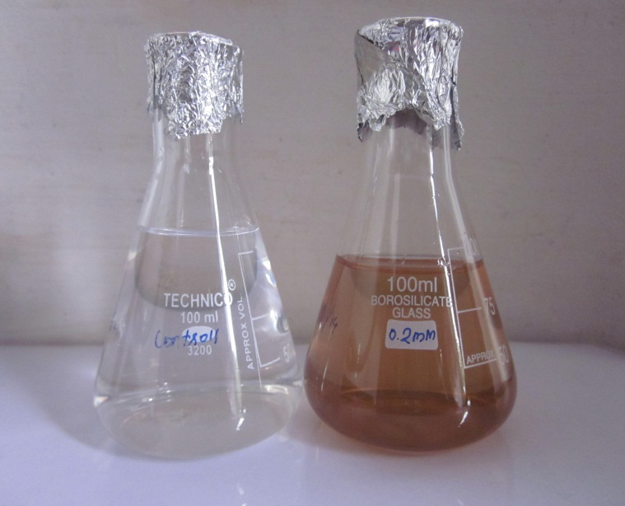

**Fig .2. Conical flasks with the aqueous extract before (left flask) and after the reaction with Ag+ for 12 hrs. (right flask).**

**4.2 Ultraviolet-Visible spectroscopy**

Silver nanoparticles are characterized with UV-Visible spectroscopy. UV-visible spectra recorded the culture supernatant *of Phormidium fragile* in reaction medium with different time intervals of reaction is plotted in a graph (Fig.3). It was observed from the spectra that the silver nanoparticles surface plasmon resonance peak occurred between 410-420 nm. UV-Visible spectrum of the colloid of silver nanoparticles has recorded as a function of time by using a quartz cuvette with silver nitrate as the reference. This technique has proved to be very useful for the analysis of metal nanoparticles (Sastry *etal.,*1998)

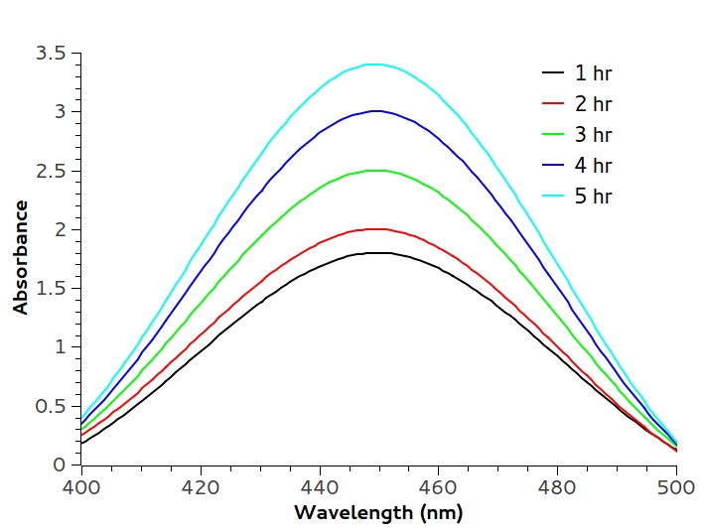

**4.3 X-ray diffraction Analysis**

Synthesis of silver nanoparticles using the culture supernatant of *Phormidium fragile* was further proved by the characteristic XRD Peaks (Fig.4). The XRD pattern shows seven peaks, the intense peaks in the spectrum of 2θ values ranging from 32.19 to 77.29 (Table. 1). XRD spectrum of crystalline silver structure have been published by the joint committee on powder diffraction standards (file no.04-0783). The diffraction at the 32.190◦,38.07◦ ,64.50◦,and77.29◦ can be indexed to the (111), (200), (220) and (311), planes of the face- centered cubic (fcc) silver, respectively .

The FWHM values measured for 111,200, 220, and 311 planes of reflection were used with Debye-Scherer equation to calculate the size of the nanoparticles. The average size of the particles was 2.6 nm. with size range from 0.023 nm to 2.2 nm. Wide angle X-ray diffraction (WAXs) was carried out for determine the structure and particle size of nanoparticles. The broadening of Bragg peaks representative of face centered cubic (fcc). Sathyavathi *et al.,* 2010). XRD pattern thus clearly showed that the nanoparticles formed by the culture supernatant of *Phormidium fragile* are crystalline in nature (Huang *et* *al*.,2007).

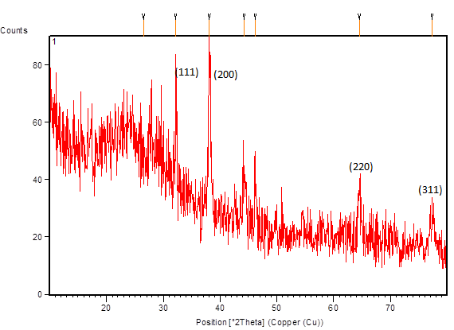**fig.4. XRD Pattern of synthesized silver nanoparticles (peaks corresponding to silver).**

**Table 1. Size of the NPs synthesized by the extract of *Phormidium fragile*.**

|  |  |  |  |  |  |
| --- | --- | --- | --- | --- | --- |
| Pos(2T◦h) | Height  (cts) | FWHM Left(2Th◦) | d spacing  (A◦) | Rel.int(%) | Size of  Silver nanoparticles(nm) |
| 6.5(2)  32.190(8)  38.072(2)  44.25(4)  46.21(3)  64.50(5)  77.29(7) | 14(2)  49(6)  42(5)  14(2)  14(3)  10(2)  9(2) | 8(1)  0.07(2)  0.39(7)  0.6(1)  0.32(8)  0.6(1)  1.0(2) | 3.35956  2.77854  2.36212  2.04505  1.96313  1.44349  1.23343 | 27.63  100.00  85.59  28.35  28.27  21.21  17.57 | 0.023  2.2  0.38  0.25  1.00  0.36  0.25 |
| Average size of the Nano particle is = 0.63 | | | | | |

**4.FTIR-Analysis** It was observe that the possible interaction between silver ions withaqueous extract of *Phormidium fragile* is shown in Fig.5.The small peak at 3919.08, 3779.94, 3692.97 were corresponding to O-HStretching.The peak at 3409.02 represent N-H (amines, amides).The small peaks at 2921.83 represent C-H (in alkanes), C=N respectively.The strong brond peaks at 1597.68 and 1383.15 were corrsponding to C=C, C-H (in alkanes) respectively. The broad bond at 1026.25 represent C-O (either, alchol etc.). The position of these bonds are close to that reported for native proteins (Golbulic *et a*l.,2000).



**Fig.5. FTIR of the band representing various functional groups.**

**4.5 Bactericidal assay**

The antibacterial activity of synthesized nanoparticles and commercially available antibiotics were carried out against *Xanthomonas oryzae.* The silver nanoparticle showed considerable zone of inhibition against *Xanthomonas oryzae.* The zone of inhibition of commercial antibiotics likeTetracyclineand Ampicillin disc showed inhibition hallow of 3.8mm and 2.9mm respectively (Table 2and fig .6).

The inhibition zone was described in mm and mean value of Triplicate. The efficiency of various silver basedantimicrobial agent in polyamide toward their silver ions release in an *aqu*eous medium was also studied. The efficiency of various silver based antimicrobial agent in polyamide toward their silver ions released in aqueous medium was also reported in number of plants including algae, yeast, fungi (Arya,2010).

**Table:2 Zone of inhibition (mm) of Nano particle against Xanthomonas oryzae**.

|  |  |  |  |  |
| --- | --- | --- | --- | --- |
| **S.NO** | **Name of the organism** | **Nano particles 10µg/ml** | **Antibiotics** | |
| **Tetracycline 10µg/ml** | **Ampicillin 10µg/ml** |
| 1. | *Xanthomonas oryzae* | 2.7 | 3.8 | 2.9 |
|  |  |

**Fig: 6 *Xanthomonas oryzae***

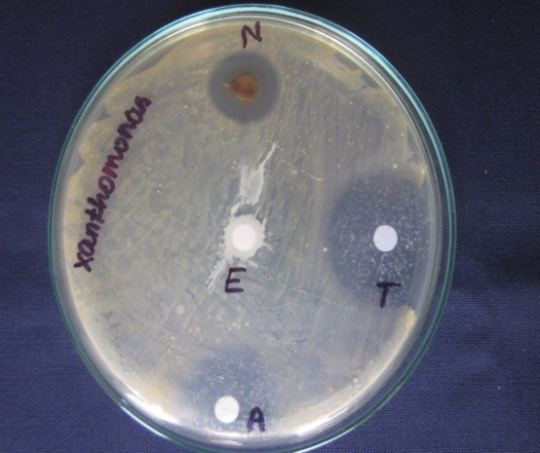

**N- Nanoparticles T – Tetracycline A – Ampicillin E- Plant Extract**

**5.Summary**

The eco-friendly process of the synthesis of nano particles is emerging into an important branch of nanotechnology. Traditionally metallic silver nanoparticles are synthesized by wet chemical synthesis techniques. Such approach uses toxic chemicals. The present study deals with the alternative, cost effective and green approach. The culture supernatant of *Phormidium fragile* is used for reduction silver ions. Synthesis of silver nano particles are usually observed by change in color of the reduction medium. The color of the medium change into brown.

In UV visible spectroscopy, the peak value increases between 440-460 nm rang , indicating the biosynthesis of nano particles. Further, the synthesized silver nano particles are confirmed by XRD The peaks at 32.19, 38.07, 64.50 and 77.29 indicates silver nano particle.

The average size of the nanoparticle is calculated using Debye Scherer formula. It was calculated that the average size of nano particles is 0.63 nm. The antibacterial activity of the synthesized nanoparticles is carried out against *Xanthomonas oryzae*. It was found that the synthesized nano particle show inhibitory effect on *Xanthomonas oryzae* , the zone of inhibition is 2.7 mm.

References

1. Jain, D.H., K. Daima., S.Kachiwaha and S.L.Kotheri.2009. Synthesis of plants mediated silver nanoparticles using papaya fruit extract an evolution of their antimicrobial activities. Digest Journal of Nanomaterials and Biostrutures. 4:557-563.
2. Golbulic.S, L.senog 2000..Early cyano bacterial record preservation 393.(41). Gole A ,C. Dash ,S.R Sainker ,A.B .Mandle ,M. Rao ,M. Sastry, Anal. Chem.72(2000)14041.
3. Taniguchi, N. 1974. On the basic concept of nanotechnology. Proc. Intl. Conf. Prod. Eng. Tokyo, Part II. Japan Society of Precision Engineering.
4. Huang J, Li Q, Sun D, Lu Y, Su Y, Yang X, Wang H, Wang Y, Shao W, He N, Hong J, Chen C. Biosynthesis of silver and gold nanoparticles by novel sundried *Cinnamomum camphora* leaf. Nanotechnology,2007; (18):105104-105114.

1. Sastry, M., V. Patil and S.R. Sanker. 1998. Electrostatically controlled diffusion of carboxylic acid derivatized silver colloidal particles in thermally evaporated fatty amine films. F Phys. Chem. B. 102: 1404-10.
2. Sathyavathi, R., M. Balamurali Krishna., S. Venugopal Rao., R. Saritha and Narayana Rao. 2010 Biosynthesis of silver nanoparticles using Coriandrum sativum leaf extract and their application in nonlinear optics. Adv. Sci Letters, 3:1-6.
3. Chopra, I.,2007. The increasing use of silver-based products as antimicrobial agents: A useful development or a cause for concern-Author response.J. Antimicrob.Chemother.,59587-590.
4. Karthick.R Ganesh s, evaluation of antibacterial activity of silver nano particles synthsisfrombacteria2011(3).131-140
5. Leela A, Vivekanandan M. Tapping the unexploited plant resources for the synthesis of silver nanoparticles. African Journal of Biotechnology, 2008;(7):3162-3165

10 .Singh, A., Jain, D., Upadhyay, M.K., Khandelwal and Verma, H.N. (2010) Green synthesis of silver nanoparticles using Ar­gemone mexicana leaf extracts and evaluation of their antimicrobial activities. Digest Journal of Nanomaterials and Biostruc­tures,5,483-48

1. Arya, v.2010, Living system eco-friendly nanoparticle Digest J. Nano meter. Biostr., 5:9-21.