Instantaneous adaptive pq theory based dstatcom with ann for harmonic extraction
Dr.D.Venugopal¹, A.Thirupathi², and Ch,Bhasker³

1Associate Professor, Department of Electrical and Electronics Engineering, Kamala Institute of Technology & Science, Singapur, Huzurabad, Karimnagar, Telangana, India. E-mail: venufacts20m@gmail.com ²Assistant Professor Department of Electrical and Electronics Engineering, Kamala Institute of Technology & Science, Singapur, Huzurabad, Karimnagar, Telangana, India³Assistant Professor Department of Electrical and Electronics Engineering, Kamala Institute of Technology & Science, Singapur, Huzurabad, Karimnagar, Telangana, India.
ABSTRACT As non-linear loads are used, the power system faces many consequences, among which the quality of power is contemplated as a major concern. Hence it is vital to deliver the power without any disturbances which paves the way for this work, here PV fed DSTATCOM is employed, which also mitigates the harmonics. Instantaneous adaptive P-Q theory-based ANN is utilized for generating the reference current and the harmonic components are extractedusingthe gating sequence of the three-phase VSI. Thus, the opposite harmonics are injected atthe point of common coupling (PCC) using three-phase VSI, therebythe active and reactive power flow in the distribution system is controlled. The proposed methodology is validated by using MATLAB simulation. Keywords: DSTATCOM; ANN;Instantaneous adaptive PQ theory; PI Controller.
I. INTRODUCTION
The standard power system is obtained by power quality (PQ) and the increase of non-linear loads in distributed system results in PQ problems. The PQ problems comprises electrical harmonics, low power factor, voltage sag or swell and flickers, among these issues’ harmonics are most harmful and it is generated by the electronic equipment’s [1] [2]. Due to harmonics, the supply voltage in distributed system is distorted and the sensitive load operation is distressed [3].To overcome these quality issues FACTS(Flexible AC transmission systems) devices are employed and through the FACTS application, the features like, power flow, stability, voltage profile, power factor and loss minimization are enhanced. The popular FACTS devices are Static Var Compensators (SVC) and Thyristor Controlled Series Capacitors (TCSC), here, the SVC is represented as shunt compensation and TCSC is represented as series compensation [4].
Initially the power quality issue is achieved by two modes of SVC (i.e. voltage regulation as well as volt ampere reactive control mode) through which the voltage is regulated as required by the system and susceptance is maintained as constant [5]. The SVC is capable of providing the reactive power rapidly and downside of SVC is slow dynamic response. Further TCSC is utilized to overcome the SVC complications, TCSC is achieved in both high voltage (HV) and extra high voltage (EHV). In power system the power flow control is enhanced by TCSC, as it limits the current by improving the voltage,through which the voltage sag is recognized [6]. The advantage of TCSC is that, it restricts short circuit current and it switches to controllable inductance from controllable capacitance and the downside of TCSC, which yield parallel resonance among the capacitors. To overcome the drawbacks of these two FACTS, Static synchronous compensator (STATCOM) [7] is utilized which increases the capacity of power transmission and in the downside of this FACTS, the energy storage is impossible. To overcome these FACTS issues, here Distribution static compensator (DSTATCOM) is used.
In power system, the reference current is generated by utilizing some theories, initially synchronous reference frame (SRF) theory is employed. SRF is achieved in series active filter, by which the reference voltage is generated for dynamic voltage restorer. However, it is easy to compute but it is extremely hard to extract the harmonics accurately [8]. Another theory, which is employed to overcome SRF issue is P-Q theory through which the active power filter is controlled and alsoit analyzes the distorted voltage issues. However, the accurate harmonics are extracted but the execution is complex [9], to overcome these both issues, adaptive P-Q theory is used.
This work presents a section of MPPT and DSTATCOM. Generally, FACTS devices are utilized to rectify the PQ issues like voltage sag and swell [10-15]. When supply is given to the load side, it produces power quality problems. To overcome this problem, DSTATCOM fed PV is used in this proposed work whichimproves power factor and reduces THD. At the DSTATCOM side, a $3Φ$ VSI is utilized which convert DC to AC. Here, a PV panel is used as DC source. An instantaneous adaptive P-Q theory-based ANN is used for the generation of current and harmonics extraction. Now, the extracted harmonics are given to PWM generator and it generates pulse which is given to three phase voltage source inverter that injects opposite harmonics to PCC and therefore it reduces harmonics in source current.
- Proposed System
The proposed block diagram comprises 3Ф AC source, PV system, Luo converter, ANN based MPPT, PWM generator and non-linear load. The proposed block diagram is depicted in Fig 1.
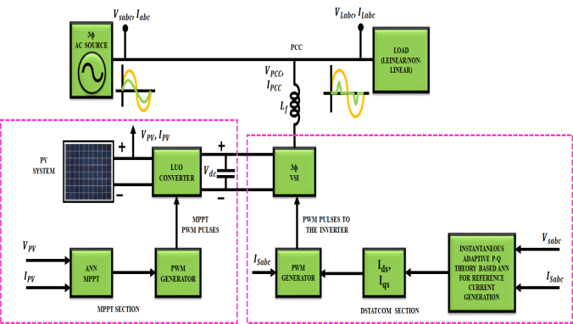
Figure 1. Proposed block diagram
A 3Ф AC supply is fed to non-linear load which produces PQ issues like voltage sag and swell. Generally, the voltage and current areinphase, but due to non-linear load, harmonic problem occurs and it affects the source current. If THD occurs above$5\%$, the life time of load and generator gets reduced. To overcome this problem, Distribution static compensator (DSTATCOM) is used. To inject harmonics at PCC, a 3Ф VSI is implemented on DSTATCOM and the PCC is connected with a 3Ф VSI through the coupling inductor. In order to give DC supply to three phase VSI, a PV panel is used. The PV panel output voltage is $120 V$ DC and this voltage is given to input of Luo converter. Due to change in temperature and intensity,the output voltage of PV panel is varied and so, by using Luo converter it will boost up the voltage to a $600V$ DC. MPPT is used to extract maximum power from PV panel. MPPT based Artificial Neural Network is used to maintain output voltage as constant. Now, this voltage is given to three phase VSI that converts DC to AC. An instantaneous adaptive P-Q theory based ANN is used for generating reference current and the harmonics extraction. Now, the extracted harmonics are given to PWM generator and it generates the pulse which is given to the three-phase voltage source inverter which injects opposite harmonics to PCC and therefore it reduces harmonics and compensates the reactive power.
II.MODELLING OF PROPOSED SYSTEM
- ANN based Instantaneous adaptive P-Q theory for reference current generation
Instantaneous adaptive P-Q theory based ANN is utilized for generating reference current and to compensate current harmonics and reactive power which are generated by non-linear loads. According to this theory, the $p-q$ powers are measured and their termsin AC and DC are instantaneously divided. The instantaneous powers are measured from $αβ$ frame and it is expressed as,
$\left[\begin{matrix}p \\ q\end{matrix}\right]=\left[\begin{matrix}v_{α} & v_{β} \\ {-v}_{β} & v_{α}\end{matrix}\right]\left[\begin{matrix}i_{α} \\ i_{β}\end{matrix}\right]$ (1)
The source voltage in $αβ$ frame is deduced by the common expression as,
$\left[\begin{matrix}v_{sα} \\ v_{sβ}\end{matrix}\right]={\left[\begin{matrix}i_{α} & i_{β} \\ {-i}_{β} & i_{α}\end{matrix}\right]}^{-1}\left[\begin{matrix}p \\ q\end{matrix}\right]=\frac{1}{{i_{α}}^{2}+{i_{β}}^{2}}\left[\begin{matrix}i_{α} & {-i}_{β} \\ i_{β} & i_{α}\end{matrix}\right]\left[\begin{matrix}p \\ q\end{matrix}\right]$ (2)
The block diagram of reference current generation system is depicted in Fig 2.
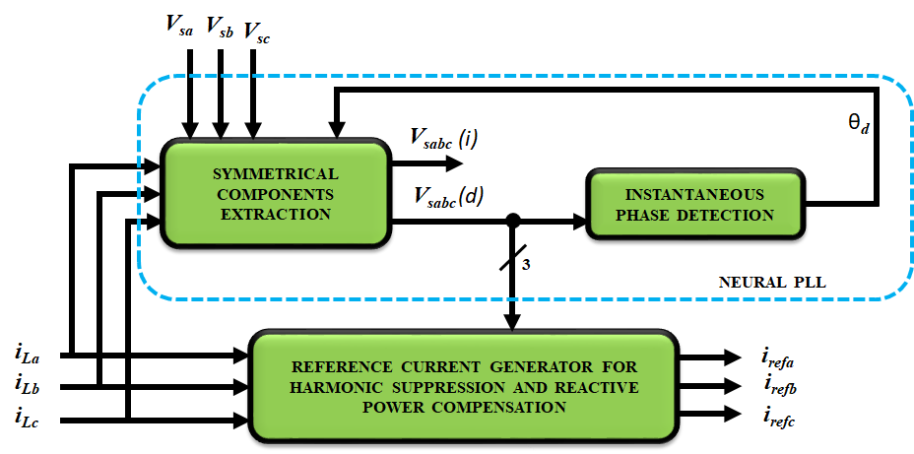
Figure2. Block diagram of reference current generation system
The symmetrical components of extraction system are depicted in Fig 3.
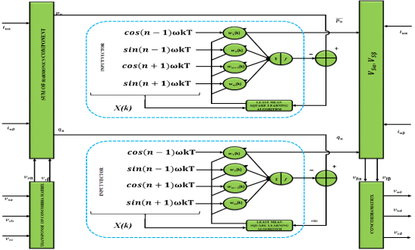
Figure3. Symmetrical components extraction system
The fundamental direct voltage element is also attained from by means of unit amplitude currents, which provides from a direct fundamental element and DC terms of associated fictitious powers.
$\left[\begin{matrix}i_{uα} \\ i_{uβ}\end{matrix}\right]=\left[\begin{matrix}\cos{ωt} \\ \sin{ωt}\end{matrix}\right]$ (3)
The fictitious powers $p_{u} and q_{u}$ are calculated from currents $i_{uα} and i_{uβ}$ and $αβ$ space voltages which is expressed in below equation.
${\left[\begin{matrix}v_{sα} & v_{sβ}\end{matrix}\right]}^{T}=\sqrt{2/3}{C_{32}}^{T}v_{abc}={T_{32}}^{T}v_{abc}$ (4)
Where the Clark and coordinate matrixes are denoted as$C_{32} and T_{32}$.
The sum of harmonics element is expressed as,
$p_{u}=v_{sα}i_{uα}+v_{sβ}i_{uβ}$ (5)
Equation (4) is rewritten with a linearly separable equation which is noted in below equation and it approximated by an ANN. It is expressed as,
$y=X^{T}W$ (6)
Where the input and weights vectors are denoted as$X and W$, Output of ANN is denoted as$y$, which is based on supervised learning. The input vector $X$ is obtained from sinusoidal signals multiple of the fundamental element. At $k^{th}$iteration, ANN’s output of $y_{k}$ is compared with desired value$p_{u}$. The error obtained is$e=p_{u}-y$, this is utilized by an optimal least mean square learning algorithm, which is used to correct weights of $w_{k}$ for the next sampling time to convergence. The $w_{k}$of $W$elements after training denotes power amplitudes that results from direct voltages at frequency $nω$ and the currents are obtained from equation (2). Finally, by transforming the first two elements of$W$, i.e. the DC parts of the instantaneous powers$p_{u} and q_{u}$, into the $αβ$voltage space with equation (1) and by multiplying them with${ T}_{32}$, the fundamental direct voltages $v_{abc}\left(d\right)$of the $3Ф$system are obtained. With the same concept, the fictitious reactive power $q_{u}$is also obtained.
- Reference current generation
In $3Ф$ systems, the instantaneous current and voltages are transformed into instantaneous space vectors. These vectors are simply transformed into $αβ$ orthogonal coordinates and it is expressed as,
$\left[\begin{matrix}i_{cα} \\ i_{cβ}\end{matrix}\right]=\sqrt{\frac{2}{3}}\left[\begin{matrix}1 & -\frac{1}{2} & -\frac{1}{2} \\ 0 & \frac{\sqrt{3}}{2} & -\frac{\sqrt{3}}{2}\end{matrix}\right]\left[\begin{matrix}i_{ca} \\ i_{cb} \\ i_{cc}\end{matrix}\right]=T_{32}\left[\begin{matrix}i_{ca} \\ i_{cb} \\ i_{cc}\end{matrix}\right]$ (7)
The instantaneous real and reactive power with AC and DC termis represented as,
$p=\overline{p}+\hat{p} ; q=\overline{q}+\hat{q}$ (8)
The DC values of $p and q (\overline{p}, \overline{q})$ are generated with positive sequence element of load current and AC values of $p and q (\hat{p} , \hat{q})$ are generated with harmonic component of load current. Now equation (23) is transformed as,
$\left[\begin{matrix}i_{α} \\ i_{β}\end{matrix}\right]={\left[\begin{matrix}v_{α} & v_{β} \\ {-v}_{β} & v_{α}\end{matrix}\right]}^{-1}\left[\begin{matrix}p \\ q\end{matrix}\right]=\frac{1}{∆}\left[\begin{matrix}v_{α} & -v_{β} \\ v_{β} & v_{α}\end{matrix}\right]\left[\begin{matrix}p \\ q\end{matrix}\right]$ (9)
Where $∆={v_{α}}^{2}+{v_{β}}^{2}$
The compensating currents ($i_{refα} and i_{refβ})$ on $αβ$ frame are measured using $-\hat{p} and-\hat{q}$ in order to compensate harmonics and instantaneous reactive power and it is expressed as,
$\left[\begin{matrix}i_{refα} \\ i_{refβ}\end{matrix}\right]=\frac{1}{∆}\left[\begin{matrix}v_{α} & -v_{β} \\ v_{β} & v_{α}\end{matrix}\right]\left[\begin{matrix}-\hat{p}+p_{dc} \\ -q\end{matrix}\right]$ (10)
Where, $p_{dc}$ is known as added power in order to attain voltage capacitor $v_{dc}$ at the side of DC inverter. The compensating reference currents in $a-b-c$ co-ordinates is expressed by the following equation are,
$\left[\begin{matrix}i_{refa} \\ i_{refb} \\ i_{refc}\end{matrix}\right]=\sqrt{\frac{2}{3}}{\left[\begin{matrix}1 & -\frac{1}{2} & -\frac{1}{2} \\ 0 & \frac{\sqrt{3}}{2} & -\frac{\sqrt{3}}{2}\end{matrix}\right]}^{T}\left[\begin{matrix}i_{refα} \\ i_{refβ}\end{matrix}\right]=T_{32}\left[\begin{matrix}i_{refα} \\ i_{refβ}\end{matrix}\right]$ (11)
In this work, the reference current signals are generated by Instantaneous adaptive P-Q theory-based ANN and this signal is given to PWM generator which compares reference signal with carrier signal and generates pulses which are given to $3Ф$ VSI through coupling inductor through which opposite harmonics are injected to PCC and therefore reduces harmonics and compensates the reactive power.
III. RESULTS AND DISCUSSIONS
The performance of proposed system is scrutinizedvia simulation in MATLAB. The harmonic reduction is achieved by means of instantaneous PQ theory with ANNand the DC-link voltage is maintained as constant. The parameters used for the simulation are given in Table 1.
Table 1 Design parameters
Parameters | Values
Input Frequency | 50Hz
Input voltage | 415V
Input Source resistor ${(R}_{s})$ | 1Ω
Input Source inductor ${(L}_{s})$ | 0.1mH
DC-link capacitance ${(C}_{DC})$ | 2200µF
Ref. Voltage ${(V}_{DC(ref)})$ | 1200V
Coupling Inductor ${(L}_{f})$ | 3mH

The AC source voltage and current waveforms are depicted in Fig 4&5 accordingly. From the Fig 4,it is noted that the input voltage of $415V$ is maintained. When this $415V$is given to a non-linear load, initially harmonics will occur in the source current and after the time of $0.04ms,$ the waveform becomes sinusoidal due to DSTATCOM whichreduces harmonics.
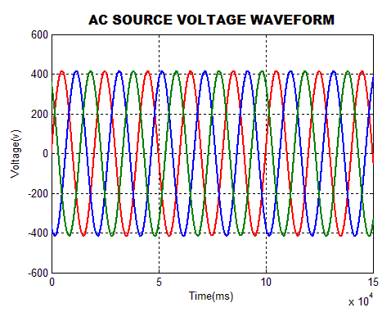  Figure4. AC source voltage waveform | 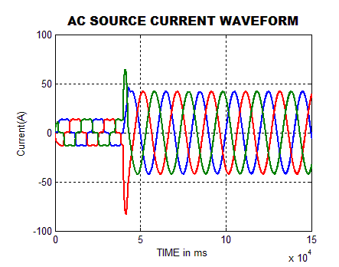  Figure5. AC source current waveform

As depicted in Fig 6, the waveform of current injected at the PCCwithout using the proposed inverter and its control circuits will contain severe harmonics due to the non-linear nature of the load. It is therefore necessary to eliminate all these harmonics by injecting the opposite phase harmonics at the PCC using the inverter circuit. The output voltage of $3Ф$ voltage source inverter is injected to the PCC via coupling inductor to reduce the source current harmonics.
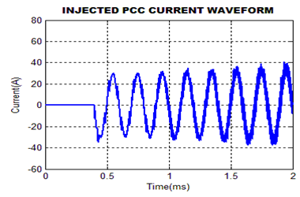
Figure6. Injected PCC current waveform
After injecting the inverter output voltage at the PCC, the Load voltage and current waveformsbecome sinusoidal is depicted in Fig 7&8 accordingly. It is also observed that the load voltage is maintained constant and after the time of $4ms,$the initially existedharmonicsin load current is disappearedthe waveform becomes sinusoidal.
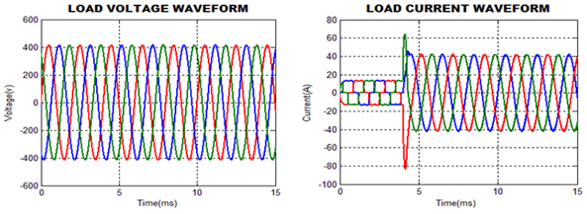
Figure7. Load voltage waveform Figure8. Load current Waveform
The input voltage and current waveform is depicted in Fig 9. From this waveform, it is observed that initially the input voltage and current are not in in-phase and after the time of$4ms,$ it becomes sinusoidal.
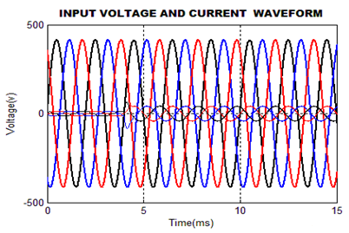
Figure9. Input Voltage and Current waveform
The Load Real and Reactive Power are depicted in Fig 10&11 respectively. The amplitude of harmonics defines the level of real and reactive powers in the line. For the given load, the real power lies above 16000W and the reactive power has the value that ranges between -170VAR to -50VAR.
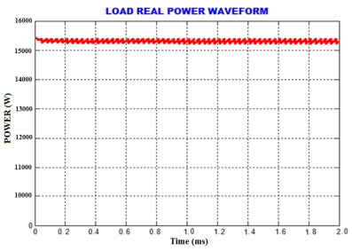  Figure 10. Waveform for Load Real Power | 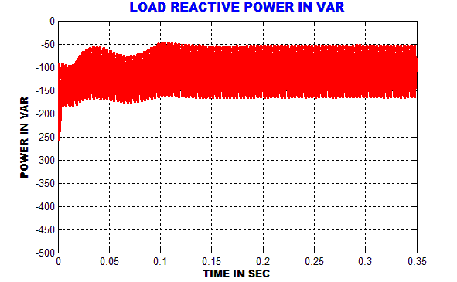  Figure 11. Waveform for Load Reactive Power

The source current THD is depicted in Fig 12. From this figure, it is observed that the THD attained in source current is$3.61\%$.
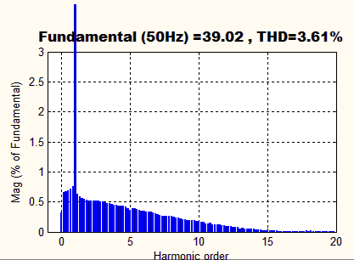
Figure12. Source current THD with ANN controller
The source voltage THD with ANN controller is depicted in Fig 13. From this figure, it is observed that the source voltage of THD with ANN controller attained is $0.68\%$.

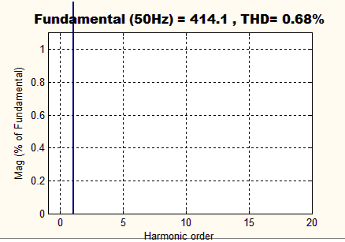  Figure13.Source Voltage THD with ANN controller | Figure14. Comparison of THD
The comparison of Total Harmonic Distortion is depicted in Fig 14.
From the Figure, it is observed that the source current THD with ANN is considered as a best when comparing to PI and FLC since it has the reduced value. The value attained is $3.61\%$.
IV. CONCLUSION
Because of the usage of non-linear loads, the power system has faced numerous disturbances and among these disturbances, harmonics is an important factor that affects the quality of power. In this work a PV fed D-STATCOM is employed for the mitigation of harmonics. The generation of reference current and harmonics are extracted by instantaneous adaptive P-Q theory and thus the gating sequence for three-phase VSI is generated. By means of three-phase VSI, opposite harmonics are injected to PCC. Thus the reactive power flow through the distribution system is controlled thereby mitigating the harmonics and compensating the reactive power. The proposed methodology is simulated using MATLAB and the results obtained are satisfactory.
V.REFERENCES
[1] Bin Zhou; Renxi Gong, Year: 2019, “Study on Pricing Method of Power Quality Differentiated Market Service in Distribution Grid”, IEEE Access, vol: 7, pp: 147021 – 147028.

[2] FarzamNejabatkhah; Yun Wei Li; Hao Tian, Year: 2019, “Power Quality Control of Smart Hybrid AC/DC Microgrids: An Overview”, IEEE Access, vol: 7, pp: 52295 – 52318.

[3] Piotr Gnaciński; Tomasz Tarasiuk; Janusz Mindy kowski; Marcin Pepliński; Mariusz Górniak; Damian Hallmann; Andrzej Piłlat, Year: 2020, “Power Quality and Energy-Efficient Operation of Marine Induction Motors”, IEEE Access, vol: 8, pp: 152193 – 152203.

[4] Huilian Liao; Sami Abdel rahman; Jovica V. Milanović, Year: 2017, “Zonal Mitigation of Power Quality Using FACTS Devices for Provision of Differentiated Quality of Electricity Supply in Networks With Renewable Generation”, IEEE Transactions on Power Delivery, vol: 32, pp:1975 – 1985.

[5] TetianaBogodorova; Luigi Vanfretti, Year: 2017, “Model Structure Choice for a Static VAR Compensator Under Modeling Uncertainty and Incomplete Information”, IEEE Access, vol: 5,pp: 22657 – 22666.
[6] Yanhong Luo; Shengnan Zhao; Dongsheng Yang; Huaguang Zhang, Year: 2020, “A new robust adaptive neural network backstepping control for single machine infinite power system with TCSC”, IEEE/CAA Journal of AutomaticaSinica, vol: 7, pp: 48 – 56.

[7] Rajiv K. Varma; HesamaldinMaleki, Year: 2019, “PV Solar System Control as STATCOM (PV-STATCOM) for Power Oscillation Damping”, IEEE Transactions on Sustainable Energy, vol: 10, pp:1793 – 1803.

[8] Kangante Vishal; Vijayaganesh R, Year: 2018, “An Improved SRF-Theory Based Controller Applied to Three Phase Grid Interfaced PV-System for Power Quality Improvement and Islanding Detection”, 2018 IEEE Innovative Smart Grid Technologies - Asia (ISGT Asia), Conference Paper, pp:1-6.

[9] Asim Datta; RishirajSarker; Imraj Hazarika, Year: 2019, “An Efficient Technique Using Modified p–q Theory for Controlling Power Flow in a Single-Stage Single-Phase Grid-Connected PV System”, IEEE Transactions on Industrial Informatics, vol: 15, pp:4635 – 4645.
[10] Vedik B, Naveen P and Shiva C K 2020 A novel disruption based symbiotic organisms search to solve economic dispatch Evol. Intel. https://doi.org/10.1007/s12065-020-00506-5
[11] Nandi M, Shiva C K, and Mukherjee V, 2019 Moth-Flame Algorithm for TCSC-and SMES-Based Controller Design in Automatic Generation Control of a Two-Area Multi-unit Hydro-power System Iranian Journal of Science and Technology, Transactions of Electrical Engineering, 1-24.
[12] Mudi J, Shiva C K, and Mukherjee V 2019 Multi-verse optimization algorithm for LFC of power system with imposed nonlinearities using three-degree-of-freedom PID controller Iranian Journal of Science and Technology, Transactions of Electrical Engineering 43(4) 837-856.
[13] Dr Chandan: Nandi, M., Shiva, C. K., & Mukherjee, V. (2019). A moth–flame optimization for UPFC–RFB-based load frequency stabilization of a realistic power system with various nonlinearities. Iranian Journal of Science and Technology, Transactions of Electrical Engineering, 43(1), 581-606.
[14] Dr Chandan: Nandi, M., Shiva, C. K., & Mukherjee, V. (2019). Moth-Flame Algorithm for TCSC-and SMES-Based Controller Design in Automatic Generation Control of a Two-Area Multi-unit Hydro-power System. Iranian Journal of Science and Technology, Transactions of Electrical Engineering, 1-24
[15] H. P. Vemuganti, S. Dharmavarapu, S. K. Ganjikunta, H. M. Suryawanshi and H. Abu Rub. (2020) A Survey on Reduced Switch Count Multilevel Inverters. IEEE Open Journal of the Industrial Electronics Society, doi: 10.1109/OJIES.2021.3050214.

