Synthesis and Characterization of MoO₃ Nanorods
Neha Desai, Rajesh Kavade
Department of Chemistry, K.B.P. Mahavidyalaya Pandharpur
Email id of corresponding author :- nehadesai323@gmail.com
Abstract:-
In the present investigation we have synthesised MoO₃ nanoparticles by chemical bath deposition. The synthesised MoO₃ nanoparticles are well indexed to hexagonal crystal structure. The morphological study reveals presence of nanorods with hexagonal crystal structure. The optical study shows direct allowed band gap with absorption in ultra violet region. The compositional analysis shows presence of molybdenum and oxygen in the synthesised nanoparticles.
Keywords :- MoO₃, CBD, nanorods
Introduction:-
Recently, the transition metal oxides (TMOs) attracting a great deal of attention in the field of material science due to its variety of crystal phases and properties. The nano crystalline transition metal oxides such as TiO₂, MoO₃ and ZnO are most widely studied by various researchers all over the world. Among the transition metal oxides Molybdenum trioxide (MoO₃) exhibit better intercalation chemistry with unique chemical, electrochemical, electronic and catalytic properties.
MoO₃ is the most produced product of molybdenum worldwide than any other molybdenum compound due to the comparative instability of molybdenum oxides of lower oxidation states.
The MoO₃ exhibits variety of crystal phases such as orthorhombic (α-MoO₃) and hexagonal (h-MoO₃). From these two hexagonal form of MoO₃ is metastable which orthorhombic form of MoO₃ is thermodynamically more stable than any other form.
Molybdenum trioxide (MoO₃) exhibits excellent structural, chemical, electrical, catalytic, and optical properties . They possess a perovskite-like structure which makes them a suitable candidate for optoelectronic applications. Several studies were carried out to know more about the optical, structural and morphological properties of MoO₃. Potential applications of MoO₃ include sensors, catalysts, fuel cells, solar cells, supercapacitors, memory devices, etc.
Experimental:-
Chemical bath deposition method is used for the synthesis of MoO3 nanomaterials. In a typical synthesis ammonium heptamolybdate tetrahydrate (AHM) and conc. Nitric acid (HNO3) is used as a precursor for the reaction.
In a experimental setup, 15ml of 0.05M AHM solution was taken in reaction bath. The temperature of solution was increased slowly up to 50⁰ C by using heating mantle. To this 5ml of concentrated HNO₃ was added in a drop wise manner with constant stirring to obtain a clear solution. This clear solution was then stirred for 15 minutes and temperature of the reaction bath was maintained to 70⁰ C for 30 minutes to obtain the yellowish white coloured precipitate of h –MoO₃. Then the reaction mixture was cool at room temperature. Finally, the precipitate of h-MoO₃ was filtered by Buchner funnel using whatman filter paper no 42. Then the precipitate was washed with hot distilled water and product was dried in muffle furnace at 50⁰ C for 2 hours.
Growth and reaction mechanism:-
The growth of nanoparticles by CBD follows Ostwald ripening law. According to the Ostwald ripening law, the number of smaller crystallites sacrifices themselves to form larger crystallites. As a result of this initially the seed nuclei is formed by using the Ostwald ripening. After this these seed nuclei combine to form a multi-nucleation centres. The uniform growth of the nanoparticles is possible due to ripening of multi-nucleation centres. Hence to obtain a desired morphology control over the process of nucleation or growth is the most important aspect. Hence by controlling the parameters of CBD we have obtained the growth of nano rods for the MoO₃. The nano rods are 1D in nature with hexagonal cross section. The 1D nanomaterial is having a higher surface area. Hence they show a better catalytic activity. The reactions which are taking place are as follows,
Optical study :
In order to study optical properties of MoO₃, optical absorption of h-MoO₃ and α-MoO₃ is recorded on UV spectrophotometer in range 190 to 700nm, the absorption spectra clearly indicates that MoO₃ is active in UV region. The band gap for MoO₃ samples are calculated by the classical absorption equation. It is found that the λ_{max} value for h-MoO₃ is 280nm and for α-MoO₃ λ_{max} is 300nm. From λ_{max} values of both the samples it is clear that the band gap for MoO₃ is near about 3eV. From this we can conclude that MoO₃ is wide band gap semiconductor material.
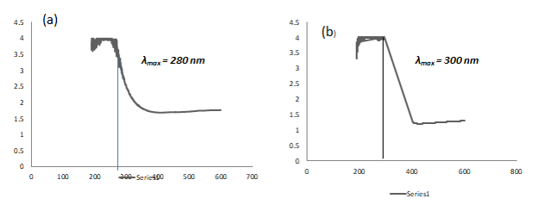

Fig 1 : (a) Graph of h- MoO₃ ( Wavelength vs Absorbance) (b) Graph of α MoO₃ ( Wavelength vs Absorbance).

Structural study :
The structural study aspects of MoO₃ nanoparticles was determined by using X-Ray diffraction. XRD pattern of the samples h-MoO₃ is shown in figure 2,
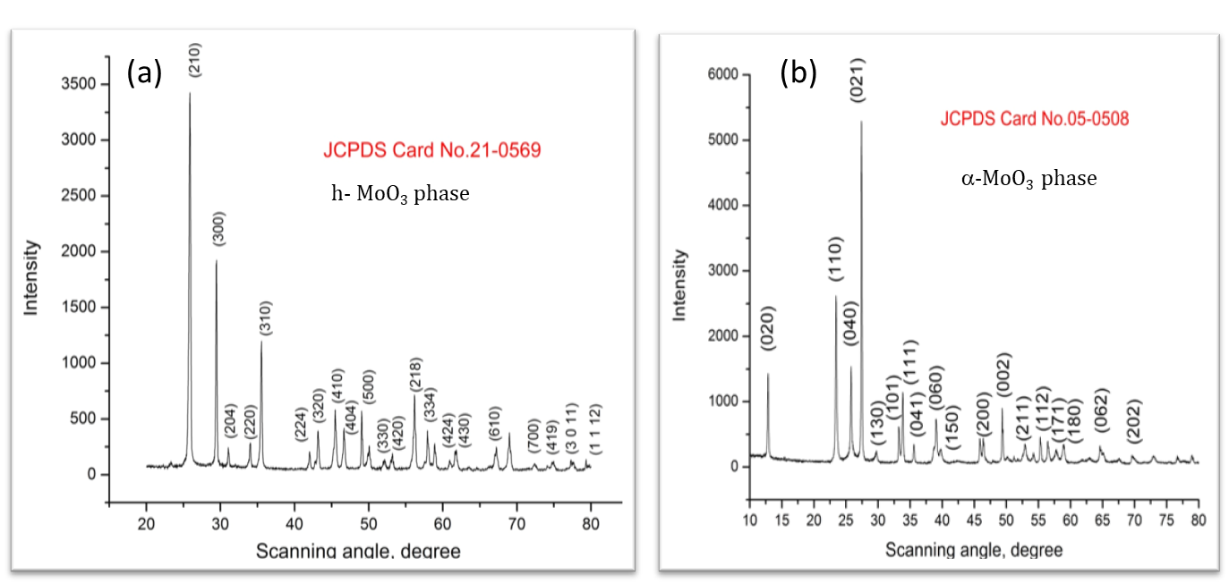
Fig 2. XRD pattern of h-MoO₃
The crystal structure and phase identification of MoO₃ sample was carried out by using X-ray diffraction analysis. Here we have synthesized h-MoO₃ nanoparticles. All the peaks in the XRD are well indexed to the JCPDS card no. 21-0569. No extra peaks due to impurity are seen.
The crystallite size is calculated by using equation,
D= 0.9λ/βCosƟ
The crystallite size is calculated by using most intense (210) peak. The crystallite size of h-MoO₃ is 35nm.

Morphological study :-
Morphology of nanomaterials plays a crucial role in physical and chemical properties of nanomaterials. To study the morphological aspects of MoO₃ nanopaticles. The surface morphology of both h-MoO₃ was characterize by SEM analysis. Figure below clearly indicates presence of 1D hexagonal rods. All the nanorods are assembled together to form nanoflower like structure. The size of each nanoflower is about 1 micron.
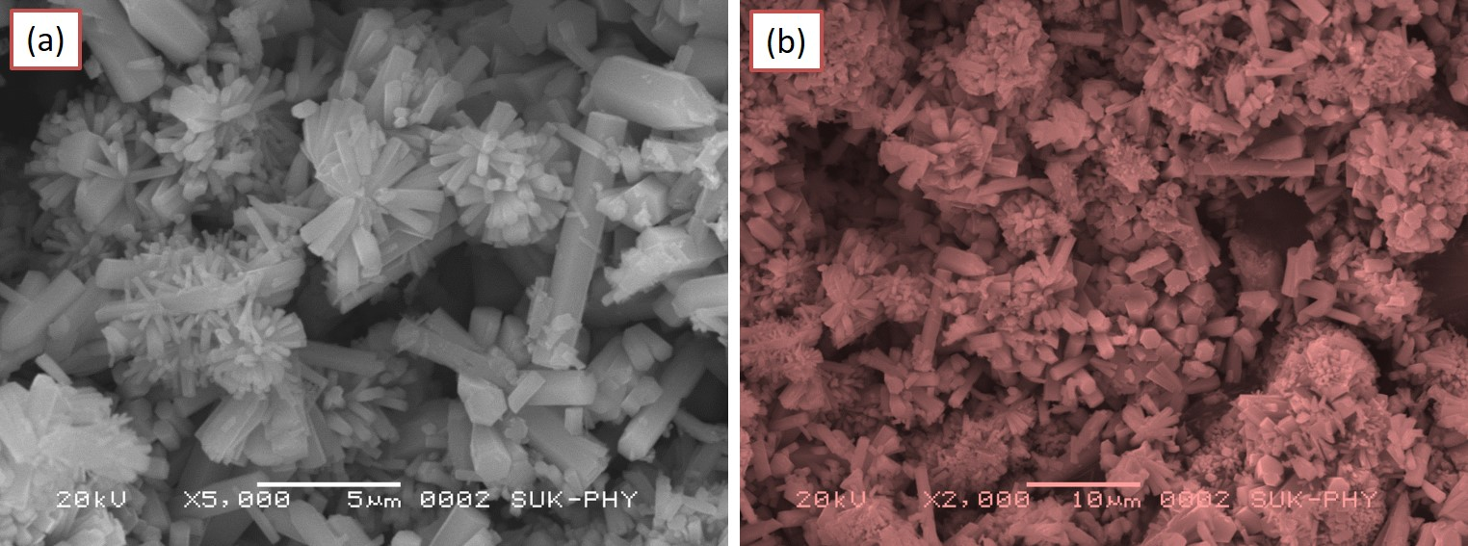
Fig.3 SEM micrographs of MoO3 nanorods

Compositional analysis:-
In order to confirm the composition of a nanomaterial EDS analysis is carried out. The presence of Mo and O in synthesised nanopowder is shown in the EDS spectra.
The observed and actual atomic percentage is in good agreement.

EDS spectrum of MoO3 thin film

Conclusions:-
The MoO₃ nanopowder is synthesized by chemical bath deposition. The structural study shows hexagonal crystal structure. The SEM micrographs reveals nanorod like structure. The EDS spectra confirms presence of molybdenum and oxygen. The optical study reveals the absorption in the Ultra violet region. All these properties reveals that MoO3 is a better candidate for gas sensing .
References:-
- Trans. Nonferrous Met. Soc. China 33(2023) 2155−2167.
- Results in OpticsVolume 11, May 2023, 100374
- Int. J. Electrochem. Sci., 15 (2020) 9824 – 9837.
- Materials Science in Semiconductor ProcessingVolume 150, 1 November 2022, 106974
- International Journal of Hydrogen Energy Volume 47, Issue 47, 1 June 2022, Pages 20475-20493
- Arabian Journal of Chemistry Volume 15, Issue 9, September 2022, 104083

Reference id - IIPER1655365759.

