Spray pyrolyzed prepared thin films of tetragonal indium sulfide

Syed Ghause Ibrahim
Department of First-Year Engineering
Prof. Ram Meghe College of Engineering & Management, Badnera-444701, M.S, India
M. M. Hasan Farooqi
Department of Applied Science and Humanities, Jamia Millia Islamia,
New Delhi 110025, India

ABSTRACT
In today's era of technology and research, nanotechnology plays a vital role. In every field, the structures are becoming miniature, which reduces the circuit size and cost but effectively increases the working efficiencies. In this regard, nanostructured thin films have great importance due to their numerous and outstanding applications in the field of optoelectronic devices as they retain extraordinary properties related to electronic and optical fields. In the present research, indium sulfide (In₂S₃) films were grown on glass substrates by the spray pyrolysis technique. The deposited films are nanocrystalline with a tetragonal lattice with a preferred orientation (2 0 6) and a direct bandgap of 2.80 eV. The as-deposited films have an electrical resistivity ranging from 10⁴ Ω.cm. The In₂S₃ thin films have n-type conductivity as confirmed by thermo-emf studies.
Keywords - Nanostructured thin films; Optical characterization; Electrical characterization.

INTRODUCTION

In today’s research scenario, thin films of indium sulfide play a vital role in numerous scientific and technical applications due to their important photo-conducting properties, large bandgap, and constancy. Indium sulfide is an III-VI semiconductor material. Depending on temperature and pressure, it can take various polymorphic structures like alpha (α), beta (β), and gamma (γ) depending on the operational parameters. As compared to α and γ, at room temperature, β- In₂S₃ is the most stable structure. As reported by Bube, “β- In₂S₃ is an n-type semiconductor with a direct bandgap of 1.98 eV” [1].
In a stoichiometric In₂S₃ crystal, the degree of disorder is high due to its complicated structures, which made this material makes useful in different fields [2]. T. Theresa John et al. [3], “fabricated cells with a single layer of CuInS₂ and a double layer of In₂S₃ using CSP technique with Ag electrode. The layer of silver-coated on the surface of the In₂S₃ buffer layer helped in improving the crystallinity of the In₂S₃ layer which might result in the better collection of photogenerated carriers at the electrode”. According to M. Calixto-Rodriguez et al. [4], the deposited indium sulfide thin films have a bandgap of 2.04 eV with negative type conductivity and these films can be used in photovoltaic heterojunction devices for making window material. P.O’Brien et al. [5] used a low-pressure metal-organic chemical vapor deposition technique for the deposition of α-In₂S₃. They also reveal that precursors play a vital role while determining steps in the deposition process, irrespective of the optimized parameters such as used substrate, temperature, etc. K. Hara et al. [6] suggested that metal sulfides can be used for different applications in optoelectronics, photovoltaic, and photoelectrochemical solar cell devices as inorganic semiconductor materials.
S. Rasool et al. [7] implemented a thermal evaporation technique to deposit films of In₂S₃ using a glass substrate and studied the optical properties which reveal that the films at 300ºC have good crystal structure with consistent morphology with a bandgap of 2.74eV. According to Cherian et al. [8], if an appropriate amount of chlorine is doped in β-In₂S₃ thin ﬁlm, high photosensitivity can be achieved due to which the resultant material can be used in various photovoltaic implementations. Yahmadi et al. [9] observed that the deposition parameters as well as substrate annealing temperature intensely affect the film deposition. The films obtained by them were homogeneous and crystalline when annealed at 400°C. Using the chemical bath deposition technique; Meng et al. [10] deposited n-type cubic structured indium sulfide thin films.
Mari et al. [11] electrochemically deposit tetragonal phased thin films and utilize them as a buffer layer in place of CdS in photovoltaic devices. Hsiao et al. [12] deposited tetragonal In₂S₃ on the p-Si substrate by chemical bath deposition method with a bandgap of 2.5 eV. Sall et al. [13] deposited β- In₂S₃ thin films on the ITO glass substrate by varying the temperature and reported that the films have a tetragonal phase and the films deposited at 300°C has higher transmittance value and a bandgap of 2.95eV. By using the thermal evaporation technique, Chander et al. [14] deposited thin films of indium sulfide and study the electrical, structural, and optical properties by changing thickness. They reveal that deposited films have an amorphous phase but as they increase the film thickness the phase changes to crystalline. Similarly, the refractive index and conductivity increase while the excitation coefficient and resistivity decrease with thickness. Currently, different techniques were used for In₂S₃ film deposition. There are different works from different researchers that confirm that there is a remarkable influence on the performance with respect to the deposition used. Films deposited by physical vapor deposition show negative type conductivity and have a bandgap of 2.80 eV [15].
Puspitasari et al. [16] utilized a chemical bath deposition technique to deposit indium sulﬁde films and reports n-type conductivity with polycrystalline nature and cubical lattice having a bandgap of 2.84 eV. Spiering et al. [17], adopted the atomic layer chemical vapor deposition method was used to deposit indium sulﬁde films that replace cadmium film as a buffer layer in thin-film solar cells. The thermal evaporation technique was used by Timoumi et al. [18] for the deposition of indium sulﬁde films which they have used as a substitute for cadmium sulﬁde film which may be implemented as buffer coating in thin-film solar cell technologies.
In regards to finding a replacement for buffer material (cadmium sulfide) in Cu(In,Ga)Se₂ solar cell, indium sulﬁde films were deposited using ultrasonically sprayed layers, and different parameters were studied by Ernits et al. [19]. Rahman et al. [20] report the studies of physical properties of spray deposited In₂S₃ thin films at 300°C using glass substrates and also reveal that if the temperature is further increased, the decreases in the bandgap to 2.50eV from 2.90eV is observed. The spray-deposited films prepared by Soro et al., show the value of the bandgap as 2.90 eV and this value decreases to 2.45 eV when deposited by the electrochemical deposition method [21, 22]. Barreau et al. [23] utilized the physical vapor deposition method to deposit n-type indium sulfide films with a variation in bandgap from 2.1eV to 2.9 eV concerning oxygen percentage. Yaxin Ji et al. [24] investigated the photoconductive properties and physical properties with the impact of thickness variation in single-phase β-In₂S₃ films fabricated using RF magnetron sputtering.
In the current research work, indium sulfide (In₂S₃) thin ﬁlms were deposited by simple and low-cost spray pyrolysis method at 573K, and the composition-dependent structural, morphological, optical, and electrical characterization were studied.

EXPERIMENTAL DETAILS

Researchers are more focused on the development of cost-effective deposition techniques to deposit thin films. Spray pyrolysis has been utilized since 1982. Bates et al. deposited thin films (about 1μm) of CuInSe2 by spray pyrolysis [22], as it is a continuous, controllable, and economical process for the preparation of nanoparticles. From this point of view in the present research work, a simple, economical spray pyrolysis deposition method is used for the deposition of thin films of indium sulfide (In₂S₃).
Indium sulfide (In₂S₃) thin films were prepared on the non-conducting glass as substrate using a precursor solution containing thiourea (CH₄N₂S), indium (III) chloride (InCl₃) dissolved in doubled distilled water. The solution prepared by adding 20 mL of 0.1M indium chloride to 20 mL of 0.2M thiourea in a measuring cylinder was of stable phase. Aqueous solutions of 0.2M CS(NH₂)₂ and 0.1M (InCl₃.4H₂O) were used as sources for S and In, respectively. Substrate cleaning plays an important role in obtaining good-quality of adhesive film. If the substrate is not cleaned properly the unclean oleaginous substrate results in non-uniform and non-adhesive thin film deposition.
The substrates were commercially available micro-glass slides having a size of 26 × 76 × 2 mm³ that were kept in a beaker containing chromic acid and boiled for 30 minutes, and then these glass slides were washed thoroughly with liquid detergent and acetone. At last, these glass slides were cleaned ultrasonically with double distilled water for at least 10 minutes before the start of the deposition process.
While depositing the film, the spray flow rate is one of the most important parameters and it must be optimized exactly because the film deposition on substrate depends on this factor. In the present work, the optimized value of the spray flow rate is found to be 3mL/min. The total solution sprayed was 10 mL in volume. The deposited films show cracks and irregular deposition if the spray rate exceeds the optimized value of flow rate and if these values are lower than the optimized value the deposited films are uneven/broken due to inadequate amount of solution sprayed.
Several trials were carried out for optimizing different parameters (Table 1), such as the temperature of the substrate, flow rate, spray solution volume, etc. [25]. The distance between the substrate and nozzle was kept 25 cm while the optimized temperature was found to be 573 K for film deposition.
The gravimetric weight difference method was used for the determination of the thickness of the film which is found to be 210 nm. Structural analysis was carried out using an X-ray diffractometer (PANalytical X’Pert Pro) with CuKα radiations of wavelength 1.5404Å surface morphological investigations were done by using JEOL-6380A scanning electron microscope. Perkin Elmer (Lambda 25 UV-VIS spectrophotometer) was used for the determination of the optical properties of the as-deposited thin films.
Table1: Optimized preparative parameters

Name of Parameter | Optimized value
Composition of spray solution | 20 mL,0.1 M Indium chloride + 20 mL, 0.2 M Thiourea
Nature of substrate | Amorphous glass
Substrate temperature | 573 ±5K
Spray rate | 3 mL /min
Spray nozzle diameter | 0.5 mm
Nozzle to substrate distance | 25 cm
Compressed air pressure | 2.5 kg/cm²

- RESULT AND DISCUSSION
- Structural properties
X-ray diffractometry is a well-known process for the determination of structural patterns of deposited materials. In the existing investigation, indium sulfide thin films were chemically deposited on a nonconducting glass substrate. A multipurpose X-ray diffractometer (PANalytical X’Pert Pro) with CuKα radiations of wavelength 1.5404Å is used.
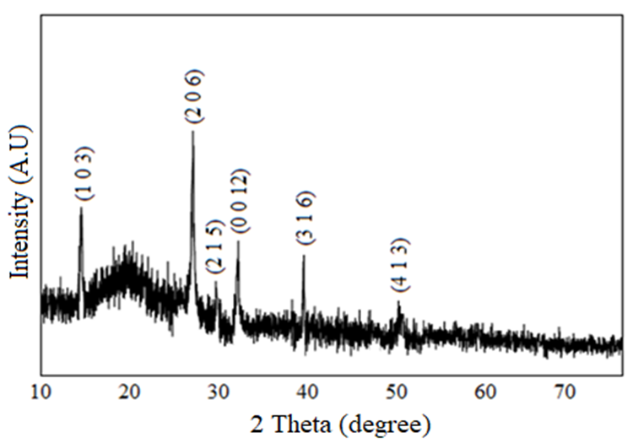
Figure1: XRD pattern of In₂S₃ thin films

Figure 1 shows the structural pattern of indium sulfide thin films which reveals the existence of (103), (206), (215), (0012), (316), and (413) peaks with tetragonal structure and having the preferred orientation along (206) plane and reflects on its texture which is very uniform and highly oriented. The appearance of X-ray reflections at 2θ=14.015°, 28.915°, 29.469°, 33.191°, 41.001°, and 50.101° is in correlation with JCPDS (25-0390) standards as shown in Table 2.
For calculating the grain size full-width half-maximum data was used. Then the values are put in Debye Scherrer’s formula [26]. The obtained value of crystallite size for the ﬁlms was 39 nm.

D = Kλ/βCosθ ------- (1)

Where D is grain size, λ is X-ray wavelength (0.154 nm), β represents full width-at-half-maximum, θ denotes Bragg’s angle respectively.

Table 2: Comparison of observed and standard XRD data of In₂S₃ thin films (JCPDS card 25-0390)

Film | Observed data |  | Standard data |  | h k l | Phase
 | 2θ (degree) | d (Å) | 2θ (degree) | d (Å)
In₂S₃ | 14.015  28.915  29.469  33.191  41.001  50.101 | 6.321  3.006  3.131  2.741  2.209  1.769 | 14.250  28.662  29.604  33.228  41.010  50.039 | 6.210  3.112  3.015  2.694  2.199  1.821 | 1 0 3  2 0 6  2 1 5  0 0 12  3 1 6  4 1 3 | Tetragonal  Tetragonal  Tetragonal  Tetragonal  Tetragonal  Tetragonal

Surface morphology

To study the surface morphology of the film, scanning electron microscopy is the most suitable technique. It gives microscopic information on the surface topography.

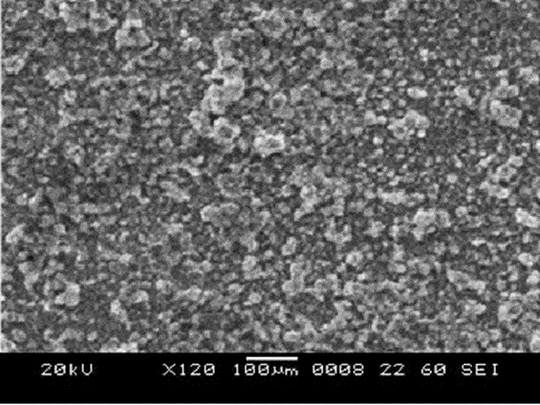

Figure 2: SEM micrographs of In₂S₃ thin film

Figure 2 shows the surface micrographs of In₂S₃ thin film, the deposited films were well-covered, homogeneous, dense, continuous, and compact with no cracks or voids Tiny grains were observed which may be the results of the quick crystallization between the precursors during the film drying. The average grain size was found to be 47.61nm.

Optical properties

For the determination of the optical properties of In₂S₃ thin films, Perkin Elmer (Lambda 25 UV-VIS spectrophotometer) was utilized in the wavelength ranging from 300nm to 1100nm. Figure 3 shows the graph plotted between variations of optical absorption versus wavelength.

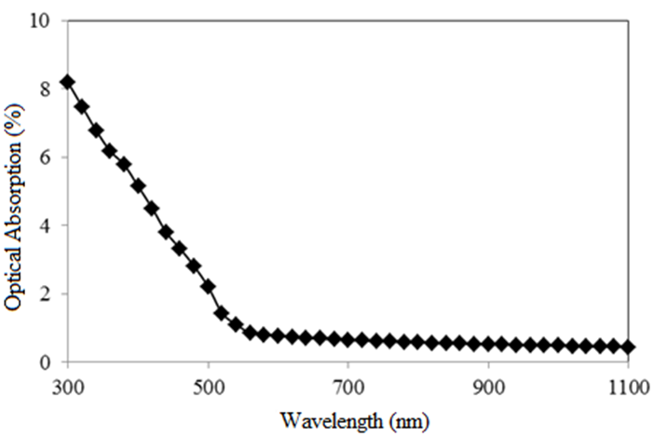

Figure 3: Variation of optical absorption vs. wavelength for spray deposited In₂S₃ thin film

The graph of (αhυ)² versus photon energy (hυ) plotted for direct transition (Figure 4) and optical bandgap was determined as using the formula,

αhυ = A(hυ – Eg)n --------- (2)

“Where “hυ” denotes the energy of a photon, “Eg” represents bandgap energy, and “A” and “n” are constants. As we know, the values of n = 1/2 for direct allowed transitions, n = 2 for indirectly allowed transitions, and n = 3/2 for directly forbidden transitions.” [26]

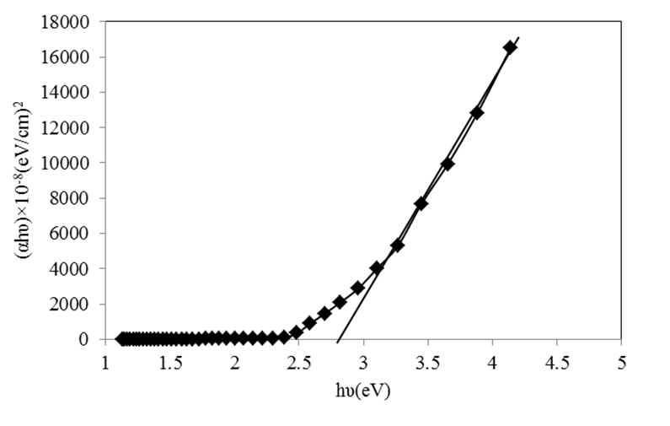

Figure 4: Plot of (αhυ)² versus hυ for spray deposited In₂S₃ thin film

From above Figure 4 direct transition is observed with a bandgap of 2.80 eV, hence we can say that In₂S₃ is a wide bandgap semiconductor material due to which they may be used for making high temperatures and high-power operated devices.

Electrical properties

The electrical properties of materials are the ability to conduct electrical current. Electrical properties are further separated as the resistivity of the material, the conductivity of the material, the temperature coefficient of the material, material dielectric strength, and thermoelectricity. “The two-probe method is one of the standards and most commonly used methods for the measurement of resistivity for very high resistive samples like sheets/ﬁlms of polymers” [26]. From Figure 5, we say that the I–V characteristics obtained are linear in nature.

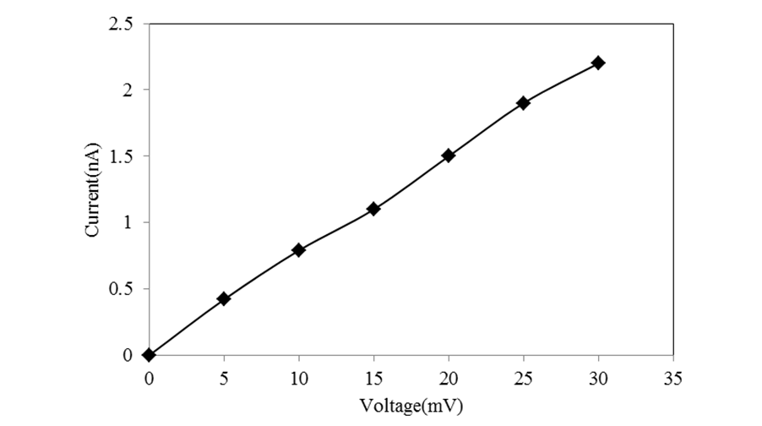
Figure 5: I-V characteristics of spray deposited In₂S₃ thin films

By varying the temperature from 303K to 483K the relation between resistivity with temperature for In₂S₃ thin ﬁlms was studied. It was observed that an increase in the temperature is indirectly proportional to resistivity which shows the semiconductor behavior of the material [14]. At room temperature, the value of electrical resistivity is 10⁴ Ω cm, which was found to be closer to the values reported [2, 23, 27] while the value of resistivity reported by M. Kundakci et.al [28] and R.Yoosuf et.al [29] is greater than that of the deposited film which may be due to deposition temperature and thickness of the film.

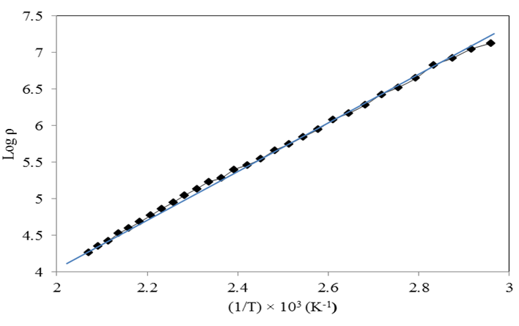

Figure 6: Variation of Log of resistivity with 1/T for spray deposited In₂S₃ thin film

The electrical conductivity in the as-deposited thin film may be due to the thermal excitation of electrons, present impurities, and lattice defects or may be due to the influence of the utilized deposition methods, the temperature of the substrate, film thickness, and cationic and anionic concentrations.

Figure 6 shows the graph between the log of resistivity with (1/T). The thermal activation energy was calculated by,

ρ = ρ_(0 ) 〖exp〗^((E_0⁄kT) ) --------- (3)

Where “ρ” denotes resistivity, “ρ₀” is a constant, and Boltzmann constant “k”. From the calculations, the activation energy (E₀) was found to be 0.063 eV which also shows the dependence on the deposition process and deposition temperature.

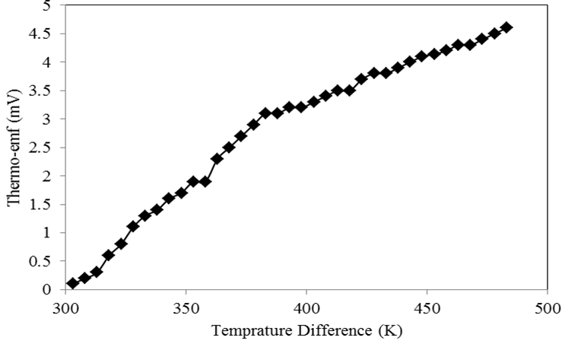
Figure 7: Variation of thermo emf (mV) with temperature difference for spray deposited In₂S₃ thin film

Thermo-electric power (TEP) was evaluated in the current investigation as a function of temperature in the range of 304-483K (Figure 7). The polarity of the thermoelectric voltage indicates that the films exhibit n-type conductivity, which is in good agreement with the findings that have been reported [10, 30].

CONCLUSION

We conclude that, indium sulfide (In₂S₃) films were grown by spray pyrolysis technique on glass substrates. The films are nanocrystalline with tetragonal lattice having preferred orientation (2 0 6) and exhibit a direct bandgap of 2.80 eV. The as-deposited films have electrical resistivity ranging to 10⁴ Ωcm. The In₂S₃ thin films are having n-type conductivity which was confirmed by thermo-emf studies. This amalgamated alloy compound might be ecologically pleasant and appropriate as a potential buffer layer in the manufacturing of heterojunction solar cells due to which we can achieve greater efficiency at an economical cost and which may also be useful in optoelectronic devices in the future.

REFERENCES

- R.H. Bube, Photoconductivity in indium sulfide powders and crystal, J. Phys. Chem. Solids, 10 (1959) 333-335
- M. Mathew, R. Jayakrishnan. P.M.R. Kumar. C. Sudha Kartha, K.P. Vijayakumar, Y. Kashiwaba, T. Abe, Anomalous behavior of silver doped indium sulfide thin films, J. Appl. Phys., 100 (2006) 33504 DOI: 10.1063/1.2221531
- T.T.John, M.Mathew, C.S.Kartha, K.P.Vijayaku.T.Abe, Y.Kashiwaba, CuInS2/In2S3 thin-film solar cell using spray pyrolysis technique having 9.5% efficiency, Sol. Energy Mater. Sol. Cells 89(1) (2006) 27-36 DOI:10.1016/j.solmat.2004.12.005
- M. Calixto-Rodriguez, A. Tiburcio-Silver, A. Ortiz, A. Sanchez-Juarez, Optoelectronical properties of indium sulfide thin films prepared by spray pyrolysis for photovoltaic applications, Thin Solid Films 480–481 (2005) 133-137 DOI:10.1016/j.tsf.2004.11.046
- P.O’Brien, D.JOctway, J.R.Walsh, Novel precursors for the growth of α-In2S3: trisdialkyldithiocarbamates of indium, Thin Solid Films Thin Solid Films, 315(1-2)(1998) 57-61 DOI:10.1016/s0040-6090(97)00691-3
- K.Hara, K.Sayama, M.Arakawa, Semiconductor-sensitized solar cells based on nanocrystalline In2S3/In2O3 thin-film electrodes, Solar Energy Materials and Solar Cells, 62(4)(2000)441–447 DOI:10.1016/s0927-0248(00)00027-1
- S. Rasool, K. Saritha, K.T. Ramakrishna Reddy, K. Raveendranath Reddy, L. Bychto, A. Patryn, M. Maliński, M.S. Tivanov, V.F. Gremenok Optical properties of thermally evaporated In2S3 thin ﬁlms measured using photoacoustic spectroscopy, Materials Science in Semiconductor Processing 72 (2017) 4–8 DOI: http://dx.doi.org/10.1016/j.mssp.2017.09.009
- A.S. Cherian, M. Methew, C.S. Kartha, K.P. Vijayakumar, Role of chlorine on the optoelectronic properties of β-In2S3 thin ﬁlms, Thin Solid Films 518 (2010) 1779–1783 DOI:10.1016/j.tsf.2009.09.031
- B. Yahmadi, N. Kamoun, R. Bennaceur, M. Mnari, M. Dachraoui, K. Abdelkrim, Structural analysis of indium sulfide thin films elaborated by chemical bath deposition, Thin Solid Films 473 (2005) 201–207 DOI:10.1016/j.tsf.2004.04.002
- X. Meng, Y. Lu, X. Zhang, B. Yang, G. Yi, J. Jia, Fabrication and characterization of indium sulfide thin films deposited on SAMs modified substrates surfaces by chemical bath deposition, Appl. Surf. Sci. 258 (2011) 649–656 DOI:10.1016/j.apsusc.2011.07.036
- B. Mari, M. Mollar, D. Soro, R. Henriquez, R. Schrebler, H. Gomez, Electrodeposition of In2S3 Thin Films onto FTO Substrate from DMSO Solution, J. Electrochem. Sci. 8 (2013) 3510-3523
- Y.J. Hsiao, C.H. Lu, L.W. Ji, T.H. Meen, Y.L. Chen, H.P. Chi, Characterization of photovoltaics with In2S3 nanoflakes/p-Si heterojunction, Nanoscale Research Letters, 9(1)32(2014) 1-7 DOI:10.1186/1556-276x-9-32
- T. Sall, B.M. Soucase, M. Mollar, B. Hartitti, M. Fahoume, Chemical spray pyrolysis of β-In2S3 thin films deposited at different temperatures, J. Phys. Chem. Solids 76 (2015) 100–104 DOI: http://dx.doi.org/10.1016/j.jpcs.2014.08.007
- S. Chander, S. Choudhary, A. Purohit, N. Kumari, S.P. Nehra, M.S. Dhaka, Effect of Thickness on Structural, Optical and Electrical Properties of In2S3 Thin Films Grown by Thermal Evaporation for Solar Cell Buffer Layer Applications, Mater. Focus 4(3) (2015) 184-185 DOI:10.1166/mat.2015.1236
- N. Barreau, J.C. Bemede, H.E.I. Maliki, S. Marsillac, X. Castel, J. Pinel, Recent studies on In2S3 containing oxygen thin ﬁlms, Solid State Commun. 122 (2002) 445
- I. Puspitasari, T.P. Gujar, K.D. Jung, O.S. Joo, Simple chemical method for a nanoporous network of In2S3 platelets for buﬀer layer in CIS solar cells, J. Mater. Process. Technol. 201 (2008) 775 DOI:10.1016/j.jmatprotec.2007.11.307
- S. Spiering, D. Hariskos, M. Powalla, N. Naghavi, D. Lincot, Cd-free Cu(In,Ga)Se2 thin-ﬁlm solar modules with In2S3 buﬀer layer by ALCVD, Thin Solid Films 431(2003) 359 DOI:10.1016/S0040-6090(03)00151-2
- A. Timouni, H. Bouzouita, M. Kanraz, B. Rezig Fabrication and characterization of In2S3 thin ﬁlms deposited by thermal evaporation technique, Thin Solid ﬁlms 480 (2005) 124 DOI:10.1016/j.tsf.2004.11.036
- K. Emits, D. Bremaud, S. Buecheler, C.J. Hibberd, M. Kaelin, G. Khrypunov, U. Miiller, E. Mellikov, A.N. Tiwari, Characterization of ultrasonically sprayed InxSy buﬀer layers for Cu(In,Ga)Se2 solar cells, Thin Solid Films 515 (2007) 6051 DOI:10.1016/j.tsf.2006.12.168
- F. Rahman, J. Podder, M. Ichimura, Structural, optical and electrical characterization of spray pyrolyzed indium sulfide thin films, Surface Review, and Letters, 20(2) (2013) 1350014 DOI: 10.1142/S0218625X13500145
- D. Soro, B. Fofana, M. Sidibé, B. Aka, B. Mari, S.Touré, Compositional, structural, and optical properties analysis of β-In2S3 Thin Films Prepared by Chemical Spray Pyrolysis and Electrochemical Deposition Techniques” J. Engg. Technol. 4(1) (2017) 686-691
- C.W. Bates, K. F. Nelson, S. A. Raza, Spray pyrolysis and heat treatment of CuInSe2 for photovoltaic applications, Thin Solid Films, 88(3)(1982)279–283, DOI:10.1016/0040-6090(82)90058-x
- N.Barreau, S.Marsillac, D.Albertini, J.C.Bernede, Structural, optical and electrical properties of β-In2S3-3xO3x thin films obtained by PVD, Thin Solid Films 403-404(1) (2002) 331-334 DOI:10.1016/s0040-6090(01)01512-7
- Yaxin Ji, Yufeng Ou, Zhou Yu, Yong Yan, Dan Wang, Chuanpeng Yan, Lian Liu, Yong Zhang, Yong Zhao, Effect of film thickness on physical properties of RF sputtered In2S3 layers, Surface & Coatings Technology, 276 (2015) 587-594, DOI: 10.1016/ j.surfcoat. 2015. 06.011
- S. G. Ibrahim, A.U. Ubale, Structural, electrical and optical properties of nanostructured Cd1-xFexS thin ﬁlms deposited by chemical spray pyrolysis technique, J. Mol. Struct. 1076 (2014) 291–298 DOI: https://doi.org/10.1016/j.molstruc.2014.07.065
- A.U. Ubale, S. G. Ibrahim, Effect of acetic acid complex on physical properties of nanostructured spray deposited FeCdS3 thin films. Journal of Alloys and Compounds, 509(5)(2011) 2364–2367 DOI:10.1016/j.jallcom.2010.11.020
- B. Tiss, N. Bouguila, M. Kraini, K. Khirouni, C. Vázquez–Vázquez, L. Cunha, S. Alaya, Electrical transport of sprayed In2S3:Ag thin films. Materials Science in Semiconductor Processing, 114(2020) 105080 DOI: https://doi.org/10.1016/j.mssp.2020.105080
- M. Kundakci, A. Ateş, A. Astam, M. Yildirim, Structural, optical and electrical properties of CdS, Cd0.5In0.5S and In2S3 thin films grown by SILAR method Physica E: Low-Dimensional Systems and Nanostructures, 40(3) (2008) 600–605 DOI:10.1016/j.physe.2007.08.145
- R.Yoosuf, M. Jayaraj, Optical and photoelectrical properties of β-InS thin films prepared by two-stage process. Solar Energy Materials and Solar Cells, 89(1)(2005)85–94. DOI:10.1016/j.solmat.2005.01.004
- N. Naghavi, R. Henriquez, V. Laptev, D. Lincot, D, Growth studies and characterisation of In2S3 thin films deposited by atomic layer deposition (ALD). Applied Surface Science, 222(1-4)(2004) 65–73 DOI:10.1016/j.apsusc.2003.08.011

