BOOK CHAPTER - I
MOUNTAGE IN SILKWORM COCOON PRODUCTION
Author: Dr. Himangshu Barman, Scientist, Central Silk Board
Guwahati, Kamrup, India

- INTRODUCTION
Silk is Nature’s gift to mankind and a commercial fibre of animal origin other than wool and cotton. Being an eco-friendly, biodegradable and self-sustaining material, silk has assumed special relevance in present age. Regarding silk there has been a interesting colocal story that silk was discovered by Xilingji (Hsi-ling-chi), wife of China’s 3rd Emperor, Huangdi (Hoang-Ti), in 2640 B.C. While making tea, Xilingji accidentally dropped a silkworm cocoon into a cup of hot water and found that the silk fibre could be loosened and unwound. Fibres from several cocoons could be twisted together to make a thread that was strong enough to be woven into cloth. Thereafter, Xilingji discovered not only the means of raising silk worms, but also the manners of reeling silk and of employing it to make garments. Later sericulture spread throughout China, and silk became a precious commodity, highly sought after by other countries. A story also reveals that a Chinese princess married an Indian prince. She carried silkworm eggs/mulberry cocoons in her elaborate head dress. She disclosed the secret of raising silkworms thus, silk production spread in India.
Sericulture is an agro-based cottage industry involving interdependent rural, semi-urban and urban-based activities in which estimated participation of women is about 60%. All the sections of sericulture industry, viz. mulberry cultivation, silkworm seed production, silkworm rearing, reeling and weaving of silk and collection of by products and its processing provide a large scale employment, thereby a source of livelihood for the rural and tribal people. Thus, in contrast to any other agro-based profession the role of women in sericulture industry is dominating which will be helpful for improving the status of women in family enterprises. India is the only country in the world where all the four types of silk viz. Eri, Muga, Tasar and Mulberry are produced. North-eastern part of India is the only region in the world where all four varieties of silk are produced. Following sericigenus insects are commercially exploited by mankind.
(i) Mulberry silk worm
• Bombyx mori (Bombycidae)
• Bombyx mandarina (Bombycidae)
(ii) Tasar silk worm
• Antheraea mylitta (Saturnidae)
• Antheraea pernyi (Saturnidae)
• Antheraea yamamai (Saturnidae)
• Antheraea paphia (Saturnidae)
• Antheraea royeli (Saturnidae)
(iii) Muga Silkworm
• Antheraea assama (Saturnidae)
(iv) Eri silk worm
• Philosamia ricini (Saturnidae)
• Philosamia canningi (Saturnidae)
• Philosamia cyanthea (Saturnidae)
Natures in regards to food plants, habitats behaviour, climate preferences and product outputs are different in these four types of silkworms. Mulberry silkworm has narrow food plant selection preferring only on mulberry leaves and fully indoor habitation. Rest species of silkworm are of wild, outdoor habitation having wide range of food plant selection. For this reason they are wild in natural habitats and have wild counterpart species indicating that they have specific habitats conditions in alike climate. Similar to other members of group Insecta, all these four silkworms pass through four stages viz. egg, larvae, pupa and adult, to complete their life cycle. Of these stages pupal stage is very important that is termed as ‘economic stage’ of silkworms.

- PUPAL STAGE
Larvae are the immature form of an animal that hatches from an egg and undergoes several moults before becoming a pupa. Pupae are the transitional stage between the larva and the adult. The pupa is typically immobile and enclosed in a cocoon or chrysalis. Just prior to ecdysis, fifth-instar larvae (sometimes referred to as the pre-pupal stage) become inactive and stop feeding. Finally, the larva attaches itself to the selected surface by the anal organ and begins the pupation process. In case of silkworm, such fifth instar larvae ready for pupation is termed as ripen larvae. These ripen larvae before sitting for pupation, release all excreta including litters with urine they inside their body. This stage is also called as holy stage of silkworm. Ripen larvae thus become lighter in weight and have sufficient silk juice in their silk gland. Once ripen larvae release all excreta from body, they search for safe and convenient place for cocooning. A weave is netted around by the silkworm to hold itself. After that it swings its head, spinning a fibre made of a protein and becomes a silk fibre. Several caterpillars form a protective layer around pupa and this covering is known as the cocoon.
After cocoon formation is over, larvae remain physically inactive or undergo a dormant period. In this dormant period their body transform into pupa and then adult moth through a complex physio-biochemical process termed as Metamorphosis. The changes during metamorphosis, include those of structural, physiological and biochemical nature. These are marked by disintegration and atrophy of some structures, cellular death in some tissues, morphogenesis and differentiation of certain new structures and remodelling of some others. Tadpole haemoglobin is changed into an adult haemoglobin that binds oxygen more slowly and releases it more rapidly than does tadpole haemoglobin. The liver enzymes change also, reflecting the change in habitat. First, the caterpillar digests itself, releasing enzymes to dissolve all of its tissues. If someone is to cut open a cocoon or chrysalis at just the right time, caterpillar soup would ooze out. But the contents of the pupa are not entirely an amorphous mass. Certain highly organized groups of cells known as imaginal discs survive the digestive process. Before hatching, when a caterpillar is still developing inside its egg, it grows an imaginal disc for each of the adult body parts it will need as a mature butterfly or moth—discs for its eyes, for its wings, its legs and so on. In some species, these imaginal discs remain dormant throughout the caterpillar's life; in other species, the discs begin to take the shape of adult body parts even before the caterpillar forms a cocoon. Once a caterpillar has disintegrated all of its tissues except for the imaginal discs, those discs use the protein-rich soup all around them to fuel the rapid cell division required to form the wings, antennae, legs, eyes, genitals and all the other features of an adult butterfly or moth. Depending on the species, certain caterpillar muscles and sections of the nervous system are largely preserved in the adult butterfly. One study even suggests that moths remember what they learned in later stages of their lives as caterpillars. The process of pupation is controlled by hormones. Investigations showed that the pupal powder contained 7.6% moisture, 71.9% crude protein, 20.1% fat and 4.0% ash on a dry matter basis. The mineral analysis indicated high K content with a low Na/K ratio and low heavy metal content.
During pupation, larval structures break down, and adult structures such as wings appear for the first time. The adult emerges by either splitting the pupal skin (cocoon), chewing its way out, or secreting a fluid that softens the silk protein present in cocoon. Soon after pupation the pupa is white in colour and soft but gradually turns brown to dark brown and the pupal skin becomes harder. The prominent morphological parts visible on pupa are a pair of large compound eyes, a pair of large antennae, fore and hind wings and the legs. The growth and development activities during pupation of silkworm is greatly influenced by environmental conditions such ambient temperature, humidity, physical environment around them, disturbances. Moreover, physical health of ripen larvae which in turn influenced by feeding on food plant leaves, diseases incidences at pre-ripen stage, greatly affect pupation process. In low environment temperature condition prevail during winter season slower pupation process resulting prolong pupation period. Unlike winter season, pupation is faster in summer season resulting shorter pupation period. If disease or undernutrition condition prevail in larval stages, it also greatly influences pupation process. Resultant is underdeveloped, crippled adults. This also influences cocoon size sometimes flimsy cocoons. Further, if pupation is in normal way, may also express trouble in coupling and laying.

- COCOON
In the pupa stage, a weave is netted around by the silkworm to hold itself. After that it swings its head, spinning a fibre made of a protein and becomes a silk fibre. Several caterpillars form a protective layer around pupa and this covering is known as the cocoon. Just before metamorphosis process starts, cocoon formation process initiate. This cocoon formation process takes several days. This period also depends upon species and prevailing ambient environment conditions. In cocoon formation process, one special organ called “spinneret’ present at mouth part play key role. During larval development stages, silk juice comprising fibroin and sericin proteins got accumulated in silk gland. With this silk juice of silk gland, cocooning larvae built around a highly compactly unknotted protective cover so called ‘cocoon’. The silkworm spins the cocoon using a single spinneret organ. Two glands inside the worm produce the two components of liquid silk, which become a solid fiber upon contact with each other and air. The cocoon is a single, unbroken strand of silk that is approximately a kilometer in length. Each fibre is composed of two fibroins coated by a layer of sericin. The cocoon has a three-dimensional (3-D) nonwoven structure with multiple layers. Sericin acts as an adhesive to maintain the random fibre and the multi-layer structure in the whole cocoon. Once cocoon is formed, it remains dormant inside the cocoon for considerable period. During this period metamorphosis occurs through physio-biochemical changes. Inside the cocoon it transform into pupa and then adult moth. Thus, cocoon not only provide protection but also create a congenital environment maintaining constant temperature and humidity inside it for successful metamorphosis phenomena.
The shape, size, structure, and properties of cocoons are different due to the diversity of genes, living environment, diet, and life cycle of silkworms, meaning cocoons have some unique characteristics. Study is important in regards to the structural characteristics and differences in performance of every layer of the cocoon as well as their role in the cocoon’s mechanical protection, humidity control, temperature buffering, and UV protection. Cocoon is a type of unique and important biopolymer composite in nature with excellent microstructure and ecological functions. Cocoons of different shapes and structures are formed in a programmed manner through the regular swing of the head and the cyclical bending and stretching of the body to adapt to different environments [Zhang J. et al, 2013]. The process of silk spinning and cocoon construction has undergone long-term natural selection and extensive evolution. Although cocoons are thin and lightweight, they can protect silkworms from various invasions in nature and provide a good place for silkworm metabolism [Chen F. et al, 2012, Reddy N. et al, 2013, Reddy N. et al 2010]. B cocoons have a nonobvious multilayer structure with hierarchical tensile mechanical properties from the outer layer to the inner layer [Zhang J. et al, 2013, Chen F. et al 2012]. The inner layer has finer silk and denser microstructure than other cocoon layers, so it has superior static and dynamic characteristics [Zhao H. et al 2007]. Stretching, compression, and gas diffusion properties of silkworm cocoons are closely related to the cocoon structure. Silkworm cocoons have interesting unidirectional gas transfer properties, which is beneficial for the survival of silkworm pupae [Roy M. et al 2012, Kusurkar T.S. et al 2015, Blossman-Myer B. et al 2010]. Calcium oxalate crystals exist on the outer surface of cocoons, which can produce unique protective functions [Blossman-Myer B. 2010, Gheysens T. et al 2021]. The special structure and components of the cocoon also provide it with excellent ability of temperature and humidity regulation and control [Jin X., Zhang J. et al 2014]. Sericin, silk fibroin, and calcium oxalate in the cocoon layer have a certain capacity for adsorption of UVA, UVB, and UVC from sunlight, respectively [Kaur J. et al 2013].
03.1. COCOON TYPE
There are four types of silkworms commercially rear cocoons which are used in silk industry. These are Mulberry silk, Muga silk, Eri silk and Tasar silk. As these silkworms are genetically different, their cocoons are also different in terms of colour, size, shape and types of yarn yields. In cases of Mulberry, Muga and Tasar, the cocoon is a continuous thread when reel. Unlike these three silks, Eri cocoon is fragmented threads and is spanned to yarn. Mulberry cocoons are fine silver glossy in colour and smaller in size having fine oval shape. Muga cocoon is also like Mulberry cocoon in shape but elongated one and bright whitish brown in colour that yield golden glossy yarn. Alike to Muga cocoon Tasar cocoon is fine oval in shape and bigger one.

Commercially, silkworm cocoons are classified into three categories, green cocoon, reel cocoon, pierce cocoon. Green cocoons are living cocoons while pupa inside it remain alive. Green cocoons are used for grainage to produce eggs for next crops. Reel cocoons are dead cocoons in which pupae were killed by stifling process. Stifling is a process whereby pupae inside cocoons are killed by artificial heating or sometimes by sundry. These cocoons are stored for reeling into yarn. While adult moths are emerged from cocoon they pierce the cocoon making a hole to escape leaving the cocoon shell. These cocoon shells re called as pierce cocoons. Pierce cocoons are difficult to reel to have continuous thread. Pierce cocoons are spanned into yard like Eri yarn and are of lower grade. But Eri pierce cocoons have same value to span cocoon.

Yagi (1926) classified cocoons into four types by their formation of the exit hole of the adults and the modes of attachment. They were: (1) stalked and closed, (2) stalk less and closed, (3) stalk less and open, and (4) stalked and open. In silkworm, Mulberry cocoons are stalk less and closed whereas Muga and Tasar cocoons are stalked closed. Eri cocoons are stalk less and open.

- MOUNTAGES
Mounting is considered to be a crucial stage in sericulture with regard to obtaining a bumper harvest and good quality cocoons. After completion of larval life span, the matured 5th stage larvae discarded its complete excreta consisting of liquid and semi-solid substances. When larvae are fully mature, they become translucent, their body shrinks, and they stop feeding and become restlessly moving here and there to search a suitable place to attach themselves for cocoon spinning and pupation. Now the worms are ready for spinning cocoons. The matured worms produce a hollow sound when it is rubbed gently between fingers. This is the time for picking the ripe worms and putting them on mountages. While cocooning, it is observed that the worms require at least two supporting sides. By continuous movement of head, silk fluid is released in minute quantity which hardens to form a long continuous filament. The silkworm at first lays the foundation for the cocoon structure by weaving a preliminary web providing the necessary foot hold for the larva to spin the compact shell of cocoon. Owing to characteristic movements of the head, the silk filament is deposited in a series of short waves forming the figure of eight. This way layers are built and added to form the compact cocoon shell. After the compact shell of the cocoon is formed, the shrinking larva wraps itself and detaches from the shell and becomes pupa or chrysalis.
The main concern of this task is the search for better material that will be used to realize the frames where the silkworms mount to spin cocoons. Cocooning aids or mounting frames should therefore be specified. A good mounting unit should have the following characteristics. Mounting operation is one of the times bound and labour intensive activities in silkworm rearing. To spin cocoons, mature silkworms need mountages (cocoon frames) as supports. The process of moving mature larva on to the cocoons frame is called mounting. Mounting process in silkworm rearing is the most labour intensive operation to be simplified. Mounting should not be delayed when larvae mature as it results in loss of silk besides production of poor quality cocoons. There are different methods of mounting of which the most common methods are viz. pick up, natural and shoot shaking (Jobrai) and self-mounting method. Among these, the most commonly used methods by south Indian farmers are picking of individual mature larvae and living them on bamboo mountages or using plastic collapsible mountages on rearing bed for self-mounting. Between these two methods pick up method is found to be ideal for mounting the quality of cocoons obtained is better when compared to self-mounting method, since the silk worms are picked at right time. However this method needs more space and is labour intensive hence, costly. The material and structure of montages significantly affect the quality of cocoon filament and also the labour required for mounting and harvesting the cocoons. The basic concept of mountages is to provide an angular uniform space for silk worm to facilitate easy cocoon formation. The fabrication and type of mountages depends on the availability of chief materials in the respective places. If the material and structure of mountages are not proper, it will affect the shape and size of cocoons, decides increasing of double, deformed, soiled cocoons and wastages of silk in the form of floss. Spinning is the last stage of rearing. It requires suitable mounting device to get good quality cocoon for reeling. This is the most important step in silkworm rearing wherein the mature worms will be mounted on proper cocooning device. If care is not taken in this stage, the quality as well as quantity of the cocoon may get affected adversely. In north eastern India, most of the farmers used bundle of dried leaves called ‘JALI’ for cocooning in eri-culture as a common practice since long back. The commonly used mountages are chandraki, basket filled with dry leaves, jali (a bundle of dry leaves like mango, jack fruit, some ornamental plants, etc.) and gunny bag filled with dry leaves. The leaves should not be completely dried; semi-dried leaves are suitable for easy spinning. After keeping the optimum number of worms in the respective mountages, it is covered by newspaper or cloth to make support and calm and semi-dark, a suitable condition for cocooning is complete. However, if disturb it stops spinning for a short period. Due to unavailability of suitable place and disturbance, the larvae spin a defective cocoon and even fail to spin cocoons. If the physiological condition inside the body is abnormal and the larvae often die without pupating. Mounting of immature and over matured larvae results in poor cocoon quality. The quality of cocoon is also depending upon the type of mountages, density of worms in mounting and different mounting methods / models. During spinning, temperature, relative humidity and aeration influence cocoon quality. Many workers have studied the different types of mountages in mulberry silkworm (Geetha Devi et al., 1990; Singh et al., 1994, 1998; Himantharaj, 1995; Singh, 1995; Kumaresan et al., 2007) and muga silkworm (Barah & Samson, 1990; Sahu et al., 1998) in different parts of the country. However, in eri culture no detail work has been undertaken for fabrication or performance of mounting devices except the preliminary studies of Debaraj & Brahma (2003); Patil & Savanurmath (1994).

Many workers have been putting effort to develop suitable mounting device for silkworms and reported some advantageous mountage for mulberry silkworm as well as Muga silkworm. But in Eri sector very less number of workers reported their works on Eri mountage devices e. g. Debaraj & Brahma (2003); Patil & Savanurmath (1994). According to many workers, humidity and temperature of the mountage play great significant rules in cocoon qualities. Subhas V. Naik et al., 2008 reported that reeling characteristics, raw silk yield and quality of raw silk are significantly better in the case of cocoons spun under low temperature and low humidity condition. They found that high temperature and high humidity particularly without air circulation have affected severely reelability, raw silk yield, raw silk neatness & cleanness and tensile properties of raw silk. G. V. Prasad et al., 2011 designed and develop Radial Mountage for mulberry silkworm to minimize manpower investment, transportation, spinning & storage space, disinfection & maintenance.

An ideal mountage system should have the following characters.
Convenient space with suitable dimension for spinning proper-sized cocoon.
Should not allow formation of double or malformed or flimsy cocoons.
Should have provisions for cleaning the excreta of spinning larvae.
Should be suitable for easy harvesting of cocoons.
Should be cheap, durable and easy to handle.
For better cocooning in mountage systems, following cares are to be taken during mountage.
Only ripe worms should be mounted. Unripe worms spoil other cocoons with their excreta while overripe worms hastily spin cocoons which are malformed, flattened, sticky and inferior.
An optimum temperature (24°C) should be maintained in spinning place. Too low temperature causes delayed formation of cocoons, and affects colour, lustre and texture of the silk. Too high temperature results in the formation of deformed cocoons with thick filament.
The ideal humidity for spinning is 60-70%. Ventilation is needed to dry the wet silk into firm cocoon and to evaporate the water or excreta released by the worms during spinning.
The mountages should be disinfected before and after use.
The spinning worms should not be disturbed which otherwise would result suspension of spinning and breaking of thread.

The most important device that helps or supports the silkworms (larvae) for comfortable spinning their cocoon is called cocoonage or mountage. It determines both the quality and quantity of the cocoons. Different types of cocoonages are used in different parts of India. In general, these are made of wood, bamboo, cardboard, plastic, grass, dry leaves, twigs, etc. Mounting is the process of transferring the ripe worms to the mountages. On the mountage, the ripe worms exude silk, spin the cocoon around itself and transformed into the pupa inside it. The pupa after metamorphosing into adult moth comes out by piercing open the cocoon. The aim of sericulture is to rear the silkworm providing them optimum conditions and mountages so that they can spin good cocoon with high and best silk content.
In general, ripe worms are collected in a tray one by one by hand and then transferred to the mountages. Though some worms may be injured while picking and handling, but by this method, only ripe worms can be picked and distributed more uniformly in the mountages
In another method, a number of mature larvae is collected simultaneously and transferred to the mountage. Here, mature, immature and over-mature worms are mounted together; hence, cocoon formed by them may not be uniform.
Sometimes, in the rearing tray, when worms are ripen, straw rope nets / rush nets or cleaning nets are spread over the rearing beds and left for some time. Ripe worms crawl alone on the nets while unripe worms continue feeding. The nets with ripe worms are then shaken on the mountages to transfer them without touching by hand.
Still in another way, small branches of mulberry are spread over the rearing bed. Ripen worms crawling over them are then shaken off on the mountages. Besides branch, dried weeds (Russia) or cut straw (Japan) can also be used for transferring the ripe worms to mountages. Number of ripe worms per mountage is very important. In general, one ripe worm requires an area that is the square of its body length for spinning its cocoon.
In Sericulture, generally used mountages can be divided into two groups, viz. Traditional Mountages and Modern or Scientific Mountages.

  - TRADITIONAL MOUNTAGE

04.01.01. PLANT LEAFY TWIGS

Sericulture is itself is a traditional cultural practices adopted by various ethnic groups living in nuke and corner of the world. At present era there are several technological interventions at various stages of this traditional cultural practice. In general villagers used dry leaves of different plant species for cocooning of ripen larvae of Mulberry, Muga and Eri silkworm. During the culturing process prior to collecting ripen larvae of the crop, tree twigs are cut and dried. For this purpose leaves of several locally available plant species have been used. Generally Mango tree, Jackfruit tree, Banana tree etc are locally available in villages. Dried plant leaves used for silkworm cocooning in Muga and Eri is colloquially called as “Jali”. Dried twigs are kept in a room either in hip or remain hanging from bamboo bars. Ripen larvae are released on these twigs and larvae remain settled on leaves for cocooning. After 6/7 days cocooning is completed in normal temperate seasons, however in winter when temperature is low it takes more days cocooning to be completed. Cocoons from leaf mountage are harvested manually one by one.

This traditional mountage has some advantages and disadvantages. Advantages of using “Leaves Mountage” are easily available materials and eco-friendly in nature. Different plant species are easily available to the farmers in their surrounding environment. Being raw plant material this has no after use disposal problem as well as no bed effect on spinning silkworms. But this type of mountage has certain disadvantage that directly affect cocoon economy. Collection of plant leaf twigs and drying in sunlight is time consuming and labour intensive. Rainy climate at the time of culturing process further harassed it, no sunlight to dry the twigs. As a result semi dried or non-dried plant leaf twigs are used in mountage. This result loss in cocoon harvest as a good numbers of larvae cannot spin to good cocoons or flimsy cocoons or cannot spin into cocoon. Cocoons harvested are also not good enough up to expectation. This is because fresh leaves or semi-dried leaves create heating conditions inside the mountage by raising humidity inside mountage. Moreover, aeration inside mountage is not sufficient that’s needed for spinning larvae. This also resulted fungal growth on the cocoons. Further, leafy twigs one used for mountage cannot be used in next time as mountage as leaves shade from its twigs. So each time of cocooning activities fresh plant leaf twigs are to be used which is of labour expensive, not economically helpful to farmers as more money is to invest on labour in each crop. In “Leaf Mountage” harvesting of cocoons are also difficult needs more time and labour as cocoons have harvest one by one manually from the leaves. Thus, this traditional mountage system is not commercially viable in sericulture practices.
Sometimes farmers use Gunny Bags for mountage where dry plant leaf twigs are kept to be used by larvae to spin into cocoons. Nylon net is also used for this purpose instead of Gunny Bags.

04.01.02. CHANDRIKA

This round- or rectangular- shaped mountage is made of bamboo mat supported by split bamboo reapers on all sides. On the mat, a bamboo tape of 4-5 cm width is wound in a spiral manner. About 1000 worms can be mounted on this mountage. These are easy to handle, repairable and cocoons spinned on Chandrika are of good quality. However, bamboo being a protected plant, nowadays Chandrika is rare and costly. It is prone to damage by rodents and requires a lot of area when not in use. Besides, occurrence of stained cocoons is more in Chandrika. Chandrika is popular in South India and West Bengal (Sanchita Kad).
04.01.03. SCREEN-TYPE MOUNTAGE
It is made of bamboo or wooden or plastic reapers on which, instead of spiral bamboo tape, longitudinal strips with triangular peaks are placed. The screen can be folded and stored.
This mountage can be kept clean and well- ventilated and hence, cocoons spun on this mountage are of good quality. It is more durable than Chandrika. But occurrences of double cocoons are frequent in it (Sanchita Kad).

  - MODERN OR SCIENTIFIC MOUNTAGES
04.02.01. PLASTIC MOUNTAGE OR COLLAPSIBLE MOUNTAGE
Like Chandrika, but is made from plastic instead of bamboo and hence, more durable, easy to clean, not prone to rodent attack, and produce lesser number of double cocoons. Once invested, further maintenance, care or expenditure are not incurred. But these mountages are costly than Chandrika. The cocoons produced on these mountages are more flimsy and not of uniform size and hence not frequently used by farmers (Sanchita Kad). Highly popular across the Sericulture industry, Netrika Sericulture Nets play a vital role in the breeding of silk worms. It helps in formation and harvesting of silk worm cocoons and conduct the process in a hygienic environment. This type of modern mountage has some advantages. Our sericulture nets are more versatile than traditional bamboo mountages. As compared to bamboo mountages our nets are machine made; so they have uniform corrugation which helps in uniform cocoon formation and easy harvesting. Easy to clean and helps maintain a hygienic environment. Long-lasting and can be reused for years. Non-biodegradable for longer life compared to bamboo mountages. Easy to store transport.
04.02.02. JAPANESE LOW COST MOUNTAGE

In this modified Japanese mountage, a wooden frame of 4 longitudinal rods is attached by means of cross-spokes at two ends to a central axis. Each rod has a number of pegs placed at equal distances. These pegs are connected by long threads of twisted rice straw in a regular pattern like that of charpoy. The size of frame and the number of pegs can be modified according to the requirement of the rearer. This mountage is cheap, more durable and make less chances of disease spread.
04.02.03. BAMBOO STRIP MOUNTAGE

Made of bamboo strips that are either nailed on wooden reaper or placed in grooves of wooden reapers. Several such frames are placed one above the other with the lower one keeping on four uniform bricks or wooden blocks. This mountages are cheap, durable, easy to handle and harvest the cocoons (Sanchita Kad).
04.02.04. BOTTLE BRUSH MOUNTAGE

This recently introduced mountage consists of a thick coconut or jute fibre rope into which 6-9″ sticks (midrib of coconut leaves) are inserted very closely. These are used by the worms as support. The worms spin their cocoons in the space between the sticks. This mountage is very cheap; can be made easily and occupies little space compared to Chandrika (Sanchita Kad).
04.02.05. PLASTIC BOTTLE BRUSH

This modified bottle brush was innovated by researchers of Central Sericulture Research and Training Institute (CSR and TI), Mysore with assistance from JICA. Here, each plastic rope has 8 branches of 1.5 cm length with 2 sub-branches of 9 cm length. The branches are equally distributed at a distance of 1 cm at the base and 4 cm at the ends of the branch in a circular fashion. The circle formed by branches and sub-branches is 24 cm in diameter. Their surfaces are granulated (rough) in order to provide grip to the worms during spinning to minimise floss loss. Fifty such individual pieces are jointed together with an iron rod and at the end of that rod, a steel stopper is fixed tightly, so as to keep the whole mountage in a correct position. This mountage is durable and can be reused after disinfection. It allows easy harvesting and also self-mounting in shoot rearing method as well.
Many other mountages popular in some other countries are now being introduced in Indian sericulture. For example, folded straw mountage, straw rope mountage, rotary mountage from Japan, and folded bamboo strip mountage from China, etc.(Sanchita Kad).
- MODERN MOUNTAGES DEVELOPED IN INDIA

  - PULL STRIPS MOUNTAGE
“Pull Strips Mountage” has been developed by Barman H. et al in 2014 at Regional Sericulture Research Station, Mendipather, Meghalaya. Proper mountage system not only facilitates ripen Eri silkworm to spine cocoon to fullest extent but also minimizes cocoon harvesting labour. Materials used as well as interior environment with convenient facilities in mountage system are two important factors that directly influence in cocooning process. According to many workers, humidity and temperature of the mountage play great significant rules in cocoon qualities. It is reported that reeling characteristics, raw silk yield and quality of raw silk are significantly better in the case of cocoons spun under low temperature and low humidity condition. It is also found that high temperature and high humidity particularly without air circulation have affected severely reelability, raw silk yield, raw silk neatness & cleanness and tensile properties of raw silk (Barman H. et al, 2014).
Considering all these necessary points, a convenient mountage has been designed and developed which has named as “Pull Strips Mountage”. It is fabricated with materials like wooden plank finish with sand mica, strips of sand mica and, perforated muslin cloth. It is of 2′x 1½′x 4″size and covered on both bottom and upper sides by perforated cloth foldable by wood stick frame. The entire inner chamber is divided into many elongated chambers to facilitate cocooning with several strips that can be removed by pulling out after cocooning is completed (Barman H. et al, 2014).

TABLE – 1: Comparative performance in different mounting parameters of Pull Strip Mountage and other generally used mountages for Eri Silkworm spinning.

Sl. No. | Types of Mountage | Free Area of Mountage (sq. feet) | Nos. of ripen larvae | Good Cocoon  (%) | Flimsy Cocoon  (%) | Dead/non-spinning larvae  (%) | Double Cocoon  (%) | Cocoon Weight (gram) | Shell Weight (gram) | Silk Ratio (%) | Time require to harvest  (minutes)
01 | 02 | 03 | 04 | 05 | 06 | 07 | 08 | 09 | 10 | 11 | 12
1. | Bamboo Chandrika | 3 | 200 | 93.5±0.7 | 1.5±1.7 | 2±0.7 | 1±0.1 | 2.32±0.094 | 0.29±0.017 | 12.5±0.202 | 15±0.4
2. | Plant Leave (Jali) | 3 | 200 | 91±1.8 | 4.5±1.3 | 3.5±0.8 | 1±0.1 | 2.36±0.054 | 0.30±0.007 | 12.71±0.008 | 17±2.4
3. | Pull Strip Mountage | 3 | 200 | 98±5.2 | 0.5±2.7 | 1±1.7 | 0.5±0.4 | 2.67±0.256 | 0.36±0.053 | 13.48±0.778 | 2±12.6
4. | Gunny Bag with plant leaves | 3 | 200 | 90.5±2.3 | 5.5±2.3 | 3±0.3 | 1±0.1 | 2.35±0.064 | 0.28±0.027 | 11.91±0.792 | 20±5.4
5. | Jali covered with nylon net | 3 | 200 | 91±1.8 | 4±0.8 | 4±1.3 | 1±0.1 | 2.37±0.044 | 0.306±0.001 | 12.91±0.208 | 19±4.4
SD |  |  |  | 2.804 | 1.887 | 1.150 | 0.2 | 0.1291 | 0.0278 | 0.5132 | 6.5299
P-value at 0.05 level |  |  |  | 0.53216 | 0.57636 | 0.9292 | 0.0228 | 0.0239 | 0.0294 | 0.0643 | 0.0268

Note: p- value has been calculated against data of Pull Strip Mountage.

During cocooning period the mountage is kept vertical either in stand or hanging in air to facilitate more aeration. Cocooning performances of this mountage has been compared with some of traditionally used mountages by Eri rearers of North Eastern region of India, like Plant Leave (Jali), Bamboo Chandraki, Gunny Bag with plant leave, Jali covered with nylon net. Good cocoon spinning is maximum achieving 98% in PSM. Flimsy and double cocoon formation restrict at 0.5% only, whereas dead/non-cocooning larvae are found 1%. Good cocooning in PSM is 6.5% higher at an average than the other mountage systems tested. In flimsy cocoon formation PSM shows a difference of 3.375% less than 3.875% average in other mountage systems. In case of dead/non-cocooning larvae, PSM has been found 2.125% economy over other systems that are accounted in the experiment. Thus, in quantitative parameters PSM is found to be more beneficial system for Eri silkworm mounting. Thus cocoon spine in PSM is of superior quality in term of cocoon and shell weight which gives a higher silk ratio of 13.4 indicating more yean recovery than cocoons spine in other systems (Barman H. et al, 2014).

Since cocoon harvesting operation is labour intensive and time consuming process the time required in this process is a very important economy parameter. If time require to harvest cocoon is less then labour investment will also be less. Time require to harvest cocoons from mountage is very less in case of PSM. Since, this is labour intensive process PSM facilitate 88.73% less labour cost over rest of systems in an average. Time require to harvest cocoons from mountage is very less in case of PSM that accounts only 2 minutes to harvest 197 nos. cocoon. Whereas it takes 20 minutes to collect 192 nos. cocoon in Gunny Bag with plant leaves, 19 minutes in Jali covered with nylon net to collect 190 no’s cocoon, 17 minutes in Jali to collect 191 nos. cocoon and, 15 minutes in Bamboo Chandrika to collect 190 nos. cocoon. Thus, PSM facilitate 88.73% less labour cost over rest of systems in an average (Barman H. et al, 2014).

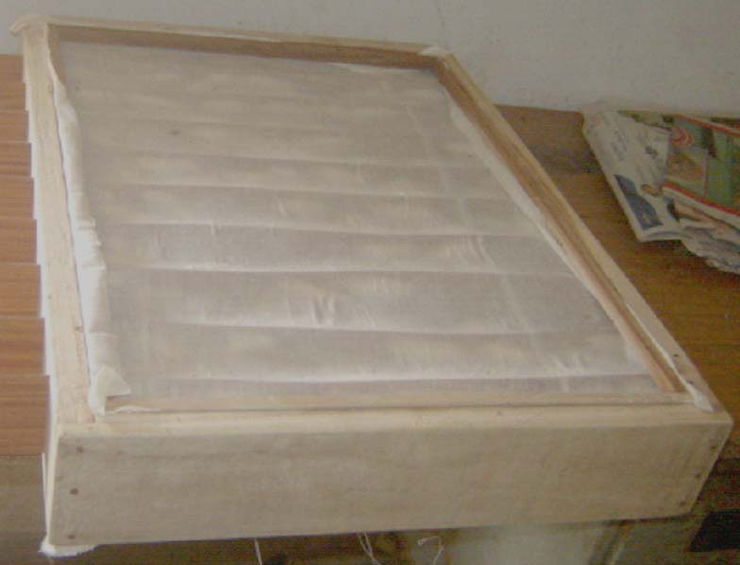
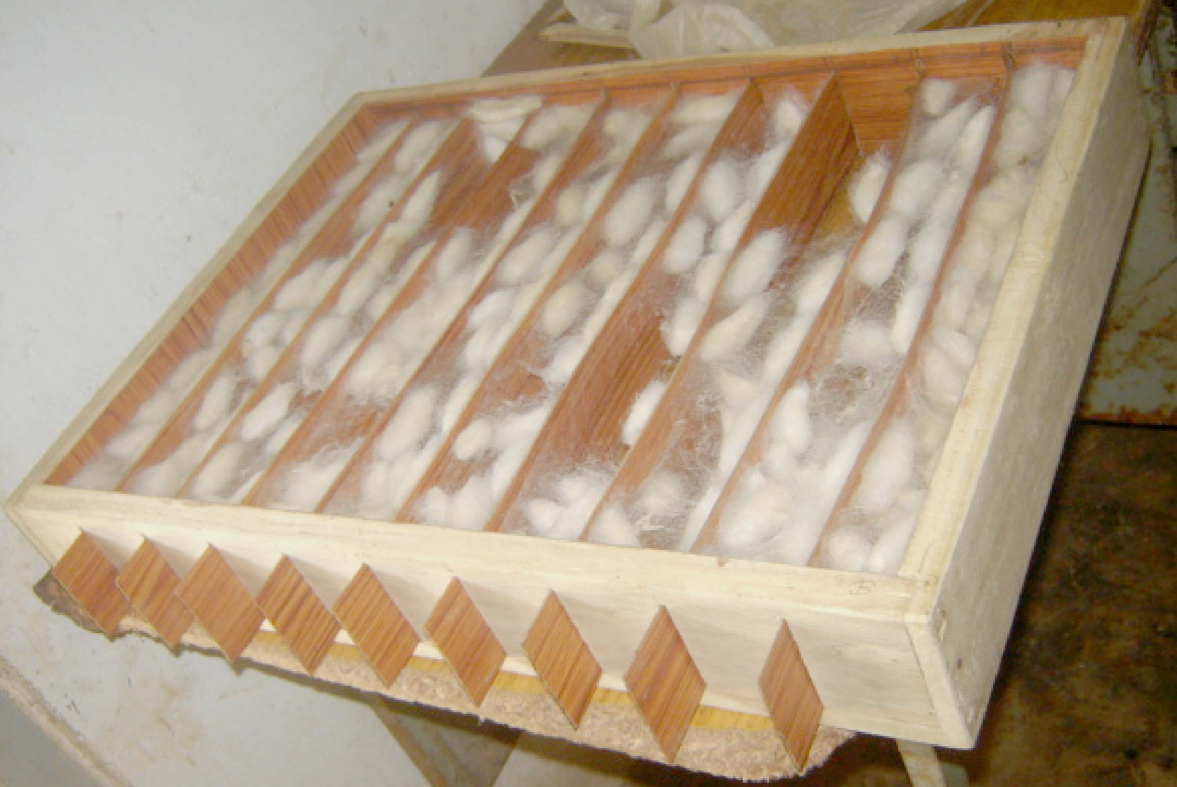
FIGURES: Eri silkworm Cocoon formation in Pull Strips Mountage.

  - STORAGE AND COCOONING DEVICE FOR ERI, MUGA AND MULBERRY SILKWORM
A new Mountage technology had been developed under DST (seed) project “Socio-economic uplifting of farmers through adoption of improved technologies and skill development in Eri culture” by Dr. Himangshu Barman and Miss Meghasree Baishya at Regional Sericulture Research Station, Boko, Kamrup. This technology has been applied for patenting vide Patent Application No. 201931027256 Date/Time: 08/07/2019 05:07:45. In this technology invented device not only perform mountage of silkworms of Muga, Eri and Mulberry but can also be carried other activities of silkworm culture like early stage rearing of Eri and Mulberry silkworm, cocoon shell storage, green cocoon storage and moth emergence. Storage and Cocooning Device for Eri, Muga and Mulberry Silkworm’ had been designed and developed so as to overcome all difficulties face during mountage to produce good cocoons. It can be used repeatedly for several years providing more durability depending upon materials used to fabricate it. Cocoons can be harvested easily in very short time minimizing labour investment. No moisture and heating problem inside this mountage and have good aeration. Cocoons produced are net and clean with more shell weight and silk recovery. Flimsy cocoons and dead larvae are very negligible or almost nil. Needs minimum ground floor area. Thus, In comparison to other conventional method and existing technical method, this method is technically advantageous and required small area and several operations can be carried in one device. Such a device of 6000 cocooning capacity (double stepped) requires only 3 feet X 3 feet floor area. To increase capacity, it may be triple stepped, quadruple stepped and so on that requires same floor area (Himangshu Barman and Meghasree Baishya, 2019).
.

This device has so developed that all following processes can be done in the same device, such as :- A) Cocooning

C) Early stage rearing

D) Green Cocoon Storage & Moth emergence

F) Cocoon and cocoon shell Storage

Otherwise all these sericulture activities are to be carried of separately with specific infrastructure facilities and spaces. Present rearing equipment’s used for rearing purposes is not distinguish operations of early and late stage rearing. Same are the cases for cocooning and grainage activities that require separate equipment’s. Thus, a poor and marginal farmer cannot afford financially to have all these facilities for himself. This new device called “Storage and Cocooning Device for Eri, Muga and Mulberry Silkworm” can be used for early stages rearing, cocooning, seed cocoon storage and moth emergence, and reeling cocoon storage in Eri and Mulberry-culture, whereas early stage rearing of Muga silkworm cannot be carried in this device (Himangshu Barman and Meghasree Baishya, 2019).
.
05.02.01 Cocooning
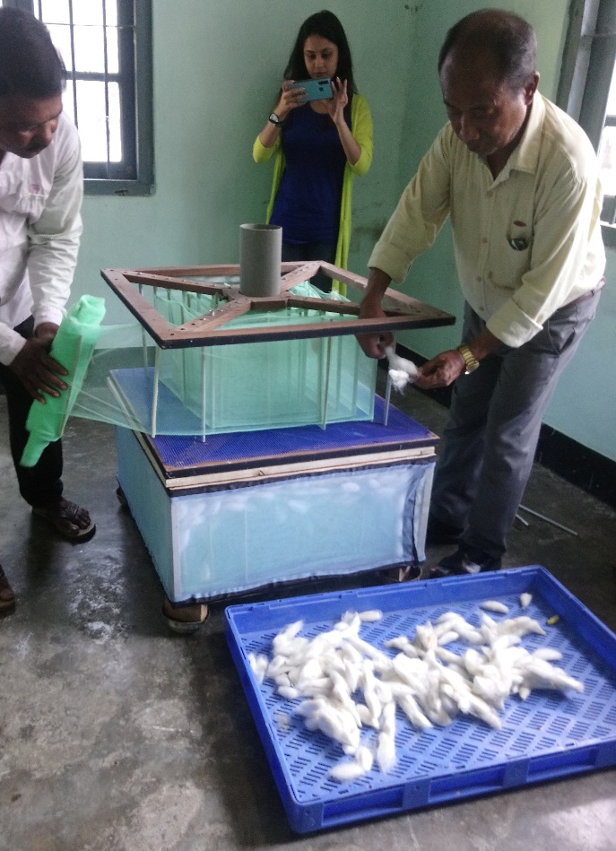
Cocooning stage of insect is important in which the ripen larvae search for a suitable place and form a loose thermostatic cover around the body by secreting silk juice in thread form netting into cocoon. Inside cocoon, larvae remain active physio-chemically and undergo physical changes of its body transforming into pupa and then into moth before piercing out of cocoon. Thus, a suitable place for cocoon formation is important for silkworm larvae. If the ripen larvae do not get a protected suitable place or otherwise disturbed by physical or mechanical changes, cocoon forming process will not be scientifically complete. This will affect in metamorphosis process of larvae that ultimately negatively influence in health of emerged moth affecting coupling and egg laying activities. On other hand, as cocooning process is incomplete, cocoon shell will have less silk thread or silk recovery will be less. This is very important from economic point of view in commercial rearing of silkworm as well as labour investment involved in the process. In “Storage and Cocooning Device for Eri, Muga and Mulberry Silkworm” all these difficulties have been overcame. It is fully protected, even ants cannot disturb cocooning larvae. Larvae get two surface support to form cocoon and ensure no physical and mechanical disturbances, no fluctuating moisture and heat generation. Being folding and permanent, it can be used repeatedly in each rearing and in any weather conditions without difficulties. Space, time required and labour investment is very less. Moreover, it is neat and clean process (Himangshu Barman and Meghasree Baishya, 2019).
At the time of ripening of larvae, the device is arranged in a suitable place and ripen larvae are to be kept in the system by lifting the lid. As natural, larvae remain wondering and finally select place for cocooning. After required period of cocooning, cocoons are to be harvested by dismantling cocooning system of the device. If larvae number is high, another device can be arranged above in the system and so on to accommodate more larvae.

05.02.02. Early stage rearing

In silkworm rearing, early stage rearing is consider as crucial because it ultimately determine the success of the crop. At early stage, tender worms require special care for vigorous growth or robust health as well as minimum mortality. If all these are maintained at early stage, a good crop can be expected. Moreover, at early stage, different types of insect, ants and other predators cause considerable damage to the crop. Thus, undisrupted feeding with flashy tender leaves and protection from all these harmful pests, is to be ensured to get good, robust early stage worms. Humidity inside it can be maintain by keeping wet foam pads in between double wall to keep the tender leaves fresh for better feeding rate. All the four post of the device are equipped with ant preventing system. In such a device of 3’ x 3’ x 1’ size, 100 nos. DFLs can be reared up to 2rd stage. After rearing early stages up to 2nd-3rd, worms are to be reared in conventional bunch system (Himangshu Barman and Meghasree Baishya, 2019).

REFERENCE

1. Zhang J., Kaur J., Rajkhowa R., Li J.L., Liu X.Y., Wang X.G. Mechanical properties and structure of silkworm cocoons: A comparative study of Bombyx mori, Antheraea assamensis, Antheraea pernyi and Antheraea mylitta silkworm cocoons. Mater. Sci. Eng. C Mater. Biol. Appl. 2013;33:3206–3213.doi: 10.1016/j.msec.2013.03.051. [PubMed][CrossRef] [Google Scholar]
2. Chen F., Porter D., Vollrath F. Structure and physical properties of silkworm cocoons. J. R. Soc. Interface. 2012;9:2299–2308.doi: 10.1098/rsif.2011.0887. [PMC free article] [PubMed] [CrossRef] [Google Scholar]
3. Reddy N., Zhao Y., Yang Y. Structure and Properties of Cocoons and Silk Fibers Produced by Attacus atlas. J. Polym. Environ. 2013;21:16–23. doi: 10.1007/s10924-012-0549-8. [CrossRef] [Google Scholar]
4. Reddy N., Yang Y. Structure and properties of cocoons and silk fibers produced by Hyalophora cecropia. J. Mater. Sci. 2010;45:4414–4421. doi: 10.1007/s10853-010-4523-3. [CrossRef] [Google Scholar]
5. Zhao H.-P., Feng X.-Q., Cui W.-Z., Zou F.-Z. Mechanical properties of silkworm cocoon pelades. Eng. Fract. Mech. 2007;74:1953–1962. doi: 10.1016/j.engfracmech.2006.06.010. [CrossRef] [Google Scholar]
6. Zhang J., Rajkhowa R., Li J.L., Liu X.Y., Wang X.G. Silkworm cocoon as natural material and structure for thermal insulation. Mater. Des. 2013;49:842–849. doi: 10.1016/j.matdes.2013.02.006. [CrossRef] [Google Scholar]
7. Chen F., Porter D., Vollrath F. Silk cocoon (Bombyx mori): Multi-layer structure and mechanical properties. Acta Biomater. 2012;8:2620–2627. doi: 10.1016/j.actbio.2012.03.043. [PubMed] [CrossRef] [Google Scholar]
8. Roy M., Meena S.K., Kusurkar T.S., Singh S.K., Sethy N.K., Bhargava K., Sarkar S., Das M. Carbondioxide Gating in Silk Cocoon. Biointerphases. 2012;7 doi: 10.1007/s13758-012-0045-7. [PubMed] [CrossRef] [Google Scholar]
9. Kusurkar T.S., Gangwar A., Bawankar M., Mandal A., Dethe D., Thakur A.K., Singh S.K., Bhargava K., Khurana S., Sethy N.K., et al. A glowing antioxidant from tasar silk cocoon. RSC Adv. 2015;5:104563–104573. doi: 10.1039/C5RA14148F. [CrossRef] [Google Scholar]
10. Blossman-Myer B., Burggren W.W. The silk cocoon of the silkworm, Bombyx mori: Macro structure and its influence on transmural diffusion of oxygen and water vapor. Comp. Biochem. Physiol. A Mol. Integr. Physiol. 2010;155:259–263. doi: 10.1016/j.cbpa.2009.11.007. [PubMed] [CrossRef] [Google Scholar]
11. Gheysens T., Collins A., Raina S., Vollrath F., Knight D.P. Demineralization Enables Reeling of Wild Silk moth Cocoons. Bio macromolecules. 2011;12:2257–2266. doi: 10.1021/bm2003362. [PubMed] [CrossRef] [Google Scholar]
12. Jin X., Zhang J., Gao W., Li J., Wang X. Cocoon of the silkworm Antheraea pernyi as an example of a thermally insulating biological interface. Biointerphases. 2014;9 doi: 10.1116/1.4890982. [PubMed] [CrossRef] [Google Scholar]
13. Kaur J., Rajkhowa R., Tsuzuki T., Millington K., Zhang J., Wang X. Photo protection by Silk Cocoons. Bio macromolecules. 2013;14:3660–3667. doi: 10.1021/bm401023h. [PubMed] [CrossRef] [Google Scholar]
14. Yagi, N. (1926). The cocooning behaviour of a saturnian caterpillar (Dictyoploca japonica); a problem in analysis of insect conduct. J. Exp. Zool. 46, 245–259. doi: 10.1002/jez.1400460205.
15. Barman H., Gohain P. N., B. C. Choudhury and Giridhar K. ( 2014): Development of Pull Strips Mountage for Samia ricini Donovan and Mounting Performances Over Traditionally Used Mountages. International Journal of Life Sciences, Vol.3, No.1, January-April, , pp. 34-40.
16. Devaraj Y., Singh N. I., Sarmah M. C., and Singh R. (2012): Fabrication of suitable low coat bamboo mountages for Eri silkworm, Samia ricini Donovan. Mun. Ent. Zool. Vol. 7, No. 1, 646-649 pp.
17. Geetha Devi, R. G., Himantharaj, M. T., Vindhya, G. S. & Mathur, V. B. (1990): Can plastic collapsible mountages replace the bamboo mountage? Indian silk, 10 : 26-28.
18. Singh G. B., Rajan, R. K., Inokuchi, T., Himanthraj M. T. and Meenal A. (1994): Studies on the use of plastic bottle brush mountages for silkworm mounting and its effect on cocoon characters and reelability. Indian J. of Seric. 33(1), 405-408.
19. Himantharaj, M. T., Meenal, A., Rajan, R. K., Muroga, A. & Kamble, C. K. (1995): Rotary mountage for quality cocoons. Indian silk, 34 (2): 25-27.
20. Singh, G. B. (1995): Silkworm mountages. Indian silk, (May issue), p. 13-16.
21. Kumaresan, P., Hiriyanna, Y. K., Balakrishnappa, Y. K. & Geetha Devi, R. G. (2007): Performance of different types of mountages in Tumkur district of Karnataka – an economic analysis. Indian J. Seric., 46 (2): 169-172.
22. Barah, A. & Samson, M. V. (1990): Effect of various mountages on the cocooning of the muga silkworm, Antheraea assama Westwood. Sericologia, 30 (3): 313-321.
23. Sahu, A. K., Singha, B. B., Rajkhowa, G. & Das, P. K. (1998): Improvement in muga silkworm seed technology: The box type mountage, a new model for cocooning of muga silkworm Antheraea assama Westwood. Sericologia, 38 (2): 331-341.
24. Patil, G. M. & Savanurmath, C. J. (1994): Eri silkworm – The Poor Man’s Friend. Indian Silk, 33 (4): 41-45.
25. Subhas V. Naik and Somashekar T. H. (2008): Influence of temperature and humidity maintained during cocoon spinning on reeling performance and quality of raw silk of Indian bivoltine hybrid cocoons. Sericologia 48(4)376- 389.
26. Prasad G. V., Monohar Reddy R., Raghupathi M., Mogili T., Raju Ch. S., and Qadri S. M. H. (2011): Radial mountage (RM) – a simple self mounting and cocoon spinning tool of domestic mulberry silkworm, Bombyx mori (Linn). Sericologia 51(4) 485 – 494.
27. Velayudhan, K*., Balachandran, N., RadhaKrishnan, S., Singh, B.K. and Jayaprakash, P ( 2013); Biodiversity in eri silkworm Samia ricini (Donovan) genetic resources and its conservation, Journal of Aquatic Biology and Fisheries Vol. 2/2014/ pp. 817 to 824.
28. S.T. Naphade , C.J. Hiware and S.B. Avhad (2010); Development of improved mountage using mango plant twigs during lack of sufficient number or absence of mountages on field for silkworm cocoon. Recent Research in Science and Technology, 2(7): 05-08.

29. Sanchita Kad; Mountage: Meaning and Types | Sericulture; https://www.notesonzoology.com/sericulture/mountage-meaning-and-types-sericulture/200.

30. Himangshu Barman and Meghasree Baishya (2019); Storage and Cocooning device for Eri, Muga and Mulberry Silkworm, a new technology developed under DST (SEED) project, Technical Booklet, 03 – 09.

---------------------------------------------------------------------- X XXXXXXXXXXX----------------------------------------------------------------

