Nanotechnology in Food Science
Author Name: Dr. Sheetal Sonawdekar, Jidnesh Amar Bhandari*.
Affiliation Name: D Y Patil University School of Biotechnology and Bioinformatics -Navi Mumbai, India
Email: jid.bha.bt21@dypatil.edu

ABSTRACT
Numerous scientific and industrial fields, including the food business, have seen significant change as a result of recent advances in nanotechnology. In order to give customers food that is safe and free of contamination and to ensure that the food has enhanced functional features that are acceptable to consumers, this chapter summarizes the potential of nanoparticles for their uses in the food business. It explains about different packaging including improved, active, smart, and bio based. It also focuses on safety issues, and challenges.
Keywords: Nanotechnology, improved packaging, active packaging, smart packaging, bio-based packaging.

- INTRODUCTION

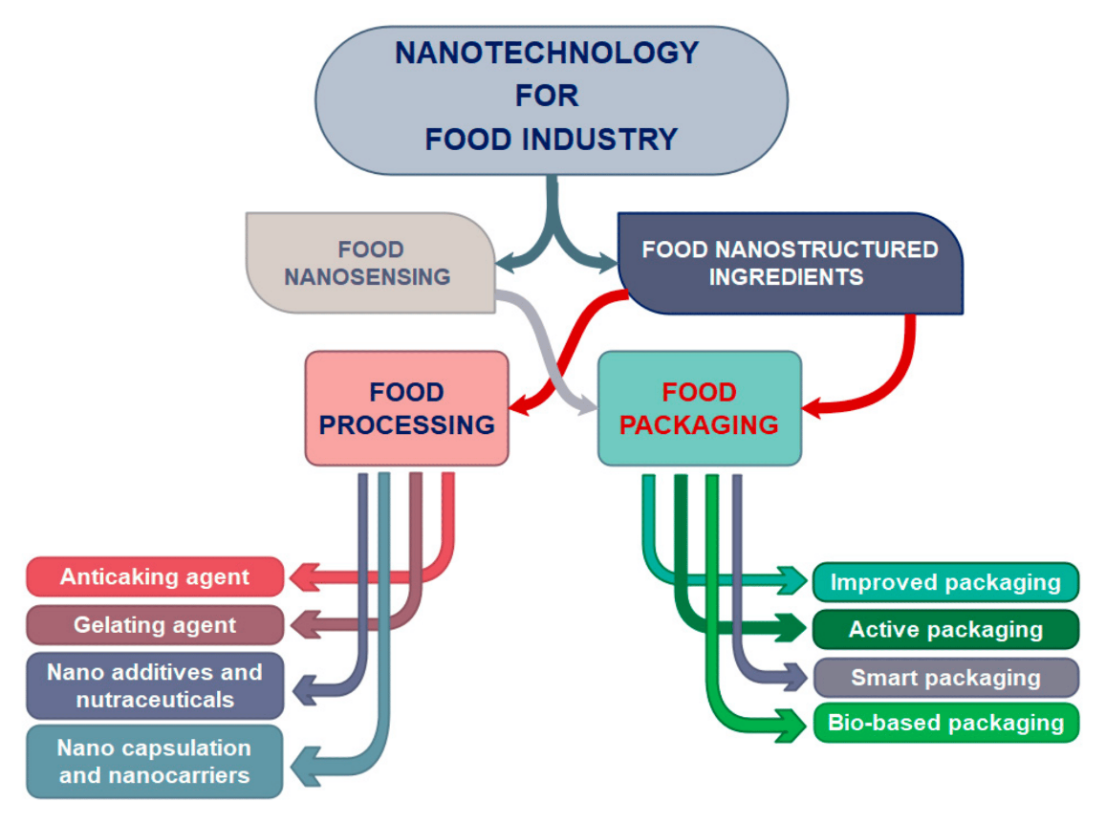
Nanotechnology has grown in importance as a desirable technology for the food sector over the last few decades. It provides a wide range of opportunities for the production and utilization of structures, materials, or systems with new or better features in numerous industries, including agriculture, food, and medicine, nanotechnology has sparked a new industrial revolution. The usage of nanotechnology has drastically decreased the percentage of losses due to food packaging. It is a technology which works on the nanometer scale and deals with nano atoms, nano molecules, or macromolecules with the size of 1-100nm [Kuswandi,2016]. Nanotechnology promises numerous interesting changes to improve health, wealth, and quality of life, as well as reducing impact on the environment. In comparison to traditional packaging materials, nanomaterials and edible coatings enhanced with nanoparticles offer improved food product preservation and quality maintenance. To increase shelf life, nano-packaging can also be made to release antimicrobials, antioxidants, enzymes, flavors, and nutraceuticals. Nanomaterials significantly improve food quality and safety as well as the health advantages that food provides. Nanotechnology allows for the incorporation of nanoparticles into films to create nanofilms that can increase the permeability of some gases with the goal of lowering the concentration of harmful gases, such as carbon dioxide (CO2) or oxygen (O2), which negatively affect food shelf life and can also be used as barrier materials to stop microbial spoilage. Packaging materials may be used less frequently if biomaterials are used, and the enormous waste problem may also be resolved. Additionally, it has been discovered that they remain stable at high temperatures and pressures. Food nano sensing and food nanostructured components are the two main applications of nanotechnology in the food sector. While the field of food nano sensing improves food quality and safety, nanostructured food ingredients include a wide range of applications, including food processing and food packaging. In food processing industry, nanostructures and nanostructured materials can be used as: (a) food additives and carriers for intelligent nutrient delivery; to improve nutritional value of food; (b) anti-caking agents; to improve food consistency and prevent lump formation; (c) gelating agents; to improve food texture; and (d) nanocapsules and nanocarriers; to protect aroma, flavor, and other ingredients in food [Primozic et al.,2021]. While enhanced packaging, active packaging, smart packaging, and bio-based packaging are taken into consideration in the field of food nano-packaging. This paper summarizes the role of (bio)nanotechnology in food science with a focus on the use of (bio)nanomaterials in packaging. It also discusses potential unfavorable consequences of the use of nanotechnology in the food industry.
Fig. 1. Application of nanotechnology in different fields of food industry [Primozic et al.,2021].
- Nanotechnology in Food Processing

Better consistency, taste, and texture are promised by the creation of food ingredients incorporating nanostructures. Nanotechnology extends the shelf lives of many food products and decreases food waste from microbial contamination. The presence of pollutants, mycotoxins, and microbes in food can be demonstrated using nanosensors. Many synthetic and natural polymer based encapsulating delivery systems have been developed for bioavailability and preservation of the active food components. Additionally, the contribution of nanotechnology to the enhancement of food products in terms of (i) food texture, (ii) food appearance, (iii) food flavor, (iv) food nutritional content, and (v) food shelf-life can be used to assess the significance of nanotechnology in food processing. Unexpectedly, nanotechnology not only has an impact on the aforementioned aspects but also drastically alters food products, giving them brand new qualities.

- Texture, Taste, and Appearance of food: Numerous solutions for boosting food quality and flavor are made available by nanotechnology. To improve taste release and retention and to offer culinary balance, nanoencapsulation techniques [method used to enclose bioactive compound in a matrix to preserve coated component (food flavor/ ingredients)] have been frequently used. Nanoemulsions are widely used to deliver lipid-soluble bioactive chemicals. They can also be engineered to improve water-dispersion and bioavailability. Due to its subcellular size, which results in a higher medication bioavailability, nanoparticles offer a viable method of enhancing the bioavailability of nutraceutical components when compared to bigger particles, they often take longer period and release enclosed substances more gradually. Numerous metallic oxides, including silicon dioxide (SiO2) and titanium dioxide (TiO2), have historically been utilized as coloring or flow agents in culinary products. Silicon dioxide (SiO2) is one of the most widely used food nanomaterials for transferring flavors or aromas in food products. The powdered sugar coating on doughnuts contains TiO2 as a coloring agent.

- Nutritional Value: Most bioactive substances, including lipids, proteins, carbohydrates, and vitamins, are sensitive to the stomach's highly acidic environment and its enzyme activity. The poor water solubility of these bioactive substances makes them difficult to absorb in non-capsulated form, but encapsulation not only makes them resistant to such harsh conditions, it also makes them easy to assimilate in food products. Small edible capsules made of nanoparticles are being developed with the goal of improving the distribution of medications, vitamins, and delicate micronutrients in daily diets. Such kind of edible capsules come under nutraceutical food which can be beneficial to the overall population. Numerous methods, including nanocomposite, nanoemulsification, and nanostructuration, have been employed to more efficiently disperse nutrients, such as protein and antioxidants for precisely targeted nutritional and health benefits. By enhancing antioxidants' solubility and bioavailability, in vitro and in vivo stability, and capacity to avoid unfavorable interactions with other dietary ingredients, lipid-based nanoencapsulation methods improve antioxidant effectiveness.

- Preservation or shelf life: The shelf life of functional foods is extended by the nanoencapsulation of these bioactive ingredients where bioactive components frequently degrade and ultimately become inactive by slowing down or preventing the process of degradation until the product is delivered to the target site. Additionally, edible nano-coatings on different food components may operate as a barrier against moisture and gas exchange, deliver tastes, colors, antioxidants, enzymes, and anti-browning agents, and extend the shelf-life of manufactured meals even after the packaging has been opened [Maddela et al.,2023]. It is frequently possible to slow down chemical breakdown processes by modifying the interfacial layer’s properties around functional elements. For example, when curcumin, the most active and least stable bioactive component of turmeric (Curcuma longa), was encapsulated, it was discovered to be stable to pasteurization and to varying ionic strengths while still retaining its antioxidant activity [A N A Sari et al.,2020].

- Nanotechnology in Food Packaging

One of the most important measures in ensuring food safety is food packaging. Enclosing food to shield it from tampering or contamination from physical, chemical, and biological sources is referred to as food packaging. Food packaging's main goals are to avoid contamination and spoiling, maximize sensitivity by encouraging enzyme activity, and minimize weight loss. Functional nanomaterials with physico-chemical enhancements, such as better mechanical strength, durability, flexibility, and moisture and temperature stability, can be used to create superior food packaging. The packaging material implemented with such properties is known as Improved packaging. Nanomaterials with active properties, such as those with antimicrobial, antioxidant, and UV protective properties are termed Active Packaging. Nanosensors with smart or intelligent properties for the detection of gases and small organic molecules, active stage, and product identification such packaging is termed as Smart Packaging. Bionanomaterials can be used to increase bio-based properties such as biodegradability, biocompatibility, low-waste, and eco-friendly packaging. Such packaging is termed Bio-based packaging.

- Improved Food Packaging: The main objective of improved food packaging is to strengthen the mechanical and physical features of the packaging, such as gas barrier capabilities, resistance to temperature and humidity, mechanical strength, and flexibility. This is accomplished by incorporating functional nanoparticles into polymer materials. The nanoparticles enhance the packaging's barrier qualities, reducing oxygen and carbon dioxide permeability by up to 80-90%. In comparison to the material without the addition of montmorillonite clay nanoparticles, the oxygen barrier characteristics of the nanocomposite films were increased by 59% and 90%, respectively, with the addition of just 3% (w/w) clay. The advantages of using nanomaterials for food packaging over traditional packaging materials are numerous. Nano-coating is the most used nanotechnology technique for enhancing the characteristics of food packaging. These coatings can be also from edible material.

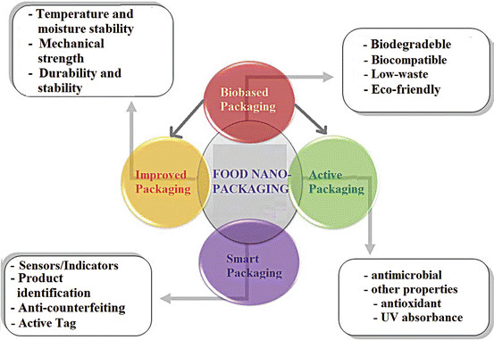
Fig. 2 Food nano packaging, classification, functions, and features [Kuswandi,2016].

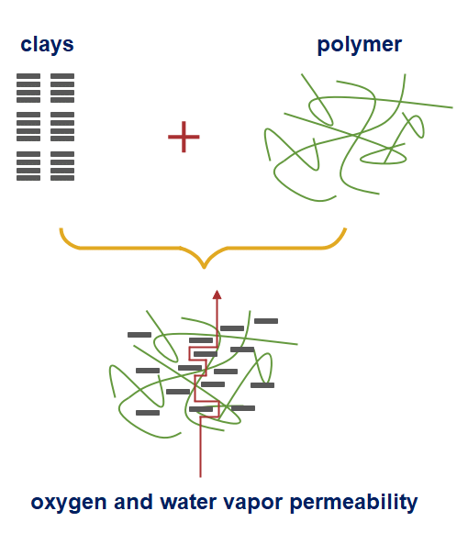
These coatings can be also from edible material. Applying edible nano-coatings is simple and can be done by rubbing, spraying, or submerging. They typically contain eco-friendly components and do not need to be removed from food before eating. These nano-coating films currently offer nanostructures in which organic compounds with antibacterial and antioxidant activity can be added to boost the positive effects on the freshness of fresh produce. Clay nanocomposite-based food packaging materials are shatterproof, lightweight, heat resistant, and have improved shelf life.
Fig. 3 Diagrammatic representation of nonlinear and prolonged pathway of oxygen, and water vapor permeability formed due to incorporation of clay into a polymer matrix film [Primozic et al.,2021].

- Active Packaging: For the purpose of reducing food waste and enhancing food safety, new materials and technologies must be developed. The creation of active materials for active packaging to enhance the shelf life of the product is one of the potential ways to decrease food spoilage and the corresponding decrease in food waste. The traditional materials for food packaging include non-biodegradable polyethylene (PE), polypropylene (PP), and polyethylene terephthalate (PET), where O2 and H2O molecules cannot penetrate. A variety of scavengers, absorbers, emitters, and coatings are included in new active food packaging. These substances could be used in standard non-biodegradable packaging, but they are increasingly combined with biodegradable elements.

- Antimicrobial Active Packaging: Utilizing antimicrobial active packaging helps preserve food and increase its shelf life by preventing the growth of microorganisms. This could be accomplished by including an active substance into the packing material or by coating it. Antimicrobial drugs behave variably depending on the pathogenic bacteria due to differing physiologies. The characteristics of microorganisms, such as cell wall composition (Gram negative or Gram positive), oxygen requirements (aerobes or anaerobes), growth stage (spores or/and vegetative cells), acid/osmosis resistance, and optimal growth temperatures (mesophilic, thermophilic, etc.), are the fundamental criteria for choosing the appropriate antimicrobial agent. Due to their high antibacterial activity, antimicrobial nanomaterials including Ag, TiO2, ZnO, magnesium oxide (MgO) etc. nanoparticles are very suitable agents for antimicrobial active packaging systems. Food packaging frequently uses TiO2 nanoparticles, which are non-toxic to humans and authorized as food additives and food contact materials.

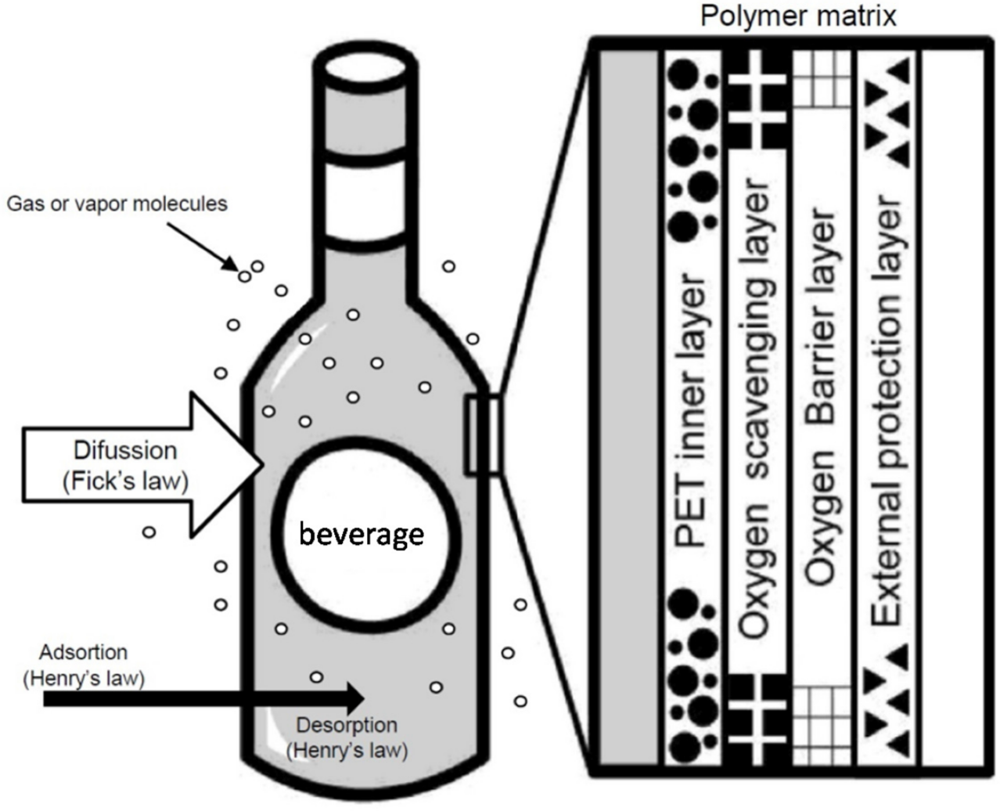
- Oxygen Scavenging Films: Many foods deteriorate either directly or indirectly as a result of oxygen (O 2) [Kuswandi,2016]. For instance, direct oxidation reactions cause vegetable oils to go rancid and fruits to turn brown [Kuswandi,2016]. As a result, adding oxygen scavengers to food packaging can keep oxygen levels very low, which is advantageous for a variety of applications since it can lengthen the food's shelf life.
Fig. 4 Illustration of oxygen scavenging films [Ramos et al.,2015].

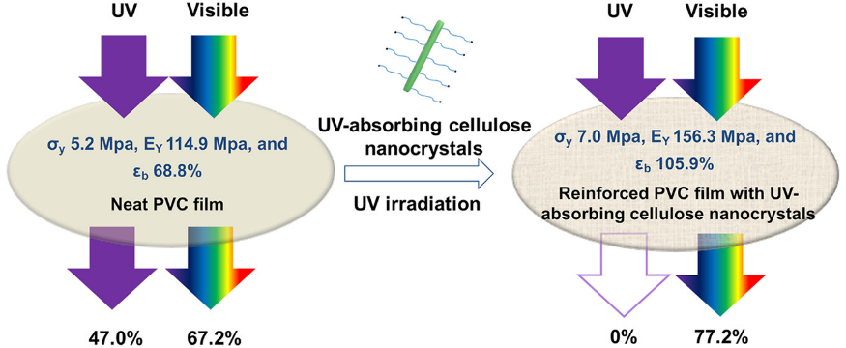
- UV Absorbing Films: In today’s world, UV absorbing films can be greatly used in the beverage industry to retain the desired quality of product. In PET bottles some tests are being carried out using UV rays to observe whether the quality of the product is hampered or not without using the films. If plastic degrades at a faster rate, then UV absorbing films can be beneficial. The transparency of food/ beverage packaging can also be enhanced. In this way, UV films are introduced to tackle degradation, and enhance the visibility of the food product.
Fig. 5 Illustration of UV absorbing films [Zhang et al.,2018].
- Smart Packaging: Nanoparticles can be used to monitor chemical, biochemical, or even microbiological development inside the food and/or the environment surrounding the product in order to improve food packaging with smart or intelligent features. In order to identify food spoiling, specific bacteria and specific gases can be detected using nano sensors. Nano sensors are used to react to internal or external parameter changes in food and/or the environment around it. For food analysis (detection of toxins, chemicals, and food pathogens), flavor or color detection, etc., nanosensors are utilized in smart packaging. For example, when gas is created due to food spoiling, the packaging changes color of the indication and alerts the client to the unsuitability of the product. The most recent advancements in polymer nanoparticles for smart food packaging include traceability, oxygen indicators, rotting /spoilage indicators, and product identification.
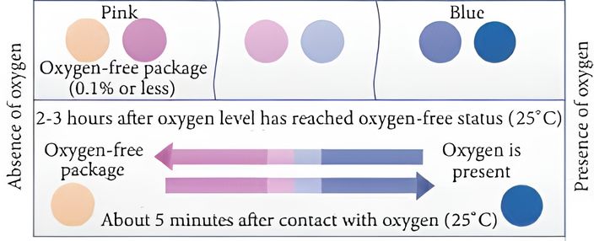
- Oxygen indicators: During food preservation, oxygen enables the growth of aerobic microorganisms. Various packaging systems such as nitrogen or vacuum packaging systems are used to avoid the passage of oxygen into the food headspace. An oxygen leak indicator is represented in the below diagram. The oxygen indicator below clearly states that if oxygen is present in the headspace of the packaging material, the color would turn to blue. The nanoparticles of titanium dioxide are used in oxygen indicators.
Fig. 6 Illustration of color changing ability of oxygen indicators [A N A Sari et al.,2021].

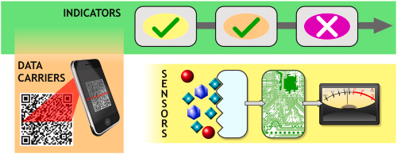
- Traceability or Active Tags: Packaging contains radiofrequency identification active tags for the traceability of the required food product. The tags are electronic information-based devices that automatically trace and identify objects by transmitting data from a tag affixed to the object over radio frequency [Kuswandi,2016]. Additionally, sensor packaging is now able to include low-cost radio frequency identification tags because of nanotechnology. The RF identification tags with nanotechnology capabilities are substantially more compact, flexible, and can be printed on thin labels. This makes tags more versatile and makes production significantly less expensive. They have a wider capacity, faster transmission rate, multiple exchanges of information can be done, and the number of tags can be read at once.
Fig. 7 Illustration of active tags [Azeredo et al.,2021].

- Bio Based Packaging: Biobased packaging refers to biodegradable packaging materials used to limit moisture transfer and/or gas exchange in food products in order to enhance safety and maintain the nutritive and sensory quality. These packaging materials are thought to be greener than other types of traditional packaging films. Bio-based packaging employs renewable resources rather than fossil fuels to make the materials, and energy can be recovered by incineration after disposal. Starch based, chitosan based, and cellulose based nanomaterials are some of the nanomaterials used in bio-based packaging. These additions inevitably have favorable consequences on people’s health, the environment, and society at large. These advantages might be strengthened even more by carrying out the clever functions with reliable technology and sustainable natural materials.

- Strach based nanoparticles: A variety of green materials can be made as starter materials using starch. Seeds and the tubers or roots of plants contain starch. The main crop from which starch is generated worldwide is corn. Starch based nanoparticles can be used in combination with compostable plastics such as PHA, PLA, PBS etc. Starch added to plastics increases their mechanical, processing, water resistance qualities, and prevents exchange of gases between food & environment.

- SAFETY ISSUES

In addition to the many benefits that nanotechnology has for the food sector, there are safety concerns with nanomaterials that must be taken into consideration. The risk that nanoparticles from packaging materials could enter food and its effects on consumer health is as a result of safety issues with nanomaterials. Although a substance is deemed to be GRAS (generally recognized as safe), more research must be done to determine the risk posed by its nano equivalents because the physiochemical properties in nanostates are very dissimilar from those in macrostate [Singh et al.,2017]. To assure product quality, health and safety requirements, and environmental laws, regulatory agencies must also create some criteria for commercial goods. Additionally, these are required to guarantee the safe use of these nano-packaging, with a focus on improving knowledge of their potential toxicological effects, migration potential, and levels of exposure for both workers and consumers, with a focus on the effects of the chosen nanomaterials on human health following chronic exposure. If all regulations are followed, the successful incorporation of nanomaterial into food packaging would significantly contribute to improving the world's food supply in terms of health, safety, tastiness, nutrition, and environmental friendliness.
- CHALLENGES

Before nanotechnology can be employed to create really new products and processes in the food sector, there are a number of challenges to be addressed. Making effective and secure food delivery systems is the major challenge. The migration of nanoparticles from packaging materials into food products and their leaching into food is a serious concern for ensuring the safety of meals. It is important to be aware of the potential risks, toxicological issues, and environmental concerns associated with nanoparticles. It is well known that nanoparticles can enter a variety of tissues and organs by breaching the biological barrier. Before producing, packaging, and ingesting nano-based food products in people, it is crucial to consider a thorough danger assessment program, regulatory frameworks, biosecurity, and public concerns.
- FUTURE SCOPE

Due to the usage of nanotechnology, incredible advancements in the domains of food science and technology, and in research have been made. Using nanotechnology to identify pollutants, diseases, and pesticides can help maintain food quality through tracking, tracing, and monitoring. It would be simple and quick to identify food pathogens including viruses, bacteria, and mycotoxins using nanosensors, which are quick, labor-saving, and precise. If specific laws and regulations pertaining to nanotechnology are created in order to solve the numerous safety problems associated with this technology, it is likely that nanotechnology may eventually come to dominate the whole field of food production. In the next ten years, it is anticipated that the food packaging industry will lead the way in terms of emerging trends in nanotechnology, with blockchain technology projected to dominate.

CONCLUSION

Without a doubt, nanotechnology presents enormous opportunity for creative advancements in food processing and packaging that can benefit both consumers and industry. Utilizing nanoparticles in food or packaging materials, the application of nanotechnology in the food industry is aimed at enhancing food quality and safety. Nanosensor-equipped smart packaging may potentially advise customers about the condition of the food it contains. Nanosensors built into food packaging warn consumers when a product is no longer suitable for consumption. Sensors can alert consumers before food spoils or provide precise nutritional information about the contents. The packaging materials of the future will be able to meet the needs of keeping perishable foods. The invasion of bacteria and other microbes, a threat to food safety, will be stopped by nano-structured materials. The consumer may be informed by the nanosensors built into the packaging if a food has degraded and is no longer safe to eat. Furthermore, positive outcomes have been obtained in the use of nanomaterials for food preservation, where they may shield the food from moisture, lipids, gases, off tastes, and aromas. Transparency of safety issues and environmental effect should take precedence when addressing the emergence of nanotechnology in food systems. As a result, mandatory testing of nanofoods is necessary before they are put on the market.

REFERENCES
[1] Rajesh Singh, Shradha Dutt, Priyanka Sharma, Ashok K. Sundramoorthy, Aman Dubey, Anoop Singh, Sandeep Arya, “Future of Nanotechnology in Food Industry Challenges in Processing, Packaging, and Food Safety”.
[2] Bhupinder S Sekhon, “Food nanotechnology- an overview”.
[3] A. Wallace Hayes, Saura C. Sahu, “Nanotechnology in the Food Industry: A Short Review”.
[4] Mateja Primozic, Zeljko Knez, Maja Leitgeb. “(Bio) Nanotechnology in Food Science - Food Packaging”.
[5] Trepti Singh, Shruti Shukla, Pradeep Kumar, Verinder Wahla, Vivek K. Bajpai, Irfan A. Rather, “Application of Nanotechnology in Food Science: Perception and Overview”.
[6] Bambang Kuswandi, “Nanotechnology in Food Packaging”.
[7] Zahra H. Mohammad, Faizan Ahmad, Salam A. Ibrahim, Sadaf Zaidi, “Application of nanotechnology in different aspects of the food industry”.
[8] Alweera Ashfaq, Nazia Khursheed, Samra Fatima, Zayeema Anjum, Kaiser Younis, “Application of nanotechnology in Food packaging: Pros and Cons”.
[9] A N A Sari et al., “Innovation of oxygen indicators for packaging leak detector: A review”.
[10] Ravindra V. Gadhave, Abhijit Das, Prakash A. Mahanwar, Pradeep T. Gadekar, “Starch Based Bio Plastics: The Future of Sustainable Packaging”.
[11] Naga Raju Maddela, Lizziane Kreti Winkelstroter, “Microbiology for Cleaner Production and Environmental Sustainability”.
[12] Marina Ramos, Arantzazu Valdes, Ana Cristina Mellinas, Maria Carmen Garrigos, “ New Trends in Beverage Packaging Systems: A Review”.
[13] Zhen Zhang, Gilles Sebe, Xiaosong Wang, Kam C. Tam, “ UV Absorbing Cellulose Nanocrystals as Functional Reinforcing Fillers in Poly (vinyl chloride) Films”.
[14] A N A Sari, E Warsiki, I A Kartika, “ Innovation of oxygen indicator for packaging leak indicator : A review”.
[15] Henriette M. C. Azeredo, Daniel Souza Correa, “Smart choices: Mechanisms of intelligent food packaging”.

