Bioethanol production from Horticultural waste
Gouthami Y¹., Praveen Gidagiri ²., Bhuvaneshwari G³., Geetha lekshmi⁴ and Shameena⁵
Department of Post Harvest Technology, College of Horticulture, Bagalkot, Karnataka
Department of Post Harvest Management, College of Agriculture, Vellyani, Thiruvananthapuram, Kerala
Department of Post-Harvest Management, College of Horticulture, Bagalkot
Department of Post Harvest Management, College of Agriculture, Vellyani, Thiruvananthapuram, Kerala
Department of Post Harvest Management, College of Agriculture, Vellyani, Thiruvananthapuram, Kerala

1. INTRODUCTION
In India, about 350 million tonnes of agricultural waste is generated annually. According to estimations made by the Ministry of New and Renewable Energy, this waste can produce green fertilizer for use in agriculture (Goel et al., 2022). It can generate more than 18,000 MW of power annually. Globally, about 1.3 billion tonnes of food products for human consumption get wasted or lost yearly. For example, total world potato waste is estimated to be 12 million tonnes per annum, of which 2 million tonnes of potato waste is generated in India alone (Anon., 2020). This potato waste, in turn, generates obnoxious gases and greenhouse gases, besides foul odour, around the landfill sites.
Numerous technologies have been explored to transform agricultural waste into valuable resources by creating bio commodities with potential market demand. These include the development of products like fermented beverages, single-cell proteins (SCP), single-cell oils (SCO), biocolours, flavors, polysaccharides, bioethanol, biogas, biopesticides, plant growth regulators, and biohydrogen through microbial processing (Panda et al., 2017).
The global economy heavily relies on various fossil fuels for generating energy, producing fuel, electricity, and various products (Uihlein and Schbek, 2009; Ballesteros et al., 2006). This overreliance on fossil fuels has resulted in a notable rise in greenhouse gas concentrations within the Earth's atmosphere, leading to substantial environmental degradation(Sain et al., 2018). There is growing interest in shifting towards renewable energy sources to address this issue. Renewable biomass fuels, including bioethanol, biodiesel, and bio-hydrogen, present a viable alternative to petroleum-based fuels. These renewable fuels can be derived from sources such as sugarcane, corn, algae, agricultural waste, and fruit and vegetable residues, offering a potential solution to the environmental challenges of excessive fossil fuel consumption.
2. BIOETHANOL AND ITS IMPORTANCE
Bioethanol is a liquid biofuel produced by microbial fermentation of several different types of feedstocks, such as corn, soybeans, wheat straw, woodchips, fruits and vegetable wastes, and, more recently, microalgae. Bioethanol is non-toxic, biodegradable, and does not cause environmental pollution compared to fossil fuels. The conversion of waste to bioethanol can reduce the emission of greenhouse gases (Stichnothe and Azapagic, 2009). Waste materials containing cellulose, lignin, and lignocellulosic can produce bioethanol. In addition, biomass containing high carbon content, including waste, can produce bioethanol by converting polysaccharides into simple fermentable sugars. The yeast fermentation of these sugars can result in the production of bioethanol. North America and Brazil produce large quantities of bioethanol as a transportation fuel. It is necessary to increase the production and use of bioethanol as an alternative to petroleum fuel.
There are many advantages of biofuel as a bioenergy source. Biofuel is considered carbon neutral due to the release of carbon dioxide while burning, which is equal to the amount that the plants absorb, and they do not contribute to the increase of global warming. Biofuel encourages farm income, reduces energy costs, and promotes further rural development while pleasing the environmental community. Production of biofuel replaces the usage of high price petroleum.
The bioethanol production process is classified into three generations.
  - First-generation bioethanol
  - Second-generation bioethanol
  - Third-generation bioethanol
2.1 First-generation bioethanol
Initially, first-generation ethanol was primarily sourced from the sugars and starches in food crops like corn, wheat, and sugarcane. Notably, sugarcane was a key feedstock for sugar-based ethanol in Brazil, while corn and grains were commonly used for starch-based ethanol, particularly in the USA. This trend extended to other countries involved in ethanol production, including China, Canada, France, Germany, and Sweden, as highlighted by Arifin et al. (2014).

Brazil stood out for its dominant sugar-based ethanol production from sugarcane, making up a significant portion of the global output. Conversely, the USA was a major player in starch-based ethanol production, accounting for the largest share at 58%. Brazil followed with 28%, while China, Canada, and Thailand contributed smaller amounts (3%, 2%, and 1% respectively). Moreover, within the European Union, France and Germany were leading contributors, collectively contributing 6% to global ethanol production, according to Niphadkar et al. (2017)
Consequently, there is a quest for more effective and efficient alternatives. Plant waste biomass, predominantly composed of lignocellulosic materials, holds promise in generating innovative biofuels called second-generation biofuels.
Drawbacks and current status
Corn is the primary source of ethanol production, particularly in the United States, where a significant portion—40% or more—of the corn crop is allocated for this purpose. However, this reliance on corn is compounded by its status as a staple food in various countries, leading to a worldwide surge in food prices and exacerbating hunger-related issues. This same predicament arises when sugarcane is utilized as a feedstock for ethanol production.
The cultivation of these crops necessitates the application of pesticides and fertilizers, incurring substantial costs while also contributing to the contamination of soil and water resources. Consequently, environmental hazards present an additional constraint in the production process. Furthermore, ethanol production from corn faces challenges such as a sluggish production rate and relatively low energy yield, with a net yield of around 20%.
2.2 Second-generation bioethanol
Second-generation bioethanol production employs "plant biomass" that is notably more affordable, abundant, and devoid of conflicts related to food usage (Gomez et al., 2008). This approach to ethanol production was strategically devised to circumvent the contentious issue of food versus fuel, focusing on utilizing agricultural residues and forest waste, primarily comprising various forms of lignocellulosic materials (Lennartsson et al., 2014). Although second-generation bioethanol production processes were initially nascent, advancements in bioprocess strategies, cost reduction, and the availability of sustainable resources have propelled them into a lucrative venture for a few producers. E.g.: - Borregaard Company (Norway) is often considered the largest second-generation ethanol-producing unit (Rodsrud et al., 2012).
Drawbacks or production constraints of second-generation bioethanol
One of the significant issues associated with second-generation bioethanol production was the deterioration of sugars and the substantial energy consumption during pretreatment operations, leading to elevated overall process expenses (Palacios-Bereche et al., 2013; Dias et al., 2014). The requirement for effective microorganisms capable of concurrently fermenting C₅ and C₆ sugars into bioethanol posed another challenge. Moreover, the enzymes utilized for the saccharification process were expensive, further contributing to the overall production costs.
2.3Third-generation bioethanol
Third-generation bioethanol harnesses biomass rich in carbon content for production purposes. Seaweed and marine algae like Enteromorpha species, having 70% carbohydrate on a dry weight basis, can be used for bioethanol production (Nahak et al., 2011). Borines et al. (2013) produced ethanol (10–15%) from polysaccharides from Sargassum spp. by optimizing pretreatment conditions of glucose and reducing sugar. Due to the significant biomass conversion potential (46,760–140,290 L/ha), there is a heightened focus on advancing research to produce third-generation biofuels, especially from macro or microalgae (Chaudhary et al., 2014).
Drawback
A significant challenge in algal biorefining was the direct absence of fermentable sugars. To address this, further optimization of pretreatment methods was necessary.
Table 1. Approximate ethanol yields from different feedstocks.
Bioethanol Generation | Biomass Source | Ethanol Yield (L/t) | Reference
First generation | Sugar beet  Sugar cane  Cassava  Maize  Rice  Wheat | 110 (L/t)  70–75 (L/t)  137–180 (L/t)  400 (L/t)  430 (L/t)  340 (L/t) | FAO, 2008
Second generation | Corn stover  Wheat straw  Sugarcane bagasse  Juice from Agave americana leaves  Rice straw | 362–456 (L/t)  406 (L/t)  318–500 (L/t)  34 (L/t)  416 (L/t) | Corbin et al., 2015
Third generation | Microalgae  Brown seaweeds (macroalgae)  Seagrass (macroalgae)  Green seaweeds (macroalgae)  Red seaweeds (macroalgae) | 167–501 (L/t)  12–1128 (L/t)  747 (L/t)  72–608 (L/t)  12–595 (L/t) | Ramachandra and Hebbale, 2020

Among the three-generation process of bioethanol production, the second-generation process comprises a wide range of novel biofuels based on new feedstocks from lignocellulosic materials, which include agricultural wastes (e.g., straw), energy crops (e.g., Miscanthus, poplar), forestry products and wastes and parts of municipal solid waste. Hence second generation (2G) bioethanol production process is an attractive alternative for biowaste utilization (Niphadkar et al., 2017)
3. RAW MATERIALS USED FOR BIOETHANOL PRODUCTION
Raw materials that can be utilized for bioethanol production can be classified based on their chemical composition, i.e., carbohydrate sources can be classified into three groups:
- Sugar-containing raw materials: sugarcane, sweet sorghum, molasses, whey, sugar beet
- Starch-containing feedstocks: grains such as wheat corn, tubers such as cassava
- Lignocellulosic biomass: agricultural waste like straw, crop and wood residues, etc. (Mussatto et al., 2010).
However, first-generation feedstocks containing sugar and starch- products compete with their use as food or feed and will influence their supply. Therefore, lignocellulosic biomass (second generation) can be utilized as an alternative feedstock for bioethanol production since they are readily available, low in cost, and widely distributed, and will not compete with food and feed crops (Tomas-Pejo et al., 2011).
4. PRETREATMENT OF BIOMASS FOR BIOETHANOL PRODUCTION
The most critical hurdle in biofuel production is the pretreatment of biomass. Lignocellulosic biomass has three main constituents: hemicellulose, lignin, and cellulose. The pretreatment techniques encompass processes that enable the solubilization and separation of one or more of these constituent parts within the biomass. This serves the purpose of rendering the solid biomass residue more amenable to subsequent chemical or biological treatments. (Demirbas, 2005). The pretreatment is done to break the matrix to reduce the degree of crystallinity of the cellulose and to increase the fraction of amorphous cellulose, which is the most suitable form for enzymatic attack (Sanchez and Cardona, 2008).
The goals of an effective pretreatment process are
- production of sugars directly or subsequently by hydrolysis
- To avoid loss and degradation of sugars formed
- To limit the formation of inhibitory products
- To reduce energy demands
- To minimize costs
The four fundamental pretreatment techniques are physical, chemical, physicochemical, and biological. Generally, a combination of these processes is used in the pretreatment step.
4.1 PHYSICAL PRETREATMENT
4.1.1 Mechanical size reduction

The initial stage in ethanol production from agricultural solid wastes involves comminution, which encompasses milling, grinding, or chipping. The aim is to decrease cellulose crystallinity (as highlighted by Sun and Cheng in 2002) and enhance the effectiveness of subsequent processing stages. Various methods are typically employed, including wet milling, dry milling, vibratory ball milling, and compression milling. While size reduction can yield improved outcomes, excessive reduction to achieve fine particle sizes can negatively impact subsequent processes, such as pretreatment and enzymatic hydrolysis.
4.1.2 Pyrolysis
Pyrolysis is an endothermic process where less input of energy is required. In this process, the materials are treated at a temperature greater than 300 ºC to rapidly decompose cellulose to produce gaseous products such as H₂, CO, and residual char. The residual char is further treated by leaching with water or mild acid. The water leachate contains enough carbon sources to support microbial growth for bioethanol production. Glucose is the main component of water leachate. An average of 55% of the total weight of biomass is lost during water leaching (Das et al., 2004).
4.2 PHYSICOCHEMICAL PRETREATMENT
4.2.1 Steam explosion or autohydrolysis
Steam explosion is a promising method of pretreatment to make biomass more accessible to cellulase attack (Neves et al., 2007). This pretreatment method without any catalyst is promising, and the biomass fractionates to yield levulinic acid, xylitol, and alcohol. In the autohydrolysis method, the biomass is heated using high-pressure steam (20-50 bar, 160-290 ºC) for a few minutes; the reaction is then stopped by sudden decompression to atmospheric pressure (Sanchez and Cardona, 2008). Steam expansion within the lignocellulosic matrix separates the individual fibers (Balat et al., 2008).
4.2.2 Liquid hot water method
This method uses compressed hot liquid water to hydrolyze the hemicellulose at a pressure above the saturation point (Neves et al., 2007). The hydrothermal pretreatment method releases a high fraction of hemicellulosic sugars as oligomers. The treatment generally occurs at temperatures of 170-230 ºC and pressures above 5 MPa for 20 min.
4.2.3 Ammonia fiber explosion
Ammonia fiber explosion (AFEX) pretreatment involves liquid ammonia and steam explosion (Balat et al., 2008). Ammonia fiber explosion is an alkaline thermal pretreatment that exposes the lignocellulosic materials to high temperature and pressure treatment followed by rapid pressure release.
4.2.4 CO₂ explosion
CO₂ explosion acts in a manner like that of the steam and ammonia explosion techniques. Conversion yields are higher compared to the steam explosion method (Hamelinck et al., 2005). However, a CO₂ explosion is more cost-effective than an ammonia explosion and does not cause the formation of inhibitors as in a steam explosion (Prasad et al., 2007).
4.3 CHEMICAL PRETREATMENT
This method involves the usage of dilute acid, alkali, ammonia, organic solvent, SO₂, CO₂, or other chemicals. These methods are easy to operate and have good conversion yields in a short period.
4.3.1 Acid pretreatment
Acid pretreatment is considered one of the most essential techniques and aims for high yields of sugars from lignocellulosic material. It is usually carried out by concentrated or diluted acids at temperatures between 130 ºC and 210 ºC. Moiser et al. (2005) reported higher hydrolysis yield from lignocellulose pretreated with diluted H₂SO₄ than other acids. Sulfuric acid is widely used for acid pretreatment among various acid types (Cardona et al., 2009). When wheat straw was treated with 0.75% v/v H₂SO₄ at 121 ºC for 1 hour, a saccharification yield of 74% was obtained (Saha et al., 2005).
4.3.2 Alkaline pretreatment
Alkali treatment disrupts the cell wall's lignocellulose by dissolving hemicelluloses, lignin, and silica, hydrolyzing uronic and acetic esters, and swelling cellulose. The crystallinity of cellulose is decreased due to swelling. Pretreatment with alkali digests the lignin matrix and makes hemicellulose and cellulose available for enzymatic degradation (Pandey et al., 2000a). NaOH will boost hardwood digestibility from 14% to 55% by lowering the lignin level from 24-55% to 20% (Kumar and Wyman, 2009).
4.3.3 Wet oxidation
In wet oxidation, the feedstock material is treated with water and either by air or oxygen at temperatures above 120 ºC (Martin et al., 2007). The water is added to the biomass at 1 L per 6 g.
4.3.4 Organosolv pretreatment
Organic solvents or organosolv pulping processes serve as viable alternatives for the delignification of lignocellulosic materials (Sain, 2020). The Organosolv pulping process involves using organic solvent/water mixtures, which obviates the need to incinerate the liquor and allows for the isolation of lignins through solvent distillation. Notable examples of such pretreatment techniques include using 90% formic acid combined with pressurized carbon dioxide (50% alcohol/water mixture and 50% carbon dioxide). Various other organic solvents that can be employed for delignification include methanol, ethanol, acetic acid, performic acid, peracetic acid, and acetone (Zhao et al., 2009).
4.4 BIOLOGICAL PRETREATMENT
Biological pretreatments offer an environmentally friendly approach compared to other methods since they circumvent the use of chemicals, demand minimal energy, generate no waste streams or corrosion issues, and produce fewer inhibitors. In this technique, microorganisms such as brown, white, and soft rot fungi play a pivotal role in breaking down lignin and hemicellulose. (Sanchez, 2009).
4.4.1 Enzymes hydrolysis
Enzymatic hydrolysis is a process that employs enzymes to break down raw lignocellulosic materials (Sain, 2020). Cellulases, a class of enzymes, play a vital role in enzymatically breaking down cellulose, allowing yeast or bacteria to ferment the resulting reducing sugars into ethanol (Sun and Cheng, 2002). During the cellulose hydrolysis process, three primary categories of cellulases are involved: endoglucanases, which target less crystalline areas within the cellulose structure to generate unbound chain ends; exoglucanases/cellobiohydrolases, which further break down the molecule by eliminating cellobiose units from these unbound chain ends; and β-glucosidases, which catalyze the conversion of cellobiose into glucose (Prasad et al., 2007).
Enzymatic hydrolysis can be divided into two main stages:
Primary Hydrolysis: In this stage, endoglucanases and exoglucanases act on the surface of a solid substrate, releasing oligosaccharides (short chains of glucose units, typically up to 6) into the liquid phase.
Secondary Hydrolysis: This stage involves the continued hydrolysis of the released oligosaccharides. Cellobiohydrolases further break down the oligosaccharides into cellobiose, and β-glucosidases convert cellobiose into glucose.

Lignin, tightly bound to cellulose, is often inaccessible to cellulases. Therefore, the primary mechanism for breaking down lignin involves peroxidases. Lignin peroxidase/ligninase and manganese peroxidase/Mn-dependent peroxidase are the most crucial peroxidase enzymes in this process. Laccase, synthesized by various types of white rot fungi, can also be utilized for this purpose (Binod et al., 2010).
Enzymatic hydrolysis is considered more environmentally friendly than acid hydrolysis of lignocellulose due to its high selectivity and milder reaction conditions (pH around 5 and temperatures below 50°C). Additionally, it produces more glucose with minimal byproduct production, which is advantageous for the subsequent fermentation of the hydrolysate.
5. BIOETHANOL PRODUCTION PROCESS
Bioethanol production can derive from a diverse range of carbohydrates, including monosaccharides, disaccharides, and polysaccharides. Polysaccharides are typically structured as chains of linked monosaccharides formed through dehydration syntheses. The process generally involves breaking down polysaccharides and disaccharides into monosaccharides, which are further converted into bioethanol and CO₂.
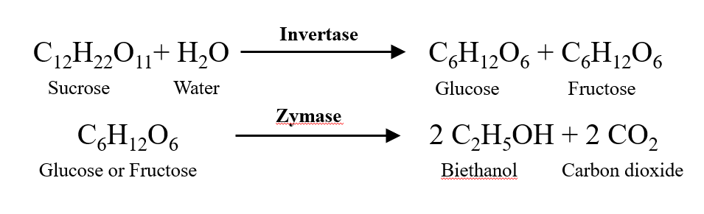
Yeast fermentation is a widely recognized natural metabolic procedure in which specialized yeast strains convert intricate carbohydrates into simple sugars, followed by the conversion of these sugars into either alcohol or acid. Cellulose conversion into bioethanol generally involves a dual process encompassing enzymatic hydrolysis and fermentation.

Bioethanol production largely depends on fermentation processes, which are,
- Simultaneous saccharification and fermentation (SSF)
- Simultaneous saccharification and co-fermentation (SSCF)
- Separate hydrolysis and fermentation (SHF)
- Solid-state fermentation (SSF)
5.1 Simultaneous saccharification and fermentation (SSF)
Enzymatic hydrolysis and fermentation are integrated through the simultaneous saccharification and fermentation (SSF) technique, allowing for the production of value-added products within a single stage. An enzyme complex is used in this procedure to hydrolyze cellulose and produce sugars. Later, these sugars are utilized by microbes and transformed into value-added products. SSF is superior to other fermentative procedures in many ways. The use of a single vessel for the fermentation and saccharification, which reduces residence times and capital costs of the process, and the reduction of inhibitory compounds from enzymatic hydrolysis, which improves the process' overall performance, are a few advantages when compared to separate enzymatic hydrolysis and fermentation (SHF). These benefits have led to extensive research on using SSF to make biofuels like ethanol and butanol from butanol from lignocellulosic and starchy raw materials (Das-Neves et al., 2007). The ideal temperature for enzymatic hydrolysis is often more critical than the fermentation temperature, so finding an equilibrium point of pH and temperature at which the process functions properly is also a prerequisite (Niphadkar et al., 2017)
5.2 Simultaneous saccharification and co-fermentation (SSCF)
Simultaneous saccharification and co-fermentation (SSCF) is another alternate process to SSF, which simultaneously allows hexose and pentose fermentation. In SSCF configuration, microorganisms used for fermentation should have similar operating pH and temperature. SSCF offers the potential of streamlined processing while reducing capital costs (Cardona and Sanchez, 2007).
5.3 Separate hydrolysis and fermentation (SHF)
The separate hydrolysis and fermentation (SHF) process has been implemented for ethanol production and is a starch-based ethanol production process. In this process, starch is initially catalysed by the action of amylolytic enzymes, viz. α-amylase (for liquefaction) and glucoamylase (for saccharification). The process can be accomplished by fermentation in separate vessels. The major disadvantage of this process is inhibiting enzyme activity due to the accumulation of hydrolysed sugar. It is also expensive and time-consuming (Das-Neves et al., 2007).
5.4 Solid-state fermentation (SSF)
Solid-state fermentation is a practical, economical, and promising technology that eliminates the need for the extraction of sugar while allowing microorganisms to grow on the surface of solid materials without the presence of free water. This results in lower distillation and purification costs. Additionally, SSF is a proven technique for producing a variety of enzymes, making it a suitable technique for the enzymatic pretreatment and hydrolysis of substrates and subsequent bioethanol production (Pandey et al., 2000b).
- FERMENTATION MODES
6.1 Batch fermentation: A set amount of medium, which includes nutrients and other components, is given to microorganisms. As people ingest nutrients, the culture and environment are continuously changing.
Advantages | Disadvantages
- Inexpensive  - Low danger of contamination  - Less need for control  - Simpler sterilization | - Ethanol production with fewer cells per cell  - increased downtime between batches because of vessel setup, cleaning, and sterilization

  - Fed-Batch fermentation: Microorganisms are introduced to the media by inoculation, and after growing in a batch environment for a predetermined period, nutrients are gradually added during the fermentation (Yang and Sha, 2019).
Advantages | Disadvantages
- Higher ethanol accumulation  - Limited byproduct accumulation  - Maintenance of maximum viable cell concentration  - Increased cell lifespan  - Control of variables like pH, temperature, and dissolved oxygen | - Rising expenses for process control  - Increased downtime between batches because of cleaning, vessel setup, and sterilization

6.3 Continuous fermentation: The fermenter continuously replaces the nutrients consumed with a fresh medium. The removal of hazardous metabolites, used media, and ethanol is ongoing (Yang and Sha, 2019).
Advantages | Disadvantages
- Reduced vessel cleaning downtime  - Increased productivity  - Lower costs; greater degree of control  - Ability to automate  - More cost-effective  - Less prone to human error. | - Long development times can raise the danger of contamination  - Cell aggregation can inhibit optimal steady-state growth.

Table 2. Difference between batch, fed batch, and continuous fermentation
Characteristics | Batch | Fed batch | Continuous
Cultivation system | Closed type | Semi-closed type | Open type
Addition of fresh nutrition | No | Yes | Yes
Volume of culture | Constant | Increases | Constant
Removal of wastes | No | No | Yes
Chance of contamination | Minimum | Intermediate | Maximum
Growth phase | Lag, Log, Stationary, and Decline phase | Lag, Log, Stationary, and Decline phase | Lag and Log phase
Log phase | Shorter | Longer | Longest and continuous
Product yield | Low | Medium | High

7. BIOETHANOL SEPARATION AND PURIFICATION
Two energy-intensive separation stages are required for producing pure ethanol (95.63 % by mass) from binary azeotrope ethanol-water (Huang et al., 2008). In the first phase, ethanol is concentrated to a mass concentration of between 92.4 and 94% by conventional distillation. An energy-efficient option with relatively moderate investments is cyclic distillation to purify ethanol.
The process of ethanol dehydration is used in the second phase to create anhydrous ethanol, which has ethanol concentrations higher than those seen in azeotropic composition. That can be accomplished using pressure-swing distillation (Mulia-Soto and Flores-Tlacuahuac, 2011), extractive distillation (with liquid solvent, dissolved salt, their mixture, ionic liquids, and hyperbranched polymers), azeotropic distillation, and combinations of these techniques.
Membrane techniques have attracted attention as an alternative to conventional distillation because of a variety of benefits that make them appealing for the separation of liquid mixtures. They can separate temperature-sensitive materials because of their excellent separation efficiency, cheap energy, and operating costs, lack of waste streams, and ability to operate at low temperatures (Radocaj and Diosady, 2014).
Parallel to fermentation, pervaporation is a possibility. This technique, which is safe for the working microorganism and allows for in-situ ethanol extraction, shows promise (Kaewkannetra et al., 2011). Gas stripping is an additional method in addition to distillation for the extraction of ethanol and other volatile components from fermentation broth (de Vrije et al., 2013).
According to Marjani et al. (2014), ethanol separation also used the carbon nanotube-integrated polyamide nanocomposite membrane. The silicalite-1, polydimethylsiloxane, and polyvinylidene fluoride hybrid composite membranes were used to ferment sorghum juice and continuous bioprocess. (Cai et al., 2016).
4. Fourth-generation bioethanol (4G)
Genetically modified algae can produce more products and have many other advantages than wild-type algae. CRISPR/Cas9 is a commonly utilized method in genetic engineering because it combines effective transfection and targeted gene disruption.
The successful manufacture of ethanol and other fuel products, including butanol, isobutanol, and modified fatty acids, has been achieved in fourth-generation biofuel methods that depend on genetically enhanced Cyanobacteria.

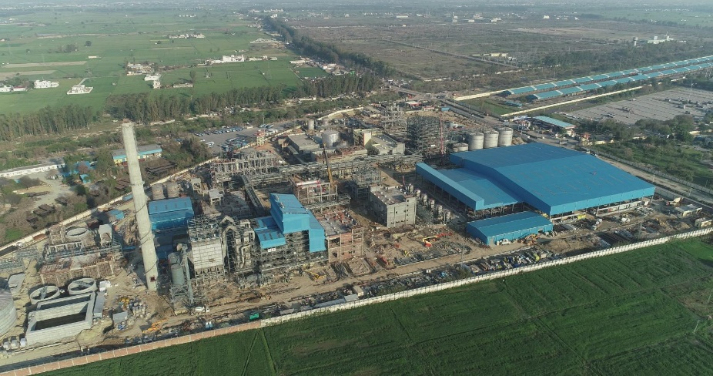

Asia's First 2G Ethanol Bio-Refinery of Indian Oil Corporation Limited (IOCL) at
Panipat, Haryana (10th Aug 2022).

Advantages of Bioethanol
- Carbon neutral
- Encourages farm income
- Reduce energy costs
- Replaces the usage of high price petroleum
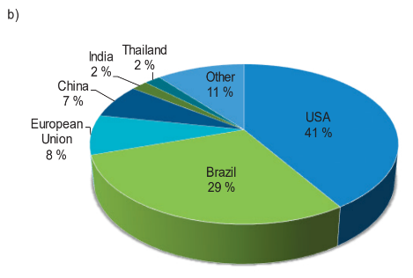
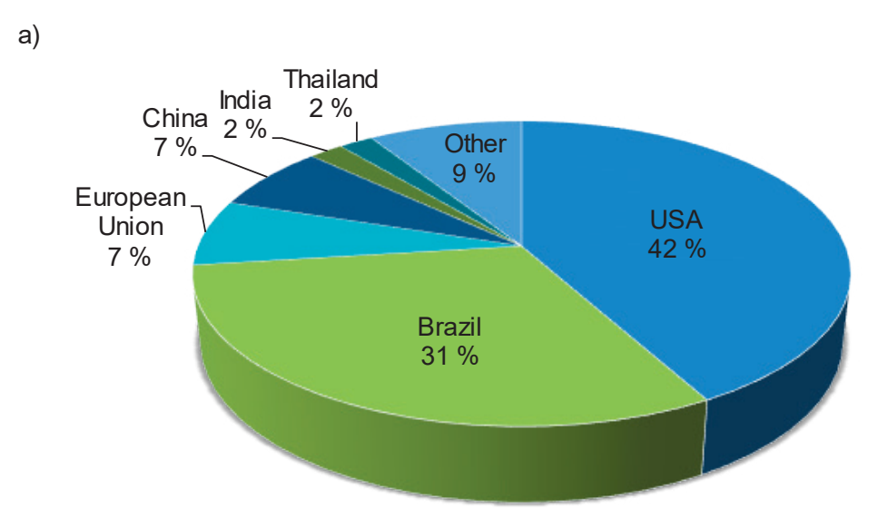
Fig. 12: Predictions of the world bioethanol (a) production and (b) consumption by 2024(Busic et al., 2018)
https://pib.gov.in/PressReleasePage.aspx?PRID=1885392

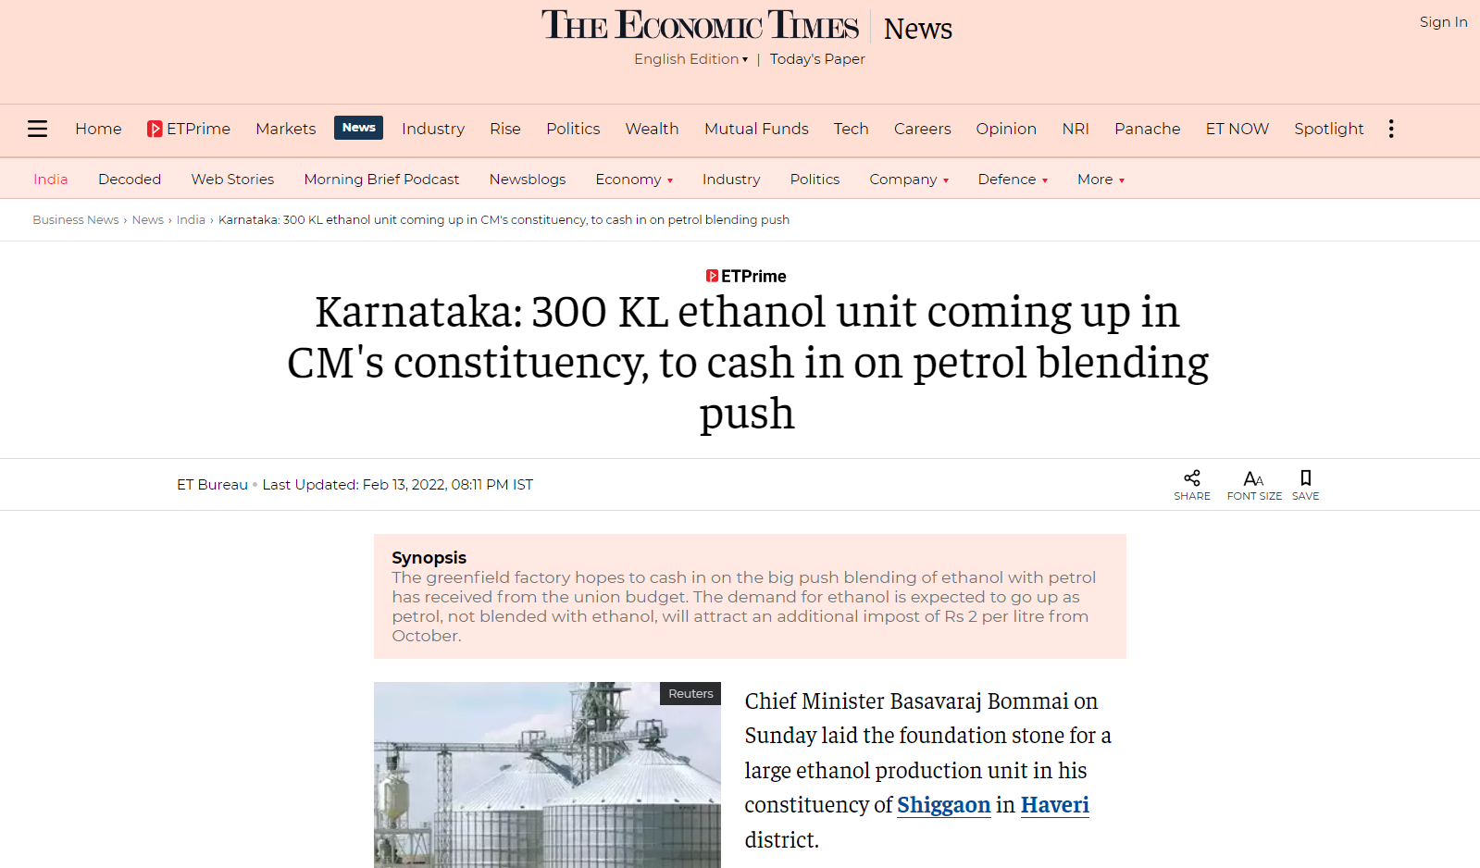
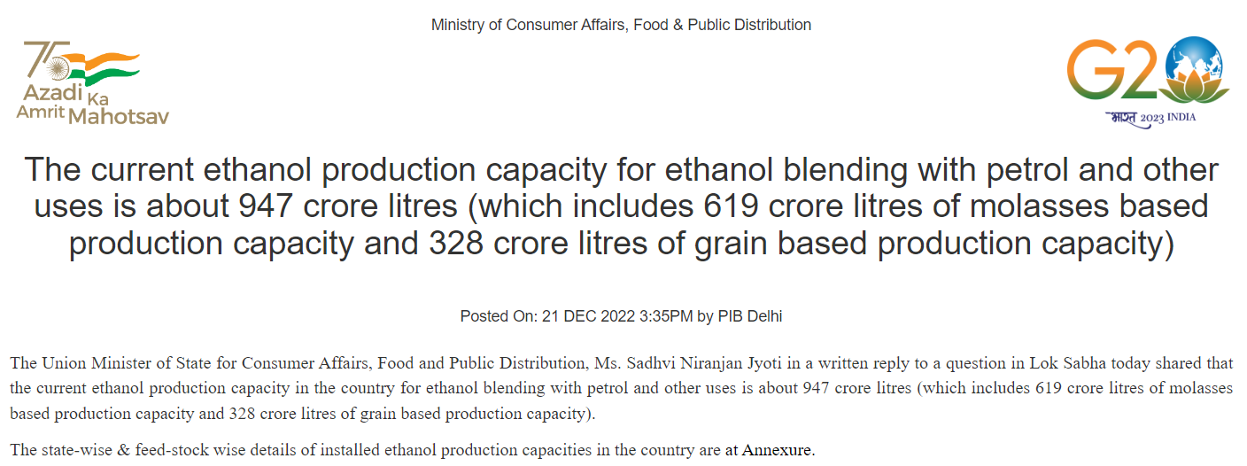

Ministry of Petroleum & Natural Gas
India has achieved the 10 percent ethanol blending target, 5 months ahead of schedule. Posted On: 05 JUN 2022 2:11 PM by PIB Delhi
A "Roadmap for Ethanol Blending in India 2020-25" was released by the Hon'ble Prime Minister in June 2021, which lays out a detailed pathway for achieving 20 percent ethanol blending. This roadmap also mentioned an intermediate milestone of 10 percent blending by November 2022. Twelve commercial plants have already been proposed to be built under the Pradhan Mantri JI-VAN (Jaiv Indhan-Vatavaran Anukool Fasal Awashesh Nivaran) Yojana in regions with adequate biomass supply.
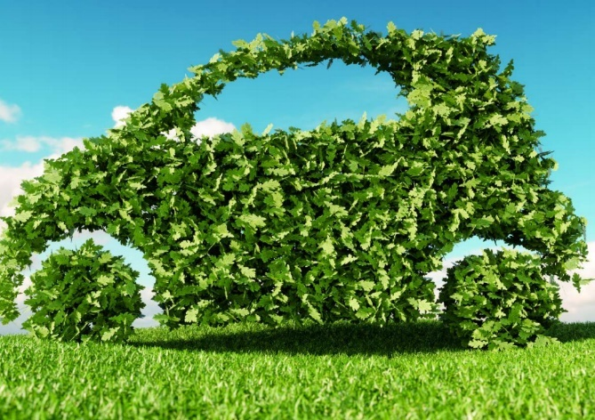
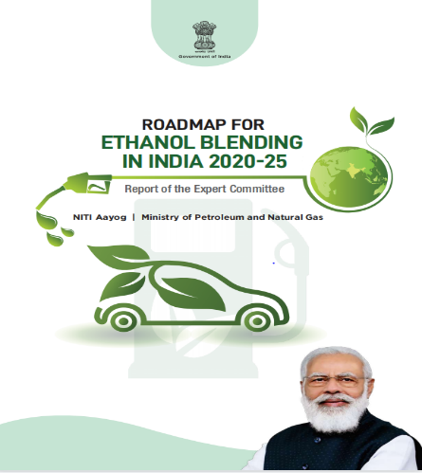

Companies
- Balrampur Chini Mills Ltd.
- Triveni Engineering Ind.
- Shree Renuka Sugars Ltd.
- EID Parry (India) Ltd
- Bajaj Hindusthan Sugar Company
- Godavari Biorefineries Limited
- Dalmia Bharat Sugar and Industries Limited
- Simbhaoli Sugars Limited
Uses of Bioethanol has several applications, including:
Uses of Fuel: It is blended with gasoline to create ethanol fuel (commonly known as E10 or E85, depending on the ethanol-to-gasoline ratio). Ethanol is a renewable and cleaner-burning alternative to fossil fuels, reducing greenhouse gas emissions and dependence on finite resources.
1. Industrial Applications: Ethanol is used as a solvent in the manufacturing of various products, including pharmaceuticals, personal care items, and cleaning agents.
2. Alcoholic Beverages: Ethanol is the primary alcohol in alcoholic beverages.
Benefits and Challenges: Bioethanol offers several environmental benefits, as it is produced from renewable resources and reduces net carbon dioxide emissions compared to fossil fuels. However, there are also challenges associated with its production, including competition with food crops, land-use changes, and potential impacts on water resources.
Researchers and scientists continue improving bioethanol production methods and exploring alternative feedstocks that are less resource-intensive and do not directly compete with food production. Additionally, advancements in second-generation biofuels, such as cellulosic ethanol, aim to use non-food-based feedstocks like agricultural residues and municipal solid waste, further reducing environmental impacts.
Overall, bioethanol remains an essential component of the global effort to transition to more sustainable and environmentally friendly energy sources.
9. CONCLUSION
India produces roughly 350 million tonnes of agricultural waste annually. Uncontrolled agricultural solid waste disposal and burning has led to pollution, a threat to human life, and other environmental issues. These wastes can be managed effectively through various uses, including the manufacture of fuel, fertilizers, animal feed, etc. Transforming agricultural residue into bioethanol holds the potential to maintain environmental cleanliness, and generating bioenergy offers a solution to address the challenges stemming from the decline of fossil fuel resources. The environmentally friendly bioethanol made from agricultural waste is a valuable replacement for fossil fuels. Burning conventional gasoline with a small amount of bioethanol produces less greenhouse gas emissions. Modern automobiles can also run flawlessly on bioethanol blends without modifying their engines, which has improved environmental sustainability and reduced energy use. The need for sustainable energy sources to reduce dependency on imported petroleum oil means that bioethanol is a potential alternative energy source in the future.
- Eco-friendly alternative to non-renewable fuels
- Environment clean
- Reduces greenhouse gas emissions during combustion
- Modern motor vehicles operate smoothly using bioethanol blends without requiring engine adjustments.
10. REFERENCES
[Anonymous]. 2020. Creating Wealth From Agricultural Waste. Ministry of Agriculture and Farmers Welfare, Government of India, 148p.
Anoop, P. 2014. Utilization of pineapple (Ananas comosus (L.) Merr.) Biomass for biofuel production. M.Sc.(Ag) thesis, Kerala Agricultural University, Thrissur, 103p.
Arifin, Y., Tanudjaja, E., Dimyati, A., and Pinontoan, R. 2014. A second generation biofuel from cellulosic agricultural byproduct fermentation using clostridium species for electricity generation. Energy Procedia 47: 310–315.
Balat, M., Balat, H., and Oz, C. 2008. Progress in bioethanol processing. Prog. Energy Combust. Sci. 34: 551-573.
Ballesteros, I., Negro, M. J., Oliva, J. M., Cabanas, A., Manzanares, P., and Ballesteros, M. 2006. Ethanol production from steam-explosion pretreated wheat straw. App. Biochem. Biotechnol.130: 496-508.
Banerjee, S., Sen, R., Pandey, R. A., Chakrabarti, T., Satpute, D., and Giri, B. S. 2009. Evaluation of wet air oxidation as a pretreatment strategy for bioethanol production from rice husk and process optimization. Biomass Bioenerg. 33: 1680-1686.
Binod, P., Sindhu, R., Singhania, R. R., Vikram, S., Devi, L., and Nagalakshmi, S. 2010. Bioethanol production from rice straw: An overview. Bioresour. Technol. 101(13): 4767–4774.
Borines, M. G., de Leon, R. L., and Cuello, J. L. 2013. Bioethanol production from the macroalgae Sargassum spp. Bioresour. Technol. 138: 22–29.
Cai, D., Hu, S., Chen, C., Wang, Y., Zhang, C., and Miao, Q. 2016. Immobilized ethanol fermentation coupled to pervaporation with silicalite-1/polydimethylsiloxane/polyvinylidene fluoride composite membrane. Bioresour. Technol. 220: 124–131.
Cardona, C. A. and Sanchez, O. J. 2007. Fuel ethanol production: Process design:trends and integration opportunities. Bioresour. Technol. 98(12): 2415-2457.
Cardona, C. A., Quintero, J. A., and Paz, I. C. 2009. Production of bioethanol from sugarcane bagasse: status and perspectives. Bioresour. Technol. 101(13): 4754-4766.
Casabar, J. T., Unpaprom, Y., and Ramaraj, R. 2019. Fermentation of pineapple fruit peel wastes for bioethanol production. Biomass Conv. Bioref. 15: 56-65.
Chaudhary, L., Pradhan, P., and Soni, N. 2014. Algae as a feedstock for bioethanol production: new entrance in biofuel world. Int. J. Chem. Tech. Res. 6(2): 1381–1389.
Corbin, K. R., Byrt, C. S., Bauer, S., DeBolt, S., Chambers, D., Holtum, J. A. M., Karem, G., Henderson, M., Lahnstein, J., and Beahan, C. T. 2015. Prospecting for energy-rich renewable raw materials: Agave leaf case study. PLoS ONE 10: 135382.
Danmaliki, G. I., Muhammad, A. M., Shamsuddeen, A. A., and Usman, B. J. 2016. Bioethanol production from banana peels. IOSR J. Environ. Sci., Toxicol. Food Technol. 10 (6): 56-62.
Das, P., Ganesha, A., and Wangikar, P. 2004. Influence of pretreatment for deashing of sugarcane bagasse on pyrolysis products. Biomass Bioenerg. 27: 445-457.
Das-Neves, M. A., Toshinori, K., Naoto, S., and Nakajima. 2007. State of the art and future trends of bioethanol production. Dyn. Biochem. Process Biotechnol. Mol. Boil. 1(1): 1-14.
de Vrije, T., Budde, M., Vander, W. H., Claassen, P. A. M., and Lopez-Contreras, A. M. 2013. ‘In situ’ removal of isopropanol, butanol, and ethanol from fermentation broth by gas stripping. Bioresour. Technol. 137: 153–159.
Demirbas, A. 2005. Bioethanol from cellulosic materials: a renewable motor fuel from biomass. Energy Sources 27: 327-333.
Dias, M. O. S., Cavalett, O., and Filhob, R. M. 2014. Integrated first and second generation ethanol production from sugarcane. Chem. Engg. Transac. 37: 445–450.
Doda, S. and Sahu, O. 2021. Production of bioethanol from biomass (Marigold flower). Materials Today: Proceedings. www.elsevier.com/locate/matpr. 1-6.
FAO (Food and Agriculture Organization) 2008. The State of Food and Agriculture 2008. Biofuels: Prospects, Risks and Opportunities. Available online: http://www.fao.org/3/i0100e/i0100e.pdf (accessed on 5 August 2021).
Goel, S., Kumar, P., Sain, M., & Singh, A. (2022). Anaerobic Treatment of Food Processing Wastes and Agricultural Effluents. In Food Processing Waste and Utilization (pp. 313-328). CRC Press.
Gomez, L. D., Clare, G. S., and McQueen-Mason, J. 2008. Sustainable liquid biofuels from biomass: the writing’s on the walls. New Phytol. 178: 473–485.
Gunam, I. B. W., Dewi, I. A. P. K., Antara, N. S., Anggreni, A. A. M. D., and Setiyo, Y. 2021. Bioethanol production from sugarcane bagasse by Saccharomyces cerevisiae ATCC 9763 immobilized in Na-alginate. IOP Conf. Series: Earth Environ. Sci. 824: 012054.
Hamelinck, C. N., Hooijdonk, G. V., and Faaij, A. P. C. 2005. Ethanol from lignocellulosic biomass: techno-economic performance in short-, middle- and long-term. Biomass Bioenerg. 28: 384-410.
Huang, H. J., Ramaswamy, S., Tschirner, U. W., and Ramarao, B. V. 2008. A review of separation technologies in current and future biorefineries. Sep. Purif. Technol. 62(1): 1–21.
Kaewkannetra, P., Chutinate, N., Moonamart, S., Kamsan, T., and Chiu, T. Y. 2011. Separation of ethanol from ethanol–water mixture and fermented sweet sorghum juice using a pervaporation membrane reactor. Desalination. 271(1–3): 88–91.
Karimi, K., Shafiei, M., and Kumar, R. 2013. Progress in physical and chemical pretreatment of lignocellulosic biomass. In: Biofuel Technologies Recent Developments. Berlin Heidelberg: Springer-Verlag; p. 53–96.
Khoshkho, S. M., Mahdavian, M., Karimi, F., Karimi-Maleh, H., and Razaghi, P. 2022. Production of bioethanol from carrot pulp in the presence of Saccharomyces cerevisiae and beet molasses inoculum; A biomass-based investigation. Chemosphere 286: 131688.
Kumar, R. and Wyman, C. E. 2009. Effects of cellulase and xylanase enzymes on the deconstruction of solids from pretreatment of poplar by leading technologies. Biotechnol. Prog. 25: 302-314.
Lennartsson, P. R., Erlandsson, P., and Taherzadeh, M. J. 2014. Integration of the first- and second-generation bioethanol processes and the importance of byproducts. Bioresour. Technol. 165: 3–8.
Marjani, A., Mohammadi, M., Pelalak, R., and Moradi, S. 2014. Ethanol purification using polyamide-carbon nanotube composite membranes. Polym. Eng. Sci. 54(4): 961–968.
Martin, C., Klinke, H. B., and Thomsen, A. B. 2007. Wet oxidation as a pretreatment method for enhancing the enzymatic convertibility of sugarcane bagasse. Enzyme Microb. Technol. 40: 426-432.
Mitchell, D.A. and Lonsane, B. K. 1990. Definition, characterization, and economic evaluation. In: Doelle, H. W. and Rolz, C. (Eds.). General Principles of Solid Substrate Fermentation. Rapid Publications of Oxford Ltd, UK.
Mosier, N., Hendrickson, R., Ho, N., Sedlak, M., and Ladisch, M. R. 2005. Optimization of pH-controlled liquid hot water pretreatment of corn stover. Bioresour. Technol. 96: 1986-1993.
Mulia-Soto, J. F. and Flores-Tlacuahuac, A. 2011. Modeling, simulation, and control of an internal heat-integrated pressure-swing distillation process for bioethanol separation. Comput. Chem. Eng. 35(8): 1532–1546.
Mussatto, S. I., Dragone, G., Guimaraes, P. M. R., Silva, J. P. A., Carneiro, L. M., and Roberto, I. C. 2010. Technological trends, global market, and challenges of bio-ethanol production. Biotechnol. Adv. 28(6): 817–830.
Nahak, S., Nahak, G., and Pradhan, I. 2011. Bioethanol from marine algae: a solution to global warming problem. J. Appl. Environ. Biol. Sci. 1(4): 74–80.
Neves, M. A., Kimura, T., Shimizu, N., and Nakajima, M. 2007. State of the art and future trends in bioethanol production, dynamic biochemistry, process biotechnology, and molecular biology. Global Science Books; 1-13.
Nguyen, T. A. D., Kim, K. R., Han, S. J., Cho, H. Y., Kim, J. W., and Park, S. M. 2010. Pretreatment of rice straw with ammonia and ionic liquid for lignocellulose conversion to fermentable sugars. Bioresour. Technol. 101(19): 7432-7438.
Niphadkar, S., Bagade, P., and Ahmed, S. 2017. Bioethanol production: insight into past, present and future perspectives. Biofuels. https://doi.org/10.1080/17597269.2017. 1334338.
Nugrahini, A. D., Kurniawan, M. P., and Kinasih, D. A. 2021. Development of lignocellulose-based bioethanol from chrysanthemum flower waste (Chrysanthemum sp.). IOP conf. series: Earth and Environ. sci. 963: 012017.
Palacios-Bereche, R., Mosqueira-Salazar, K. J., and Modesto, M. 2013. Exergetic analysis of the integrated first- and second-generation ethanol production from sugarcane. Energy 62: 46–61.
Panda, S. K., Ray, R. C., Mishra, S. S., and Kayitesi, E. 2017. Microbial processing of fruit and vegetable wastes into potential biocommodities: a review. Crit. Rev. Biotechnol. 1549-7801.
Pandey, A., Soccol, C. R., Nigam, P., and Soccol, V. T. 2000a. Biotechnological potential of agroindustrial residues. Sugarcane baggase. Bioresour. Technol. 74: 69-80.
Pandey, A., Soccol, C. R., and Mitchell, D. A. 2000b. New developments in solid-state fermentation. I. Bioprocesses and products. Process Biochem. 35 (10): 1153-1169.
Pedersen, M. and Meyer, A. S. 2009. Influence of substrate particle size and wet oxidation on physical surface structures and enzymatic hydrolysis of wheat straw. Biotechnol. Prog. 25(2): 399-408.
Phuong, D. V., Quoc, L. P. T., Tan, P. V., and Duy, L. N. D. 2019. Production of bioethanol from Robusta coffee pulp (Coffea robusta L.) in Vietnam. Foods Raw Mater. 7(1): 10-17.
Phwan, C. K., Chew, K. W., Sebayang, A. H., Ong, H. C., Ling, T. C., Malek, M. A., Yeek‑Chia, H., and Show, P. K. 2019. Effects of acids pretreatment on the microbial fermentation process for bioethanol production from microalgae. Biotechnol. Biofuels 12:191.
Prasad, S., Singh, A., and Joshi, H. C. 2007. Ethanol is an alternative fuel from agricultural, industrial, and urban residues. Resour. Conser. Recycle. 50: 1-39.
Radocaj, O. and Diosady, L. L. 2014. Continuous ethanol fermentation in immersed, cross-flow microfiltration membrane bioreactor with cell retention. J. Basic Appl. Sci. 10: 543–553.
Ramachandra, T. V. aned Hebbale, D. 2020. Bioethanol from macroalgae: Prospects and challenges. Renew. Sustain. Energy Rev. 117: 109147.
Rodriguez, L. A., Toro, M. E., Vazquez, F., Correa-Daneri, M. L., Gouiric, S. C., and Vallejo, M. D. 2010. Bioethanol production from grape and sugar beet pomaces by solid-state fermentation. Int. J. Hydrogen Energy 35: 5914-5917.
Rodsrud, G., Lersch, M., and Sjode, A. 2012. History and future of the world's most advanced biorefinery in operation. Biomass Bioenergy. 46: 46–59.
Saha, B. C., Iten, L. B., Cotta, M. A., and Wu, Y. V. 2005. Dilute acid pretreatment, enzymatic saccharification, and fermentation of wheat straw to ethanol. Process Biochem. 40: 3693-3700.
Sain, M., Kaur, M., Singh, M., & Kumar, S. (2018). Development of a Dual Fuel System to Operate Tractor on Biogas. Int. J. Pure App. Biosci, 6(1), 1710-1720.
Sain, M. (2020). Production of bioplastics and sustainable packaging materials from rice straw to eradicate stubble burning: A Mini-Review. Environment Conservation Journal, 21(3), 1-5.
Sanchez, C. 2009. Lignocellulosic residues: Biodegradation and bioconversion by fungi. Biotechnol. Adv. 27(2): 185–194.
Sanchez, O. J. and Cardona, C. A. 2008. Trends in biotechnological production of fuel ethanol from different feedstocks. Bioresour. Technol. 99: 5270-5295.
Sarkar, N., Ghosh, S. K., and Bannerjee, S. 2012. Bioethanol production from agricultural wastes: An overview. Renew. Energ. 37(1): 19–27.
Seong, Choi., Jae-Hoon, Kim., Seung, G. W., Kyoung, H. K., and Hyeun-Jong, B. 2013. Bioethanol production from mandarin (Citrus unshiu) peel waste using popping pretreatment. Appl. Energy 102: 204–210.
Stichnothe, H. and Azapagic, A. 2009. Bioethanol from Waste: Life Cycle Estimation of the Greenhouse Gas Saving Potential. Resour. Conserv. Recy. 53: 624–630.
Sun, R. C., Lawther, J. M., and Banks, W. B. 1995. Influence of alkaline pretreatments on the cell-wall components of wheat-straw. Ind. Crops Prod. 4(2): 127-145.
Sun, Y. and Cheng, J. 2002. Hydrolysis of lignocellulosic material for ethanol production: a review. Bioresour. Technol. 96: 673-686.
Taha, M. G., Khattab, A. E., Ali, H. E., and Dawood, M. A. M. 2019. Production of bio-ethanol from potato starch wastes by Saccharomyces cerevisiae. Egypt. J. Appl. Sci. 34 (12): 256-267.
Tomas-Pejo, E., Alvira, P., Ballesteros, M., and Negro, M. J. 2011. Pretreatment technologies for lignocellulose-to-bioethanol conversion. In: Pandey A, Larroche C, Ricke SC, Dussap CG, Gnansounou E, editors. Biofuels – Alternative feedstocks and conversion processes. Oxford, UK: Academic Press; 2011. pp. 149–176.
Uihlein, A. and Schbek, L. 2009. Environmental impacts of a lignocellulosic feedstock biorefinery system: an assessment. Biomass and Bioenergy 33: 793-802.
Yang, Y. and Sha, M. A. 2019. Beginner’s Guide to Bioprocess Modes—Batch, Fed-Batch, and Continuous Fermentation; Eppendorf Application Note 408; Eppendorf: Hamburg, Germany.
Zhao, X., Cheng, K., and Liu, D. 2009. Organosolv pretreatment of lignocellulosic biomass for enzymatic hydrolysis. Appl. Microbiol. Biotechnol. 82: 815-827.

