Wearable Crowdsource IOT Fusion System to Monitor Respiratory and Fever Symptoms for Pandemic Early Warning

Ms.M.Deeparani ¹
Assistant Professor, Hindusthan
College of Engineering and Technology, Coimbatore.
deeparani.bme@hicet.ac.in

Dr.M.Ganga ²
Associate Professor, Hindusthan
College of Engineering and
Technology, Coimbatore
ganga.bme@hicet.ac.in

Mr.P.E.Kamalakkannana ³
Assistant Professor,
Dr Mahalingam college of Engineering and technology, Pollachi.
pekamalakkannan@gmail.com
Abstract -Nowadays, the main serious risk to global health is the respiratory diseases, which is due to Corona virus. The outburst of COVID-19 has fetched brutal challenges to public health and has paying attention to great extent from the research and medical society. Most patients infected with corona virus will have fever. So, the body temperature monitoring has turn into one of the most vital basis for this type of pandemic prevention and testing. In this case, the measurement of body temperature is done through Forehead Thermometer, but speed is relatively slow. The cost of body temperature measurement equipment, such as infrared (IR) body temperature detection and face recognition machine, is too far above the ground, and it is not easy to put together Surveillance System for monitoring the condition of disease spread). Early detection of potential pandemics characterized by respiratory symptoms is critical for global health management. It allows for timely intervention, which can help to mitigate the likelihood of uncontrolled massive virus spread. To this end, we propose utilizing wearable devices as a tool for developing a wearable crowdsource system that can monitor various body parameters. With sensors embedded in wearable devices, people's vital signs can be measured directly and non-intrusively in real time we collect the data from wearable devices and develop machine learning algorithms to analyze the data for respiratory symptom monitoring and early warning. Our focus is on monitoring body temperature, oxygen levels, and heartbeat rate. This research has the potential to revolutionize pandemic early warning systems and transform our approach to managing public health crises in the future.

KEYWORDS-Temperature sensor, SPO2 sensor, GPS, IOT, Pulse Measurement,
1. INTRODUCTION
Detecting potential pandemics with respiratory symptoms at an early stage is vital for effective global health management as it enables timely intervention to reduce the likelihood of uncontrolled virus spread. Our proposed early warning system aims to detect potential pandemic outbreaks characterized by respiratory and fever symptoms, thus reducing the chances of a massive virus spread. The COVID-19 pandemic has significantly impacted our society, infecting millions of people globally and causing thousands of deaths daily. Despite the passage of almost three years, we are still grappling with the pandemic, and the world remains in a state of panic [1]. Increasing population crowd, earlier social contact and connections make epidemic control difficult. Conventional offline epidemic control technique with medical survey records are not efficient due to its incapability to collect health data and social contact information concurrently. A cluster-based epidemic control scheme is proposed based on Smartphone-based body area network[2]. The communication layer unites the sensing and application layer. In a distinctive case, the wearable device gathers sensor data and saves the data in local storage, which is usually tiny. Then it backs up the data to host Smartphone or a in close proximity edge server through Bluetooth or Wi-Fi. Smartphone’s go after a alike scheme and hold data communication with government agency or other accountable body and edge servers also hold wired communication. usually, for data communications for a wide geological range, 5G/6G will be feasible alternatives as an alternative of near-fi eld Bluetooth communication[3]. Our structure is data-centric and obviously it is necessary to discuss about security and privacy. The necessities for security and privacy as well as people’s recognition differ in various countries for different applications [4,8]. AI techniques can generate a free, non-invasive, real-time, large-scale COVID-19 asymptomatic screening tool to supplement present approaches in the spread of COVID-19[6].To solve this issue, we propose wearable devices to develop a wearable crowdsource system that monitors respiratory symptoms such as body vitals. RADAR-base, data collection platform collect data from wearable’s and mobile tools, can be used to quickly count and present a behavioral changes in response to public health involvement as a result of the infectious outbreaks like COVID-19. RADAR-base may be a feasible approach for employing an early warning system for reflexively assessing the local observance to interferences in epidemics and pandemics, and could help countries to act accordingly [7]. Our initial results indicate that our algorithms have higher detection accuracy and fewer false positives while utilizing minimal computing resources. This research has the potential to revolutionize pandemic early warning systems and transform our approach to managing public health crises in the future.
2. MOTIVATION
The inspiration for undertaking this research work stemmed from the recent pandemic outbreak that highlighted the need for effective monitoring of respiratory symptoms. To address this issue, we propose developing a wearable crowdsource system that utilizes ubiquitous wearable devices to monitor respiratory symptoms such as cough and fever. We collect data from these devices and use machine learning algorithms to analyze the data for early warning and respiratory symptom monitoring. Our primary focus is on detecting coughs through multi-source data fusion. Additionally, we plan to alert people in real-time using the values obtained from these wearable devices.
3. METHODS EXISTING
Various efforts have been made to address the challenges posed by pandemics, including medical and non-medical measures. While medical methods offer high-precision technology, they come at a high cost. City-wide testing, conducted in few cities, requires significant mobilization ability and resources. However, for many cities and countries, this approach is impractical or unsustainable due to the high costs involved. In addition to testing, some countries have implemented data-driven surveillance systems that collect data on morbidity, prevalence, hospitalizations, and deaths related to the pandemic. This data is managed by the government for further analysis, visualization, contact tracking, and disease impact assessment. The high cost of medical-based methods has prompted the use of non-medical solutions such as Bluetooth-enabled devices (such as smartphones and inexpensive tokens) for contact tracing. Data is also a valuable source of insight, with companies were using real-time search queries and self-reported respiratory symptoms to identify areas with a high percentage of symptom activity. While these solutions are cost-effective, they lack the accuracy and rigor inherent in medical methods. Achieving a balance between accuracy and cost is a challenging tradeoff in both medical and non-medical methods.
4. PROPOSED SYSTEM ARCHITECTURE
Our proposed research aims to develop a wearable crowdsource system that utilizes ubiquitous wearable devices to monitor respiratory symptoms like cough and fever. These devices can directly and non-intrusively measure vital signs like body temperature, oxygen level, and heartbeat rate in real-time using various sensors. We collect data from these devices and employ machine learning algorithms to analyze it for respiratory symptom monitoring and early warning. Our focus is on vital signs like body temperature, oxygen level, and heartbeat rate. We believe that this research has the potential to transform the way we implement pandemic early warning and respond to public health crises in the future. At the present time, a variety of consumer electronics have entered into people’s daily life. Wearable devices and Smartphone’s are attractive more, particularly for people of urbanized nations. Sensors with special functions are embedded into the most recent product wearable’s. Some of wrist Band as an example — include heart rate sensor, accelerometer, microphone, GPS ,temperature sensor etc. Those sensors produce plentiful multimodal information to imitate people’s crucial states and hold extra monitoring and analysis. Wearables and Smartphone’s are employed for this work. The collected data from the wearable sensors are automatically saved in the fixed storage. Then the data Input /Output is aid through the APIs, like extracting the sensor data. The system architecture of the wearable crowd source system for respiratory symptoms monitoring and early warning has four layers, namely, sensing layer, network and data processing layer and application layer[5].
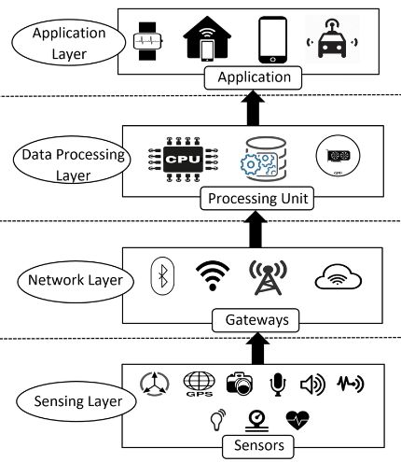

IoT Architecture [5] Sensing Layer This layer will consist of sensors, body temperature, oxygen level, and heartbeat rate sensors, GPS module, alarms etc.

5. COMPARISON TABLE

EXISTING SYSTEM | PROPOSED SYSTEM
It consists of a Healthcare platform that connects doctors and patients, and the system uses a mobile application with facial recognition-based Authentication. | In this system the individual can know about his and his surrounding health conditions within the location
It has vital checking parameters like ECG sensor, Heartbeat Sensor etc. But cannotalert you based on the conditions | Here it has vital checking parameters like Spo2 sensor, Heartbeat Sensor, temperature, sensor, GPS buzzer etc.
The former has advanced high-precision technology, but the cost is also high | High precision but low cost
PIC microcontroller is used which is a fast micro controller but does not have Wi-Fi capabilities | ESP8266 MICROCONTROLLER which is used in this system has Wi-Fi chip which helps in connecting to Iot

TABLE1: Comparison between existing system and proposed system

6. HARDWARE COMPONENTS DETAILS

This work entails a wearable glove comprising of following components-Temperature sensor, ESP8266 microcontroller,SPO2 sensor, GPS, LCD Display, battery etc.

6.1. MICROCONTROLLER
The ESP8266 is a low-cost microchip equipped with built-in TCP/IP networking software and microcontroller capability. It enables microcontrollers to establish a connection with a Wi-Fi network and form basic TCP/IP connections using commands in the Hayes style. Initially, there was a scarcity of English-language documentation regarding the chip and the commands it could receive. However, due to its extremely low price and the scarcity of external components on the module, it became a hot topic of interest for hackers who were intrigued to explore the module, the chip, and its software. They also translated the Chinese documentation to make it more accessible.
The ESP8266 module boasts powerful processing speed and a high storage capacity, which allows it to integrate easily with other devices like sensors. To ensure compatibility with other development boards, it is necessary to conduct external level shifting of voltages because this board lacks an on-board voltage regulator. Due to its cost-effectiveness, it is widely used in numerous applications, such as the Internet of Things, among others.

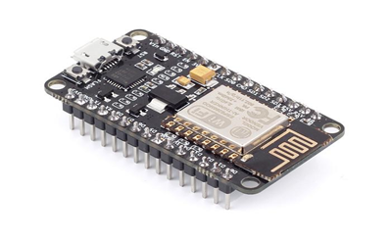
Fig.1 ESP8266

KEY FEATURES ESP8266 WIFI Module
- 32 – bit microcontroller
- Central processing unit: 80 MHz or 160 MHz
- Instruction RAM: 32 KB
- Cache RAM: 32 KB
- User data RAM: 80 KB
- ETS system data RAM: 16 Kb
- External memory: 16 MB
- General purpose input output pins: 16
- SPI supported
- I2C interface supported
- I2S interface supported
- Wi-Fi standard of 802.11 b / g / n
- UART supported on specific pins
- 10 – bit analog to digital converter (ADC)
- Protocol stack: TCP / IP

6.2. TEMPERATURE-SENSOR
The DHT11 is an veritably low- cost digital temperature and moisture detector that consists of a capacitive moisture detector and a thermistor to measure the girding air. The sensor emits a digital signal on the data pin without requiring analog input pins. Although simple to use, the sensor necessitates precise timing to obtain data. The sensor has one major drawback: it can only provide new data every two seconds, so readings from the sensor can be up to two seconds old when using the library.
The DHT11 sensor is composed of a capacitive humidity sensing element and a thermistor that detects temperature changes. The capacitor's humidity sensing has two electrodes with a moisture-holding substrate as a dielectric between them. The capacitance value varies with the change in humidity levels, causing the resistance values to alter. The integrated circuit (IC) measures and processes these resistance value changes, transforming them into digital form.
For temperature measurement, the DHT11 sensor employs a Negative Temperature Coefficient (NTC) thermistor that reduces its resistance value as the temperature rises. To obtain a higher resistance value for even the slightest temperature variation, the sensor is typically made up of semiconductor ceramics or polymers.
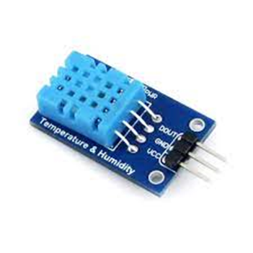
Fig.2 DHT11 sensor
The DHT11 sensor has a temperature range of 0 to 50 degrees Celsius, with a precision of 2 degrees. Its humidity range is 20 to 80%, with a precision of 5%. The sensor has a sampling rate of 1Hz, meaning it provides one reading every second. It is compact in size and operates at a voltage range of 3 to 5 volts. The maximum current utilized during measurement is 2.5mA. The DHT11 sensor comprises four pins - VCC, GND, Data Pin, and a non-connected pin. A pull-up resistor ranging from 5k to 10k ohms is provided for communication between the sensor and micro-controller.
6.3 PULSE OXIMETER SENSOR
The MAX30102 sensor is an advanced version of the MAX30100 sensor, designed for both heart rate monitoring and pulse oximetry. It features a photodetector, two LEDs, optimized optics, and low-noise signal processing components that work together to provide highly accurate readings. The sensor is easy to integrate with microcontrollers such as Arduino, ESP32, and ESP8266 Node MCU, making it ideal for use in various applications, including medical devices, fitness trackers, and wearable electronics.
One of the most significant advantages of the MAX30102 sensor is its high accuracy. The sensor's optimized optics and low-noise signal processing components enable it to provide highly accurate readings for both heart rate and oxygen saturation. This accuracy is essential in medical applications, where even small errors in measurements can have significant consequences [2]. The MAX30102 sensor's accuracy makes it ideal for use in devices such as pulse oximeters and other medical devices that require precise measurements.
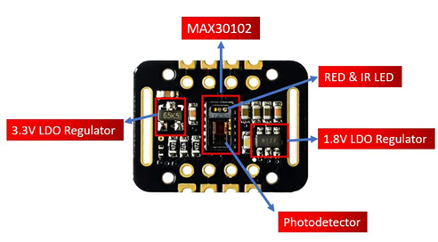
Fig.3 MAX30102 sensor
Another advantage of the MAX30102 sensor is its ease of use with microcontrollers. The sensor's compatibility with popular microcontrollers such as Arduino and ESP32 makes it easy for developers to integrate it into their projects. The MAX30102 sensor comes with a library that provides easy-to-use functions for accessing the sensor's data, making it even more accessible for developers with little or no experience in hardware programming.
The MAX30102 sensor is also highly customizable. The sensor's settings can be adjusted to meet specific application requirements, such as sampling rate, LED brightness, and LED pulse width. This flexibility makes the sensor highly versatile and suitable for a wide range of applications, from basic heart rate monitoring to more complex medical devices.
Lastly, the MAX30102 sensor is designed with low power consumption in mind. It consumes very little power, making it ideal for battery-powered devices. This low power consumption ensures that devices using the sensor can operate for extended periods without the need for frequent battery replacements. The combination of high accuracy, ease of use, customizability, and low power consumption makes the MAX30102 sensor an excellent choice for developers looking to build efficient, reliable, and accurate medical and fitness devices.
Key Features
- Heart rate monitoring: The MAX30102 sensor can accurately measure a user's heart rate through its pulse oximetry functionality.
- Pulse oximetry: The sensor can also measure the user's oxygen saturation (SpO2) levels, which is a crucial parameter for individuals with respiratory or cardiovascular issues.
- Dual LEDs: The sensor is equipped with two high-brightness LEDs that provide a strong light source for accurate measurements.
- Integrated photodetector: The sensor also includes a photodetector that accurately detects the reflected light from the LEDs.
- Ambient light cancellation: The MAX30102 sensor can effectively cancel out ambient light to ensure accurate readings, even in challenging environments.
- Low power consumption: The sensor has a low power consumption of only 1.8V, making it an ideal choice for portable and wearable devices.
- Ease of use: The MAX30102 sensor is easy to use and can be easily integrated with a variety of microcontrollers, such as Arduino and ESP32, making it a versatile and accessible solution for developers and hobbyists alike.

6.4. GPS SENSOR

A GPS (Global Positioning System) sensor is a device that receives signals from a network of satellites in orbit around the earth. It uses these signals to determine the device's current location, speed, and direction. GPS sensors are used in a variety of applications, such as navigation, tracking, and surveying. They can be found in smartphones, cars, airplanes, and boats, among other devices.

The GPS system works by measuring the time it takes for signals from at least four satellites to reach the GPS sensor. By comparing the time of arrival of the signals, the GPS sensor can calculate the distance to each satellite and use this information to determine its position on the earth's surface. The GPS sensor also takes into account factors such as the earth's curvature and atmospheric effects that can affect the accuracy of the position calculation.

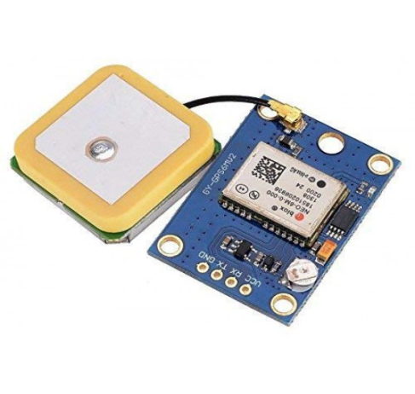
Fig.4 GPS sensor
One of the key features of GPS sensors is their ability to provide highly accurate location data. Modern GPS sensors can typically achieve accuracy to within a few meters or even centimeters, depending on the application and the specific sensor used. This makes GPS sensors ideal for applications such as navigation and surveying, where precise location data is critical.
GPS sensors have become an essential component of many modern devices and applications, from smartphones and cars to drones and industrial machinery. They have enabled a wide range of new services and capabilities, such as real-time location tracking, route planning, and geofencing. As technology continues to evolve, GPS sensors are likely to become even more ubiquitous and powerful, enabling new and innovative applications across a wide range of industries and domains.

6.5 DISPLAY
LCD displays (Liquid Crystal Display) are commonly used in Arduino projects as they provide a simple and convenient way to display information to the user. LCDs work by manipulating the behavior of liquid crystals, which are molecules that can be polarized and manipulated to control the amount of light passing through them.
The most commonly used type of LCD for Arduino projects is the 16x2 character LCD display. As the name suggests, this type of LCD has 16 columns and 2 rows of characters that can be displayed. Each character is made up of a 5x8 pixel grid, allowing for a total of 80 characters to be displayed at once.
To use an LCD display with an Arduino, you will need to connect it to the appropriate pins on the board. The pins required will vary depending on the type of display being used, but most LCD displays will require connections for power (5V and ground), as well as connections for data (typically 4 or 8 data pins) and control (e.g., enable, RS, R/W).

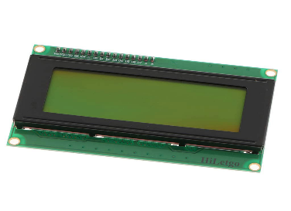
Fig 5 LCD Display

Once the LCD is connected to the Arduino, you can use the Liquid Crystal library to control the display. This library provides functions for setting the cursor position, writing text to the display, and clearing the display.

In addition to displaying text, LCD displays can also be used to display other types of information, such as sensor readings or menu options. With the ability to display multiple lines of text and control the position of the cursor, LCD displays provide a versatile and convenient way to provide feedback to the user in Arduino projects.

6.6 POWER SUPPLY

The ESP8266 is a popular microcontroller used in many Internet of Things (IoT) projects. It requires a power supply adapter to operate properly. In this article, we will discuss the power supply requirements for the ESP8266 and how to choose an appropriate power supply adapter.

The ESP8266 requires a DC power supply with a voltage between 3.0V and 3.6V. The current required depends on the application and can range from a few milliamps to several hundred milliamps. The power supply adapter should be capable of delivering the required current.

Wall adapter: A wall adapter is a simple power supply that plugs into a wall outlet and provides a fixed voltage and current. Wall adapters are typically available in various voltage and current ratings. It is important to choose an adapter that meets the voltage and current requirements of the ESP8266.

7. SOFTWARE USED
Arduino software
Arduino is an open-source electronics platform that includes a physical programmable circuit board and a software development terrain for writing code. The Arduino software is an Integrated Development Environment (IDE) based on the Processing language, which simplifies the process of writing code for microcontrollers.
IoT (Internet of Things) is a network of devices that can communicate with each other using the internet. These devices include sensors, actuators, and microcontrollers. Arduino software can be used in IoT to control and monitor these devices. Arduino boards can be programmed to receive and send data over the internet, making them a great tool for building IoT applications.

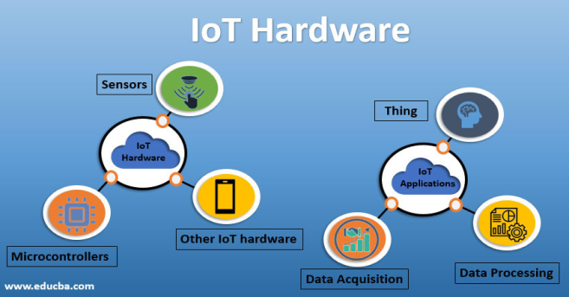

Arduino software supports a variety of programming languages, including C and C++. This makes it easy for developers to write code for their projects. The software includes a library of pre-written code, or sketches, that can be used as a starting point for new projects.
The Arduino software is also compatible with various sensors and modules, such as temperature sensors, humidity sensors, and Bluetooth modules. These sensors can be connected to the Arduino board and programmed to send data to the internet or receive commands from other devices.
In summary, Arduino software is a powerful tool for building IoT applications. It simplifies the process of writing code for microcontrollers and makes it easy to connect sensors and modules to the internet. With Arduino software, developers can create a wide range of IoT applications, from smart home devices to industrial automation systems.

8. BLOCK DIAGRAM

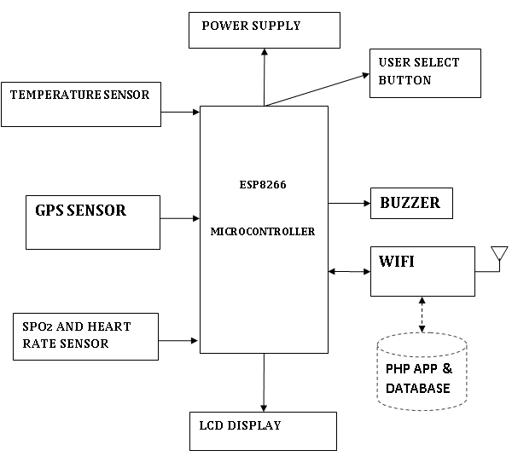

Fig.5 Block Diagram

9. CONCLUSION

The COVID-19 pandemic has had a significant impact on the world and will continue to do so for the foreseeable future. However, current methods of monitoring and detecting respiratory symptoms are either expensive or unreliable. Therefore, it is crucial to find sustainable solutions to combat the pandemic. To address this issue, our research proposes a respiratory symptom monitoring system that is both cost-effective and accurate for early warning of pandemics. We achieve this by using pervasive sensing and wearable technologies and developing a crowdsourcing-based system to monitor and detect respiratory symptoms.

10. REFERENCES

[1] M. Lipsitch, D. L. Swerdlow, and L. Finelli, “Defining the epidemiology of covid-19—studies needed,” New England journal of medicine, vol. 382, no. 13, pp. 1194–1196, 2020.
[2] Z. Zhang, H. Wang, C. Wang, and H. Fang, “Cluster-based epidemic control through smartphone-based body area networks,” IEEE Transactions on Parallel and Distributed Systems, vol. 26, no. 3, pp. 681–690, 2014.
[3] H. Yang, A. Alphones, Z. Xiong, D. Niyato, J. Zhao, and K. Wu, “Artificial intelligence-enabled intelligent 6g networks,” IEEE Network, pp. 1–9, 2020.
[4] C. Ma, J. Li, M. Ding, H. H. Yang, F. Shu, T. Q. Quek, and H. V. Poor, “On safeguarding privacy and security in the framework of federated learning,” IEEE Network, 2020.
[5] M. Farooq, W. M., A. Khairi and M. S., "A critical analysis on the security concerns of internet of things (IoT)," International Journal of Computer Applications, vol. 111, no. 7, 2015.
[6] J. Laguarta, F. Hueto, and B. Subirana, “Covid-19 artificial intelligence diagnosis using only cough recordings,” IEEE Open Journal of Engineering in Medicine and Biology, vol. 1, pp. 275–281, 2020.
[7] S. Sun, A. A. Folarin, Y. Ranjan, and et al., “Using smartphones and wearable devices to monitor behavioral changes during covid-19,” Journal of Medical Internet Research, vol. 22, no. 9, p. e19992, Sep 2020.
[8] M. Farooq, W. M., A. Khairi and M. S., "A critical analysis on the security concerns of internet of things (IoT)," International Journal of Computer Applications, vol. 111, no. 7, 2015.

