_{OBSTACLE DETECTING ROBOT}
_{Abstract}
The obstacle detecting robot is a mobile robot that uses ultrasonic sensors to detect obstacles in its path and take evasive actions to avoid collisions. The robot is based on the Arduino Uno microcontroller board and is programmed using the Arduino IDE. The robot consists of a chassis, wheels, gear motors, Arduino UNO and a motor driver IC, which controls the ultrasonic sensor. The ultrasonic sensor sends out high-frequency sound waves that bounce off objects in its path and return to the sensor. By measuring the time, it takes for the sound waves to return, the distance to the object can be calculated.
The robot is programmed to move forward until it detects an obstacle within a certain range, at which point it uses the servo motor to scan the area to the left and right to determine the best direction to avoid the obstacle. Once the direction is determined, the robot turns and continues moving in the new direction.
The obstacle detecting robot has a wide range of applications, including in industrial automation, surveillance, and exploration. Its ability to navigate around obstacles autonomously makes it a useful tool in situations where it may be unsafe or difficult for humans to operate. Overall, this project demonstrates the capabilities of the Arduino Uno microcontroller board and provides a basic framework for building more complex autonomous robots.

_{Authors}
_{Deekshith Gowda H C}
Computer Science and Engineering
_{Government Engineering College}
_{Hassan, Karnataka, India}
_{deekshithhc67@gmail.com}

_{Mithun N S}
Computer Science and Engineering
_{Government Engineering College}
_{Hassan, Karnataka, India}
_{mithunnsgowda001@gmail.com}

_{Suraj H S}
Computer Science and Engineering
_{Government Engineering College}
_{Hassan, Karnataka, India}
_{jyosurajhs@gmail.com}

_{Shreenivasa Prasad G K}
Computer Science and Engineering
_{Government Engineering College}
_{Hassan, Karnataka, India}
_{shreenivasagk503@gmail.com}

- _{INTRODUCTION}
The obstacle detecting robot is an autonomous robot that can navigate its way around obstacles without human intervention. The robot is equipped with sensors that allow it to detect objects in its path and take appropriate actions to avoid collisions. Obstacle detecting robots have a wide range of applications, including in industrial automation, surveillance, and exploration. The use of robots in industrial automation has been growing rapidly in recent years, as they can perform repetitive and dangerous tasks with high precision and reliability. Obstacle detecting robots can be used to transport materials and products within a factory or warehouse, avoiding collisions with other objects in their path. The design and development of obstacle detecting robots require expertise in robotics, electronics, and programming. The robot must be able to accurately detect and avoid obstacles while maintaining stability and maneuverability. The use of microcontrollers such as Arduino or Raspberry Pi has made it easier for hobbyists and students to build their own obstacle detecting robots. In this project, we will be building an obstacle detecting robot using Arduino Uno microcontroller board and ultrasonic sensors. The robot will be programmed to navigate through a simple obstacle course, avoiding collisions with obstacles in its path.
- ^{OVERVIEW}
The obstacle detecting robot is an autonomous robot that uses sensors to detect obstacles in its path and take evasive actions to avoid collisions. In this project, we will be building an obstacle detecting robot using an Arduino Uno microcontroller board and ultrasonic sensors. The robot will be programmed to navigate through a simple obstacle course, avoiding collisions with obstacles in its path.
- ^{OBJECTIVES}
The objective of an obstacle detecting robot with three ultrasonic sensors is to enable autonomous navigation and obstacle avoidance in a dynamic environment. The use of three ultrasonic sensors enhances the robot's ability to detect obstacles from multiple directions and provides a wider field of view, allowing for more comprehensive obstacle detection and avoidance.
- ^{PROBLEM FORMULATION}
The obstacle detecting robot is designed to solve the problem of navigating through environments that may have obstacles or hazards that could potentially cause damage to the robot or other objects in the environment. The robot is capable of detecting obstacles in its path and taking evasive actions to avoid collisions, thus ensuring safe navigation. This problem is particularly relevant in industrial automation, where robots are used for tasks such as material handling and assembly. In these applications, the robots must navigate through factory floors and warehouses, which may have obstacles such as walls, pillars, or other machines. A collision with any of these obstacles can cause damage to the robot or other objects, leading to downtime and lost productivity. The obstacle detecting robot is a solution to the problem of safe and efficient navigation in environments with obstacles or hazards. By detecting obstacles and taking evasive actions, the robot can ensure safe and efficient navigation, minimizing the risk of damage or injury.

- ^{SCOPE}
The scope of obstacle detecting robots is broad, as they can be used in a wide range of applications and environments where safe and efficient navigation is essential.
- Industrial Automation: Obstacle detecting robots are increasingly used in industrial automation applications, where they can transport materials and products within a factory or warehouse while avoiding collisions with other objects in their path. They can also be used in assembly lines and other manufacturing processes to improve efficiency and reduce downtime.
- Surveillance and Security: Obstacle detecting robots can be used in surveillance and security applications to patrol large areas and detect any intruders. They can also be used to monitor critical infrastructure and detect potential hazards.
- Search and Rescue: Obstacle detecting robots can be used in search and rescue operations to navigate through rough terrain and locate people in distress. They can also be used in disaster zones to search for survivors and assess the extent of damage.
- Exploration: Obstacle detecting robots can be used to explore unknown environments, such as the depths of the ocean or the surface of other planets. They can navigate through challenging environments and gather data on the surrounding environment.
- Personal Robotics: Obstacle detecting robots can also be used in personal robotics applications, such as home cleaning robots, robotic pets, and robotic assistants. They can navigate through homes and other environments while avoiding obstacles and performing various tasks.

- ^{FUNCTIONAL REQUIREMENT}
- Obstacle detection: The robot must be able to detect obstacles in its path using sensors such as ultrasonic sensors, infrared sensors, or LIDAR.
- Obstacle avoidance: The robot must be able to take evasive actions to avoid collisions with detected obstacles, such as changing its direction of movement or stopping its motion altogether.
- Navigation: The robot must be able to navigate through its environment, including turning, reversing, and moving forward.
- Control: The robot must be able to receive commands from its control system and execute them accordingly.
- Power Supply: The robot must have a reliable power supply, such as a battery or AC adapter, to operate.
- Durability: The robot must be durable and able to withstand shocks, impacts, and other environmental conditions.
- Maintenance: The robot must be easy to maintain and repair, with replaceable components and accessible wiring and electronics.
- Safety: The robot must be designed to operate safely, with measures in place to prevent collisions with humans or animals and avoid damage to the environment.

- ^{NON-FUNCTIONAL REQUIREMENT}
- Accuracy: The robot must be able to accurately detect and avoid obstacles in its path to prevent collisions.
- Speed: The robot must be able to move at a reasonable speed while detecting and avoiding obstacles, without compromising accuracy or safety.
- Robustness: The robot must be able to function in different environments, including different lighting conditions, weather conditions, and terrains.
- Scalability: The robot design should be scalable, so that it can be easily modified or adapted to handle different environments, tasks, or payloads.
- Reliability: The robot must be reliable and operate without failure, even under heavy use or stressful conditions.
- Security: The robot should be designed with security features, such as encryption or password protection, to prevent unauthorized access or control.
- Usability: The robot should be easy to use and operate, with clear instructions and minimal training required.
- Portability: The robot should be portable and lightweight, so that it can be easily transported to different locations.
- Cost-effectiveness: The robot design should be cost-effective, with a balance between functionality and cost, so that it can be widely adopted and used in different applications.
- ^{HARDWARE REQUIREMENT}
- ^{Processor: Intel or Ryzen}
- ^{Hard Disk: 16 GB and more}
- ^{RAM: 4 GB and more}
- ^{Keyboard: Standard Keyboard}
- ^{Arduino UNO}
- ^{Ultrasonic Sensor}
- ^{Gear Motor}
- ^{Motor Driver IC (L293D)}
- ^{Battery (12v)}
- ^{Jumper Wires}
- ^{Chassis}
- ^{Wheels}
- ^{SOFTWARE REQUIREMENT}
- Platform: Windows or Linux (64-bit system)
- ^{IDE: Arduino UNO IDE}
- Language: Arduino Programming Language

- ^{IMPLEMENTATION}

- ^{OBSTABLE DETECTION}
The obstacle is detected using an ultrasonic sensor. The sensor emits high frequency sound waves and then measures the time it takes for the sound waves to bounce back after hitting an obstacle. Based on this time measurement, the sensor can calculate the distance between the robot and the obstacle. The Arduino board then uses this distance information to determine whether there is an obstacle in the robot's path. If an obstacle is detected, the Arduino sends signals to the motor driver to stop or change the direction of the robot's wheels, allowing it to move around the obstacle and continue on its path.
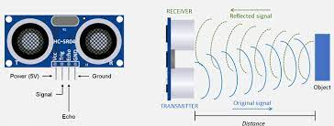
Figure 1: Obstacle detection using sensor.

Distance = (Duration of Sound Wave Travel / 2) x Speed of Sound
^{Where,}
- Duration of Sound Wave Travel is the time it takes for the sound wave to travel from the sensor to the obstacle and back, in seconds.
- Speed of Sound is the speed of sound in air, which is approximately 343 meters per second at room temperature.
- Dividing the duration of sound wave travel by 2 accounts for the fact that the sound wave has to travel to the obstacle and back to the sensor.

- ^{WORKING PRINCIPLE}
The robot moves forward until it detects an obstacle using the ultrasonic sensor. Once an obstacle is detected, the robot stops moving forward and calculates the distance to the obstacle using the ultrasonic sensor. The robot then decides whether to turn left or right based on the distance to the obstacle. If the obstacle is closer to the left side of the robot, it will turn right, and if the obstacle is closer to the right side of the robot, it will turn left. The robot continues to move forward until it detects another obstacle and repeats the process.
Hence the robot used the ultrasonic sensor to detect obstacles and avoids them by turning in the direction of the open space.

- ^{CIRCUIT DIAGRAM}

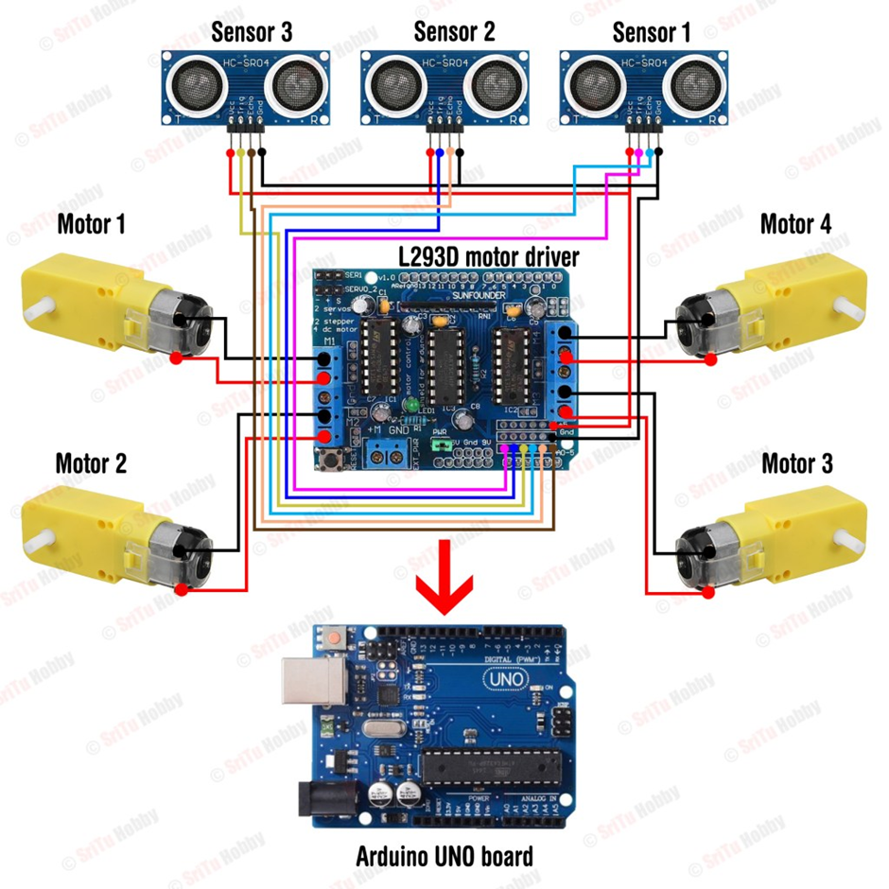

^{Figure 2: Circuit Diagram.}

- ^{EXPERIMENTAL RESULTS}

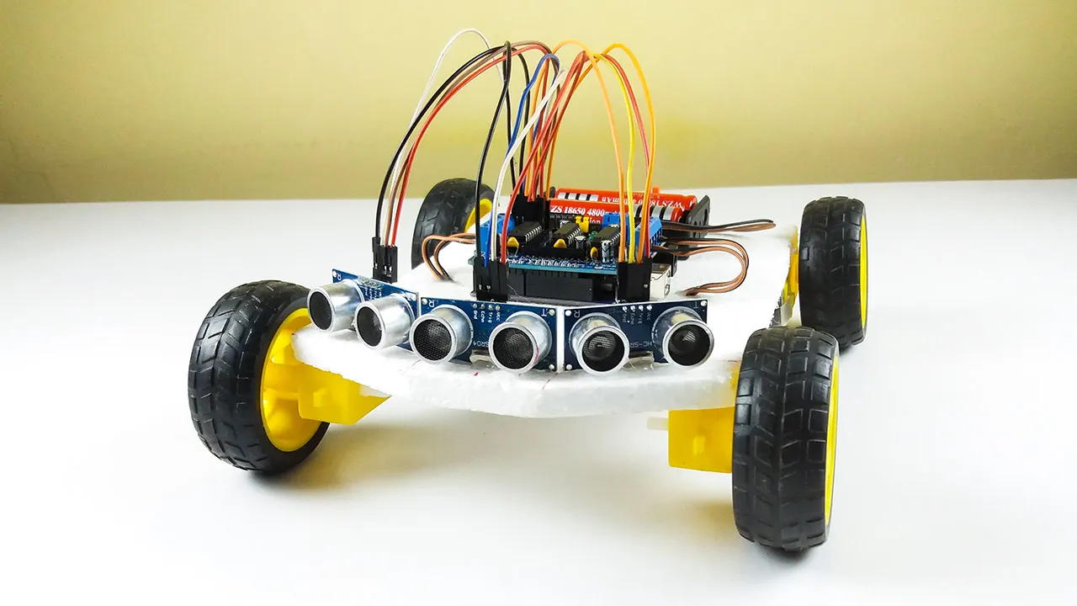
Figure 3: Final Output Picture.

- ^{CONCLUSION}
The obstacle detecting robot using three sensors based on Arduino Uno provides an even more efficient and reliable solution for detecting and avoiding obstacles. The project demonstrates the use of three ultrasonic sensors, motor driver, and Arduino Uno in developing a more sophisticated robot that can detect obstacles in multiple directions and navigate through them. By using three sensors, the robot has a wider field of view and can detect obstacles from different angles, providing better obstacle detection and avoidance capabilities.
The project also provides a great opportunity to learn about sensor fusion, which is the process of combining multiple sensor data to get a more accurate result.
Overall, the project is a great example of how sensor fusion can be used to improve the performance of a robot. By building and experimenting with this project, one can gain valuable knowledge and skills in robotics, programming, and electronics, and can use these skills to create more sophisticated robots with even better obstacle detection and avoidance capabilities.

- ^{FUTURE ENHANCEMENT}
- Adding more sensors: Although the project already uses three sensors for obstacle detection, more sensors can be added to provide even better obstacle detection and avoidance capabilities.
- Adding a camera: A camera can be added to the robot to provide visual information about the environment. This can be particularly useful in situations where the robot needs to navigate through complex and crowded environments.
- Implementing wireless communication: Wireless communication can be added to the robot to enable it to communicate with other robots or devices. This can be useful in applications where multiple robots are required to work together to perform a task.
- Implementing autonomous navigation: Autonomous navigation can be implemented to enable the robot to navigate through its environment without the need for human intervention. This can be useful in applications such as warehouse automation, where robots are required to navigate through complex environments to perform tasks.

- ^{REFERENCE}
- A.S. Riasi, M.A. Khanesar, M. Shojafar, M. Khalily and M. Sabahi, "Design and Implementation of an Obstacle Detecting and Avoiding Robot Using Three Ultrasonic Sensors", 4th International Conference on Control, Instrumentation, and Automation, Shiraz, Iran, 2013.
- R. Bharathi and P. Chitra, "Design and Development of an Obstacle Avoiding Robot Using Three Ultrasonic Sensors", International Journal of Innovative Research in Electrical, Electronics, Instrumentation and Control Engineering, vol. 3, no. 1, pp. 51- 56, 2015.
- M.R. Islam, A. Rahman, S. Ahmed, S. M. A. Hossain and M. S. Alam, "Design and Implementation of an Obstacle Avoiding Robot Using Three Ultrasonic Sensors", International Journal of Scientific and Engineering Research, vol. 5, no. 10, pp. 438- 444, 2014.
- Y. Qiu and X. Huang, "Design and Implementation of an Obstacle Avoiding Robot Using Three Ultrasonic Sensors", IEEE International Conference on Automation and Logistics, pp. 300-304, 2008.
- https://circuitdigest.com/microcontroller-projects/arduino-obstacle-avoidance-robot
- https://www.instructables.com/Obstacle-Avoiding-Robot-With-Arduino-Uno/
- https://srituhobby.com/how-to-make-an-obstacle-avoiding-robot-with-three-ultrasonic-sensors/

