CRISPR GENE EDITING: An advance technology used in HALTING BREAST
CANCER –a Genomic Study
Tayyaba Ahmad¹, Nethra S¹ and Preenon Bagchi²
¹Padmashree Institute of Management and Sciences, Bengaluru, India
²Institute of Biosciences and Technology, MGM University, Aurangabad, India
Corresponding author mail Id: 23tayyabaahmed@gmail.com
ABSTRACT
Breast cancer can occur in women and rarely in men. It includes lumps in breast and change the texture of breast. Breast cancer follows autosomal dominant inheritance pattern. About 5% to 10% of breast cancer follows hereditary pattern. Breast cancer is generally caused by germinal mutation in certain genes but mainly in BRCA1 and BRCA2gene which are present on chromosome number (17q21-31) and chromosome number (13q12-13) respectively. These genes are human tumor suppressor genes which encodes for BRCA1 and BRCA2 proteins. Breast cancer can be halted by CRISPR gene editing with no sign of toxicity in mouse (done by researchers in Boston Children’s Hospital).
Keywords: Breast Cancer, Autosomal Dominant, Suppressor Gene, CRISPR
INTRODUCTION
According to cancer statistics breast cancer poses the most common cancer entity in women and causes the second highest number of death by neoplasia after lung cancer. Researchers round the world are working to find better ways to prevent, detect and treat breast cancer and to improve the quality of life of patients and survivors. There are four types of breast cancer which includes ductal carcinoma in situ, invasive ductal carcinoma, inflammatory breast cancer, metastatic breast cancer. Breast cancer can occur both in men and women but is more common in women .breast cancer most often begins with cells in milk producing duct (invasive ductal carcinoma). Breast cancer may also begin in glandular tissues called lobules (invasive lobular carcinoma). Breast cancer occurs because of mutation in the breast genes such as BRCA1 (BReast CAncer gene) and BRCA2 genes [1].
Breast cancer comprises 10.4% of all cancer incidences among women, making it the second most common type of non-skin cancer and fifth most common type of cancer death. Cancer cells are very similar to cells of organisms from which they originated and have similar DNA and RNA. This is the reason that they often are not detected by the immune system. As immunotherapy becomes increasingly prominent in cancer treatment, CRISPRcas9 can engineered the immune cells to redirect them against cancer cells and potentiate antitumor immune responses [2].
INTRODUCTION TO CRISPR CAS9
CRISPR is an advance genomic technique, which stnds for Clustered Regularly Interspaced Short Palindromic Repeats it is discovered as a prokaryotic immune system in bacteria and archaea by researchers .It is a genomic tool which helps researchers in altering ,removing or editing the genomic sequences, this is not only a technique for advance science but also a boon to modern science, as the basic principle is easily understood by now to scientists it is considered simple and easy to operate method thus causing a drastic positive change in medical field as well. The discovery of CRISPR was found in E.Coli genome in 1987 as a series of repeated fragments of 29 nucleotides in length interspaced with variable sequence fragments of 32 nucleotides. Interest in CRISPR system and its associated cas genes led to the discovery of similar short repeat palindromic sequences of 24-40 nucleotides in several groups of bacteria and archaea. The repeat sequences are seperated by unique variable sequences of 20-58 nucleotides [3-5].
Although initially hypothesized to follow a RNA interference mechanism it was determined that CRISPR functions as a genomic memory of invading pathogens (Fig. 1). This memory is used by cas proteins, serving as guided endonucleases, to scan for invading DNA and disable it by introducing double stranded breaks. CRISPR system were classified in to six types which were grouped in to two classes, type I and type III CRISPR system both utilize set of Cas proteins. In type I systems a multiprotein CRISPR RNA complex known as cascade recognises the target DNA which is then cleaved by Cas 3. In type III systems Cas 10 assembles in to cascade like complex that recognises and cleaves the target. Type II CRISPR systems require only one protein, Cas9 to scan bind and cleave the target DNA sequence [4].
CRISPR-Cas9 is working as a potential cure for a wide range of diseases especially cancers. Brigham and Women's Hospital researchers are using CRISPR to edit cancer cells and turning them into killer cells that could deliver therapies directly to tumors. In the past 20 years, several genome-editing technologies in a wide range of applications are developed. CRISPR/Cas9 is inspired with bacterial immune system which came into existence as a revolutionizing powerful tool that facilitates correction, insertion, or deletion of genetic material both in vitro and in vivo systems. The discovery of this captivating bacterial immune defense mechanism has resulted in an unprecedent revolutionary change in medical sciences and biotechnology (Fig. 2) [1-5].
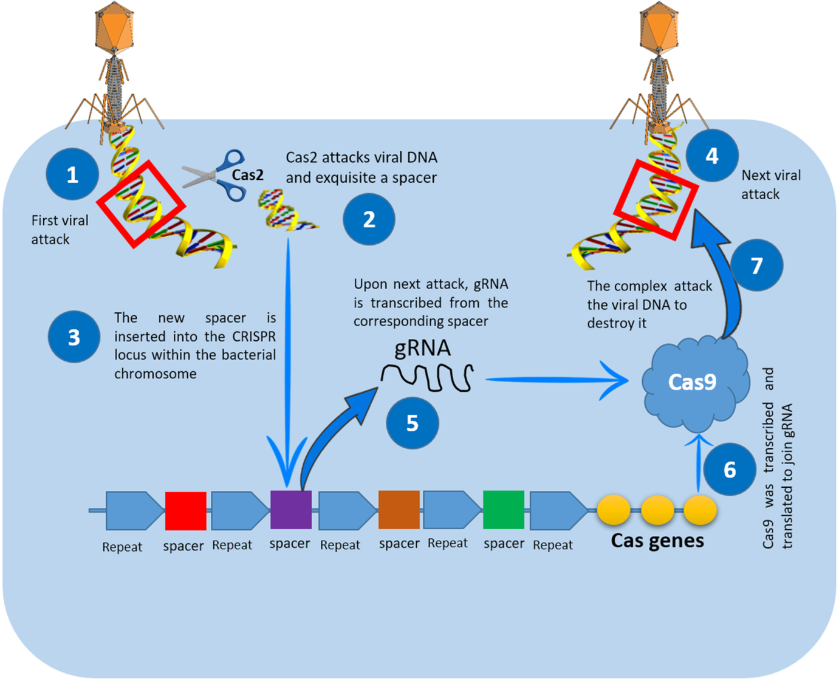
Fig. 1: How CRISPR/Cas9 works as immune system in bacteria. When the invader (plasmid or virus) enters bacteria [1], it directs a nuclease called Cas2 to snip a short sequence of the viral genome (spacer) [2] and insert it between two repeats in its CRISPR locus [3]. When this invader type come again [4], the bacteria transcribe its spacer to generate crRNA [5], which will be matured by tracrRNA. Both types of RNA associated with Cas9 [6] will be directed to the invader genome to cleave it (using Cas9) after recognizing it (using crRNA) [7] [reproduced from (6)]
Less commonly occurring breast cancers are: Medullary carcinoma, mutinous carcinoma, tubular carcinoma.
Medullary carcinoma is an invasive breast cancer that forma a distinct boundary between tumor tissue and normal tissues. They contribute to only 5% of the breast cancer [7].
Mutinous carcinoma is formed by mucous producing cancer cells. They are also called as colloid carcinoma [7, 8].
Tubular carcinoma accounts for 2% of breast cancer diagnosis. There are certain causes for occurrence of breast cancer like genetic cause, hormonal cause, dietary cause and lifestyle , exposure to U.V and X-rays [7, 8, 9].
Breast cancer can be overcome by the help of gene therapy and CRISPR. The aim of gene therapy is to deliver a nucleic acid based drug to either correct or destroy the cells harbouring the genetic aberrations [10].
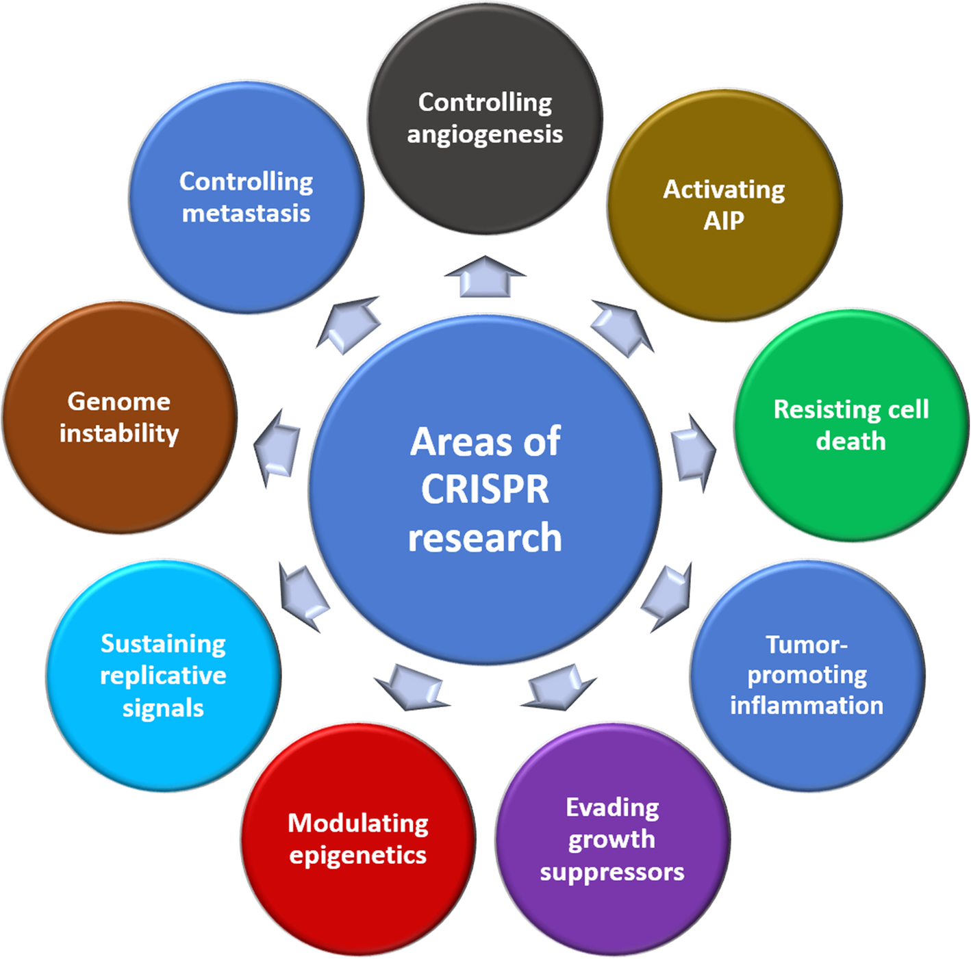
Fig. 2: Different research and treatment areas of CRISPR/Cas9 in breast cancer [reproduced from (6)]

TRIPLE NEGATIVE BREAST CANCER
It is clinically negative for expression of estrogens and progesterone(ER/PR) receptors and HER2 protein. Most of the breast cancers are hormone receptor positive which is classified as Luminal A which are hormone receptor positive (HR+) and human epidermal growth factor receptor(HER2-) and low level of (ki67) whereas Luminal B is (HR+,HER2+and high level of ki67) [11-12].
Therapeutic application crisprcas9. In order to fully understand the molecular and pathologic features classically associated with the triple negative phenotype a review of normal mammary gland parenchyma cells including their immune-phenotype is essential. The more central luminal cells classically express low molecular weight cytokeratins including CK7, CK8, CK18, CK19 along with MUC1 alpha 6integrin BCL1, ER, PR and GATA3 [13].
Approximately, 56% of triple negative breast cancer and basal like breast cancer gene, overlap with each other. The overlap ratio can be as high as 60%-90% between triple negative breast cancer and basal like breast cancer. Epidemiological data show that Triple negative breast cancer mostly occurs in premenopausal young women under 40 years old, who accounts for approximately 15 -20% of all breast cancer patients. Triple negative breast cancer is highly invasive and approximately 46%of triple negative breast cancer patients will have distant metastatis [14]. Triple negative breast cancer is associated with an overall poor prognosis as exemplified by a higher rate of early recurrence and distant metastatis to brain and lungs compared to other breast cancer subtypes.
GENES RESPONSIBLE FOR BREAST CANCER
Every human has both the BRCA1 and BRCA2 genes. A small percentage of people carry mutated BRCA1 and BRCA2 genes.
BRCA1 GENE: the gene is located on chromosome number 17. It contains 22 exons spanning about 110kb of DNA. This gene provides instruction for making a protein that act as tumor suppressor. Tumor suppressor proteins prevent cells from growing and dividing rapidly or in an uncontrolled way. BRCA1 protein is involved in repairing damaged DNA in the nucleus of many types of normal cells. The BRCA1 interacts with several other proteins to mend breaks in DNA. 65% chances with BRCA1 mutation [15].
BRCA2GENE: the gene was found on chromosome number 13 in human. The BRCA2 contains several copies of a 70 amino acids motif called BRC motif, and these motifs mediate binding to the RAD51recombinase which function in DNA repair. BRCA2 is considered as tumor suppressor gene. In eukaryotes BRCA2 protein has an important role in homologous recombinational repair 45% chances of breast cancer with BRCA2 mutation [15-17].
PROTEINS RESPONSIBLE FOR TUMOR SUPPRESSION IN BREAST CANCER
MASPIN is a protein that in human is encoded by the SERPINB5 gene. SERPINB5 was originally reported to function as tumor suppressor gene in epithelial cells, suppressing the ability of cancer cells to invade and metastasize to other tissues [10-17].
CCN6 gene provide instructions for making a protein that appear to be involved in bone growth and the maintenance of cartilage which covers and protects the ends of bones.
BECLIN 1 is an important tumor suppressor protein in mice and in human breast and ovarian cancers. This protein promotes plasma membrane localization of EC adherin which is a breast tumor suppressor molecule which prevent growth of tumor, metastases when present only on the surface of cells [10-17].
Lipocalin 2 gene is seen as a major culprit in triple-negative breast cancer, where an aggressive form of the disease for which there are few effective, along with targeted treatments [10-17].
Genome editing involves modifications of DNA through the insertion, removal, or replacement of sequences. Current methods include double stranded base repair system in to the DNA. A tumor targeted CRISPR gene editing system encapsulated in a nanogel could halt the growth of triple negative breast cancer [10-17].
METHODS TO REDUCE BREAST CANCER BY CRISPR
1. A research team from Harvey Perkins Institute of Medical Research developed a polymer system. In the study the synthetic polymer system delivered the CRISPR which preferentially horned to breast cancer cells and successfully restored the expression of two genes called MASPIN and CCN6. Typically in breast cancer these genes are not active as they should be and so by using their new delivery system the team were able to” switch on” these genes in a mouse model of breast cancer it led to reduce tumor growth. Further studies are required before using these technology on humans but for the first time the team members have now shown as completely synthetic (and targeted) delivery strategy for CRISPR can be used in mouse model of breast cancer and there was no observable toxicity [10-17].
2. A tumor targeted CRISPR gene editing system (encapsulated in a nanogel and injected in to the body) that could effectively and safely halt the growth of triple negative breast cancer. The proof of principle study from researchers at Boston Children’sHospital conducted in human tumor cells and in mice suggests a protein genetic treatment for triple negative breast cancer. The experiment showed that CRISPR editing system was able to home in on breast tumor and knock out the breast cancer promoting gene, lipocalin2. The approach attenuated tumor growth by 77% in mouse model and showed no toxicity in normal tissues [10-17]. Actually triple negative breast cancer can not be treated with hormone therapy such as HER2drugs. The treatment options are negative to chemotherapy, so a new technique like CRISPR is used [10-17].
3. Germline mutation in BRCA1 gene resulting in dysfunctional BRCA in occurrence of higher risk of breast cancer development. BRCA1 mutation in exon 11 accounts for development of breast cancer. BRCA1 protein plays role in homologous recombination mediated repair of double stranded breaks (DSB) in DNA. As poly [ADP-ribose] polymerase inhibitors (PARP) and platinum agents induce DSB that are dependent on HR (homologous recombination)pathway for repair. The treatment for PARP is not effective on many patients who carry germline BRCA1 and BRCA2 mutation [10-17].
WHY CRISPR IS REQUIRED TO DETECT BREAST CANCER
Now a days several of methods are used to detect the breast cancer among which one is mammography, MRI (magnetic resonance imagining), ultrasound. Although these are the most preferred methods but then too can’t be considered under the list of final solution to breast cancer. The above techniques are easy to operate comparatively to CRISPR but are not advance like CRISPR. As in these techniques many hurdles are needed to be crossed before reaching the final solution to disease (breast cancer). So in mammography X rays are used to examine each breast both horizontally and vertically to check the tumor formation as well the clumps of pus in breast to avoid cancer but this technique can only be used to detect the initial stage of breast cancer or the normal one not the metastatic stage . MRI is a method where magnetic resonance are used instead of rays to detect the lumps and cysts in breast which can lead to breast cancer, but it may not be considered as most preferable because it may lead to false positive results secondly it includes high cost. Studies suggests that if a MRI is done for a women who is suspected to known genetic mutation will have higher sensitivity for cancer detection as compare to mammography. Ultrasound is also used in screening of cancers like breast cancer where ultrasonic waves are used to detect cysts they might be solid cysts or fluid containing cysts and ultrasounds can also be used to identify small sized tumor which can not be easily detectable by mammography. With the help of CRISPR/Cas use of other invasive methods like screening, biopsy and many more could be reduced on scale because many a times in biopsy (tissue sampling) results are not accurate and might fluctuate so in that case as well CRISPR CANCER is an alternative (Fig. 3) [10-17].
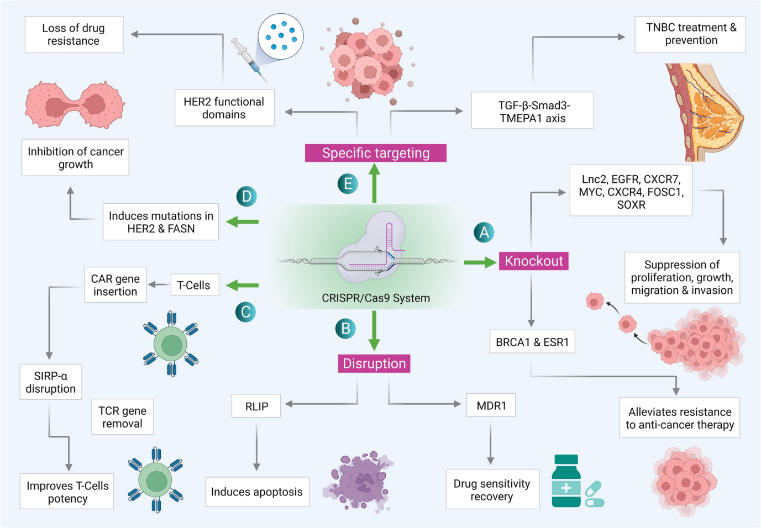
Fig. 3: Application of CRISPR/Cas9 system in the treatment of cancer: A Knock-out of various oncogenes whose overexpression or dysregulation leads to either resistance to therapy or cancer proliferation. B Genes RLIP and MDR1 are responsible for drug resistance in BC are disrupted using CRISPR/Cas for restoration of drug sensitivity. C T-cells are used for immunotherapy in BC, CRISPR/Cas has been applied in T-cells for CAR gene insertion, TCR gene removal, and SIRP-α disruption and therefore improving its potency. D Mutation in HER2 (human epidermal growth factor receptor 2) and FASN (Fatty acid synthase) induced by CRISPR/Cas9, leads to inhibition of growth of cancer cells. E TGF-Smad3-TMEPAI axis plays a role in cancer cells by enabling them to escape TGF-mediated growth inhibition and the functional domains of HER2 are required for carcinogenic activity, hence their specific targeting through CRISPR/Cas results in TNBC treatment and loss of drug resistance respectively [reproduced from (7)]
(CRISPR TECHNOLOGY FOR BREAST DIAGNOSTIC MODELLING THERAPY)
ADVANCE ARTIFICIAL INTELLIGENCE IN DETECTING BREAST CANCER
Now a days radiologists have developed artificial intelligence system to detect breast cancer system in women worldwide which is more advance than mammography as because in mammography sometimes double screening or examination is done so to avoid that this new technology has been introduced to modern era [18].
Combining artificial intelligence (AI) capacity with this technology, there more precision for modifying gene mutations, molecular cloning and causes changes in the tumor genome and causes changes in the tumor genome. This technology is rapidly becoming a powerful tool for gene prediction and AI is one of the new approaches to cancer immunotherapy and vaccine development. Hence this new approach of genome editing and cancer treatment can be associated with the production of a large amount of information, which actually becomes very costly to perform laboratory trial and error for gene editing, and artificial intelligence analyzes gene editing more accurately by analyzing data and creating a knowledge model. Artificial intelligence methodologies also facilitate to speed up the treatment of cancer by knowledge patterns discovering of gene editing [18]. This artificial intelligence technique include knowledge-based methods, machine learning approaches, and agent-based models. The knowledge-based methods determines goal of feature selection of cancer-omics data, biological, and disease entities. Using the computational tools involved in machine learning we can just input the name of the gene to be modified and the cloud-based search engine will return a list of guides which we can sort by predicted on-target or off-target effects. Machine learning approaches along with agent-based models can analysis epitope prediction and immunological prediction [18].
ROLE OF CXCL12 IN TRIPLE NEGATIVE BREAST CANCER
In this technique the knockout and co knockout process took place for certain genes like CXCR4 or CXCR7 which are responsible for triple negative breast cancer. Here the single knockout of CXCR4 and CXCR7 took place which results in downfall of growth ,cell proliferation , migration ,invasion followed by co knockout of CXCR4 and CXCR7 genes in triple negative breast cancer cell line. So to note down the experimental changes PCR sequencing and western blotting is done. The differential changes which occurred in migration and invasion of single knockout and co-knockout were induced by adding CXCL12. This results in stronger migration and invasion in CXCL12 added cells comparatively to non-added CXCL12 to cells [10-17].
ETHICAL ISSUES
CRISPR/Cas gene editing techniques are emerging as powerful research tools. [6-7]. Though it can raise persistent ethical concerns but it has been picked as favored technique for genome editing because of its high level of straightforwardness along with the requirements of very minimal efforts. Hence, these properties make this strategy alluring to be utilized by any biotechnology and bioinformatics lab [6-7].
The drawbacks of this technology, till date is the Off-target effects that might have several pathogenic consequences but the on-targets may also result in a wide range of deletions and genomic rearrangements [6-7].
FUTURE PERSPECTIVES
CRISPR/Cas9 is a powerful tool to edit genomes in laboratories. Also it serves as a therapeutic option after ensuring its safety profiles. Hence, prior applying CRISPR/Cas9 directly to human cells, the animal cancer models and bioinformatics models should serve as a preclinical platform in which this tool could be used to create models to deeply elucidate the causative genes of such disease. Again, these models should be investigated in parallel to the cancer patients, which make it easy to rapidly identify different resistance mechanisms to establish new strategies for treating the disease. Doudna and Charpentier has announced that this technology can be used in lab along with RNA-guided genome editing tool so that it can serve as an ideal platform to personalized medicine where it offers unique opportunity to edit human genome easily and straightforwardly in specific manner. This technique is a ground breaking tool and is being employed to treat various diseases. But its use in the system raises various social and ethical concerns, not only for human beings but also for other organisms and the environment. Moreover, the possibilities of gene therapy using CRISPR/Cas9 remain a promising even though a few technical obstacles exist in targeting cancer genes and this technique will hopefully this therapy will rely on carefully designed sgRNA, monitoring of potential off-target effects, and efficient delivery. Also, from fundamental research to clinical implementation, this technique is opening promising possibilities for the treatment of chemotherapeutic drug resistance [6-7].
CONCLUSION
This ground-breaking technology can be used to cure several human diseases. In this review, we highlight the most advanced CRISPR/Cas9-based approaches in tackling the challenges associated with many types of cancer including breast cancer which is not only caused by genetic mutations but also by epigenetic one, making it ideal tool to deal with mutations underlie this disease. The use of CRISPR/Cas9 in somatic cells is ethically accepted because of its low risk compared to its benefits and the germline applications for human embryos have high risks compared to its potential benefits, where it may have unknown harmful effects on future offspring [6-7].
REFERENCES
- BRCA: the breast cancer gene, National breast cancer foundation
- Yang H, Jaeger M, Walker A, Wei D, Leiker K, Weitao T. Break Breast Cancer Addiction by CRISPR/Cas9 Genome Editing. J Cancer. 2018 Jan 1;9(2):219-231. doi: 10.7150/jca.22554. PMID: 29344267; PMCID: PMC5771328. [3] Breast cancer progression can be halted with CRISPR gene editing CRISPR technology for breast cancer :diagnostics, modelling and therapy doi:10.1002/adbi.201800132
- Lino CA, Harper JC, Carney JP, Timlin JA. Delivering CRISPR: a review of the challenges and approaches. Drug Deliv. 2018 Nov;25(1):1234-1257. doi: 10.1080/10717544.2018.1474964. PMID: 29801422; PMCID: PMC6058482.
- Rodríguez‑Rodríguez DR, Ramírez‑Solís R, Garza‑Elizondo MA, Garza‑Rodríguez MD and Barrera‑Saldaña HA: Genome editing: A perspective on the application of CRISPR/Cas9 to study human diseases (Review). Int J Mol Med 43: 1559-1574, 2019
- Sabit, H., Abdel-Ghany, S., Tombuloglu, H. et al. New insights on CRISPR/Cas9-based therapy for breast Cancer. Genes and Environ 43, 15 (2021). https://doi.org/10.1186/s41021-021-00188-0
- Karn, V., Sandhya, S., Hsu, W. et al. CRISPR/Cas9 system in breast cancer therapy: advancement, limitations and future scope. Cancer Cell Int 22, 234 (2022). https://doi.org/10.1186/s12935-022-02654-3
- Impact of CXCR4 andCXCR7 knockout by CRISPR/Cas9 in breast cancer and delivery potential of gold nanomaterials, Jananee Padayachee, Moganavelli Singh doi.org/10.1177/1849543520983196
- Rodríguez-Ruiz A, Krupinski E, Mordang JJ, Schilling K, Heywang-Köbrunner SH, Sechopoulos I, Mann RM. Detection of Breast Cancer with Mammography: Effect of an Artificial Intelligence Support System. Radiology. 2019 Feb;290(2):305-314. doi: 10.1148/radiol.2018181371. Epub 2018 Nov 20. PMID: 30457482.
- Chu QD, Peddi PE, Ellis MJ, and Ma C, 2012, Molecular Basis of Triple Negative Breast Cancer and Implications for Therapy, International Journal of Breast Cancer, https://doi.org/10.1155/2012/217185
- Morrow M, Waters J, Morris E. MRI for breast cancer screening, diagnosis, and treatment. Lancet. 2011 Nov 19; 378(9805):1804-11. doi: 10.1016/S0140-6736(11)61350-0. PMID: 22098853.
- Sabit H, Abdel-Ghany S, Tombuloglu H, Cevik E, Alqosaibi A, Almulhim F, Al-Muhanaa A. New insights on CRISPR/Cas9-based therapy for breast Cancer. Genes Environ. 2021 Apr 29;43(1):15. doi: 10.1186/s41021-021-00188-0. PMID: 33926574; PMCID: PMC8082964.
- Padayachee J, Singh M. Therapeutic applications of CRISPR/Cas9 in breast cancer and delivery potential of gold nanomaterials. Nanobiomedicine (Rij). 2020 Dec 24;7:1849543520983196. doi: 10.1177/1849543520983196. PMID: 33488814; PMCID: PMC7768851.
- Yin L, Duan JJ, Bian XW, Yu SC. Triple-negative breast cancer molecular subtyping and treatment progress. Breast Cancer Res. 2020 Jun 9;22(1):61. doi: 10.1186/s13058-020-01296-5. PMID: 32517735; PMCID: PMC7285581.
- Wijshake T, Zou Z, Chen B, Zhong L, Xiao G, Xie Y, Doench JG, Bennett L, Levine B. Tumor-suppressor function of Beclin 1 in breast cancer cells requires E-cadherin. Proc Natl Acad Sci U S A. 2021 Feb 2;118(5):e2020478118. doi: 10.1073/pnas.2020478118. PMID: 33495338; PMCID: PMC7865132.
- Gokhale S. Ultrasound characterization of breast masses. Indian J Radiol Imaging. 2009 Jul-Sep;19(3):242-7. doi: 10.4103/0971-3026.54878. PMID: 19881096; PMCID: PMC2766883.
- Anders C, Carey LA. Understanding and treating triple-negative breast cancer. Oncology (Williston Park). 2008 Oct;22(11):1233-9; discussion 1239-40, 1243. PMID: 18980022; PMCID: PMC2868264.
- Sharma GN, Dave R, Sanadya J, Sharma P, Sharma KK. Various types and management of breast cancer: an overview. J Adv Pharm Technol Res. 2010 Apr;1(2):109-26. PMID: 22247839; PMCID: PMC3255438.
- Bhat, A.A., Nisar, S., Mukherjee, S. et al. Integration of CRISPR/Cas9 with artificial intelligence for improved cancer therapeutics. J Transl Med 20, 534 (2022). https://doi.org/10.1186/s12967-022-03765-1

