MRI Relaxometry: Applications, Challenges and Future Directions

Ms. Deepega S
Assistant Professor
Department of Radiology and Imaging Technology
School of Allied Health Sciences, Vinayaka Mission’s Research Foundation - DU
AVMC & H Campus, Puducherry, India
E-mail: deepegasanthanam16@gmail.com

ABSTRACT

The quantitative nature of MRI has created a lot of interest in the field. The increased sensitivity combined with the reduced subjective nature of visual assessment significantly affected the diagnosis of tissue abnormality. Conventional MR imaging is qualitative and subject to interpretation. The signal intensity of conventional MR images is affected by several contrast mechanisms that are controlled by MR equipment and software. The term quantitative relaxometry is used to describe the measurement of biological parameters, such as T1 and T2, which reflect the tissue environment in the local area and are typically expressed as absolute units. Additionally, quantitative relaxometry provides an impartial metric for the comparison of magnetic resonance imaging (MRI) scans. Furthermore, quantitative relaxometry leverages the relationship between MRI maps and physiologic parameters to offer a non-invasive substitute for biopsies and histology. This study outlines some potential clinical applications for quantitative relaxometry, such as T2/T2* mapping. Additionally, it outlines the methods and difficulties associated with obtaining precise and accurate quantitative MR maps.

Keywords: Radiology, Relaxometry, T2 Mapping, T2* Mapping, Cartigram, Iron overload, Multiple sclerosis.

- INTRODUCTION

Quantitative MRI is the process of quantifying biophysical parameters by isolating the various contrast mechanisms contributing to the overall MRI signal. An example of a basic quantitative MRI parameter that reflects the local tissue compartment is the T1 relaxation time, T2 relaxation time & T2* relaxation time. One significant benefit is the elimination of non-tissue-related effects, such as operator-dependent effects, scan parameter variations, spatial magnetic field variations, and image scaling. Ultimately, the usefulness of quantification is realized when MRI can provide quantitative measurements of biological characteristics in a manner comparable to the current gold-standard methods such as biopsy or histology. Non-invasive quantitative MRI can potentially replace traditional biopsy sampling or sampling errors by delivering quantitative physiologically relevant data across a 3D volume with high spatial resolution.

- PHYSICS OF RELAXOMETRY

The T1, T2, and T2* relaxation times are physical parameters determined by intrinsic biophysical properties of tissue.T1 Relaxation is the recovery of longitudinal magnetization caused by a process called T1 Recovery. T1 recovery occurs when the nuclei release energy to the surrounding medium or lattice and is referred to as Spin lattice relaxation. T2 Relaxation is the decay of transverse magnetization caused by a process termed T2 Decay. The process of T2 decay is called spin-spin relaxation, and it happens when the magnetic fields from the neighboring nuclei interact with each other. ^{[1]}.

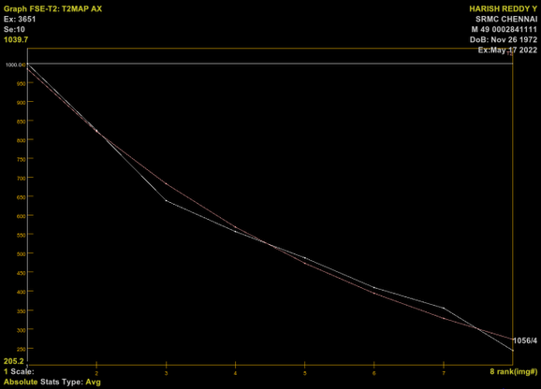
Relaxometry refers to the quantification of the rate of relaxation of the nuclei to the ground state following stimulation with an RF pulse. Relaxometry maps are visual representations of the spatial resolution of the relaxation times. These maps can be produced either by the spin-echo method or gradient echo. For example, T1, T2, and T2* maps are generated. The number of echoes is represented on the x-axis, and the signal intensity is represented on the y-axis (Figure 1). A spin-echo map, or a gradient-echo map, is a map of the relaxation rate, or relaxation time, that is (R2 = 1 / T2), or (T1 or T2), and it requires a minimum of two images to be generated.
Echo
Signal intensity

Figure 1: System-generated relaxometry map

- T2 RELAXOMETRY

Carr-Purcell-Meiboom-Gill sequence multiple spin-echo sequences are the gold standard imaging for T2 relaxometry (Figure 2). In this sequence, a 90-degree excitation pulse is preceded by a series of 180-degree refocusing pulses, and the signal is measured in the middle of the refocusing pulses where spin-echo is induced and B0 is eliminated. On repeated 180° pulses, the multiple echo height gradually decreases due to T2 de-phase ^{[2]}. This technique involves obtaining the T2 relaxation time for each voxel of an image. Its sensitivity depends on the sequence - Time of Repetition (TR) and Time of Echo (TE). The number of images obtained with different TEs should be selected in a range centered near the T2 values for the sample.

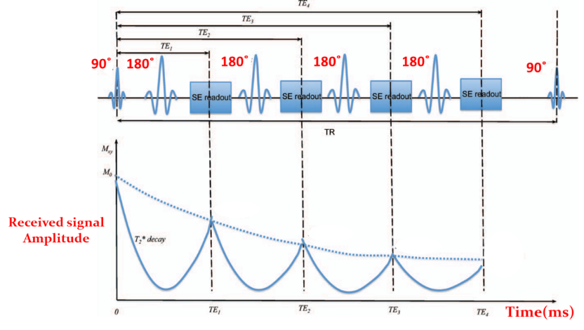

Figure 2: Schematic of a multi-echo spin echo sequence (CPMG) and T2 relaxation curve.

- T2 RELAXOMETRY – APPLICATIONS

- BRAIN
Pathological alterations in the brain are frequently accompanied by an increase in the relaxation times of T1, T2, T2*. In the hippocampus, visual evaluation of T2-weighted changes (signs of hyperintense signal in T2-weighted images) is the first evidence of pathology in hippocampal sclerosis. T2 Relaxometry is another quantification method used to measure the degree and frequency of T2 abnormalities. T2 Relaxation times of the hippocampus increase in a patient with hippocampal sclerosis (reflect gliosis in the hippocampus) ^{[3] [4]}. The increase in the T2 relaxation time in the hippocampus is large enough to indicate the possibility of more extensive damage to the hippocampus.

T2 relaxation times are measured by 16-echo sequence, i.e., multiple spin-echo sequences (Figure 3) for each oblique coronal slice at echo times between 22ms to 352 ms. T2 maps are obtained by a computer program that makes a single exponential relationship to signal intensity data from equal pixels from all 16 echoes.
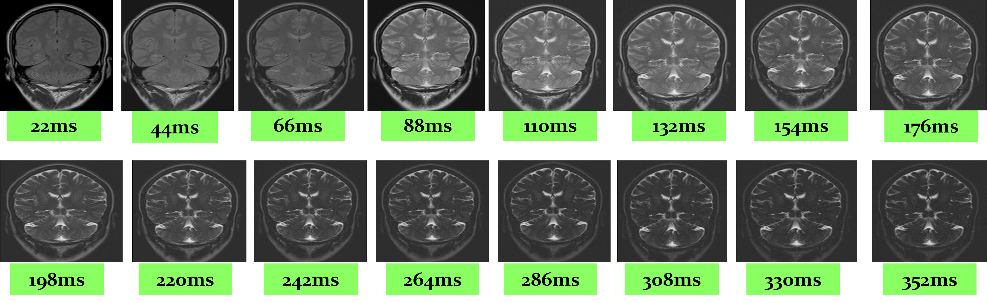

Figure 3: Representing series of images acquired in single TR = 2530ms with multiple TEs.
- MUSCULOSKELETAL

The use of quantitative relaxometry in osteoarthritis, Rheumatoid arthritis, and other cartilage degenerative conditions has been highly beneficial in the detection of early chondral deterioration and biochemical alterations before gross morphological changes. This includes the breakdown of collagen and increases water mobility in the cartilage, increasing T2 relaxation times.
T2 mapping allows for early biochemical alterations to cartilage degeneration to be identified before morphological alterations in initial osteoarthritis. The increase in the T2 relaxation time within cartilage is related to the collagen matrix. Automatic color maps are generated based on a T2 scale and allow visualization of changes to the composition of cartilage in the articular before changes in thickness can be observed. Based on a multi-echo pulse sequence that generates up to 8 echoes per single acquisition, not more than 8 echoes are generated due to the short T2 relax times of cartilage. It is widely employed in the knee ^{[5]}, shoulder, etc. (Figure 4).

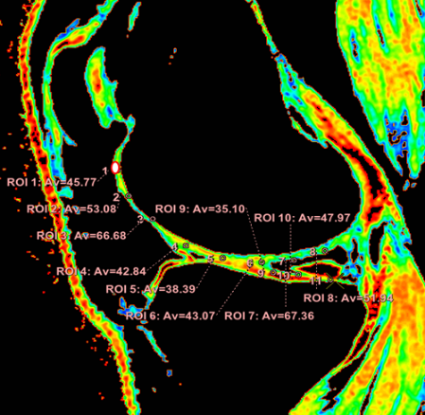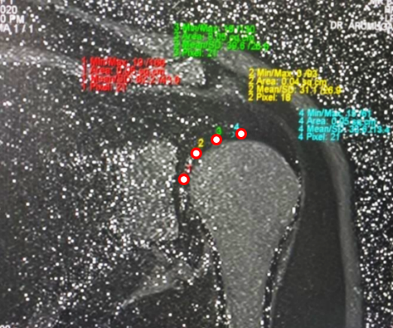
(A) (B)
Figure 4: (A) T2 Color mapping evaluation in knee joint (B) T2 Color mapping in shoulder articular cartilage.

- T2* RELAXOMETRY

Transverse magnetization decay (T2*) refers to the decay of the transverse magnetization due to spin-spin relaxation and the inhomogeneity of the magnetic field. R2* refers to the rate at which the exponential decay of the gradient echo signal is measured. Mapping T2* is done with a spoiled gradient echo with multiple echoes.
The use of T2* relaxometry as a diagnostic tool is essential for the treatment of patients with hereditary hemochromatosis, thalassemia, sickle cell disease (SCD), continuous blood transfusion, and parenteral & dietary iron overload. It is the non-invasive method of measuring iron concentration in both the liver and myocardium and is more accessible than invasive procedures like biopsy. In tissues with an iron overload (e.g., Liver) that have paramagnetic characteristics, this results in a decrease in signal intensities in the parenchyma, resulting in a decrease in the T2 relaxation time of the sample tissue.

- T2* RELAXOMETRY - IRON OVERLOAD
- LIVER
A series of images are obtained with progressively longer echo times in relaxometry, the signal intensities of the target tissue are modeled concerning the echo time, and the signal decay constants (T2*) are calculated. T2*W signal intensity decreases as the iron concentration increases increasing R2*. The iron effect and T2* decrease is proportional to the magnetic field. Iterative Decomposition of water and fat with Echo Asymmetry and Least-squares estimation (IDEAL) is a new 3-point Dixon imaging technique used to separate water and fat. It is widely used for liver imaging (Figure 5).

Figure 5: T2* Color map evaluation in liver parenchyma
- HEART
The detection of myocardial iron overload is not as straightforward as with other commonly used tests, such as serum ferritin levels. Consequently, T2* relaxation times can be employed as a guide for iron chelation therapy in patients with myocardial iron overload ^{[7]} (Figure 6).
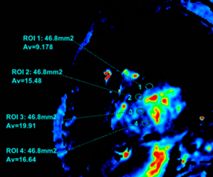

Figure 6: T2* Color map evaluation in the myocardium

- PARKINSON’S DISEASE
Iron accumulates in ferritin-containing compounds. However, unbound iron accumulates in tissues and can become toxic, potentially resulting in cell death. Patients with Parkinson’s disease (PD) have high levels of iron in the basal ganglia (Substantia nigra and red nucleus). High levels of iron in tissues result in a decrease in T2* and an increase in R2* ^{[8]}.

- ADVANTAGES OF RELAXOMETRY
Relaxometry provides the benefit of eliminating non-tissue-related effects and helps in the comparison of different patients. Reduction of biases and reproducibility are significant. It provides measurements of biological properties similar to biopsy and histology. Relaxometry, also known as quantitative magnetic resonance, is a non-invasive, reproducible technique that increases the sensitivity of tissue abnormalities beyond that of visual assessment. It provides relevant information across a 3-dimensional volume with high spatial resolution, potentially replacing invasive procedures such as biopsies, which are limited by conventional limitations such as limited biopsy sampling.

REFERENCES
[1] Westbrook C, Talbot J. MRI in Practice. John Wiley & Sons; 2018 Oct 22.
[2] Margaret Cheng HL, Stikov N, Ghugre NR, Wright GA. Practical medical applications of quantitative MR relaxometry. Journal of Magnetic Resonance Imaging. 2012 Oct;36(4):805-24. Clinical applications of MR Relaxometry, Nikola Stikov. et.al.
[3] Nataraja V, Farook AS, Elangovan V, Ahmed A, Magudeeswaran PK. Magnetic Resonance Imaging Evaluation of Hippocampus with T2 Relaxation Time. INTERNATIONAL JOURNAL OF SCIENTIFIC STUDY. 2017;5(1):116-20.
[4] Winston GP, Vos SB, Burdett JL, Cardoso MJ, Ourselin S, Duncan JS. Automated T2 relaxometry of the hippocampus for temporal lobe epilepsy. Epilepsia. 2017 Sep;58 (9):1645-52.
[5] Frank LR, Wong EC, Luh WM, Ahn JM, Resnick D. Articular cartilage in the knee: mapping the physiologic parameters at MR imaging with a local gradient coil—preliminary results. Radiology. 1999 Jan;210(1):241-6.
[6] Hernando D, Levin YS, Sirlin CB, Reeder SB. Quantification of liver iron with MRI: state of the art and remaining challenges. Journal of Magnetic Resonance Imaging. 2014 Nov;40(5):1003-21.
[7] Elfawal SK, Emara DM, Shehata AA. Assessment of hepatic and cardiac iron overload in thalassemia patients by magnetic resonance imaging: Our experience in Alexandria University. The Egyptian Journal of Radiology and Nuclear Medicine. 2018 Jun 1;49(2):323.
[8] Rossi M, Ruottinen H, Soimakallio S, Elovaara I, Dastidar P. Clinical MRI for iron detection in Parkinson's disease. Clinical imaging. 2013 Jul 1;37(4):631-6.

