Comparative analysis of Action Observation Therapy and Mirror box therapy with functional motor training in post stroke subjects
Thummala S Pavani¹*, Dr.S. Senthil kumar².

1 Research scholar, Garden City University, Bangalore, Karnataka, Associate Professor, East Point College Of Physiotherapy, Bangalore, India. 2Professor and Research Supervisor, School of Health Sciences, Department of Physiotherapy, Garden City University, Bangalore, India.

Back ground: This study aimed to find out the effectiveness of Action observation therapy and mirror therapy versus bilateral functional motor arm training which are two rehabilitation strategies, which enhances the motor learning and motor improvements of stroke patients by visual feedback and observation.

The primary motor cortex's excitability, the encoding of motor engrams, and motor learning are all improved by action observation. Based on the existence of the mirror neuron system (MNS), action observation treatment (AOT) is a growing neuro rehabilitative technique that is activated not only during the execution of an action but also during the observation of the same activity. The AOT suggests that by seeing and imitating various behaviours, motor symptoms of various neurological illnesses can improve in light of this "dual" activation.

In the realm of neurophysiology, it is now commonly accepted that the same brain areas that are active during the actual execution of actions are also active during action observation and execution. Regions with this action observation-action execution matching mechanism are known as the "mirror neuron system."

Objectives & aims: The purpose of this study was to compare the effects of Action Observation therapy and Mirror Box therapy with bilateral functional motor training in order to assess the efficacy of these treatments in improving functional motor capacity in patients with subacute strokes and chronic stroke subjects.

Methods/Design: Thirty people with subacute ischemic and hemorrhagic stroke were reportedly recruited for this study. Each participant was given a random assignment to receive bilateral functional motor training for 3 months, 5 days a week, along with AOT and MBT. Results were measured at three different times: baseline, right away following therapy, and three months later. The Fore Arm Bisection Task, Fugl-Meyer Assessment, and Motor Assessment Scale were the major and secondary results, respectively, of the experiment.

Patients embraced the video instruction that was used to provide it. In comparison to the bilateral functional arm training provided to group B, the experimental group's subjects underwent 3 months of AOT and MBT, or the forearm bisection task, which suggests improvements in the motor functioning of the hand and a distal shift in the pointing of the middle of the forearm. Video-therapy also appears to be promising.

Results: The video lesson that was used to provide it was well received by the patients. The experimental group's subjects underwent 3 months of AOT and MBT, or the forearm bisection task, as opposed to the bilateral functional arm training given to group B. This suggests improvements in the motor functioning of the hand and a distal shift in the pointing of the middle of the forearm. Additionally promising seems to be videotherapy.

Conclusion: According to preliminary findings, individuals receiving action observation treatment and MBT had significant gains in task completion compared to those receiving functional motor training. However, additional large-scale research including at least 30 patients in each group is necessary to confirm these findings. Video training seems to be a promising addition to neurorehabilitation because it is simple to offer, well-liked by patients, and appears to be effective. Improvement in hand function, as determined by the Motor Assessment Scale, may have occurred after six weeks of intervention.

Discussion: This study will offer empirical support for the effects of AOT and MT on motor, functional, and brain activity mechanisms in patients with subacute stroke. Rehabilitation via online or video teaching may be a further application and use of AOT and MT.

Keywords: mirror neurons, upper limb video therapy, motor recovery, rehabilitation methods, and neurological rehabilitation

Introduction
In clinical terms, a number of focused deficits are possible, including changes in loss of consciousness and impairments of sensory, motor, cognitive, perceptual, and language abilities. A stroke is the sudden loss of neurological function brought on by an interruption of blood flow to the brain.Hemiplegia (paralysis) or hemiparesis (weakness) often occur on the side of the body that is opposite the site of the lesion, and these symptoms are indicative of motor impairments.¹ The medical term for a stroke, also referred to as a brain attack or cerebrovascular accident, is a quickly progressing loss of brain functions brought on by an interruption in the blood flow to the brain⁴¹. A stroke is described by the World Health Organisation as a neurological deficit of cerebro vascular dysfunction that lasts longer than 24 hours (or is interrupted by death in with) in the 1970s.
90% of ischemic strokes and 10% of hemorrhagic strokes are the two main types of stroke. The most frequent forms are thrombotic, embolic, and lacunar, in that order. Stroke risk increases by 4-6 times in patients with high blood pressure (elevated above 160/95 mm of hg), high elevated total blood cholesterin, and low density lipoprotein cardiac diseases like rheumatic heart vascular disease, endocarditis, and cardiac surgery. The main causes of stroke are HTN, small heart disease, and diabetes.
The definition of a stroke according to WHO (1989) for adults aged 16 and older is a quickly developing clinical symptom of a focused impairment of brain function with a likely vascular origin and lasting more than 24 hours³.

The primary cause of death and disability in older persons is stroke, also known as apoplexy. Although the majority of stroke survivors are able to walk independently once again, many still struggle to complete daily tasks, especially those related to self-care and housekeeping.4. Stroke occurs due to thrombus, emboli, and haemorrhage with an incidence of 203 cases per lakh people in the age group over 20 years, with a male to female ratio of 1:7, and 12% of stroke cases are seen in the age group below 40 years. It is also reported that 1.2% of all deaths in India are due to stroke, and the cause of the disease depends on the severity of the lesion.⁵

C V A as any disorders in which an area of brain is transiently or permanently affected by ischemia or bleeding or in which one or more blood vessels of brain are primarily impaired by a pathological process .To be classified as a stroke or hemiplegia the focal neurological deficits must be present for at least 24 hours and take longer than 3 weeks to resolve when the duration of signs and symptoms is less than 24 hrs. The event is classified as Transient Ischemic Attack and is considered as a warning that stroke will occur in the future if left un attended.¹³

According to Hachinski V, Norris J, et al. in The Acute Stroke (1985), massive infarcts affecting the M C A are characterised by cerebral edoema, which is the most prevalent cause of death in acute stroke.

Stroke has two basic causes: ischemic stroke and cerebral haemorrhage. With about 80% of all strokes falling within this category, it is the most prevalent form of stroke. Atherosclerosis, or the slow buildup of cholesterol, is the most frequent cause of an ischemic stroke. It is brought on by a clot or other blockage in a brain artery. (http://Stroke Center.com).
Intra cerebral haemorrhage, caused by an aneurysm or trauma, is the abnormal bleeding into the extra vascular portion of the brain. At every stage, intra cerebral haemorrhage happens.About 12 to 24 percent of all strokes are haemorrhage strokes.14With 70% of all strokes being cerebral infarctions (thrombosis, embolism), it is the most prevalent type of stroke. 20% of the cases are haemorrhages, and 10% are still unknown.¹⁹
Hypertension, diabetes, and heart disease are the three most well acknowledged risk factors for cerebral vascular disease. Hypertension is the most crucial of these elements. Systolic or diastolic blood pressure, pulse pressure, and pressure variability are all effective stroke predictors.Increased blood fat levels, obesity, and smoking are risk factors that have been linked to stroke. Since the greatest risk factor for stroke is excessive blood pressure.²⁰
It is uncertain how many haemorrhages begin as ischemic strokes because some haemorrhages (hemorrhagic transformation) arise inside areas of ischemia.The neurological abnormalities caused by the systemic feature are bilateral and have a global aspect.15Impaired motor functions, balance issues, sensory deficits, cognitive limits, visual difficulties, aphasia, and depression are common disabilities following a stroke.⁶
Those who have survived the first stages of a stroke typically have some improvement in their mobility and capacity to do daily tasks over time. According to Warlow et al., neuroplasticity and adaptive adjustments are just two of the many theories put out to explain recovery.⁷
One of the most disabling side effects of stroke is upper limb hemiparesis, which is also the main impairment underpinning functional disability after stroke.²¹ One of the most frequent conditions that physical therapists and occupational therapists treat is upper limb hemiparesis²².Because it reduces problems like deep vein thrombosis and pressure sores, early mobilisation is preferred.²⁷
Preventing complications, managing co-morbidities, and managing stroke recurrence are the top priorities in early stroke rehabilitation.²⁶Early on after a stroke, the rehabilitation process can be improved, and functional disability can be reduced. Improved functional outcomes for patients help to increase patient satisfaction and can potentially save money on expensive long-term care costs. Strong evidence suggests that post-acute stroke cases benefit from a well-organized multidisciplinary approach.²⁴It is evident that increased treatment intensity using repetitive task oriented methods improves motor and functional recovery compared to facilitative approaches.³⁴
Theraputic Action Observation
The patients in the action observation therapy group had to watch video clips of upper limb motions or functional actions (the observation phase) and then execute those movements or actions as best they could (the execution phase).
Based on the relevant research and clinical knowledge, the action observation therapy protocol's three common categories of movements and tasks were chosen:
Active range of motion (AROM) exercises for the upper limbs, reaching movements or item manipulation, and upper limb functional tasks are just a few examples.

In order to improve the motions' intuitiveness and promote maximum corticomotor excitability, the video movements were shown from a first-person perspective¹⁵. The young actors in the videos were in good health. When someone watches something from the first person, they experience it as though they are looking through the actor's eyes. The identical directions and spatial dimensions as the actors' actions make it appear as though the viewers are carrying out the actions themselves.

On a computer screen, the patients witnessed AROM exercises being performed in video clips during phase 1 (10–15 minutes), and they then replicated the activities with both arms and hands at once.

Phase 2 (15–20 minutes) required the patients to watch a video clip of one reaching movement or one item manipulation activity for two minutes, depending on their motor skills, and then perform the movements for three minutes. Three times this pattern was repeated. The reaching actions involved reaching for items of various shapes, sizes, and weights at various positions and heights. Object manipulation included twisting and transporting things as well as grasping and releasing them.

Each session of Phase 3 (30 minutes) included one functional activity, progressing from simple to increasingly difficult tasks. Three motor acts were separated into each functional task. For example, the action of cleaning the mouth with a tissue paper was decomposed into the following 3 motor acts: (1) moving hand toward a tissue paper, (2) taking a tissue paper, and (3) bringing the tissue paper toward the mouth and wiping.

The patients were instructed to perform the action they had watched a video of for 3 minutes after watching it for 2 minutes.The patients performed the functional job completely for 3 minutes, after which they observed it for 2 minutes. This process was repeated 3 times over the course of the following 15 minutes. Folding a towel, wiping a table, drinking water, opening a small drawer, and utilising a phone are a few examples of functional chores.

THERAPEUTICAL MIRROR BOX
Patients sat in chairs and rested their forearms on a table in a radial position. The distal and proximal extremes were the tip of the middle finger and the elbow (olecranon), respectively. They were instructed to mark the midpoint of their damaged arm with their index finger.
Patients were instructed to make a ballistic movement while closing their eyes to identify the midpoint. A flexible ruler was used to measure the patient's performance throughout each trial, with the 0-cm point being set to match with the middle finger's tip.

Bisection pointing trials totaling 15 were noted. The arm length was measured before the task began. The bisection task did not have a time limit, but corrections were not permitted. In each session, patients completed a total of 30 trials—15 before and 15 after each training—for a total of 60 trials for each participant.
Each forearm bisection trial received a percentage score based on the following calculation: [(p/arm length)100], where p is the subjective midway, determined on each trial using a flexible ruler. In this equation, 0% represents the tip of the middle finger and 100% represents the elbow.

According to Sposito et al. (2012) and Garbarini et al. (2015), a number higher than 50% indicates a deviation of the subjective midpoint towards the elbow, or proximal deviation, whereas a value lower than 50% shows a deviation towards the hand, or distal deviation. Pre- and post-training bisection differences (pre-training minus post-training) were taken into account for the analysis. This formula produced a shift that was positive for proximal deviation and negative for distal deviation. Hand movements requested during 10 min of motor training, with or without the Mirror

Functional motor development
• The patients in this group underwent bilateral arm training with mirror boxes that were dose-matched, but there was no video input for this group.
• The same three kinds of movements and tasks from the action observation therapy and mirror therapy groups were applied to the active mirror box therapy intervention.
AROM exercises (10–15 minutes), reaching movements or object manipulation (15–20 minutes), and functional task practise (30 minutes) were also incorporated in treatment programmes.
• Bilateral shoulder, elbow, forearm, wrist, and finger movements were incorporated in the AROM exercises. The tasks for item manipulation included turning and transferring objects with both hands, as well as grasping and releasing objects.

Reading a magazine, folding clothes, wiping a table, and opening a tiny drawer are a few examples of practical tasks that require bilateral arm and hand movements. The patients had to move both of their arms and hands as simultaneously as they could during training. The degree of movement and task difficulty might be modified in accordance with the patient's motor development and level of ability.

AIM
To determine the effectiveness of action observation therapy & mirror neuron therapy on functional motor capacity of upper limb in acute post stroke subjects.

Objective of the study- To analyse the impact of Action Observation therapy and mirror therapy on the Fugl-Meyer assessment score and Motor assessment scale for post-stroke improvement of arm and hand motor function.

Methodology

Source of data: East Point Hospital, Bidrahalli, Bangalore.

Method of collection of data:

Patient population: Stroke victims
Convenience sampling is the sample design.
Pre- and post-experimental control designs were used in the study.
The sample size was 15 people.
The study lasted for 12 weeks.

Inclusion criteria:

1. Between the ages of 40 and 60.
2. Patients who had a stroke less than a month ago.
3. Both genders of the subjects.
4. People whose stroke diagnosis has been verified by a CT or MRI scan.
5. Subjects having grade I MRC muscular power that can be felt in the wrist extension.
6. Subjects being screened using the Fugl-Meyer score.
7. Stroke patients exhibit dynamic shoulder shrugs.

Exclusion criteria:

1. Courses with an MMSE score under 20.

2. Individuals who have receptive aphasia

3. Patients having a precarious cardiovascular condition.

4. People who have mental illnesses like severe depression or little motivation.

5. Individuals who have substantial upper limb musculoskeletal issues and any other neurological diseases besides stroke.

6. People with vision problems.

Assessment was conducted on the first day and last day of treatment session by using the followingparameters
Fugl Meyer Assessment (F M A), Motor Assessment Scale (M A S).
Treatment lasted for one hour of prescribed exercise five days a week. The exercises could be divided into sessions of two to thirty minutes each over the course of three months.

Procedure:
The subject gave their informed permission. The next step was to do a routine neurological examination on the subjects to check for inclusion and exclusion criteria.
Baseline information on the subjects, such as age, gender, the length of time since the stroke began, and the type of stroke, was also evaluated. The study's goal was explained to the participants in their native language if they met the inclusion and exclusion criteria.
The following random assignment of subjects to one of the two groups was made:

Action Observation treatment and Mirror box therapy were administered to the 15 individuals in the experimental group, but only traditional physiotherapy was given to the control group.

The group A individuals were told to adhere to the treatment plan as seen in the films and practise forearm bisection in front of a mirror box.

Group B, which consisted of 15 participants, was told to adhere to the traditional course of treatment, which includes passive movements, prolonged stretches, regular range-of-motion exercises, posture,Outcome measures:
Fugl-Meyer Assessment and Upper Arm function component of Motor Assessment Scale for measuring upper arm function.

Data analysis and results

The following is the statistical analysis done in this study.
In the current study, descriptive statistical analysis was performed using the SPSS 17 software.Results are reported as categorical measurements in number (%) with a level of significance determined at 5%. Results are presented on Mean + or - S D (Min- Max).To determine the significance of study parameters, the following methods have been used: Chi square, Wilcoxon signed rank test, Mann Whitney test, Paired t-test, and Unpaired t-test.
Table 1: Demographic variable baseline data
 |  | A Group |  | B Group |  | P-value
Number of samples |  | 15 |  | 15 |  | -
Age in years ;  Mean ± SD |  | 49.40±4.17 |  | 50.00±5.26 |  | >0.732
0nset of treatment  in days; Mean ± SD |  | 13.20±3.21 |  | 14.53±3.74 |  | >0.304
FMA; Mean ± SD |  | 36.00±10.87 |  | 28.87±9.82 |  | >0.074
Gender; No (%)  Male  Female |  | 11 (73.3%  4 (26.7%) |  | 10 (66.7%)  5 (33.3%) |  | >0.690
Side involvement;  Right  Left |  | 9(60.0%)  6(40.0%) |  | 8(53.3%)  7(46.7%) |  | >0.713
Type of stroke;No (%)  Hemorrhagic  Ischemic. |  | 6(40.0%)  9(60.0%) |  | 10(66.7%)  5(33.3%) |  | >0.413
Table 2: Comparison of age distribution

Age in years | Group A |  | Group B |  | Total
 | No | % | No | % | No | %
40-49 | 8 | 53.33 | 7 | 46.67 | 15 | 50.0
50-60 | 7 | 46.67 | 8 | 53.33 | 15 | 50.0
Total | 15 | 100.0 | 15 | 100.0 | 30 | 100.0
Mean ± SD | 49.4 ± 4.17 |  | 50.0 ± 5.26 |  | 49.7 ± 4.67

According to the table, group A's mean age is 49.40 4.17 and group B's is 50.00 5.26. As a result, the samples' ages are similar (P = 0.73, not statistically significant).

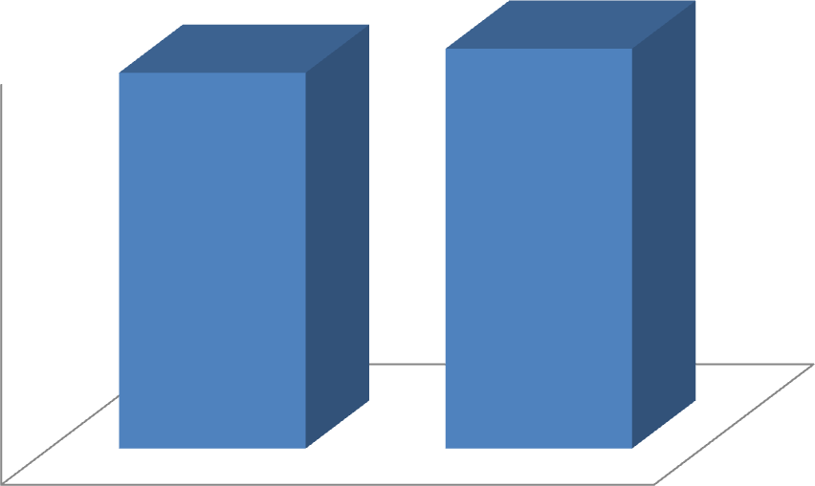
50
49.4
50

48

46

44

42

40
experimental
AGE
control
Graph 1: Age distribution of subjects studied
Gender distribution among the study subjects
Group A has 11 men and 4 men, while Group B has 10 men and 5 women. With a P value of >0.69, the gender distribution between the groups is not statistically significant.

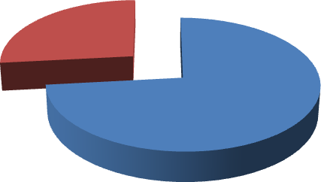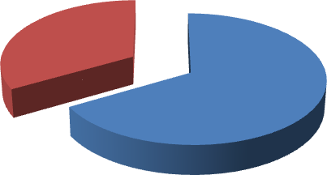

experimental

femal e 27%

male
73%

control

female
33%

male 67%

Graph 2: Percentage of gender distribution in group A Graph 3: Percentage of gender distribution in group B
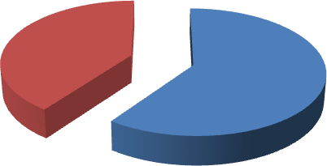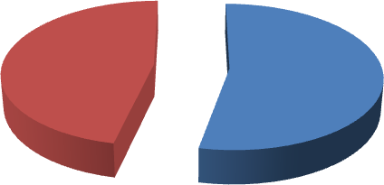
Experimental

Left
40%

Right
60%
Control

Left
47%

Right 53%
Graph 4 : Percentage of subject distribution based on the side involved in Group A Graph 5 : Percentage of subject distribution based on the side involved in Group B

Onset of treatment following stroke

The mean time from the time of the stroke till the start of treatment is 13.203.21 in Group A and 14.533.74 in Group B, as shown in Table 1, with a P value of >0.304, which is not statistically significant.
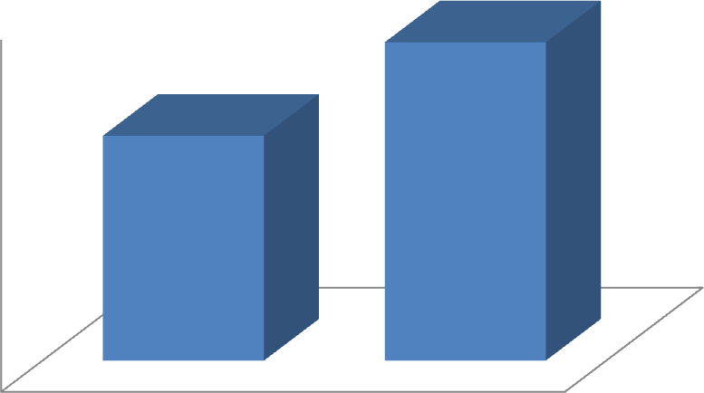
14.53
15
13.2
14

13

12

11

10
experimental
control
ONSET
Graph 6: comparison of onset of treatment between the groups.

Subject distribution in the two groups based on the type of stroke

There are 6 participants with hemorrhagic stroke in group A and 10 subjects in group B. In contrast, ischemic strokes occurred in 9 participants in group A and 5 subjects in group B.With a P value >0.413, the difference between the groups is not statistically significant.
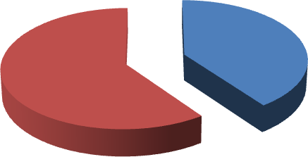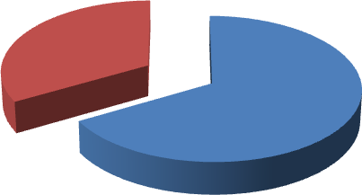
Experimental
IISH
60%
HEM
40%

Control

ISH 33%

HEM 67%

Graph 7: percentage of subject distribution based on the type of stroke in Group A Graph 8: percentage of subject distribution beads on the type of stroke in Group B

Initial evaluation for Brunnstorm VGC The mean score in Group A is 36.00 10.87, and Group B is 28.87 9.82, as shown in Table 1, with a P value of >0.074, which is not statistically significant.
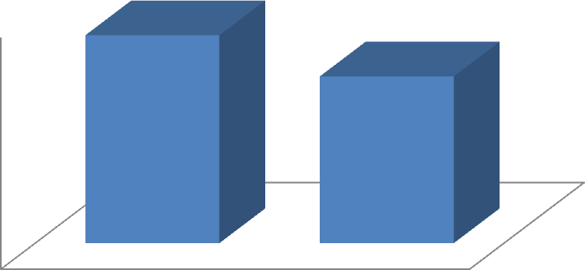
36
40
28.87
30

20

10

0
experimental
control
VGC

Graph 9: Comparison of base line score for Brunnstorm VGC in between the groups
Table 3: Base line data for outcome variables.

Base line data for outcome variables
Variables | Group A | Group B | P Value
M A S | 1.27 ± 0.80 | 0.80 ± 0.77 | >0.137
FMA | 1.20± 0.77 | 0.80 ± 0.62 | >0.130

M A S's baseline means score in group A is 1.27 0.80, whereas it is 0.80 0.77 in group B. With a P value of >0.137, these baseline means scores are not statistically significant. With a P value of 0.009, the baseline FMA scores for groups A and B are 1.20 0.77 and 1.90 1.28, respectively.These scores are notstatisticallysignificant.
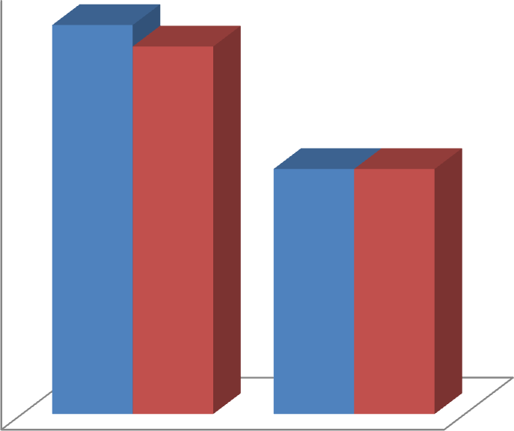
1.27
1.4
1.2
1.2

1
0.8
0.8
0.8

0.6

0.4

0.2

0
Experimental
Control
- MAS
- FMA

Graph 10: Base line data for outcome variables.

Within group analysis

Table 4: Evaluation of effect based on M A S

Motor Assessment Scale
Group | Pretest score | Post test score | P Value
Group A | 1.27 ± 0.80 | 1.67 ± 0.98 | <0.014.
Group B | 0.80 ± 0.77 | 0.87 ± 0.74 | >0.317.

In group A pretest score M A S is 1.27 ± 0.80 and post score is 1.67 ± 0.98 In group B pretest score is 0.80 ± 0.77 and post test score is 0.87 ±0.74.
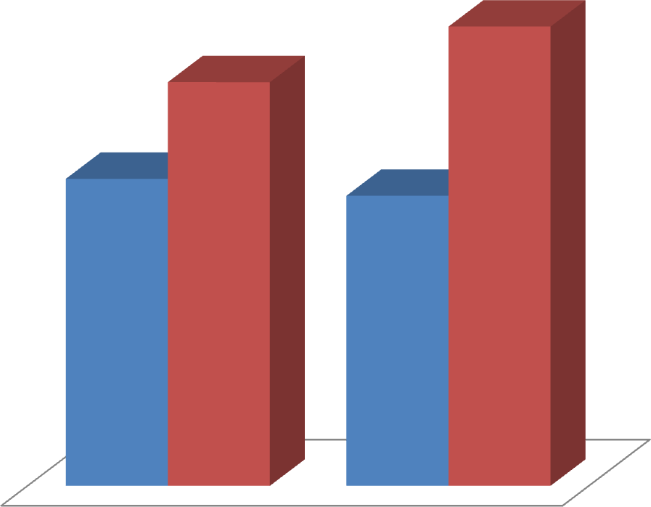

1.67

1.27

0.80
0.87

- Control ▪ EXP
Graph 11: Evaluation of effect based on M A S

Table 5: Evaluation of effect based on FMA

FUGL MEYER ASSESSMENT
Group | Pretest score | Post test score | P Value
Group A | 1.2 ± 0.77 | 1.9 ± 1.28 | <0.009.
Group B | 0.80 ± 0.62 | 1.03 ± 1.02 | >0.169.

In group A pretest score FMA is 1.2 ± 0.77 and post score is 1.9± 1.2 In group B pretest score is 0.80 ± 0.62 and post test score is 1.03±1.02.
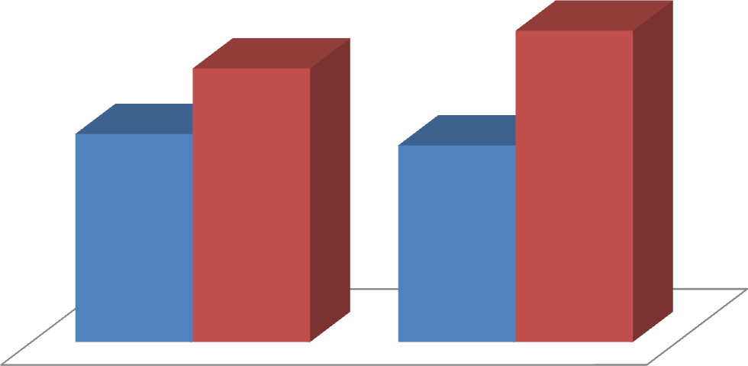
1.9
1.2
0.80
1.03
- Control
- EXP
Graph 12: Evaluation of effect based on FMA.

Between group analysis

Table 6: Difference of gain in between the groups

Difference of gain in improvement
Variables | Experimental | Control | P Value
M A S | 1.67 ± 0.99 | 0.86 ± 0.74 | < 0.029  .
FMA | 1.90 ± 1.28 | 1.03 ± 1.02 | < 0.05

With a P value of 0.29, which is statistically significant, the mean gain between the M A S pre and post test score in group A is 1.67 0.97 and in group B is 0.86 0.74. With a P value of 0.05, which is statistically significant, the mean gain between the pre- and posttest core of FMA in group A is 1.90 1.28 and group B is 1.03 1.021.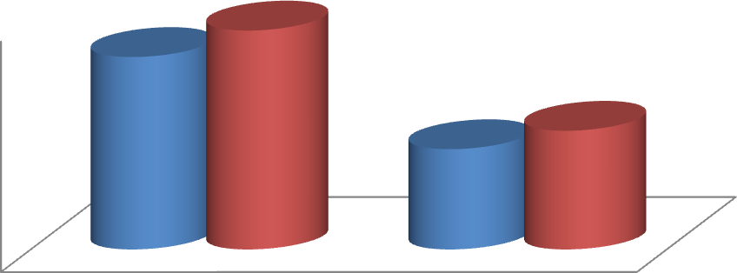
1.67
1.9
2
1.03
1.5
0.87
1
0.5
0
Experimental
Control
MAS FMA

Graph 13: Difference of gain in improvement in between the groups

Discussion

In order to enhance the motor function of the arm and hand in post-stroke individuals, the purpose of this study is to determine the effects of AOT & MBT. Consequently, based on these kind of investigations.

The main conclusion of this study was that a self-administered exercise programme for 12 weeks that involved little therapist participation and long-term administration of AOT and MBT significantly improved the motor function of the arm and hand.It is highly applicable to real-world
When the samples were matched, the baseline information for the demographic and outcome variables had a P value that was not statistically significant. As a result, the homogeneity of the sample was employed to test the important percentage of baseline attributes.

1. The pretest score for MAS in the experimental group was 1.27 0.8; with a P value of 0.014, this score significantly increased to 1.67 0.9.
2. The pretest FMA score for the experimental group was 1.2 0.77, and with a P value of 0.009, it significantly rose to 1.9 1.28.

Less females in group A and the fact that the female subjects chosen were all menopausal may explain why there are more male individuals in the experimental group, which shows better functional results.According to Cheryl D. Smith and Mathew J. Reeves, PhD,

Women consistently had worse functional results and quality of life after stroke, even after accounting for baseline differences in age, pre-stroke performance, and co-morbidities. Women from 45 to 74 years had a higher stroke death rate than men under the age of 45.compared to men, have a significantly decreased risk of dying from a stroke. The most prevalent biological justification for sex-related variations in stroke is connected to sex steroid hormones, specifically oestrogen.

While testosterone has the opposite effects, estradiol has highly significant effects on endothelia that encourage dilatation and blood flow. Similar to this, premenopausal women have the strongest cerebrovascular reactivity, while postmenopausal women respond less well than age-matched men. In addition to its effects on the vascular system, oestrogen also possesses anti-inflammatory properties that may be affected by its anti-oxidant and anti-apoptotic properties.²³

All of these findings imply that endogenous oestrogens protect women up until they reach menopause. They also show that group A contained a larger proportion of ischemic stroke patients who recovered functionally more quickly than those in group B. Vera P. M. Schepers, MD, PhD1, and Marjolijn Ketelaar, PhD2009 affirm this.
In the first two months after a stroke, ischemic stroke patients have shown greater functional improvement than hemorrhagic stroke patients, which is primarily determined by unidentified processes referred to as "spontaneous neurological recovery" and may be caused by

(i) recovery of penumbral tissue where electrical failure has occurred but membrane homeostasis is preserved, (ii) resolution of functionally suppressed regions far from the infracted area by diaschisis, and (iiA right hemisphere stroke rarely results in aphasia. Semantic comprehension issues can be present in patients (Lesser 1974), but 'phonological' abilities are often unaffected. Since the auditory association cortex is situated in the left lateral temporal lobe, simple receptive and expressive activities are frequently appropriate. And in our study, ongoing counselling and family support during the course of treatment may have contributed to the participants' quick recovery from right hemisphere injuries.

When compared to the control group, group A's subjects performed the specified exercises for an additional hour seven days a week with the option of splitting the time into two to thirty minute sessions over the course of three months.Timing and level of post-stroke therapy have been identified as significant outcome determinants. Early treatment beginning has been linked to better long-term and functional outcomes upon discharge. (2005) Horn et al. (Kwakkel and colleagues, 1997, 2004).

In this trial, we chose participants who had suffered a stroke less than one month prior, and they received rapid intervention for three months, which produces superior benefits. The rehabilitation process for the upper limb has a well-documented time course (Parke et al., 1986; Nakayama et al., 1994).Depending on the severity of the arm, the average recovery time for motor impairment after a stroke is three weeks.

A hospital-based intervention was studied in order to lessen the strain and co-morbidities on the family. To lessen the burden of disability on the individual, family, and society, intervention studies are required to explain the components of successful upper limb treatment following stroke. (Bohannon et al., 1988.

The repetitive bilateral arm tasks that are part of AOT and MBT demonstrate the interaction between the right and left hemispheres as well as cortical and sub-cortical systems, highlighting the significance of both in the coordination, planning, and execution of movement (Hatakenaka et al.).

The functional results of the proximal upper limb muscles are improved by task training. While proximal upper limb muscles can be affected in terms of mobility and functionality by injuries involving sub-cortical systems (Hatekenaka et al., 2007;).For the subjects in group A, strengthening with particular sets of particular repetitions resulted in higher functional outcomes.

In order to identify the best strategy for accelerating recovery and the ideal period of time required to regain upper limb function, studies have examined a variety of intervention kinds and therapy lengths.

Recent evaluations of upper limb rehabilitation after stroke (Teasell et al., 2005; Urton et al., 2007) came to the conclusion that there was enough data to back up the value of exercise therapy for improving upper limb function.

Limitations

  - The study was not made based on the side of the hemisphere involved which might have affected the overall outcome of the study.
  - Being hospital based intervention, supervision of subjects while doing the protocol was difficult to do, which may influence the study?

Recommendations
- Further studies should be done with larger sample size.
- The hemisphere involved may be considered in the future studies.
- Future studies can be done as a comparative study between AOT, MBT and the other facilitative approaches.
- And study can be done with the different sampling techniques

Conclusion
AOT & MBT serve to reduce the motor deficits of the arm and hand, even though there is less conclusive evidence in the literature, based on the study results and significant statistical changes for the hospital-based practise.

The experimental hypothesis, which might be summarised as the AOT & MBT is effective in increasing the motor function of the arm and hand for a lengthy period given the data, which demonstrate a substantial

Summary
Hemiplegic motor impairments are a frequent post-stroke consequence. The main goal of this study was to determine if action observation therapy is effective in enhancing hand- and arm-motor function. Two groups of fifteen people were randomly selected for the study.
For stroke recovery, the experimental group received Action Observation treatment while the control group received traditional physiotherapy. Pre- and post-treatment assessments of the motor function of the arm and hand using the MAS score and FMA as outcome measures were used to determine the treatment's effectiveness.

REFERENCES

- Duncan P, Studenski S, Richards L, Gollub S, Lai SM, Reker D, et al. Randomized clinical trial of therapeutic exercise in subacute stroke. Stroke. 2003;34:2173–80.

- Hesse S, Waldner A, Mehrholz J, Tomelleri C, Pohl M, Werner C. Combined transcranial direct current stimulation and robot-assisted arm training in subacute stroke patients: an exploratory, randomized multicenter trial. Neurorehabil Neural Repair. 2011;25:838–46.

- Kwakkel G, Kollen BJ. Predicting activities after stroke: what is clinically relevant? Int J Stroke. 2013;8:25–32.

- Pollock A, St George B, Fenton M, Firkins L. Top ten research priorities relating to life after stroke. Lancet Neurol. 2012;11:209.

- Dobkin BH, Carmichael ST. The specific requirements of neural repair trials for stroke. Neurorehabil Neural Repair. 2016;30:470–8.

- Buccino G. Action observation treatment: a novel tool in neurorehabilitation. Philos Trans R Soc Lond B Biol Sci. 2014;369:20130185.

- Deconinck FJ, Smorenburg AR, Benham A, Ledebt A, Feltham MG, Savelsbergh GJ. Reflections on mirror therapy: a systematic review of the effect of mirror visual feedback on the brain. Neurorehabil Neural Repair. 2015;29:349–61.

- Ertelt D, Small S, Solodkin A, Dettmers C, McNamara A, Binkofski F, et al. Action observation has a positive impact on rehabilitation of motor deficits after stroke. Neuroimage. 2007;36:T164–73.

- Kim J, Lee B, Lee HS, Shin KH, Kim MJ, Son E. Differences in brain waves of normal persons and stroke patients during action observation and motor imagery. J Phys Ther Sci. 2014;26:215–8.

- Franceschini M, Ceravolo MG, Agosti M, Cavallini P, Bonassi S, Dall’Armi V, et al. Clinical relevance of action observation in upper-limb stroke rehabilitation: a possible role in recovery of functional dexterity. A randomized clinical trial. Neurorehabil Neural Repair. 2012;26:456–62.

- Sugg K, Muller S, Winstein C, Hathorn D, Dempsey A. Does action observation training with immediate physical practice improve hemiparetic upper-limb function in chronic stroke? Neurorehabil Neural Repair. 2015;29: 807–17.

- Kim E, Kim K. Effects of purposeful action observation on kinematic patterns of upper extremity in individuals with hemiplegia. J Phys Ther Sci. 2015;27: 1809–11.

- Sale P, Ceravolo MG, Franceschini M. Action observation therapy in the subacute phase promotes dexterity recovery in right-hemisphere stroke patients. Biomed Res Int. 2014;2014:457538.

- Cha YJ, Yoo EY, Jung MY, Park SH, Park JH, Lee J. Effects of mental practice with action observation training on occupational performance after stroke. J Stroke Cerebrovasc Dis. 2015;24:1405–13.

- Altschuler EL, Wisdom SB, Stone L, Foster C, Galasko D, Llewellyn DM, et al. Rehabilitation of hemiparesis after stroke with a mirror. Lancet. 1999;353:2035–6.

- Thieme H, Bayn M, Wurg M, Zange C, Pohl M, Behrens J. Mirror therapy for patients with severe arm paresis after stroke-a randomized controlled trial. Clin Rehabil. 2013;27:314–24.

- Wu CY, Huang PC, Chen YT, Lin KC, Yang HW. Effects of mirror therapy on motor and sensory recovery in chronic stroke: a randomized controlled trial. Arch Phys Med Rehabil. 2013;94:1023–30.

- Sathian K, Greenspan AI, Wolf SL. Doing it with mirrors: a case study of a novel approach to neurorehabilitation. Neurorehabil Neural Repair. 2000;14:73–6.

- Molenberghs P, Cunnington R, Mattingley JB. Brain regions with mirror properties: a meta-analysis of 125 human fMRI studies. Neurosci Biobehav Rev. 2012;36:341–9.

- Rizzolatti G, Craighero L. The mirror-neuron system. Annu Rev Neurosci. 2004;27:169–92.

- Buccino G, Binkofski F, Fink GR, Fadiga L, Fogassi L, Gallese V, et al. Action observation activates premotor and parietal areas in a somatotopic manner: an fMRI study. Eur J Neurosci. 2001;13:400–4.

- Cochin S, Barthelemy C, Roux S, Martineau J. Observation and execution of movement: similarities demonstrated by quantified electroencephalography. Eur J Neurosci. 1999;11:1839–42.

- Iacoboni M, Woods RP, Brass M, Bekkering H, Mazziotta JC, Rizzolatti G. Cortical mechanisms of human imitation. Science. 1999;286:2526–8.

- O Sullivan S B,Schmitz TJ. Physicalrehabilitation: assessment and treatment. 4thed. New Delhi: Jaypee Brothers Medical publishers; 2001

- Umphered D Ann, NeurologicalRehabilitation,3rded, Philadelphia: Mosby publication, 1995.

- WHO monica project, principal investigations, The world health organization Monica project, Journal of clinical epidemiology 1998; 41:105-14.

- S sunder, text book of rehabilitation, 2nd edition, New delhi , Jay pee publicatio
,2002 , page 351.
- Anandk ,choudhary D. Neuro epidemiology ; 2001; 20:208-211.
- kotila M et al ; The profile of recovery after stroke and factors influencing outcome Stroke 1984 ; 15 : 1039-1044.
- Susan B O Sullivan. Physicalrehabilitation: Assessment and treatment, 4thedition. Philadelphia:F. A .Davis; 2001.
- Dean C, Mackey F. Motor assessment scale scores as a measure of rehabilitation outcome following stroke. Australian Journal of physical therapy 1992; 38: 31-35.
- Ernst E .A Review of stroke rehabilitation and physiotherapy .Stroke 1990; 21: 1081-1085.
- Carr J H Sheppherd RB. Neurological Rehabilitation: Optimizing motor performance, first edition, Edinburgh:Elsevier; 1998.
- ThielmannGT, DeanCM, Gentile AM. Rehabilitation of recovery after stroke: Task related training versus progressive resistive exercise. Archieves of Physical medicine and Rehabilitation 2004 oct; vol 85, Issue 10, pages 1613 – 1618.

