MOLECULAR DOCKING AND QUANTUM CHEMICAL CALCULATION OF 4-[(2, 4- DICHLORO PHENYL) AMINO] 2- METHYLIDENE 4-OXOBUTANOIC ACID BY DENSITY FUNCTIONAL THEORY

G.Mahalakshmi K.Vanasundari K.Balachandran
Assistant Professor Assistant Professor Associate Professor
Department of physics Department of physics Department of physics
Government Arts College (A), Arignar Anna Government Arts College Arignar Anna Government Arts College
Karur-639005, Tamilnadu, India. Musiri- 621211, Tmailnadu,India. Musiri- 621211, Tmailnadu, India.

ABSTRACT

4-[(2,4- dichloro phenyl) amino] 2-methylidene 4-oxobutanoic acid (DPAB) is regarded as an attractive antiviral agent. To rationalize the detailed interaction between DPAB and its inhibitors at the atomic level, an integrated computational approach by combining molecular mechanics and quantum mechanics methods was employed in this report. The spectroscopic properties of 4-[(2, 4- dichloro phenyl) amino] 2-methylidene 4-oxobutanoic acid compound were investigated by FT-IR, FT-Raman spectroscopic techniques. FT-IR (4000- 400 cm⁻¹) and FT-Raman spectra (3500-10 cm⁻¹) in the solid phase were recorded. The structural and spectroscopic data of the molecule have been obtained from DFT (B3LYP) with 6-311++G(d, p) and 6-311+G(d, p) basis set calculations. The geometry of the molecule was fully optimized, vibrational spectra were calculated and fundamental vibrations were assigned on the basis of potential energy distribution (PED) of the vibrational modes. Besides, frontier molecular orbitals (FMO), the molecular electrostatic potential (MEP), non-linear optical properties (NLO) and Fukui functions were performed.
Key words: FT-IR, FT-Raman, DFT studies, NLO

Introduction

We live in a time of rapid development of antiviral compounds. A number of antiviral drugs have been formally licensed and are widely used for the chemotherapy of specific viral infections [1-4]. An antiviral agent that prevents viral invasion or replication treats an infection or rashes the virus into latency. In recent years, the desirability of new broad-spectrum antiviral drugs has been emphasized a means of providing greater protection against a range of viruses while mitigating risks of resistance and reducing costs associated with developing drugs that are targeted to every specific virus. In view of the constant threat caused by new emerging strains of influenza and limitations of existing drugs, there is a particular need for drugs with new mechanisms of action that may be used alone or in combination with neuraminidase inhibitors to provide more optimal medical countermeasures against seasonal and pandemic influenza. Human rhinoviruses, the most important etiologic agents of the common cold, are messenger-active single-stranded monocistronic RNA viruses that have evolved a highly complex cascade of proteolytic processing events to control viral gene expression and replication. Most maturation cleavages within the precursor polyprotein are mediated by rhinovirus 3C protease (or its immediate precursor, 3CD), a cysteine protease with a trypsin-like polypeptide fold. High-resolution crystal structures of the enzyme from three viral serotypes have been used for the design. Antiviral therapeutics with profiles of high potency, low resistance, and low toxicity remain challenging and obtaining such agents continues to be an active area of therapeutic development. Due to their unique three-dimensional structural features, DPAB has been identified as one of the privileged chemo types of antiviral drug development. The present work describes the molecular docking and quantum chemical calculation of 4-[(2, 4- dichlrophenyl) amino] 2- methylidene 4-oxo butanoic acid by density functional theory.The redistribution of electron density in various bonding and antibonding orbitals along with stabilization energies have been calculated by natural bond orbital analysis to give clear proof of stabilization originating from hyper-conjugation of variety of intra- molecular interaction.
The nonlinear properties, Mulliken atomic charges and Fukui functions have been analyzed. Molecular docking is a powerful computational tool for predicting the binding affinity of a ligand with the proteins, which are very much useful and effective in modern structure-based drug designing. The structure of the target protein can be obtained from the protein data bank (PDB) format. The ligand protein molecular docking can predict that the preferred orientation of the ligand with respect to the protein to form a stable complex and its derivatives.

Computational details

All the calculations of the title compound were carried out using Gaussian 09 software [5] by utilizing Becke’s three parameter hybrid model with the Lee- Yang-Parr correlation functional (B3LYP) method. The 6-311++G(d, p) and 6- 311+G(d, p) basis set were employed to predict the molecular structure and vibrational wavenumbers. Gauss View program was used for the visualization of optimized structures [6]. Molecular electrostatic potentials and Natural population analysis were also computed at the same level. The noncovalent interactions were studied and their reduced density gradient was graphed by Multiwfn [7]. Molecular docking studies were performed with the help of Autodock-vina software [8].

Results and discussions

Geometrical structures
The molecular structure along with numbering of atoms of DPAB is obtained from Gaussian 09 program and is as shown in Fig.1. The global minimum energy obtained by DFT structure optimization using 6-311+G(d, p) basis set for the DPAB as -1632.5 a.u. The optimized geometrical parameters (bond lengths and bond angles) of the molecule are given in Table 1. There is not seen an important difference between 6-311++G(d, p) and 6-311+G(d, p) basis sets of the methods. The C-H bond lengths of CH₂ groups and Phenyl ring are found to be 1.09 and 1.08 Å showing closer agreement with the literature [9].

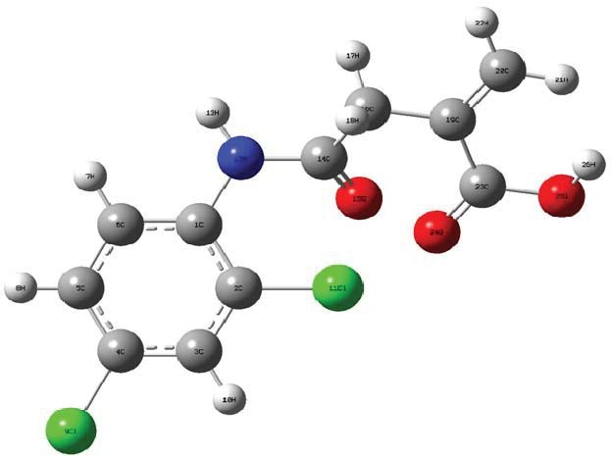

Fig. 1 Optimized geometrical structure of [(2, 4- dichloro phenyl) amino] 2-methylidene 4-oxobutanoic acid

In the present study, the C-C bond lengths are computed from 1.39−1.41Å showing a closer agreement with the experimental data and literature [10]. As seen some differences between calculated and experimental could be due to the fact that the calculations are obtained from gas phase however experimental results are taken solid phase. The bond angle between Cl₁₁-O₂₄-C₂₃ (149.43), C₁-N₁₂- C₁₄ (127.91), N₁₂-C₁₄-O₁₅ (125.22) and C₁₉-C₂₀-H₂₁ (123.03) indicates delocalization formed in this molecule. Further, it shows that higher electronegative property of Oxygen and Nitrogen atoms. The optimized C-N bond length is 1.37 Å show good coherent with the literature [11]. The ring C-C-C, bond angles observed in the range of 117.46°−121.97°, show well correlation with the experimental values [12]. The C-X (X= F, Cl, Br, I) bond length indicates a considerable increase when substituted in a package of C-H. The substitution of Cl atom elongate the bond lengths of C₂-Cl₁₁ (1.76Å), C₄-Cl₉ (1.76 Å) greater than the other bonds in the ring.

Vibrational spectral analysis
The aim of this part of the study is the assignment of the vibrations to make a comparison with the related molecules and also with the results obtained from the theoretical calculations. Title molecule consists of 26 atoms with 72 normal modes of vibrations and considered under C₁ point group symmetry. The detailed analysis of fundamental modes of vibration with experimental and theoretical frequencies, and PED of title molecule using DFT/B3LYP method by using split- valence basis sets (6-311++G(d, p) and (6-311+G(d, p) function are reported in Table 2. The experimental and calculated infrared and Raman spectra were given in Figs.2 and 3 respectively. The calculated spectra are shown for comparative purpose. There are some strong frequencies useful to characterize the vibrational assignments of the title compound.
Aromatic compounds commonly exhibit multiple weak bands in the region 3100-3000 cm⁻¹ [13] due to aromatic C-H stretching vibrations. Accordingly, in the present study the C-H stretching vibrations of DPAB is observed at 3098, 3085, 3021[6-311++G(d, p)] and 3095, 3071, 3015 cm⁻¹ [6-311+G(d, p)]. Corresponding experimental vibrations are identified at 3188, 3074 (FT-IR) and 3072 cm⁻¹ (FT-Raman). The bands due to C-H in-plane and out-of plane bending vibration interacting somewhat with C-C stretching vibration are observed as a number of medium weak intensity sharp bands in the region 1300−1000 cm⁻¹ and 1000-750 cm⁻¹ [14]. In DPAB, the C-H in-plane bending vibrations are observed at 1348, 1317, 1183 (FT-IR), 1148 cm⁻¹ and, (FT-Raman) respectively. Theoretical spectrum obtained at 977, 874, 855 and 841cm⁻¹ [(6-311++G(d, p)] are identified as CH out-plane bending vibrations. In the present case, carbon-carbon stretching vibrations are assigned at 1579, 1519, cm⁻¹ (FT-IR) and 1603, 1293 cm⁻¹ (FT-Raman).
The methylene group (CH₂) of the title molecule which works as a bridge between the COOH group and phenyl ring, shows the CH₂ asymmetric stretching, symmetric stretching, scissoring, rocking, wagging and twisting vibrational modes. The asymmetric and symmetric C-H stretching vibrations of CH₂ appear in the range 2936−2916 cm⁻¹ and 2865−2845 cm⁻¹ respectively [7]. The observed FT-Raman band at 2993cm⁻¹ is assigned as CH₂ asymmetric stretching mode and corresponding calculated wavenumbers are 3089, 2995 cm⁻¹(6-311G+(d, P) and 3088, 2991 (6-311G++(d, P) . The CH₂ scissoring vibrations appear normally in the region 1490−1435 cm⁻¹ as a medium intense band [15]. In the present case, The CH₂ scissoring mode is found to be strongly mixed with the CH₂ scissoring modes of the phenyl ring, and the dominant CH₂ scissoring mode is assigned at 1476, 1455 cm⁻¹ (6-311++G(d, p) with experimental FT-IR band at 1474 and 1454 cm⁻¹. CH₂ wagging mode is calculated at 1287 (88%) and 1233 cm⁻¹ (94%) which is in good agreement with the observed band at 1286 and 1231 cm⁻¹ in the FT-IR spectrum. The dominant mode corresponding to the CH₂ rocking vibrational motions are assigned at 867 and 788 cm⁻¹, respectively and in good agreement with experimental data (866 cm⁻¹ in FT-IR and FT-Raman). The absorption bands arising from C-N symmetric stretching modes are observed in the wavenumber region 1150-850 cm⁻¹ [16−17]. The calculated spectrum of 6-311++G(d, p) and 6-311+G(d, p) at 1208 and 1206 cm⁻¹ are assigned to the C-N stretching mode of DAPB.
The structural unit of C=O has an excellent group frequency, which is described as a stretching vibration. Almost all carbonyl compounds have a very intense and narrow peak in the range of 1800−1600 cm⁻¹ [18]. The multiple bonded groups are highly polar and therefore give rise to an intense infrared absorption band in the region 1700 cm⁻¹−1800 cm⁻¹. The carbon-oxygen double bond is formed by π-π bonding between carbon and oxygen. Because of the different electronegativities of the carbon and oxygen atoms, the bonding electrons are not equally distributed between the atoms [19]. In our present study, the C=O stretching vibration is observed at 1682 cm⁻¹ as a strong band in FT-Raman, and the computed wavenumbers at 1718 and 1683 cm⁻¹ with PED contributions of 82% and 70%. Both the experimentally observed FT-IR and FT-Raman bands show excellent agreement with our theoretical values. Jian et al. [20] reported C=O stretching vibration of 1-acetyl-3-(2, 4-dichloro-5-fluro-phenyl)-5-phenyl- pyrazoline at 1660 cm⁻¹ (exp), and 1708 cm⁻¹ (6-31G*).

Transmittance (a.u.)
OBSERVED
B3LYP/6-311++G(d,p)
B3LYP/6-311+G(d,p)

4000
3500 3000 2500 2000

Wavenumber (cm⁻¹)
1500
1000
500

Fig. 2 FT-IR spectrum of [(2, 4- dichlro phenyl) amino] 2-methylidene 4-oxobutanoic acid]

4000 3500 3000 2500 2000 1500 1000 500 50

OBSERVED

B3LYP/6-311+G(d,p)

B3LYP/6-311++G(d,p)

Wavenumber (cm⁻¹)

Fig.3 FT-Raman spectrum of - [(2, 4- dichlro phenyl) amino] 2-methylidene 4-oxobutanoic acid
The vibrational mode belonging to the bond between the ring and halogen atom is worth to discuss here since mixing of vibrations is possible due to the lowering of the molecular symmetry and the presence of heavy atom on the periphery of the molecule [21]. The C-Cl absorption is observed in the broad region between 750 – 580 cm⁻¹ [22]. Thus, the band observed in IR spectrum at 656 cm⁻¹ and FT-Raman at 669 cm⁻¹ is assigned to the C-Cl stretching mode of DPAB. The C-Cl in-plane bending mode is observed at 547 cm⁻¹ (FT-IR) and theoretically at 515, 465 cm⁻¹ [6-311++G(d, p)] and 511, 422 cm⁻¹ [6-311+G(d, p)]. The calculated value of C-Cl out-of-plane bending is computed at 190, 138 (6- 311G+(d, p)), 192, 141 cm⁻¹ (6-311G++ (d, p)).

NBO

The Natural bond orbital analysis (NBO) were performed using NBO 3.1 program [23] as implemented in the Gaussian 09 package at B3LYP/6- 311++G(d, p) level basis set. NBO analysis is carried out to determine all possible interactions between filled (donor) Lewis type NBOs and empty (acceptor) non- Lewis NBOs, and evaluating perturbation theory. Stabilization energy E⁽²⁾ by secon-dorder NBO analysis explains some of the significant donor-acceptor interactions and their second-order perturbation energies E⁽²⁾. The most important donor-acceptor interactions are listed in Table 3 and 4. NBO analysis focuses to illustrate the role of inter and intra-molecular bonding. It also gives a justified base for finding charge transfer or hyper-conjugative interactions in the molecular system. The lone pair of electrons present on O₂₄ atom interacted with anti- bonding orbital σ*C₂ –Cl₁₁, π*C₁₄-O₁₅, σ*C₁₉-C₂₃, π*C₂₃-O₂₄, and σ*C₂₃-O₂₅ through resonance, lead to strong conjugative stabilization energy 6.35, 28.71, 6.08, 9.74 and 19.57 Kcal/mol. Furthermore, in DPAB lone pair LPπO₂₅ interacted with the anti-bonding orbital of C₂₃-O₂₄, C₁₄-O₁₅, C₁₄-O₁₅, and C₁₉-C₂₀, through hyper-conjugation to pi-anti-bonding orbital. The stabilization energies for such hyper-conjugation are 28.45, 8.17, 132.45, 26.09 Kcal/mol. The energy difference between interacting atoms is proportional to the stabilization of orbital interaction. Hence, the strongest interactions of stabilization occur between dominant donors and acceptors [24]. The LPπO₁₅→σ*N₁₂-C₁₄, LPσO₂₄→σ*C₂-Cl₁₁, LPπO₂₄→σ*C₁₄-O₁₅, LPπO₂₅→C₂₃-O₂₄ stabilized the resulting complex by 18.82, 9.11, 28.71, 28.45 kcal/mol, respectively.

Mulliken atomic charges

The charge distribution on a molecule has a significant influence on the vibrational spectra. The atomic charge in molecules is fundamental to chemistry. For instance, the atomic charge has been describing the processes of electro negativity equalization and charge transfer in chemical reactions [25−26]. Mulliken atomic charges are computed by the DFT/B3LYP method 6-311++G(d, p) basis set. The computed reactive atomic charges play an important role in the application of quantum mechanical calculations of the molecular system. The Mulliken atomic charges of the title compound are tabulated in Table 5 and shown in Fig.4. The results show that substitution of the phenyl ring by chlorine atoms leads to redistribution of electron density. The charges of CH₂ groups are same distribution. Hydrogen atoms exhibit a positive charge, which is an acceptor atom. Oxygen (O₂₅= −0.54 a.u) and Nitrogen (N₁₂= −0.64 a.u) have high negative charge, which are donor atoms.

MEP

The 3D plot of the molecular electrostatic potential map surface for DPAB is shown in Fig. 8.5. The visual method provides to understand the reaction between structure and the active site of the molecule. It is used to identify the electrophilic and nucleophilic reactivity site and also hydrogen bonding interactions. The MEP [27] contains information about the entire electron constitute of the molecule and defines regions of nucleophilicity and electrophilicity on the molecular surface and was plotted for DPAB. Negative electrostatic potential corresponds to the attraction of protein by concentrated electron density in the molecule (represented by red) and positive electrostatic potential corresponds to the repulsion of a proton by atomic nuclei in the region of low electron density (represented by blue color). The MEP of DPAB shows clearly the two major negative potential regions around oxygen atom of carbonyl group and nitrogen of phenyl ring. The MEP map drawn in the molecular plane reveals maximum values of positive potential and negative potential corresponding to the electrophilic and nucleophilic region and is +9.623 a.u and –9.623 a.u respectively.

(a)
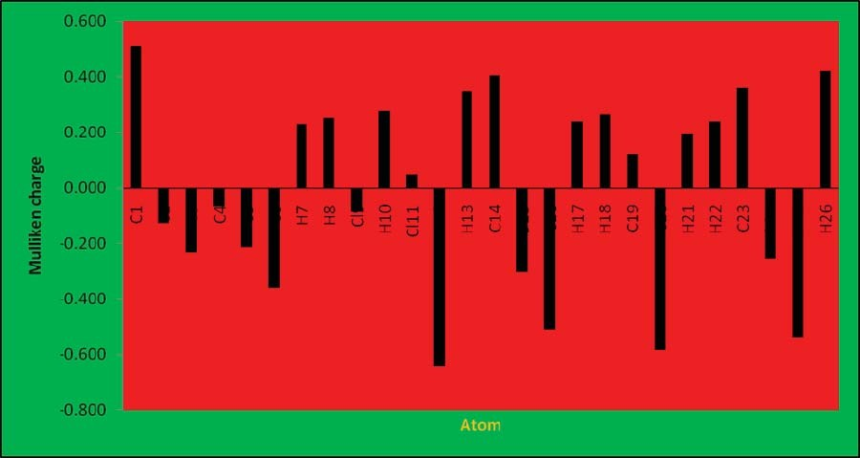

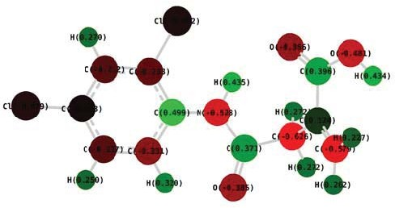
(b)

Fig. 4 (a) The histogram of calculated Mulliken charge and (b) Atoms with their mulliken charge values of [(2, 4- dichlro phenyl) amino] 2-methylidene 4-oxobutanoic acid]

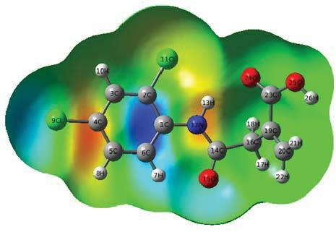

Fig. 5 The 3D surface map of [(2, 4- dichloro phenyl) amino] 2-methylidene 4- oxobutanoic acid

Frontier molecular orbitals and their related molecular properties
Frontier molecular (HOMO−LUMO) orbital plays an important role in the electric and optical properties, as well as in UV-Vis spectra and chemical reactions [27]. The highest molecular orbital (HOMO) and lowest unoccupied molecular orbital (LUMO) are very important parameters for quantum chemistry. The HOMO is the orbital that primarily acts as an electron donor while the LUMO is the orbital that largely acts as an electron acceptor. According to the molecular orbital coefficients analyses based on DFT/B3LYP/6-311G++ (d, p) optimized structure indicate that frontier molecular orbital are mainly composed of p atomic orbital, so electronic transitions from the HOMO-2, HOMO-1 and HOMO to the LUMO are mainly derived from the n-π* transitions. Fig. 6 shows the distributions and energy levels of the HOMO-2, HOMO-1, and HOMO, LUMO and LUMO-2, LUMO+2 orbital for the molecule in the gas phase for DPAB, the positive phase is red and the negative one is green. In the title compound, the LUMO is delocalized over the whole system except on the CH₂ group and LUMO is delocalized over the whole system except on the CH₂ groups. Accordingly, the HOMO-LUMO transition implies an electron density transfer from the phenyl rings to the methyl groups. The quantum chemical parameters are predicted with the HOMO and LUMO orbital energy. Ionization energy and electron affinity can be expressed through HOMO and LUMO orbital energies as I= −E_{HOMO} and A= −E_{LUMO}. The hardness corresponds to the gap between the LUMO and HOMO energies. The larger the HOMO-LUMO energy gap, the harder the molecule.
The global hardness is predicted using the relation η= (E_{LUMO}−E_{HOMO})/2. The hardness has been associated with the stability of the chemical system. The reciprocal of the hardness will give the softness of the chemical system. The reciprocal of the hardness will give the softness σ = 1/η. The electron affinity can be used in combination with ionization energy to give electronic chemical potential = − (E_{LUMO}+E_{HOMO})/2. The global electrophilicity index is given by ω = μ²/2η. This index measures the stabilization in energy when the system acquired an additional electronic charge from the environment. For the title compound, the above said parameters are tabulated in Table.8.6. The energy separation between the HOMO−LUMO gaps clearly indicates the high excitation states (2.41eV), good stability and a large chemical hardness for the title compound.

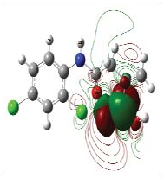
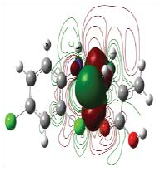
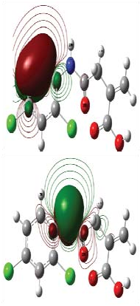
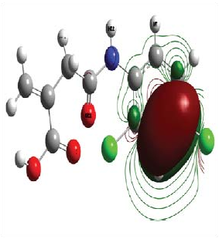
HOMO
Fig. 6 HOMO-LUMO plot of [(2, 4- dichloro phenyl) amino] 2-methylidene 4-oxobutanoic acid]
4.15eV
4.37eV
5.85eV
2.41eV
3.46eV
4.85eV
4.15eV
4.62eV
5.12eV

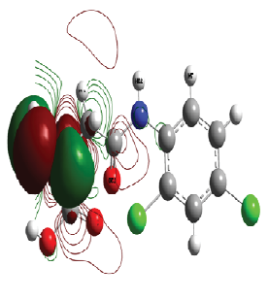
LUMO

Weak interaction analysis by reduced density gradient (RDG) method

To graphically investigate the interactions between the methylene and carboxylic group with a phenyl ring, the RDG analysis was implemented. The RDG analysis is used to illustrate the nature of the weak interactions between molecules. From the results, one can obviously distinguish the kind of interactions. The scatter graph of the optimized configurations of the title compound was shown in Fig. 7, the abscissa of scatter graph showed low density and low gradient spikes, which confirm the existence of weak interactions. The results given by quantum chemical calculations were subjected to weak interactions analysis by reduced density gradient (RDG) method on the Multiwfn software package. RDG method, coming from the density and its first derivative (s = 1/2(3π²)^{1/3})Δρ/ρ^{4/3}), is a fundamental dimensionless quantity in DFT used to describe the deviation from a homogeneous electron distribution, where ρ is the electron density, its reduced gradient, and Δρ is normalization gradient. It is generally accepted that in this method the reduced gradient will have very large positive values in density tails. (i-e region far from molecule, in which the density is decreasing to zero exponentially). RDG enables one to distinguish repulsive nature of the interactions or the allegedly attractive and to rank their relative strength on a visual basis when combined with the sign of the second principal local curvature of the electron density ρ(r). The non-covalent interactions descriptor provides a rich representation of electronic effects such as hydrogen bonds, Van der Waals interactions and steric repulsion [28]. As can be seen from Fig.7, benzene ring showed more steric effect than carboxyl and methyl group. The negative values of (λ₂)ρ indicates strong attractive interactions, while the positive values mean the repulsive interactions. The color on the RDG isosurface between the CH₂ and COOH showed that strong Van der Waals interaction formed.

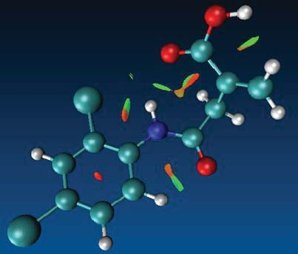
(a)

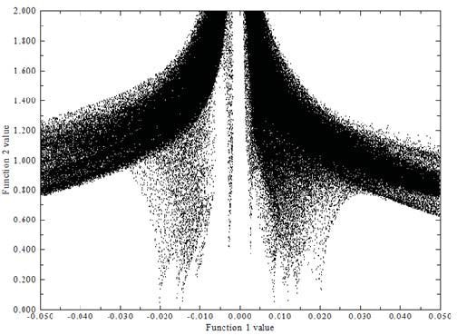
(b)

Fig.7. (a) Plots of the RDG versus λ (2) p and (b) Colour scaling of interactions of [(2, 4- dichloro phenyl) amino] 2-methylidene 4- oxobutanoic acid

Hyperpolarizability calculations

The polarization of the molecule by an external radiation field is often approximated as the creation of an induced dipole moment by an external electric field. Under the weak polarization condition, we can use a Taylor series expansion in the electric field components to demonstrate the dipolar interaction with the external radiation electric field. The first order hyperpolarizability (β₀) of the title compound is calculated based on the finite field approach. In the presence of an applied electric field, the energy to a system is a function of the electric field. The first order hyperpolarizability is a third rank tensor there can be described by 3 x 3 x 3 matrix. The 27 components from the 3D matrix can be reduced to 10 components due to the Kleinmann symmetry [29]. Their components of β are the coefficients in the Taylor series expansion of the energy in the external electric field. When the external electric field is weak and homogenous, this expansion becomes,

E=E₀-Σμ_{i}F^{i}-1/2Σα_{ij}F^{i}F^{j}-1/6Σβ_{ijk}F^{i}F^{j}F^{k}-1/24Σγ_{ijk}lF^{i}F^{j}F^{k}F^{l}+…….

where E₀ is the energy of the unperturbed molecule, F_{i} is the field at the origin, μ_{i,} α_{ij,} β_{ijk,} and γ_{ijk} are the components of dipole moment, polarizability, the first hyperpolarizabilities and second hyperpolarizability respectively.
The components of Non-linear optical (NLO) effects arise from the interactions of electromagnetic fields in various media to produce new fields altered in phase, frequency, amplitude or other propagation characteristics from the incident fields [30]. The values of dipolemoment (μ_{tot}), and first-order hyperpolarizability (β_{tot}) of the molecule were calculated by the Gaussian 09W program. The dipole moment and first static hyperpolarizability (β) value are calculated to be 4.2 Debye and 8.07x10⁻³⁰ e.s.u, which are very larger than that of Urea (1.37 Debye and 0.13x10⁻³⁰ e.s.u) [31]. Urea is a classical molecule used in the study of the NLO properties of the molecular systems and is used often as a threshold value for comparative purposes.

- Fukui functions

The electron density-based local reactivity descriptors such as Fukui functions are proposed to explain the chemical selectivity or reactivity at a particular site of a chemical system [32]. It has a property that contains all the information about a molecular system and plays an important role in calculating the chemical quantities. Parr and Yang [33] proposed a finite difference approach to evaluate Fukui functions indices, i-e nuclophilic, electrophilic and radical attacks. The Fukui function is defined as [34]
f(r) = ^{ð𝜌} ^{(𝑟)}r
ð𝑁

where ρ(r) is the electron density, N is the number of electrons and r is the external potential exerted by the nucleus. Fukui function denotes the propensity of the electron density to deform at a given position of accepting or donating electrons [35]. Also, it is possible to define the corresponding condensed or atomic Fuki functions on the k^{th} atom site as,

f_{k}⁺ = q_{k}(N+1) – q_{k}(N), for a nucleophilic attack
f_{k}⁻⁻ =q_{k}(N)-q_{k}(N-1), for an electrophilic attack
f_{k}⁰ =1/2 {q_{k}(N+1) – q_{k}(N – 1)} for a radical attack

where +,-,0 signs show the nucleophilic, electrophilic and radical attack. In theses equation, q_{k} is the atomic charge at the K^{th} atomic site, N is Neutral (N), anionic (N+1) and cationic (N-1). To solve the negative Fukui function problem, various attempts have been made by different groups. Kolandaivel et al., [36] introduced the atomic descriptor to determine the local reactive sites of the molecular system. Fukui function and local softness for selected atomic sites of DPAB are listed in Table 7. It has been observed that Cl₁₁, H₈ and C₂₃ have higher f_{k}⁺ value indicates the possible site of a nucleophilic attack. The calculated f_{k}⁻ values predict the possible site for electrophilic attack. The atoms C₂, C₁₉ and C₄ have more f_{k}⁻ values indicate the favorable site for electrophilic attack.

Molecular docking study

The protein-drug interaction was studied by automated docking to determine the orientation of inhibitors bound to the active site of the target protein. A genetic algorithm method, implemented in the program Autodock 4.2 was employed [8]. The 2D structures (.mol) of the DPAB are converted to 3D structure (.pdb). The protein structure file was downloaded from the protein data bank [37] was edited by removing the hetero atoms adding C-terminal oxygen. For docking calculations, Gasteinger partial charges were assigned to the inhibitors and non-polar hydrogen atoms were assigned to the inhibitors and non-polar hydrogen atoms were merged. All torsions were allowed to rotate during docking. The grid map was centered at the residues of the protein. The number of docking run was 50, the population in the genetic algorithm was 250, and the number of energy evaluation was 1000. The docking results for inhibitors against the protein, showed minimum docking energy, inhibition constant, with RMSD as noted. The molecular docking of the protein with DPAB yielded best possible conformations with parameters including the docking energy, binding energy, intermolecular energy, inhibition constant and RMSD (Table 8). Molecular docking studies were performed using Auto dock tool software. The target protein 1cqq [38] from Rhinovirus was downloaded from Protein Data Bank (PDB ID 1CQQ) and the active site was chosen. Molecular docking study was carried out for the title compound. Fig. 8.8 shows the active site of three-dimensional structure of a target receptor molecule protein. The target protein is geometrically optimized. The title compound is docked against active site protein using Discovery studio which gives an insight into the binding modes. Among the all active sites, the pocket found to be best active contains 58 amino acids. The minimum docking energy was found in the residue-ligand (−5.47 kcal/mol) and RMSD (root mean square deviation) 112.36 Å, and estimation inhibition constant of 797.29 μM.

Conclusion

The examination of the present work has enlightened the spectroscopic properties such as optimized geometrical parameters, vibrational assignments and electrical properties of the title compound by applying FT-IR and FT-Raman title molecule revealed the necessary techniques and theoretical studies done by the density functional theory. The comparative influence associated with experimental and theoretical knowledge gave all of us the full description of vibrational assignments of the title molecule. The charge transfer occurs in the molecule between HOMO and LUMO energies, and frontier energy gap is calculated. The band gap energy of HOMO−LUMO is 2.41eV. Molecular electrostatic potential diagram of title molecule revealed the negative and positive region. Fukui function helps to identify the electrophilic and nucleophilic nature of the title molecule. The molecular docking study shows that the lowest binding energy for title compound with the protein is −5.17 kcal/mol.

REFERENCE

- M.L. Shaw, Rev. Med. Virol 21 (2011) 358.
- M.S. Diaramond, M. Farzan, Nat. Rev. Immunol. 13 (2013) 46.
- Y. Debing, D. Jochmans, J. Neyts, Curr. Opin. Virol 3 (2013) 217.
- Y. Zhou, G. Simmons, Expert, Rev. Anti. Infect. Ther. 10 (2012) 1129.
- M.J. Frisch, G.W. Trucks, H.B. Schlegel, G.E. Scuseria, M.A. Robb, J.R. Cheeseman, V.G. Zakrzewski, J.A. Montgomery, Jr., R.E. Stratmann, J.C. Burant, S. Dapprich, J.M. Millam, A.D. Daniels, K.N. Kudin, M.C. Strain, O. Farkas, J. Tomasi, V. Barone, M. Cossi, R. Cammi, B. Mennucci, C. Pomelli, C. Adamo, S. Clifford, J. Ochterski, G.A. Petersson, P.Y. Ayala, Q. Cui, K. Morokuma, D.K. Malick, A.D. Rabuck, K. Raghavachari, J.B. Foresman, J. Cioslowski, J.V. Ortiz, A.G. Baboul, B.B. Stefanov, G. Liu, A. Liashenko, P. Piskorz, I. Komaromi, R. Gomperts, R.L. Martin, D.J. Fox, T. Keith, M.A. Al-Laham, C.Y. Peng, A. Nanayakkara, M. Challacombe, P.M.W. Gill, B. Johnson, W. Chen, M.W. Wong, J.L. Andres, C. Gonzalez, M. Head-Gordon, E.S. Replogle, J.A. Pople, Gaussian 09, B.01 Revision, Gaussian Inc., Wallingford, CT, 2010.
- H.T. Varghese, C.Y. Panicker, D. Philip, J. Raman Spect. 38 (2007) 309.
- B. Smith, Infrared spectral interpretation, CRC Press, Boca Raton, 1999.
- O. Trott, A.J. Olson, J. Comput. Chem. 31 (2010) 455.
- T. Rajamani, S. Muthu, Solid State Sci. 13 (2013) 90.
- P. Skyes, A guide book to mechanism in organic chemistry, 6th Ed., Pearson Education, India, New Delhi, 2004.
- I. Sidir, Y.G. Sidir, E. Tasal, C.V. Ogretir, J. Mol. Struct. 2013 (2012) 67.
- D.A. Matthews, P.S. Dragovich, S.E. Webber, S.A. Fuhrman, A.K. Patick, L.S. Zalman, T.F. Hendrickson, R.A. Love, T.J. Prins, J.T. Marakovits, R. Zhou, J. Tikhe, C.E. Ford, J.W. Meador, R.A. Ferre, E.L. Brown, S.L. Binford, M.A. Brothers, D.M. DeLisle, S.T. Worland, Proc. Natl. Acad. Sci. USA 96 (1999) 11000.
- R. Ditchfield, J. Chem. Phys. 56 (1972) 5688.
- O. Hernandez, K.S. Knight, W. Van Beek, A. Boucekkine, A. Boudjada,
W. Paulus, J. Meinnel, J. Mol. Struct. 791 (2006) 41.
- J.R. Durig, T.S. Little, T.K. Gounev, J.K. Gardner, J.F. Sullivan, J. Mol. Struct. Theochem. 375 (1996) 83.
- S. Kundoo, A.N. Banarjee, P. Saha, K.K. Chattopadhyaya, Mater Lett. 57 (2003) 2193.
- W. Wattanathana, N. Nootsuwan, C. Veranitisagul, N. Koonsaeng, S. Suramitr, A. Laobuthee, S. Murugavel S. Sundaramoorthy, D. Lakshmanan, R. Subahashini, P. Pavan Kumar, J. Mol. Struct. 1131 (2017) 51.
- M. Silverstein, G.C. Basseler, C. Morill, Spectrometric identification of organic compounds, Wiley, New York, 1981.
- N. Subramani, N. Sundaraganesan, S. Sudha, V. Arulmozhi, G.D. Sockalingam, M. Bergamin, Spectrochim. Acta A 78 (2011) 1058.
- F. Jian, P. Zhou, H. Guo, Y. Li, Spctrochim. Acta A 69 (2008) 647.
- L.J. Bellamy, Third Ed., Chapman and Halls, London, 1975.
- C.S. Hiremath, T. Sundius, Spectrochim. Acta A 74 (2009) 1260.
- E.D. Glendening, A.E. Reed, J.E. Carpenter, F. Weinhold, NBO Version 3.1, Theoretical chemistry institute and department of chemistry, University of Wisconsin, Madison, 1988.
- M. Mushtaque, M. Jahan, M. Ali, M. Shahzad Khan, M. Shahid Khan, P. Sahay, A. Kesarwani, J. Mol. Strct. 1122 (2016) 164.
- S. Fliszar, Charge distributions and chemical Effects, Springer, New York, 1983
- J. Sponer, P. Hobza, Int. J. Quantum. Chem. 57 (1996) 959..
- I. Fleming, Frontier orbitals and organic chemical reactions, Wiley, London, 1976.
- D. Li, Y. Yang, C. Li, Y. Liu, J. Lumins. 182 (2017) 15.
- D.A. Kleinmann, Phys. Rev. 126 (1962) 1977.
- R.K. Roy, H. Hirao, S. Krishnamoorthy, S.Pal, J. Chem. Phys. 115 (2001) 2901.
- M. Adant, L. Dupuis, L. Bredas, Int. J. Quantum Chem. 56 (2004) 497.
- P. Bultnick, R. Carbo-Dorca, W. Langenaekar, J. Chem. Phys. 118 (2003) 4349.
- R.G. Parr, W.J. Yang, J. Am. Chem. Soc. 106 (1984) 4049.
- R.G. Parr, W. Yang, Density functional theory of atoms and molecules, Oxford University Press, New York, 1989.
- P.W. Ayers, R.G. Parr, J. Am. Chem. Soc. 122 (2000) 2010.
- P. Kolandaivel, G. Parveen, P. Selvarengan, J. Chem. Sci. 117 (2005) 591.
- http://www.rcsb.org/pdb/home/home.do.
- D.A. Matthews, P.S. Dragovich, S.E. Webber, S.A. Fuhrman, A.K. Patick, L.S. Zalman, T.F. Hendrickson, R.A. Love, T.J. Prins, J.T. Marakovits, R. Zhou, J. Tikhe, C.E. Ford, J.W. Meador, R.A. Ferre, E.L. Brown, S.L. Binford, M.A. Brothers, D.M. DeLisle, S.T. Worland, Proc. Natl. Acad. Sci. USA 96 (1999) 11000.

- 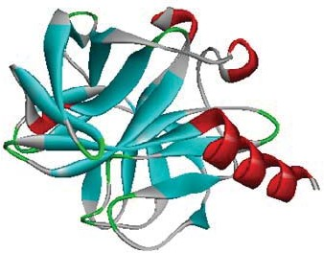 b) 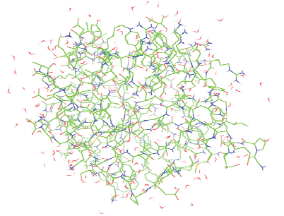

c)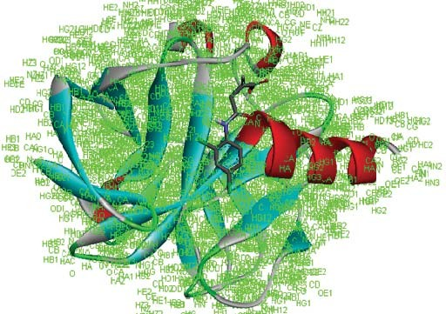d) 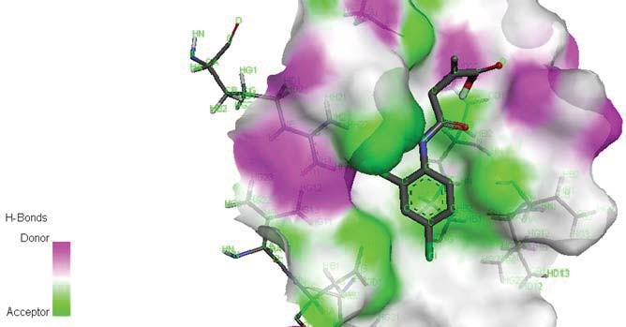

e) 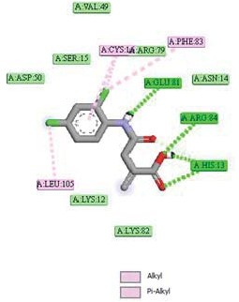 f) 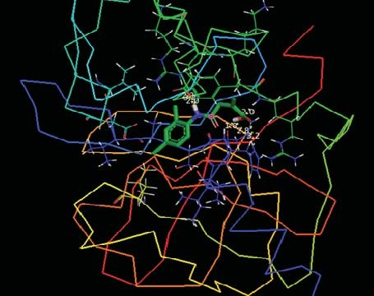

Fig. 8 (a) Xray structure of protein (b) Adopted molecular system consists of drug molecule and amino acid residues (c)Protein-ligand docked pose (d) Surface view of protein- ligand (e) Different types of interactions formed between ligand-protein (f) Docked ligand embedded into the active site of protein

Table 1
Optimized geometrical parameters of 4–[(2, 4–dichloro phenyl) amino] 2– methylidene 4–oxobutanoic acid, atom labeling according to Fig. 8.1
Bond length (Å)

Parameters
6-311G++(d, p) 6-311G+(d, p)

C₁-C₂ | 1.41 | 1.41
C₁-C₆ | 1.41 | 1.41
C₁-N₁₂ | 1.41 | 1.41
C₂-C₃ | 1.39 | 1.40
C₂-Cl₁₁ | 1.76 | 1.76
C₃-C₄ | 1.39 | 1.40
C₃-H₁₀ | 1.08 | 1.08
C₄-C₅ | 1.39 | 1.40
C₄-Cl₉ | 1.76 | 1.76
C₅-C₆ | 1.40 | 1.40
C₅-H₈ | 1.09 | 1.08
C₆-H₇ | 1.08 | 1.08
Cl₁₁-O₁₅ | 5.29 | 5.28
Cl₁₁-O₂₄ | 3.58 | 3.52
N12-H13 | 1.02 | 1.02
N12-C14 | 1.37 | 1.37
C14-O15 | 1.23 | 1.23
C14-C16 | 1.54 | 1.54
O15-O24 | 4.59 | 4.60
C16-H17 | 1.09 | 1.09
C16-H18 | 1.09 | 1.09
C16-C19 | 1.52 | 1.52
C19-C20 | 1.34 | 1.34
C19-C23 | 1.50 | 1.50
C20-H21 | 1.09 | 1.09
C20-H22 | 1.09 | 1.09
C23-O24 | 1.22 | 1.22
C23-O25 | 1.36 | 1.36
O25-H26 | 0.97 | 0.97

Parameter | Bond angle (°)
C₂-C₁-C₆ | 117.46 | 117.47
C₂-C₁-N ₁₂ | 119.23 | 119.24
C₆-C₁-N₁₂ | 123.31 | 123.29
C₁-C₂-C₃ | 121.84 | 121.97
C₁-C₂-Cl₁₁ | 120.31 | 120.17
C₃-C₂-Cl₁₁ | 117.85 | 117.87
C₂-C₃-C₄ | 119.16 | 118.93
C₂-C₃-H₁₀ | 119.96 | 120.09
C₄-C₃-H₁₀ | 120.88 | 120.97
C₃-C₄-C₅ | 120.49 | 120.66
C₃-C₄-Cl₉ | 119.35 | 119.26
C₅-C₄-Cl₉ | 120.16 | 120.08
C₄-C₅-C₆ | 119.92 | 119.78
C₄-C₅-H₈ | 120.25 | 120.28
C₆-C₅-H₈ | 119.82 | 119.94
C₁-C₆-C₅ | 121.13 | 121.19
C₁-C₆-H₇ | 118.79 | 118.53
C₅₋C₆-H₇ | 120.08 | 120.28
C₂-Cl₁₁-O₂₅ | 49.18 | 49.14
C₂-Cl₁₁-O₂₄ | 104.73 | 105.92
C1-N12-H13 | 116.44 | 116.50
C1-N12-C14 | 127.91 | 127.66
H13-N12-C14 | 115.54 | 115.75
N₁₂-C1₄-O₁₅ | 125.22 | 125.17
N12-C14-C16 | 114.45 | 114.54
O15-C14-C16 | 120.33 | 120.29
Cl11-O15-C14 | 35.60 | 35.72
C14-O15-O24 | 13.45 | 11.80
C14-C16-H17 | 105.39 | 105.48
C14-C16-H18 | 110.27 | 110.01
C14-C16-C19 | 112.70 | 112.99
H17-C16-H18 | 108.74 | 109.01
H17-C16-C19 | 109.60 | 109.50

H18-C16-C19 | 109.98 | 109.72
C16-C19-C20 | 122.41 | 122.58
C16-C19-C23 | 115.31 | 115.28
C20-C19-C23 | 122.09 | 122.01
C19-C20-H21 | 123.03 | 122.71
C19-C20-H22 | 120.90 | 120.83
H21-C20-H22 | 115.99 | 116.38
C19-C23-O24 | 121.99 | 122.06
C19-C23-O25 | 118.25 | 118.13
O24-C23-O25 | 119.76 | 119.81
Cl11-O24-C23 | 149.43 | 147.74
O15-C23-C24 | 76.07 | 76.48
C23-O25-H26 | 110.11 | 109.82
Parameter | Dihedral angle (°)
C₆-C₁-C₂-C₃ | 0.32 | 0.27
C₆-C₁-C₂-Cl₁₁ | -179.62 | -179.70
N₁₂-C₁-C₂-C₃ | -179.94 | 179.97
N₁₂-C₁-C₂-Cl₁₁ | 0.12 | 0.00
C₂-C₁-C₆-C₅ | -0.16 | -0.16
C₂-C₁-C₆-H₇ | 179.67 | 179.67
N₁₂-C₁-C₆-C₅ | -179.89 | -179.84
N₁₂-C₁-C₆-H₇ | -0.06 | -0.02
C₂-C₁-N₁₂-H₁₃ | 7.42 | 6.13
C₂-C₁-N₁₂-C₁₄ | -176.75 | -177.54
C₆-C₁-N₁₂-H₁₃ | -172.85 | -174.19
C₆-C₁-N₁₂-C₁₄ | 2.98 | 2.14
C₁-C₂-C₃-C₄ | -0.24 | -0.20
C₁-C₂-C₃-H₁₀ | 179.92 | 179.93
H₁₁-C₂-C₃-C₄ | 179.69 | 179.77
H₁₁-C₂-C₃-H₁₀ | -0.14 | -0.10
C₁-C₂-Cl₁₁-O₁₅ | 1.67 | 1.26
C₁-C₂-Cl₁₁-O₂₄ | -18.69 | -16.39
C₃-C₂-Cl₁₁-O₁₅ | -178.27 | -178.72
C₃-C₂-Cl₁₁-O₂₄ | 161.37 | 163.64

C₂-C₃-C₄-C₅ | 0.01 | 0.00
C₂-C₃-C₄-Cl₉ | -179.91 | -179.95
H₁₀-C₃-C₄-C₅ | 179.84 | 179.87
H₁₀-C₃-C₄-Cl₉ | -0.08 | -0.08
C₃-C₄-C₅-C₆ | 0.14 | 0.11
C₃-C₄-C₅-H₈ | -179.91 | -179.90
C_{l9}-C₄-C₅-C₆ | -179.93 | -179.94
C_{l9}-C₄-C₅-H₈ | 0.02 | 0.04
C₄-C₅-C₆-C₁ | -0.06 | -0.03
C₄-C₅-C₆-H₇ | -179.89 | -179.85
H₈-C₅-C₆-C₁ | 179.99 | 179.98
H₈-C₅-C₆-H₇ | 0.16 | 0.16
C₂-Cl₁₁-O₁₅-C₁₄ | -175.99 | -177.24
C₂-Cl₁₁-O₂₄-C₂₃ | -19.47 | -27.94
C1-N12-C14-O15 | -0.58 | -0.55
C1-N12-C14-C16 | 179.25 | 179.11
H13-N12-C14-O15 | 175.28 | 175.80
H13-N12-C14-C16 | -4.89 | -4.53
N12-C14-O15-Cl11 | 2.82 | 2.06
N12-C14-O15-O24 | -106.77 | -107.43
C16-C14-O15-C11 | -177.00 | -177.58
C16-C14-O15-O24 | 73.42 | 72.92
N12-O14-C16-H17 | -162.44 | -164.85
N12-C14-C16-H18 | -45.26 | -47.42
N12-C14-C16-C19 | 78.06 | 75.57
O15-C14-C16-H17 | 17.40 | 14.83
O15-C14-C16-H18 | 134.58 | 132.26
O15-C14-C16-C19 | -102.10 | -104.75
C14-O15-O24-C23 | -143.21 | -145.13
C14-C16-C19-C20 | 82.17 | 83.54
C14-C16-C19-C23 | -92.87 | -92.35
H17-C16-C19-C20 | -34.85 | -33.71
H17-C16-C19-C23 | 150.10 | 150.40
H18-C16-C19-C20 | -154.34 | -153.31

H18-C16-C19-C23 | 30.61 | 30.80
C16-C19-C20-H21 | -174.81 | -175.14
C16-C19-C20-H22 | 1.89 | 1.54
C23-C19-C20-H21 | -0.10 | 0.48
C23-C19-C20-C22 | 176.61 | 177.16
C16-C19-C23-O24 | 22.17 | 21.70
C16-C19-C23-O25 | -157.65 | -157.97
C20-C19-C23-O24 | -152.90 | -154.21
C20-C19-C23-O25 | 27.29 | 26.11
C19-C23-O24-C11 | 51.33 | 57.18
C19-C23-O24-O15 | 13.33 | 13.06
O25-C23-O24-C11 | -128.86 | -123.15
O25-C23-O24-O15 | -166.86 | -167.27
C19-C23-O25-H26 | 9.01 | 8.35
O24-C23-O25-H26 | -170.81 | -171.33

Table 2 Observed and calculated wavenumber and vibrational assignments of 4–
[(2, 4–dichloro phenyl) amino] 2–methylidene 4–oxobutanoic acid

Observed wavenumber (cm^{–1})
Calculated wavenumber
(cm–1) Vibrational

Mode
assingnments (PED %)

No B3LYP/6-311++G(d, p) B3LYP/6-311+G(d, p)

FT–IR FT– RAMAN

Un scaled scaled

Un Scaled scaled

1 | 3282 |  | 3758 | 3288 | 3825 | 3280 | νOH (100)
2 |  | 3513 | 3494 | 3185 | 3513 | 3181 | νNH (100)
3 | 3188 |  | 3269 | 3098 | 3275 | 3095 | νCH (84)
4 |  |  | 3250 | 3089 | 3257 | 3088 | ν_{as}CH₂(97)
5 | 3074 | 3072 | 3233 | 3085 | 3245 | 3071 | νCH (74)
6 | 3014 |  | 3222 | 3021 | 3233 | 3015 | νCH(23)+νCC(21)
7 |  | 2993 | 3165 | 2995 | 3173 | 2991 | ν_{as}CH₂(38)+νCC(19)
8 |  | 2941 | 3156 | 2948 | 3164 | 2940 | νCH₂(52)+νNC(11)
9 | 2924 |  | 3091 | 2931 | 3103 | 2925 | νCH₂(62)+νNC(22)
10 |  |  | 1802 | 1718 | 1798 | 2915 | νC=O(82)
11 |  | 1682 | 753 | 1683 | 1747 | 1680 | νCO(70)+γCN(20)+δNH(10)
12 | 1630 |  | 1690 | 1635 | 1687 | 1630 | νCC(71)+δ_{sciss}CH(11)
13 |  | 1603 | 1639 | 1604 | 1640 | 1600 | νC=C(100)+νOH(20)
14 | 1579 |  | 1622 | 1583 | 1620 | 1580 | νCC(100)
15 | 1519 |  | 1565 | 1522 | 1562 | 1521 | νCC(67)+δNH(13)
16 | 1474 |  | 1499 | 1476 | 1501 | 1475 | δ_{sciss}CH₂(82)
17 | 1454 |  | 1494 | 1455 | 1483 | 1452 | δ_{sciss}CH₂(82)
18 | 1395 | 1399 | 1460 | 1394 | 1450 | 1398 | γOH(76)+δCH(10)
19 | 1348 |  | 1419 | 1351 | 1419 | 1350 | βCH(57)+Ringγ (18)
20 | 1317 |  | 1376 | 1320 | 1370 | 1318 | βCH(98)
21 |  | 1293 | 1336 | 1296 | 1336 | 1295 | νCC(80)
22 | 1286 |  | 1322 | 1287 | 1315 | 1284 | γ_{wag}CH₂(88)
23 |  |  | 1297 | 1258 | 1296 | 1253 | νCC(74)+δCCl(12)+νCN(10)
24 | 1231 |  | 1283 | 1233 | 1279 | 1230 | γ_{wag}CH₂(94)
25 |  |  | 1265 | 1208 | 1262 | 1206 | νNC(58)
26 |  |  | 1248 | 1187 | 1246 | 1184 | ν_{as}OH(43)+νOC(19)
27 | 1183 | 1148 | 1178 | 1151 | 1178 | 1150 | βCH(14)+βCCC(14)
28 |  |  | 1169 | 1122 | 1167 | 1119 | ν_{as}CC(62)+γ_{wag}CH₂(18))
29 | 1101 |  | 1130 | 1104 | 1131 | 1102 | γCC(60)+ γCH(16)
30 | 1056 |  | 1120 | 1055 | 1119 | 1056 | ρCH₂(18))
31 |  |  | 1065 | 989 | 1063 | 988 | γCC(60)+γCH(16)+γ CO(10)
32 |  | 962 | 977 | 964 | 979 | 960 | γCH(89)
33 |  |  | 976 | 940 | 978 | 943 | γOH(88)

34 | 918 |  | 965 | 923 | 964 | 921 | δ_{wag}CH₂(94)
35 | 866 | 866 | 960 | 867 | 961 | 865 | ρCH₂(42)
36 |  |  | 945 | 855 | 944 | 854 | γCH(42)+ γCC(35
37 |  |  | 874 | 843 | 875 | 840 | γCH(89)
38 | 822 | 825 | 866 | 826 | 866 | 825 | γCCl(52)+γCO(20)+γCC(12)
39 |  |  | 841 | 815 | 841 | 812 | γCH(89)
40 |  |  | 826 | 799 | 824 | 798 | γCCl(61)+ γRing(21)
41 | 785 |  | 812 | 788 | 811 | 786 | ρCH₂(61)
42 | 726 |  | 793 | 727 | 792 | 725 | γNH(77)
43 |  |  | 739 | 684 | 746 | 683 | γ OH(51)
44 |  | 669 | 718 | 673 | 724 | 670 | νCCl(81)
45 | 656 |  | 711 | 658 | 721 | 655 | νCCl(81)
46 |  |  | 672 | 639 | 673 | 635 | γCCl(66)
47 | 626 |  | 661 | 628 | 659 | 626 | Ring γ (70)+ γ CN(18)
48 | 592 |  | 601 | 597 | 599 | 594 | γCN(66)+ γ CO(18)
49 | 564 |  | 578 | 565 | 576 | 564 | γCN(65)+γCO(18)+ γCC(10)
50 | 564 |  | 568 | 548 | 568 | 548 | γCN(65)+ CO(18)+δCC(10)
51 | 547 |  | 542 | 515 | 540 | 511 | βCCl(52)
52 |  |  | 519 | 490 | 508 | 487 | γOH(57)+γCC(18)+νCC(10)
53 |  |  | 465 | 425 | 463 | 422 | βCCl (46)
54 |  |  | 453 | 410 | 453 | 409 | βCCl (65)
55 |  | 397 | 449 | 398 | 450 | 397 | ρCH₂ (52)
56 |  |  | 396 | 385 | 396 | 383 | Ring γ (52)+ γ CN(21)
57 |  | 361 | 375 | 362 | 374 | 360 | Ring γ (66)+ γ CN(21)
58 |  |  | 359 | 319 | 362 | 316 | γCC(57)+ γ CH₂(20)
59 |  |  | 347 | 301 | 345 | 292 | γCN(55)+γCC(21)+γCH(10)
60 |  |  | 303 | 278 | 302 | 276 | γCC(53)+γCH₂(18)
61 |  | 241 | 268 | 244 | 268 | 240 | γCN(53)+νCC(20)+νCH(10)
62 |  | 220 | 245 | 230 | 243 | 222 | γCC(53)+γCH₂(18)
63 |  | 191 | 193 | 192 | 193 | 190 | βCCl(11)
64 |  |  | 174 | 164 | 175 | 161 | γCC(60)+γCO(18)
65 |  |  | 170 | 141 | 171 | 138 | βCCl(11)
66 |  | 120 | 122 | 121 | 122 | 120 | Ring breathing (51)
67 |  |  | 115 | 112 | 113 | 109 | δ_{wag}CH₂ +γCN(19)+γCC(12)
68 |  |  | 73 | 71 | 74 | 71 | δRing (52)
69 |  |  | 62 | 61 | 66 | 60 | γCCl(55)+γNH(19)
70 |  |  | 54 | 52 | 54 | 51 | γCO (49)+γCC(23)+wCH₂(10)
71 |  |  | 32 | 32 | 33 | 30 | γCCl(53)+γNH(19)
72 |  |  | 16 | 5 | 17 | 15 | γCO(50)+γNH(21)
ν − symmetric stretching, ν_{as}−asymmetric stretching, β− in-plane bending, γ − out-of-
plane bending, ρ−rocking, δ_{wag}−wagging, δ_{sciss}− scisssoring

Table 3
Second order perturbation theory analysis of 4 – [(2, 4 – dichloro phenyl) amino] 2 –
methylidene 4 – oxobutanoic acid
Bond (A-B) | ED/e(a.u) | EDA% | EDB% | NBO | S% | P%
σC₁-C₂ | 1.97- | 50.30 | 49.70 | 0.70(sp^{1.73})+0.70(sp^{1.66}) | 36.62 | 63.30
 | 0.04 |  |  |  | 37.63 | 62.30
σC₁-N₁₂ | 1.97- | 37.98 | 62.02 | 0.61(sp2.79)+0.78(sp^{1.83}) | 26.34 | 73.52
 | 0.03 |  |  |  | 35.28 | 64.68
σC₂-C₃ | 1.97- | 50.22 | 49.78 | 0.70(sp^{1.63})+0.70(sp^{1.76}) | 37.98 | 61.97
 | 0.02 |  |  |  | 36.14 | 63.78
σC₂-Cl₁₁ | 1.96- | 44.99 | 55.01 | 0.67(sp^{3.11})+0.74(sp^{6.23}) | 24.26 | 75.55
 | 0.07 |  |  |  | 13.77 | 85.73
σC₄-Cl₉ | 1.97- | 42.21 | 57.79 | 0.64(sp^{3.30})+0.76(sp^{4.38}) | 23.20 | 76.56
 | 0.03 |  |  |  | 18.50 | 81.04
C14-O15 | 1.98- | 31.79 | 68.21 | 0.56(SP^{2.22})+0.82(SP^{1.85}) | 30.98 | 68.73
 | 0.02 |  |  |  | 35.04 | 64.85
C14-C16 | 1.97- | 47.75 | 52.25 | 0.69(SP^{1.71})+0.72(SP^{2.94}) | 36.84 | 63.07
 | 0.05 |  |  |  | 25.39 | 74.54
C23-O25 | 1.98- | 31.26 | 68.74 | 0.55(SP^{2.52})+0.82(SP^{2.74}) | 28.32 | 71.41
 | 0.07 |  |  |  | 26.71 | 73.19
SP0.23 SP0.58 SP0.87 SP0.76 SP1.00
LPσ(Cl₉) | 1.98
LPσ(Cl₁₁) | 1.97
LPσ(O₁₅) | 1.95
LPσ(O₂₄) | 1.94
LPσ(O₂₅) | 1.97

81.51 | 18.47
63.21 | 36.78
53.49 | 46.46
56.69 | 43.28
50.08 | 49.86

Table 4
Second order perturbation theory analysis of fock matrix in NBO analysis for 4–[(2, 4–dichloro phenyl) amino] 2–methylidene 4–oxobutanoic acid
Donor NBO (i) | Acceptor NBO (j) | kcal/mol
σC₁-C₂ | σ*C₃-C₄ | 24.46
 | σ*C₅-C₆ | 18.79
σC₂-Cl₁₁ | σ*C₁-C₆ | 4.47
 | σ*C₃-C₄ | 4.39
σC₃-H₁₀ | σ*C₁-C₂ | 6.15
 | σ*C₄-C₅ | 5.67
σC₄-Cl₉ | σ*C₂-C₃ | 4.17
σC₅-H₈ | σ*C₁-C₆ | 5.45
 | σ*C₃-C₄ | 5.84
σC₁₆-H₁₈ | σ*C₁₄-O₁₅ | 6.19
 | σ*C₁₉-C₂₀ | 4.36
σC₂₀-H₂₂ | σ*C₁₆-C₁₉ | 7.06
 | σ*C₁₉-C₂₃ | 7.32
LPσCl₁₁ | σ*C₁-C₂ | 5.82
 | σ*C₂₃-O₂₄ | 6.37
LP πCl₁₁ | σ*C₂-C₃ | 4.38
LPσN₁₂ | π *C₁-C₂ | 28.38
 | π *C₁₄ -O₁₅ | 28.44
LPσO₁₅ | π *C₁₄-O₁₅ | 10.15
 | π *C₂₃-O₂₄ | 10.11
LP πO₁₅ | σ*N₁₂ -C₁₄ | 18.82
 | π *C₁₄-O₁₅ | 7.65
 | σ*C₁₄ -C₁₆ | 7.48
 | π *C₂₃-O₂₄ | 32.06
LPσO₂₄ | σ*C₂-Cl₁₁ | 9.11
 | σ*C₁₄-O₁₅ | 5.30
 | π *C₁₄-O₁₅ | 9.13
 | σ* C₁₉-C₂₃ | 6.18
LP πO₂₄ | σ*C₂-Cl₁₁ | 6.35
 | π * C₁₄-O₁₅ | 28.71
 | σ*C₁₉-C₂₃ | 6.08
 | π *C₂₃-O₂₄ | 9.74
 | σ*C₂₃-O₂₅ | 19.57
LPσO₂₅ | σ* C₁₉-C₂₃ | 6.21
LP πO₂₅ | π *C₂₃-O₂₄ | 28.45
 | π *C₁₄-O₁₅ | 8.17
 | π *C₁₄-O₁₅ | 132.45
π *C₁₉ -C₂₀ 26.09

Table 5
The charge distribution 4–[(2, 4–dichloro phenyl) amino] 2–methylidene 4– oxobutanoic acid of calculated by Mulliken charge method
Mulliken Charge (e)

Atom
(B3LP/6-311++G(d, p)

C₁ 0.51
C₂ -0.13
C₃ -0.23
C₄ -0.07
C₅ -0.21
C₆ -0.36
H₇ 0.23
H₈ 0.25
Cl₉ -0.09
H₁₀ 0.28
Cl₁₁ 0.05
N₁₂ -0.64
H₁₃ 0.35
C₁₄ 0.40
O₁₅ -0.30
C₁₆ -0.51
H₁₇ 0.24
H₁₈ 0.26
C₁₉ 0.12
C₂₀ -0.58
H₂₁ 0.19
H₂₂ 0.24
C₂₃ 0.36
O₂₄ -0.25
O₂₅ -0.54
H₂₆ 0.42

Table 6
Molecular properties of 4–[(2, 4–dichloro phenyl) amino] 2–methylidene 4– oxobutanoic acid

Molecular  Properties | Energy gap  (eV) | Ionization potential (I) | Electron affinity (A) | Glopal  hardness (η) | Electro  negativity (χ) | Chemical  softness (σ) | Chemical potential (μ)
 |  | (eV) | (eV) | (eV) | (eV) | (eV) | (eV)
EHOMO | 2.41 | 0.17 | 0.08 | 0.04 | 0.12 | 22.49 | -0.13
EHOMO-1 | 4.62 | 0.21 | 0.04 | 0.12 | 0.13 | 15.23 | -0.12
EHOMO-2 | 5.85 | 0.24 | 0.01 | 0.13 | 0.14 | 9.08 | -0.11

Table 7
Fukui functions of 4–[(2, 4–dichlorophenyl) amino] 2–methylidene 4–oxobutanoic acid Mulliken atomic charges (e) Fukui functions
i j
ATOMS | q(N) | q(N+1) | q(N-1) | 𝑓+ | 𝑓− | 𝑓0  j
C₁ | 0.53 | 0.51 | 0.50 | 0.03 | -0.03 | 0.06
C₂ | -0.13 | -0.13 | -0.13 | -0.02 | 0.02 | -0.04
C₃ | -0.21 | -0.23 | -0.27 | 0.02 | -0.02 | 0.04
C₄ | -0.08 | -0.07 | -0.06 | 0.00 | 0.01 | -0.01
C₅ | -0.19 | -0.21 | -0.23 | 0.03 | -0.04 | 0.07
C₆ | -0.34 | -0.36 | -0.38 | 0.02 | -0.01 | 0.02
H₇ | 0.26 | 0.23 | 0.21 | 0.05 | -0.05 | 0.11
H₈ | 0.28 | 0.25 | 0.22 | 0.06 | -0.06 | 0.12
Cl₉ | -0.01 | -0.09 | -0.16 | 0.10 | -0.09 | 0.19
H10 | 0.30 | 0.28 | 0.26 | 0.10 | -0.09 | 0.19
Cl₁₁ | 0.11 | 0.05 | 0.02 | 0.17 | -0.14 | 0.31
N12 | -0.62 | -0.64 | -0.64 | 0.03 | 0.00 | 0.03
H13 | 0.39 | 0.35 | 0.31 | 0.04 | -0.04 | 0.08
C14 | 0.44 | 0.40 | 0.33 | 0.00 | -0.04 | 0.04
O15 | -0.20 | -0.30 | -0.32 | 0.04 | -0.03 | 0.07
C16 | -0.50 | -0.51 | -0.51 | 0.00 | 0.00 | 0.00
H17 | 0.29 | 0.24 | 0.20 | 0.04 | -0.05 | 0.09
H18 | 0.31 | 0.26 | 0.22 | 0.03 | -0.03 | 0.07
C19 | 0.10 | 0.12 | 0.09 | -0.02 | 0.02 | -0.04
C20 | -0.48 | -0.58 | -0.76 | 0.05 | -0.06 | 0.11
H21 | 0.22 | 0.19 | 0.15 | 0.04 | -0.05 | 0.09

H22 0.28 | 0.24 | 0.19 | 0.05 | -0.06 | 0.11
C23 0.44 | 0.36 | 0.28 | 0.06 | -0.07 | 0.13
O24 -0.17 | -0.25 | -0.31 | 0.01 | -0.01 | 0.02
O25 -0.47 | -0.54 | -0.59 | 0.05 | -0.05 | 0.10
H26 0.46 | 0.42 | 0.40 | 0.03 | -0.03 | 0.05

Table 8
Bond distance between ligand and residues

Protein PDB ID (1FZV)
Ligand
 | Residues | Bond distance
 | TYR35/O  GLU39/HN | 2.1 Å  2.0 Å
4–[(2,4–dichloro phenyl)amino] 2–methylidene4– | LYS52/HZ2 | 1.9 Å
oxobutanoic acid | GLY/38CA | 3.0 Å
 | GLY38/HN  LYS/HD1 | 1.9 Å  2.0 Å
Estimated inhibition constant  Total internal energy |  | 797.29 μM  -0.42 kcal/mol
Electrostatic energy  Binding energy |  | -1.30 kcal/mol  -5.47 kcal/mol
RMSD |  | 112.36 Å

