CHAPTER NAME - ROLE OF MAGNIFICATION IN DENTISTRY

AUTHORS – DR K SATHYA NARAYANAN, DR TINI TREESA BENNY, DR ANJANA ALEYS MATHEW

ORGANIZATION NAME – SATHYABAMA DENTAL COLLEGE AND HOSPITAL, CHENNAI
CHAPTER CONTENTS
- INTRODUCTION
- MAGNIFICATION SYSTEMS
- LOUPES
- DENTAL OPERATING MICROSCOPE
- ERGONOMICS
- ENDOSCOPE
- OROSCOPE
- RECENT ADVANCES
- CONCLUSION

INTRODUCTION
Diagnosis of any oral disease is almost entirely based on visual examination, sometimes aided by radiographs. Furthermore, the assessment of carious lesion activity also relies on visual indicators. Enhancing the operator's visual acuity has the potential to decrease the necessity for operative treatments. When viewed at higher magnifications, several characteristics indicating lesion inactivity, such as dark color, glossiness, and lack of dental plaque retention, may suggest delaying operative intervention, provided that the caries risk remains unchanged. (25). It is, therefore, clear that all dentists, specifically restorative dentists and endodontists routinely perform procedures requiring resolution well beyond the 0.2-mm limit of human sight. The unaided human eye can discern intricate details, but it falls short of the capabilities achieved when an image is sharpened and magnified (26).Any device that enhances or improves a clinician's resolving power is extremely beneficial in producing high-quality precision dentistry. This is where magnification helps. Magnification systems like loupes and the dental operating microscope fill that optical void and provide clinicians an increased image size with improved clarity by many orders of magnitude, improved posture while practicing, which translates into less stress and fatigue during the day, a higher confidence level, and ultimately a higher quality of care (25).
MAGNIFICATION SYSTEMS
Broadly, the concept of magnification-enhanced dentistry incorporates the use of two types of optical magnification systems:
(a) Loupes
(b) Dental operating microscope
In addition to these, surgical endodontics makes use of two other systems, specifically:
c) Endoscope
d) Orascope
LOUPES
The primary magnification system employed in dentistry is the magnifying loupe. These loupes were created to tackle issues associated with working in close proximity, reduced depth of field, and eye strain that can occur when getting closer to the subject. (1)
Fig.1. loupes
CLASSIFICATION
There are 3 types of binocular magnifying loupes (1):
(1) a diopter, flat-plane, single lens loupe,
(2) a surgical telescope with a Galilean system configuration (2-lens system)
(3) a surgical telescope with a Keplerian system configuration (prism roof design that folds the path of light).
- SIMPLE LOUPES
Additionally known as diopter/flat plane systems. One pair of positive meniscus lenses make up a simple pair of loupes (Figure 2). At magnification levels exceeding 1.5x, spherical aberration and colour fringing limit the use of these loupes, which are essentially magnifying lenses. Because a single lens concentrates distinct wavelengths (colours) of light at various places, colour fringing results. The sole selling advantage of this kind of loupe has historically been its low price, however due to advancements in optical technology, none of the major optical suppliers evaluated today offer this kind of system. Most drugstores sell it under the name "reading glasses." (3)

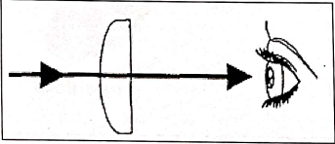
Fig.2. Simple Loupes

SURGICAL TELESCOPES
- Galilean (conical shaped lens) (Figure 3,4)
- Keplerian (cylindrical lens) (Figure 3,5)
These designs create an enlarged viewing image by employing a multiple-lens system made of glass. This system is typically positioned at a working distance ranging from 11 to 20 inches (28 to 51 centimeters). The recommended and frequently utilized working distance falls within the range of 11 to 15 inches (28 to 38 centimeters). (1).
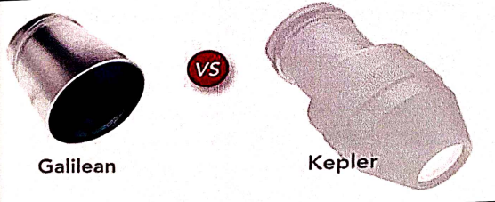
Fig 3. Galilean and Keplerian Loupes

COMPOUND LENSES
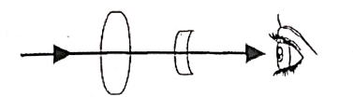
Fig 4 compound lenses
Compound loupes are comprised of two magnification lenses that are separated by air spaces. (Fig 4, 5). The inner eyepiece lens is concave, while the outer objective lens is convex. Collectively, these lenses provide significantly enhanced optical properties compared to simple glasses. With the inclusion of an additional lens in this system, higher magnification powers, increased depth of field, and extended working distances can be achieved without a corresponding increase in size and weight. This enables magnification ranging from 2x to 4.5x. (3,4).
Fig 5. Galilean/Compound Loupes

PRISMATIC LENSES
.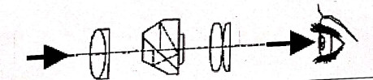
Fig 6. Prismatic loupes
Prismatic loupes offer the highest available optical quality in the present day. These loupes are constructed with two convex lenses and a Schmidt prism, essentially functioning as low-power telescopes with intricate light paths that can provide magnifications of up to 6x. The inclusion of the prism elongates the path of light by directing it through a series of mirror reflections inside the loupe. This process of "folding" the light path effectively shortens the physical barrel of the loupe.( Fig 6 and 7). (1)
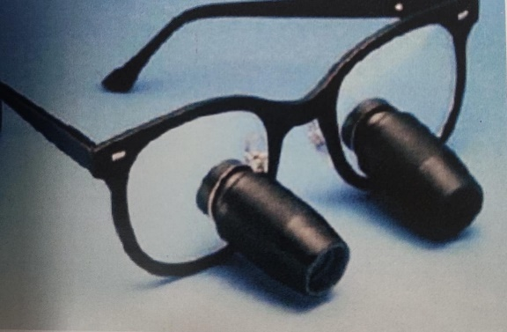
Fig.7.Keplerian system of loupes
SELECTION OF LOUPES
Although there are no straight forward recommendations that can be made, some knowledge about optical principles and loupe design can be used in order to make prudent judgments. (5).
- POWER:
Loupe systems incorporate a combination of both positive and negative lenses, making them compound loupes. Additionally, these loupes can accommodate corrective prescription lenses. As a result, the effective diopter (refractive) power of a loupe is not consistently correlated with its magnification level.When evaluating the quality of loupes, factors such as resolution and the size of the field at the operating site are far more important criteria than the sheer size of the magnified image. The primary focus should be on achieving a sharp image at the most suitable and comfortable working distance. These criteria are highly dependent on personal preferences, the operator's height, and the specific type of procedures being performed. (3) The choice of magnification level should generally consider the practitioner's height. Taller practitioners may benefit from higher magnification because their heads are naturally farther from the operating site, resulting in a smaller image. (5)
2) PRESCRIPTIONS
In order to maximize visual optics and to prevent eyestrain and fatigue, dentists should use their normal visual correction.
For flip-up loupes:
In a flip-up loupe system, optical prescriptions can only be inserted into the carrier or frame lens. This design allows for convenient adjustments to the surgeon's prescription, a service that can be easily provided by a local optician. When the loupe barrels are flipped down into the working position, the dentist can look through the carrier lens, which contains their corrected vision, and then seamlessly switch to looking through the barrels for enhanced clarity during procedures.
For through-the-lens systems:
Prescriptions can be incorporated into both the optical barrels (located at the back of the barrel) and the carrier lens of these loupes. However, it's important to note that if future prescription changes are required, loupes with prescriptions in the barrels would need to be returned to the manufacturing company for adjustments. For contact lens wearers or those who prefer not to have their correction integrated into the loupes, this option allows them to use the loupes without prescription modifications. (3)
3) MATERIAL:
Although plastic devices are cheaper and lighter than crushed glass equivalents, they have significant drawbacks. Plastics have a much higher index of refraction than glass because they soften at very low temperatures. They are far easier to scratch than glass. Antireflective coatings are very challenging to apply because of heat constraints and chemical interactions. The ABBE number and index of refraction, which quantify how well a medium bends light in relation to dispersion, are the main characteristics of glass lenses. The index of refraction is raised by lead monoxide (PbO), boron oxide, and fluorides (5).
5) POSITION & POSTURE:
To maintain eye contact while communicating with patients, it's crucial for dentists to have the ability to see over their apparatus. Additionally, the loupes used should allow for clear observation of instrument movement and the actions of staff. Dentists are particularly concerned with their operator positioning, and the choice of surgical telescopes can significantly impact their posture. Loupes that are mounted in the lower third of the lens and have an adequate downward angle can help keep the head aligned more closely with the long axis between the shoulder and hip. This reduces the reliance on anti-gravity muscles and promotes better balance of the body's mass. The choice of loupes should take into account factors such as age, physical condition, operatory setup, type of practice, and personal preferences of the operator. When clinicians wear loupes, they should be able to sit or stand comfortably with a natural posture. Achieving this requires careful selection of the focal length, declination angle, and proper alignment of the binocular loupe optics (5).
DENTAL OPERATING MICROSCOPE
Apotheker and Jako in 1981 introduced the first dental operating microscope (Figure 8) with the following goals in mind:
- Stereoscopic and binocular vision, providing a three-dimensional view.
- Magnification in the range of approximately 5-10x, offering high resolution and excellent contrast.
- A wide field of view with a flat and distortion-free image.
- An adequate working distance between the object and the microscope, typically ranging from 200 to 300 millimeters.
- Ease of maneuverability, allowing attachment to the dental unit, dental chair, floor mount, or ceiling mount for flexibility in positioning.
- Sufficient illumination for direct observation and photographic recording, without relying solely on the dental light.
- Compatibility with modern technological advancements, such as surgical lasers and monochromatic illumination, to support advanced dental procedures.
- Affordability with a moderate cost, ensuring accessibility for dental practitioners.

- 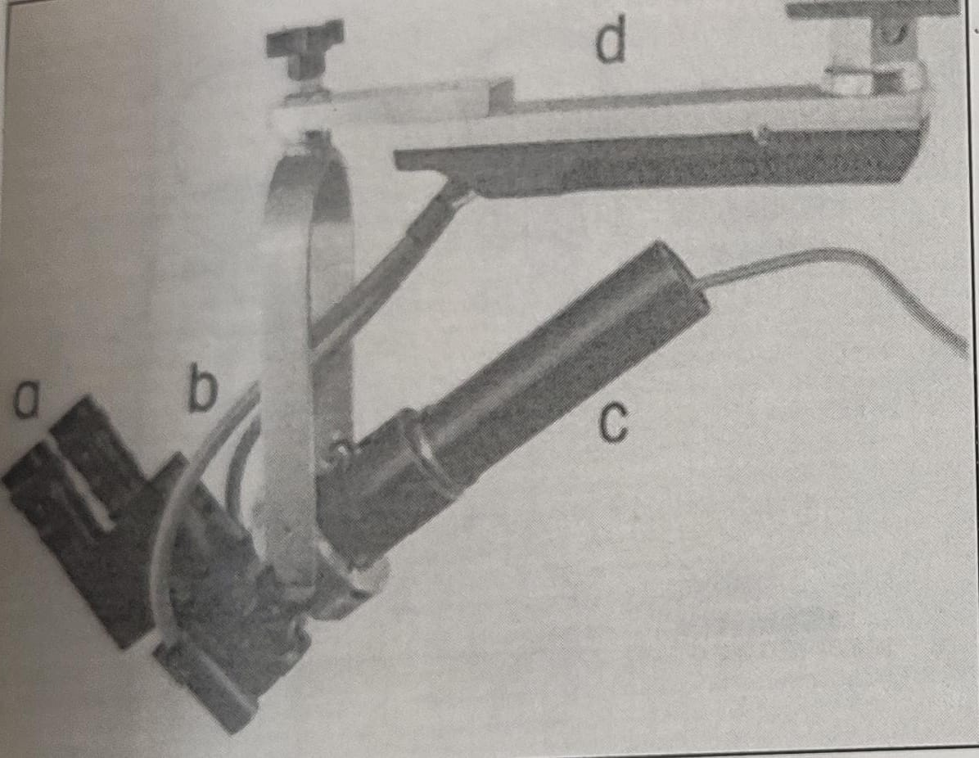
Fig 8. Components of apotheker's dental microscope.
a -Adjustable eyepieces, b-Coaxial fiberoptic illumination, c -Microvideo camera with zoom capability d- Suspension
Two types of stereoscopic microscopes were in use at the time. (Figure 9) (6)
1. Greenough type
- This design involves positioning two monocular microscopes side by side at an angle, aligning their objectives to focus on the same object, much like a pair of loupes.
- One drawback of this design is that it necessitates the user to converge their eyes in order to view the image, and extended use of the microscope can lead to eyestrain and fatigue.

2. Galilean type
- This magnifying loupe is integrated with a binocular viewing system, tailored to its specific application.
- It successfully meets all predefined criteria for a dental microscope, primarily achieved by utilizing parallel binoculars. This configuration offers enhanced eye protection to users, minimizing the risk of eyestrain.
- It is constructed based on Galilean principles, featuring fully coated optics and achromatic lenses. This attachment also enables an assistant or a student to observe procedures with the benefit of magnification.
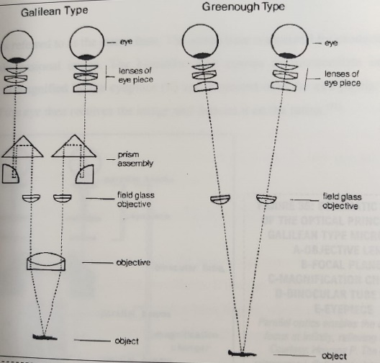
Fig 9. Galilean type and Greenough type microscope
NEW AND IMPROVED DENTAL OPERATING MICROSCOPE
In 1999, Gary Carr introduced a dental operating microscope (DOM) characterized by Galilean optics and a user-friendly dental design. This innovative device offered numerous advantages, making it suitable for a wide range of endodontic and restorative treatments (Fig 10). The DOM featured inclined binoculars that allowed for comfortable sit-down dentistry, a magnification changer offering five separate magnifications ranging from 3.5x to 30x, and a secure installation option on the wall or ceiling. It also included adapters for attaching an assistant's scope and integrating video or 35-mm cameras for documentation purposes.One noteworthy improvement in this DOM was its optical setup, with the light path aligned with the visual path through the utilization of a confocal illumination module. This design choice significantly enhanced illumination compared to the previous microscope, which had a tilted light path. (1)
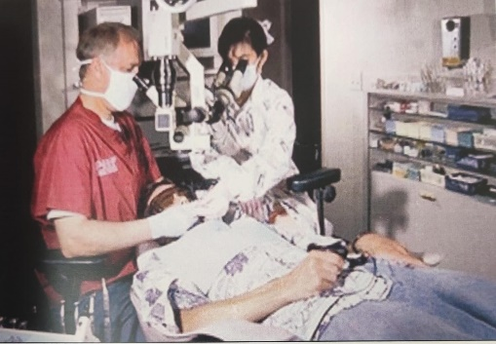
Fig.10. GARY CARR'S MODERN DENTAL OPERATING MICROSCOPE Today's OM allows the doctor and the assistant to ergonomically view the same field. This OM is fitted with a CCD

PARTS OF A MICROSCOPE
The DOM is a complicated system of lenses that allows stereoscopic vision at magnification of approximately 4x-40x with excellent illumination of the working area (2).
❖ Objective lens
n a dental operating microscope (DOM), the objective lens is the initial optical component through which image information passes on its journey from the object being observed to the viewer's eye. Typical working distances for these lenses are 200, 250, and 300 mm. The lens mount often features an engraving indicating the focal length, which generally corresponds to the lens's working distance. To achieve clear image visibility, it's essential to maintain a working distance of approximately 250 mm between the objective lens and the object under examination (e.g., when the lens is labeled as f = 250 mm). This places the object within the lens's focal point. When the lens is set at a distance of 250 mm from the object, the DOM can be adjusted vertically (lifted or lowered) to focus on the subject. It's important to note that the shorter the focal distance, which corresponds to the lens's working distance, the greater the end magnification and the higher the resolution that can be achieved in the observed image. (7)
- Binocular tubes
Binoculars serve the primary purpose of housing and supporting the eyepieces. Inside the binocular tube head, there is a lens with a specific focal distance. This lens is responsible for projecting an intermediate image, which is then directed into the focal plane of the eyepieces located inside the tube head. This optical arrangement ensures that the resulting image is upright and accurate. It's important to note that the distance between the pupils, known as the interpupillary distance, can vary from person to person and typically falls within the range of 54 to 76 mm. Proper adjustment of the binoculars to match the user's interpupillary distance is essential for comfortable and effective viewing.
TYPES:
- Straight
- Inclined
DOMs are used in an almost perpendicular position above the patient in dentistry. (7) Swiveling tubes that enable continuous and adjustable viewing offer enhanced flexibility in the vertical dimension. They allow for multiple axis locations of the microscope body, accommodating various positions while ensuring that the binocular eyepieces remain comfortably aligned with the user's eyes. This feature greatly improves the user's ability to adapt the microscope to their specific needs and working conditions. (8) A 45° inclined tube head is fixed at an angle of 45° and offers limited ergonomics. An inclinable tube head (0-180°) allows the dentist to alter the angle of the eyepiece holders by 180° (Figure 11) Even more flexible and adaptable to different body heights and working postures of the dentist is the foldable tube head (Figure 12) (7).
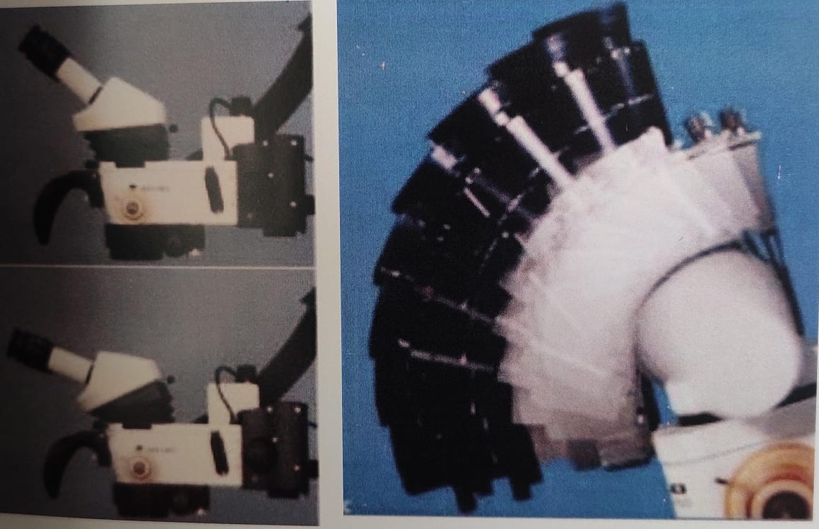
Fig .11. INCLINABLE BINOCULARS Fig 12. Multilink design of the foldable tube heads
- Eyepieces
On the eyepieces, the magnification factor (10x or 12.5x) is marked. Eyepieces with a 12.5x magnification are preferred by those who need higher magnifications, such as endodontists. However, 10x eyepieces provide a far wider field of view and can therefore give a greater overview of the entire treatment region. There is a ring for dioptric adjustment on eyepieces. This implies that dentists can utilize the DOM whether or not they have great vision. In order for the dentist's eyes to be in the exit pupils of the eyepieces and be able to see the whole field of view, they must be at a specific distance from the eyepieces. Dentists should remove their distancing rings if they wear spectacles because the glasses already act as a spacer (Figure 13). (7)
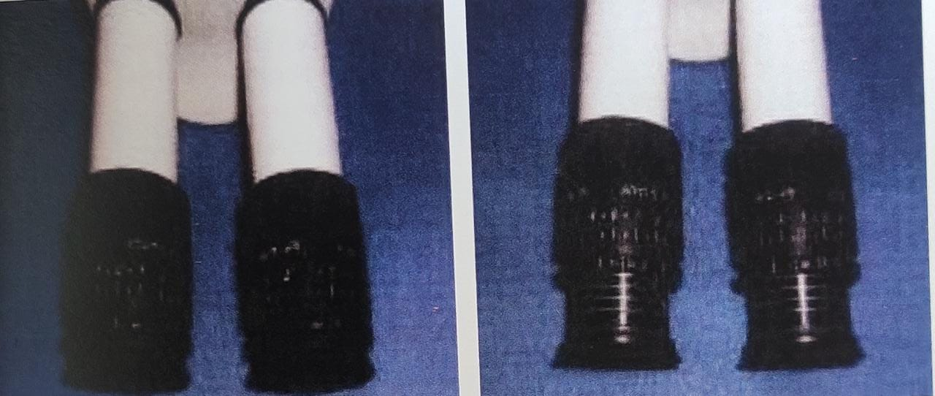
Fig .13 left-eyecups retracted for operators who wear glasses; right-eyecups, extended for operators who do not wear glasses.
Setting the eyepieces
The diopter range typically spans from -5 to +5, allowing for the adjustment of eye lenses to accommodate different users' vision needs. Additionally, an adjustable interpupillary distance feature ensures the correct alignment for stereoscopic vision across the entire visual field(Fig 14). To achieve proper focus on the work area, which lies between the objective lens and the operating field, users can manually adjust the focal length using a small knob. The aim is to manipulate this knob until the two divergent circles of light converge and combine to form a single, clear focus area, ensuring precise visualization during tasks. (8).
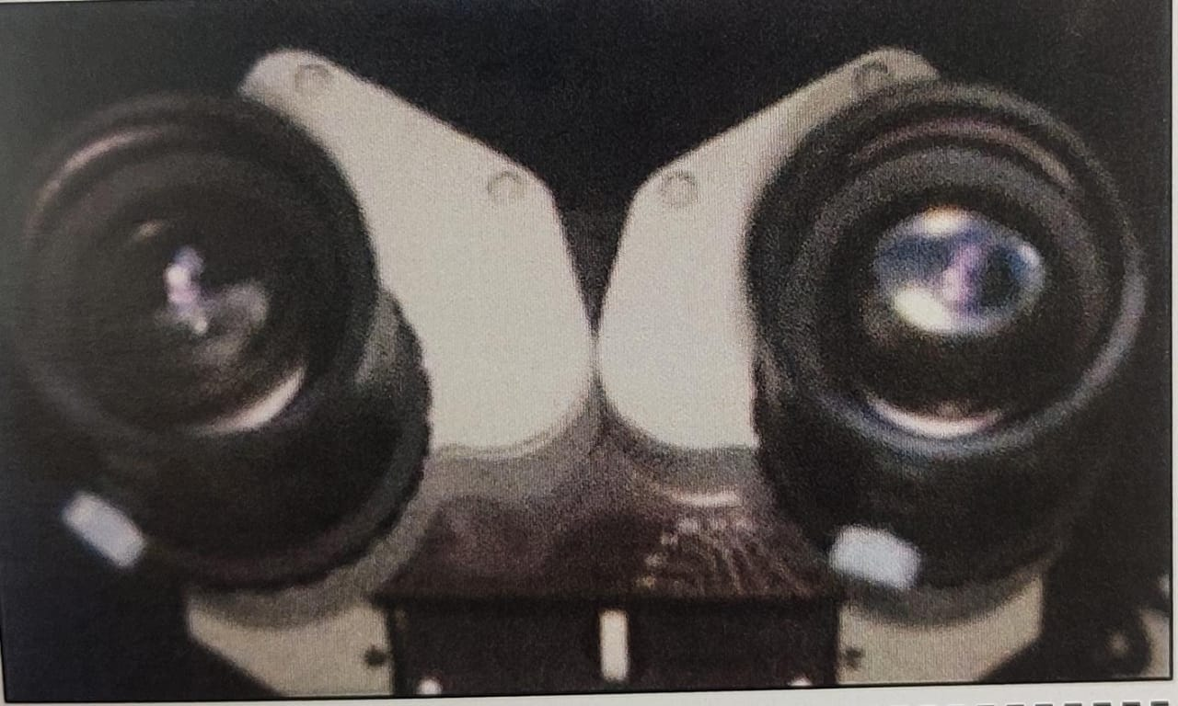
Fig.14. Adjustable intraocular distance permits correct alignment of eyepieces to individual needs.
❖ Magnification changers
During treatment it is important that the magnification factor can be altered to gain an overview at lower magnifications and to view in more detail at higher magnifications. There are two technical solutions for this purpose:
1. Magnification changer (Galilean changer)
2. Stepless zoom system. (7)
Magnification changers in microscopes are typically situated within the microscope head and are available in two primary types: manual step/zoom changers and power zoom changers ( 8).Manual step changers, consist of two telescope systems mounted on a turret, similar to laboratory microscopes. This turret is connected to a dial, conveniently located on the side of the microscope housing. Rotating the dial allows the user to position one lens in front of the other within the changer, thereby producing a fixed magnification factor (9). By rotating the dial again, the positions of the lenses are reversed, resulting in a different magnification factor ( Fig 15). Commonly used magnification factors for manual step changers include 0.4, 0.6, 1.0, 1.6, and 2.5, providing flexibility in magnification levels for various applications.(7)
Fig 15. 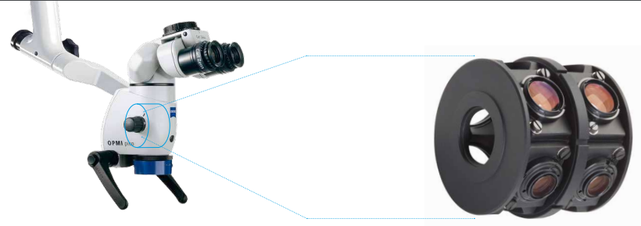 Magnification step-changers

A manual zoom changer is essentially a set of lenses that can be adjusted along a focusing ring to provide a wide range of magnification factors. On the other hand, a power zoom changer is a mechanized version of the manual zoom changer. Both power and manual zoom changers, often referred to as stepless changers as shown in Figure 16, offer a seamless transition between magnification levels. Compared to manual step changers, which require rotating a turret and result in momentary visual disruptions or jumps as you move between magnification levels, power and manual zoom changers provide a smoother and continuous adjustment of magnification without such interruptions.
This feature can enhance the user experience and improve precision during microscopy tasks. 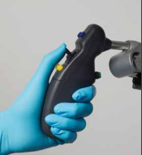
Fig 16. Left-manual zoom; right-motorized zoom
❖ Total magnification
Power of magnification is decided by a magnification factor. A combination of 4 factors determine the total magnification of an operating microscope.
They are:
i. Focal length of the binocular
ii. Focal length of the objective lens
iii. Eyepiece power
iv. Magnification changer factor
❖ Lighting unit
On the back of the microscope, there is a pre-centered lamp/bulb socket where the light source is located. In the vicinity of the image's ray paths, a collecting system and two reflecting prisms transmit light through the front objective, but they do not in any way interfere with the rays themselves (11).Finally, the illumination creates a bright, evenly lighted circular point in the working field region that is almost parallel to the viewing axis. This location is centred within the field of view of the microscope. This sort of lighting, known as "coaxial," has the ability to eliminate shadows.
Light sources can be:
1. Incandescent bulbs (older models)
2. Quartz halogen light bulb
- First dental microscope light source used
- Light is carried via fiber optics which have a tendency to absorb light and cause deficiencies
- Artificial yellow light due to higher color temperature which is not indicated for high-quality documentation.
3. Xenon light.
100-watt xenon lights produce white light like daylight at 5000° kelvin and function up to 10 times longer than halogen lamps and deliver exceptionally bright images with sharper contrast. (2)
4. Light emitting diode (LED)
LEDs (Light Emitting Diodes) are often chosen for microscope lighting because they closely resemble natural daylight in color temperature, much like xenon lamps. Additionally, they emit very little heat from the back of the light source, which leads to a significantly reduced temperature in the immediate vicinity of the microscope. This characteristic not only contributes to the comfort of the operator but also helps in maintaining a stable working environment, which can be crucial for certain applications in microscopy. (12)
ACCESSORIES
- Filters
This offers uncompromising expertise while handling light-sensitive materials during adhesive and bonding procedures with the aid of a microscope. The operator can work with full sight from the coaxial lighting and magnification with the orange filter in place without the frustration of the photosensitive materials curing too soon. Additionally, a green filter is offered for surgical procedures(8).
Beam splitter
The main component that enables the installation of additional observation and documentation equipment is the beam splitter. It is feasible to place beam-splitting cubes in the route of the parallel rays that permit some of the rays to pass through without being obstructed while 90° deflecting another portion of the rays away from the original path to the outside. Each light stream is split in half by the beam splitter (Figure 17), with one half travelling to the operator's eye and the other half to the accessory. (27)
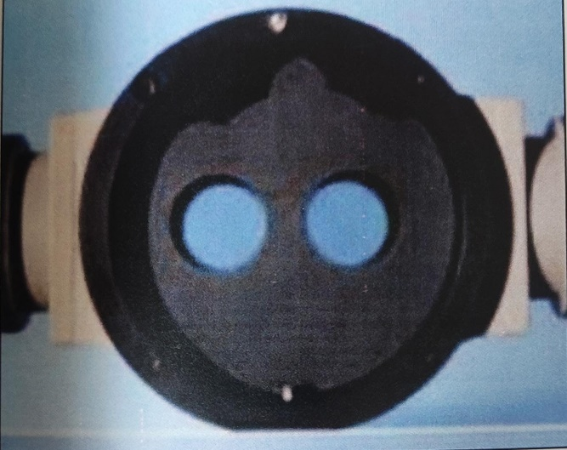
Fig 17. Beam splitter
❖ Documentation accessories
The 35 mm camera and the video camera are these. Through specially created picture or video adaptors attached to the beam splitter, they can be installed separately or together (Figure 18). The ability of the digital camera to transfer the photographs straight into a computer allows for the quick organisation of a large image database. A monitor, a videotape recorder, and a video printer can all be linked to the video camera. The second surgical assistant can use the monitor to track the surgical operation and provide the operator with the appropriate instruments at the appropriate time, in addition to motivating the patient who can see the full filmed procedure. (10)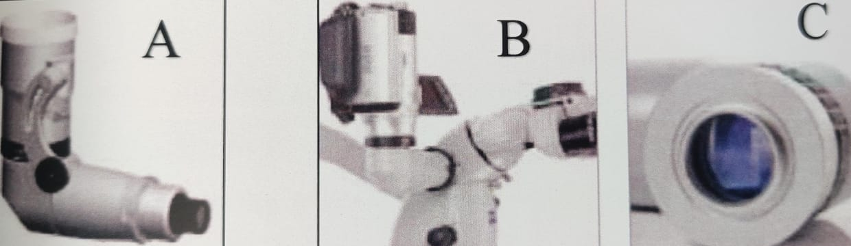
Fig 18. A) still adapter for cameras; b, c) flexiomotion adapter for video cameras
- Co-observation tube
Co-observation refers to the ability to watch a procedure under the operating microscope with an additional person (such as an assistant) or even more people (such as students or coworkers). The live image is frequently displayed on a monitor using a camera. A camera-based co-observation has the benefit of allowing one or more people to watch the procedure without having to directly look through the operating microscope. It is feasible to mount a co-observation tube in order to provide the co-observer a 3D perception. An optical splitter between the body and the binocular tube can be used to link the co-observation tube. (7)
OPERATOR POSITION
The dentist must decide whether to work with direct or indirect vision of the operating field. This decision can lead to adjustments in the microscope's position and may involve the use of mirrors to aid in focusing the image. It is important for the dentist to position themselves behind the patient's head, typically with an orientation between the 9 and 12 o'clock positions, while seated on a bench or adjustable chair. For the majority of endodontic procedures, the 11- or 12-o'clock position is considered the most suitable (as shown in Figure 19). While positions other than 11 or 12 o'clock, such as the 9 o'clock position, may initially appear more comfortable when learning to use a dental operating microscope (DOM), as one becomes more skilled, it is usually unnecessary to switch to these positions. The 11- or 12-o'clock position tends to be the most effective and efficient choice for experienced practitioners. (13)
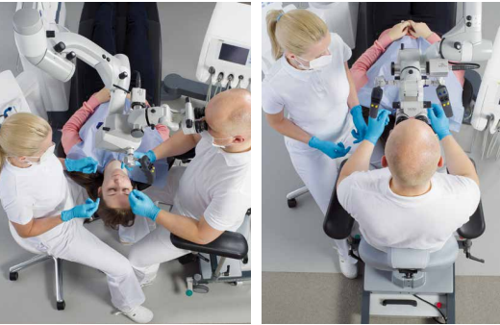
Fig 19. Operator position. Left:9 o clock position; right: 12 o clock position
Once seated:
To ensure an ergonomic and comfortable working posture when using a dental operating microscope, the operator should follow these guidelines:
- Adjust the seating position so that the hips form a 90° angle with the floor, the knees create a 90° angle with the hips, and the forearms are positioned at a 90° angle to the upper arms.
- Position the forearms comfortably on the armrests of the operator's chair and keep the feet flat on the floor for stability.
- Maintain a neutral back position, with the spine upright and perpendicular to the floor. The natural lordosis (the inward curve) of the lower back should be supported by the lumbar support of the chair.
- Tilt the eyepiece in a manner that allows the head and neck to be held at an angle that can be comfortably sustained without strain or discomfort.
- These ergonomic considerations are essential for the operator's comfort and well-being during prolonged procedures using a dental operating microscope, helping to minimize the risk of musculoskeletal issues and promote efficient and accurate work.(1).
OPERATOR CHAIR
The dentist's chair should meet specific ergonomic criteria to ensure a comfortable and healthy working posture. Here are the key considerations:
Mobility: The chair should have a minimum of five wheels, allowing the dentist to achieve an angle between 105° and 110° between the leg and thigh when seated. This positioning tilts the pelvis forward for comfort.
Seat Dimensions: The chair's seat dimensions are crucial. It should be designed to prevent pressure points on the pelvis and thighs. The seat must be divided into two parts: a horizontal portion with a minimum length of 15 cm (to accommodate the ischial tuberosities) and a front anti-clinal angle of 20° in relation to the horizontal plane, providing optimal support for the thighs.
Size: The maximum seat depth should be 40 cm, the width between 40 cm and 43 cm, and the height of the lumbar support should range from 12 cm to 30 cm, ensuring it does not exceed the level of the iliac crest.
Lumbar Support: The lumbar support should be vertically adjustable within the range of 17 cm to 22 cm, and up to 24 cm for taller dentists. This adjustment allows for customization to support the lower back without inhibiting arm movements.
Ocular Selection: Selecting the correct oculars is critical, as it affects the optimal positioning of the dental operating microscope. This aspect ensures that the microscope aligns well with the dentist's working posture, contributing to comfortable and efficient dental procedures.
Adhering to these ergonomic guidelines is essential for the dentist's well-being and comfort during procedures, reducing the risk of musculoskeletal issues and promoting efficient and accurate work. (14)
ROUGH POSITIONING OF THE PATIENT
Patient positioning is crucial for ensuring that the working area is optimally situated in relation to the dental operating microscope (DOM). Here are some key considerations:
Patient's Position: The patient should be positioned in a manner that allows for a slight supine to a Trendelenburg position. This positioning helps bring the working area as close as possible to the DOM, facilitating clear visualization during procedures.
Head Position: The head position of the patient can be further adjusted using the horizontal and vertical control buttons of the chair. This adjustment allows for precise control over the relative distance between the patient's head and the microscope, ensuring an optimal working position.
Procedures in the Maxilla: For procedures in the maxilla (upper jaw), it is typically best to position the patient's head so that the occlusal plane (the biting surface) is perpendicular to the ground. This orientation aligns with the usual working positions for maxillary procedures.
Procedures in the Mandible: Conversely, for procedures in the mandible (lower jaw), it is generally more suitable to position the patient's head so that the occlusal plane is parallel to the ground. This orientation corresponds to the typical working positions for mandibular procedures. By carefully adjusting the patient's position and the orientation of the occlusal plane, dental practitioners can optimize the working conditions and visualization when using a dental operating microscope, ensuring the accuracy and efficiency of dental procedures. (14)
Fig 20. Patient position A-Supine position B-Head rest adjusted for indirect (mirror) view of mandible where the mandibular occlusal plane is vertical C-Head rest positioned for indirect view of the maxillary teeth with maxillary occlusal plane vertical
ADJUSTMENT OF THE INTERPUPILLARY DISTANCE
When using binoculars, each eye typically sees a small circle of light. To achieve the best viewing experience, follow these steps for adjusting the interpupillary distance:
Adjust the Binocular Head: Begin by manipulating the two halves of the binocular head on the microscope. Move them apart and then together until the two circles of light merge into a single illuminated circle, aligning with each eye's perspective (as shown in Figure 21). This process ensures that the binoculars are properly set for your interpupillary distance.
Use Adjustable Rubber Cups: The eyepieces often have adjustable rubber cups that extend from their ends. Here's how to use them:
For Glasses Wearers: If you wear glasses, ensure that the rubber cups are in the lowered or retracted position (as shown in Figure 24). This provides sufficient space for your eyeglasses while maintaining comfort during use.
Without Glasses: If you don't wear glasses while using the binoculars, keep the rubber cups in the raised position (as shown in Figure 22). This configuration is more suitable for users without glasses and ensures that the binoculars fit comfortably.
These adjustments help tailor the binoculars to your specific needs and preferences, ensuring a comfortable and effective viewing experience while using the microscope. (10).
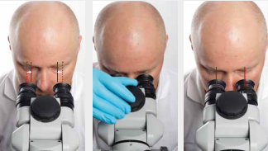
Fig 21. Interpupillary distance
(left) a-widest distance; b-adjusting distance; c-correct distance (right)- Start from the widest position of the eyepieces and use knob of the tube head to adjust the distance of the eyepieces to your interpupillary distance so that the two eyepiece images merge into one
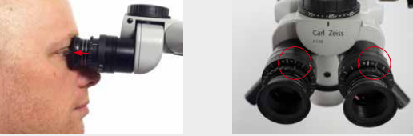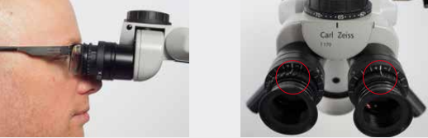
Fig 22. Adjusting eyepieces
Eyecups: Adjust the eyecups in such a way that the entire field of view can be seen.
- Viewing without eyeglasses: screw out the eyecups until 2-3 silver rings are visible
- Viewing with eyeglasses: screw in the eyecups all the way (no silver ring visible)
Diopter correction: Set the diopter setting ring on the DOM to 0 diopters.
- Viewing without eyeglasses: set diopter correction according to your correction value of the eye
- Viewing with eyeglasses: set diopter setting ring on the OPMI to 0 diopters

ERGONOMICS
ERGONOMIC MOTIONS
An understanding of efficient workflow using a DOM entails knowledge of the basics of ergonomic motion (1). Ergonomic motion is divided into 5 classes of motion
- Class I motion: This involves primarily moving only the fingers (as shown in Figure 23).
- Class II motion: It includes movements of the fingers and wrists (as depicted in Figure 24).
- Class III motion: Movement starts from the elbow (illustrated in Figure 25).
- Class IV motion: This class involves movement originating from the shoulder (shown in Figure 26).
- Class V motion: It comprises movements that require twisting or bending at the waist.
Understanding these motion classes is important for designing ergonomic workspaces and tools in dentistry, as it helps reduce the risk of musculoskeletal strain and discomfort during dental procedures.(Figure 27)

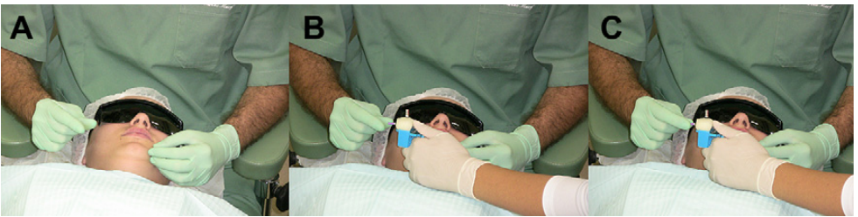
Fig. 23 (A) Fingers waiting for the file. (B) File placed in between fingers. (C) Fingers capturing file.

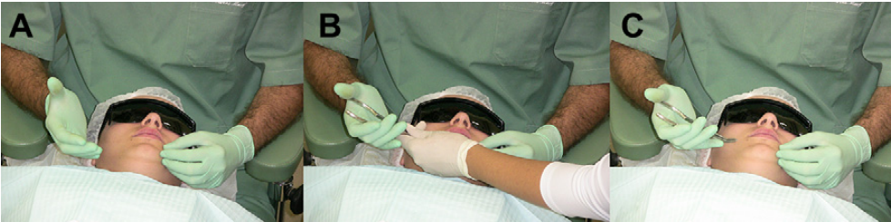
Fig. 24. (A) Hand waiting for the instrument. (B) Fingers and wrist movement receiving the instrument. (C) Fingers movement receiving the instrument.
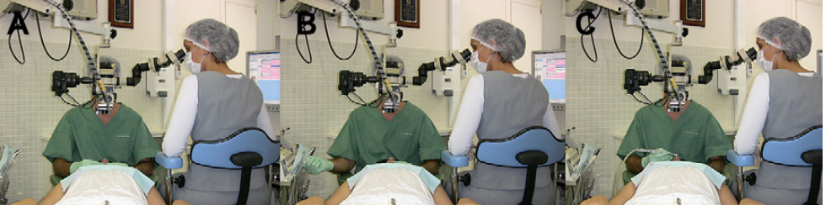Fig. 25. (A) Elbow rested at the stool support. (B) Supported elbow rotation and instrument apprehension. (C) Supported elbow rotation to working position

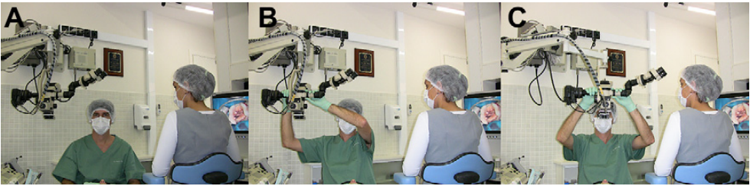
Fig. 26. (A) Professional at the neutral position. (B) Shoulders, arms, elbows, and hands moving to reach the OM. (C) OM moved to the ideal position without rotational movement of the waist.
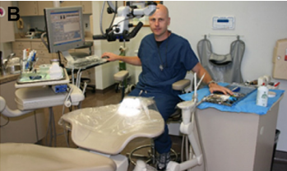
FIGURE 27: CIRCLE OF INFLUENCE The circle of influence design takes into consideration the 3 participants of the dental team: doctor, assistant, and patient. Maximum ergonomics, efficiency, and comfort for all members are achieved with this office design.

POSTURAL AWARENESS TECHNIQUES
Maintaining proper ergonomic posture is crucial for dental practitioners to prevent musculoskeletal discomfort and ensure efficient patient care. Here are some guidelines for achieving and maintaining ergonomic posture in the dental operatory:
Low Back Curve: Tilt the seat angle of your chair slightly forward, approximately five to 15 degrees. This adjustment helps increase the low back curve, positioning your hips slightly higher than your knees and creating a hip angle greater than 90 degrees. This allows for closer positioning to the patient. If your chair lacks this feature, consider retrofitting it with an ergonomic wedge-shaped cushion.
Proximity to the Patient: Sit as close to the patient as possible and position your knees under the patient's chair if feasible.
Operator Stool: Consider using a saddle-style operator stool, which encourages a natural low back curve by increasing the hip angle to around 130 degrees. This type of stool can be especially beneficial when the patient chair has thick backs and headrests.
Chair Adjustment: Adjust your chair so that your hips are slightly higher than your knees, distributing your weight evenly with your feet firmly on the floor. Ensure that the forward edge of the chair does not compress the backs of your thighs.
Lumbar Support: Utilize the lumbar support of the chair by adjusting it forward to make contact with your lower back.
Transverse Abdominal Muscles: Stabilize the low back curve by engaging the transverse abdominal muscles. While sitting tall with a slight curve in the low back, exhale and pull your navel toward your spine without flattening the curve. Maintain this contraction while breathing normally for one breath cycle and repeat five times. Aim to incorporate this stabilization regularly throughout your workday.
Pivoting: When pivoting forward, do so from your hips, not your waist. To stabilize the low back curve, perform the transverse abdominal muscle exercise before pivoting forward.
These ergonomic practices can help prevent discomfort and strain during dental procedures, ensuring a more comfortable and efficient work experience for dental practitioners. (15)

ENDOSCOPY

An endoscope is an illuminated instrument, typically flexible or rigid and often fiber-optic, designed for visualizing the interior of a hollow organ or part of the body, such as the bladder or esophagus. It is used for diagnostic or therapeutic purposes and usually includes one or more channels to allow the passage of instruments (like forceps or scissors) and/or tissue ( 16 , 17).

The use of endoscopes in dentistry began with Ohnishi, who performed an arthroscopic procedure on the temporomandibular joint in 1975. Subsequently, Held and colleagues ( 18) and Shulman & Leung ( 19) reported the first applications of endoscopy in surgical and nonsurgical endodontics in 1996. In 1999, Bahcall and colleagues (20) introduced an endoscopic technique for endodontic surgery.

ROD-LENS ENDOSCOPE

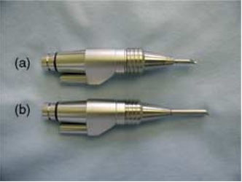
The rod-lens endoscope is constructed using a series of glass rods that work in conjunction with a camera, a light source, and a monitor (as illustrated in Figure 28). Additionally, the system can be equipped with a digital recorder, offering capabilities for streaming video or capturing still images to document procedures. The rod-lens endoscope provides clinicians with greater magnification compared to what can be achieved with loupes or even a microscope, while maintaining optical resolution similar to that of a microscope and loupes. Zooming with the endoscope is typically faster and more comfortable compared to using a microscope. However, it's important to note that endoscopes can be bulkier and may present challenges in maintaining a fixed field of vision in comparison to a microscope, which provides more stability and control over the viewing field(21).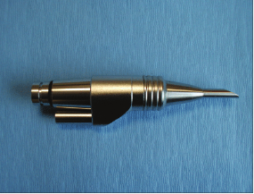
Figure 29: Types of endoscopes
a) 2.7mm tip diameter, 70°, 3 cm rod lens endoscope;
b) 4mm tip diameter, 30°, 4cm length endoscope

fig 28: rod-lens endoscope

For endodontic surgical applications, the recommended sizes of rod-lens endoscopes are as follows:
2.7 mm Lens Diameter, 70° Angulation, 3 cm Length Rod-Lens (Figure 29): This configuration is well-suited for endodontic procedures. The 70-degree angulation allows for enhanced visualization, particularly in accessing and viewing the palatal root apices of maxillary posterior teeth. 4 mm Lens Diameter, 30° Angulation, 4 cm Length Rod-Lens .This configuration is also valuable for endodontic applications. The 30-degree angulation and 4 cm length provide versatility in visualizing various aspects of the dental anatomy.
These rod-lens endoscopes are particularly useful for magnified visualization of the pulp chamber, aiding in the identification of canal orifices. They prove especially beneficial in cases where advanced chamber obliteration has occurred due to the deposition of secondary and tertiary dentin. The precise angulation and diameter of the endoscope facilitate effective exploration and treatment in such situations. (22).

ORASCOPE
An orascope used for visualization in dental procedures, but they have different construction and applications:
Orascope: An orascope is made up of fiber optics and is designed for intracanal visualization. It features a 0.8 mm tip diameter, a 0° lens, and a working portion that is 15 mm in length. The orascope is composed of 10,000 parallel visual fibers, often referred to as a 10K fiber optic orascope. Each visual fiber has a diameter ranging from 3.7 microns to 5.0 microns. Surrounding these visual fibers is a ring of larger light-transmitting fibers that provide illumination for the treatment field. Prior to using the 0.8 mm fiber optic scope, it is recommended to use -2.5× loupes or a surgical operating microscope (SOM) for conventional endodontic visualization to access the canals (22).
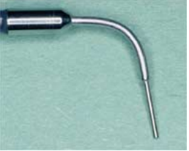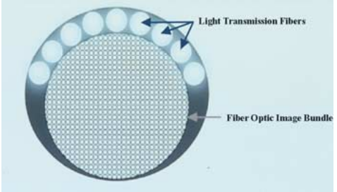
FIGURE 30: ORASCOPE
LEFT- 0.8mm tip diameter, 0°, 10K fibre orascope; RIGHT- fibre optics in orascope

ORASCOPE USE DURING CONVENTIONAL ENDODONTICS
In endodontic procedures, after the pulp chamber has been cleaned of soft tissue, clinicians often employ specific endoscopes for enhanced visualization and verification. Here's how these endoscopes are used:
4mm Lens Diameter, 30-Degree Endoscope: This endoscope is utilized to achieve higher magnification, particularly for visualizing the floor of the access cavity. It proves valuable in locating additional canal orifices and verifying the complete removal of soft tissue. Instead of using a mirror, the clinician holds the endoscope, which can be stabilized by resting it on a cusp tip.
0.8mm Orascope: The orascope is employed for visualizing the canal system. However, it's important to note that for its placement, the canal must be enlarged to a size 90 in the coronal 15mm. If the canal is not sufficiently widened, there's a risk of damaging some of the fiber bundles within the scope. The orascope provides a focus and depth of field from zero to infinity, allowing for imaging of the apical third of the canal without actually being inserted into that region. It's crucial that the canal is dry at this point. Although the orascope can see through sodium hypochlorite, this solution's high refractive index can cause significant reflected light, hindering the clarity of the image.These endoscopic tools enhance the precision and thoroughness of endodontic procedures by providing magnified visual access to critical areas of the tooth and root canal system (22).
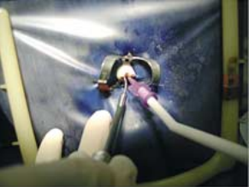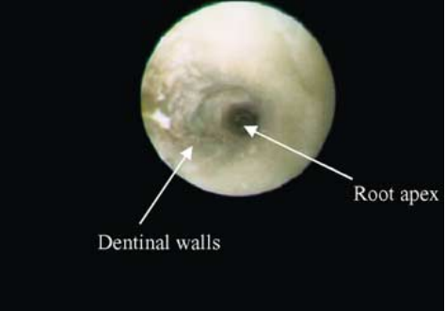
FIGURE 31 LEFT- placement of 0.8mm orascope along with micro suction; RIGHT- in vivo image of intracanal visualization with 0.8mm orascope

RECENT ADVANCES
VARIOSCOPE
It is a portable head-mounted operating microscope for surgical navigation, sometimes known as augmented reality. Additional computer-generated scenes are displayed in it. It includes a built-in camera for documentation. The operator head's mobility is one of the varioscope's greatest advantages over surgical microscopes, which are less manoeuvrable due to heavy equipment. (23)
VIDEOSCOPE
In a study conducted by Al-Shaikhly et al, (24), the researchers compared the depth of focus (DOF), resolution, and the impact on fine motor skills between a Dental Operating Microscope (DOM) and a high-resolution videoscope (VS) in the context of endodontic procedures.
Depth of Focus (DOF) and Resolution: the DOM, particularly with its three magnification levels, exhibited greater DOF and resolution compared to the VS.
Limitations of the VS in Endodontic Treatments: While the VS was designed for use in periodontal surgical procedures, the study found that the DOM performed better when applied to endodontic procedures. The VS presented certain limitations in endodontics, including difficulties in orientation, lower magnification compared to the DOM, and potential effectiveness issues when working in confined spaces.
Based on their findings, DOM is the superior magnification instrument for endodontics, offering greater DOF, resolution, and accuracy. However, they also noted that the VS could still find utility in certain endodontic operations, depending on the specific requirements of the procedure.
HEADS-UP DISPLAY

The heads-up display is a more recent innovation in the field of magnification, using a camera that is placed over the patient and projects the image to a monitor. The operating microscope's learning curve may be lowered by the image's projection, which can be 2-dimensional (Magna Vu) or 3-dimensional (3-D) (MoraVision). These heads-up displays' ergonomic advantages have also been suggested as potentially improving treatment outcomes and communication through recording using video and still images. These systems can cost anywhere between $25,000 and $50,000 (with the 3-D system being more expensive), making them frequently more expensive than operational microscopes (28).

CONCLUSION

Patients today are more picky about what they want and critical of the kinds of outcomes they are willing to accept. The dentist must evaluate themselves in light of such patient scrutiny. The OM is a crucial addition to the arsenal of dental tools, particularly for endodontics. It aids in raising the standard of excellence to its utmost point. By every measure, endodontic surgeons today provide services with more assurance and accuracy than was feasible 20 years ago. This paradigm change and the future of the speciality were made possible by the creation of a highly developed arsenal, ground-breaking approaches, and the willingness to adopt them. The American Association of Endodontists (AAE) foresees ongoing advancements in magnification technology and other treatment methods that will further enhance endodontic outcomes in the future. The AAE firmly maintains the view that the microscope plays an integral and crucial role in the practice of modern endodontic techniques. The precision and benefits derived from using microscopes in endodontics have extended into the field of restorative dentistry, and it is anticipated that this approach will eventually become a standard practice across all facets of dentistry.
REFERANCES
- Carr GB, Murgel CAF. The Use of the Operating Microscope in Endodontics. Dental Clinics of North America. 2010 Apr;54(2):191- 214.
- Hegde R, Hegde V. Magnification-enhanced contemporary dentistry: Getting started. J Interdiscip Dentistry. 2016;6(2):91
- Baker JM, Meals RA. A practical guide to surgical loupes. The Journal of Hand Surgery. 1997 Nov;22(6):967–74.
- Arens DE. Introduction to Magnification in Endodontics. J Esthet Restor Dent. 2003 Dec;15(7):426–39.
- Caplan SA. Magnification in Dentistry. J Esthet Restor Dent. 1990 Jan;2(1):17-21
- Apotheker H, Jako GJ. A microscope for use in dentistry. Microsurgery. 1981;3(1):7-10.
- Zeiss C. Microscopic Dentistry-A Practical Guide. Carl Zeiss Meditec AG; 2014.
- Sheets CG, Paquette JM, Hatate K. Masters of Esthetic Dentistry.: the clinical microscope in an esthetic restorative practice. J Esthet Restor Dent. 2001 May;13(3):187-200.
- Rubinstein R. Magnification and illumination in apical surgery. Endodontic Topics. 2005 Jul;11(1):56–77.
- Castellucci A. The use of the operating microscope in endodontics. Endodontics, III Tridente, Firenze. 2009;956-997.
- Merino EM. Endodontic microsurgery. Quintessence London; 2009
- Kim S, Kratchman S, Karabucak B, Kohli M, Setzer F. Microsurgery in endodontics. John Wiley & Sons; 2017.
- Kinomoto Y, Takeshige F, Hayashi M, Ebisu S. Optimal Positioning for a Dental Operating Microscope During Nonsurgical Endodontics. Journal of Endodontics. 2004 Dec;30(12):860–2.
- Carreira LM. The importance of Ergonomics for Dental Medicine Procedures in the Triad Position: The Patient, the Dentist, and the Surgical Microscope. ARC Journal of Dental Science [Internet]. 2016
- Valachi B, Valachi K. Preventing musculoskeletal disorders in clinical dentistry. The Journal of the American Dental Association. 2003 Dec;134(12):1604–12.
- https://www.merriam-webster.com/dictionary/endoscope
- https://www.cancer.gov/publications/dictionaries/cancer-terms/def/endoscopy
- Held SA, Kao YH, Wells DW. Endoscope—An endodontic application. Journal of Endodontics. 1996 Jun;22(6):327–9.
- Shulman BB, Leung A. Endoscopic surgery: an alternative technique. Dentistry today. 1996;15(9):42–44.
- Bahcall JK, Di Fiore PM, Poulakidas TK. An endoscopic technique for endodontic surgery. Journal of Endodontics. 1999 Feb;25(2):132-5. 75.
- Bahcall J. Visualization in endodontics. Eur J Gen Dent. 2013;2(2):96. 34. Gultz JSL, Settembrini L, James K, Scherer W. Can you see it? A visual acuity study. J Dent Educ. 1996;60(2):222.
- Bahcall J, Barss J. Orascopic visualization technique for conventional and surgical endodontics. Int Endod J. 2003 Jun;36(6):441–7.
- Doornbusch H, Veenstra K. Frequently asked questions about the dental microscope. The Microscope in Dentistry Editorial Germany: Carl Zeiss Surgical GmbH. 2007;
- Al Shaikhly B, Harrel SK, Umorin M, Augsburger RA, Jalali P. Comparison of a Dental Operating Microscope and High-resolution 250 Videoscope for Endodontic Procedures. Journal of Endodontics. 2020 May;46(5):688-93
- . Sitbon Y, Attathom T, St-Georges AJ. Minimal intervention dentistry II: part 1. Contribution of the operating microscope to dentistry. Br Dent J. 2014 Feb;216(3):125–30.
- Arens DE. Introduction to Magnification in Endodontics. J Esthet Restor Dent. 2003 Dec;15(7):426–39
- Hoerenz P. The operating microscope. III. Accessories. Microsurgery 1980;2(1):22-26.
- Buchanan S. Endodontic News - MoraVisionTM 3D: A paradigm shift in the ergonomics of dental imaging [Internet]. Available from: https://endopracticeus.com/industry-news/moravision-3d-paradigm-

