Cancer Molecular Biomarkers of Melanoma
Vallem.Asha¹ Jayanthi chavali ², Vamsi Krishna²
Student – Sri Padmavati Mahila Visvavidyalayam Womens University India
Project faculty- environment protection training research institute -Eptri,Hyderabad Gachibowli.
Abstract:-

Melanocytes, responsible for producing the melanin pigment that imparts color to the skin, serve as the origin of melanoma, a specific form of skin cancer. Early diagnosis and treatment can enhance the prognosis for melanoma patients. Biopsy and clinical examination are the primary methods for diagnosing melanoma. However, histopathological differentiation between early invasive melanoma and pre-malignant melanocytic tumors remains challenging. Consequently, additional diagnostic techniques, such as imaging, genetic testing, biomarkers, and a comprehensive clinical history, have been developed. This investigation explores recent advancements in biomarkers aimed at assisting in the diagnosis and early detection of melanoma. Melanoma-associated antigens (MAAs), S100B, miRNAs, circulating tumor cells (CTCs), and other biomarkers show promise in detecting, diagnosing, and prognosing the disease. Nevertheless, further research is necessary to ascertain the potential utility of biomarkers in melanoma
Keywords :- Melanocytes , S100B , MicroRNAs , Biomarkers ,
Histopathology .
Introduction
Melanocytes, the skin's pigment-producing cells, are the source of melanoma, a severe form of skin cancer. It is still the most deadly type of skin cancer [1-3]. However, with early detection and treatment, melanoma may be curable [1-4]. It is the deadliest type of skin cancer and the fifth most common type of cancer overall, accounting for roughly 80% of skin cancer-related deaths in the US. Melanoma is currently present in over 1 million Americans, and incidence rates have been gradually increasing since the 1970s. Additionally, affluent countries are seeing a surge in incidence, and it accounts for 1.7% of all cancer cases globally [1-6]. Although the 5-year relative survival rate has increased to 93.7%, the survival rate for advanced illness is still only about 50%[1-4]. There are several reasons for this increase in overall popularity. improvements in diagnostic techniques, immunological treatments, and customised medications. Risk factors commonly include persons with fair complexion and lower latitudes [1-3]. Men and older patients, whose average age at diagnosis is 65, are also more likely to receive a diagnosis [1-3]. It can be difficult to diagnose melanoma since it can present itself in a variety of ways, such as a newly developed or evolving mole, a patch or bump that doesn't seem like other skin lesions, or a pain that won't go away. An additional immuno-histologic difficulty is presented by the different cytomorphologic manifestations of melanoma [4–8]. This could be attributed to the presence of immunological markers in melanoma that share similarities with markers found in other cancers, including carcinomas, as well as various tumors such as neuroendocrine and germ cell tumors. Diagnosis of melanoma primarily involves clinical examination and biopsy [1]. Nevertheless, even with a biopsy, distinguishing between a benign mole and melanoma can pose challenges for doctors [2–8]. To achieve a more precise diagnosis, additional imaging and genetic testing become necessary [2, 6, 8, 9, and 15]. While clinical examination and biopsy remain the gold standards for melanoma diagnosis, the difficulty in distinguishing between benign and malignant moles underscores the need for further testing to aid in diagnosis [1-4,7–12]. Utilizing sun protection and early detection can contribute to reducing melanoma morbidity and mortality rates. Identifying biomarkers associated with the disease has implications for prognosis and treatment, particularly in advanced-stage melanoma, where early discovery and intervention can enhance survival rates [1-3, 16-31]. This article will delve into the most contemporary techniques for diagnosing melanoma, encompassing imaging, clinical signs, and histological investigation. Additionally, we will explore the potential roles specific biomarkers may play in the diagnosis and prognosis of melanoma. Thus, the aim of this work is to provide an overview of current protocols for melanoma diagnosis using multiple biomarkers.
Methodology
We searched PubMed for articles about melanoma and biomarkers in order to examine the role of biomarkers in melanoma diagnosis over the past ten years. Using the Boolean operator "and/or," the mesh words "melanoma," "biomarkers," "diagnosis," and "prognosis" were applied. Only documents created between 2013 and 2023 (the last ten years) were included in the search parameters. Next, free full texts and abstracts were chosen. We chose research on randomised controlled trials, meta-analyses, and clinical trials. Furthermore, the selected search parameters were configured to produce English-language publications produced by humans. To find publications that most closely matched the goal and subject of this manuscript, more screening of the generated abstracts was done. After then, the content of the piece was examined to make sure it adhered to the newspaper's goals. Table 1 is below.1 below lists the inclusion and exclusion criteria. Figure 1 below shows the Prisma flow for the selected research.
Table 1: Inclusion and exclusion criteria

Table 1: Inclusion and exclusion criteria
Inclusion criteria | Exclusion criteria
1) Literature on the application of biomarkers to the detection or prognosis of melanoma | 1)Because the study focused on the role of biomarkers in melanoma, research that did not address these topics was disregarded.
2) Case-control, cohort, or randomised clinical controlled trials must be unique investigations. | 2) Scanning reviews and other non-data-driven study designs were disregarded.
3) The chosen studies may have a variety of goals, but they must all have measurable outcomes. | 3) Qualitative research was not considered
4) Studies on people. | 4) Studies on people.
5) To preserve validity and reliability, the investigations must be published in a peer-reviewed publication. | 5) Dissertations and papers published in journals without peer review were disregarded.
6) For ease of reading by the reviewers, the research must have been originally published in English. | 6) Studies that were first released in languages other than English were disregarded.
7) Works of literature published between 2013 and 2023

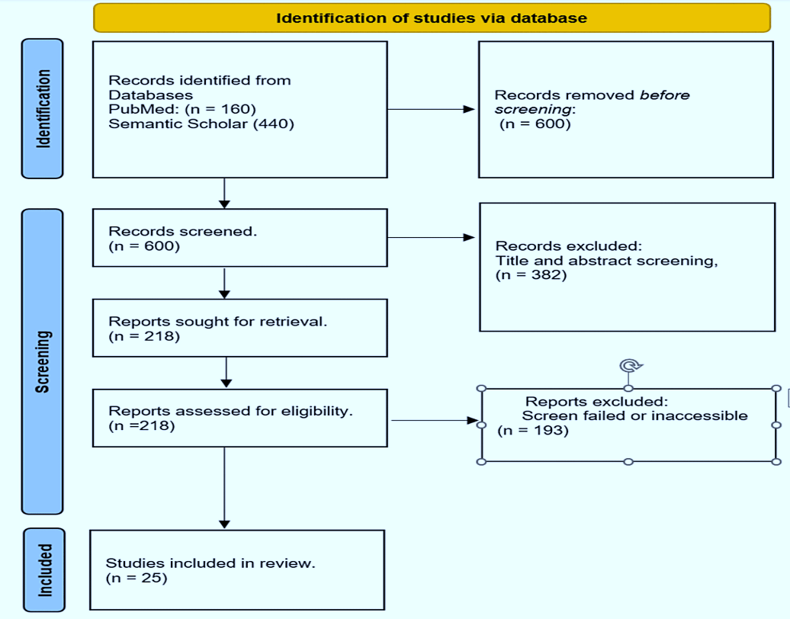

Modern methods for melanoma diagnosis Clinical Indices

The initial stage of melanoma diagnosis involves identifying atypical lesions [1-3,6-12-15]. To aid medical professionals and the general public in recognizing potential melanomas based on their characteristics, a straightforward acronym, the ABCDE approach, was developed. This mnemonic represents the five main features of an abnormal skin lesion: asymmetry, irregular border, color variability/change, dimension, and progression. These attributes are often observed in situ or during the early stages of melanomas. Asymmetry refers to the irregular shape of the lesion, where one half differs from the other. Border irregularity involves blurred, notched, or uneven edges of the lesion. "Color variability" and "color change" denote the presence of various hues, such as multiple black or brown tones, or changes in color, either lightening or darkening. Typically, the lesion has a diameter exceeding six millimeters. Evolution, defined as changes over time in size, shape, color, or texture, is also considered [1,6–8,14, 15]. If a lesion is suspected to be malignant, a biopsy is conducted, and the tissue is examined under a microscope to confirm the diagnosis [1–8]. Dermoscopy can enhance the accuracy of tissue samples [1-3,6,8,12-16].
Imaging
Imaging techniques, including CT scans, MRIs, and ultrasonography, play a crucial role in diagnosing melanoma alongside clinical indicators. MRIs and CT scans offer detailed insights into skin and surrounding tissue structures, aiding in the identification or exclusion of metastasis to other organs. Ultrasonography is particularly valuable for assessing melanoma thickness [1,3-8, 16-23]. However, individuals with cutaneous melanoma at stage 0-II (according to AAD) or stage 0 to IIIB (according to NCCN recommendations) are generally not recommended for baseline examinations. For those with stage III or higher melanoma, ESMO and NCCN suggest brain MRIs and whole-body PET scans. Moreover, ESMO recommends brain MRIs and PET scans for patients with cancers at stage pT3b or higher. According to NCCN guidelines [24], PET and MRI brain scans may be considered for patients with early-stage disease, symptoms of metastatic disease, or high-risk factors such as positive sentinel lymph nodes, microscopic satellite or in-transit metastatic lesions on pathology, or clinically palpable lymph nodes. In contrast, the CCA recommends PET and MRI brain imaging for patients with palpable lymph nodes (Grade B) but not for those with positive sentinel lymph nodes (Grade B) [24].
Histopathological Examination
The most accurate way to diagnose melanoma is by a histological analysis. A pathologist looks at the biopsy sample under a microscope to determine whether the tumour is malignant [1–8]. A typical melanoma can be described in various ways under a tissue microscope. When analysing a melanoma under a microscope, a pathologist will frequently look for a variety of unique characteristics of the cancer. For instance, whether or not perineural invasions exist, the arrangement of melanocytic cells in sheets and nests, etc. One of the lesion's additional characteristics is the number of lymphocytes, or TILs (tumour-infiltrating lymphocytes), that are present there. TILs could indicate that the immune system is actively battling melanoma cells as a result of its determination that they are abnormal[25-32]. The TILs may be referred to as "brisk," "non-brisk," or other words by the pathologist. Additionally, they might use the words "mild" or "moderate," or they might just state "absent" [1,3,5-6,8,]. Other characteristics of melanoma that can be seen under a tissue microscope include the kind of melanoma, the depth of invasion, the presence or absence of ulceration, the mitotic count, the presence or lack of regression, and the presence or absence of satellite lesions. In addition to the material type, the pathologist may take into account the excision technique, the lesion's position and side on the body, the melanoma subtype, the excision margin, the tumor's size, and whether it is in situ or invasive [4-6].
Biomarkers for the diagnosis of melanoma
Early melanoma exhibits genetic and anatomical irregularities, including aberrant collagen-like sequences, structural proteins, UV-induced DNA mutations, oncogenic BRAFV600E mutations, and molecular signaling pathways. These complex molecular changes and processes within a cell may trigger the synthesis of chemokines, cytokines, endopeptidases, phaeomelanin precursors, melanin-associated antigens, dimeric proteins like S100-B, RNA/DNA microarray products, and other tumorigenic outcomes, either in the early or late stages. Early detection and treatment of melanoma remain critical for improving patient survival and prognosis [1-3,6-9,15]. Biomarkers, chemical indicators present in blood, tissue, and other biological samples, play a crucial role in determining the presence or progression of a disease [6–12]. Diagnostic tests for melanoma include circulating tumor cells (CTCs), microRNAs (miRNAs), circulating tumor antigens (MAAs), CRP, LDH, and various potential biomarkers for S100B [4, 6–12]. Numerous putative melanoma biomarkers, such as Melan-A, circulating tumor DNA, MIAs, and cell-free DNA, have been identified and thoroughly examined in scientific studies [5–14, 18–25]. The field of biomarkers for melanoma detection is still evolving, as no single biomarker currently meets the criteria for a minimally viable test (ctDNA) [6–14, 18–25]. These distinctive characteristics are elaborated upon (refer to the conceptual image in Figure 2 below).
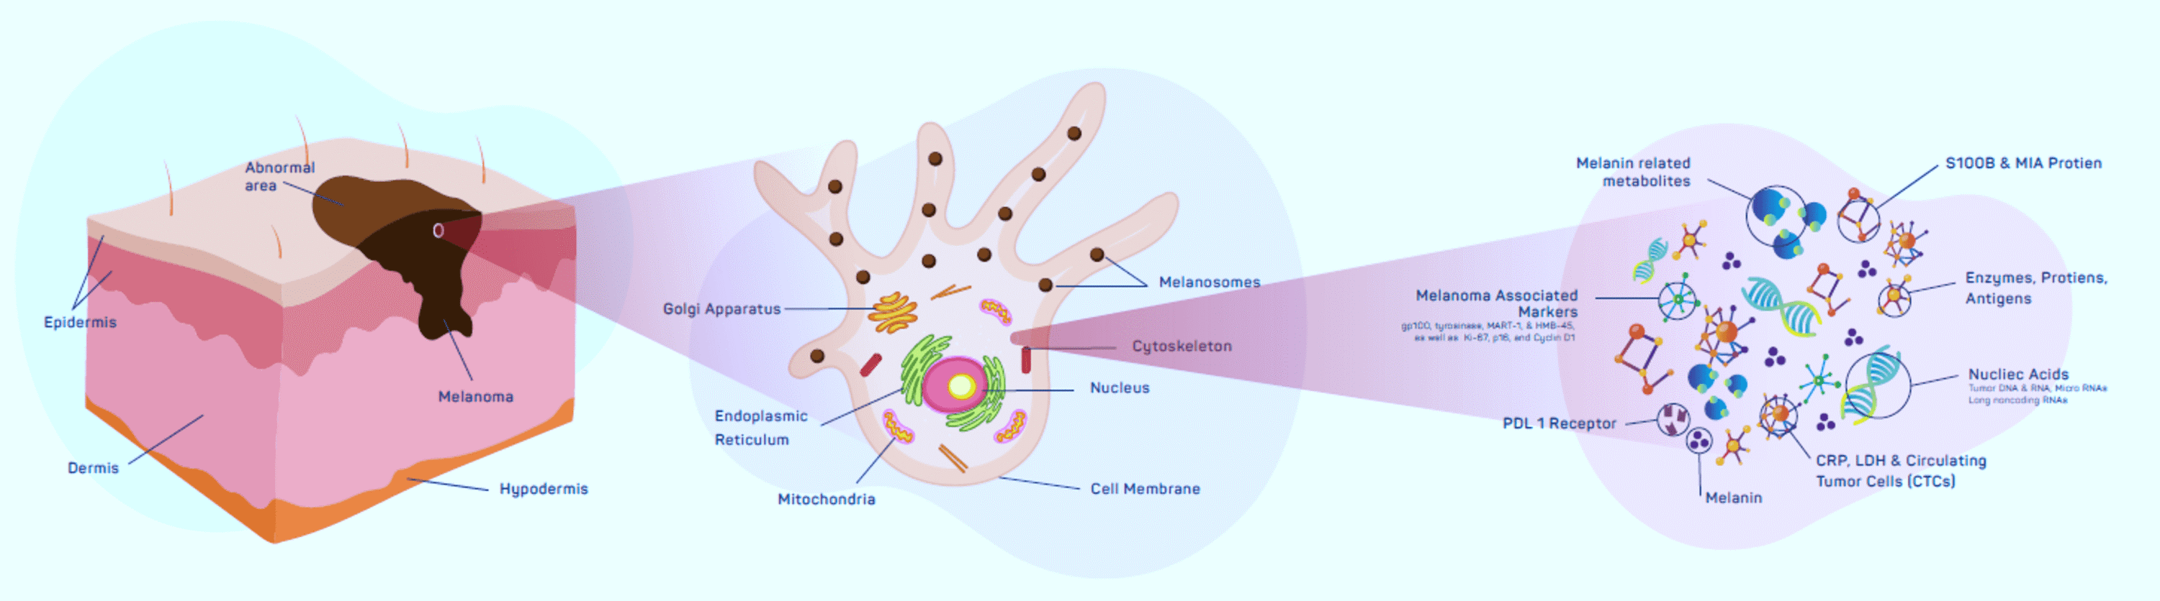

An outline for determining the qualities of the least cumbersome biomarker tests
Sensitivity, specificity, positive predictive value (PPV), negative predictive value (NPV), and the area under the receiver operating characteristic curve (AUC-ROC) are the methods for evaluating the importance of biomarker tests with limited characteristics [17, 18]. Two proteins known as MAAs, Pmel-17/gp100 and MART-1/melan-A, are only expressed in melanoma cells and not in healthy cells when it comes to melanoma. Because these proteins are distinctive to melanoma cells and can elicit an immune response, they have attracted a lot of interest as possible biomarkers for melanoma. Studies have demonstrated a correlation between the prognosis and course of melanoma and the presence of MAAs in individuals [5-8]. A different study [9] looked at the expression of different MAAs in individuals with melanoma and discovered a strong correlation between one MAA, MAGE-A3, and poor survival results [4-11-14]. According to the prognosis, patients with high levels of MAA (CYT-MAA) had an 81% increased chance of recurrence than individuals with undetectable levels. Irene and colleagues evaluated the prognostic significance of MAA in 117 patients and found that it is a useful predictive biomarker, especially for individuals who have had tumor removal [31]. Studies on the role of Melan-A have generated conflicting results over the past decade. Melan-A, a unique membrane protein recognized by T lymphocytes, exhibits a high specificity of 99% in distinguishing non-melanocytic cells from melanoma, according to multiple studies, especially in early-stage tumors. However, other researchers have raised concerns about its specificity due to its staining capabilities and reported reduced sensitivity (approximately 86%). Non-pigmented epithelial cells or their derivatives, such as Leydig, adrenocortical, ovarian, and theca cells, along with other pigmented epithelia like the retina, do not express Melan-A [26]. In rare instances, it has been observed that a subgroup of lesions lacking MAA or HLA expression experiences rapid regression. However, the precise mechanism underlying this specific association is not yet fully understood [32–34]. To regulate gene expression, small non-coding RNA molecules known as miRNAs target specific mRNA molecules. MiRNAs have been recognized as potential biomarkers for melanoma and other cancers, with numerous studies investigating their expression in melanoma and their potential utility as prognostic and diagnostic biomarkers.
For instance, numerous investigations have identified distinct microRNAs (miRNAs) with varied expression patterns in melanoma patients compared to healthy individuals, suggesting their potential utility as diagnostic biomarkers [6–15, 33]. The exploration of alternative biomarkers, such as miRNAs and exosomes, for melanoma diagnosis has been the subject of several review studies [26–33]. The hypotheses proposed by the authors [4–15] suggest that these markers could enhance the precision of melanoma diagnosis, predict the disease's progression, and indicate responsiveness to treatment. A study analyzing 126 blood samples resembling melanoma revealed significant alterations in miRNA levels during the advanced stages of the disease [34]. Several studies highlight the potential of miRNA as a prognostic indicator for disease progression. For instance, Shanthi et al. reported comparable findings in a pooled meta-analysis involving 2669 patients, despite some inconclusive results. The study yielded an overall effect size of 1.043 (95% CI 0.921-1.181; p = 0.506), with a 4.3% mortality rate among individuals exhibiting this marker.
Primary tumor cells release circulating tumor cells (CTCs) into the bloodstream. These cells have been studied as possible biomarkers for melanoma and other malignancies. They are especially attractive because they can shed light on therapy response and tumor metastasis. A number of further studies looking at CTCs in melanoma patients have found a link between CTCs and a poor prognosis and the advancement of the illness [4–15]. Other research has also linked CTCs to poor prognosis. For example, Morcelin et al. [36] reported higher rates of progression-free survival and overall survival in early-stage melanoma compared to late-stage melanoma, with hazard ratios of 2.45 and 2.42, respectively. This conclusion was drawn from a meta-analysis involving 5433 melanoma patients from 53 trials.
Biomarkers such as circulating tumor DNA (ctDNA) and cell-free DNA (cfDNA) have emerged as compelling diagnostic tools for melanoma. Several studies have demonstrated the potential of ctDNA as a diagnostic biomarker for melanoma [6–10]. In a study involving 135 patients with advanced melanoma, ctDNA was detected in 57% of cases [13]. The presence of ctDNA showed correlations with variables such as overall survival, disease stage, and tumor burden. Moreover, ctDNA was identified in individuals with smaller tumors and earlier disease stages, suggesting its potential application in early melanoma detection [13–15]. These findings indicate that ctDNA could serve as a valuable diagnostic tool for melanoma, particularly in situations where traditional diagnostic methods like biopsy may be impractical.

The overexpression of the secreted protein MIA in melanoma has shown promise for both prognostic and diagnostic purposes [4-15,37-39]. However, as a standalone biomarker, it has limitations due to its relatively low sensitivity and specificity. A study examined the diagnostic utility of melanoma inhibitory activity (MIA) in stage I and stage II cutaneous melanoma patients under observation. The study included data from 5,334 MIA serum level measurements obtained from 1,079 consecutive stage I and stage II melanoma patients during standard follow-up intervals. The study employed statistical methods such as Somers' Dxy rank correlation and calculated the sensitivity, specificity, and area under the receiver-operating characteristics curve for MIA. Among the patients with metastases, the sensitivity of MIA testing for stage II and stage I patients was 65.6% and 67.6%, respectively. Specificity values were 76.9% and 66.7% for patients in stages I and II, respectively. The study determined that 12.0 ng/ml was the most reliable upper limit for normal MIA levels, compared to 8.8 ng/ml and 15.0 ng/ml in the study.
Additionally, the results of multivariate analysis indicated a significantly higher rate of false-positive readings among elderly individuals, particularly those with increased Breslow thickness. The study's findings also revealed that MIA levels exhibited an increase in 5.6% of individuals with early-stage melanoma, reaching as high as 89.5% in patients with advanced-stage melanoma [25]. ctDNA has emerged as a promising blood-based biomarker for melanoma detection, as demonstrated in various studies [4-6,8-15,20-25]. However, further clinical trials are needed to establish its diagnostic performance with certainty.
Over the past century, HMb-45 has been extensively studied as a potential immunohistochemical marker. The monoclonal antibody HMb-45 exhibits a sensitivity range of 66% to 97%, with lower sensitivity in cases of metastatic melanoma. Glycoproteins such as gp100 and Pmel17 are typically stained in the region between junctional nevus cells and melanoma cells. Numerous peer-reviewed articles have consistently demonstrated a melanoma specificity ranging from 91% to 100% for HMb-45, although it tends to perform less effectively in detecting the desmoplastic variant of melanoma [26].
Researchers have also explored the relationship between elevated lactate dehydrogenase (LDH) levels and survival indicators in melanoma over time. Although the quantitative definition of the degree of LDH change from baseline in predicting overall survival (OS) has not been firmly established, studies have investigated its effectiveness in this regard. The significance of this biomarker has been substantiated by numerous studies and recommendations. In a retrospective 10-year investigation involving 48 patients to assess the predictive value of circulating blood biomarkers, Arana et al. identified changes from baseline as predictors of overall survival (OS) [38]. Henry et al. conducted a study examining the diagnostic and predictive utility of a combination of biomarkers in 121 individuals, revealing significant correlation values between the serum biomarkers S100B, LDH, MIA, proteasome, and OS [39]. The 7th edition of AJCC recommended using elevated LDH levels for categorizing metastatic lesions. The 8th edition introduced additional anatomic sites for the M1C metastatic category [37].
Recently, non-invasive methods have achieved significant success in assessing the expression of melanotic genes in skin lesions. Several studies evaluating gene expression have demonstrated substantial success with non-invasive biopatch collection techniques. For instance, studies conducted by Gerami and his team have shown that non-invasive methods like this can increase biopsy sensitivity from 95.0% to 98.6% and specificity from 32.1% to 56.9%. Additional research has reported that adopting these non-invasive methods for collecting and assessing melanotic gene expression can improve sensitivity and specificity by 91% and 69%, respectively [27-29]. However, it's worth noting that this method has limitations, including its inability to detect melanotic lesions in areas that are challenging to visualize, such as the mucosa, nails, soles of the feet, and hands, as well as some uncertainty regarding its predictive value [29].
Future advancements in melanoma detection
Nowadays, visual inspection is used to identify the majority of skin malignancies, including melanoma [1-3]. For this, a variety of imaging methods are useful, including optical coherence tomography (OCT), dermoscopy, and reflectance confocal microscopy (RCM). Nonetheless, the creation of more precise non-invasive diagnostic techniques ought to be the main goal of future research on melanoma diagnosis. Using artificial intelligence (AI) to assess histology and clinical images to help with diagnosis and prognosis is one exciting area of research [1-3,28-34]. Furthermore, more and more scientists are looking into the possibility of using liquid biopsies to find circulating cancer cells and cell-free DNA. These methods may make it easier to evaluate treatment responses and make early diagnoses [1-3,17-26].
It's worth noting that most of these markers are more prevalent in advanced stages of melanoma. Consequently, these markers are rarely used for early diagnosis due to their serum levels [33]. Therefore, research should concentrate on developing more sensitive and specific markers for early diagnosis among those at risk for melanoma, even though certain other markers have demonstrated encouraging results as potential prognostic indicators for early disease detection or prognosis of therapy effects. These developments in science could eventually lead to better patient outcomes by facilitating early detection and therapy response tracking. It's critical to recognize that, given the arbitrary selection of a small number of significant biomarkers and the exclusion of potentially relevant markers, constraints in study selection may have created bias in this investigation.

Conclusions
In conclusion, the overabundance of skin cells called melanocytes is the cause of melanoma, a type of skin cancer. Early melanoma diagnosis and identification are essential for successful treatment and better patient outcomes. Various biomarkers with potential for melanoma diagnosis have been identified through diverse methods and technologies. Currently, there is active ongoing research exploring a range of promising biomarkers for melanoma diagnosis.
However, it is important to note that further research is required to establish the clinical utility of these biomarkers. Their diagnostic efficacy must be rigorously validated through comprehensive clinical trials before they can be integrated into clinical practice. The process of determining the essential attributes of biomarker tests ensures a consistent approach to assessing their diagnostic accuracy, ultimately allowing only highly accurate biomarkers to be employed in clinical settings.
References:-
- Saginala K, Barsouk A, Aluru JS, Rawla P, Barsouk A: Epidemiology of melanoma. Med Sci (Basel). 2021, 9:63. 10.3390/medsci9040063
- Khushalani NI, Truong TG, Thompson JF: Current challenges in access to melanoma care: a multidisciplinary perspective. Am Soc Clin Oncol Educ Book. 2021, 41:e295-303. 10.1200/EDBK_320301
- Matthews NH, Li WQ, Qureshi AA, Weinstock MA, Cho E: Epidemiology of Melanoma. Cutaneous Melanoma. Codon Publications, Brisbane (AU); 2017. 10.15586/codon.cutaneousmelanoma.2017.ch1
- Welch HG, Mazer BL, Adamson AS: The rapid rise in cutaneous melanoma diagnoses. N Engl J Med. 2021, 384:72-9. 10.1056/NEJMsb2019760
- Pawlik L, Morgenroth S, Dummer R: Recent progress in the diagnosis and treatment of melanoma and other skin cancers. Cancers (Basel). 2023, 15:10.3390/cancers15061824
- Ward WH, Lambreton F, Goel N, Yu JQ, Farma JM: Clinical Presentation and Staging of Melanoma. Ward WH, Farma JM (ed): Codon Publications, Brisbane (AU); 2017. 10.15586/codon.cutaneousmelanoma.2017.ch6https://www.ncbi.nlm.nih.gov/books/NBK481857/.
- Deacon DC, Smith EA, Judson-Torres RL: Molecular biomarkers for melanoma screening, diagnosis, and prognosis: current state and future prospects. Front Med (Lausanne). 2021, 8:642380. 10.3389/fmed.2021.642380
- Davis LE, Shalin SC, Tackett AJ: Current state of melanoma diagnosis and treatment. Cancer Biol Ther. 2019, 20:1366-79. 10.1080/15384047.2019.1640032
- de Miranda FS, Barauna VG, Dos Santos L, Costa G, Vassallo PF, Campos LC: Properties and application of cell-free DNA as a clinical biomarker. Int J Mol Sci. 2021, 22:10.3390/ijms22179110
- Lee JH, Long GV, Boyd S, et al.: Circulating tumour DNA predicts response to anti-PD1 antibodies in metastatic melanoma. Ann Oncol. 2017, 28:1130-6. 10.1093/annonc/mdx026
- Knuever J, Weiss J, Persa OD, Kreuzer K, Mauch C, Hallek M, Schlaak M: The use of circulating cell-free tumor DNA in routine diagnostics of metastatic melanoma patients. Sci Rep. 2020, 10:4940. 10.1038/s41598-020-61818-1
- Switzer B, Puzanov I, Skitzki JJ, Hamad L, Ernstoff MS: Managing metastatic melanoma in 2022: a clinical review. JCO Oncol Pract. 2022, 18:335-51. 10.1200/OP.21.00686
- Hamid O, Robert C, Daud A, et al.: Safety and tumor responses with lambrolizumab (anti-PD-1) in melanoma. N Engl J Med. 2013, 369:134-44. 10.1056/NEJMoa1305133
- Syeda MM, Wiggins JM, Corless BC, et al.: Circulating tumour DNA in patients with advanced melanoma treated with dabrafenib or dabrafenib plus trametinib: a clinical validation study. Lancet Oncol. 2021, 22:370-80. 10.1016/S1470-2045(20)30726-9
- FDA Approves Blood Tests That Can Help Guide Cancer Treatment. (2020). Accessed: January 3, 2023: https://www.cancer.gov/news-events/cancer-currents-blog/2020/fda-guardant-360-foundation-one-cancer-liquid-biopsy.
- Vider J, Croaker A, Cox AJ, et al.: Comparison of skin biopsy sample processing and storage methods on high dimensional immune gene expression using the Nanostring nCounter system. Diagn Pathol. 2020, 15:57. 10.1186/s13000-020-00974-4
- Garcia J, Kamps-Hughes N, Geiguer F, Couraud S, Sarver B, Payen L, Ionescu-Zanetti C: Sensitivity, specificity, and accuracy of a liquid biopsy approach utilizing molecular amplification pools. Sci Rep. 2021, 11:10761. 10.1038/s41598-021-89592-8
- Ray P, Le Manach Y, Riou B, Houle TT: Statistical evaluation of a biomarker. Anesthesiology. 2010, 112:1023-40. 10.1097/ALN.0b013e3181d47604
- Nguyen LT, Saibil SD, Sotov V, et al.: Phase II clinical trial of adoptive cell therapy for patients with metastatic melanoma with autologous tumor-infiltrating lymphocytes and low-dose interleukin-2. Cancer Immunol Immunother. 2019, 68:773-85. 10.1007/s00262-019-02307-x
- Guo Y, Zhang X, Wang L, et al.: The plasma exosomal miR-1180-3p serves as a novel potential diagnostic marker for cutaneous melanoma. Cancer Cell Int. 2021, 21:487. 10.1186/s12935-021-02164-8
- Tsao H, Atkins MB, Sober AJ: Management of cutaneous melanoma. N Engl J Med. 2004, 351:998-1012. 10.1056/NEJMra041245
- Arnolds O, Zhong X, Tuo Yip K, et al.: NMR-based drug development and improvement against malignant melanoma - implications for the MIA protein family. Curr Med Chem. 2017, 24:1788-96. 10.2174/0929867324666170608104347
- Guba M, Bosserhoff AK, Steinbauer M, Abels C, Anthuber M, Buettner R, Jauch KW: Overexpression of melanoma inhibitory activity (MIA) enhances extravasation and metastasis of A-mel 3 melanoma cells in vivo. Br J Cancer. 2000, 83:1216-22. 10.1054/bjoc.2000.1424
- El Fitori J, Kleeff J, Giese NA, Guweidhi A, Bosserhoff AK, Büchler MW, Friess H: Melanoma Inhibitory Activity (MIA) increases the invasiveness of pancreatic cancer cells. Cancer Cell Int. 2005, 5:3. 10.1186/1475-2867-5-3
- Hofmann MA, Gussmann F, Fritsche A, et al.: Diagnostic value of melanoma inhibitory activity serum marker in the follow-up of patients with stage I or II cutaneous melanoma. Melanoma Res. 2009, 19:17-23. 10.1097/CMR.0b013e32831bc78c
- Weinstein D, Leininger J, Hamby C, Safai B: Diagnostic and prognostic biomarkers in melanoma. J Clin Aesthet Dermatol. 2014, 7:13-24.
- Ferris LK, Jansen B, Ho J, et al.: Utility of a noninvasive 2-gene molecular assay for cutaneous melanoma and effect on the decision to biopsy. JAMA Dermatol. 2017, 153:675-80. 10.1001/jamadermatol.2017.0473
- Cullison SRJ, Jansen B, Yao Z, Ferris LK: Risk stratification of severely dysplastic nevi by non-invasively obtained gene expression and mutation analyses. SKIN. 2020, 4:124-129. 10.25251/skin.4.2.5
- Gerami P, Yao Z, Polsky D, et al.: Development and validation of a noninvasive 2-gene molecular assay for cutaneous melanoma. J Am Acad Dermatol. 2017, 76:114-120.e2. 10.1016/j.jaad.2016.07.038
- Mocellin S, Zavagno G, Nitti D: The prognostic value of serum S100B in patients with cutaneous melanoma: a meta-analysis. Int J Cancer. 2008, 123:2370-6. 10.1002/ijc.23794
- Vergilis IJ, Szarek M, Ferrone S, Reynolds S: Presence and prognostic significance of melanoma-associated antigens CYT-MAA and HMW-MAA in serum of patients with melanoma. The Journal of investigative dermatology. 2005, 125:526-31.
- Cormier J, Hijazi Y, Abati A, et al.: Heterogeneous expression of melanoma‐associated antigens and HLA‐A2 in metastatic melanoma in vivo. Int J Cancer. 1998, 75:
- Brochez L, Naeyaert JM: Serological markers for melanoma. Br J Dermatol. 2000, 143:256-68. 10.1046/j.1365-2133.2000.03649.x
- Margue C, Reinsbach S, Philippidou D, et al.: Comparison of a healthy miRNome with melanoma patient miRNomes: are microRNAs suitable serum biomarkers for cancer?. Oncotarget. 2015, 6:12110-12127.
- Sabarimurugan S, Madurantakam Royam M, Das A, Das S, K M G, Jayaraj R: Systematic review and meta-analysis of the prognostic significance of miRNAs in melanoma patients. Mol Diagn Ther. 2018, 22:653-69. 10.1007/s40291-018-0357-5
- Mocellin S, Hoon D, Ambrosi A, Nitti D, Rossi C: The prognostic value of circulating tumor cells in patients with melanoma: a systematic review and meta-analysis. Clinical Cancer Research. 2006, 12:4605-4613.
- Gershenwald JE, Scolyer RA, Hess KR, et al.: Melanoma staging: Evidence-based changes in the American Joint Committee on Cancer eighth edition cancer staging manual. CA Cancer J Clin. 2017, 67:472-92. 10.3322/caac.21409
- Irurzun-Arana I, Asín-Prieto E, Martín-Algarra S, Trocóniz IF: Predicting circulating biomarker response and its impact on the survival of advanced melanoma patients treated with adjuvant therapy. Sci Rep. 2020, 10:7478. 10.1038/s41598-020-63441-6
- Henry L, Fabre C, Guiraud I, et al.: Clinical use of p-proteasome in discriminating metastatic melanoma patients: comparative study with LDH, MIA and S100B protein. Int J Cancer. 2013, 133:142-8. 10.1002/ijc.27991

