Food Diet Recommendation System Using Machine Learning

^{Sheela.S} | ^{Shalini.S} | ^{Shabeen Taj}
Assistant Professor, Department of CSE | Associate Professor, Department of CSE | Assistant Professor, Department of CSE
Global Academy of Technology, Bangalore  sheela.s@gat.ac.in | Dayanand Sagar Academy of Technology Bangalore  Shalini.siddamallapa@gmail.com | Government Engineering Collge, Ramnagar,  ^{BM Road}  ^{shab2en@gmail.com}

Abstract—People from all around the world are getting more concerned in their health and way of life in today's modern environment. But, avoiding junk food and exercising alone are insufficient; we also need to eat a balanced diet. A healthy life can be attained with a diet that is balanced for our height, weight, and age. Your diet can help you achieve and maintain a healthy weight, lower your chance of developing chronic diseases (including cancer and heart disease), and improve your general health when combined with physical activity. Your body receives the nutrients it needs for proper operation from a balanced diet. The quantity of energy that a food contains is measured in calories. In general, our body uses calories for breathing, moving around while walking or jogging, etc. generally a person needs 2000 calories per day but specifically, the intake of calories depends upon a person's physical aspects like weight, height, age, and gender. So, your food choices each day affect your health — how you feel today, tomorrow, and in the future. Thus, a proposed system gives recommends a diet plan based on your physical aspects and your end goal.

Keywords—Machine Learning, KNN, Random Forest Algorithm, Recommendation System, Diet Plan, BMI, Calories.
INTRODUCTION
Recent research has demonstrated that a robust diet prescribed to patients by a dietician or an Artificial Intelligence automated medical diet-based cloud system can prolong longevity, guard against additional disease, and enhance overall quality of life. The patient-justification dietician's for the recommender system is still unclear to medical professionals. This study suggests a deep learning approach for health based on medical datasets that automatically identifies which meal should be provided to which patient based on the ailment and other parameters like age, gender, weight, calories, protein, fat, sodium, fibre, and cholesterol.

A system that monitors a user (patient/dietician) in a personalised manner towards remarkable or acceptable diets or food intake across a wide range of possible selections is known as a recommendation system for patients/dieticians.[1]. A recommendation system for patients/dieticians is cautiously implemented to encourage the patients to take nutritional supplements; diets and food which are considered better to meet the patient's health needs, taste, and dietary preferences.

However, food and diet are complex domains bringing many challenges for recommendation technologies. For making recommendations, thousands of food items/ingredients have to be collected. Besides, because foods/ingredients are usually combined in a recipe instead of being consumed separately, this exponentially increases the complexity of a recommender system (Freyne and Berkovsky 2010). Furthermore, food
recommender systems not only recommend food suiting users' preferences but also suggest healthy food choices, keep track of eating behavior, understand health problems, and persuade to change user behavior.
From the earliest period of foetal development to old age, nutrition is the fundamental building block for human health and development. For survival, physical growth, mentaldevelopment, performance and productivity, health, and overall well-being, healthy diet and sufficient nutrition are unquestionable necessities [2].

This paper is a survey study of the food diet recommendation system. Section two summarizes related work. Section three discusses of algorithms used. Section four is an extensive review of the food diet recommendation system. Section five concludes the paper with summary comments on the content.
- RECOMMENDER SYSTEM
Any system that "produces individualised recommendations as output or has the effect of leading the user in a personalised approach to interesting or useful objects in a broad space of possible possibilities" is defined as a recommender system (RSS). [3]. They have been used in a variety of contexts, including e- commerce [4], e-learning [5], e-government [6], and e-tourism [7], and have become recognised as an effective way to address the issue of information overload.

Registered dietitians now have a fresh way to practise their profession and profit from healthcare thanks to nutrition informatics.

- LITERATURE SURVEY
Shubhanshi Saini, Sanjay Kumar Dubey proposed that recommends diet to jaundice patient by using Analytic Hierarchy Process (AHP). This technique for diet recommendation has not been used before and it provides a new perspective which is different from conventional techniques. In AHP, critically important nutrients are taken as factors and alternative diet plans are evaluated on the basis of these factors in order to select the best option. The result is the diet plan which includes meals to be consumed by a jaundice patient at breakfast, lunch and dinner. The results obtained by AHP are further validated using Fuzzy Analytic Hierarchy Process (FAHP). FAHP provided the same results as obtained from AHP.

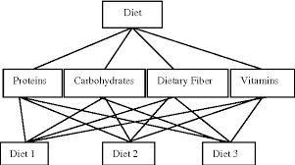
Steps to be followed in AHP:

Step1: On the basis of the questionnaire and survey conducted these elements are weighted on the scale of 0-9.
A sample table is shown in Table 1.The weight of each criterion if filled as compared to their importance with other criterions. For example: weight 7 shows that criteria 1 is highly important as compared to criteria 2 and vice versa.

Step 2: The tables then created are used for calculating the nth root of the product and their sum. Calculate by multiplying the complete row and then taking the nth root, where n= no. of elements in the matrix.

Step 3: Eigen vector ω is then calculated by dividing the nth root product by their sum.

Step 4: Next stage is to calculate ƛ max so as to calculate Consistency Index (C.I) and Consistency Ratio (C.R). Aw is calculated by summation of product of each element of row to eigen vector.
ƛ ⁄ω (1) where, ƛ max is eigen value and ω is the eigen vector.

Step 5: Consistency Index is then calculated as (ƛ)
- International Journal of Intelligent Engineering and Systems, Vol.10, No.4, 2017 DOI: 10.22266/ijies2017.0831.10

Step 6: Finally the Consistency Ratio is calculated as

- Where, R.I represents the average of consistency index. According to Saaty, C.R < 0.1 means that the judgements made are trustworthy and if C.R > 0.1 that means the judgements made is not consistent.
- RELATED WORK
It is suggested that diabetic patients adopt a Food Recommendation System (FRS) [8] that analyses food clusters using K-mean clustering and Self Organizing Maps. According on nutrition and food criteria, the proposed approach suggests substituting certain items. FRS, however, falls short in addressing the disease level issue because the patient's diabetes level might change hourly depending on their circumstances, and the meal suggestions can also change as a result.

In order to better serve customers' individual needs, meal recommendation tries to offer a list of ranked food items. Here, food is used in a more general sense and refers to everything that is connected to food, including meals, recipes, coffee shops, and dining establishments. Research on food recommendations often spans multiple disciplines, including anthropology, psychology, biology, anthropology, sociology, and food scienceand social sciences

As compared to other recommendation categories, there are primarily three characteristics exclusive to food recommendations. (1) Dietary recommendations require a variety of circumstances and subject-matter expertise. Rich user context (such as heart rate and number of steps taken) and external environmental context (such as context relevant to physical activity and health) captured from various sensors describe users' actual physical conditions and their surroundings and thus provide useful information for an exact match between user requirement and food items. For instance, a food recommendation after exercise that uses sensors is likely to suggest to one person foods high in protein and water. Also, eating advice is crucial for good health. Hence, for constraint optimization and computing, the food recommender system should also include medical information, nutritional knowledge, and other pertinent domain knowledge. (2) The most notable difference from the user's perspective is that dietary recommendations are highly relevant to the user's health. Consequently, the optimal system for making meal recommendations should selfadaptively create a trade-off between each user's unique food preferences and interests and their unique nutritional and health needs. For instance, even if a diabetic prefers sweet foods, it would be more logical to suggest to him/her foods that are lower in sugar than before. In addition to user health demands, meal recommendations should take into account other intricate and nuanced user needs, like allergies and lifestyle choices.

Algorithms and Methods used

K-Means Algorithm

The K-means algorithm is an iterative algorithm that seeks to divide the dataset into pre-specified separate non-overlapping subgroups (clusters), each of which contains just one group to which each data point belongs.Itseeks to make the intra-cluster data points as comparable as feasible while keeping the clusters as diverse (far) away as possible. In order to minimise the sum of the squared distances between the data points and the cluster centroid, which represents the average value of all the data points in the cluster, it distributes the data points to clusters in a hierarchical fashion. As the degree of variance inside the cluster drops, the homogeneity (similarity) of the data points within the cluster rises.
The K-means algorithm operates in the manner described below: Indicate K, the total number of clusters.
- Initialize centroids by randomly choosing K data points for the centroids after shuffling the dataset first.
- Continue iterating until the centroids do not change. i.e., the clustering of data points remains constant.
- Add the squared distances between each data point and each centroid.
- Connect every data point to the nearest cluster (centroid).
- Calculate the centroids for each cluster by averaging all the data points that make up that cluster.
In our study, the data set is divided into the three categories of lunch, breakfast, and dinner using the k-means clustering algorithm.The diagram below illustrates how the three categories are separated from the cluster dataset. This allows us to eventually separate the dataset into train and test datasets for each of the three categories, and the random forest approach is then used to build the model.

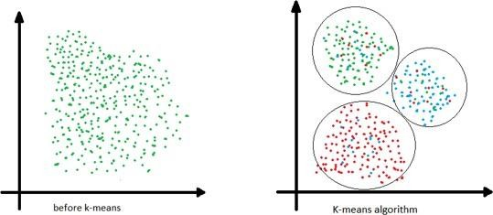
Fig-1: K-Means Algorithm

Random Forest Algorithm

A supervised classification algorithm is the Random Forest algorithm. From its name, it is clear that the goal is to erroneously produce a forest. The more trees a forest has, the more accurate its results will be; conversely, the fewer trees a forest has, the less accurate its results will be. To be clear, building the decision using the information gain or gain index approach is not the same as building the forest. A tool for supporting decisions is the decision tree. It displays the potential outcomes using a graph that resembles a tree. The decision tree will create a set of rules if you provide it with a training dataset that includes targets and features.These rules can be used to perform predictions.
After our dataset is divided into three categories, Random forest now aids in extracting classes from the dataset. If you feed a training dataset containing features and labels into a decision tree, it will come up with a set of rules that it will use to make predictions. Random forest is a collection of decision tree clusters.

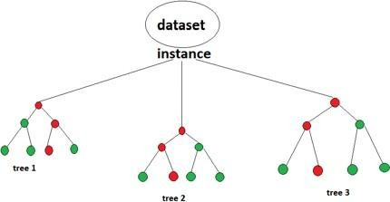
Fig-2: Random Forest Algorithm

Table A: Summary of Technical Evaluation Findings for Each Unit

S.N | Title, authors, year, and nation | Title of the System | The nature of the recommendation system | kinds of AI methods used in recommen dation systems | system components | computer platform
1 | A mobile | System | Knowledge- | Rule | The patient's | Quick and
 | application for | for | based | base | profile, the user's | effective
 | managing | recomme | recommender |  | favourites, periodic | for
 | Diabetic  patients Nutrition: A  food | nding Iranian snacks | system |  | reports, the  reminder setting,  the recording of lab results, and the | detecting  known malware,  in use for
 | recommender |  |  |  | request for a snack | many
 | system |  |  |  | are all included. | years, and
 | Norouzi et |  |  |  |  | successful
 | al[9]2018 |  |  |  |  | for
 |  |  |  |  |  | detecting
 |  |  |  |  |  | malware
 |  |  |  |  |  | from the
 |  |  |  |  |  | same
 |  |  |  |  |  | family
2 | PERSON-  Personalized Expert | PERSON | Hybrid recommender systems (HRS) | Genetic algorithms and deep learning | A decision recommendation model, a DNN | -
 | Recommendati |  |  | neural | model for
 | on System for |  |  | networks (GA) | categorising
 | Optimized |  |  |  | products, a word
 | Nutrition Chen |  |  |  | embedding and
 | et al. [10] 2018 |  |  |  | padding model,
 |  |  |  |  | and an operational
 |  |  |  |  | state machine
3 | A hybrid architecture for a thorough | - | Hybrid recommender systems (HRS) | Rule base | The two sorts of modules are core modules and | -
 | diet and |  |  |  | supporting
 | exercise |  |  |  | modules. While the
 | advice system |  |  |  | supporting
 | Ali et al. [11] |  |  |  | modules support
 | South Korea, |  |  |  | the main module,
 | 2018. |  |  |  | functions as the
 |  |  |  |  | framework's
 |  |  |  |  | primary
 |  |  |  |  | functioning engine.
 |  |  |  |  | These are the
 |  |  |  |  | modules: Data
 |  |  |  |  | gathering and
 |  |  |  |  | processing,
 |  |  |  |  | creation of context,
 |  |  |  |  | repository of
 |  |  |  |  | expert knowledge,
 |  |  |  |  | and presentation

4 | DIETOS: a | DIETOS | Content-based | - | User profiler for | Internet resource
 | recommender |  | recommender |  | DIETOS, food
 | system for health |  | systems (CB) |  | filter for DIETOS,
 | profiling and diet |  |  |  | security for
 | management in |  |  |  | DIETOS,
 | chronic diseases |  |  |  | reminder for
 | Agapito et al. [12] |  |  |  | DIETOS, history
 | 2017 Italy |  |  |  | for DIETOS, and
 |  |  |  |  | CKD calculator.
5 | Food | Collaborative | Self- | - | - | -
 | recommendation | filtering | Organizing
 | system using | recommender | Map (SOM) K-
 | clustering analysis | systems (CF) | mean clustering
 | for diabetic
 | patients Phanich et
 | al. [13] 2010
 | Thailand
6 | Online Recommender | Nutri | Knowledge- based | Rule base | - | Smartphone application
 | System for |  | recommender
 | Personalized |  | systems (KBS)
 | Nutrition Advice
 | Franco [14] 2017
 | UK

Results and Discussion
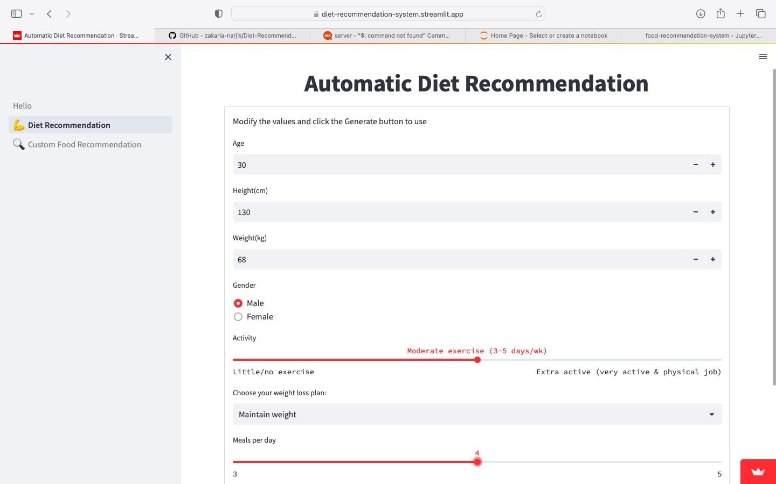
Fig 1: user login page
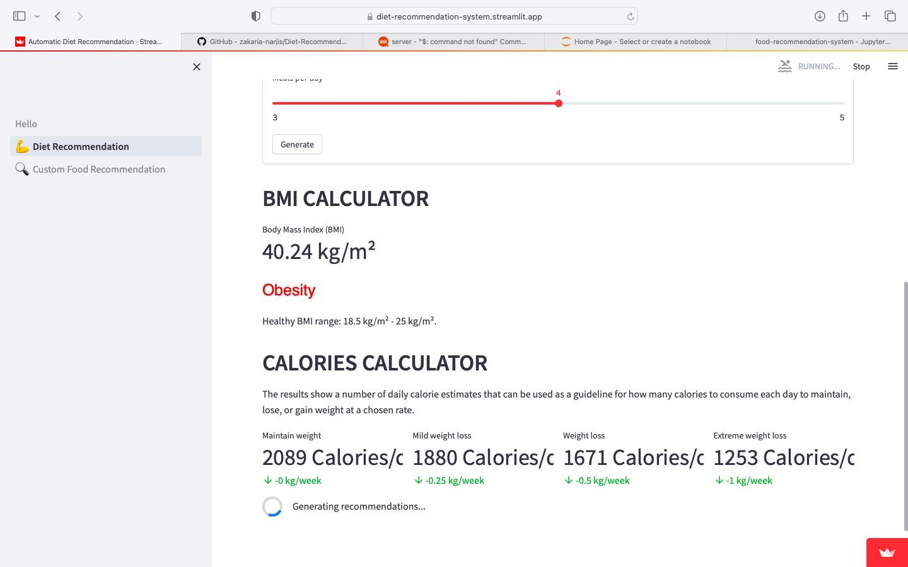
Fig 2 : caluclating BMI value

Fig 1 and Fig 2 depicts the login page for the user to give the deatils and the caluclated BMI value based on the user details

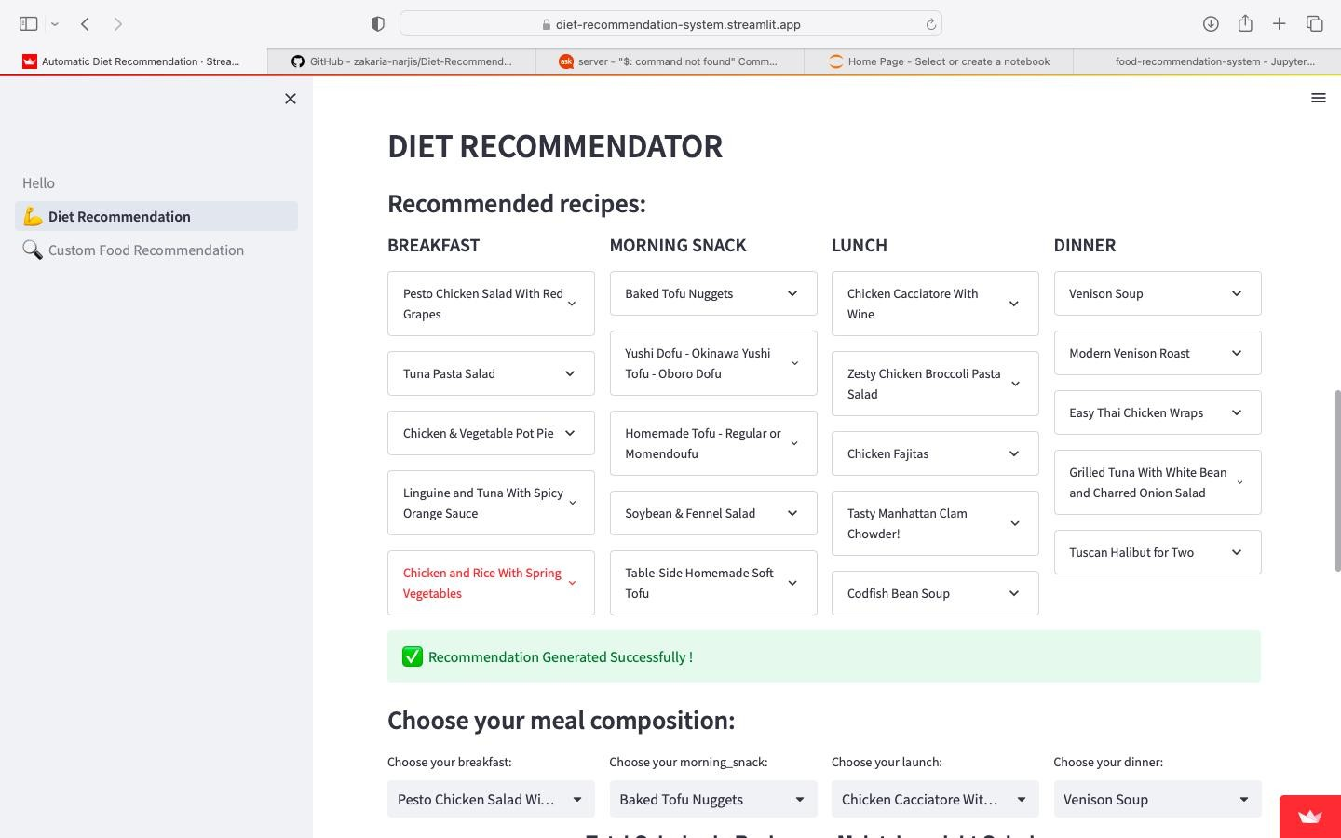
Fig 3 : Recommended food items
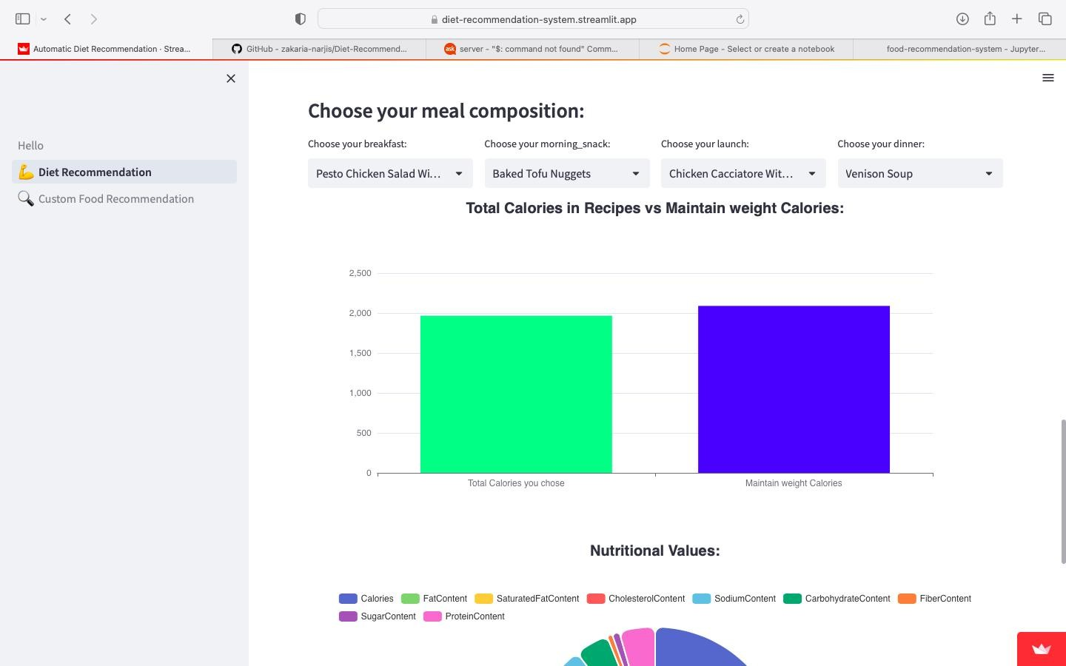
Fig 4 : Bar graph of the nutrients value

Fig 3 and Fig 4 depicts the food items recommended for the user and depicts the bar graph of the nutrients value.

- CONCLUSION
Developing technologies like artificial intelligence and machine learning are crucial to the growth of the IT (Information Technology) industries. Using these technologies, we have developed projects for people who seek dietary advice and want to live healthy lives. To live a healthy and fit life, nutritional guidance is becoming more and more important. A healthy diet plan is developed by the system by accepting the user's preferences and profile.

REFERENCES

T. N. Trang Tran, M. Atas, A. Felfernig, and M. Stettinger, ‘‘An overview of recommender systems in the healthy food domain,’’ J. Intell. Inf. Syst., vol. 50, no. 3, pp. 501–526, Jun. 2018.

- S. Saini and S. K. Dubey, ‘‘Recommendation of diet to jaundice patient on the basis of nutrients using AHP and fuzzy AHP technique,’’ Int. J. Intell. Eng. Syst., vol. 10, no. 4, pp. 91–99, Jul. 2017, doi: 10.22266/ ijies2017.0831.10.

- L. Yang, C.-K. Hsieh, H. Yang, J. P. Pollak, N. Dell, S. Belongie, C. Cole, and D. Estrin, ‘‘Yum-Me: A personalized nutrient-based meal recommender system,’’ ACM Trans.
Inf. System., vol. 36, no. 1, pp. 1–31, Jul. 2017

- J. Mariapun, C.-W. Ng, and N. N. Hairi, ‘‘The gradual shift of overweight, obesity, and abdominal obesity towards
the poor in a multi-ethnic developing country: Findings fromthe Malaysian National health and morbidity surveys,’’ J. Epidemiol., vol. 28, no. 6, pp. 279–286, Jun. 2018.

- H. Dinçer, S. Yüksel, and L. Martínez, ‘‘Balanced scorecard-based analysis about European energy investment policies: A hybrid hesitant fuzzy decision-making approach with Quality Function Deployment,’’ Expert Syst. Appl., vol. 115, pp. 152–171, Jan. 2019.

- F. Rehman, O. Khalid, N. Haq, A. R. Khan, and K. B. Sajjad, ‘‘Diet-right: A smart food recommendation system,’’KSII Trans. Internet Inf. Syst., vol. 11, no. 6, Jun. 29, 2017, doi: 10.3837/tiis.2017.06.006.

- C. Iwendi, Z. Zhang, and X. Du, ‘‘ACO based key management routing mechanism for WSN security and data collection,’’ in Proc. IEEE Int. Conf. Ind. Technol.(ICIT), Lyon, France, Feb. 2018, pp. 1935–1939, doi: 10.1109/icit.2018.8352482

- S. Norouzi, A. K. Ghalibaf, and S. Sistani, ‘‘A mobile application for managing diabetic patients’ nutrition: A food recommender system,’’ Arch. Iranian Med., vol. 21, no. 10, pp. 466–472, 2018

- M. Raut, K. Prabhu, R. Fatehpuria, S. Bangar, and S. Sahu, ‘‘A personalized diet recommendation system using fuzzy ontology,’’ Int. J. Eng. Sci. Invention, vol. 7, no. 3,pp. 51–55, 2018.
- R. Yera Toledo, A. A. Alzahrani, and L. Martinez, ‘‘A food recommender system considering nutritional information and user preferences,’’ IEEE Access, vol. 7, pp. 96695–96711, 2019

- H. Jenzer, S. Busser, and F. Scheidegger-Balmer, ‘‘Nutrition and dietetic product shortages are a neglected issue in alerting systems and in reg istries,’’ J. Clin. Nutrition, vol. 2, no. 3, p. 15, 2016, doi: 10.4172/2472-
1921.100022.

- N. Leipold, M. Lurz, and M. Bohm, ‘‘Nutrilize a personalized nutrition recommender system: An enable study,’’ HealthRecSys, vol. 3, no. 4, pp. 4–10, 2018.

[14]A. Baldominos Gomez, F. Rada, and Y. Saez, ‘‘DataCare: Big data ana lytics solution for intelligent healthcare management,’’ Int. J. Interact. Multimedia Artif. Intell., vol. 4, no. 7, p. 13, Mar. 2017.

[15]G. Agapito, B. Calabrese, P. H. Guzzi, M. Cannataro, M. Simeoni, I. Care, T. Lamprinoudi, G. Fuiano, and A. Pujia, ‘‘DIETOS: A rec ommender system for adaptive diet monitoring and personalized food suggestion,’’ in Proc. IEEE 12th Int. Conf. Wireless Mobile Comput., Netw. Commun. (WiMob), New York, NY, USA, Oct. 2016, pp. 1–8, doi: 10.1109/wimob.2016.7763190.

