OCCURRENCE AND ORIGIN OF GROUNDWATER
Author – Vibhanshu Vaibhav Singh

ABSTRACT- Nearly all groundwater may be regarded as being a kind of water. A relatively tiny quantity of groundwater from other sources, sometimes known as general forms of groundwater, such as magmatic water, connate water, juvenile water, and metamorphic water, may enter the water cycle. A critical natural resource, groundwater is essential for supporting many human endeavours and maintaining life. For efficient administration and long-term use, it is crucial to comprehend its incidence and genesis. The current level of knowledge on the occurrence and origin of groundwater is thoroughly reviewed in this abstract. Groundwater is a result of intricate geological, hydrological, and climatic variables. This paper discusses the distribution and storage capabilities of several aquifer types, including as confined, unconfined, and perched aquifers. The paper explains the interaction between precipitation, infiltration, and subsurface flow as it digs into the dynamics of groundwater recharge and discharge processes.

- INTRODUCTION

The groundwater is primarily obtained through a process known as "recharge," which includes water moving from the surface into the subsurface. Here is a step-by-step breakdown of the formation of groundwater:
Precipitation: Whether rain or snow, precipitation is the main source of groundwater. Water that falls on the Earth's surface during rain or snowfall either seeps into the soil or runs off into rivers and streams.
Infiltration: Water seeps into the earth through porous rock layers and the soil in a process known as infiltration. Not all precipitation-related water seeps in; some is lost to evaporation and surface runoff. Through the pore spaces and fissures in the underlying materials, the water that permeates the soil travels downhill.
Soil Zone: In the pore spaces of the uppermost subsurface layer, often referred to as the "unsaturated zone" or "vadose zone," there is both water and air. The water in this region, which is typically above the water table, is kept in place by capillary and molecular forces.
Water Table: Water gradually descends to a level where all the pore spaces are filled with water. The "water table" is the line separating the saturated zone from the unsaturated zone. All pore spaces below the water table are completely saturated with water.
Saturated Zone: The "saturated zone," often referred to as the "phreatic zone," is the area below the water table. Groundwater is stored in this zone where the connecting pore spaces and cracks are flooded with water.
Aquifers: Geologic formations known as aquifers have great permeability, allowing water to flow through them at rates sufficient to support wells and springs. These formations serve as subsurface reservoirs that store and convey groundwater, such as porous rock layers or unconsolidated deposits like sand and gravel.

- VERTICAL DISTRIBUTION OF SUBSURFACE WATER

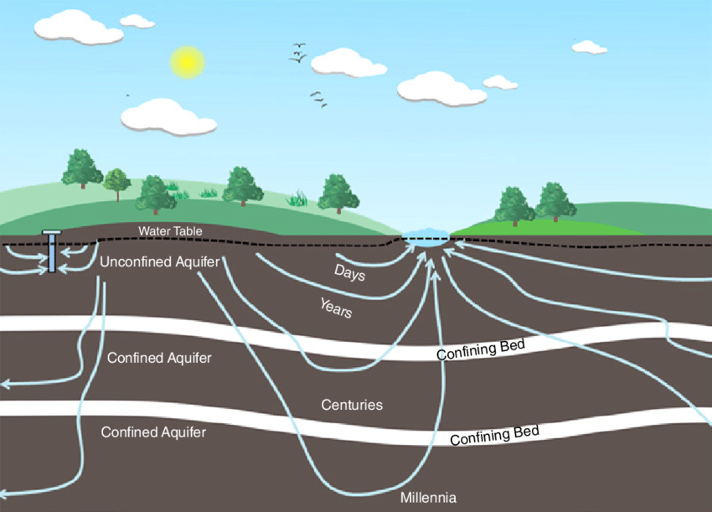
Let's first think about the hydrological zones that exist below the surface in order to comprehend the presence of groundwater and its vertical distribution. Unsaturated zone, also known as zone of aeration, is the region between the ground's surface and the top of the capillary fringe. It is composed of pores or interstices that are partially filled with water and partially with air. In the unsaturated zone, water is maintained at a pressure lower than atmospheric pressure. The term "capillary zone" refers to the region between the bottom of the unsaturated zone and the top of the water table where the majority of voids are filled with water, but the water is maintained at a lower pressure than the atmospheric pressure. Finally, the zone extending from the water table to an impermeable layer is called saturated zone (or, zone of saturation), wherein all voids are completely filled with water. In this zone, water is held at a pressure greater than the atmospheric pressure, and hence it moves in a direction based on the contiguous hydraulic situation.
Fig.2.1 Groundwater Flow System.
Source: https://www.researchgate.net/publication/340239283_Sustainable_Systems_for_Groundwater_Resource_Management

The "soil-water zone" and "intermediate zone" are further divisions of the unsaturated zone (Todd, 1980). The vadose zone is the region that is between the top of the water table and the ground's surface. The unsaturated zone and capillary zone, sometimes referred to as "capillary fringe," make up the vadose zone. Vadose water, which is kept at a pressure lower than atmospheric pressure, is the water that exists in the vadose zone. Because of the matric potential and gravity, this water can still travel inside the vadose zone, but it cannot exit the zone into alternative water collection methods that are exposed to air pressure, such as wells, pits, or wells. It should be noted that the word vadose zone is technically more accurate than the phrase unsaturated zone. This is due to the possibility of saturation in some vadose zone regions, despite the fact that water pressure is lower than atmospheric pressure. As a result, the term "vadose zone" has gained popularity and is often used in the domains of soil physics and groundwater hydrology today. Groundwater is the general term for the water that is kept in the saturation zone. Groundwater is not all subterranean water; rather, it only includes free water or gravitational water (water that flows freely into wells under the influence of gravity). Therefore, according to Bouwer (1978), a precise and useful definition of groundwater is "that portion of the water beneath the earth's surface, which can be collected through wells, tunnels, or drainage galleries, or which naturally flows to the earth's surface via seeps or springs." Groundwater may be found at depths of 1 m or more to 1000 m or more. There are some locations where there is no groundwater at all.

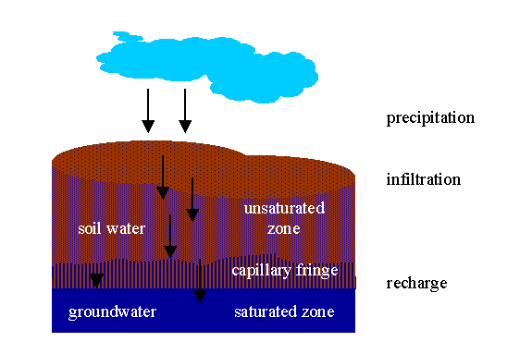

Fig.2.2 Source: Ideo.columbia.edu

- TYPES OF SUBSURFACE FORMATIONS

The substance found below the surface of the earth is typically referred to as subsurface formation or subsurface deposit in subsurface hydrology. Soil and geologic formations make up the first and second major categories of subsurface formations, respectively. As is well known, the weathering of rocks creates soil. However, there are three types of geologic formations: consolidated, semi-consolidated, and unconsolidated. Consolidated geologic formations are rocks with densely packed grains that are produced by cementation, compaction, and recrystallization. They go by the name "hard rocks" as well. Igneous and metamorphic rocks like granite, basalt, and schist, as well as indurated sedimentary rocks like sandstone, shale, and limestone, are examples of consolidated geologic formations.
Sedimentary rocks with partial induration and various degrees of intergranular porosity preservation are classified as semi-consolidated geologic formations. Because of its high primary porosity and early cementation, sandstone is thought to be the most prolific of the semi-consolidated sedimentary rocks. On the other hand, non-indurated colluvial, alluvial, aeolian (wind-borne sediments), lacustrine, marine (coastal), and glacial deposits make up unconsolidated geologic formations. These deposits/formations are made up of pebbles, gravel, clay, silt, and sand.

- TYPES OF AQUIFERS

(1) Unconfined Aquifer
(2) Perched Aquifer
(3) Confined Aquifer
(4) Leaky Aquifer or Semi-Confined Aquifer.

- Unconfined Aquifer:
- An aquifer with a confining layer at its bottom but no confining layer overlying it is referred to as an unconfined aquifer. Since it is often exposed to the environment, water is partially saturated in its top region.
- The water table, which is the top surface of saturation and is subject to air pressure, is another name for this aquifer.

- Perched Aquifers:
- Perched aquifers are a particular type of unconfined aquifer that develop when a lens-shaped layer of impermeable or somewhat impervious material is found inside the water-bearing unconfined aquifer.
- The perched aquifer, whose top layer is known as the perched water table, is the water storage generated above the lens.

- Artesian Aquifer, also known as Confined Aquifer.
- It is a particular kind of aquifer that is enclosed by strata both above and below.
- As a result, the water in the aquifer is kept under pressure. It is sometimes referred to as a pressure aquifer.
- Positive hydrostatic pressure will result in circumstances for a flowing well if the aquifer has a high outcrop laterally above the ground surface. Water from such a well rises to the surface naturally without the need for pumping. Piezometric surface is the imagined level to which the water will ascend.

- Leaky Aquifer: Because the confining layers are not completely impermeable, genuinely contained aquifers are uncommon in nature.
- A leaky aquifer or semiconfined aquifer is one that is overlain or underlain by a semi-pervious layer (aquitard) 16 through which vertical leakage occurs due to head difference.
- The semi-confining layer's permeability is typically very low in comparison to the main aquifer's permeability, so any water that seeps vertically through it is internally diverted to move horizontally in the main aquifer.

Aquifers come in many different geologic formation types. While consolidated geologic formations (i.e., hard rocks) serve as aquifers primarily due to secondary porosity caused by fractures, fissures, solution cavities/channels, lava tubes, shrinkage cracks, etc., unconsolidated geologic formations (e.g., alluvial deposits) and semi-consolidated geologic formations (i.e., sandstones) serve as aquifers due to primary porosity (i. Alluvial deposits, limestone, volcanic rocks, sandstone, and weathered igneous and metamorphic rocks are the geologic formations that may contain aquifers. Conglomerates and solid igneous and metamorphic rocks, on the other hand, are often used as bedrock or confining strata. Although clay, silt, and coarser particles combined with clay and/or silt are often porous, most of the time their pores are so tiny that they can be considered impermeable or semi-permeable. They work better as restricting layers, whether they are leaky or not. Keep in mind that the lithology, stratigraphy, and structure of rock formations determine the aquifers' or confining layers' composition, extent, and vertical distribution.
Confining layers are the geologic formations that aren't aquifers in hydrogeology. According to Fetter (2000: "A geologic formation having little or no intrinsic permeability"), a restricting layer is such. According to whether they may significantly contribute to leakage through them or not, confining layers can be classified as either "leaky confining layers" or "non-leaky confining layers" (Fetter, 2000).
The inherent permeability (k) of confining layers is less than 10 Darcy; this limit is arbitrary and dependent on regional factors (Fetter, 2000). For instance, a layer of silt 10 Darcy thick may be used to fill a tiny well in clay (k–10 Darcy) locations. On the other hand, if the same silty layer was discovered in a region of coarse gravels with k = 100 Darcy, it may be regarded as a restricting layer. Although it travels extremely slowly, groundwater does pass through the majority of limiting strata. Confining layers are often divided into aquitards, aquicludes, and aquifuges. In subsurface hydrology, however, the words "non-leaky confining layer" and "leaky confining layer" are becoming used to describe whether a confining layer is leaky or not.
A geologic structure known as an aquiclude is one that can hold a substantial amount of water but cannot transport a comparable amount of water. An excellent illustration of aquiclude is clay. A geologic feature known as an aquitard is capable of both storing some water and transmitting it at a pace that is lower than that of an aquifer. An aquitard may contain a considerable volume of water even though it may not generate water profitably. Aquitard is best exemplified by sandy clay. Aquifuge, on the other hand, is a geologic feature that is unable of either storing or transmitting water.
An ideal illustration of aquifuge is solid stone. Aquitards and aquicludes are basically leaky confining layers, in contrast to aquifuge, which is essentially a non-leaky confining layer. The fact that leakage through aquicludes is typically very tiny and may be regarded as practically unimportant means that in practise, aquiclude is frequently thought of as a non-leaky confining layer.

- REFERENCES

- Sustainable Systems for Groundwater Resource Management

- https://www.researchgate.net/publication/340239283_Sustainable_Systems_for_Groundwater_Resource_Management

- https://waterpolitics.com/2019/02/13/groundwater-take-more-than-a-century-to-adapt-to-climate-change

- "Principles of Groundwater Flow" by Jacob Bear and Alexander H.-D. Cheng - A classic text that covers the fundamental principles of groundwater flow, including Darcy's law and various flow equations.

- Modelling groundwater flow and contaminant transport
/ https://searchworks.stanford.edu/view/9113453

- "Groundwater Hydrology" by David Keith Todd and Larry W. Mays - An introductory textbook that covers various aspects of groundwater hydrology, including flow, aquifer properties, and well hydraulics.

- https://books.google.co.in/books/about/Groundwater_Hydrology.html?id=aIO2QgAACAAJ&redir_esc=y

