BIOENERGY
*Roli O.Mishra, Dr.Chetna Rahangdale
*[1] Department of Life Science (Zoology), Shri Shankaracharya Professional University, Bhilai, Durg C.G, India.
[2] Department of Life Science (Zoology), Assistant Professor, Shri Shankaracharya Professional University, Bhilai, Durg, C.G India.
Email:* roliavi18@gmail.com, chetna.rahangdale1984@gmail.com
[1]Introduction- Bio-energy is energy that is created or produced from biofuel or biogas in simple terms we can say that derived from biological root. These substances contain like timber, organic waste, cultivation crops, etc. At that time these substances used to make renewable energy which is obtain in the form of electricity and gases. But, it can still acquire just like of a fluid; empower us to use it in automobiles. Although it is one of the ancient modes of energy, It also help and support our attempts as we move away from crude oil, coal, natural gas etc. and decreases carbon emissions. The direct produce or outcome by light synthesis. (I.e. plant parts such as leaves, stems, etc.) The indirect produce or outcome by light synthesis (i.e. animal weight concluding from the using of plant parts). The light synthesis or photosynthesis is a process in which we use sun energy to merge CO2 (carbon dioxide) from the environment with H2O (water) and different nutrients from the ground i.e. soil to produce plant matter or biomass. Eco-clean energy or bioenergy is one of the energy resources that is available to meet the large energy on our demand. It is a configuration of continuous energy which is obtains from the newly biological matters called as biomass, which we use in thermal energy, shipment ammunition and electronic equipments. Eco-green energy, outcomes are supportable in bioderived (i.e. utilize sustainable energy through natural assets like plants, animals and micro organisms etc.) exists to encourage derive a link between biological sciences and the manufacture of energy and bio-outcomes from trees, algae and waste. As long as biofuel may be utilized as a energy right (e.g. timber), In respect of biogas and biofuel have time to time applied equally. No matter how, the term biofuel standardly indicate the natural or unflamed substances the energy is made up of. The terms biogas or biofuel are usually used for gas or liquid forms energy subsequently. Recently, eco-clean energy is the main root of sustainable energy which gives the energy used in power generation, energy for fabrication and buildings, and for transportation. International Energy Agency (IEA) pattern signify that modern eco-clean energy is an important element upcoming fuel-efficient worldwide power technique assuming worldwide weather vary agreement have being connect.
[2]Chronicle of eco -clean energy (bioenergy) - Most of the people know that bioenergy is a modern form of energy but they don’t know it is not the true. In fact bioenergy or eco clean energy dates back years. Bioenergy, used from golden ages. In which people make food by the help of plant or animal materials. There are abundance proof to indicate Homo sapiens adopting eco-clean energy between 230,000 and 1.5 one thousand thousand years ago. Since then fire was invented, then started adopt renewable energy resembling timbers. Individual possess a deep memoir of igniting biological substances to produce energy and adapted for meal preparation together with warm on cold nights. There is consistent a faith that it help to the humans becoming more energetic, while it also could have proceed in an expand in intelligence, expected to a growth in calorie consumption.
The history of Bioenergy dates back as far as man's first uses of fire. Photo Credit: Happy Midnight from Museum Vietnamese History CC BY-SA 3.0
Eco-clean energy Saga changed in the 19th Eternity
In 19th eternity, further current uses of Bioenergy become visible in the 1820s, oil lamps operate from stir 2,2-dimethyl-3-methylenenorbornane and spirits. In Land of Liberty, the transaction of eco-clean energy given in lantern constituted many liquid units once a year. Simultaneously, the earliest inner ignition engine was registered or patented in the land of liberty. Karl Benz Enrolled in 1886, the mechanism operates on a alloy of ethyl hydrate and turpentine. Therefore demonstrate that eco- clean energy could, actually, drive mechanism. One after the other, it showed probably a part for renewable energy to power the manufacturing cycle. Previously, animal or train oil was the lubricant of liberty (i.e. used to make producing soap and lamp fuel). And then the new methanol derive from alloy attain from cereal convert well received as the bare components perhaps gathered conveniently. Accordingly, countryman start apply their individually calm to generate eco-green energy from agricultural crop residues.
Eco-clean energy Saga changed in the 20th Eternity
In 20th eternity approx in 1970s, a fuel contingency due to geology dispute (i.e. bureaucratic issues connecting 2 or more countries roots of stress.) Consequence, the Organization of Petroleum Exporting Countries (OPEC), construct a deduction in the quantity of fossil fuel sell abroad. This deficiency of power source enforced a response from scholar and governments. During a broader observation of sustainable energy origin, they determine change biotic materials into power.
When the 20th eternity was coming to a close, then the importance of Eco-clean energy enhance connect to a amplifying alertness of the contaminate regard of crude oil and their global warming gases. Researchers stared the discussion of climate change so that the amount of CO2 can be reduced in environment. Therefore, the history of eco-clean energy immediate turn was stamped by expands atmosphere challenges.
[3]Classification of eco-clean energy- Mainly there are three forms of bioenergy are biofuel, biopower, bioproducts. Eco-clean energy is obtained from biofuel of some sort; involve woods, plants, plant consequence and other parallel products.
Biofuel- Biofuel is the most common form of eco-clean energy. Biofuel such as ethanol and biodiesel are purified from raw plant products, like switch grass or corn, and made into useless fuel. although biofuel normally cannot be used solitary to power existing cars, Their capability to exchange some percentage of crude oil in automobiles presently on the road today give it a special advantage through crude oil. The vehicles which we use daily that also run on some percentage of biofuel. Therefore biofuel are very expensive as we pursue conversion to carbon free energy.
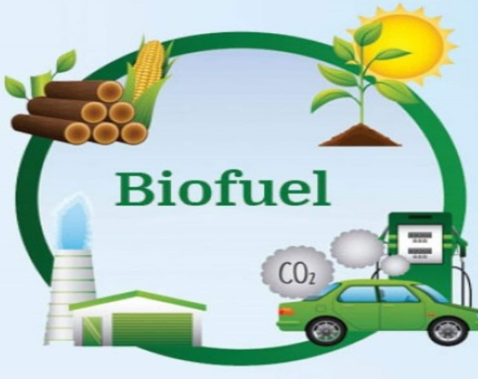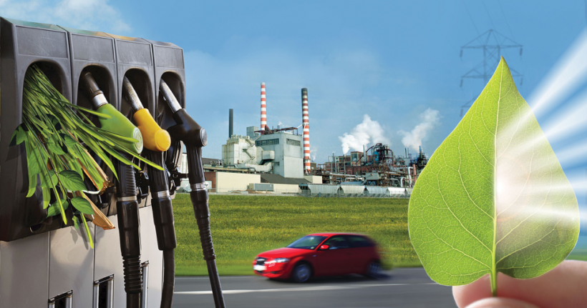
Biopower- Biopower gives subsidy on flaming or burning, bacterial breakdown, and transformation of gas or liquid fuel. Biopower uses biofuel in similar procedure to those recently used to generate energy to reach same results with more sustainable derivation. These techniques allow biofuel to be transforming to a state in which it can be burned energy as an exchange for coal or natural gas.
Bioproducts- Bioproducts are not a direct root of energy like the other operate of bioenergy, it extend a special service in coping petroleum in the use of consequence such as oil, grease wax, and industrial substances. This use of biofuel or biomass can reduce our dependence on fossil fuels and provide productive welfare.
[4]Types of bioenergy or Eco-clean energy
It contains biogas, biodiesel and bioethanol, which collected from the plants (corn, sugarcane), wood, agricultural wastes, and bagage. Eco-clean energy is deliberating renewable because its source is unlimited or limitless as plants obtain their energy from the sun through photosynthesis which can be restored.
Biogas- Biogas is not any particular gas name but it is a name of different type of gases. Occasionally called swamp gas, marsh gas, compost gas, sewer gas in the US. Biogas is a naturally happen and renewable source of energy, derive from the disintegration of biotic (living) matters. Biogas is not to be distracted with 'natural' gas, which is a finite-resource of power.
Biodiesel- Biodiesel is a sustainable or infinite, recyclable fuel produced domestically from animal fats, vegetable oils or converted from restaurant oil waste. Biodiesel converge couple of the biomass-based diesel and mostly advanced biofuel essential for the sustainable Fuel Standard. Renewable diesel is specific from biodiesel
[5]Eco-clean energy examples- Britain’s electricity affords bear a magnificent conversion from crude oil to eco- clean energy. Wind is the low cost and huge granter, with climbing quantity of solar on the grid. The bioenergy group covers various different methods of producing energy from biological substances. Few types of bioenergy are difficult, such as flaming trees for fuel, or first origination biofuel. But it’s important to accept and differentiate between good and bad eco-clean energy.
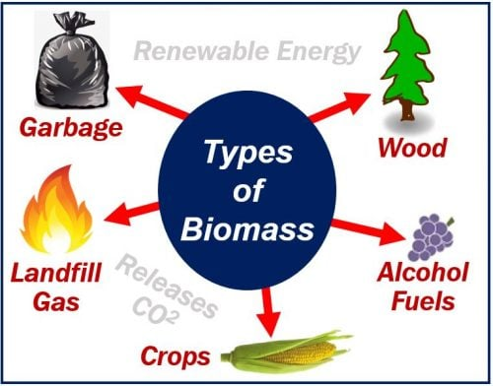
Cultivation or farming waste-There is so many useless products which we get from farming or agriculture that can be used for energy. Like slurry from animal ranch, sugarcane bagasse i.e. wastage of burning sugarcane, and maize production also assent plentiful waste biomass. In the Philippines, coconut shells and those shells are ignited whether for energy or for heat in food scorching. Remit biological substances to the soil is important for continuous agriculture, and few can be nourish to animals too, if the energy is generated by fermentation digestion rather than burning, the condensation can fix be used as manure.
Food and trading waste- obviously, we should not waste food, but there is every time going to be a definite amount of it, particularly at the economic level. This can be recycling for energy. The food waste could come from restaurants, homes through
committee waste bins, and there are also wastes from manufacturing that can be incorporated. Waste from woodland can also be helpful here, embrace wood shaving or thinned-out trees. This is especially useful in mingled heat and power plants; therefore that electricity from burning isn’t wasted.
[6]Techniques how energy generates- Abundantly electricity produced from biomass are generated through direct ignition. Biofuel is scorched inside a vessel to generate high-tension condensation. Here condensation flows up a succession of turbine blades, foster it to revolve. Revolve about the turbine drives a electric generator and generating electricity. Direct ignition is nearly common technique for transforming biomass to functional energy. All biofuel can be scorched continuously for warming buildings and aqua, for regulating commercial procedure of heat, and for producing electricity in condensation turbines. Thermo chemical transformation of biofuel contains biogas and desulphurization.
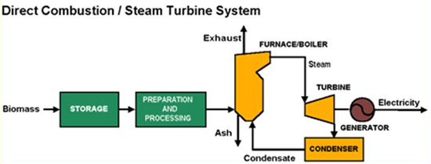
A simple direct combustion or steam turbine technique is invented of various factors. Due to condensation cycle, Here consists of some subsequent elements are -
- Cooling tower
- Combustor / furnace
- Condenser
- Exhaust / emissions controls
- System controls (automated).
- Steam turbine
- Generator
- Boiler
- Fuel storage and handling equipment
- Pumps
- Fans
[7]Biofuel energy for conveying- Sustainable energy roots, biomass can be changed immediately into liquid fuels, called "biofuel," to assist join shipping fuel needs. Generally there are two types of biofuel. Which we use currently are biodiesel and ethanol, each of which shows the initial or first generation of biofuel mechanics.
Biodiesel is a manufacture residentially, clean-ignition, renewable substitute for petroleum diesel. Through biodiesel as an automobile fuel increases energy protection, better air quality and the surroundings, and supply security advantage.
An aeronautical biofuel or bio-jet fuel or bio-aviation fuel (BAF) is a biofuel used to power aircraft and is said to be a sustainable aviation fuel (SAF). The International Air Transport Association (IATA) examine it a essential to lessen the carbon impression within the surrounding shock of aviation.

[8]Eco-clean energy uses in daily life- Biomass- i.e. algae, biological plant, useless materials etc. uses every day. Which we use in personal care products, drink kettle, nutritional addition, and fuel. Entire these commodities are encouraged growing our bioeconomy-a condition used to elaborate the addition of generous, sustainable, residential biomass to the U.S. wealth. Their mass- production also expands U.S. energy security and approving American jobs.
Aroma and Beauty Products- Bioproducts source materials can be utilize to produce a variety of particular care products, such as lotion, sun-tan oil, shampoo, mascara, and many more. For example, the acetone(C3H6O) is also known as propanone in our nail paint remover can be produced by evaporation of plant sugars, Although the palmitic acid that gives your hair that polished shining after you condition is one of the most common hydrogenated fat found in plants and bacteria. Due to the demand of government has modernized commercial interest in biobased beauty products, and innovations in biotechnology are making these materials low priced and more expertly to produce.
Nourishment Supplements and Food Preservatives- Seaweeds are highly oil manufacturer capable of producing up to 5,000 US liquid measure of oil per yard. The oil gathered from seaweeds can be converted into renewable fuels or used in different implementations. For example, a number of nourishment supplement brands are take out or extracting omega-3 fatty acids, generally found in fish oils, directly from seaweeds. In addition, some food taste can also trace their origin from biomass. Cellulose, A biotic material that gives plants their strong structural support, can be transform into sustainable chemicals for the aroma commerce.
Washing powder and Cleaning Commodities- The strength of washing power and janitor duplicity in their ability to abolish undesired matters from surfaces. They expected this unique feature to two classes of chemicals- surface active agent and solvents-one and the other of the chemicals are manufacture from biomass. These renewable chemicals are constructing in washing detergents, sprinkling cleaners, and different cleaning products etc.
Polymers (Plastic) and more Materials- Renewable polymers can supply the identical assortment and dependability of conventional polymers but they are assembling from sustainable, vegan substances. Some agencies have already started to merge these new materials into their consequence lines. For example, BETO funded Virent Inc’s BioForming, Automation to transform plant material into a polymer substance that can be used to manufacture clothing fibers and receptacle for fluids. Coca-Cola manipulates this mechanism to offer consumers its 100% biobased and reprocess Plant Bottle.

[9]Pros and Cons of eco-clean energy-On the pros side, Eco-clean energy is a globally feasible, dependable sort of eco-clean energy. Harvesting biofuel for power can as well assist us lessen waste. Although, there’re cons want to think about: compared through other root for power, biomass perhaps costly to store, conveying, and collect.
Pros
- Eco- clean energy a reliable origin of sustainable energy. There will not ever have a deficiency of waste that can be transform to energy. Besides, there is debris, dung and crops will be biomass to produce bioenergy.
- Eco-clean energy can be keep with little energy dropping,
- Assuming that there is agriculture will be a continuous energy origin.
- Bioenergy release little or no glasshouse gas discharge and is carbon neutral. The carbon that is generating by biomass is resorbing by the next crop of plants.
- Eco-clean energy coupled as a waste disposal estimate.
- Bioenergy crops help balanced soils, enhance soil fertility, and reduce erosion.
- Eco-clean energy is an origin of clean energy, the use of which cans outcomes in tax credits from the US government.
- Bioenergy decreases the need for garbage a lot.
- Usually, Eco-clean energy plants are sending able, meaning that can comfortably be turned on or off. This grants more relevant for power grid operators to acknowledge to times of consumption point.
Cons
- Utilizing timber from natural forests can lead to erosion if the forests are not replanted.
- The expenditure of shipping, harvesting, and treatment of biomass can be pricey.
- Conserving and processing of biomass essential large amounts of capacity.
- Several fuel origins are seasonal.
- However, contend with food production in certain cases.
- Eco-clean energy plants have a large impression and require a lot of capacity, freeze the location options.
- Most of the renewable energy, like solar power, is notably more area-efficient.
- Eco-clean energy production basically creates liquid power like biodiesel or ethanol that can then be used in other applications also like ignition mechanism. Although, electric motors can be 3-4 times more or repeatedly well organized than internal ignition mechanism, which make eco-clean energy much less fertile in terms of power for vehicle convey.

[10]Propagation or generation of Biofuel-Renewable energy research and expansion has showed us to three different generations of biofuel. Individual generation has isolated raw materials and its own possible advantage and disadvantage. If we conversation about first generation biofuel, we are mention to biofuel from an alive raw crop such as corn grain alcohol. Second generation biofuel are obtained from polysaccharide biomass such as everlasting or perennial grasses. Third generation biofuel are to be made from seaweed or algae.
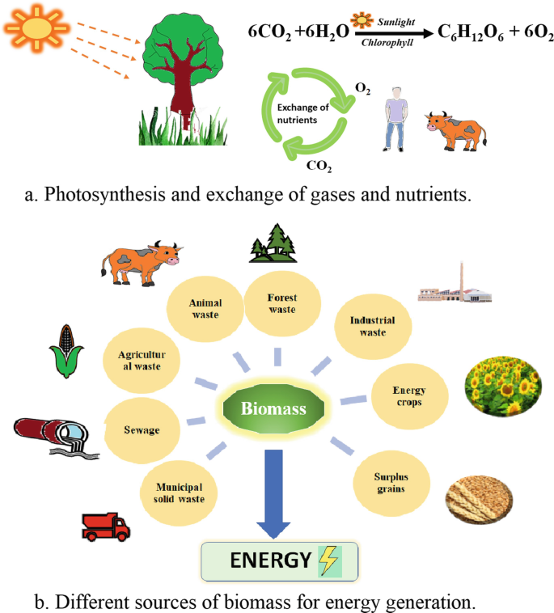
First Generation Biofuel - The first generation biofuel are originated from cellulose, vegetable oil. Purifying these components to become a transportation fuel requires simple biochemical operations for cellulose to ethanol or vegetable oil to biodiesel. These procedures have previously been grown up in the food industry, confining the need for advance research and expansion before generating transportation fuels. Although, those crops need accelerated agricultural production (fertilizer), as unfavorable to less input for everlasting or perennial grasses.
Second Generation Biofuel - The second generation biofuel are normally to be derived from polysaccharide or cellulosic biomass origin comprises crop debris, everlasting or perennial grasses, and trees. They may be grown on marginal meadow where raw crop generation is not beneficial. By devote one to areas that are tremendously consumed or have marginal land condition, this keep away from competition with productive ground that may be best used to grow food yield or crop.
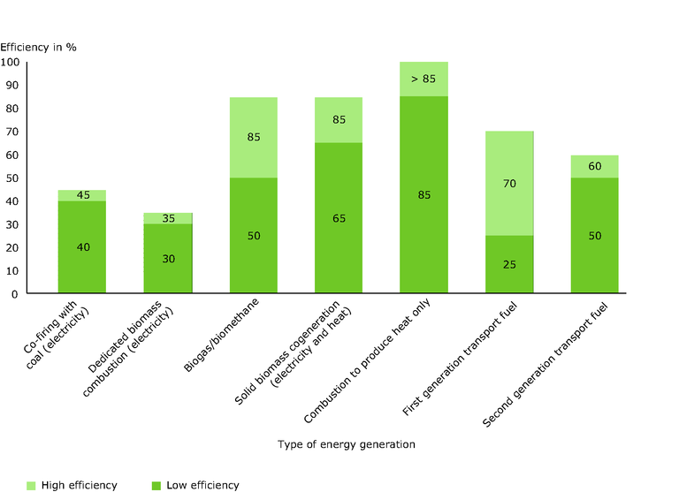
Third Generation Biofuel – The third generation biofuel biomass or oil is gathered from seaweed or algae. An oil manufacture alga (so call Oilgae) does not need arrangements, and expand rapidly. Although, protecting the environment for ideal growth is demanding and costly.
[11]Conclusion- At last in conclusion, biomass energy is a manifestation of sustainable energy that possess the certain implicit to play an essential role for every progression toward a more renewable or eco-clean energy for upcoming. Its eco-friendliness, that’s why also known as eco-clean energy, low influence on the environment, and possible to construct local jobs make it an alluring alternative for countries around the world.
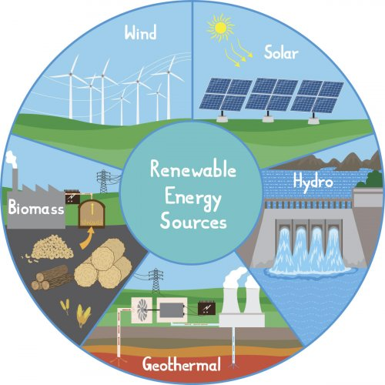
IMPACT OF RENEWABLE ENERGY PROJECTS-SOURCE-Internet

