Microcontroller based solar powered seed sowing machine
INTRODUCTION
India is the country of agriculture. Agriculture is the main profession of India. The economic condition of India depends strongly on agriculture. Therefore, it is necessary to adopt newer techniques and skills to improve the yield of agriculture. At the same time, the population of India is growing day by day. Hence it becomes necessary to improve the profession of agriculture in order to full fill the demand. There are various activities one need to carry out for effective farming. One among is seed sowing process. It is one of the tedious, time consuming and laborious work. There are various traditional methods of seed sowing. They are discussed in brief here.
  - Traditional Sowing Methods
Sowing of Seed is the processes of putting the seed in the soil at a particular depth for good germination. The conventional methods include manually broadcasting, opening furrows by a country plough and dropping the seeds by hand and dropping seeds in the furrow by a bamboo/metal funnel attached to a country plough. For sowing in small areas dibbling i.e., making holes or slits by a stick or tool and dropping seeds by hand, is practiced.
1.1.1: Animal drawn multi-crop planter
In earlier days animals were used to sow the seed. One such method is shown in Fig.1.1.
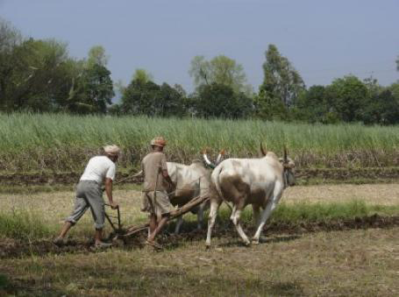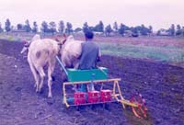
Fig.1.1 (a) Fig.1.1 (b) Fig.1.2
Fig 1.1 (a) and (b) Animal drawn multi-crop planter Fig 1.2The tractor operated seed sowing

Fig 1.1 (a) shows common method of seed sowing. In this method seed sowing is carried out using two oxen. Two persons are involved. One is for preparing the furrows and another for sowing the seed. Fig 1.1 (b) shows animal drawn 3-row planter is a multi-crop planter for planting of bold and small seeds. The planter is also suitable for sowing of inter-crops as different seeds can be filled in different boxes. These traditional methods are time consuming. Hence to save the time, machine operated seed sowing technique has come up.
1.1.2Tractor operated seed sowing
For planting of bold and small seeds tractor operated 6-row inclined plate planter which is a multi-crop planter is used. It is having a frame with tool bar, modular seed boxes, openers for furrow and a system for ground drive wheel. It will have six modular design seed boxes with inclined plate type seed metering mechanism which acts independently. Different types of Seed plates for sowing different seeds can be selected and changed as desired. The plate thickness, number and size of cells on seed plate vary according to seed size and desired plant-to-plant spacing. For operation, the seed is filled in the hopper, seeds are picked up by the cells of inclined plate and delivered in the opening connected to furrow opener through seed tubes. Shoe type furrow openers ensure deep seed placement in moist zone for sowing under dry land condition. Modular seed box-furrow opener units are adjustable for sowing seeds at different row-to-row spacing. By changing the transmission ratio the plant to plant spacing can be changed.
1.1.3 Limitations of Traditional Sowing Methods of Seed
- In manual method of sowing the seeds, it is difficult to attain uniformity in
spacing or distributing the seeds.
- Farmer may sow at the required rate but inter- row and intra – row spacing
Of seeds is likely to be uneven which results in bunching and gaps in field. The
control over depth of seed placement may not be good.
- Because two persons are required for dropping seedand Fertilizer labor
requirement is high.
- The effect of inaccuracies in seed placement on plant stand is greater in case of
crops sown under dry farming conditions.
- Use of tractor works out to be costlier and is not environment friendly.

To overcome the above said drawbacks, it is required to design a low cast, automatic and environment friendly sowing machine for seeds.
METHODOLOGY
The method used for the implementation of the work is described with the help of block diagram and is shown in Fig 1.1.
POWER
MANAGEMENT
CIRCUIT
PV CELL
OR
SOLAR PANEL

BATTERY PACK
POWER SUPPLY CIRCUIT

IC REGULATOR (+5V SUPPLY)
MOTOR 3
GEAR MOTOR

MEGA AT 2560
CONTROLLER

MOTOR 1
JOHNSON MOTOR

DRIVER CIRCUIT
DRIVER AND POSITION CONTROL
SEED NOZZEL AND ARMS
MOTOR 2
JOHNSON MOTOR

LCD DISPLAY
SEED CONTAINER

IR SENSOR

BLUETOOTH MODULE
BUZZER

Fig. 1.3Block Diagram of sowing machine for seeds
In the diagram, motor 1 and motor 2 are used for driving the sowing machine of seeds. The third motor is used for controlling the opening as well as closing of the nozzle of the seed container. These motors are powered from the energy generated by the solar PV cell. The controlling operation of the machine is carried out using microcontroller. Blue tooth module is used for giving controlled signal for the to and fro movement of the machine. The sensors are used to check the status of the container to indicate whether it is empty or not. The buzzer is used to indicate the empty status of the seed container.
The logic used in the work is given in the Fig.1.2
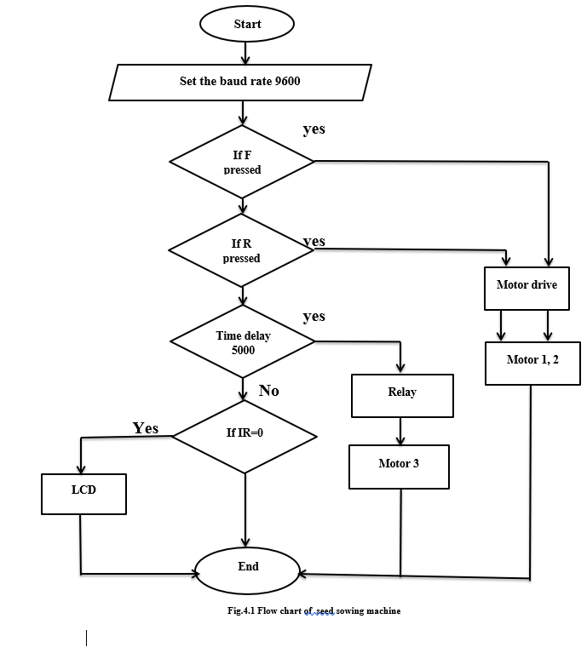
Fig 1.2 Flow chart
On receiving the signal from blue tooth module and IR sensor, microcontroller generates signal to drive the motors and display the information on the LCD. Buzzer indicates the empty condition of the seed container.
3.0 HARDWARE COMPONENTS
The hardware components used for fabrication and operation of the sowing machine of seeds are.
  - Mechanical components
The mechanical hardware components used for the fabrication of the machine are frame, Hopper, Disc Shaft and Plough
  - Electrical components
The electrical hardware components used for the operation of the seed sowing machine are: Solar panel, Johnson motor, AT MEGA 2560 Microcontroller,7805 voltage regulators, LCD display, Driver circuit, Gear Motor, Blue tooth module, IR sensor,Photo diode and relay
The interfacing of all these electrical components for their controlled operation is shown in Fig.1.3

V 1KΩ GND
PHOTO DIODE
ZCD
D7 D6 D5 D4 RS E VCC GND

A1 VCC
A0 2
3
4
5
6
MICRO - CONTROLLER
MEGA-AT 2560
9
10
11 8
12
RX

12

BUZZER

+5V
+12V

+5V
IN1
IN2
IN3
IN4
OUT1
L293 DRIVER CIRCUIT
OUT2
OUT4 OUT3

+VCC
M331
BLUETOOTH
TX
VCC
M2

+ 5V
M1

Fig 3.15 Interfacing all the components with microcontroller

4.0 Results and discussions
The complete assembly of the machine is shown in Fig 1.4.

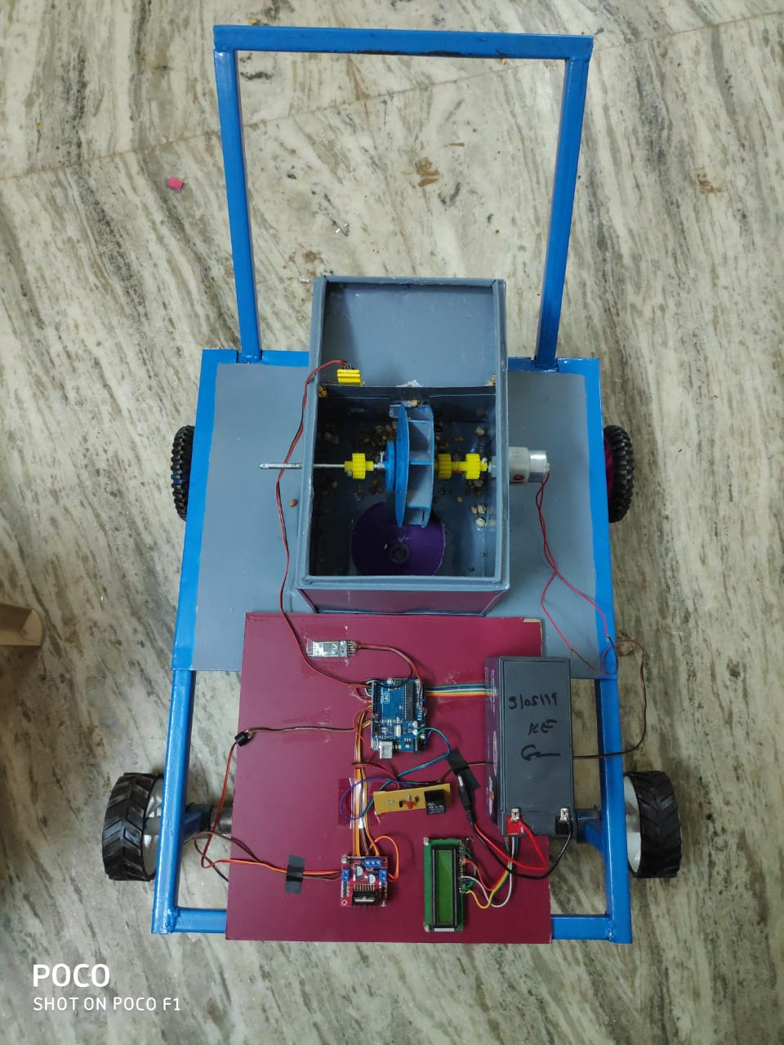
Fig 1.4 Model of Seed sowing machine
The speed of the Johnson DC motor and gear motor is controlled by varying the delay. As the delay increases, the voltage applied decreases, hence the speed of the DC motor and gear motor decreases. This results in increase in distance between the seeds. The results are shown in the Table 1.1 and Table 1.2 and in Fig 1.5
Table 1.1 Speed of the motors and time delay
Time Delay | Johnson motor speed | Gear motor speed
1 sec | 2.5 R.P.S | 0.25 R.P.S
1.5 sec | 1.6 R.P.S | 0.1 R.P.S

From this table it is clear that the speed of the motor is controlled by controlling the delay in the program.
\

Table 1.2 Seed to seed distance and Time delay
Time Delay  (seconds) | Seed to seed distance  (mm)
1 sec | 190
1.5 sec | 280
2 sec | 350
2.5 sec | 400

Fig.1.5 Relation between seed to seed distance and time delay

From the tables 1.1 and 1.2 it is clear that as the delay increases the distance between seeds will also increase.

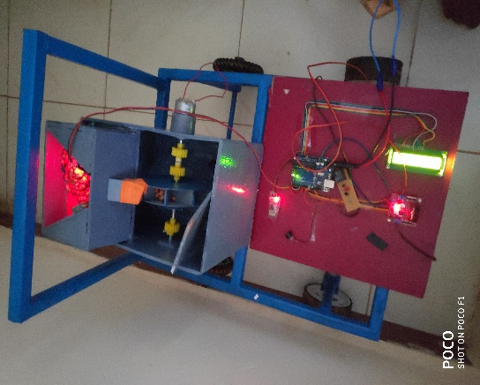
The condition of the seed container whether it is full or empty is also checked and results are presented in the Fig 1.6

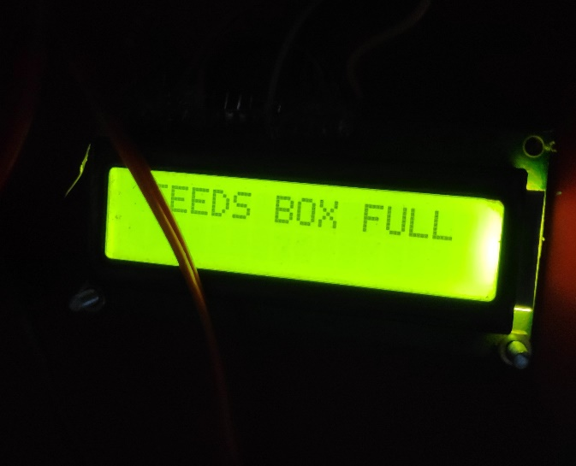
(a)

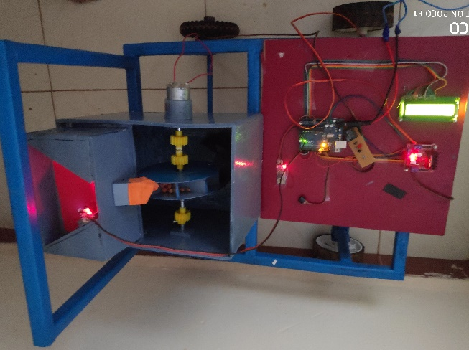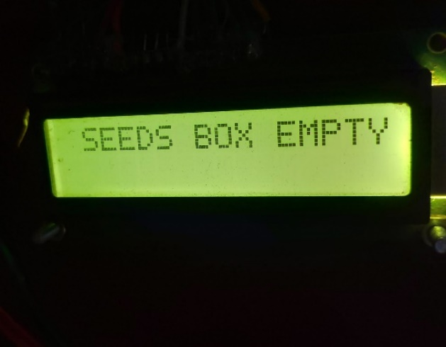
(b)
Fig.1.6 Seed Container condition (a) seed container is full (b) Seed container is empty

The Fig 1.6 (a) shows that, when seed sowing machine’s container is full the IR Sensor does not send a signal to the buzzer through Arduino so it does not make sound. The LCD displays that “seeds box is full”.

The Fig 1.6 (b) shows that, when seed sowing machine container is empty, IR Sensor sends a signal to the buzzer through the Arduino so it makes sound then the LCD displays that “seeds box is empty.
From the results, it is seen that the operation of the machine is easy. The distance between the seeds can be controlled very easily simply by changing the delay in the programme.
The condition of the seed container is monitored and displays the status. Hence, it is possible to carry out effective sowing, which intern results in increased yield and reduces labour cost and time. The machine works out to be cheaper as it is fed by solar.
REFERENCES
[1] A. R. Kyada& D. B Patel, “Design And Development Of Manually Operated Seed Planter Machine” of Lecture 5th International & 26th All India Manufacturing Technology, Design and Research Conference (AIMTDR 2014) , IIT Guwahati, Assam, India. Vol 2. Dec. 2014
[2] D. Ramesh , H.P. Girishkumar, “ Agriculture Seed Sowing Equipments: A Review” , ISSN N0.:2278-7798,Vol.3. July 2014.
[3] A.Kannan , K. Esakkiraja , S. Thimmarayan, “Design And Modification Of Multipurpose Sowing Machine” VOL:2 ,ISSN (ONLINE): 2321-3051, Jan. 2014.
[4] Roshan V. Marode, P.Gajanan, and K.Swapnil , “Design & Implementation of Multiseed Sowing Machine”, Vol : 2,No. 4, Oct. 2013.
[5] A.Rohokale , “International journal of advanced agriculture system with proper seed spacing”. 2004
[6] B.Shivaprasad, M. Ravishankara, B.Shoba “Design And Implementation Of Seeding And Fertilizing Agriculture Robot” , Vol. 1(3), pp.190-213, 2010.

