Chapter: Understanding Ventilator-Associated Pneumonia (VAP)

- Introduction:
Ventilator-associated pneumonia (VAP) is a significant lung infection that develops 48-72 hours after endotracheal intubation. It is characterized by the presence of new or worsening lung infiltrates, systemic signs of infection such as fever and altered white blood cell counts, changes in sputum characteristics, and the identification of causative pathogens [1]. In this chapter, we delve into the pathogenesis, microbiology, and transmission of VAP, shedding light on the intricate factors contributing to its development.

- The Pathogenesis of VAP:
The development of VAP is influenced by a complex interplay of factors, including the presence of an endotracheal tube, bacterial invasion, and host immunity. The primary risk factor is the endotracheal tube, which compromises the body's natural defenses against microaspiration near the tube's cuff. Microaspiration can occur during intubation, leading to the formation of bacterial biofilms within the tube. These biofilms, typically composed of Gram-negative bacteria and fungi, provide a direct route for infectious agents to reach the lower respiratory tract. Additionally, the pooling and trickling of secretions around the cuff, impaired mucociliary clearance, and gravity-dependent mucus flow further facilitate bacterial access to the lower airways [2].

- Microbiology of VAP:
The microbial profile of VAP varies depending on the duration of mechanical ventilation. Early-onset VAP, occurring within five days of intubation, is commonly caused by antibiotic-sensitive bacteria such as Streptococcus pneumoniae, Haemophilus influenzae, and Staphylococcus aureus (including methicillin-sensitive strains). In contrast, late-onset VAP, manifesting five days or more after intubation, is frequently attributed to multidrug-resistant pathogens like Pseudomonas aeruginosa, Acinetobacter baumannii, methicillin-resistant Staphylococcus aureus (MRSA), and extended-spectrum beta-lactamase-producing bacteria. The choice of antibiotics for treatment is influenced by the timing and nature of the infection [2].

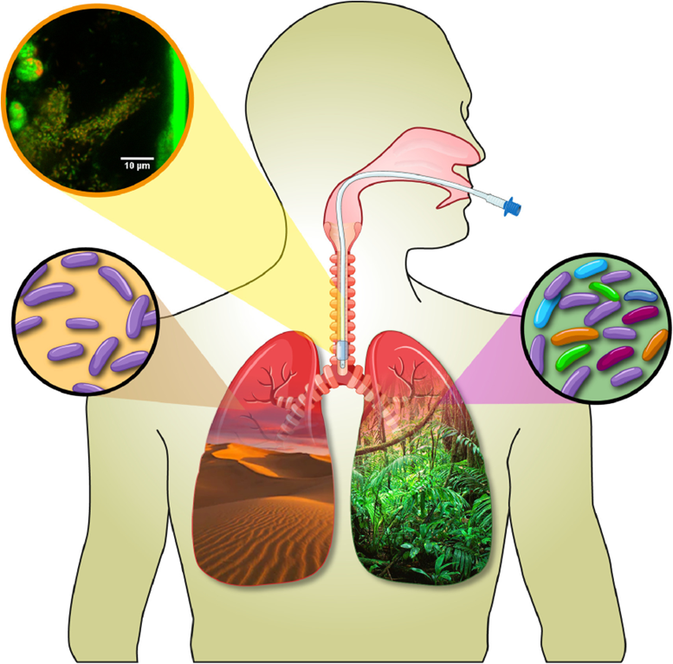
Fig 1: Microbiology of VAP

- Transmission of VAP:
Acinetobacter baumannii, a notorious opportunistic pathogen, is responsible for various nosocomial infections, including VAP. It possesses innate and acquired mechanisms that confer resistance to a wide array of antibiotics, making treatment challenging [9]. The pathogens responsible for VAP, their frequencies, and mechanisms of multi-drug resistance are as follows:

Pseudomonas (24.4%): Upregulation of efflux pumps, downregulation of outer membrane porin channels, and acquisition of plasmid-mediated metallo-beta-lactamases [2].
Staphylococcus aureus (20.4%, with >50% being MRSA): Synthesis of penicillin-binding proteins (PBPs) with reduced affinity for beta-lactam antibiotics, encoded by the mecA gene [2].
Enterobacteriaceae (14.1%, including various species): Production of AmpC-type enzymes through plasmid-mediated extended-spectrum beta-lactamase (ESBL) synthesis [2].
Streptococcus species (12.1%).
Hemophilus species (9.8%).
Acinetobacter species (7.9%): Production of carbapenemases or metallo-enzymes.
Neisseria species (2.6%).
Stenotrophomonas maltophilia (1.7%).
Coagulase-negative Staphylococcus (1.4%).
Others (4.7%), including fungi, Corynebacterium, Moraxella, and Enterococcus [2].

- Diagnosis of Ventilator-Associated Pneumonia (VAP)

Introduction:
The accurate and timely diagnosis of Ventilator-Associated Pneumonia (VAP) is essential for effective management and treatment. In this chapter, we explore various diagnostic methods and tools used to identify VAP, shedding light on their advantages, limitations, and recent advancements.

- Diagnostic Approaches:

Chest X-rays and Lung Ultrasound:
Chest X-rays are routinely conducted in the Intensive Care Unit (ICU) for mechanically ventilated patients, with infiltrates or consolidations often considered indicative of VAP. However, several clinical conditions can mimic VAP on radiographs, including aspiration, atelectasis, congestive heart failure, acute respiratory distress syndrome (ARDS), pleural effusion, and intra-alveolar hemorrhage. Thus, relying solely on chest radiography is discouraged. VAP diagnosis should incorporate a combination of diagnostic tools, including lung ultrasounds, which have shown superiority over bedside chest X-rays and comparability with chest CT scans for VAP diagnosis [3].

Clinical Diagnosis:
Common clinical indicators of VAP include leukocytosis, purulent tracheobronchial secretions, and the presence of a new or expanding infiltrate on a chest radiograph. However, unlike community-acquired pneumonia, established clinical criteria alone are only partially useful for diagnosing VAP [3].

Radiologic Diagnosis:
Portable chest radiographs, while essential, exhibit both sensitivity and specificity limitations. VAP diagnosis through chest X-rays is further complicated by the variability in interpretation and film quality. Notably, VAP can be improbable if a chest X-ray appears normal. In certain cases, computed tomography scans have revealed opacities missed by portable chest X-rays [3].

Microbiologic Diagnosis:
Cultures of pleural fluid and blood are essential for confirming VAP diagnosis. Even if VAP extends to the blood or pleural space in only a minority of cases, treatment is initiated when organisms known to cause pneumonia are cultured. As such, specialists often recommend two rounds of blood cultures and thoracentesis when non-loculated pleural effusions less than 10 mm in diameter are identified on lateral decubitus chest radiographs. The use of ultrasonography guidance may be necessary for loculated effusions. It's important to note that the sensitivity of blood cultures for VAP diagnosis is less than 25% [3].

Advances in Diagnostic Techniques:
The use of next-generation PCR techniques, specifically digital PCR (dPCR), offers advantages over traditional PCR methods, including higher sensitivity and the ability to overcome PCR inhibitors. dPCR provides absolute quantification without the need for a standard curve and offers excellent consistency. This technology has the potential to enhance the early identification and management of VAP [4].

The INHALE Trial:
The INHALE Randomized Controlled Trial explores the use of molecular diagnostic technology, such as the BioFire FilmArray, to guide antibiotic treatment for Hospital-Acquired Pneumonia (HAP) and VAP. This technology enables rapid identification of infections and antibiotic resistance, aiding in timely and targeted treatment decisions for critically ill patients [5].

Diagnostic Kit Parameters:
Effective diagnostic tests play a crucial role in clinical practice. To guide clinicians in their decision-making, diagnostic tests must meet specific criteria, including sensitivity, specificity, predictive values, and likelihood ratios. These parameters help determine the accuracy and reliability of diagnostic tools, ensuring that they are effectively applied in patient care [6].

Primer Design for PCR:
The success of PCR assays depends significantly on the design of primers. Primers must be carefully crafted to ensure perfect sequence alignment with the target fragment for amplification. Various factors, such as primer length, melting temperature (Tm), CG content, and nucleotide sequence composition, influence primer design. Understanding these factors is essential for creating effective PCR assays for VAP diagnosis [7].

Determining Optimal Annealing Temperature (Ta):
The optimal annealing temperature (Ta) is a critical parameter in PCR assays. It represents the temperature range where PCR amplification efficiency is highest without generating non-specific products. Ta is influenced by the primer quality, the Tm of the primers, and the length of the PCR fragment. Achieving the ideal Ta is crucial for the success of PCR-based VAP diagnostic tests [7].

- Conclusion:
In conclusion, ongoing research is rapidly expanding our knowledge of the fundamental mechanisms underlying Ventilator-Associated Pneumonia (VAP). This growing understanding holds the promise of uncovering potential therapeutic targets aimed at enhancing the body's defense mechanisms, mitigating lung injury, and preventing infections. Given the rising challenge of antimicrobial resistance and the limited discovery of new antibiotics, it is imperative that we continue to invest in studies focused on unraveling the intricate mechanisms of VAP. These efforts are essential in our quest to develop innovative approaches for both prevention and treatment in the battle against this serious healthcare-associated infection [8].

- References:

- Kalanuria AA, Ziai W, Mirski M. Ventilator-associated pneumonia in the ICU. Crit Care. 2014 Mar 18;18(2):208. doi: 10.1186/cc13775. Erratum in: Crit Care. 2016;20:29. Zai, Wendy [corrected to Ziai, Wendy]. PMID: 25029020; PMCID: PMC4056625.
- Zhou H, Gebhardt MJ, Czyz DM, Yao Y, Shuman HA. The gigA/gigB Genes Regulate the Growth, Stress Response, and Virulence of Acinetobacter baumannii ATCC 17978 Strain. Front Microbiol. 2021 Aug 4;12:723949. doi: 10.3389/fmicb.2021.723949. PMID: 34421881; PMCID: PMC8371402.
- Gaber, Sayed∗; Tayeh, Osama; Wahab, Khaled A.; Mohamed, Nader; Essawy, Tarek. Early Detection of Ventilator-Associated Pneumonia: Bedside Tools. The Egyptian Journal of Critical Care Medicine 7(2 and 3):p 74-79, December 2020. | DOI: 10.1097/EJ9.0000000000000015
- Merino I, de la Fuente A, Domínguez-Gil M, Eiros JM, Tedim AP, Bermejo-Martín JF. Digital PCR applications for the diagnosis and management of infection in critical care medicine. Crit Care. 2022 Mar 21;26(1):63. doi: 10.1186/s13054-022-03948-8. PMID: 35313934; PMCID: PMC8935253.
- High J, Enne VI, Barber JA, Brealey D, Turner DA, Horne R, Peters M, Dhesi Z, Wagner AP, Pandolfo AM, Stirling S, Russell C, O'Grady J, Swart AM, Gant V, Livermore DM; INHALE Study Group. INHALE: the impact of using FilmArray Pneumonia Panel molecular diagnostics for hospital-acquired and ventilator-associated pneumonia on antimicrobial stewardship and patient outcomes in UK Critical Care-study protocol for a multicentre randomised controlled trial. Trials. 2021 Oct 7;22(1):680. doi: 10.1186/s13063-021-05618-6. PMID: 34620213; PMCID: PMC8496625.
- Bruno P. The importance of diagnostic test parameters in the interpretation of clinical test findings: The Prone Hip Extension Test as an example. J Can Chiropr Assoc. 2011 Jun;55(2):69-75. PMID: 21629460; PMCID: PMC3095582.
- Ruslan Kalendar, David Lee, Alan H. Schulman, Java web tools for PCR, in silico PCR, and oligonucleotide assembly and analysis,Genomics,Volume 98, Issue 2,2011,Pages 137-144,ISSN 0888-7543
- Aykac, K., Ozsurekci, Y., & Tanir Basaranoglu, S. (2017). Future Directions and Molecular Basis of Ventilator-Associated Pneumonia. Canadian Respiratory Journal, 2017, 1–8. doi:10.1155/2017/2614602

