Internet of Things (IoT) and its different uses in agriculture
Rajeev Kumar, Sukanya Barua, V. Sangeetha
ICAR-Indian Agricultural Research Institute, Pusa, New Delhi-110012
Email: rajeeviitkgp11@gmail.com

Introduction

Internet of things (IoT) inaugurates new paradigm of agriculture which eradicates problem of high labour requirement, increases field of financial investors in rural areas, prosperity of farmers and facilitates productivity and sustainability. It also reduces time of data collection, analysis of collected data and decision making which are important for success of any sector.

IoT uses in agriculture will play the important role to reduce the labour cost and increase scope of the agricultural investors, prosperity of farmers, productivity and sustainability. Monitoring, surveillance, information collection, analysis of collected information and decision making are important component for success of any sector. Monitoring on real time data of agricultural system play a key role for reducing the cost of operation as well as input cost and enhance the rural labour efficiency in the farming system such as fish, livestock, and cattle farming. IoT enabled monitoring system of these farming is better than traditional human monitoring. Cost of IoT monitoring is very low as compared to farm labours.

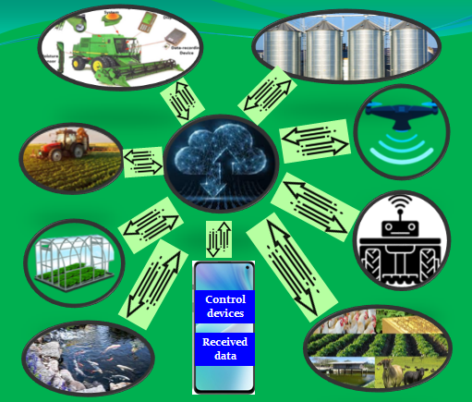

Fig. 1 Different agriculture systems control and monitor by IoT technology

IoT technology based monitoring of agricultural operation on real time may be incorporated in the crops cultivation practices, crop health assessment, identification of presence of insect in the crops, grain storage practices, quality and climate monitoring during the transportation of grain from farmer to mandi, monitoring of farm labour and management system, quality control during the value added product production inside the agricultural industry. IoT enabled monitoring may reduce the cost of farm manager and labours and also increase the work efficiency of farm labours. Controlling and monitoring may be used the same technology for different operation such as depth of tillage operation, recommended quantities of sowing of seed, fertilisation and chemical application, nutrient deficiency in the crops, losses during the harvesting and threshing by external human being. Climate parameter such as temperature and humidity, chemical and fertiliser application inside greenhouse may be monitored and control by IoT enabled transceiver. Temperature and humidity inside the storage structure and pest, disease and self-life of harvested grain may be monitored and controlled through IoT enabled devices. Quality control of finished product in the industry and efficient utilisation of industry employee from any place at low cost may be done through IoT embedded camera in the factory. Fishing on personal pond by the other unknown person, feeding to fish at proper time interval, cleaning of pond may be monitored and controlled by IoT enabled devices. Monitoring of Goat, pig and poultry farming for feeding, heath assessment, hygienic maintenance of farm, climate parameter, light condition, growth of cattle can be monitored from IoT monitoring gadget.

Natural input resource like water, seeds, fertiliser can be saved significantly by accurate application during crops cultivations. Improve the input efficiency and reduce labours and manager cost, managers don't need to keep for a long time on the farm, farmer can manage own farm from home or abroad even on holiday by using the IoT technology. New agricultural applications e.g. smart farming, precision farming and automation may be managed through IoT enabled devices to increase operational efficiency, lower the costs of operation, reduce waste, and improve the quality and quantity of yield.

IoT in agriculture technologies comprise specialized equipment, wireless connectivity, web and mobile software and IT services. Data are collected by smart agricultural sensors, visual monitoring camera, motion detector sensors, wearable digital devices and network of sensors. Agriculture practices can be controlled through actuator, robotics and autonomous vehicles, automated hardware, variable rate technology etc. Collected data may be received and transmitted using IoT transceiver or radio frequency devices, mobile terminals, WSN equipment and transmit these data to the cloud through IoT transceiver. This data can be used to track the state of the business in general as well as staff performance, equipment efficiency. The ability to foresee the output of production allows planning for better product distribution.

Common steps in IoT implementation
- Device and sensor deployment: This step involves installing IoT devices and sensors in the field. These devices and sensors can come in a variety of forms, including cameras, microphones, temperature sensors, and more. They can be connected to a network of gateways or edge devices that can transmit the data to a central location for analysis.
- Data collection and storage: Data is collected from the IoT devices and sensors and it transmitted to a central location, where it is stored for further analysis. This data can include sensor readings, device status and other information relevant to the particular application.
- Data analysis and processing: The collected data is analyzed and processed to gain insights and make decisions. Machine learning algorithms and other data analytics techniques can be used to identify patterns in the data, make predictions, and extract meaningful information.
- Actuation: Based on the insights gained from the data analysis, the system can take automated actions. For example, if a sensor reading indicates that a machine is about to fail, the system can send out a maintenance request, or send a message to an operator to shut down the machine.
In general overview of four steps in IoT implementation and there may be additional steps depending on the specific application and the complexity of the IoT system.

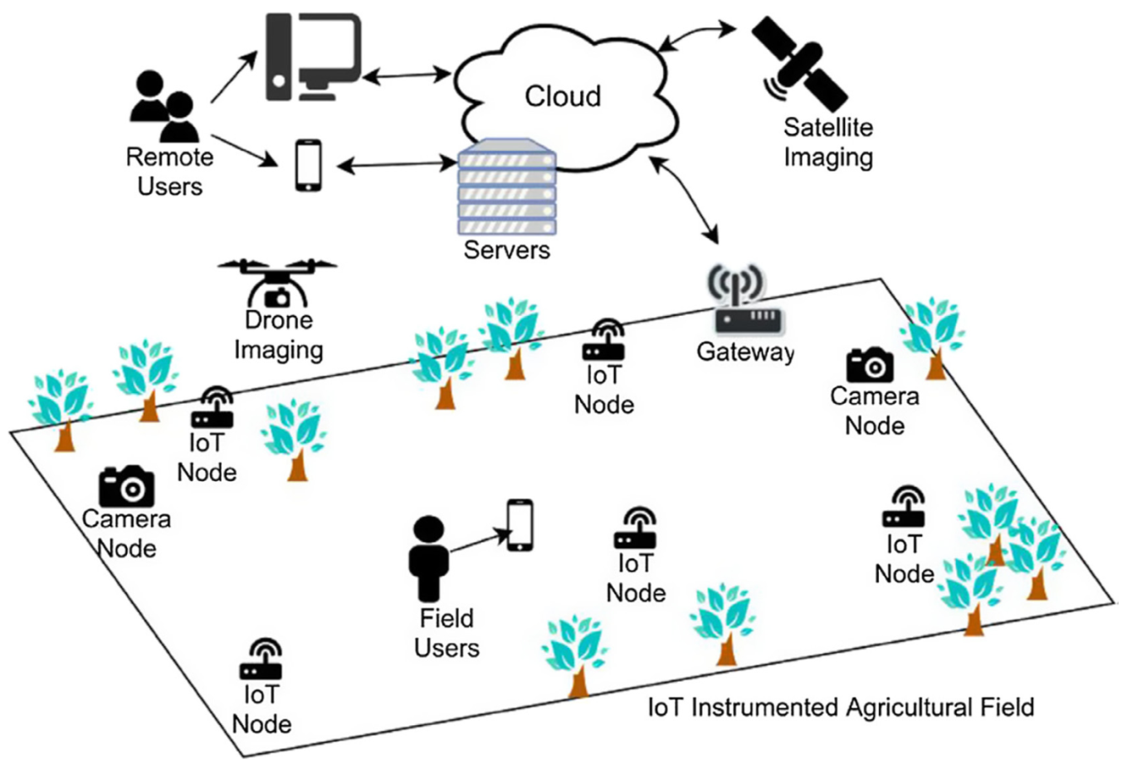

IoT Instrumented Agriculture Field

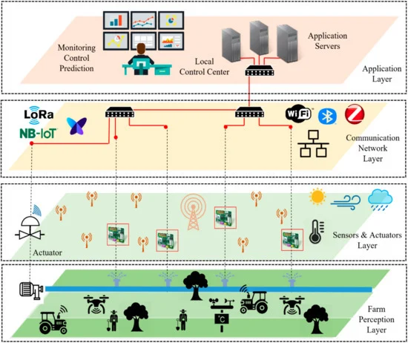

Layer of IoT in Agriculture

Applications of IoT in Smart farming

The use of technologies like the Internet of Things, sensors, navigational aids, robotics, and artificial intelligence on farm is referred to as "smart agriculture." The ultimate objective is to maximise the use of human labour while raising crop quality and yield. Smart farming is developed for monitoring the crop field with the help of sensors (light, humidity, temperature, soil moisture, etc.) and automating the irrigation system. The farmers can monitor crops field and control the operation from anywhere with the help of IoT-enable smart farming digital gadget for efficient farming as compared with the conventional farming approach. In addition to targeting conventional, large farming operations, IoT-based smart farming can also serve as a new lever for uplift of other rising or common trends in agriculture, such as organic farming, family farming (complex or small spaces, specific cattle and/or cultures, preservation of particular or high-quality varieties, etc.), and enhance the use of human labour and quality of crops and their yield.

Applications of IoT in Precision Agriculture

An information and technology based farm management system is used to identify, analyse and manage variability within fields by doing all practices of crop production in right dose, right input, and right place at right time in right way for optimum profitability, sustainability and protection of the land resource. It is a systems approach to farming for maximizing the effectiveness of crop inputs. Precision farming can be made the farming practice more controlled and accurate when it comes to raising livestock and growing crops. The use of information technology (IT) and other tools like sensors, control systems, robots, autonomous vehicles, automated hardware, variable rate technology, yield monitor etc are vital elements in this kind of farm management. Data may be saved on cloud and analysis is done online and the decision is executed with the help of attached IoT enabled transceiver with input application attached with prime mower. Inbuilt IoT transceiver with GPS module in the Robots, Autonomous Agricultural vehicles may be operated from any location. The same technology may be used in the variable-rate applicator and it can be operated from any location. Input such as fertiliser and seed may be sown by analysing yield statistics of previous year or by using a satellite yield map.

The IoT transceiver with GPS module and soil moisture probe technologies work together to offer complete local in-season agronomy support as well as suggestions for improving water use efficiency. These data are optimised in one location at the village level for water management so that consultants and farmers can profit from the advantages of built-in IoT precision irrigation.

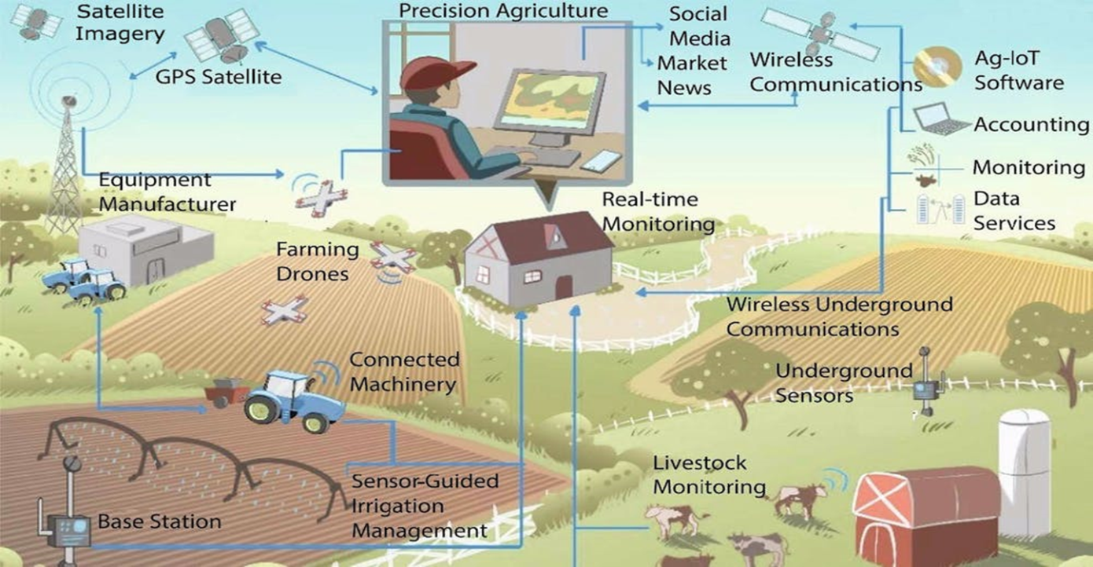

Concept of IoT enabled Precision Agriculture

Applications of IoT in the Agricultural Drones

Technology has changed over time and agricultural drones are very good example of this. Drones are being used in agriculture in order to enhance various agricultural practices. The aerial-based drones are being used in agriculture for monitoring the crop health assessment, need based irrigation, crop field monitoring, chemical spraying, forest seed planting and soil and field properties analysis. IoT transceiver with GPS module in the drones for gathering valuable data via a series of sensors that are used for image/video capturing, GIS mapping, multispectral and thermal reflection data, visual imagery during the flight and surveying of agricultural land etc. Chemical spraying by entering in the crop field especially for toll crop such as maize, sugar cane etc is very difficult task for any human being or sprayer with tractor. Chemical spraying by drone is one of very good option to be used in this crops.

Data received from IoT incorporated drone may be stored in the cloud, it may be used to determine plant health indices, plant counting and yield prediction, plant height measurement, canopy cover mapping, field water ponding mapping, scouting reports, stockpile measuring, chlorophyll measurement, nitrogen content in wheat, drainage mapping, weed pressure mapping, and so on from stored data at a centre.

Applications of IoT in the Livestock Monitoring

Large area farm holding owners may utilize IoT applications to record the data such as GPS location, presence of well-being, and health of their cattle. This recorded data helps them in identifying their animals that are sick so they can be isolated from the herd, thereby preventing the spread of disease. It also reduces the labour costs as ranchers can locate their cattle and also the cattle owners can observe their cows that are pregnant and about to give birth with the help of IoT based sensors.

Applications of IoT in the Greenhouses

Greenhouse farming is a methodology that helps in enhancing the yield of vegetables, fruits, cash crops, etc. Crops may be grown even in unseasonal period in the Greenhouse. Environmental parameters inside the Greenhouses may be controlled through manual intervention. Studies suggest that manual methods are less effective than modern options. Monitoring and controlling the climatic parameter via an embedded IoT technology in the greenhouse could eliminate the need for manual intervention. Different sensors that measure environmental factors accordingly to generate the ambient ambience and deliver the input as per plant demand are used to regulate the environment inside the IoT embedded greenhouse. A cloud server can be created outside of greenhouse for accessing the environment inside the greenhouse using IoT for eliminating the need of constant manual monitoring. IoT embedded design provides cost-effective and optimal solutions for farmers with minimal manual intervention. The IoT sensors in the greenhouse provide information on the light levels, pressure, humidity, and temperature and water requirement. IoT technology integrated Actuators automatically open/close the window, turn on/off lights, heaters, mister fans, pump.

Conclusion

The IoT applications in the agriculture are making it possible to collect useful data for farmers and ranchers. Large land holding owners, Agricultural investors and small farmers must understand the potential of IoT technology for operating agricultural operation by installing it in the farms to reduce the farm labours cost and increase the transparency of work and sustainability in their productions. Farmers may live their life more comfortable by using IoT technology in their crop fields. IoT enabled precision agriculture are being used to optimum input application to achieve high crop yields and reduce operational costs by knowing variability within the field and cattle. IoT enabled agricultural Drones are being used in agriculture in order to enhance various agricultural practices such as crop health assessment, difficult topography irrigation, crop field monitoring, chemical spraying in the tall crop, forest planting, and soil and field property analysis. Livestock tracking and geo-fencing Farm owners can utilize IoT applications to collect data regarding the location, well-being, and health of their cattle. IoT integrated Greenhouses may be monitored and control the climate and eliminate the need for manual intervention. IoT enabled Smart farming may reduce inputs and enhance productivity of fertilizer, water, utilization etc. and help in automating the irrigation system.

