Chemical Basis of Stability of Drug
Authors: Dr. Manisha Ashwin Tayde
Professor, HOD, Pharmaceutical Chemistry Department
SPE’s Smt. Narmadaben Popatlal Thakkar Institute of Pharmacy
Nasik 422003.
Maharashtra, India
Mail Id: mtayde82@gmail.com
ABSTRACT:
Pharmaceutical stability indicates the capacity of substance to maintain the predetermined levels of identity, potency, and purity over the period of its shelf life. This chapter's primary focus is on the pharmaceutical substances' chemical stability in the solid form. A marketable drug must remain stable in a variety of conditions, such as temperature and relative humidity extremes. The therapeutic efficacy and toxicological consequences of pharmaceuticals are influenced by their chemical instability. The chapter looks into the crystalline forms of pharmaceutical substances' chemical reactivity. It looks at several examples of solid-state reactions employed in pharmaceutical applications as well as solid-state reaction routes and procedures.
When drug molecule is subjected to different environmental variation its quality may changes over time and this has been shown in testing called stability testing. In order to examine approaches to increase some functional groups' stability during storage, this chapter gives summary of the chemical explanation for some functional groups' resistance to events like hydrolytic and oxidative degradation inside pharmacological molecules.
The chapter goes over the variables that influence how quickly chemical reactions occur. It outlines methods for reducing chemical reactions and/or stabilising medicinal ingredients.
Keywords: Stability of drug, Metabolism, Chemical Reactions,

1. INTRODUCTION
"Drug stability" refers to a drug's capacity to maintain its therapeutic effects during the course of storage or its shelf life. We all have likely observed the expiration dates on the several bottles of medications, liquids, and ointments we store and have likely pondered why some of them last longer than others. A number of factors, some environmental and others drug-specific, have an impact on the stability of a treatment.
Drug preparations must be made in a way that ensures a drug's proper bioavailability and its stability in connection with physical and chemical properties over the prescribed shelf-life since drug research and development must prioritise safety and efficacy (1).
Both chemical and physical changes might occur to a medication product. The first alters the chemical substance's form but not its chemical makeup, so no new or broken chemical bonds are created (2).
A drug's physical instability can occur in a variety of ways, including changes to how it looks, drug release, polymorphic alterations, adsorption, and more. On the other hand, chemical modifications describe alterations in the chemical structure brought on by drug degradation and interactions with excipients in the formulation. These modifications may lessen the drug's strength, raising questions about its usefulness, while also posing a safety risk because the breakdown products may be hazardous (3,4).
A drug's intrinsic feature of chemical stability is governed by its chemical structure. Due to the addition of other substances (such excipients), the dose form may create drug instability. Drug stability must also be checked during the drug's packaging, storage, and manufacturing processes. In this context, the issue of drug stability is a crucial one for both new and generic medications when conducting drug research and development. (5)
According to USP, product stability refers to how well a product maintains its original attributes during its entire shelf life. Our compounded preparation shouldn't undergo any alterations after its expiration date. The five categories of stability that make up a compound's overall stability are chemical, physical, microbiological, therapeutic, and toxicological. Chemical stability is nothing but the preservation of the chemical identity and potency of each active pharmaceutical ingredient (API). Physical stability means the preservation of characteristics like appearance, solubility, suspendability, and particle size. The preservation of resistance to microbial proliferation is referred to as microbiological stability. A prolonged therapeutic effect is referred to as therapeutic stability. There is no appreciable rise in toxicity, which is referred to as toxicological stability.
Chemical modifications are alterations in the chemical composition that result from medication degradation and interactions with excipients included in formulations. These modifications may lessen the drug's strength, raising questions about its usefulness, while also posing a safety risk because the breakdown products may be hazardous. (6)

1.1Factors affecting stability of drugs

USP 1191 discusses 11 elements that impact a product's stability. Heat, light, oxidation, and hydrolysis are the four most important and frequent elements for compounded medications out of those 11.

1.1.1Heat
In order to prepare several regularly compounded dosage forms, heat is needed. This comprises rapid dissolve tablets (RDTs), troches, lollipops, and suppositories. Compounders must exercise caution since several APIs, such as liothyronine sodium (T3) and oxytocin, are highly prone to degrading at temperatures below or close to those needed to create these dosage forms.
Making oxytocin troches is a common request. Troche bases normally need to melt between 50 and 65 degrees Celsius. At PCCA, we heated oxytocin to 55° C and held it there for five minutes in order to study the oxytocin's deterioration. 10% of the oxytocin's efficacy was lost. This shows that oxytocin shouldn't be exposed to heat and that using a troche instead of another dose form, like sublingual drops or sprays, is a good idea.
Seasonal temperature variations should also be taken into account, particularly if the compound is being delivered. In those weather conditions, insulated shipment packaging might be required. Taking this into account when acquiring chemicals is also important.
Additionally, heat always quickens chemical processes. Each 10° increase in temperature may result in an exponential rise in the pace at which an API degrades when considering processes like hydrolysis and oxidation. For instance, a medicine that is vulnerable to hydrolysis and is exposed to a 20° increase in temperature may lose up to 96% of its shelf life in an extreme scenario detailed in USP Chapter 1191. This scenario does not apply to all hydrolizable compounds, but it does highlight the importance of understanding how heat can impact a medicine.
- The broad temperature ranges needed to prepare different dosage forms that need to be heated are listed below; however, the actual temperature may vary depending on the formula's contents, including the base employed, and the process. For instance, RDTs can be baked at 80° C for 30 minutes instead of the standard 110° C for 15 minutes when utilizing PCCA's basic RDT-PlusTM. The temperature is frequently raised to 160° C for lollipops, but the compounder wouldn't add the API until the temperature has returned to 90° C.
- Suppositories: 38-55° C
- Troches: 50-65° C
- Rapid dissolve tablets: 80-110° C
- Lollipops: 90-160° C

1.1.2 Light
Some APIs are light-sensitive. Both photo-oxidation and photolysis can be brought on by light. Free radicals, which are chemical intermediaries capable of sustaining chain reactions, can also be produced by light. Consequently, if at all possible, it is a good idea to disperse substances in light-resistant containers.
Retinol is one drug that is sensitive to UV light. Del Rosso et al. (2012) observed that after being subjected to ultraviolet radiation for eight hours, micronized tretinoin in one type of gel disintegrated by 9%, and another type of gel by 72%. The product with 9% degradation nevertheless raises concerns despite the fact that there was a significant difference between the two products' rates of chemical deterioration (7).

When in water, methylcobalamin is extremely light sensitive. When exposed to light, it will not, however, change in appearance. Beakers and containers should be covered in aluminum foil to reduce light exposure while mixing with methylcobalamin. Additionally, it must always be kept in a light-resistant container.

Contrarily, apomorphine does undergo a color change when exposed to light and water. Compounders should take the necessary steps to minimize its exposure to light as it transforms from a grayish-white look to a dark greenish-black appearance.

Oxidation

Some compounds or drug molecules are susceptible to oxidation. Ex.Hydroquinone has a molecular structure containing two hydroxyl groups directly attached to an aromatic ring. Because of its structure, hydroquinone is more likely to oxidize. Hydroquinone turns dark and loses its medicinal efficacy as it oxidizes. Another frequent compounded ingredient that oxidizes to a brown color and loses its therapeutic efficacy is epinephrine.
Conjugated dienes (free fatty acids) and heterocyclic aromatic rings (nitroso derivatives) are other chemical structures
that can oxidize.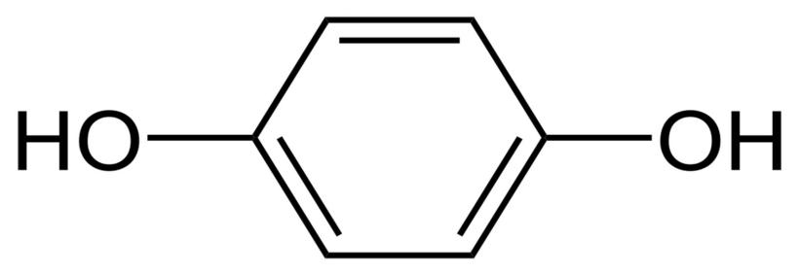
Figure 1: Chemical Structure of Hydroquinone
The chemical structure of hydroquinone (pictured above), with its two hydroxyl groups bonded to an aromatic ring, makes it very likely to oxidize. (8)

1.1.3 Hydrolysis

The chemical linkages that are most likely to hydrolyze in the presence of water are amides and esters. For instance, in the presence of water, aspirin hydrolyzes to acetic acid and salicylic acid, but in a dry environment, aspirin hydrolysis is negligible. When designing formulations that are anhydrous, it is useful to distinguish compounds that include amide and/or ester functional groups in order to spot probable hydrolysis.

Figure 2: Chemical structure of amide
An amide functional group (pictured above) is a chemical structure within a molecule that, among other things, makes that molecule more likely to decompose in the presence of water.
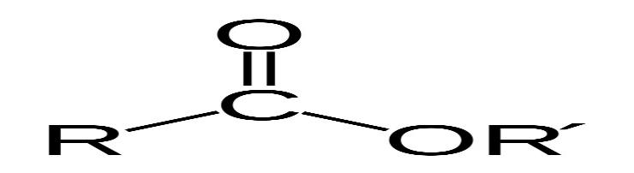
Figure 3: Chemical structure of ester group
An ester functional group (pictured above) is a chemical structure that gives molecules various properties, including the tendency to break down in the presence of water. (9,10)
1.2Chemical aspects of Drug metabolism:
The medicine is metabolised through specific chemical reactions once the drug molecule interacts with enzymes that can alter its chemical structure. On the other hand, the body's enzymes not converting a medication is chiefly responsible for its stability after delivery. A decline in efficacy is commonly caused by the chemical deterioration that many drugs experience, whether as a result of interactions with enzymes or improper handling and storage.
Knowledge of functional structure of drug molecule which may be more prone for metabolism and also of those which are not could be very much useful at the time of patients counselling. This information is needed for storage as well as administration of drug molecules.
Example, Dispensing medications into monitored dose systems (MDS), when they are taken out of their original packaging and put in an environment atmosphere chemical class are being explored as part of a medicines usage review, knowledge of functional groups is helpful.

1.3 Chemical reactions

Drugs frequently contain very small chemical components. Due to difference in bond connections, structure of functional groups the two drugs are distinguished from one another.
The two main chemical reactions that affect a drug's stability are oxidation and hydrolysis. When a molecule's electrons are taken away (or added), it goes through an oxidation process. Such reactions can be sparked by specific trace metals, heat or light. Storage of sensitive drugs in amber colored container can be the one of preventive measure for avoiding oxidative decomposition of drugs, and so it is less considered than hydrolysis.
Oxidation and hydrolysis are the main chemical processes that impact a drug's stability. A molecule undergoes oxidation when its electrons are removed (or added) and such processes can be started by light, heat, or specific trace metals. Since oxidative degradation can frequently be reduced to acceptable levels by storing susceptible drugs in the absence of light (e.g., use of amber vials) and oxygen (e.g., store under nitrogen or argon), or by using antioxidants in the formulation, it has not been studied in as much detail as hydrolysis
Hydrolysis is the more prevalent method of drug breakdown and can be considered in regard to both stability as well as metabolism.

1.3.1 Hydrolysis
A molecule reacts with water to break a chemical bond within itself, a process known as hydrolysis. Esters and amides are the functional groups that are most typically present in medications that are hydrolyzable, but there are many other functional groups that are as well. A carboxylic acid, an alcohol (XH=ROH) or an amine (XH=R1R2NH) are the bond breaking reaction products of an ester (X=OR) or an amide (X=NR1R2, where R, R1 and R2 can each have any arbitrary structure).
Figure 1 depicts the mechanism for this reaction.

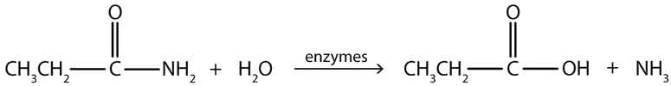
Figure 4: Simple mechanism of hydrolysis of esters and amides
The double bond of carbonyl group present in an ester or amide becomes polarized, making the oxygen small negative and the carbon with a slight positive. This is observed due to high electron negativity of oxygen than carbon and so it withdraws electrons to itself. This polarization fascilitates the electrons of the oxygen atom in water to be attracted to the slightly positive charge of the aforementioned carbon atom, which results in hydrolysis. This polarization and subsequent interactions are increased by protonating the carbonyl oxygen.
Esters react with water more quickly than amides do, and both an acid and a base are capable of catalysing these reactions. The pH of the water affects the rate. Similar to this, various enzymes of plasma and body fluids acts as catalyst for hydrolysis of esters and amides in the in vivo metabolism . There is small difference in structures of these two groups i.e. ester has oxygen and nitrogen is present in amide in same place, which makes difference in speed of hydrolysis reactions of these two groups. Example Structure of Lidocaine and Procaine (figure 5).
Due to this difference attraction between the carbon of C=O and a water molecule increases by making this carbon much more positively charged in the ester as compared to amide. Positive charge of carbonyl carbon of amide has vanishes because of presence of nitrogen so it is less attracted to water , on the other hand, displays the opposite behaviour.

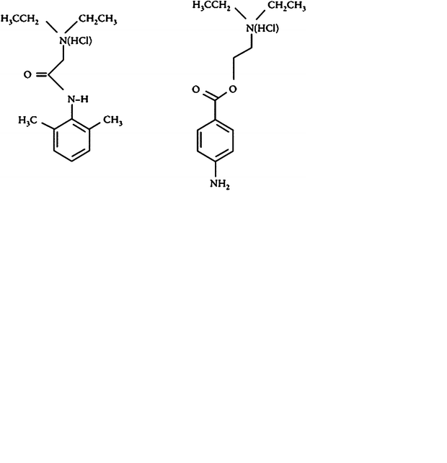
Figure 5: Chemical structures of lidocaine and procaine
Procaine, a local anesthetic that contains an ester, is no longer frequently used. Though its action as local anesthetic is good, but duration of action is short as it contains ester group and it hydrolyzes quickly. In contrast, the amide bond in lidocaine is less easily hydrolyzed than the ester of procaine. Since it is more resistant to the effects of hydrolysis, together with its bulkier structure, lidocaine has a longer duration of action than other local anesthetics.
Additionally, hydrolytic enzymes readily hydrolyze the methyl ester in the ADHD medicine methylphenidate (Figure 6) to create ritalinic acid, which is the primary (inactive) urine metabolite in individuals.

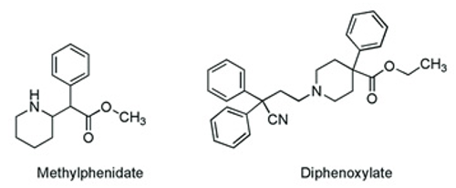
Figure 6: Structures of methylphenidate and diphenoxylate

Because of presence of such groups that are easily hydrolyzed and so drug becomes inactive in such cases it needs to be taken more frequently to keep the therapeutic level constant. Hydrolysis, on the other hand, has a place. The drug diphenoxylate (Figure 6),contain ester group, an easily hydrolyzed to carboxylic acid in humans and becomes five times more powerful than the parent ester at preventing diarrhea.

1.3.1.1 Prodrug strategy
Salicylic acid works well as a pain reliever. However, the presence of the free alcohol moiety causes gastric hemorrhage. This effect is reduced by converting this alcohol group as an ester and providing patients with aspirin, which is subsequently hydrolyzed in the body to release the active component. Such a method is one that is used in pro-drug strategies. Another result of aspirin hydrolysis is acetic acid. When aspirin pills are incorrectly stored, a lingering vinegar odour suggests that hydrolysis is occurring.
An interesting example of a prodrug is the angiotensin-converting enzyme inhibitor Enalapril, whose ester is hydrolyzed in the body to form the active carboxylic acid derivative Enalaprilate (used as an i.v. of Enalapril for hypertensive cases).
Another example is of cyclic ester (a lactone) in type I statins like Simvastatin.It is hydrolyzed by enzymes in body so to form the ring-opened structure, hydroxy-acid that is actually producing the therapeutic effect.

1.3.1.2 Amide-containing drugs
Amide-containing drugs can also hydrolyze, as was earlier shown, but this process proceeds much more slowly than it does with esters. One example is the hydrolysis of the beta-lactam antibiotics stretched cyclic-amide rings (amides that are a part of rings are known as lactams). Penicillin antibiotics are commonly made as aqueous pediatric solutions just before dispensing since they are not sufficiently stable to be administered and stored in aqueous form for an extended period of time.

Some suspensions (containing lactam) should also be kept in the refrigerator to reduce hydrolysis of the strained lactam ring. Through the action of hydrolytic enzymes, b-lactam antibiotics are likewise sensitive to hydrolysis. The selected route of administration may be directly impacted by such chemical instability and its repercussions. To understand why some substances (like penicillins and cephalosporins, which both include a stretched, hydrolysis-prone b-lactam ring) are incompatible with continuous infusion, one only needs to consider them.

1.3.1.3Other functional groups

Esters and amides are the two kinds of medications that are most commonly discovered to be hydrolyzable. Nonetheless, a wide range of distinct functional groups have the ability to interact with water in a way that disrupts bonding. Examples include sulphates, which are found in heparin, phosphate esters, which are found in hydrocortisone sodium phosphate, imines, which are found in Diazepam, and acetals, which are found in Digoxin.

1.3.1.4 Preventing hydrolysis
Although hydrolysis can be problematic, as was already indicated, there are a number of ways to prevent or reduce it. The preventive measures are slightly more difficult for in vivo metabolism. If the troublesome hydrolysis is detected early enough in the medicinal research phase, it is possible to chemically modify the structure of the active substance to prevent hydrolysis.
However, different dose form modifications may also be necessary as preventive measures for medications that are already prone to instability. For dry powders, water should be used to reconstitute them before administering them, as the breakdown of drugs in liquid dosage forms is dependent on water.
Similarly, if a drug is known to hydrolyze at room temperature, patients can be advised to store it in a cool place. Furthermore, it is the responsibility of chemists to precisely label the box with the required information.
Additionally, because temperature affects the rate of the hydrolysis reaction, sterilising some medications with heat may be challenging. By altering the base's composition, the stability of the active ingredient in semi-solid dosage forms (ointments and creams) can be managed. Reducing the water content of the excipients used in the formulation or incorporating a less hygroscopic form of the medication are two related strategies for lessening a drug's susceptibility to hydrolysis in a solid dosage form.
Important factors can be found and suitable action made to prevent the problems that oxidation poses to the quality of a medical product after study and analysis of the data.
1.4 Oxidation:
Oxidation is the second most common drug decomposition process after hydrolysis. However, because oxidation is mechanistically more complex than hydrolysis and generates a wider range of breakdown products, it can be challenging to control. A drug's propensity for oxidation can be discovered by studying forced degradation. Accelerated study of drug and excipient mixtures can give a more accurate picture of how degradation in the solid form develops since excipients are the most frequent sources of pollutants that might begin oxidation of a solid medicinal product.
Phenols (like morphine), catecholamines (such as adrenaline (epinephrine) and noradrenaline (norepinephrine), as well as polyunsaturated substances like oils, fats, and fat-soluble vitamins (such as vitamins A and E), are among the some pharmacological classes that show effect of oxidation. Oxidation reaction may involve radical chain reactions, often known as autoxidation reactions, can be quite challenging.
The primary oxidative degradation pathways listed below are
1.4.1Autoxidation (initiated by radicals);
Initiation:
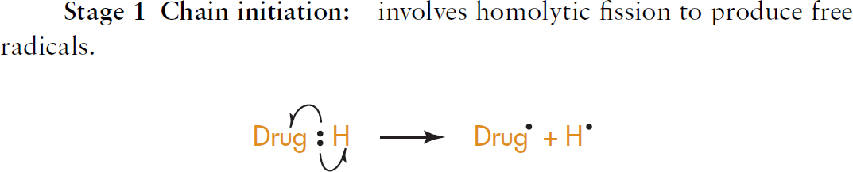
Propagation
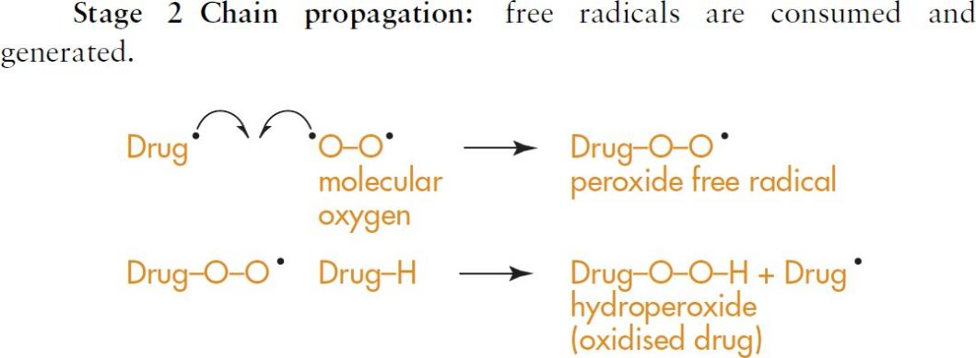

Termination:
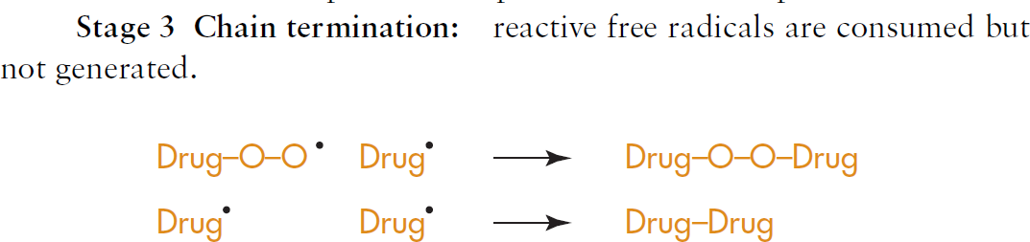
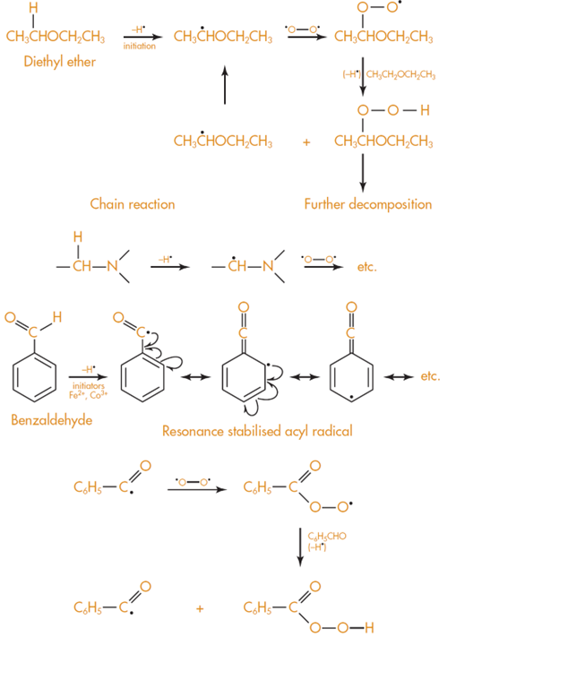

Figure7:Bond breaking between carbon and hydrogen

Some bonds between O-H like in phenols and between N-H like in aryl amines undergo oxidation easily.
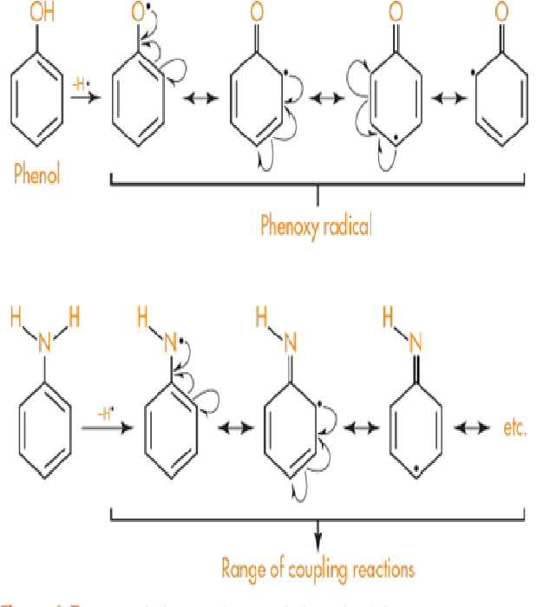
Figure 8:Breaking of bond between oxygen and hydrogen, between nitrogen hydrogen
1.4.2 Nucleophilic/electrophilic Oxidation:
There are several examples of drugs having phenolic OH groups such as Morphine from opiates category (and related opiates) and paracetamol from analgesic category as well as salbutamol from bronchodilator (Figure 9).

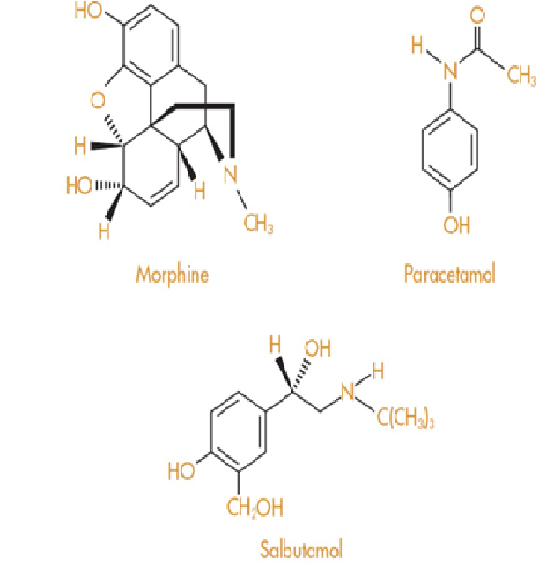

Figure 9: Structure of Morphine paracetamol; and salbutamol containing phenolic groups

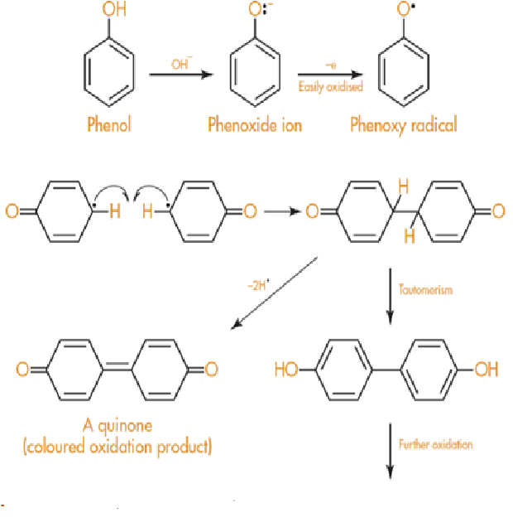
Figure10: Oxidation of phenoxide ion
Particularly vulnerable to oxidation are drugs with two phenolic groups, such as adrenaline (epinephrine) and other catecholamines, such as isoprenaline and noradrenaline (norepinephrine). These drugs must be prepared at an acidic pH. These substances are all crystalline solids, white in colour, that turn black when exposed to air.
On oxidation, adrenaline produces the red-colored chemical adrenochrome (Figure 11), which can then polymerise to produce black compounds with a structure like that of melanin, the pigment found naturally in skin.

For this reason, adrenaline injections that become pink or contain crystals of a black substance shouldn't be used. The formulation of adrenaline for injection is acid tartrate (Figure 11), which has a pH of about 3 in aqueous solution.

Since just one carboxylic acid group of tartaric acid is used up in the production of salt with adrenaline, it is known as the acid tartrate. The final carboxylic group is left to act as an acid as a result.

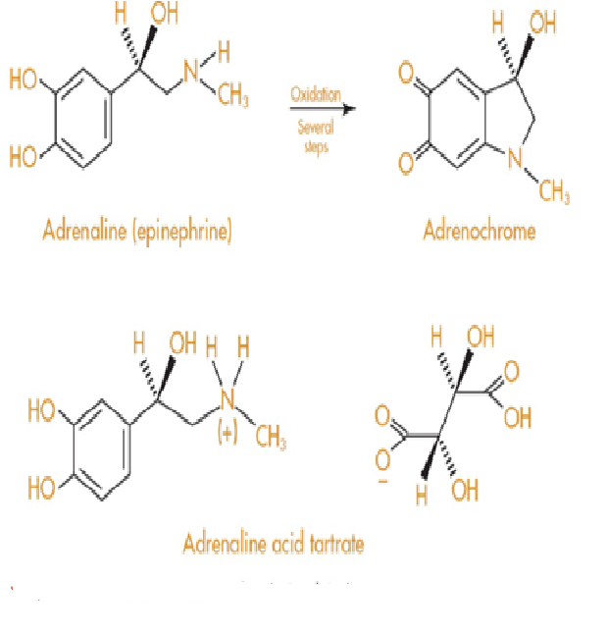

Figure 11:Oxidation of Adrenaline

Breaking of the nitrogen–hydrogen bond in aromatic amines occurs in a same way as to that of breaking of O-H bonds in phenols, producing complex mixture of products as involved coupling reactions of the type shown in Figure 12.
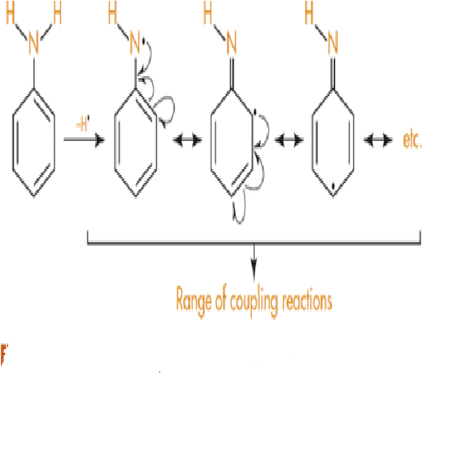
Figure 12:Nitrogen hydrogen bond cleavage in amines

1.4.3Prevention of oxidative deterioration
1.4.3.1Exclusion of oxygen
It should be quite evident that removing oxygen from the formulation will reduce oxidative degradation if oxygen in the air is the source of the oxidation. This is typically accomplished by substituting an atmosphere of an inert gas (such as nitrogen or argon) for the oxygen. Furthermore, to reduce the chance of air reaching the medication, the container needs to be securely closed after being fully loaded with the product.
1.4.3.2Use of amber or coloured glass containers
Amber glass provides some protection to chemicals that are sensitive to light because it blocks light with wavelengths of up to 470 nm. Because the medication is suspended or dissolved in propellant and kept in a sealed aluminium container, special formulations—like metered dose inhalers—also provide protection against light and oxygen. These inhalers are used to treat asthma.
1.4.3.3Use of chelating agents
Minute concentrations of metal ions, such as 0.05 ppm Cu2_, can catalyse oxidation reactions, which is why glass or stainless steel equipment should be used whenever feasible for manufacturing chemicals that are susceptible to oxidation. Chelation compounds like disodium edetate are used to chelate and remove metal ions when their presence cannot be avoided. Disodium edetate is the disodium salt of ethylenediaminetetraacetic acid, or EDTA, and is shown in Figure 13.

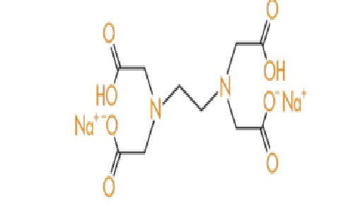

Figure 13: Structure of Disodium EDTA
1.4.3.4Use of antioxidants
Antioxidants are substances that readily oxidise to produce free radicals but are then insufficiently reactive to continue the chain reaction of breakdown. It gives its lives in an altruistic effort to protect the medication or drug. Phenols make up the majority of antioxidants; two of the most widely used types are given in Figure14.

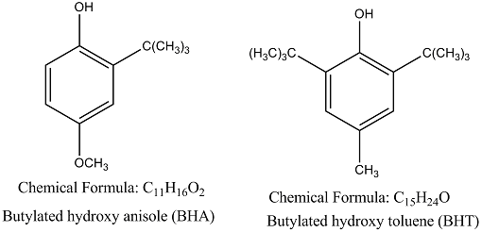
Figure14 : Structure of BHT and BHA

Because of its antioxidant properties, ascorbic acid, generally known as vitamin C, is added to medications and food items. Food producers proudly declare that their goods contain "added vitamin C." (see Figure 15).

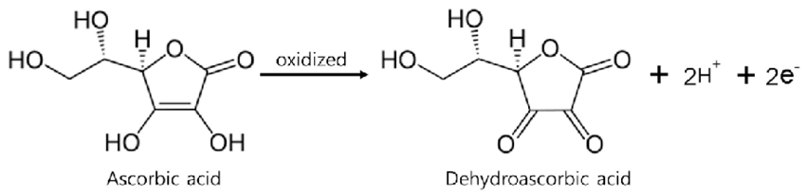
Figure 15: Ascorbic acid oxidation to diketone

2.0 Conclusion:

Pharmaceutical items are frequently subjected to stability studies to ensure that they remain secure, of superior quality, and efficient throughout the duration of their shelf lives. The World Health Organisation (WHO), the International Conference on Harmonisation (ICH), and other groups have established guidelines for certain medicinal products. Oxidation is the second most common medication breakdown process after hydrolysis. However, because oxidation is mechanistically more complex than hydrolysis and generates a wider range of breakdown products, it can be challenging to control. There are different methods to prevent drugs from degradation and increase its stability.To provide patients with a medication that is both safe and effective, chemists need to be aware of the basic chemistry underpinning drug stability.

2.0 REFERENCES:
1. Guo J.J., Pandey S., Doyle J., Bian B., Lis Y., Raisch D.W. A Review of Quantitative Risk–Benefit Methodologies for Assessing Drug Safety and Efficacy—Report of the ISPOR Risk–Benefit Management Working Group. Value Health. 2010;13:657–666. doi: 10.1111/j.1524-4733.2010.00725.x
2. Zumdahl S.S., Zumdahl S.A. Chemistry. 9th ed. Brooks/Cole, Cengage Learning; Belmont, CA, USA: 2014
3. Rams-Baron M., Jachowicz R., Boldyreva E., Zhou D., Jamroz W., Paluch M. Physical Instability: A Key Problem of Amorphous Drugs. In: Rams-Baron M., Jachowicz R., Boldyreva E., Zhou D., Jamroz W., Paluch M., editors. Amorphous Drugs: Benefits and Challenges. Springer International Publishing; Cham, Switzerland: 2018. pp. 107–157.
4. Sinclair W., Leane M., Clarke G., Dennis A., Tobyn M., Timmins P. Physical Stability and Recrystallization Kinetics of Amorphous Ibipinabant Drug Product by Fourier Transform Raman Spectroscopy. J. Pharm. Sci. 2011;100:4687–4699. doi: 10.1002/jps.22658.
5. Anonymous. ICH Q1A (R2) Stability Testing of New Drug Substances and Products. [(accessed on 24 April 2021)]. Available online: https://www.ema.europa.eu/en/ich-q1a-r2-stability-testing-new-drug-substances-drug-products
6. Ali M.A., Hemingway R., Ott M.A. In Silico Drug Degradation Prediction. In: Bajaj S., Singh S., editors. Methods for Stability Testing of Pharmaceuticals; Methods in Pharmacology and Toxicology. Springer; New York, NY, USA: 2018. pp. 53–73.
7. Del Rosso, J. Q., Harper, J., Pillai, R., & Moore, R., Tretinoin photostability: Comparison of micronized tretinoin (0.05%) gel and tretinoin (0.025%) gel following exposure to ultraviolet A light. The Journal of Clinical and Aesthetic Dermatology, 20125(1), 27-29.
8.United States Pharmacopeial Convention. (2021). General Chapter 1191 stability considerations in dispensing practice. InUnited States pharmacopeia and national formulary 2021. https://www.uspnf.com/
9.United States Pharmacopeial Convention. (2021). Proposed revisions to 795 pharmaceutical compounding — Nonsterile preparations .
10.Handbook of Pharmaceutical Analysis by HPLC
Anissa W. Wong, Aruna Datla, in Separation Science and Technology, 2005.
11.Tiwari R.N., Bonde C.G. LC, LC–MS/TOF and MSn Studies for the Identification and Characterization of Degradation Products of Nelfinavir Mesylate. J. Pharm. Biomed. Anal. 2011;55:435–445. doi: 10.1016/j.jpba.2011.02.020.
12.Beckwith A.L.J., Eichinger P.H., Mooney B.A., Prager R.H. Amine Autoxidation in Aqueous Solution. Aust. J. Chem. 1983;36:719–739. doi: 10.1071/CH9830719.
13. Guerrieri P., Taylor L.S. Role of Salt and Excipient Properties on Disproportionation in the Solid-State. Pharm. Res. 2009; 26:2015–2026. doi: 10.1007/s11095-009-9918-y.
14.The Pharmaceutical Journal, Oct 2010.DOI:10.1211/PJ.2021.1.72642.
15. TJ Snape, AM Astles, J Davies, Understanding the chemical basis of drug stability and degradation; Pharm J,2010;28576224106.
16.DW Reynolds, KL Facchine, J Mullaney, Available guidance and best practices for conducting forced degradation studies; PharmTechnol,2002;2624856.

17. Rao G, Goyal A, Development of stability indicating studies for pharmaceutical products: an innovative step; Int.J.Pharm Chem Anal.2016;3(03)110-16.
18. Schmidt, G.M.J. (1971). Photodimerization in the solid state. Pure and Applied Chemistry 27 (4): 647–678.
19.Gonzalez O,Ramirez I.O,Ramirez B.I, Peter O. C,Balesteros M.P,Torrado J.J,Serrano D.R,Drug Stability, ICH Versus Aceelerated Predictive stability studies. Pharmaceutics,2022;14(11),2324.
20.Aashgiri S,Gaud R.G, Sneha S, Uppal V, Stability studies of Pharmaceutical Products.World Journal of Pharmaceutical Research,2019:8(8),479-92.
21. Zimei Wu, Drug stability testing and formulation strategies. Pharmaceutical Development and Technology,2018:23(10),941.

