Assessment of Microplastic Contamination in the Sediments of Adyar River, Chennai: Distribution and Source Identification

*¹Mohamed Afzal J, ¹Sanju P, ¹Arfat Nazir,
¹Department of Geology, University of Madras, Guindy Campus,
Chennai, India 600025
*Corresponding author: Afzal J, E-mail: mohamedafzal15dec@gmail.com
² P.Mohana
²Centre for Remote Sensing and Geoinformatics, Sathyabama Institute of Science & Technology, Chennai-600119, Tamil Nadu, India
³ P.Amaladas
³Institute of Forest Genetics & Tree Breeding (IFGTB), Coimbatore, 641002, Tamil Nadu, India
⁴G.Kanagaraj
⁴ Department of Geology, Government Arts College (Autonomous),
Karur, 639005, Tamil Nadu, India
⁵S.Muthusamy
⁵PG and Research Department of Geology
V.O.Chidambaram College, Thoothukudi-628008, Tamil Nadu, India
(Affiliated to Manonmaniam Sundaranar University, Tirunelveli)
ABSTRACT
Plastic pollution, including the insidious presence of microplastics, has emerged as one of the most pressing and alarming global issues affecting aquatic ecosystems worldwide. The rapid increase in plastic waste, particularly in the form of microplastics, is posing a significant threat to the health and sustainability of marine and freshwater environments. The present study is aimed to assess microplastic contamination in sediment samples collected from the Adyar River in Chennai, India. A total of 10 Sediment samples were collected from different locations all along the river for Microplastic analysis. The identification of microplastics was carried out utilizing a stereomicroscope. The present study reveals the mean concentration of MPs in the sediment sample was. 1977± 137(Average ± Standard Error, n=10). MP/kg, of dry weight of the sediment sample. The prominent shape types of MPs in the sediments were into fibers (47%), films (21%), fragments (18%), pellets (10%), foam (2%), and beads (2%)., The colour of the MP was mostly, transparent (34.45%), followed by red (20.40%), white (18.75%), blue (14.52 %), orange (6.08%), green (2.19%), yellow (2.19%), and black (1.35%) Furthermore, Raman spectroscopy was employed to investigate and characterize the polymer compositions of the MPs. Raman Spectroscopy results showed the predominant abundance of microplastics, such as nylon, polypropylene, polymethyl (methacrylate), and polystyrene. Showing textiles, Plastic Litter, wastewater as sources of Microplastics in this river. The findings underscore the pressing requirement for efficient waste management approaches, encompassing responsible disposal and recycling practices, to address the issue of microplastic pollution in the Adyar River. Additionally, it is imperative to enhance public awareness regarding the detrimental effects of microplastics and implement proactive measures to protect the Adyar River's ecosystem and foster sustainable water resource management.
Keywords: Microplastics, contamination, River, Raman Spectroscopy, Polymers, Chennai, India
- INTRODUCTION
Pollution is a significant global concern, and plastic waste stands as one of its primary contributors. The widespread usage of plastics has led to a substantial increase in production, with approximately 9.2 billion tons of plastic manufactured between 1950 and 2017[1].Alarmingly, between 8 to 11 million tonnes of plastic waste enter the oceans annually [1]Initially, most plastics are utilized and discarded on land; however, projections indicate that by 2030, the quantity of microplastics in certain oceanic regions may double [2] Once plastic pollution accumulates in the environment, it becomes challenging to reverse its effects[3]. A staggering global estimate suggests that approximately 5.25 trillion plastic particles, weighing a total of 268,940 tons, currently exist in the world's oceans [4]. The most critical factors for plastic waste accumulation in the environment are extensive use, limited recycling, and the durability of plastic polymers.[5]. Plastic pollution becomes worse when microplastics disintegrate into smaller particles as a result of various physical, chemical, and environmental factors [6]. Larger plastics enter the aquatic environment through runoff from the land and gradually degrade into particles larger than 5mm, which are referred to as macroplastics, while particles smaller than 5mm are referred to as microplastics. MPs can also be classified as primary or secondary, with primary referring to micro-sized particles and secondary referring to MPs produced by MP breakdown.[2], [6], [7]. Microplastics are known to be present in terrestrial, freshwater, and marine environments [8]–[11]In marine ecosystems, MPs are prevalent in surface waters, sediments, and marine organisms[12]. Moreover, MPs have been detected in freshwater environments through the analysis of various samples, including lake water and lake surface sediment, river sediments [13], [14] and, The role of Rivers in transporting microplastics to the oceans is well known [15] . According to Meijer et al., [16]an estimated 80% of marine plastic debris originates from inland sources. Several studies have pointed out urban regions, particularly industrial areas, as significant contributors to microplastic pollution in rivers [17], [18] thereby posing threats to both fluvial and marine [19], [20]. Microplastics come from a variety of sources and enter rivers via a variety of routes. Microplastics, for example, can be transported via surface run-off from agricultural areas, released into the atmosphere as aerial emissions from industries or sewage sludge application, and discharged from wastewater treatment plants.[21], [22] Fragmentation of larger plastic items, the abrasion of synthetic textiles, and the release of microbeads from personal care products also act as sources [23], [24]. In case of river systems microplastics can enter through various pathways, such as stormwater runoff, industrial discharges, and the improper disposal of plastic waste, as well as from urban and agricultural sources[21], [25]. Once in rivers, microplastics can undergo complex transport and fate processes, ranging from buoyant floating behavior to sedimentation, leading to their accumulation in riverbeds and banks [26]In the recent review about microplastic in rivers of southern India [27]highlights the missing knowledge in research about microplastic in rivers therefore This study aims to assess the presence, distribution, characteristics, and composition of microplastics in sediment samples from the Adyar River. By conducting fieldwork and laboratory analyses, we seek to gain insights into the abundance and types of microplastics present in the sediment. This information will contribute to a better understanding of the microplastic pollution in the Adyar River and provide valuable data for future mitigation efforts.

- MATERIALS AND METHODS
- Study Area
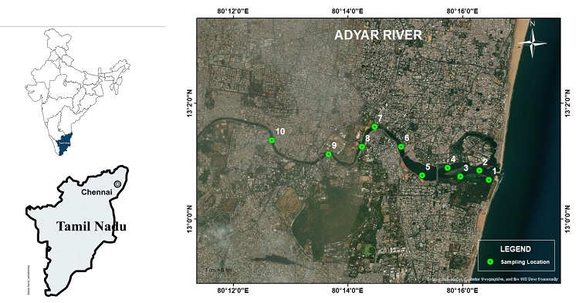
This study focused on Adyar River, located in Chennai, the capital city of Tamil Nadu, India. The Adyar River stretches between 12°50'49" and 13°17'24" North latitude and 79°59'53" and 80°20'12" East longitude on the Coromandel coast in southern India. It is one of the three major rivers in Chennai and has a length of 42 km with a catchment area of 860 sq. km. It has been demonstrated in the past that salty water intrusion and industrial and domestic wastewater contamination of the river both exist. About 8.1 106 liters/day of home sewage and 0.775106 liters/day of industrial effluents were allowed to be legally dumped into the Adyar in 1999[28]. The selection of sampling sites took into account factors such as proximity to industrial areas, urban settlements, and potential sources of pollution. This approach aimed to capture a comprehensive understanding of microplastic pollution in the sediment across the Adyar River.
- Sample collection and Microplastic extraction.

Extensive fieldwork was conducted along the Adyar River to collect sediment samples for analysis. Sampling locations were selected based on representative areas of the river and its surrounding environment. In June 2022, a total of 10 sampling locations were chosen, sediment samples were collected from each location (Fig.1). The samples were carefully collected using pre-cleaned equipment weighing up to (1 kg) was then transferred into glass bottles using a steel spoon followed by wrapping in aluminum foil to avoid further contamination[2] To extract microplastics from sediments Around 100 g of wet sediment sample was oven dried for 36 hours at 55º C before being sorted using 10 mesh, 18 mesh, and 50 mesh sieves[14]The dried sample was then transferred to a glass beaker for wet peroxide oxidation to remove organic matter. The sample was treated with 20ml of 30% hydrogen peroxide until the organic matter was completely digested [29]The sample was then treated with a sodium chloride solution with a density of 1.2g/cm3 and kept overnight for density separation of the microplastics present [14], [30], [31].

- Microplastic analysis
MP's colour and morphology were identified and counted using a stereomicroscope NIKON SMZ25. Identifications were made with a 40x magnification digital microscope camera attached to a stereo microscope. To further ascertain the composition of the polymers, the Xplora Plus Raman microscope (Horiba Scientific), was used to identify the microplastic Polymer. For source identification, the MP's Raman spectroscopy data were compared to reference spectra. [32].
- Quality Assurance and Control
In order to prevent the airborne microplastic contamination throughout all stages of sample collection, storage, processing, and analysis, meticulous efforts were undertaken. A comprehensive plastic-free protocol was implemented at each step of the experiment to ensure that all materials and equipment used were completely devoid of plastic components. Environmental blanks were created by placing a filter membrane, saturated with deionized water filtered through a 1.6 µm filter, onto an uncovered Petri dish. A thorough analysis of these blanks facilitated the detection and quantification of background microplastic contamination, ensuring accurate interpretation of the sample results.

- RESULTS AND DISCUSSION

- Abundance and distribution of microplastics
Following a thorough evaluation of the blank samples, our research has revealed important insights into the concentration and characteristics of microplastics (MPs) in sediment samples collected from the Adyar river. The average concentration of MPs in the sediment sample was found to be 1977±137 MP/kg (Average ± Standard Error, n=10), based on the dry weight of the sediment. (Fig.2) One notable finding was the significant variation in MP concentrations across different sampling locations, with higher concentrations observed in sample no.1 towards the end of the river and lower concentrations in sample no.8(Fig.3) (Table1) This distribution suggests that certain areas may be more susceptible to microplastic pollution than others.
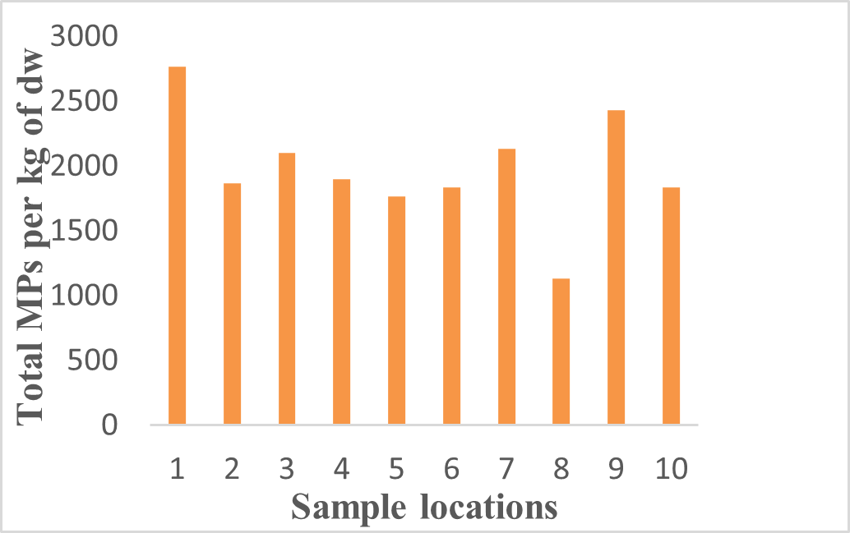

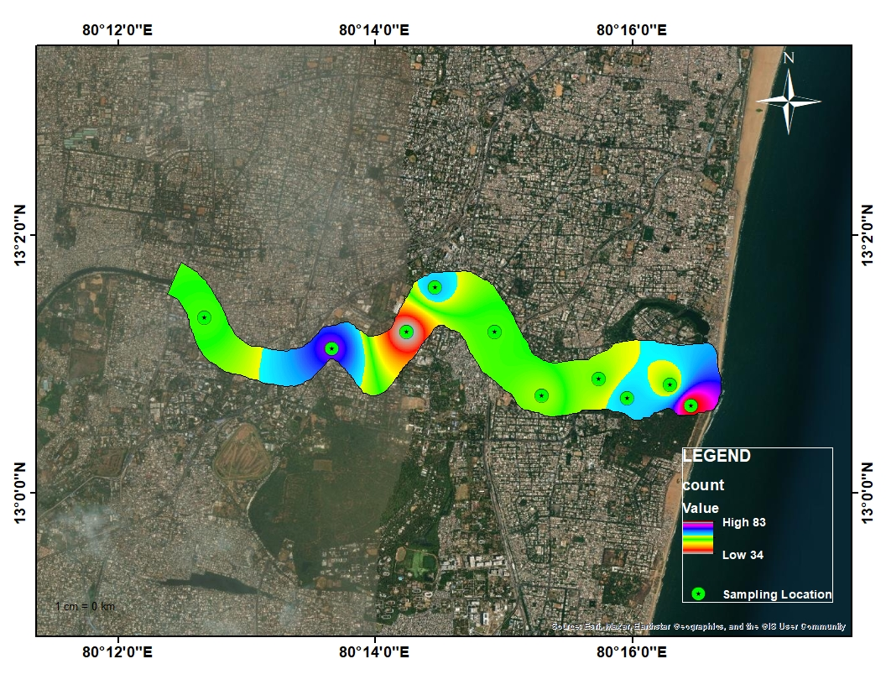
Figure 3The Spatial Distibution Map Showing Microplastic count in Adyar Sediment Samples
Figure 2 The Concentrations of Microplastics Particles in Sediment Samples of Adyar River

Table1. The sampling sites and MP color, shape and size in Adyar. river sediments
Sample.no | Longitude | Latitude | Red | Blue | Green | Yellow | White | Transparent | Black | Orange | Total | Fiber | Film | Fragment | Pellet | Bead | Foam | Total | Size 1000μm | Size 1000μm | Total
1 | 80.27 | 13.01 | 17 | 20 | 10 | 0 | 3 | 30 | 0 | 3 | 83 | 38 | 28 | 0 | 17 | 0 | 0 | 83 | 54 | 29 | 83
2 | 80.27 | 13.01 | 12 | 27 | 0 | 3 | 0 | 10 | 0 | 4 | 56 | 18 | 14 | 15 | 0 | 1 | 8 | 56 | 39 | 17 | 56
3 | 80.26 | 13.01 | 18 | 0 | 0 | 2 | 11 | 20 | 0 | 12 | 63 | 28 | 14 | 14 | 4 | 3 | 0 | 63 | 47 | 16 | 63
4 | 80.2 | 13.01 | 14 | 11 | 0 | 0 | 0 | 25 | 5 | 2 | 57 | 28 | 9 | 12 | 8 | 0 | 0 | 57 | 39 | 18 | 57
5 | 80.25 | 13.01 | 15 | 0 | 0 | 3 | 33 | 2 | 0 | 0 | 53 | 41 | 5 | 4 | 3 | 0 | 0 | 53 | 34 | 19 | 53
6 | 80.248 | 13.02 | 17 | 1 | 2 | 0 | 5 | 30 | 0 | 0 | 55 | 25 | 6 | 15 | 4 | 0 | 5 | 55 | 41 | 14 | 55
7 | 80.24 | 13.02 | 6 | 10 | 0 | 0 | 25 | 23 | 0 | 0 | 64 | 39 | 15 | 5 | 5 | 0 | 0 | 64 | 53 | 11 | 64
8 | 80.23 | 13.02 | 1 | 1 | 1 | 0 | 20 | 10 | 0 | 1 | 34 | 20 | 11 | 3 | 0 | 0 | 0 | 34 | 22 | 12 | 34
9 | 80.22 | 13.01 | 20 | 14 | 0 | 3 | 0 | 30 | 0 | 6 | 73 | 25 | 17 | 21 | 10 | 0 | 0 | 73 | 53 | 20 | 73
10 | 80.21 | 13.02 | 1 | 2 | 0 | 2 | 14 | 24 | 4 | 8 | 55 | 18 | 7 | 16 | 8 | 6 | 0 | 55 | 36 | 19 | 55

- Colour, Shape and size distribution
This research investigation focused on the categorization of microplastic (MP) particles into eight distinct colors: mainly, transparent (34.45%), followed by red (20.40%), white (18.75%), blue (14.52 %), orange (6.08%), green (2.19%), yellow (2.19%), and black (1.35%), (Fig. 4). The significance of color in microplastics was explored, revealing its influence on their behavior and environmental impact. The color of microplastics plays a crucial role in their visual detectability, aiding in their identification in environmental samples [33]Moreover, it provides valuable clues about their sources, facilitating the identification of pollution origins [34]. The color of microplastics also affects their interaction with the environment. Dark-colored microplastics may absorb more solar radiation, leading to changes in their distribution within aquatic environments, while light-colored ones may undergo photodegradation more readily [35], [36].Additionally, the preference of certain organisms to ingest specific colors can impact their uptake within the food web, potentially influencing animal behavior and fitness [37].Furthermore, the colorants used in plastics may contain additives that can leach into the environment upon degradation, raising concerns about potential harm to aquatic organisms and human exposure [38].In terms of shape distribution six differ types of shapes was identified both primary and secondary microplastics as fibers (47%), films (21%), fragments (18%), pellets (10%), foam (2%), and beads (2%) Fig.5) (Fig.6) With higher concentration of fiber in sample no.5 and lowest concentration on sample no.10.Fiber-shaped microplastics exhibit enhanced buoyancy and surface area-to-volume ratio, making them more prone to long-range transport in aquatic systems.[39] The generation of microfibers occurs primarily through the shedding and fragmentation of larger textile items during washing, wearing, and disposal processes [40]. These tiny fibers enter wastewater systems and can eventually find their way into rivers, lakes, and oceans due to incomplete filtration in wastewater treatment plants [41].Once released into the environment, microfibers become a persistent and widespread form of microplastic pollution.
The spatial distribution of fragment-type and film-type(Fig.7)(Fig.8) microplastics in study area showed the irregular distribution towards the end of channel this irregularity can be explained by the retention of MP by sediment as a common process of MP transport in fluvial systems [10], [42],Since there was a very low flow rate in the Adyar River during sampling, no remobilization could have taken place with an increasing flow velocity[10], [42], [43] Therefore, previously deposited MP is not further transported and stored in the fluvial sediment as a temporary sink [44]. Additionally, it should be noted that due to the highly varying weather conditions in the study area, namely, the change from the monsoon and dry seasons, The distribution of fragment-type and film-type microplastics in rivers is a significant concern due to its potential environmental impact. Fragment-type microplastics, resulting from the breakdown of larger plastic items, and film-type microplastics, originating from plastic wraps and bags, have been detected in rivers worldwide. Research has shown that rivers act as major conduits for microplastic transport from land to sea, accumulating these particles in riverbeds and banks[39], [45].The irregular shapes of fragment-type microplastics make them challenging to quantify accurately, but they have been found to be prevalent in river sediment samples. Film-type microplastics, with their thin and flexible nature, are often observed floating on the water's surface, especially in areas with high plastic waste influxes[46], [47].The distribution of both microplastic types in rivers is influenced by factors such as local population density, industrial activities, and waste management practices, which contribute to the pollution load entering these water bodies[39], [48].Understanding the distribution patterns of fragment-type and film-type microplastics in rivers is crucial for developing effective strategies to mitigate their environmental impacts and prevent further pollution of aquatic ecosystems. the spatial distribution pellet, bead, and foam. revealed a notable pattern in the distribution. Pellet debris dominated the samples, accounting for approximately 98% of the observed occurrences. This substantial prevalence suggests that pellets are the most common type of MPs in this particular area. On the other hand, bead type was found in about 20% of the samples, indicating a lower occurrence compared to pellets. Similarly, foam debris was present in approximately 26% of the samples, signifying a moderate frequency in the area. Understanding the role of color in microplastics is crucial for mitigating pollution and accurately assessing environmental risks. By gaining insights into how color influences microplastics' behavior and interactions, we can work towards more effective pollution management and safeguarding both ecosystems and human well-being. the majority of microplastics in the sediment samples were smaller < 1000 μm, (Fig.9), with 70% falling within this size range. The remaining 30% of microplastics were larger than >1000 μm(Fig 10).. The presence of smaller microplastics suggests the potential for ingestion by benthic organisms, which could have ecological implications for the Adyar River's ecosystem.
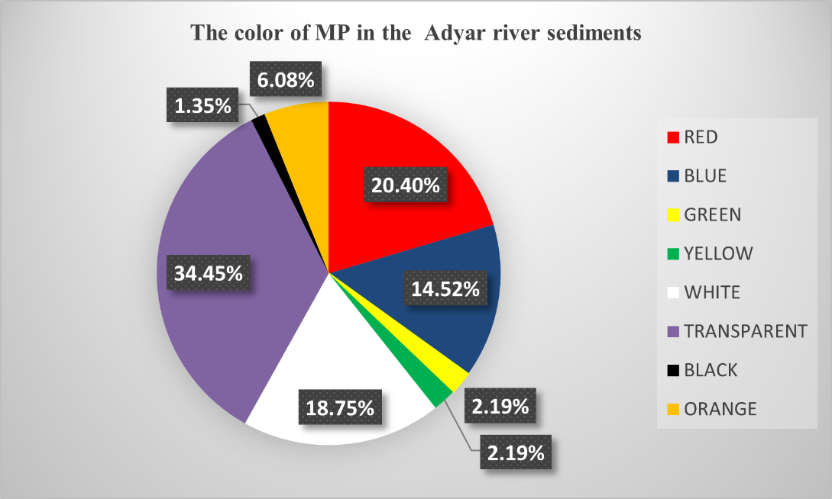
Figure 4The colour of Mps in Adyar river sediments

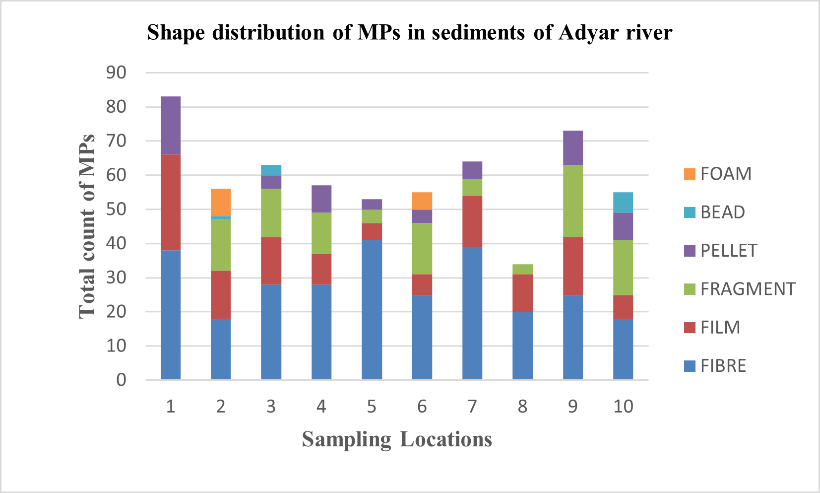
Figure.6 Microplastic Shapes (A) Fibre (B) Foam(C) Fibre (D) Fragment
Figure 5 Shape Distribution in Adyar river sediment samples

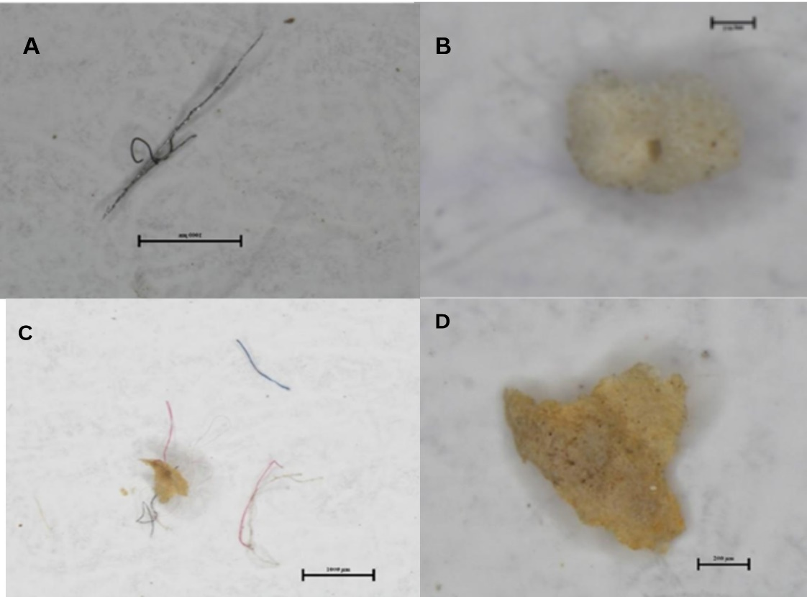

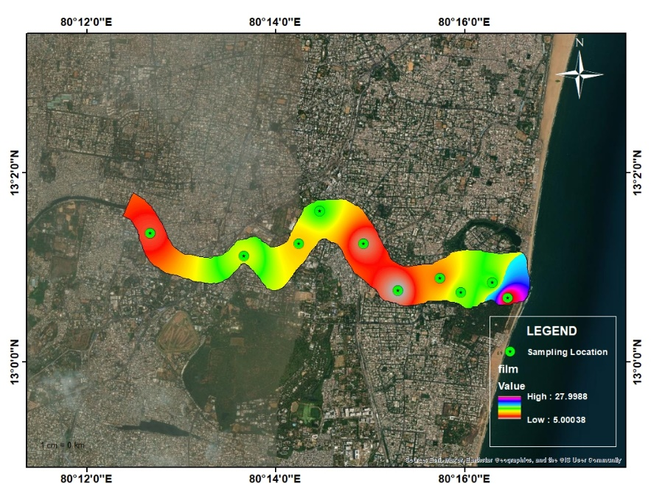
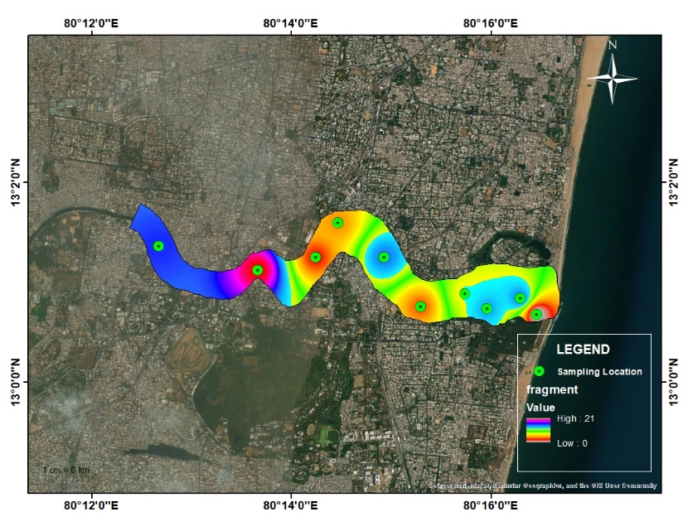
Figure 8 the Spatial Distribution of Film Shape Microplastics in the Adyar River
Figure 7The Spatial Distribution of Fragment Shape Microplastics in the Adyar River

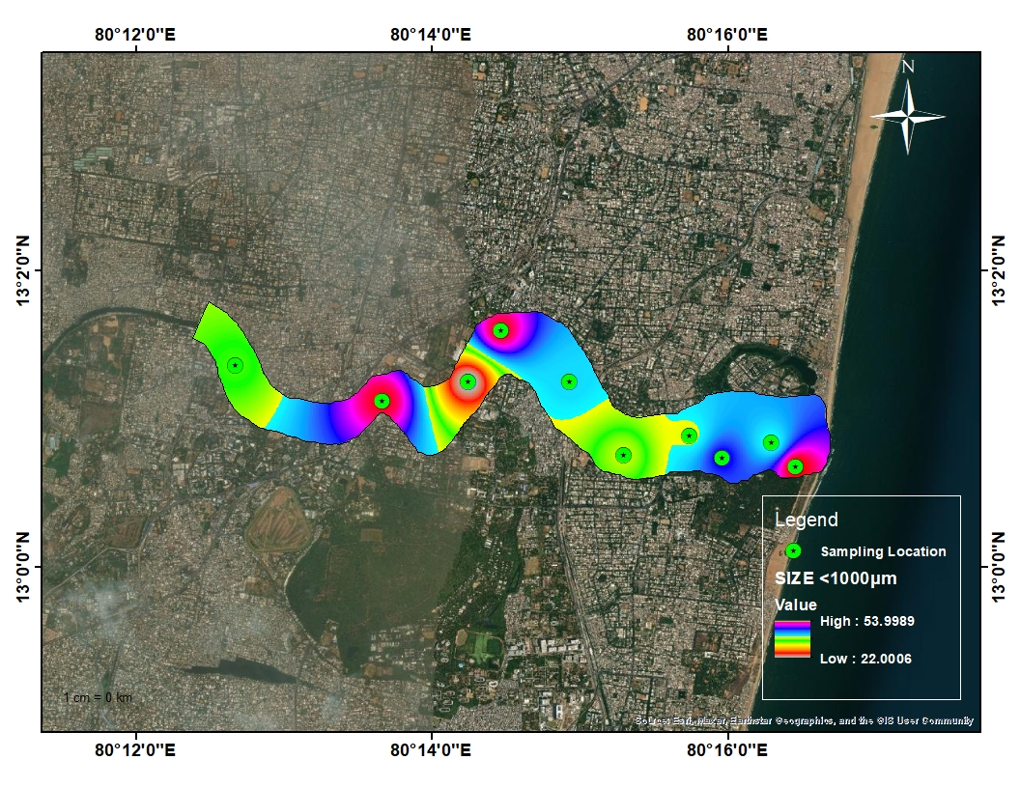
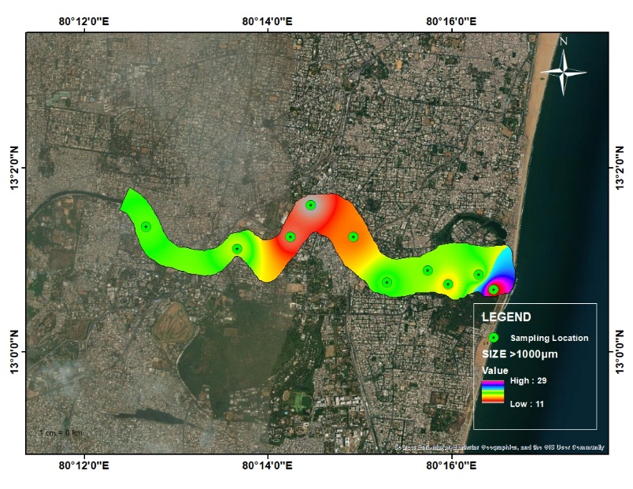
` `
Figure 9 the Spatial Distribution of size>1000 μm Microplastics in the Adyar River

Figure 10the Spatial Distribution of size<1000 μm Microplastics in the Adyar River

- Polymer identification
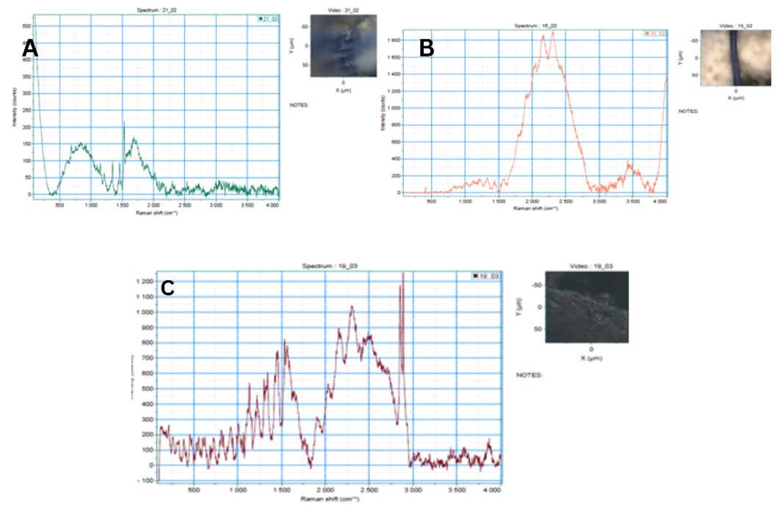
The findings of this investigation indicated that nylon constituted the largest proportion of the microplastics, accounting for 44% of the identified polymers. Polypropylene and polymethyl (methacrylate) were also prominent, making up 21% each, while polystyrene represented 15% of the detected microplastics (Fig.11). These polymers are widely used in the production of various consumer goods, including packaging materials, textiles, and household items. The persistence of these plastic polymers in the environment is a cause for concern. Microplastics can endure for extended periods, leading to potential ecological and health implications. As these tiny plastic particles find their way into water bodies and soil, they can be ingested by marine organisms and, subsequently, enter the food chain, potentially reaching humans. This could lead to adverse effects on both wildlife and human health.

Figure.11 Raman Spectrum and polymer characterization of Selected Mp samples (A) Nylon (B) Polyproplene(c) Polystrene

- Possible sources
The presence of polymers such as nylon, Polypropylene, and polymethyl (methacrylate) in rivers can be attributed to various human activities and industrial processes. These synthetic polymers are commonly used in the production of a wide range of products, and their widespread use has led to their release into the environment, including rivers and water bodies. Here are some possible sources of these polymers in rivers: Industrial discharges: Many industries utilize nylon, polypropylene, and polymethyl (methacrylate) in their manufacturing processes. During the production of plastic-based goods, the residues, waste materials, and accidental spills can find their way into nearby water bodies, including rivers. Improper waste management practices in some industries may lead to direct discharge of polymer-containing effluents into rivers, contributing to their presence in the aquatic environment.[49].Urban runoff and littering in urban areas, plastic-based materials, including nylon, polypropylene, and polymethyl (methacrylate) products, are commonly used in everyday items such as packaging, textiles, and consumer goods. When these items are improperly disposed of or discarded as litter, they can be carried by rainfall runoff and wind into stormwater drains, eventually reaching rivers. Studies have shown that urban runoff is a significant source of microplastics in rivers and other water bodies[39].Sewage and wastewater treatment plants: Domestic and industrial wastewater often contains microplastics derived from the breakdown of larger plastic items, including nylon, polypropylene, and polymethyl (methacrylate) products. Although wastewater treatment plants are designed to remove pollutants, they may not effectively capture all microplastics, allowing some of these polymer particles to enter the river systems through treated effluents [50]Outdoor recreational activities, such as fishing, boating, , also contribute to the presence of these polymers in rivers. Fishing lines and nets made of nylon and other synthetic fibers can be lost or abandoned in the water, leading to long-term pollution. Additionally, discarded plastic items used during recreational activities can degrade into smaller particles, further exacerbating the microplastic contamination in rivers [51]In conclusion, the presence of nylon, polypropylene, and polymethyl (methacrylate) polymers in rivers is largely attributed to human activities and industrial processes. The widespread use and improper disposal of plastic-based products, along with the limitations of waste management systems, contribute to the contamination of rivers with these synthetic polymers. Addressing this issue requires a comprehensive approach, including better waste management practices, increased awareness and education about plastic pollution, and more stringent regulations on industrial discharges and plastic production to safeguard our aquatic ecosystems.

- CONCLUSION

The results of this research provide compelling evidence of a significant issue regarding MP pollution in the sediments of Adyar river, an urban river located in Chennai region of Tamilnadu India. Through the analysis of sediment samples, it was determined that the mean concentration of microplastics was 1977± 137MPs per Kg of dw indicating a substantial presence of microplastics within the river ecosystem. Furthermore, variations in microplastic concentrations were observed across different regions of river. The end of the river, exhibited a higher concentration of microplastics. The MPs shape groups in the sediments were identified as fibers (47%), films (21%), fragments (18%), pellets (10%), foam (2%), and beads (2%) with eight distinct colors that are Transparent (34%), Red (20%), followed by white (19%), blue (15%), orange (6%), green (2%), yellow (2%), black (1%), To gain further understanding of the composition of the microplastics, Raman spectroscopy was employed. The results revealed that the predominant polymer type in the microplastic samples was like nylon, polypropylene, polymethyl (methacrylate), and polystyrene.

The findings of this study highlight the urgent need for effective waste management practices, including proper disposal and recycling of plastic materials. Additionally, raising public awareness about the detrimental effects of microplastics and promoting sustainable behaviors can help reduce the input of microplastics into the Adyar River and protect its ecosystem. Mitigation measures should focus on minimizing the release of microplastics into the environment and implementing strategies for the removal and remediation of existing microplastics in sediments. Collaborative efforts between government, industries, and the public are crucial for addressing microplastic pollution and ensuring the long-term health and sustainability of the Adyar River ecosystem.

REFRENCES
[1] A. T. Williams and N. Rangel-Buitrago, “The past, present, and future of plastic pollution,” Mar. Pollut. Bull., vol. 176, p. 113429, Mar. 2022, doi: 10.1016/j.marpolbul.2022.113429.
[2] R. C. Hale, M. E. Seeley, M. J. La Guardia, L. Mai, and E. Y. Zeng, “A Global Perspective on Microplastics,” J. Geophys. Res. Oceans, vol. 125, no. 1, Jan. 2020, doi: 10.1029/2018JC014719.
[3] M. MacLeod, H. P. H. Arp, M. B. Tekman, and A. Jahnke, “The global threat from plastic pollution,” Science, vol. 373, no. 6550, pp. 61–65, Jul. 2021, doi: 10.1126/science.abg5433.
[4] M. Eriksen et al., “Plastic Pollution in the World’s Oceans: More than 5 Trillion Plastic Pieces Weighing over 250,000 Tons Afloat at Sea,” PLOS ONE, vol. 9, no. 12, p. e111913, Dec. 2014, doi: 10.1371/journal.pone.0111913.
[5] R. C. Thompson, C. J. Moore, F. S. vom Saal, and S. H. Swan, “Plastics, the environment and human health: current consensus and future trends,” Philos. Trans. R. Soc. B Biol. Sci., vol. 364, no. 1526, pp. 2153–2166, Jul. 2009, doi: 10.1098/rstb.2009.0053.
[6] P. Heinrich, L. Hanslik, N. Kämmer, and T. Braunbeck, “The tox is in the detail: technical fundamentals for designing, performing, and interpreting experiments on toxicity of microplastics and associated substances,” Environ. Sci. Pollut. Res. Int., vol. 27, no. 18, pp. 22292–22318, Jun. 2020, doi: 10.1007/s11356-020-08859-1.
[7] I. E. Napper et al., “Reaching New Heights in Plastic Pollution—Preliminary Findings of Microplastics on Mount Everest,” One Earth, vol. 3, no. 5, pp. 621–630, Nov. 2020, doi: 10.1016/j.oneear.2020.10.020.
[8] J. Dusaucy, D. Gateuille, Y. Perrette, and E. Naffrechoux, “Microplastic pollution of worldwide lakes,” Environ. Pollut. Barking Essex 1987, vol. 284, p. 117075, Sep. 2021, doi: 10.1016/j.envpol.2021.117075.
[9] K. Gopinath et al., “Quantification of microplastic in Red Hills Lake of Chennai city, Tamil Nadu, India,” Environ. Sci. Pollut. Res., vol. 27, no. 26, pp. 33297–33306, Sep. 2020, doi: 10.1007/s11356-020-09622-2.
[10] S. Lechthaler et al., “Baseline Study on Microplastics in Indian Rivers under Different Anthropogenic Influences,” Water, vol. 13, no. 12, Art. no. 12, Jan. 2021, doi: 10.3390/w13121648.
[11] S. Sruthy and E. V. Ramasamy, “Microplastic pollution in Vembanad Lake, Kerala, India: The first report of microplastics in lake and estuarine sediments in India,” Environ. Pollut., vol. 222, pp. 315–322, Mar. 2017, doi: 10.1016/j.envpol.2016.12.038.
[12] S. C. Gall and R. C. Thompson, “The impact of debris on marine life,” Mar. Pollut. Bull., vol. 92, no. 1–2, pp. 170–179, Mar. 2015, doi: 10.1016/j.marpolbul.2014.12.041.
[13] A. Esfandiari et al., “Distribution and transport of microplastics in groundwater (Shiraz aquifer, southwest Iran),” Water Res., vol. 220, p. 118622, Jul. 2022, doi: 10.1016/j.watres.2022.118622.
[14] K. Neelavannan, I. S. Sen, A. M. Lone, and K. Gopinath, “Microplastics in the high-altitude Himalayas: Assessment of microplastic contamination in freshwater lake sediments, Northwest Himalaya (India),” Chemosphere, vol. 290, p. 133354, Mar. 2022, doi: 10.1016/j.chemosphere.2021.133354.
[15] L. C. M. Lebreton, J. van der Zwet, J.-W. Damsteeg, B. Slat, A. Andrady, and J. Reisser, “River plastic emissions to the world’s oceans,” Nat. Commun., vol. 8, no. 1, Art. no. 1, Jun. 2017, doi: 10.1038/ncomms15611.
[16] L. J. J. Meijer, T. van Emmerik, R. van der Ent, C. Schmidt, and L. Lebreton, “More than 1000 rivers account for 80% of global riverine plastic emissions into the ocean,” Sci. Adv., vol. 7, no. 18, p. eaaz5803, doi: 10.1126/sciadv.aaz5803.
[17] N. Schmidt, D. Thibault, F. Galgani, A. Paluselli, and R. Sempéré, “Occurrence of microplastics in surface waters of the Gulf of Lion (NW Mediterranean Sea),” Prog. Oceanogr., vol. 163, pp. 214–220, Apr. 2018, doi: 10.1016/j.pocean.2017.11.010.
[18] F. Petersen and J. A. Hubbart, “The occurrence and transport of microplastics: The state of the science,” Sci. Total Environ., vol. 758, p. 143936, Mar. 2021, doi: 10.1016/j.scitotenv.2020.143936.
[19] D. Eerkes-Medrano, R. C. Thompson, and D. C. Aldridge, “Microplastics in freshwater systems: a review of the emerging threats, identification of knowledge gaps and prioritisation of research needs,” Water Res., vol. 75, pp. 63–82, May 2015, doi: 10.1016/j.watres.2015.02.012.
[20] R. M. Blair, S. Waldron, V. Phoenix, and C. Gauchotte-Lindsay, “Micro- and Nanoplastic Pollution of Freshwater and Wastewater Treatment Systems,” Springer Sci. Rev., vol. 5, no. 1, pp. 19–30, Dec. 2017, doi: 10.1007/s40362-017-0044-7.
[21] A. A. Horton, A. Walton, D. J. Spurgeon, E. Lahive, and C. Svendsen, “Microplastics in freshwater and terrestrial environments: Evaluating the current understanding to identify the knowledge gaps and future research priorities,” Sci. Total Environ., vol. 586, pp. 127–141, May 2017, doi: 10.1016/j.scitotenv.2017.01.190.
[22] A. Horton and S. Dixon, “Microplastics: An introduction to environmental transport processes,” Wiley Interdiscip. Rev. Water, vol. 5, p. e1268, Dec. 2017, doi: 10.1002/wat2.1268.
[23] M. Smith, D. C. Love, C. M. Rochman, and R. A. Neff, “Microplastics in Seafood and the Implications for Human Health,” Curr. Environ. Health Rep., vol. 5, no. 3, pp. 375–386, Sep. 2018, doi: 10.1007/s40572-018-0206-z.
[24] R. C. Thompson et al., “Lost at sea: where is all the plastic?,” Science, vol. 304, no. 5672, p. 838, May 2004, doi: 10.1126/science.1094559.
[25] M. Wagner et al., “Microplastics in freshwater ecosystems: what we know and what we need to know,” Environ. Sci. Eur., vol. 26, no. 1, p. 12, Jul. 2014, doi: 10.1186/s12302-014-0012-7.
[26] S. Ziajahromi, P. A. Neale, L. Rintoul, and F. D. L. Leusch, “Wastewater treatment plants as a pathway for microplastics: Development of a new approach to sample wastewater-based microplastics,” Water Res., vol. 112, pp. 93–99, Apr. 2017, doi: 10.1016/j.watres.2017.01.042.
[27] S. Veerasingam, M. Saha, V. Suneel, and P. Vethamony, “Microplastic pollution: A serious threat to the marine ecosystem,” Blue Waters - Newslett Mar Env. Prot., vol. 18, pp. 6–9, Jan. 2017.
[28] B. Bhattacharya, D. Santra, M. Das, and M. Sarkar, “5. Proceedings of the 4th National Seminar on Pollution in Urban Industrial Environment, Editors: Prof. Badal Bhattacharya & Dr. Sarmila Pal , Institute of Ecotoxicology and Environmental Sciences, March, 2015.,” Sep. 2015. doi: 10.13140/RG.2.1.2420.6562.
[29] M. Zobkov and E. Еsiukova, “Microplastics in Baltic bottom sediments: Quantification procedures and first results,” Mar. Pollut. Bull., vol. 114, Oct. 2016, doi: 10.1016/j.marpolbul.2016.10.060.
[30] J. Masura, J. Baker, G. Foster, and C. Arthur, “Laboratory Methods for the Analysis of Microplastics in the Marine Environment: Recommendations for quantifying synthetic particles in waters and sediments.,” NOAA Marine Debris Division, Report, 2015. doi: 10.25607/OBP-604.
[31] J. Yang et al., “Microplastics in an agricultural soil following repeated application of three types of sewage sludge: A field study,” Environ. Pollut., vol. 289, p. 117943, Nov. 2021, doi: 10.1016/j.envpol.2021.117943.
[32] L. Cabernard, L. Roscher, C. Lorenz, G. Gerdts, and S. Primpke, “Comparison of Raman and Fourier Transform Infrared Spectroscopy for the Quantification of Microplastics in the Aquatic Environment,” Environ. Sci. Technol., vol. 52, no. 22, pp. 13279–13288, Nov. 2018, doi: 10.1021/acs.est.8b03438.
[33] I. Chubarenko, A. Bagaev, M. Zobkov, and E. Еsiukova, “On some physical and dynamical properties of microplastic particles in marine environment,” Mar. Pollut. Bull., vol. 108, May 2016, doi: 10.1016/j.marpolbul.2016.04.048.
[34] M. Cordova, T. Hadi, and B. Prayudha, “Occurrence and abundance of microplastics in coral reef sediment: a case study in Sekotong, Lombok-Indonesia,” Adv. Environ. Sci. Bioflux 2066-7647, vol. 10, pp. 23–29, Apr. 2018, doi: 10.5281/zenodo.1297719.
[35] P. Corcoran, M. Biesinger, and M. Grifi, “Plastics and beaches: A degrading relationship,” Mar. Pollut. Bull., vol. 58, pp. 80–84, Jan. 2009, doi: 10.1016/j.marpolbul.2008.08.022.
[36] S. M. Mintenig, I. Int-Veen, M. G. J. Löder, S. Primpke, and G. Gerdts, “Identification of microplastic in effluents of waste water treatment plants using focal plane array-based micro-Fourier-transform infrared imaging,” Water Res., vol. 108, pp. 365–372, Jan. 2017, doi: 10.1016/j.watres.2016.11.015.
[37] J. P. G. L. Frias, V. Otero, and P. Sobral, “Evidence of microplastics in samples of zooplankton from Portuguese coastal waters,” Mar. Environ. Res., vol. 95, pp. 89–95, Apr. 2014, doi: 10.1016/j.marenvres.2014.01.001.
[38] E. L. Teuten, S. J. Rowland, T. S. Galloway, and R. C. Thompson, “Potential for plastics to transport hydrophobic contaminants,” Environ. Sci. Technol., vol. 41, no. 22, pp. 7759–7764, Nov. 2007, doi: 10.1021/es071737s.
[39] K. Zhang et al., “Understanding plastic degradation and microplastic formation in the environment: A review,” Environ. Pollut. Barking Essex 1987, vol. 274, p. 116554, Apr. 2021, doi: 10.1016/j.envpol.2021.116554.
[40] B. M. Carney Almroth, L. Åström, S. Roslund, H. Petersson, M. Johansson, and N.-K. Persson, “Quantifying shedding of synthetic fibers from textiles; a source of microplastics released into the environment,” Environ. Sci. Pollut. Res., vol. 25, no. 2, pp. 1191–1199, Jan. 2018, doi: 10.1007/s11356-017-0528-7.
[41] N. L. Hartline, N. J. Bruce, S. N. Karba, E. O. Ruff, S. U. Sonar, and P. A. Holden, “Microfiber Masses Recovered from Conventional Machine Washing of New or Aged Garments,” Environ. Sci. Technol., vol. 50, no. 21, pp. 11532–11538, Nov. 2016, doi: 10.1021/acs.est.6b03045.
[42] K. Waldschläger and H. Schüttrumpf, “Erosion Behavior of Different Microplastic Particles in Comparison to Natural Sediments,” Environ. Sci. Technol., vol. 53, no. 22, pp. 13219–13227, Nov. 2019, doi: 10.1021/acs.est.9b05394.
[43] L. Nizzetto, G. Bussi, M. N. Futter, D. Butterfield, and P. G. Whitehead, “A theoretical assessment of microplastic transport in river catchments and their retention by soils and river sediments,” Environ. Sci. Process. Impacts, vol. 18, no. 8, pp. 1050–1059, Aug. 2016, doi: 10.1039/c6em00206d.
[44] K. Waldschläger, S. Lechthaler, G. Stauch, and H. Schüttrumpf, “The way of microplastic through the environment - Application of the source-pathway-receptor model (review),” Sci. Total Environ., vol. 713, p. 136584, Apr. 2020, doi: 10.1016/j.scitotenv.2020.136584.
[45] S. A. Carr, J. Liu, and A. G. Tesoro, “Transport and fate of microplastic particles in wastewater treatment plants,” Water Res., vol. 91, pp. 174–182, Mar. 2016, doi: 10.1016/j.watres.2016.01.002.
[46] F. Murphy, C. Ewins, F. Carbonnier, and B. Quinn, “Wastewater Treatment Works (WwTW) as a Source of Microplastics in the Aquatic Environment,” Environ. Sci. Technol., vol. 50, no. 11, pp. 5800–5808, Jun. 2016, doi: 10.1021/acs.est.5b05416.
[47] A. Scholz-Lechner and D. Ramler, “The discharge of certain amounts of industrial microplastic from a production plant into the River Danube is permitted by the Austrian legislation,” Environ. Pollut., vol. 200, pp. 159–160, Feb. 2015, doi: 10.1016/j.envpol.2015.02.019.
[48] J. Zhu et al., “Microplastic pollution in the Maowei Sea, a typical mariculture bay of China,” Sci. Total Environ., vol. 658, pp. 62–68, Mar. 2019, doi: 10.1016/j.scitotenv.2018.12.192.
[49] M. A. Browne et al., “Accumulation of Microplastic on Shorelines Woldwide: Sources and Sinks,” Environ. Sci. Technol., vol. 45, pp. 9175–9, Sep. 2011, doi: 10.1021/es201811s.
[50] K. A. V. Zubris and B. K. Richards, “Synthetic fibers as an indicator of land application of sludge,” Environ. Pollut. Barking Essex 1987, vol. 138, no. 2, pp. 201–211, Nov. 2005, doi: 10.1016/j.envpol.2005.04.013.
[51] R. Castaneda, S. Avlijas, A. Simard, and A. Ricciardi, “Microplastic pollution in St. Lawrence River sediments,” Can. J. Fish. Aquat. Sci., Sep. 2014, doi: 10.1139/cjfas-2014-0281.

