Design and Prototyping of Sensor-basedAnti-Theft Security System using Microcontroller

Mrs. R.Bhuvaneswari, D.K.M. College for Women(Autonomous), Vellore-1, Tamil Nadu, India mail:msrbhuvana@gmail.com

ABSTRACT

To address the safety of the home or other facility, a microcontroller-based solar-powered anti-theft automated security system is developed with arrays of sensors to detect possible intrusion incidents. The designed system produces three kinds of alarms (Buzzer, bi-color LED, and SMS) with a security breach notification through an LCD, based on the data from its interfaced sensors (Motion Sensor, Fire Sensor, and Glass-break Sensor). The controller used to control all aspects of the system is Atmega8. A Light Depended Resistor (LDR) and a Potentiometer (POT) are used to build the Motion Sensor; Temperature Detector LM35 is used as the Fire Sensor; and a sensitive metal strip is used to build a custom Glass-break Sensor. WIFI module with IOT is used to design an SMS generating system as one of the alarming methods. The designed system is found to be consumed very low power with a 5V supply since when it is ON, the bi-color LED (0.1watt) requires only 0.98µA and 23.5mA of current, and 4.88mW and 117.5mW of power during its state change; and the Buzzer consumes only 0.49mW of power when it is ON. The system is designed with the consideration of incorporating for security enhancement Technique.The design of simple hardware circuit enables every user to use this wireless home security system with ultrasonic sensor, Gas sensor, Smoke sensor and Motor driven door locking system at Home. Whichgreatly improving the anti-theft security performance of outdoor advertising lighting.

Keywords :Microcontroller, Security System, Motion Sensor,Fire Sensor, Glass-break Sensor,SMS (Short Message Service).

INTRODUCTION
A security system involves the detection of intrusion, trespassing, or unauthorized entry into a home or any protected area and getting alarmed of such unauthorized access to protect assets and people from being damaged or harmed. Since the emerging of modern technology, commercial, industrial, and military properties have been extensively using some sort of security system for safeguarding against theft, property damage, or personal harm [1], [2]. In recent years, the importance and demand for home security systems have been noticeably rising as well, especially in urban areas. Since nowadays, people are increasingly keeping them out of home for works and other purposes, houses are becoming victims of burglary by means of illegal entry by force, such as breaking a glass-window or slashing a glass-door or by entering through an unlocked door or an open window. Studies have pointed out that burglaries and intrusion-related crimes occur extremely less in places where a home security system is installed [3].
Not very long ago, home security systems or monitoring cannot be accomplished without human maneuver. Even today, security guards and trained-up dogs are common practice to tackle the issue, since it is evident that the crime is not going away from our society completely. Besides, people are remaining outside more than ever today, leaving their homes vulnerable if proper measures are not taken. While human security guards and trained-up dogs are reliable to a certain degree, but maintaining them is always costly and they can be fooled and corrupted. To address these issues, and to keep up with the rapidly evolving technology, the home security system needs to be automated with minimum human intervention to keep it safe, no matter if the home is occupied or empty.
The concept of automated home security systems has been around since the 1970s.
But with the progress and expansion of technology, both our expectations and the idea of home security systems have been shifted [4], [5]. Home security systems involve some critical parameters like gas leakage system, fire/smoke alarming system, theft, and intruders monitoring system, etc. Many sophisticated techniques and systems are now available to serve the purpose. The latest programmable devices, controllers, sensors, video cameras, and loud buzzers are used to address the issue. Recently, very comprehensive and error-free systems are available, which are both accurate and cost-effective [6]–[8]. Many alarm monitoring services of today’s home security system now allow users to access their system via the Internet. Users can check the system status remotely, and even view real-time video feed if CCTV cameras are installed. Today’s systems even allow users to change their security passwords, lockout the security passwords, and arm or disarm the security system via the Internet [3], [9]. However, the trend of low cost and low power Microcontroller based home security system automation is not yet faded, rather still emerging. Hence, the work in this paper is focused on the very area.
Any system or device that is required to measure, store, control, calculate, or display information is an appropriate candidate for using a microcontroller in it [10]. A microcontroller is a small electronic device that can be considered as a single-chip and special-purpose computing machine dedicated to repetitively accomplishing a specific task. Similar to a general-purpose computer, a microcontroller comprises CPU core, memory units (RAM, ROM, Flash), and I/O ports [11]. Since the device is very small, and it is designed to control objects, processes, or events; hence the name microcontroller. Another term used for it is embedded controller since the microcontroller and its supporting circuitry are often constructed into, or embedded in, the devices they are programmed to control [10].
The uses and engineering application area of the microcontroller is enormous, including automatically controlled products like vehicles, engine control systems, power tools, toys, and office machinery which are commonly used i.e. photo-copier, printer, and fax machines [10]. During the 1990s, microcontrollers having EEPROM (such as flash memory) became available which made projects like the one described in this paper feasible and efficient, since these kinds of microcontrollers could be erased and reprogrammed using only electrical signals [10].A novel advertising lighting anti-thefts security system based on GPS and digital controltechnologies is designed and implementation in this paper. The system uses other digital control
technologies, which can achieve outdoor lighting remote real-time online monitoring and alarmwarning functions.

OBJECTIVE
Develop a home security system prototype, simple but highly efficient that has the function of sending an SMS message to the homeowner´s mobile number in the event of an intrusion alert, to prevent property damage and provide protection for family members. The prototype is based on Arduino, Pir motion detection sensor and GSM module. Home security systems are an important feature of modern home installation that must be affordable, reliable and effective.
The system design and working principle
According to market needs analysis, the main functions of the system design requirements are:human PIR infrared monitor whether someone close to advertising lighting lamps, once someoneclose, it will send a signal to the controller level, then the controller to capture abnormal signals, voicealarm module will drive a warning sound, and LCD display warning information. If the systemdetects the lamp stolen, the controller will drive GPRS module send alarm/location information andmessage to the host computer monitoring software, then inform the staff as soon as possible.
The designed system consists of a terminal site controller and remote monitoring control software.The terminal site controller including MCU controller, lightinglamps status detection, securitymonitoring, position information and alarm module. The remote monitoring control software mainlyrealizes the lights work status and position display, alarm information.
MATERIALS AND METHODS
The designed automated security system mainly involves a microcontroller (Atmega8) as the brain, three sensors (Motion sensor, Fire/Temperature sensor, Glass-breaking sensor) for detecting anomalies at the home or application area, and three output methods (LED, Buzzer, SMS) for providing the necessary alarms. As per the focus of this paper, a brief explanation of Atmega8 and three sensors are provided below, followed by a detailed list of components, a system flow chart, and a block diagram.
ADVANTAGES
- WIFI module is used to design an SMS generating system as one of the alarming methods.
- That burglaries and intrusion-related crimes occur extremely less in places where a home security system is installed.
- Home security systems the latest programmable devices, controllers, sensors, video cameras, and loud buzzers are used to address the issue.
Atmega8
ATmega from Atmel AVR is a family of 8-bit microprocessors and microcontrollers. From a vast range of features depending on the model, the following ones ar mostly present in all of their products: 4256 kB Flash memory, 28 to 100 pins in SMD or DIP package, a watchdog timer, and up to 20 MHz clock speed. Besides, the Atmega family offers on-chip Flash, SRAM, and internal EEPROM.
The one used in this work is Atmega8 in a DIP package, which is an 8-bit Atmel microcontroller with 8kB in-system programmable Flash, designed in advanced RISC architecture. Its operating voltage is 4.5V – 5.5V, and it has 512Bytes EEPROM and 1kB Internal SRAM [13]. shows the pin-out diagram of an Atmega8 in the DIP package.
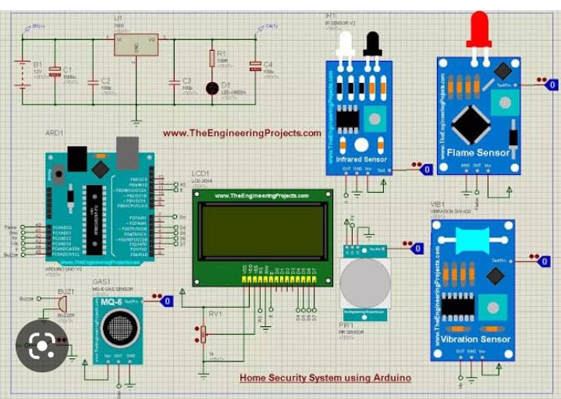
FIGURE :1
- Motion Sensor (LDR):
Light Dependent Resistors (LDRs) are a type of nonlinear resistor that can change its value based on the change in incident light intensity. LDRs are also known as Photo Resistor, Photo Conductor, Photo Conductive Cell, or just Photo Cell. They are made out of semiconductors, especially from the compounds of CdSe, CdS, InSb, or PbS. In the absence of light, the resistance of an LRD is very high, sometimes up to 1M. But when the sensor is exposed to light, its resistance decreases radically, even down to a few Ohms. LDR is used in this work because they are cheap to get and simple to handle. The only limitation is that they take a few seconds to get back to their original position once the light is absent again.A motion sensor, or motion detector, is an electronic device that uses a sensor to detect nearby people or objects.
Motion sensors are an important component of any security system. When a sensor detects motion, it will send an alert to your security system, and with newer systems, right to your mobile phone. If you have subscribed to an alarm monitoring service, motion sensors can even be configured to send an alert to your monitoring team.
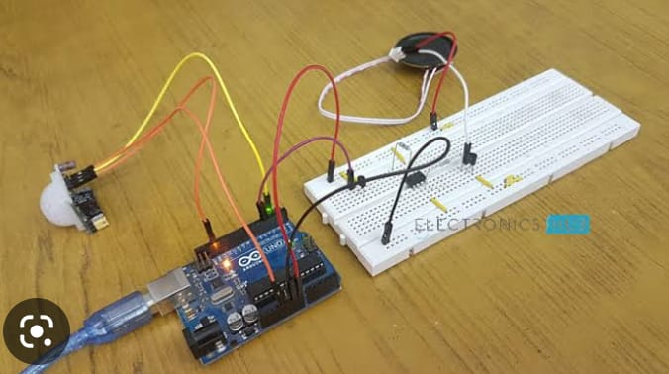
FIGURE : 2
- Fire/Temperature Sensor (LM35):
The LM35 is selected as the temperature sensor for this work, which is a precision temperature sensing IC with an output voltage linearly proportional to the temperature. A big advantage of these sensors is that they are calibrated directly in Celsius (Centigrade), and promise 0.5Â°C ensured accuracy (at 25Â°C). The operating voltage of LM35 sensors is 4V to 30V, and they cover a full 55Â°C to 150Â°C temperature range.

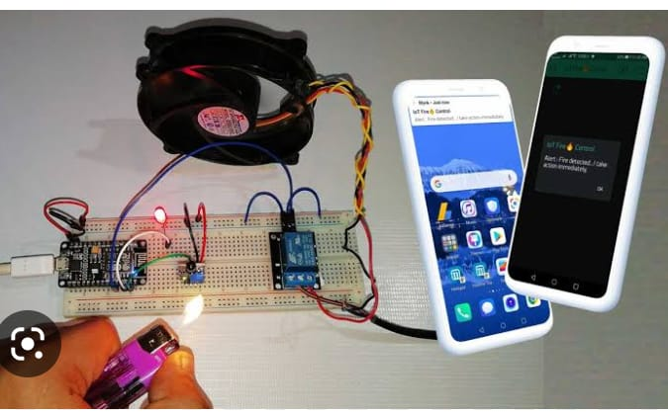
FIGURE : 3

- Glass-break Sensor:
Glass-break sensors can be built in two different ways based on the detection method, as per some research and commercial devices.
One way to build is based on vibration and another based on acoustic sound. For the first way, thedetector usually has a shock sensor mounted on the glass to get sufficient transmission of the vibration and detect it.
For the second way, the crystal of a piezoelectric sensor is tuned to the resonance frequency of 40 and 12 kHz to detect the breaking sound.
This sensor also has to be mounted on the glass. In this paper, the proposed method involves placing a tiny metal strip (current conductor) around the outer periphery of a glass window or door, so that when the glass breaks the strip breaks as well which changes the current flow in the controller to take an action.
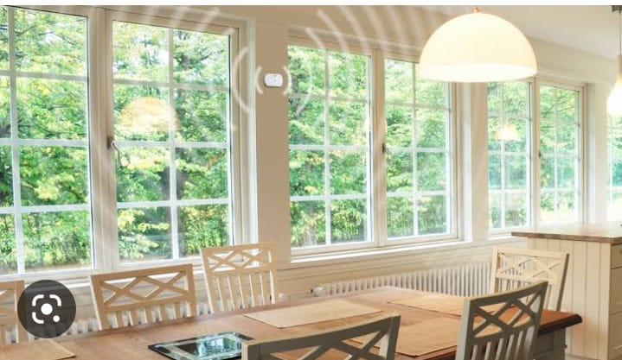
FIGURE : 4
System Flow Chart: The heart of this work is the automated security system, and to better represent its workflow step-by-step, a logic flowchart is provided in Figure 5. The core concept is to monitor the sensor (Motion, Fire, Glass-break) inputs for Real- Time Voltage (RTV) change and compare them with the predefined SET Voltage (SV); and then changing the status of the output modules (LED, Buzzer, SMS) accordingly.
Electronic circuit/hardware design: As mentioned before, the design part of the work presentedin this paper can be divided into two parts:
- Design of the security system, which involves two separate circuits; one for motion sensing and glass-breaking detection, another for fire/temperature detection. And,
- Design of the Sun- tracking solar system. The design of all the circuits is done by Schematic Capture of Proteus 7.7 Professional and presented in the following sub-sections, where the power supply is taken to be 5V dc throughout the system. Design of the Security System represents the circuit for motion sensing [21] and glass-breaking detection, where an LED (red) is connected with the power terminal of +5V dc. A Light Depending Resistor (LDR) and a voltage dividing series resistor are connected to the rectifiers output (+5V), where the divided voltage is interpreted as a metal strip that encloses the outer periphery of a glass window or door which is interfaced with the microcontroller (ATmega8) through ADC (4). The voltage across the Potentiometer (POT) is considered as the SV, which is interfaced with the Atmega8 through ADC (3); and the voltage across R2 is considered as the RTV, which is interfaced with the Atmega8 through ADC (4). This RTV varies according to the change in light intensity on the LDR, or the connection of the metal strip (glass-breaking sensor). As an output device for alarm indicating, a pair of Red and Yellow LEDs (represents a bi-color LED) with series resistor R6 and R7 is interfaced with the Atmega8 through two NPN transistors as their driver. As per the design, when RTV>SV, LED is OFF and vice versa. A buzzer is also connected as an output device for alarming, through a series NPN transistor as its driver. When the metal strip is disconnected due to glass breaking, the RTV<SV, which disconnects R2 from the Atmega8, and an SMS is sent to a preprogrammed mobile number as an alert, A temperature sensor circuit using LM35 is also to detect fire, and the incident will be alerted through SMS as well.
CONCLUSION
A microcontroller-based Sun-tracking solar-powered anti- theft automated security system is designed with three kinds of incident detection sensors (motion, fire, glass-break) and threekinds of alarm methods (Buzzer, bi-color LED, SMS). The core part of the security system is also constructed and tested. The designed system is verified to be functional and useful in security protection, which features automatic control of the LED (color-changing in blinking manner), alarming (when LED is ON) with Buzzer and SMS, and displaying the information according to the different scenarios of security measures. The system operates on 5V dc supply, requiring less than 1mA of current and 5mW of power during standby conditions. When the system is ON, during the bi-color LEDs blinking sequences (Yellow-Off-Red) it consumes less than 25mA of current and 120mW of power. And, the buzzer takes less than 0.5mW of power while ON, which makes it a very low power system and suitable for working reliably with solar energy for a longer duration when grid connection is not available. To make the system even more efficient and sustainable a Sun-tracking solar system is also designed. Alert SMS generation system for Fire and Glass-break detection is also verified and confirmed to be reliable with the designed security system. This anti-theft system can be applied in homes or any kind of facility where security is a concern, and the control unit can be placed locally or remotely for monitoring.
FUTURE SCOPES
Engineering is a continuous process of experimenting, problem solving, and innovation for different kinds of applications. Every engineering projects have some sort of scopes to improve or extend them, and the work presented in this paper is not an exception. Besides the existing possible applications of the designed system, the future scopes, according to the revised block diagram in, may involve: (i) designing the Grid Control Unit to complete the power management system between Solar and Grid, (ii) designing a wireless Transmitter and Receiver compatible with the system to make it true remote-area applicable, and (iii) physical implementation of the whole system including the Sun-tracking system.
REFERENCES
- M. K. Hossain, P. Biswas, M. Mynuddin, and S. Morsalin, Design and implementation of an IoT-based smart home security system, International Journal of Modern Embedded System (IJMES), vol. 2, no.6, pp. 8592, 2014, doi: 10.2991/ijndc.k.190326.004.
- P. K. Dasari, D. S. Harsha, and E. Chandrasekhar, Implementation of Low Cost Home Monitoring, Controlling and Security System using IoT, International Journal of Engineering Research & Technology (IJERT), vol. 8, no. 06, pp. 11611164, Jun. 2019, [Online]. Available: https://www.ijert.org/implementation-of-low-cost-home-monitoring- controlling-and-security-system-using-iot.
- A. Elfasakhany, J. HernÃ¡ndez, J. C. GarcÃa, M. Reyes, and F. Martell, Design and Development of a House-Mobile Security System, Engineering, vol. 03, no. 12, pp. 12131224, Dec. 2011, doi: 10.4236/eng.2011.312151.
- A. Cyril Jose and R. Malekian, Smart Home Automation Security: A Literature Review, The Smart Computing Review, vol. 5, no. 4, pp. 269 285, Aug. 2015, doi: 10.6029/smartcr.2015.04.004.
- S. Chitnis, N. Deshpande, and A. Shaligram, An Investigative Study for Smart Home Security: Issues, Challenges and Countermeasures, Wireless Senso Network, vol. 8, no. April, pp. 6168, Apr. 2016, doi: 10.4236/wsn.2016.84006.
- R. M. V. and P. V. H. F. Sudhindra, S.J. Annarao, Design and Development of ARM-7 based Home Security System with GSM Technology, International Journal on Emerging Technologies, vol. 6, no. 2, pp. 5760, Oct. 2016.
- A. Bhatt, S. Bisht, and D. C. A. Andola, Anti-Theft Tracking System for Mobile-Vehicles, International Journal on Emerging Technologies, vol. 8, no. 1, pp. 554556, 2017.

