Manganese Biocatalysis
Gopinath Mavankal, PhD
Johnson & Johnson
Vision Care, Supply Chain
Jacksonville, Florida, USA
gmavankal@gmail.com
ABSTRACT
Manganese, a 3d transition metal, with variable oxidation states(-3 to +7) is ubiquitous in earth’s crust, has low toxicity, and as a catalyst in cyanobacterial photosynthesis accumulated oxygen over vast swathes of the ocean and oxygenated the water which gradually escaped into the atmosphere displacing methane sometime between 2.4 – 2.1 billion years ago¹. Cyanobacteria evolved from an anaerobic environment to produce oxygen which wiped out much of anaerobic life and gave rise to aerobic metabolism. Manganese thus plays a central role in evolution. Biophysical and biochemical studies of manganese as a biocatalyst is described from a chemical and biological perspective in this chapter. The dissertation work done by the author dictates the choices in this chapter that are thus more like vignettes considering the vast amount of ongoing work in the area of Manganese biocatalysis.
I. INTRODUCTION
The electron transport chain (ETC) of mitochondria and chloroplasts are similar in that they are both capable of synthesizing adenosine triphosphate (ATP), are made of protein complexes that receive and release electrons. Mitochondrial ETC uses chemical energy from redox reactions while chloroplasts use light energy. The electron donors, the energy source and electron acceptors differ between the two organelles, however, Manganese plays a role as a catalyst in both.
II. ETC in Mitochondria(Respiration) and Chloroplasts (Photosynthesis)
Both mitochondria and chloroplasts use an electron transport chain to generate ATP, but the processes differ in terms of location and input/output molecules. An electron transport chain (ETC) is a series of protein complexes located in the inner mitochondrial membrane (in eukaryotes) or the plasma membrane (in prokaryotes). It plays a crucial role in cellular respiration and photosynthesis, where it is responsible for transferring electrons and generating ATP (adenosine triphosphate), the energy currency of cells. In cellular respiration, the ETC is part of the aerobic respiration process. During the breakdown of glucose in the presence of oxygen, NADH (Nicotinamide adenine dinucleotide) and FADH2 (Flavin adenine dinucleotide) molecules are generated in earlier steps. These high-energy electron carriers donate their electrons to the ETC. The electron transport chain consists of several protein complexes, including NADH dehydrogenase, cytochrome b-c1 complex, cytochrome c, and cytochrome oxidase. These complexes are embedded within the mitochondrial or plasma membrane and contain specific electron carrier molecules such as flavin mononucleotide (FMN), iron-sulfur clusters, and heme groups. The flow of electrons through the ETC occurs in a sequential manner. Initially, NADH donates its electrons to the first complex of the ETC, often called Complex I. From there, the electrons are transferred to the subsequent complexes through a series of redox reactions, where electrons are shuttled between different electron carrier molecules. As the electrons move through the ETC, they lose energy. This energy is used to actively transport protons (H+) across the mitochondrial or plasma membrane, creating an electrochemical gradient. This gradient drives ATP synthesis by a process called oxidative phosphorylation. At the end of the ETC, oxygen acts as the final electron acceptor, combining with protons to form water. This step ensures the continuation of the electron flow, as oxygen is a strong electron acceptor.
- Mitochondria (Respiration)
a. Location: The electron transport chain in mitochondria is located in the inner mitochondrial membrane.
b. Input: The input molecules are reduced coenzymes, specifically NADH and FADH2, produced during glycolysis, the citric acid cycle, and fatty acid oxidation.
c. Output: The output is ATP, which is produced through oxidative phosphorylation. Oxygen (O2) serves as the final electron acceptor, creating water (H2O) as a byproduct.
B. Chloroplasts (Photosynthesis)
a. Location: The electron transport chain in photosynthesis is located in the thylakoid membrane of chloroplasts.
b. Input: The input molecule is light energy absorbed by pigments such as chlorophyll. This energy is captured in the form of electrons in a molecule called chlorophyll
c, Output: The output molecules are ATP and NADPH, which are used to power the synthesis of carbohydrates during the Calvin cycle (also known as the dark reactions of photosynthesis).
III. Water Oxidation: The Molecular components and processes.
Four membrane spanning multi-subunit protein complexes present in the thylakoid membrane of chloroplasts work in concert to convert light energy into chemical energy². In the late 1960s Murata identified what is termed as “state transitions” based on photochemical quenching observed in the kinetics of chlorophyll fluorescence⁴. The complex that acts as the antenna for light energy uses protein bound pigments that interact with two of the four complexes, namely, Photosystem I and Photosystem II. The functional identification of the protein complexes involved in the process is often restricted by what can be purified and isolated for study³. Fluorescence analyses indicate that the affinity of the light harvesting complex for PSI and PSII differ in affinity and the stoichiometry of the association is also different. The cytochrome b6f complex carries out a cyclic energy transfer such that part of the electrons transferred from PSII to PSI are cycled back to PSI. It must be noted that the thylakoid membrane provides the separation between the stroma and the inner compartment of the thylakoids as shown in Figure 1⁵.
Figure 1. Transverse Section: Schematic Diagram of the chloroplast
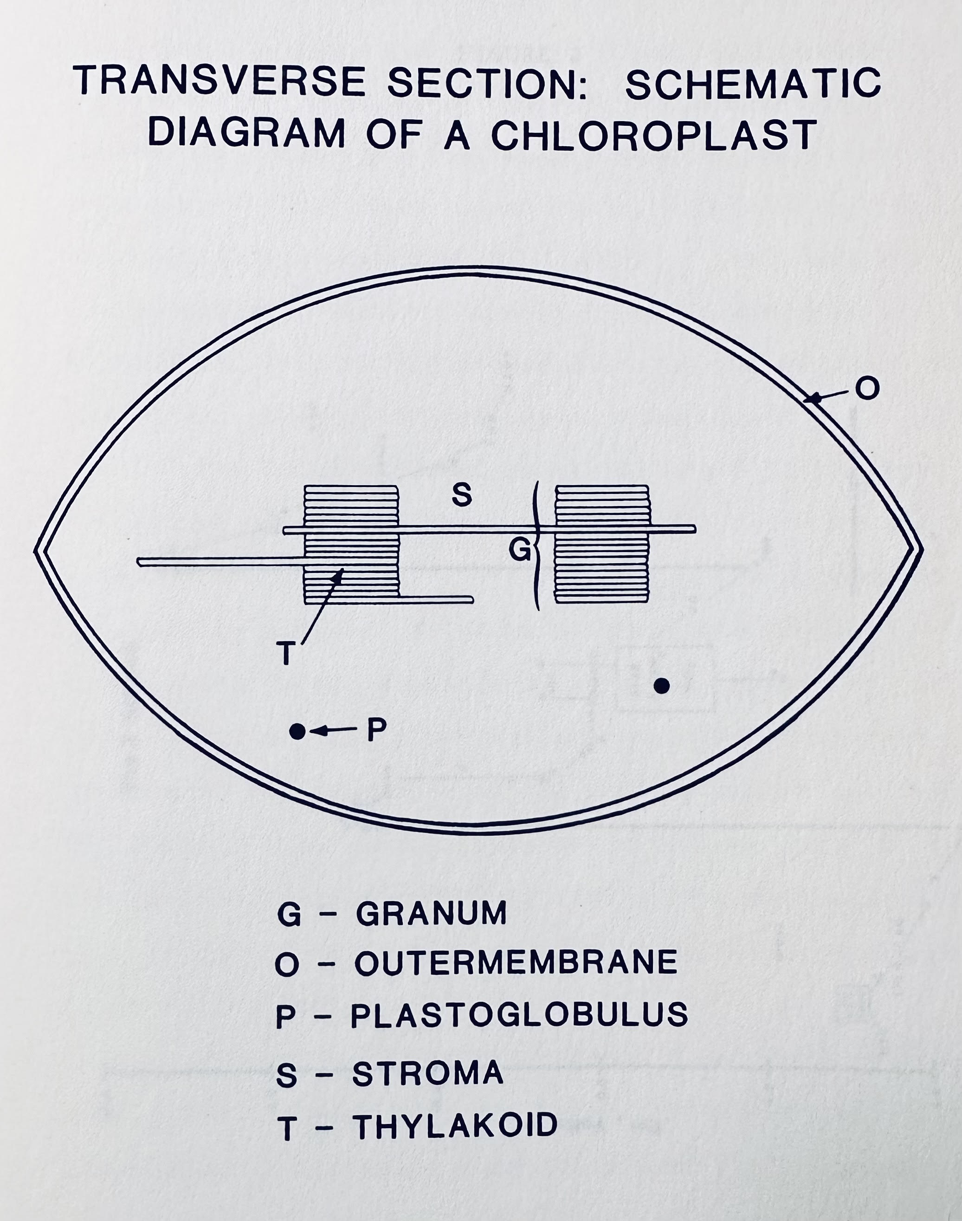 The separation between the stroma and the inner compartment of the thylakoids by the lipid bilayer creates the structure for charge separation. In the inner compartment or lumen of the thylakoid lie exposed through channels of water among the protein surfaces what is termed as the Reaction Center (RC). The RC is the location for four Manganese ions referred to as a cluster as they are held in place through covalent bonds that include bridging oxygen atoms to form a specific geometric pattern of a tetramer. Three of four manganese were found to be more tightly coupled as revealed through Electron Paramagnetic Resonance studies⁵. Furthermore, it was observed that calcium added to the medium was necessary to leach out one of the four manganese in preparations of photosystem II whose activity was measured using the oxygen electrode response to light the preparation was exposed to⁵. Reconstitution of this activity was attempted but it was found that the preparation that was depleted of one of four manganese was just as able to produce oxygen as the preparation that was not treated with Calcium and retained all four managanese^{6,7}. The manganese cluster is the catalytic site for the oxidation of water to oxygen with a resultant charge separation when the protons and the oxygen are released to the lumen of the thylakoid while the electrons that are sourced from water are directed through the electron transport chain where Plastoquinone resides on the other side of the membrane, as described in the review². The reaction can be represented as
Equation 1. 2H2O+2PQ+4H+stroma/cytoplasm−→hvO2+2PQH2+4H+lumen
The broad applicability of Electron Paramagnetic Resonance to study free radicals and metals with unpaired electrons comes handy. The anisotropy that is induced by the varying magnetic field applied at the sample while the microwave radiation is held constant leads to an absorption pattern that results in fine structure in the spectrum. A general theory for analyzing the EPR spectra monomeric manganese (II) bound to proteins is presented by Meirovitch and Pupko¹⁰. This anisotropy can arise within the Manganese center and the studies using EPR⁵ were coupled with functional measures of the reaction center using oxygen evolution measured by the initial rate of oxygen evolution using a Clark electrode upon illumination of the cell⁹. Manganese content was determined by flame atomic Absorption Spectrometry¹¹. The finding that three of four Manganese suffice for oxygen evolution is not the generally accepted view where the four Manganese along with Calcium is considered essential. As the ability to mimic this process in Artificial Photosynthesis is still limited, it might be useful to consider alternatives to the generally accepted view, if it could result in more successful outcomes with designing water oxidation catalysts
IV. Artificial Photosynthesis.
Solar driven water oxidation that generates hydrogen ions in a bionic leaf is coupled with a bioengineered bacterium to convert carbon dioxide from air in a report by Dogutan and Nocera¹² . The hurdles to inexpensive, durable heterogenous catalyst for mimicking water oxidation is due to an insufficient understanding of the reaction mechanisms in a review by Zhang et. al.¹³. The reaction rates at which electron transfer occurs between the light harvesting complexes (LHC1 and LHC2) and the reaction center (RC) pigments is in the order of pico to femto seconds range. As the last step is the slowest (pico seconds versus femto seconds) it prevents back reactions. McConnell, Li and Brudvig provide a review of natural and artificial photosynthesis¹⁴. Zhang and Sun¹⁵ provide a review of the opportunities and challenges of molecular catalysts. The catalytic turnover rate (TON) and turnover frequency (TOF) are parameters that define a good water oxidation catalyst. In nature Water oxidation occurs at a low overpotential (approximately 160 mV) and a high reaction rate (100 – 400 per second). The actual mechanism of water oxidation in Photosynthesis, as to how the O-O bond formation occurs is yet to be determined and there are two candidate mechanisms that are proposed and lack experimental verification. The candidate mechanisms are a water nucleophilic attack (WNA) and interaction between two M-O intermediate (I2M) pathways to form O-O bonds (oxygen evolution) catalyzed by molecular catalysts. The first molecular water oxidation catalyst (WOC) reported in the 1980s was Ru based, the so-called blue dimer (BD). It had a TON of 13 and TOF of 0.0042 per second. It was close to three decades before a breakthrough was seen with a molecular WOC with a TON of 2000 and a TOF of 41 per second. This breakthrough was accomplished by using carboxylate groups into the ligands and a special steric configuration that allowed 7-coordination at the at the catalytic site. The overpotential was reduced from 370 mV to 180 mV and the TON changed from 0.004 per second to 41 per second and a change in TON from 13 to 2000¹⁵. This change was inspired by the OEC in PSII containing several carboxylate ligands. Among the challenges to overcome are that current WOCs are noble metal Ruthenium based and not the earth abundant metals. Low stability, high cost and moderate light absorption limits commercialization of the technology.
V. Manganese in Superoxide Dismutase
Reactive oxygen species (ROS) result from the ETC in mitochondria. Dismutation is a chemical reaction in which a single compound is simultaneously oxidized and reduced, resulting in the formation of two different products. In the context of Superoxide dismutase (SOD) enzymes, dismutation refers to the enzymatic reaction in which superoxide radicals (O2-) (ROS) are converted into oxygen (O2) and hydrogen peroxide (H2O2). superoxide (O2-) is dismutated into molecular oxygen (O2) through oxidation, and hydrogen peroxide (H2O2) is formed through reduction. Besides mitochondria, SODs, discovered in 1968 use other transition metals and have a wide distribution in other tissues as well with a similar protective function that plays an important role in a wide range of disease conditions such as cancer of the colon lung and lymphatic system as well as neurodegenerative diseases. The human Mn-SOD (manganese superoxide dismutase) enzyme is a homotetramer, meaning it consists of four identical subunits, each containing a manganese metal ion as a cofactor. The structure of human Mn-SOD enzyme can be described as follows:
1. Subunit Structure: Each subunit of the Mn-SOD enzyme consists of a single polypeptide chain folded into a compact globular structure. The polypeptide chain comprises approximately 200 amino acid residues. The four subunits come together to form the complete Mn-SOD enzyme.
2. Active Site: The active site of Mn-SOD, where the manganese ion is located, is situated in the interior of each subunit. The manganese metal ion is coordinated by amino acid residues of the protein, forming the catalytic center. The coordination environment surrounding the manganese ion helps facilitate the dismutation reaction of superoxide radicals.
3. Secondary Structure: The protein chain of Mn-SOD contains various secondary structures including alpha helices and beta strands. These structural elements provide stability and contribute to the overall folding of the enzyme.
4. Quaternary Structure: The homotetramer assembly of Mn-SOD is stabilized by non-covalent interactions between the individual subunits. These interactions can involve hydrogen bonding, ionic interactions, van der Waals forces, and hydrophobic interactions. The quaternary structure of Mn-SOD is crucial for its stability and enzymatic activity. The precise arrangement and three-dimensional structure of human Mn-SOD have been determined using techniques such as X-ray crystallography or nuclear magnetic resonance (NMR) spectroscopy. These methods have allowed scientists to visualize and understand the detailed structure and coordination of the manganese cofactor within the Mn-SOD enzyme.
References
- https://asm.org/Articles/2022/February/The-Great-Oxidation-Event-How-Cyanobacteria-Change# (accessed on 14 Jun 2023)
- Shevela, D., Kern, J.F., Govindjee, G. et al. Solar energy conversion by photosystem II: principles and structures. Photosynth Res 156, 279–307 (2023). https://doi.org/10.1007/s11120-022-00991-y
- Pierre Galka and others, Functional Analyses of the Plant Photosystem I–Light-Harvesting Complex II Supercomplex Reveal That Light-Harvesting Complex II Loosely Bound to Photosystem II Is a Very Efficient Antenna for Photosystem I in State II, The Plant Cell, Volume 24, Issue 7, July 2012, Pages 2963–2978, https://doi.org/10.1105/tpc.112.100339
- Murata, N. The discovery of state transitions in photosynthesis 40 years ago. Photosynth Res 99, 155–160 (2009). https://doi.org/10.1007/s11120-008-9389-8
- Gopinath R. Mavankal. Biophysical Investigations of Manganese at the Water-Oxidation Site of Spinach Photosystem II. Ph.D. dissertation, University of Southern Mississippi, May 1989.
- Mavankal, G., McCain, D. (1991). Photosystem 2 Remains Capable of Oxygen Evolution After Losing 1/4 of its Initial Manganese Content. Photosynthetica, 25(4), 631-638.
Available at: https://aquila.usm.edu/fac_pubs/7156
- Terry M. Bricker. Biochemistry 1992 31 (19), 4623-4628. Oxygen evolution in the absence of the 33-kilodalton manganese-stabilizing protein. DOI: 10.1021/bi00134a012
- Bonke, S.A., Risse, T., Schnegg, A. et al. In situ electron paramagnetic resonance spectroscopy for catalysis. Nat Rev Methods Primers 1, 33 (2021). https://doi.org/10.1038/s43586-021-00031-4
- Luís González, Carlos Bolaño, François Pellissier. Use of Oxygen Electrode in Measurements of Photosynthesis and Respiration. Handbook of Plant Ecophysiology Techniques, Chapter 9, 2001. ISBN : 978-0-7923-7053-6
- Meirovitch, E., and Poupko, R., J. Phys. Chem., 82, 17,1920, (1978).
- Sergio L.C. Ferreira, Marcos A. Bezerra, Adilson S. Santos, Walter N.L. dos Santos, Cleber G. Novaes, Olivia M.C. de Oliveira, Michael L. Oliveira, Rui L. Garcia. Atomic absorption spectrometry – A multi element technique. TrAC Trends in Analytical Chemistry, Volume 100, Pages 1-6 (2018)/ ISSN 0165-9936. https://doi.org/10.1016/j.trac.2017.12.012.
- Dilek K. Dogutan and Daniel G. Nocera. Artificial Photosynthesis at Efficiencies Greatly Exceeding That of Natural Photosynthesis. Accounts of Chemical Research 2019 52 (11), 3143-3148. DOI: 10.1021/acs.accounts.9b00380
- Hongna Zhang, Tianying Liu, Nicholas Dulock, Benjamin P. Williams, Yuanxing Wang, Boqiang Chen, Haden Wikar, David Z. Wang, Gary W. Brudvig, Dunwei Wang and Matthias M. Waegele. Atomically dispersed Ir catalysts exhibit supportdependent water oxidation kinetics during photocatalysis. Chem. Sci., 2023, 14, 6601-6607. DOI: 10.1039/d3sc00603d
- Iain McConnell, Gonghu Li, and Gary W. Brudvig. j.chembiol.2010.05.005 (2010). Correspondence: gary.brudvig@yale.edu. DOI 10.1016
- Biaobiao Zhang and Licheng Sun. Artificial photosynthesis: opportunities and challenges of molecular catalysts. Chem. Soc. Rev., 2019, 48, 2216-2264. DOI: 10.1039/C8CS00897C

