IMPACT OF SEARCH ENGINE OPTIMIZATION ON BRAND VISIBILITY AND BUSINESS GROWTH OF COMPANIES

Ms. Abhidnya Patankar ¹
Dr. Suvrashis Sarkar ²

Abstract:
This study explores the impact of search engine optimization (SEO) on brand visibility and business growth. It begins by giving a thorough explanation of SEO, which involves strategically optimizing a website to improve its visibility and position on search engine result pages (SERPs). The study also makes a distinction between on-page and off-page SEO, explaining how each tactic helps boost a website's online visibility and organic traffic. While off-page SEO works on constructing external links, social media involvement, and online reputation management, on-page SEO concentrates on optimizing components immediately within the website, such as keyword research, meta tags, content optimization, and website layout. The study also incorporates a respondent company in this research satisfaction survey conducted to evaluate the impact of SEO services provided to websites. Feedback from respondent companies in this research highlights the effectiveness of SEO in enhancing brand visibility and attracting potential customers, leading to measurable business growth. The survey unveils the positive correlation between well-executed SEO strategies and increased website traffic, conversions, and overall success for businesses. In conclusion, the study underscores the crucial role of SEO in augmenting brand visibility and fostering business growth, making it an indispensable tool for companies looking to thrive in the competitive digital landscape.

Keywords: Search Engine Optimization, on-page, off-page, SEO

- Ms. Abhidnya Patankar: Marketing Management student at MET Institute of PGDM, Bandra – Mumbai, India. abhidnyapatankar2001@gmail.com
- Dr. Suvrashis Sarkar: Associate Professor of Marketing Management at MET Institute of PGDM, Bandra – Mumbai, India. suvrashissarkar@gmail.com

Introduction:

Any efforts taken by a firm or individual to promote their products and services fall under the umbrella of marketing. Marketing encompasses all forms of consumer goods and service sales as well as promotion and advertising. Marketing encompasses both traditional and digital marketing. The practice of promoting products and services via the Internet and other online-based digital platforms, such as mobile phones, desktop computers, and other digital media and platforms, is known as digital marketing. It is a subset of marketing. This development impacted how businesses and brands use technology for marketing in the 1990s and 2000s. Digital marketing efforts have multiplied because of customers' greater usage of digital devices rather than physical stores, increased integration of digital platforms into marketing tactics, and everyday life. SEO, SEM, content marketing, influencer marketing, content automation, campaign marketing, data-driven marketing, e-commerce marketing, social media marketing, social media optimization, e-mail direct marketing, display advertising, e-books, and game advertising are all examples of online marketing strategies.
One of the primary objectives of modern digital marketing is to increase brand recognition. Raising brand awareness is essential for digital marketing and marketing in general since it has an impact on brand perception and customer decision-making. Recent patterns show that businesses and digital marketers are giving brand awareness a higher priority and devoting more of their efforts to establishing brand recognition. This is evidenced by the observation that 81% of digital marketers tried to increase brand recognition in the last year, according to 2019 Content Marketing Institute research. According to a different Content Marketing Institute survey, 89% of B2B marketers now prioritize building brand recognition over efforts to increase sales. To raise brand awareness among consumers, digital marketing tactics may leverage one or many online platforms and methods.

Creating brand awareness may involve the following techniques or tools:

Search Engine Optimization (SEO):
The visibility of company websites and brand-related content for popular industry-related search queries may be improved using search engine optimization tactics. Featured snippets, knowledge panels, and local SEO are just a few of the search features and search results that are considered to have a rising impact on consumer behavior, which is said to be related to the necessity of SEO to raise brand awareness.

Search engine marketing (SEM):
PPC advertising, often known as search engine marketing (SEM), comprises the purchase of ad space in noticeable, prominent positions at the top of search results pages and websites. It has been discovered that the use of search ads increases brand identification, awareness, and conversions.

Social media marketing:
With a focus on connection and content, social media marketing has the characteristics of being always in a marketing mode and interacting with respondent companies in this research. The marketing process must be continuously monitored, summarized, and managed, and the marketing aim must be adjusted in response to customer and market feedback. According to 70% of marketers, the main goal of social media marketing is to raise brand recognition. Facebook, Instagram, Twitter, and YouTube are the most popular platforms now used, according to social media marketing firms. As of 2022, LinkedIn has been identified as one of the social media platforms that corporate executives use most frequently due to its ability for business networking.

Content marketing:
By creating and distributing relevant articles, podcasts, videos, and other media, content marketing is a marketing approach used for attracting, hold onto, and growing an audience. When it comes time to buy what you sell, this strategy establishes ability, increases brand awareness, and keeps your company at the top of customers' minds.

Background of SEO:

Most people now use search engines as a regular part of their life to get answers when they are uncertain about anything. But when using search engines, a user can obtain hundreds or even thousands of results, which spreads the results out over several pages. The results on the second or third page will receive significantly less traffic than those on the first page, which can constitute a problem. In actuality, the top page of Google "captures 71% of search traffic clicks and has been reported to be as high as 92% in recent years," according to Kelly Shelton, VP of marketing at Boostability. Due to this, an intriguing technique known as Search Engine Optimization (SEO) was developed.

What is SEO?

The word "search engine optimization" describes a collection of techniques used to improve the positioning and visibility of web pages in organic search results. Because organic search is the most widely used way for users to locate and access online information, having a good SEO strategy is essential to increasing both the quality and quantity of visitors to your website. By providing material that satisfies user search needs, search engines promote SEO actions that help both the user search experience and page's rating.
The term "SEO" refers to the process of optimizing a website utilizing natural methods; its main goal is to offer users the best content and outcomes in order to improve the user experience. Three steps can be used to sum up how search engines like Google operate. The search engine must crawl, index, and rank content before returning results when users search for keywords on Google. The search engine launches robots through crawling that follow links created to find material. The information is then found by Google, indexed, and added to a database of URLs. Finally, the search engine can start ranking results once the discovered URLs are in the database.
Furthermore, both on-page optimization and off-page optimization are given importance in the SEO study of a small organization. Making a website's content simple to find and bringing in organic traffic, like through images or keywords, are both examples of on-page optimization. While on-page optimization is the main focus, off-page optimization refers to outside elements like links to the website.

The following are the importance of SEO:

- Organic search results:
Organic search results are the listing that a search engine considers to be most relevant to the user's query and show up on the search engine results page (SERP). There are a lot of advertising on many SERPs. In contrast to paid advertising, which is ranked by advertiser bids, organic search results are determined using the search engine's own algorithms. Positioning a page higher in organic search results cannot be bought.
- Quality of organic traffic:
The quality of organic traffic refers to how relevant the information on your website is to the user's search query. No matter how many people visit your website, if they think you're an Apple computer resource when you're really just a farmer selling apples, they're likely to leave without buying anything. Only those visitors to your website who are genuinely interested in the products, information, or other resources they find there make up high-quality traffic. High-quality SEO makes use of the efforts made by the search engine to match a user's search intent to the web pages displayed in the SERP.

- Quantity of organic traffic:
By "quantity of organic traffic," we suggest the number of people who find your website through natural search results. It is important to use your SEO strategy to rank relevant pages as highly as you can because visitors are far more likely to click on search results that are close to the top of the SERP. The more highly qualified visitors you attract to your website, the more likely it is that you will see a rise in worthwhile conversions.

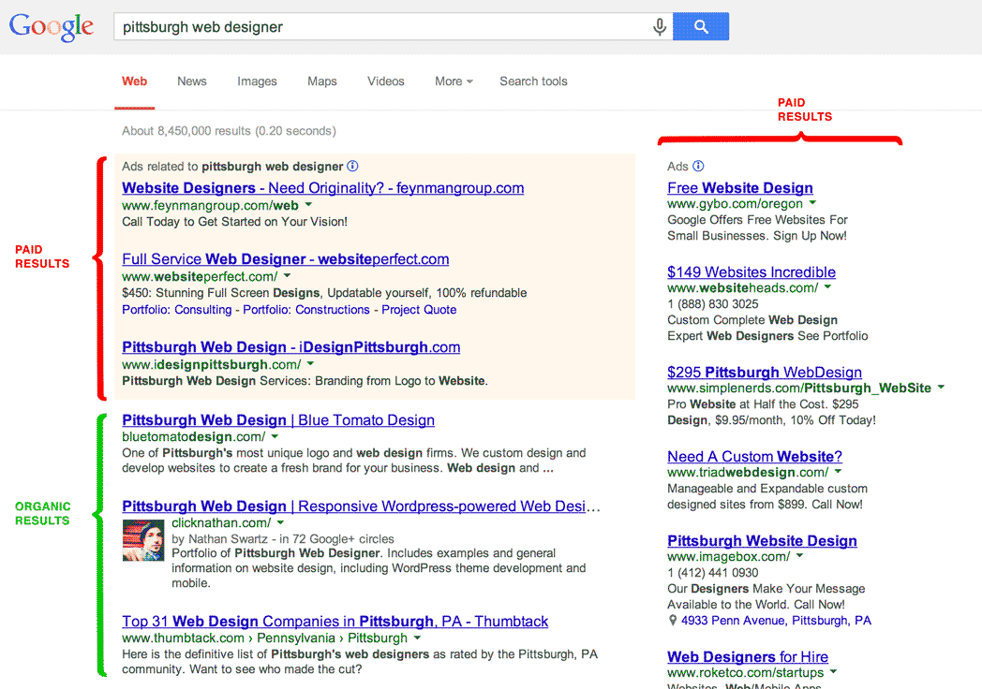
Fig. 1 Google Search Result

Advantages of using SEO:

You may boost brand recognition, boost business revenue, and even lend legitimacy to your brand with the appropriate SEO approach. Regardless of your business's industry or size, it has identified a few very specific advantages of including SEO in your marketing approach below:

1. Brings Organic Search Traffic:
Viewers who land on your website naturally are known as organic traffic. Your website needs to be efficiently optimized to direct this traffic in the right direction. The intention is for Google to acknowledge that your website provided the most pertinent responses to users’ inquiries. Approximately 63,000 Google searches are made every second and your company may compete for some of those search results with the correct SEO plan. Concentrating on keywords related to your company and the information you want to convey to your audience is one of the finest ways to increase your SEO. Every website on the internet is examined by Google’s web crawlers for certain keywords, intuitive user interfaces and overall reliability. These bots take advantage of these details to establish the best answers for each query.

2. Generates Leads Cost-Effectively:
SEO is one of the most affordable ways to increase your online presence compared to cold calling, unsolicited emails, and other forms of outbound marketing. When used strategically, SEO enables you to reach out to people who are searching for your product or service, have found your article or listing using those terms, and are now on your website. These leads are therefore primed and prepared to commit. Almost every internet activity begins with a search. Furthermore, SEO is permanent. Well-managed SEO can continue to generate high-quality visitors to your site over time, unlike paid online ads that cease doing so once the campaign is complete. Although implementing SEO at your company can take some time, it is unlikely to require more advertising spending, which raises the possibility of increased business revenue. You can develop a thorough plan for enhancing your organic presence with the aid of a digital marketing bootcamp that teaches SEO strategy.

3. Increases Brand Awareness:
You want to be recognized as a leader in your field while simultaneously offering your audience a useful answer. How do you make sure that people recognize your brand in a world where there are 1.88 billion websites? One of the finest methods to achieve this objective is using an SEO plan. The first page of Google will increase your authority and visibility. After you've optimised your content to match search terms, you should see an increase in clicks, which will increase engagement and trustworthiness. Your SEO strategy's momentum may spark a series of events that raise awareness of your business.

4. Get you Ahead of the Competition:
Every industry is competitive. You should research the SEO methods of your rivals in the same way that you would research their print marketing tactics. You can find out what keywords your competitors rank for, how many pieces of content they have, their linking strategy, and much more by visiting websites like Moz and SEMrush. You may develop a plan to outperform your rivals once you focus on the keywords that are most pertinent to your sector.
Searching for possibilities where your rivals fail is one method to achieve this. Find opportunities where you can improve your SEO around that word or phrase to appear more prominently in Google searches.
5. Builds trust:
Even with a solid SEO strategy, it takes time to win over customers to your business. Invest in high-quality content for your viewers if you want to become known as a trustworthy source of current information. As a result, your score may rise as people perceive your company more favorably. In addition to looking for specific phrases to rank your website, Google also considers how frequently and authoritatively you engage with your audience. Even if they don't end up making a purchase from you, Google takes into account how you treat your website visitors. EAT, or expertise, authoritativeness, and trustworthiness, is the three-part system Google utilizes to rank websites. It means that if your material is not relevant to your audience, then using a term frequently is pointless.

Types of SEO:

A) On-Page Optimization:
The practice of optimizing specific webpages so that they appear higher than others in search results and receive more traffic from search engines is known as on-page SEO, also known as on-site SEO. Updates should be applied to the on-page text, title tags, internal links, and other elements. Search engines like Google scan keywords and other on-page SEO indicators to determine if a website matches a user's search intent. In addition, if the search engine thinks the page will be useful to the user, it will rank higher in search results.

Elements include in On-Page activities:
Keyword Research- The process of choosing the keywords you should include in your written content to help drive traffic to your website is known as keyword research. Businesses and marketers use the method of keyword research to find out what people are looking for. To improve their SEO ranks in the search engine results pages (SERPs), effective keyword research findings are added to new or current content. Both SEO and general marketing goals might benefit from keyword research. Furthermore, while developing new page content or items, keyword research can assist marketers find phrases they may not have otherwise considered.

Title Tags and Meta Description- The header of a web page contains HTML code for title tags and Meta descriptions. They aid search engines in comprehending the information on a page. The title tag and Meta description of a page are often displayed whenever that page is displayed in search engine results. The title tag is a web page's title element that provides a summary of the information on the page. Under 60 characters should make up the title tag. A brief overview of the information on the web page should be included in the Meta description element. A Meta description allows you a little more room to explain to users what you're offering while the title tag is fairly constrained. This is an opportunity to give them a compelling reason to click on your website.

This is how Title tag looks in HTML code:
<head>
<title>Your title here</title>
</head>
In HTML Code, this is how Meta description looks like:
<head>
<meta name=” description” content=” This is where you add your meta description. Make it count.”>
</head>
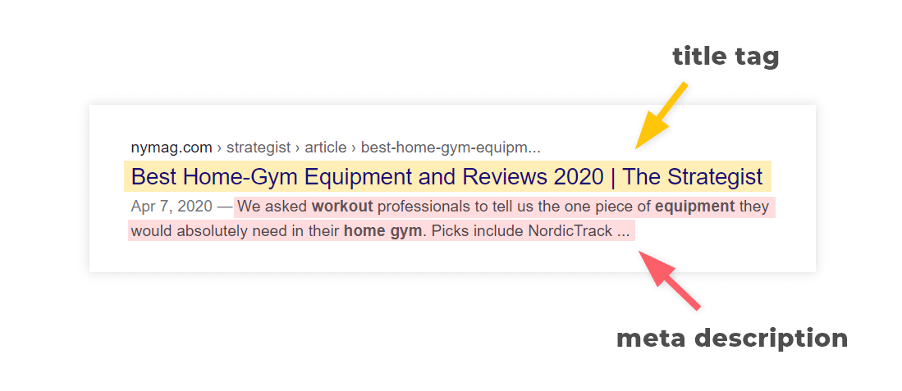
Fig. 2 Title Tags and Meta Description

Heading tags Optimization- HTML header elements instruct a browser on the styling to apply when displaying a block of text on a webpage. Header tags are helpful for both users and search engines. They offer an overview of the content that your users will soon be reading. They provide a hierarchy and context for search engines like Google about what your page is all about. Think of header tags as the chapter headings in a book. By quickly scanning them, you can obtain an excellent sense of the content. Header tags are important for SEO since they help Google understand your content in addition to making your website more user-friendly by making your content more readable and accessible.

This is how heading tags looks like in HTML code:
<h2>What is a Header Tag?</h2>
From <h1> to <h6>, HTML header tags are arranged in a hierarchy.
The most significant text, such as the main theme or title of a piece of material, is designated with an H1 tag.
Subheadings are frequently used with the H2 and H3 tags.
Finally, more structure can be added within those subsections by using the H4, H5, and H6 tags.

Internal Linking- Any link from one page of your website to another is considered an internal link. Links are a common way for visitors to your website and search engines to find content. Links allow visitors to your website to browse and discover the material they're looking for. Links are another navigational tool that search engines use. A page without any links won't be visible to visitors. As the site owner, you have authority over internal linking. Your most crucial pages will be directed to by the right internal links, which will also direct Google to them. Internal linking to an anchor text which is considered as anchor text.
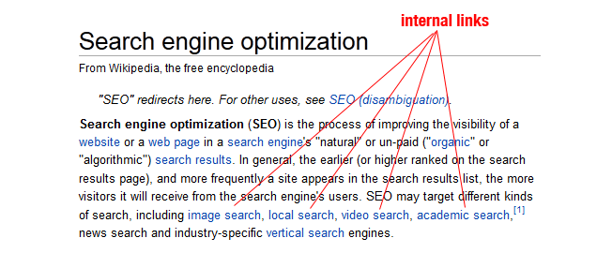
Fig. 3 Internal Linking
Adding FAQ to the pages- The People Also Ask (PAA) box, an interactive search result that shows a box of queries that other searchers have made in relation to your initial search, should be your first port of call. The durability of this SERP feature will be ensured by PAA's functional ability to enable Google to raise the quantity of featured snippets. Target PAA that have mediocre responses that can be strengthened, if you can discover them. You should still include these queries in your content even if the current PAA findings are perfect and you don't intend to overthrow the existing ranking page. Why? This will guarantee that your material is comprehensive and solid. In other words, semantic search is the key to everything. To begin optimizing for PAA, start by immediately asking the questions that are relevant in subheadings and providing the right answers in list or paragraph format. In the case of lengthy articles, you might be able to do this right in an H2. You might wish to include a specific FAQ section to your e-commerce pages. To improve the appearance of your search results, all you need is the ability to alter headings and copy.
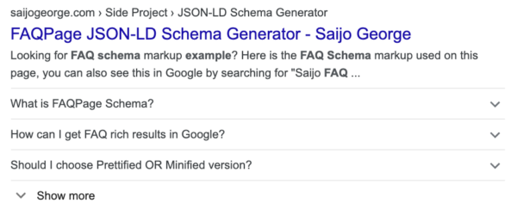
Fig. 4 Adding FAQ to the pages
Adding Alt Tags to Images- For search engines to have a text alternative for images, image tags are added with an HTML feature called an alt tag, also referred to as a "alt attribute" or "alt description." An e-commerce store's search engine rankings may be improved by including product images in alt tags. Although search engines and other robots cannot understand images, they can be crucial to how people view a particular online page. Alt tags, which provide text that search engines may read, solve this problem. When Googlebot or other search engine crawlers examine a page, properly worded alt text affects how it is indexed and where it ranks.
Alt text is contained within the image tag: <img src="myimage.png" alt="nike_air_zoom" />.
Adding Valid Schema Markup- A group of code snippets known as schema markup can be added to any page of a website to highlight particular features in search results. Pages with structured data typically have higher click-through rates than those without, since searchers find the snippets to be more interesting and appealing. Structured data that is insufficient could cost you crucial organic SERP presence.
B) Off-Page Optimization:
Off-page SEO refers to SEO strategies applied outside of the website itself to improve a website's rankings. These strategies usually involve things like social media marketing, link building, and guest posting. Off-page SEO seeks to boost the authority and confidence that search engines and website visitors place on your website. It is one of the essential elements of a successful SEO strategy. Consider off-page SEO as building your website's visibility. Furthermore, reputable websites frequently have higher rankings since search engines prioritize their E-A-T (expertise, authority, and trustworthiness) factors. One of the best ways to show E-A-T is through off-page SEO components like backlinks, reviews, and recommendations.
Elements include in Off-Page activities:
Infographic Submission- The words "information" and "graphics" are combined to generate the term "Infographic." It is a method of graphically displaying some information. A link builder and a visual designer collaborate on off-page SEO activities such as infographic submission. Earning a backlink is the primary objective of this action. The link builder would locate websites that allow infographics and publish the high-quality infographics over there. The graphic designer would create the infographics. Infographic submission is more complicated than it appears. For infographics to be visually appealing, a lot of imagination and effort must be put out. Additionally, as we already mentioned, searching for free infographic submission websites takes time. One of the best SEO strategies is this one. The benefits of submitting infographics are numerous. One of the most obvious ones is that they provide data in a way that is easier for people to understand than just text: visually. They are also a fantastic technique to communicate information in a clear and engaging manner. They can be used to market your goods and services or to clarify a notion. If you submit infographics correctly, they can work wonders for your company. In reality, infographics may eventually play a significant role in your marketing plan. You may reach new audiences and raise brand exposure if you use the correct paid or free infographic submission sites. The major advantage of using free infographic submission sites is that you don't have to pay for each infographic submission. It saves you a lot of money as well as time.
Business Listing- One of the off-page components is known as business listing. It is an internet listing for your company which includes the Name, Address, and Contact information as well as other significant information. Many websites, including Foursquare, Justdial, Yelp, and Yellow Pages, provide free business listings. Users can use these thorough tools to look up relevant businesses online. It is a crucial factor to take into account. The most crucial information you must enter when adding your company in internet business directories is Name, Address, and Phone number. Also referred to as NAP data. Providing a link to your company website, images, reviews, and operating hours is considered as one of the good ideas. Business listing is a method of collecting all businesses in a single place (in a list), so anyone can obtain relevant business information as needed.
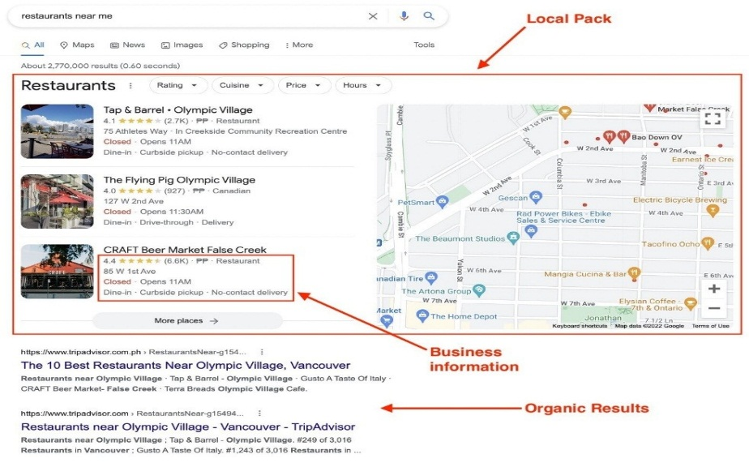
Fig. 5 Business Listing

Social Book Marking- As part of off-page optimization, you can store your links on online bookmarking sites by submitting them to social bookmarking websites. These web sites with tags can be visited from any computer with internet connection using these links or bookmarks. Each of these bookmarks serves as a backlink, which improves the SEO of a website. These bookmarked links are regarded as high-quality backlinks because most bookmarking websites allow you to title your URL and include relevant descriptions and keywords. As a result, the title, which serves as the anchor text for the backlink, is kept with the link. To turn your social bookmark into a keyword-anchored hyperlink, you may also include your primary keywords in the title. Examples of the popular social bookmarking sites are twitter.com, pinterest.com, digg.com, delicious.com and reddit.com.

Guest Blogging- When you invite a third party to write a blog post for your website as a guest author, this is known as guest blogging. Usually, the author is a professional in the organization's field or an authority on topics related to it. It can be an excellent approach to collaborate with others in the same sector, whether in the area of sales or in conjunction with tactics like affiliate marketing.

Classified Submission- This is an additional SEO tool that can assist in raising the position of the keyword in the search results. These advertisements are published on third-party websites and include links to the website and other pertinent information about the brand you are promoting. The only drawback to this is one is the advertisements are published for a short period of time and then they are deleted. Therefore, you need to pay the party back frequently. Classified submission is a great way to advertise online, albeit being a little expensive. The owner must remember that the advertisement needs to be brief and to the point. Within the confines of the space given to you, your suggestion should be presented.

Literature Review:

The Importance of Search Engine Optimization in Business.
Author: Dakshita Jain, Manav Mittal and Prof Abhishek Venkteshwar
Published year: 2020
The research paper emphasizes that SEO is a continuous process and a valuable investment for enhancing visibility and achieving growth. It highlights the crucial role search engines play in content dissemination and explains how SEO strategies can improve a website's presence on search engine result pages (SERPs), resulting in increased organic traffic. The paper aims to demonstrate the significance of SEO in driving economic gains for businesses and provides insights on how to effectively implement SEO strategies. By implementing SEO techniques, businesses can optimize their websites to align with search engine algorithms, improving their chances of appearing higher in SERPs and attracting more organic traffic. Overall, the paper emphasizes the importance of SEO in enhancing visibility, attracting organic traffic, and achieving growth objectives for businesses.

The impact of SEO on business.
Author: Rana, Bishnu
Published Year: 2016
The primary objective of the paper is to evaluate the efficacy of SEO techniques in attaining organic rankings on search engine result pages (SERPs), with a particular emphasis on Google. Additionally, it aims to showcase the influence of implementing SEO strategies on business growth by presenting relevant case studies. The research paper also endeavors to provide valuable insights into the current market's demand for SEO and its potential to create opportunities for businesses. In essence, the study examines how organizations can expand their visibility and reach a broader audience by improving their online presence on search engines, specifically focusing on Google.

The Importance of using Search Engine Optimization for Small Businesses.
Author: Alexander Ingman
Published Year: 2022
The objective of this research paper is to shed light on the importance of Search Engine Optimization (SEO) for small businesses and their ability to compete effectively with larger firms in the digital landscape. The paper focuses on two key research questions: firstly, how small businesses can derive benefits from implementing SEO strategies, and secondly, how they can optimize their utilization of SEO techniques. By exploring these questions, the research aims to provide insights into the specific advantages that SEO offers to small businesses, such as improved online visibility, increased organic traffic, and enhanced brand recognition. Additionally, the paper seeks to provide practical guidance on how small businesses can effectively implement SEO practices, including keyword research, on-page optimization, content creation, and link building. Ultimately, the research paper aims to equip small businesses with the knowledge and strategies necessary to leverage SEO as a powerful tool for growth and competitiveness in the digital marketplace.

The Benefits of Search Engine Optimization in Google for Businesses.
Author: Riikka Pohjanen
Published Year: 2019
The study focuses on highlighting the benefits of Search Engine Optimization (SEO) in the context of Google for businesses. While acknowledging the limitations of relying on electronic sources and a limited number of case studies for quantitative analysis, the research aims to evaluate the impact of SEO adjustments on business growth. This involves analyzing the performance of businesses before and after implementing SEO strategies to understand their effectiveness. The main objective is to examine how companies can broaden their reach, increase their visibility, and engage with a wider audience by improving their online presence on search engines, with a particular emphasis on Google. By optimizing their website and content for search engine algorithms, businesses can improve their rankings on Google's search result pages, leading to increased organic traffic and potential conversions. Overall, the study aims to demonstrate the tangible advantages of SEO for businesses seeking to enhance their exposure and maximize their online presence on Google.

Search Engine Optimization and the connection with Knowledge Graphs
Author: Milla Marianna Hietala, Oliver Marshall
Published Year: 2021
In their research, the authors draw attention to the evolution of SEO practices in response to the constant updates in search engine algorithms. They emphasize that SEO has transcended the traditional approach of solely focusing on keyword optimization. Instead, modern SEO strategies now encompass a broader range of factors, including user intent, quality content, and user experience. The authors stress the significance of this evolution for businesses and website owners who seek to remain competitive in the ever-changing digital landscape. Additionally, prioritizing the creation of high-quality and relevant content not only satisfies user expectations but also contributes to higher search engine rankings. The authors emphasize the importance of optimizing the overall user experience, as search engines increasingly value websites that provide seamless navigation, fast loading times, and mobile responsiveness. Ultimately, the authors' insights underscore the need for businesses and website owners to adapt their SEO strategies to align with the evolving expectations of search engine algorithms and user preferences.

Research Methodology:

Exploratory and Descriptive research methods were used for conducting this research qualitatively. The scope of this research involved studying certain companies from India, Middle East and USA for their digital marketing work particularly Search Engine Optimization. These companies were selected by convenience sampling method.

Data Collection:

Secondary Data:

A literature review was done before the study even started to see if this subject has been studied before. This subject and how it affects growth, has been studied before. There was a success in compiling relevant literature to back up this study. Since a "search engine" and "search engine result page" are essential to the SEO process, it was important to begin with those concepts in the case of SEO. "Search engine optimization" and more specifically "search engine optimization strategies" were used as search terms during the second reading process, and since that concept is rather broad in and of itself, we decided to concentrate on SEO strategies and techniques, which we believed would be the most advantageous and effective. Selected research papers as mentioned in the literature review were the important source of secondary data.

Primary Data:

Primary data was collected by observation method and by survey questionnaire (using Google Form). The absence of physical interviews/ one-to-one interaction was the only drawback of the online data collecting. All questions were closed-ended. The scope of this research involved studying certain companies from India, Middle East and USA for their digital marketing work particularly Search Engine Optimization. These companies were selected by convenience sampling method. Accordingly, 10 companies were surveyed for primary data collection. The same form, without any additional questions, was given to each company.

Selection of Respondents:

Evaluation and comparison of the need and expectations with the purpose of the study were the first steps in selecting the study participants. Convenience sampling was used to select 10 respondent companies as samples for this research. There has been much discussion on the ideal sample size for qualitative studies but choosing it before the study is conducted can be challenging. As a result, the quality of responses is more important than sample size when looking at in-depth results. It didn’t want to restrict this investigation to a few businesses or industries. Due to the fact that the topic is not business- or industry-specific, it chose to approach the research in this manner.
The same structured interview survey methodology was used for all the interviews, which were conducted in English and included closed-ended questions.
The information on the respondents is presented in the table below to provide some background on the interviewees.

Surveyed Companies | Company Background/ Business Type
Company A | -Business of selling fence, automated sliding gates  -India
Company B | -Business of selling home accessories and decorative items  -India
Company C | -Provide services like pet grooming, boarding and vets  -Dubai
Company D | -Business of selling various bonds and debentures  -India
Company E | -Provide services of educational courses like ACCA, CA, EA, CFA, etc  -India
Company F | -Business of selling gifts in bulk  -India
Company G | -Provide services on UI/UX  -India
Company H | -Business of selling ornaments  -USA
Company I | -Provide services of giving customized diet plans and tips  -India
Company J | -Provide pickup and drop laundry services  -Boston & Miami
Names of respondent companies have not been disclosed in the above table to maintain confidentiality.

Data Analysis:

The following data gives a picture of the survey conducted by tabulation of responses received for each question asked considering the objective of Search Engine Optimization (SEO) efforts which has been actively implemented by respondent companies in this research to improve their brand visibility and promote business growth. This survey was created to generate insightful responses from these respondent companies in this research, providing to evaluate the effectiveness of their SEO tactics as well as their impact on their businesses.
- How important do you think SEO is for your company’s online visibility and growth?
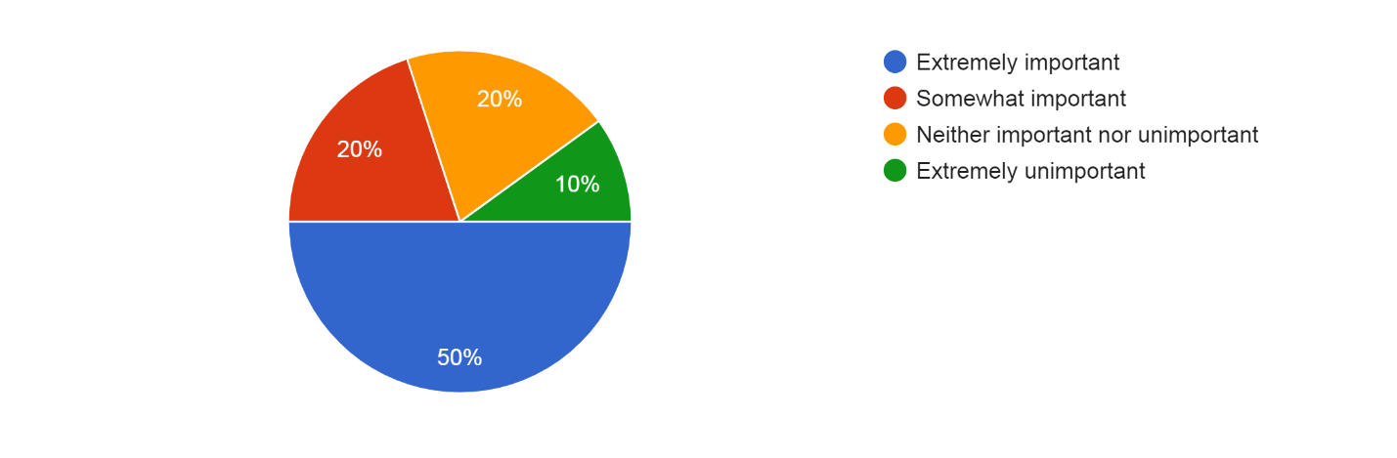
The responses indicate a range of different points of view on the significance of SEO for a company's online growth. It plays a vital part as it has been evaluated as extremely important by 50% of respondents. 20% of people think it's marginally significant, indicating an average degree of notice. Another 20% of people lack consensus, believing it to be neither crucial nor unimportant. Finally, 10% of people have a negative impression about SEO that downplays its significance. Overall, the majority of respondents recognize the value of SEO, highlighting its potential influence on online growth.
2. What are the main benefits of SEO that you have experienced for your company’s online presence and growth?
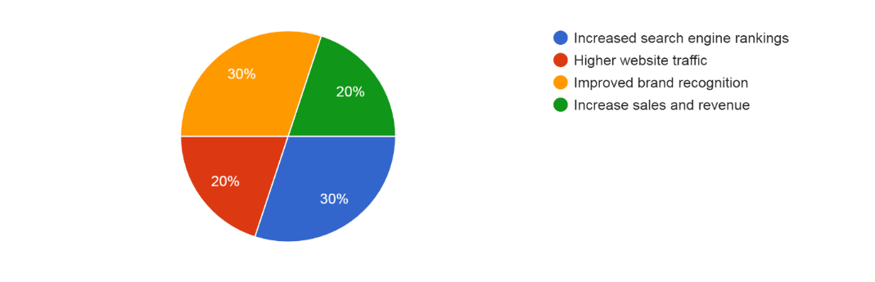
A large proportion of respondents, 30%, highlighted improved search engine rankings as a noteworthy benefit of SEO. Another 30% identified better brand awareness as a major advantage, showing that SEO has increased their brand's recognition and reputation among target audiences. Additionally, SEO-related increases in website traffic were reported by 20% of respondents, indicating that attempts to increase website traffic were successful. At least 20% of respondents stated higher revenue and sales, indicating that SEO has favorably benefited their company's expansion and financial performance.

3. What were the challenges you faced while implementing SEO strategies for your business?
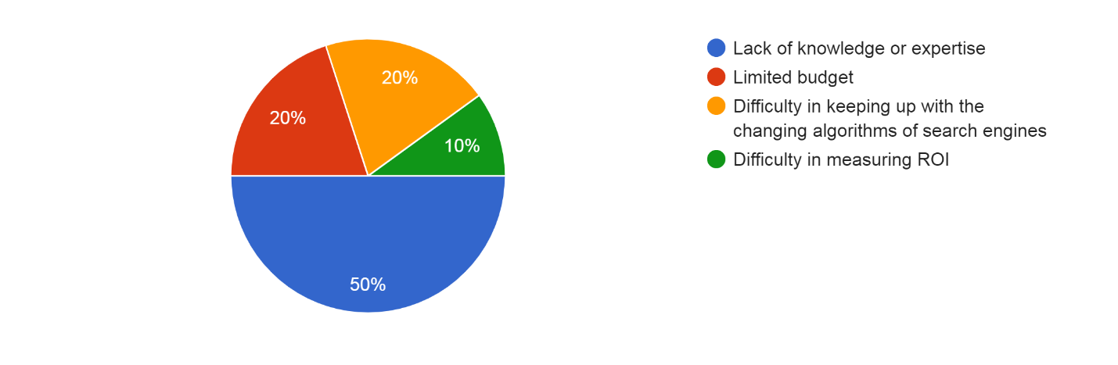
The majority of responders (50%) identified a lack of knowledge or experience in this field as their greatest challenge. A sizable fraction, 20%, also emphasized the constraints of a constrained budget, and another 20% underlined the challenge of keeping up with search engine algorithms that are continuously evolving. Only 10% of the responses came from a smaller group who said it was difficult to evaluate the ROI of their SEO efforts. Overall, our respondent commonly mentioned these issues, including insufficient knowledge, financial restrictions, algorithmic changes, and difficulties measuring ROIs.

4. When it comes to implementing SEO strategies for your business, which option would you prefer?
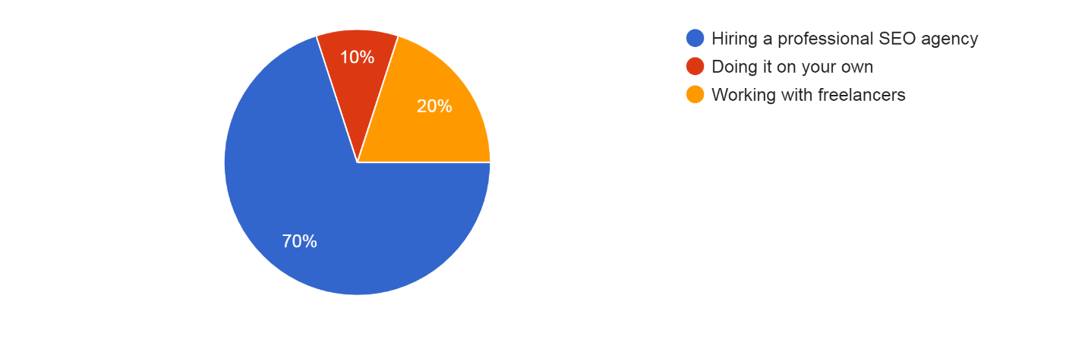
70% of respondents preferred working with a specialized SEO agency to put SEO tactics into place for their company. Only 10% (1 response) of respondents preferred to manage their SEO independently, compared to 20% who preferred working with freelancers. This is a clear trend towards looking outside the company for resources and experience for efficient SEO implementation, with professional companies being the most preferred option.

5. What are the key factors influencing your decision to choose between getting SEO services from a professional agency, working with freelancers, or handling it on your own?
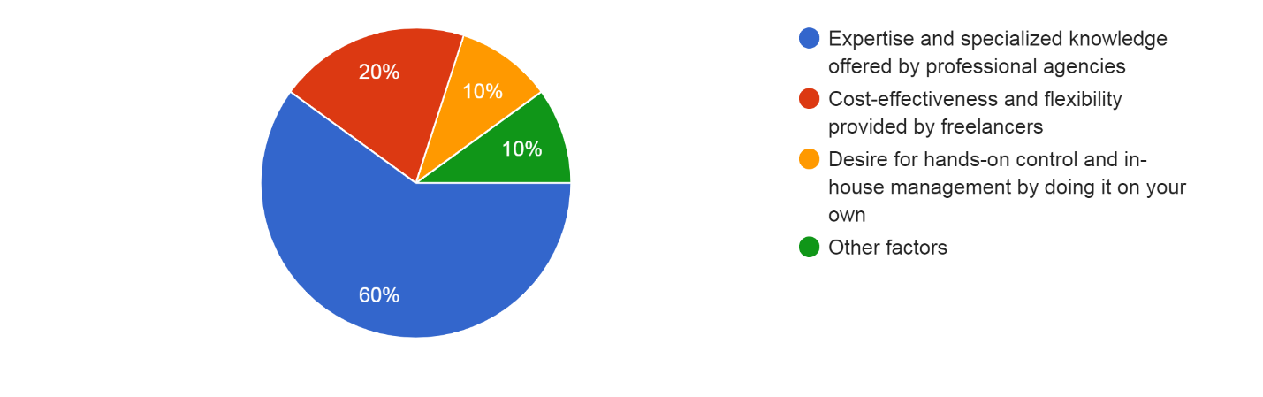
When choosing SEO services, the majority of respondents (60%) placed a high value on the experience and specialized knowledge offered by professional agencies. A smaller group (20%) prioritized the flexibility and cost-effectiveness that working with freelancers provided. However, 10% (1 response) said they would like to do SEO themselves in order to keep control and management in-house and hands-on. 10% more (1 response) identified various other considerations that had an impact on their choice.

6. How has on-page optimization (such as improving website structure, Meta tags, content optimization, etc.) impacted the overall performance and visibility of your website?
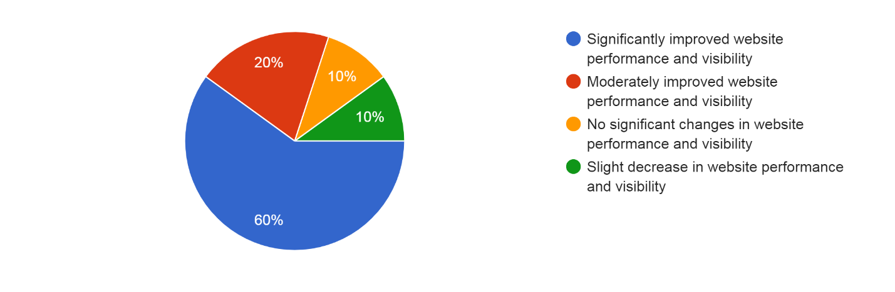
60% of those who responded said these measures have significantly improved the performance and visibility of their website. 20% described the improvement as moderate, indicating a perceptible but not particularly significant effect. Another 20% reported no appreciable changes in the functionality and visibility of the website, indicating that the optimization work did not produce meaningful outcomes. A smaller group, 10%, observed a minor decline in website performance and visibility, indicating that the on-page optimization had an adverse effect.

7. Have you experienced any change on user experience, engagement, or conversion rates as a result of on-page optimization efforts?
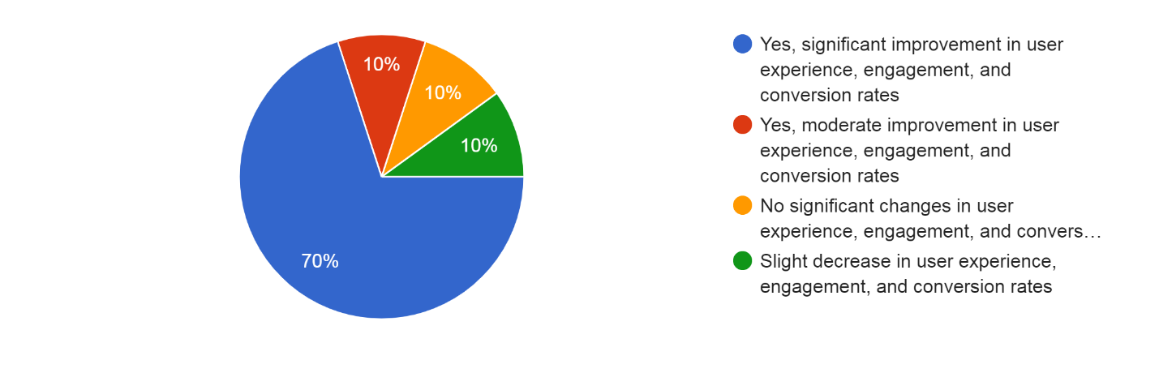
Information on the effects of on-page optimization initiatives on user experience, engagement, and conversion rates can be obtained from the data. 70% of the respondents noted beneficial outcomes because of these efforts. An additional 10% reported a moderate improvement, suggesting evident but less significant changes in these regions. Although on-page optimization efforts were made, 10% of respondents reported that they saw no appreciable increases in user experience, engagement, or conversion rates. This shows that the strategies used for this particular group of respondents might not have produced the anticipated results. A modest number of responders (10%) also mentioned a tiny decline in conversion rates, engagement, and user experience.

8. How has off-page optimization (such as link building, social media promotion, guest blogging, etc.) contributed to the online reputation and authority of your website?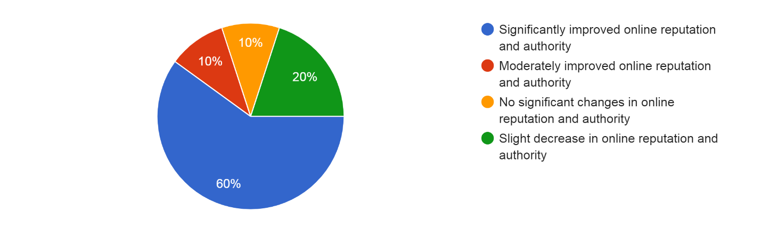
The information gathered provides insight on how off-page optimization techniques like link building, social media promotion, and guest blogging impact the reputation and authority of the websites of responders. The majority of responders (60%) stated that the off-page optimization initiatives have significantly improved the internet reputation and authority of their website. This shows that these techniques were successful in raising the authority, visibility, and influence of their websites within their respective sectors. 10% of the respondents also reported a modest boost in their authority and reputation online. Despite the off-page optimization efforts, it is crucial to note that 10% of the respondents did not see any appreciable changes in their internet reputation and authority. Furthermore, a notable percentage (20%) of respondents experienced a slight decrease in their online reputation and authority.

9. Have you seen an increase in referral traffic, brand mentions, or backlinks to your website as a result of off-page optimization efforts?
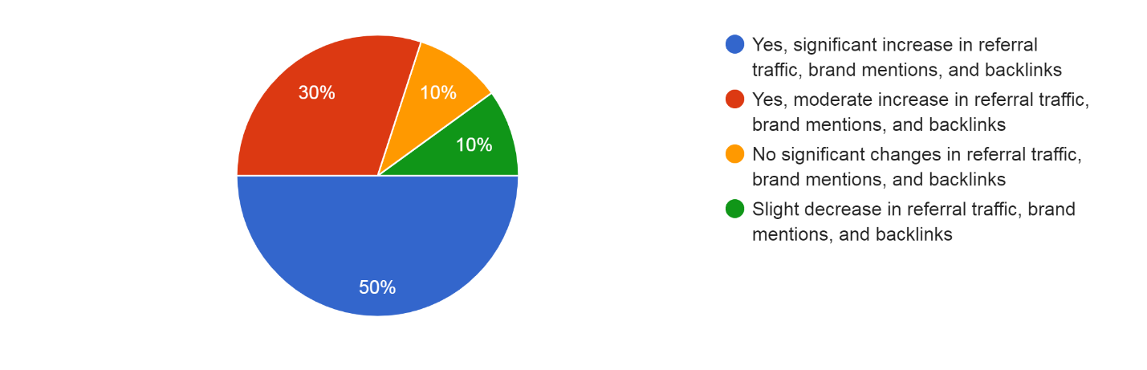
The majority of responders (50%) stated that the off-page optimization activities have significantly increased their referral traffic, brand mentions, and backlinks. This shows that these tactics were effective in boosting traffic from recommendations, raising brand awareness and recognition, and producing beneficial backlinks from outside websites. Additionally, referral traffic, brand mentions, and backlinks all moderately increased, according to 30% of the respondents. Despite the off-page optimization efforts, it's vital to note that 10% of the respondents did not notice significant improvements in referral traffic, brand mentions, or backlinks. In addition, a tiny percentage of respondents (10%) reported seeing a slight decline in backlinks, brand mentions, and referral traffic. This shows that despite the off-page optimization efforts made, some elements or difficulties may have restricted the ability to maintain or improve these metrics.

10. Have you noticed any significant improvements in your website's search engine rankings for targeted keywords?

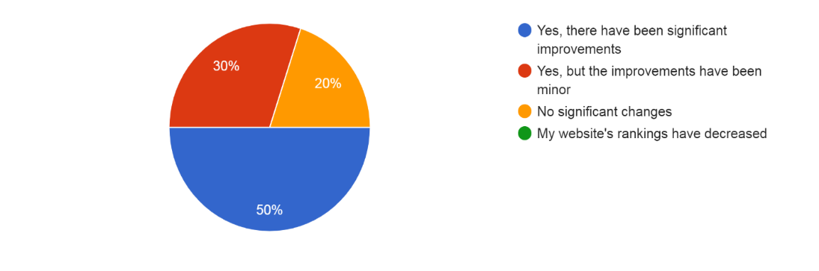

For the targeted keywords, 50% of respondents said their website's search engine rankings had significantly improved. Additionally, just 30% of the respondents noticed significant changes in search engine rankings. It is crucial to note that 20% of respondents did not notice any appreciable changes in the search engine rankings for the targeted keywords on their website. It’s also important to note that none of the respondents claimed that the ranks of their website had dropped. This implies that the used SEO methods have not had a negative impact on the search engine rankings of their website.

11. Have you experienced an increase in organic search traffic to your website?
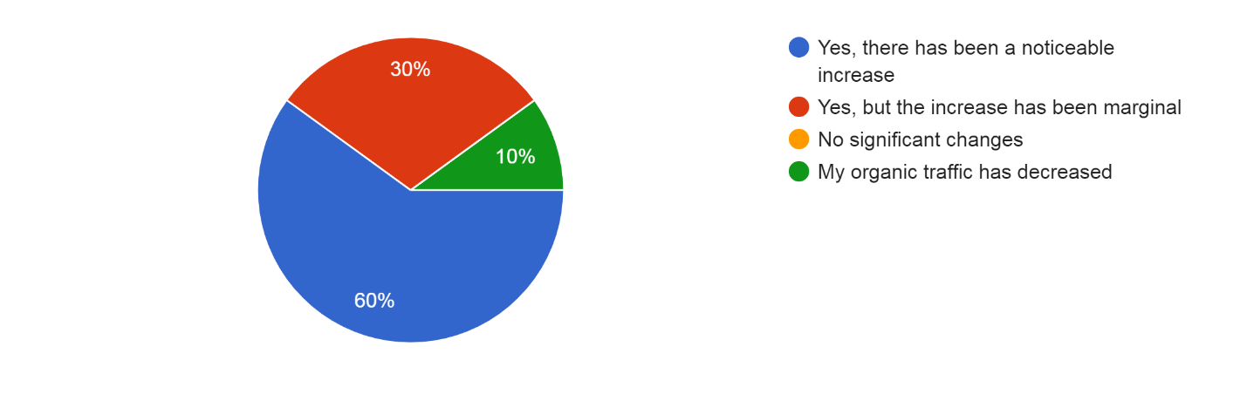
60% of those surveyed said there had been an interesting boost in traffic from organic searches. Additionally, just a small percentage of respondents (30%) reported seeing an increase in organic search traffic. No respondents noted any major shifts in the volume of organic search traffic. This shows that all respondents' levels of organic traffic have experienced some impact from SEO efforts, whether positive or negligible. 10% of the respondents, however, saw a decline in their organic traffic.

12. Have you seen an improvement in the conversion rate and sales on your website?
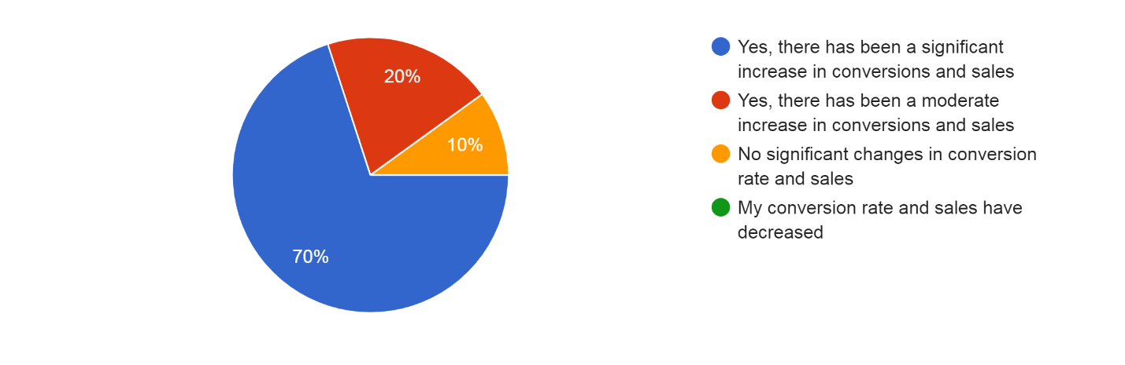
The vast majority of responders (70%) claimed that conversions and sales had significantly increased. Additionally, 20% of the respondents reported a modest boost in sales and conversions. It's important to note that 10% of respondents reported that despite the use of the tactics, there were no significant improvements in the conversion rate or sales. None of the respondents brought up a decline in sales or conversion rates. This shows that the measures put into place have neither hampered sales performance nor had a negative effect on the website's capacity to convert visitors.

13. Did the blog posts optimized for SEO receive more visibility and engagement?
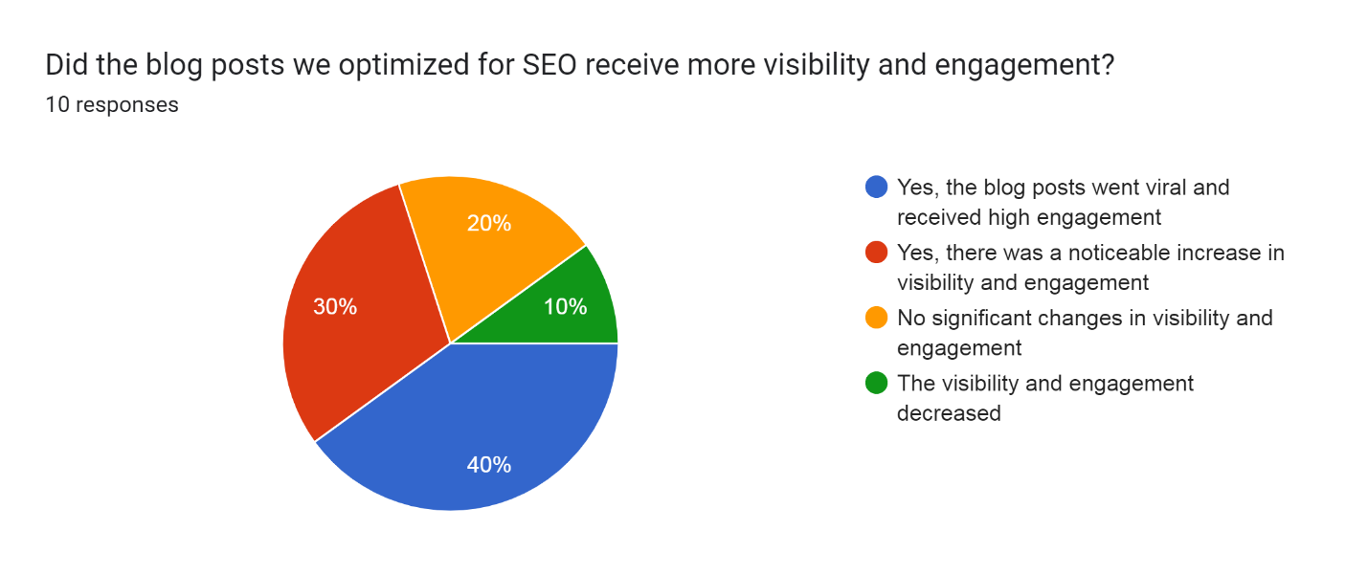
According to a noticeable majority of respondents (40%) the optimized blog entries went viral and garnered a lot of engagement. Additionally, 30% of the respondents reported that the optimized blog entries had noticed increases in visibility and interaction. Even while the enhancements may not have become viral, they nonetheless show promise to get the intended audience's attention and encourage more engagement. Despite the SEO optimization, it's crucial to note that 20% of respondents did not notice any appreciable changes in visibility and interaction. Additionally, visibility and engagement were also cited as being down by 10% of the respondents.

14. How satisfied are you with the overall increase in website traffic since SEO efforts began?
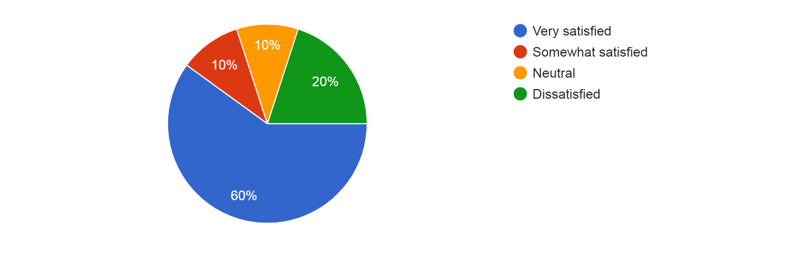
60% of those surveyed said they were extremely delighted with the overall rise in website traffic. This shows that the SEO campaigns were successful in increasing organic traffic significantly and bringing more people to their websites. 10% of the respondents said they were at least moderately satisfied with the growth in website traffic. Only 10% of respondents indicated they were indifferent about the growth in website traffic, indicating that they were neither satisfied nor dissatisfied with it. Particularly, 20% of the respondents expressed dissatisfaction with the overall growth in website traffic since the SEO campaigns started.

15. Would you recommend implementing SEO strategies to other companies seeking to improve their brand visibility and business growth?
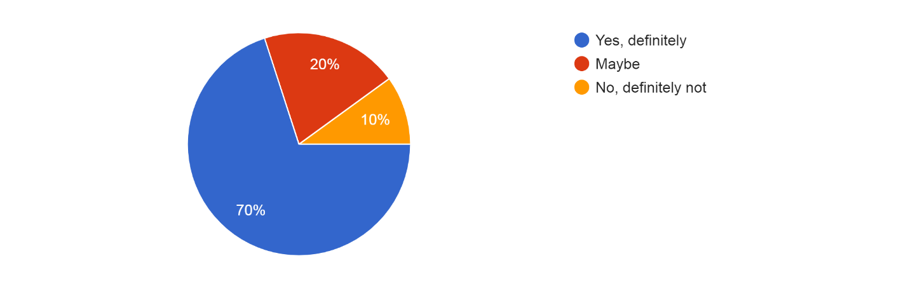
The implementation of SEO tactics was strongly recommended by a sizeable majority of respondents (70%) in the survey. This shows that the respondents have had positive experiences and have faith in strategy for raising brand awareness and promoting company expansion. Additionally, 20% of the respondents said they might suggest SEO tactics. This implies that they have seen some promising outcomes or are thinking about the advantages, but they may need more research or data before they can make a firm recommendation. However, 10% of the respondents were opposed to advising other businesses to use SEO tactics.

Conclusion:

The objective of this study was to demonstrate the impact of SEO practices on brand visibility and business growth. "How important do you think SEO is for your company's online visibility and business growth?", according to the first survey question in this study been proven to be of significant value. Through the use of research and interviews, it can be concluded that Search Engine Optimization is extremely important for a company’s online visibility and growth. Search engine optimization (SEO) is crucial in today's highly competitive online marketplace for businesses looking to increase visibility. Being strongly shown in search engine results has become essential with so many companies competing for online attention. Search engines provide entry points to the internet, directing visitors to pertinent content and goods. As a result, applying SEO tactics has emerged as a one of the important components of digital marketing.
Furthermore, another survey question used were, “When it comes to implementing SEO strategies for your business, which option would you prefer?” and “What are the key factors influencing your decision to choose between getting SEO services from a professional agency, working with freelancers, or handling it on your own?” This has proven that when it comes to implementing SEO strategies for your business, hiring a professional SEO agency is the preferred option. Their specialized expertise and knowledge in search engine optimization can make a significant difference in the success of your SEO efforts. Professional agencies have a deep understanding of the constantly evolving digital landscape and possess the necessary tools and resources to develop effective strategies tailored to your specific business goals. Their specialized skill set allows them to optimize your website, target relevant keywords, and enhance your online visibility, ultimately driving organic traffic and fostering business growth. Hence by strategizing SEO, your business stays ahead in the competitive digital marketplace.

The visibility of a brand is directly impacted by effective SEO techniques. Companies may raise their search engine ranks and increase their visibility on search engine result pages (SERPs) by optimizing website content, meta tags, and other SEO components. The possibility of generating organic traffic is significantly increased by appearing on the first page of search results due to people's tendency to click on top-ranking websites. As a result, businesses see increased click-through rates (CTRs) and opportunities to interact with potential respondent companies in this research. Additionally, SEO promotes brand credibility and recognition. A brand gains users' trust and familiarity when it repeatedly shows up in search results for pertinent keywords. The brand's reputation is improved by this constant exposure, which also promotes consumers to perceive it as a reliable and knowledgeable source in its industry. Additionally, SEO enables businesses to focus on particular demographics and keywords, increasing their visibility to the target market. Additionally, SEO enhances user interaction and engagement. Websites that provide relevant, high-quality content and a smooth browsing experience are given priority by search engines. Businesses that invest in improving their website's user experience, mobile friendliness, and loading speed typically see an increase in engagement metrics like visitors staying on the site longer, fewer bounce rates, and more page views. Additionally, SEO is a potent technique for acquiring customers and leads. Businesses may gather user information and turn visitors into leads by optimizing landing pages and putting call-to-action tactics into place. Through focused marketing initiatives, these leads can subsequently be developed into customers, leading to an increase in customer acquisition rates.
In conclusion, SEO is a crucial marketing tactic that businesses just cannot afford to ignore. There is no disputing the effect of SEO on brand recognition and company expansion. Effective SEO implementation is clearly correlated with company success, with businesses reporting more brand awareness, more organic traffic, better user engagement, and ultimately higher sales revenue and profitability. Businesses are urged to prioritize SEO implementation and make investments in order to succeed in the digital marketplace. Companies may stay ahead of the competition, boost their online exposure, and enjoy the long-term advantages of sustainable business growth by comprehending and putting SEO best practices into practice.

REFERENCES:

MOZ, (NA). What Is SEO? Retrieved from https://moz.com/learn/seo/what-is-seo

Mailchimp, (NA). What is SEO? Retrieved from https://mailchimp.com/marketing-glossary/seo/

- UsChamer, (2023). 4 Search Engine Optimization (SEO) Practices Every Small Businesses Must Know. Retrieved from https://www.uschamber.com/co/start/strategy/four-main-types-of-seo-explained

- Kelly Lyons, (2022). On-Page SEO: What It Is and How to Do It. Retrieved from https://www.semrush.com/blog/on-page-seo/

- Deanna McLean, (2023). What is Keyword Research? (And How to Do It Right). Retrieved from https://www.elegantthemes.com/blog/wordpress/what-is-keyword-research-how-to-do-it-right?

- Alexandra Gavril, (2017). A beginner’s guide to writing title tags and meta descriptions that get clicks. Retrieved from https://www.123-reg.co.uk/blog/seo-2/a-beginners-guide-to-writing-title-tags-and-meta-descriptions-that-get-clicks

- Amelia Willson, (2021). How To Use Header Tags: SEO Best Practices. Retrieved from https://www.searchenginejournal.com/on-page-seo/header-tags/

- Meike Hendriks, (2022). Internal linking for SEO: Why and how? Retrieved from https://yoast.com/internal-linking-for-seo-why-and-how/

- Carlos Silva, (2022). What Is Off-Page SEO? A Guide to Off-Page SEO Strategy. Retrieved from https://www.semrush.com/blog/off-page-seo/

- Sachin Gupta, (NA). Business Listing. Retrieved from https://dmguru.in/business-listing.html

- Pankaj Kumar, (NA). What is Classified Submission in SEO? Retrieved from https://www.pankajkumarseo.com/what-is-classified-submission/

- Pankaj Kumar, (NA). What is PPT Submission? Retrieved from https://www.pankajkumarseo.com/what-is-ppt-submission/

