Role of Non Timber Forest Products in Health and Nutrition: A Study of Wild Edible Plants in Chamba Valley of North Western Himalayas

Sumit¹, Dr. Poonam Sabbarwal², Dr. Gulshan Kumar³*, Monika Thakur⁴
¹ Department of Botany, Govt. College Chamba, Himachal Pradesh. (suminirankari@gmail.com)
² Department of Botany, Govt. College Chamba, Himachal Pradesh.
(poonamriddham777@gmail.com)
³* Department of Botany, Career Point University, Hamirpur, Himachal Pradesh.
⁴ Department of Botany, RNTGC Govt. College Sarkaghat, Mandi, Himachal Pradesh.
*Corresponding Author – (sharmagulshan1980@gmail.com)

Abstract
Non timber forest products (NTFP) are the products that are produced in forests other than timber. NTFP includes wild fruits and vegetables, mushrooms, wild meat, edible insects, honey, medicinal plants etc. Wild edible plants (WEPs) are among the most commonly used NTFPs. Man has been traditionally using forest resources to fulfil his daily needs. WEPs have played an important role in health and nutrition since ages. The inhabitants of Chamba have been using WEPs as dietary supplements for hundreds of years. Even after the development of modern system, people particularly of lower income from rural background still depends on WEPs due to high cost of vegetables and fruits and easy availability of WEPs in their vicinity. This traditional knowledge is in danger because the transmission of information between the older and younger generation no longer exists. Therefore, sincere efforts should be made by all to preserve this knowledge. Additionally, it will assist locals in generating income. An ethnobotanical survey of wild edible plants was carried out in various regions of Chamba valley of North Western Himalayas. The data was collected through interviews and face-to-face individual discussions. A total of 30 species belonging to 27 genera and 19 families are listed in this paper. The objective of this study is to access the richness of wild edible plants used by the local people of Chamba valley of North Western Himalayas
Keywords: Chamba, Himalayas, NTFP, Traditional, WEPs.

Introduction
Forests cover 31% of world’s land area. They provide a wide range of products of domestic and commercial use (Appiah, 2009). Most often, forests are valued for their timber resources. In addition to timber, forests also provide a variety of non timber forest products (NTFPs). Non timber forest products are the resources other than wood that comes from the forests and are valuable to the human society. Berries and fruits, herbs, spices, fibre, wild mushrooms, honey, gums, resin, spices, nuts, wild meat, edible insects and botanicals used for craft, cosmetics and medicinal purposes are some examples of NTFPs. NTFPs have long been used in daily life by the indigenous people all over the world. One of the most frequently utilized NTFPs is wild edible plants (WEPs). WEPs are non-cultivated and non-domesticated plants used as food. They are locally available, and their use is based on traditional ecological knowledge (Shumsky et al., 2014). WEPs have played an important role in health and nutrition since ancient times (Levetin & McMahon, 2008). They have contributed towards the food security and have enriched diet diversity. According to FAO, between 3.5 and 5.8 billion people use wild plants globally, and one billion rely on wild foods for their livelihoods and food security (Burlingame, 2000; Thakur et al. 2017). A wide variety of wild and non-cultivated edible plants are used by people in the Himalayan region as food, spices, and medicines. WEPs are the major source of food for tribal and rural communities (Badhwar & Fernandez, 2011; Saha et al. 2014). A large portion of people have frequently been able to rely on plants harvested from anthropogenic landscapes (i.e., the vicinity of rice fields, homesteads, forest patches, or fallow lands) as a valuable nutritional resource because of their accessibility and availability (Ray et al., 2020).They are rich in antioxidants and supply vitamins, minerals and trace elements to our diet (Mzid et al. 2017; Ogle, 2001). 1532 edible wild food species have been reported in India (Reddy et al. 2007; Pal etal., 2014). The Indian Himalayan region is one of the biologically most diverse regions in the world. Over 675 wild edible plant species are found in Indian Himalayan Region (Samant and Dhar, 1997; Reddy et al., 2007). For sustenance, the inhabitants of Himachal Pradesh are using about 92 wild plant species as food (Reddy et al., 2007; Pooja and Samant 2022). Chamba is a rich repository of wild plants and precious herbs. Inhabitants of Chamba valley have been using wild edible plants as a source of vegetable and fruits for hundreds of years. The traditional knowledge about wild plants and their uses is rapidly fading (Kargioglu et al., 2008). This is a result of both the modernization of indigenous cultures and the ongoing destruction of forests. Moreover wild edible plants are also disappearing due to urbanization and modernization. Therefore, sincere efforts should be made by all to conserve the rich Himalayan biological and cultural diversity. It will further help local people to ensure livelihood by exploring more livelihood options. The present paper is an attempt to document the indigenous knowledge and diversity of wild edible plants of Chamba valley.

Materials and Methods
Study area
Chamba valley also known as Ravi valley lies at the intersection of Dhauladhar and Zanskar ranges. It nestles between N latitude 32° 10΄ and 33° 13΄ and E longitude 75°49 and 77° 33΄. It is bounded on north-west by Jammu and Kashmir, on the north-east and east by Ladakh region and Lahaul and Bara-Bangal area of Himachal Pradesh, on the south-east and south by the district Kangra. The region is wholly mountainous with elevations between 6, 00 to 65, 00 m. The temperature in summer ranges from 38°c to 15°c while in winters 15°c to 0°c. The valley receives 1319 millimetres of rain annually on average. Chamba is characterized by rural, environmentally conscious communities that rely on locally accessible natural resources to meet their daily needs.
Methodology
Extensive ethno-botanical survey was carried out in different parts of Chamba valley during June 2020 to June 2021 for the collection of information on WEPs being used by local inhabitants of the study area. Data were collected through interviews and face-to-face individual discussions. Local identification of the plants was done with the help of local informers, regional floras (Chowdhery & Wadhwa, 1984; Singh & Sharma, 2006.), available literature and scientific articles. Data on plants and plant parts used were recorded including coomonly used WEPs, local name, family, edible parts and mode of utilization of plant species in the study area. The data gathered were screened with help of available literature (Anon., 1948-1976; Kirtikar & Basu, 1984; Singh and Arora, 1978; Samant, & Dhar, 1997).

Results and discussion
In the present study 30 plant species belonging to 27 genera and 19 families have been recorded as WEPs. The family Rosaceae (6 spp.) showed the highest number of edible species, followed by Moraceae (3 spp.), Amaranthaceae, Brassicaceae, Fabaceae and Polygonaceae (2 spp. each). Athyraceae, Berberidaceae, Caryophyllaceae, Ericaceae, Euphorbiaceae, Juglandaceae, Malvaceae, Morchellaceae, Oxalidaceae, Portulaceae, Punicaceae, Solanaceae and Urticaceae were represented by one species each (Fig. 1). Out of total, 14 species of herbs, 03 shrubs, 11 trees, 01 fern and 01 fungi were recorded (Fig.2). Fruits were the edible part in majority of the cases (40%) followed by leaves (30%), aerial parts (10%), seeds (7%), flowers/flower buds (7%), Fruiting body (3%) and young fronds (3%) (Fig.3). WEPs were used maximum as vegetables (15 species) followed by fruits (12 species). 05 species were used to prepare chutney, 02 species were pickled, 01 species for making drink and 01 species as seeds.

Table 1: Wild edible plants consumed in Chamba valley
Botanical Name | Local Name | Family | Life form | Plant part(s) used | Mode of use
Amaranthus viridis L. | Chauli | Amaranthaceae | Herb | Leaves | Cooked as vegetable (Bhujju).
Bauhinia variegata L. | Karali | Fabaceae | Tree | Flower buds | Flower buds are boiled and cooked as vegetable in curd.
Berberis lycium Royle. | Kasmal | Berberidaceae | Shrub | Fruits | Ripe fruits are eaten raw.
Chenopodium album L. | Bathua | Amaranthaceae | Herb | Leaves | Cooked as vegetable.
Diplazium esculentum (Retz.) Sw. | Kasrod | Athyriaceae | Fern | Young Fronds | Young fronds are eaten as vegetable along with buckwheat, also pickled.
Emblica officinalis Gaertn | Amla | Euphorbiaceae | Tree | Fruits | Fruits are eaten raw, also pickled.
Fagopyrum esculentum Monech. | Fafru | Polygonaceae | Herb | Leaves | Leaves are cooked along with vegetable fern or lentil and eaten.
Ficus palmata Forssk. | Fagudi | Moraceae | Tree | Fruits | Unripe fruits are cooked as vegetable, ripe fruits are eaten raw.
Ficus auriculata Lour. | Trimbal | Moraceae | Tree | Fruits | Ripe fruits are eaten raw.
Juglans regia L. | Khod | Juglandaceae | Tree | Seeds | Seeds are eaten raw, also used to make chutney.
Lepidium didymum L. | Bannbeenh | Brassicaceae | Herb | Leaves | Cooked as vegetable mixed with other herbs.
Malva verticillata L. | Sonchal | Malvaceae | Herb | Leaves | Leaves are cooked as vegetable.
Medicago polymorpha L. | Sanini | Fabaceae | Herb | Leaves | Cooked as vegetable.
Morchella esculenta Fr. | Guchhi | Morchellaceae | Fungi | Fruiting body | Cooked as vegetable.
Morus alba L. | Karoon | Moraceae | Tree | Fruits | Ripe fruits are eaten raw.
Nasturtium officinale W.T.Aiton | Pani saag | Brassicaceae | Herb | Aerial parts | Cooked with rice or curd as vegetable.
Oxalis corniculata L. | Ambi | Oxalidaceae | Herb | Leaves | Used to make chutney.
Portulaca oleracea L. | Kulfa | Portulacaceae | Herb | Aerial parts | Cooked as vegetable.
Potentilla indica  (Andrews) Th.Wolf | Akhe | Rosaceae | Herb | Fruits | Ripe fruits are eaten raw.
Punica granatum L. | Daroo | Punicaceae | Tree | Seeds | Dried seeds (anaardana) are used to make chutney; dried seeds are as an important ingredient in a traditional mutton recipe.
Prunus armeniaca L. | Chir | Rosaceae | Tree | Fruits | Ripe fruits are eaten raw, also used to make chutney (Chhachha).
Prunus persica (L.) Batsch | Aaroo | Rosaceae | Tree | Fruits | Ripe fruits are eaten raw.
Pyrus pashia Buch.-Ham. Ex D.Don | Kainth | Rosaceae | Tree | Fruits | Ripe fruits are eaten raw.
Rhododendron arboreum Sm. | Chiu | Ericaceae | Tree | Flowers | Flowers are used to make chutney and a drink (Rhoodendron Squash)
Rubus ellipticus Smith. | Akhre | Rosaceae | Shrub | Fruits | Ripe fruits are eaten raw.
Rubus niveus Wall. ex G.Don | Akhre | Rosaceae | Shrub | Fruits | Ripe fruits are eaten raw.
Rumex nepalensis  Spreng. | Albal | Polygonaceae | Herb | Leaves | Cooked as vegetable
Solanum nigrum Linn. | Kayan | Solanaceae | Herb | Fruits | Ripe fruit of are often eaten.
Stellaria media (L.) Vill . | Kokua | Caryophyllaceae | Herb | Aerial parts | Aerial parts are cooked as vegetable.
Urtica dioca L. | Ein | Urticaceae | Herb | Leaves | Leaves are Boiled and cooked with small amount of maize flour as vegetable.

Leaves of Amaranthus viridis, Chenopodium album, Fagopyrum esculentum, Lepidium didymium, Malva verticillata, Medicago polymorpha, Rumex nepalensis and Urtica dioca, aerial parts of Nasturtium officinale, Portulaca oleracea and Stellaria media are cooked as vegetable either alone or mixed with other leafy vegetables. Medicago polymorpha ia also cooked with potato. Flower buds of Bauhinia variegata are cooked in curd and consumed. Young Fronds of Diplazium esculentum are cooked as vegetable mixed with Fagopyrum esculentum. One of the most valuable and delicious edible fungi, Morchella esculenta is also consumed in the study area.
Leaves of Oxalis corniculata, flowers of Rhododendron arboreum, fruits of Prunus armeniaca, seeds of Juglans regia and Punica granatum are used in the preparation of chutney. Young Fronds of Diplazium esculentum, fruits of Emblica officinalis are preserved as a pickle.
Ripe fruits of Berberis lyceum, Emblica officinalis, Ficus palmata, Ficus auriculata, Morus alba, Potentilla indica, Prunus armeniaca, Prunus persica, Pyrus pashia, Rubus ellipticus, Rubus niveus and Solanum nigrum are eaten raw. A traditional mutton recipe prepared with dried seeds of Punica granatum (Daroo waala meat) is is considered a delicacy during festive occasions.

Conclusion
The Chamba Valley is home to a wide variety of edible wild plant species and a long history of their use. Since they are an excellent source of carbohydrates, proteins, vitamins, antioxidants and minerals, wild edible plants play a significant role in the nutrition of rural people. People use these plants because their elders used them and because these are easily accessible and a free gift from nature. Due to socio-cultural changes, the abundance and traditional uses of wild food plants are gradually declining. It is necessary to raise people's understanding of the sustainable use of these species in order to maintain the ecosystem's equilibrium. Additionally, initiatives should be undertaken to encourage the production of these edible wild species. Promoting the consumption of wild edible plants can assist locals in generating income and aid in the uplift of rural communities.

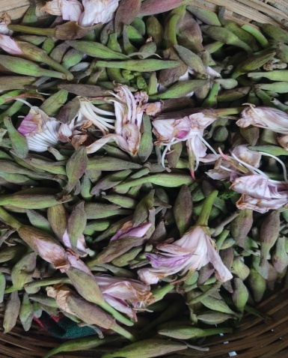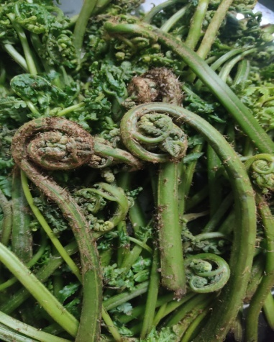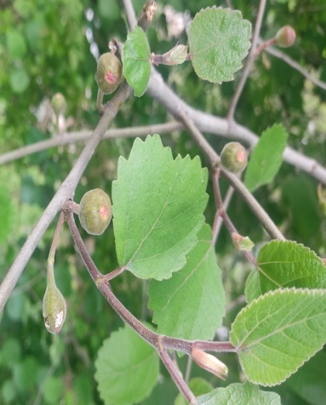
Ficus palmata Forssk.

Diplazium esculentum (Retz.) Sw.
Bauhinia variegata L.

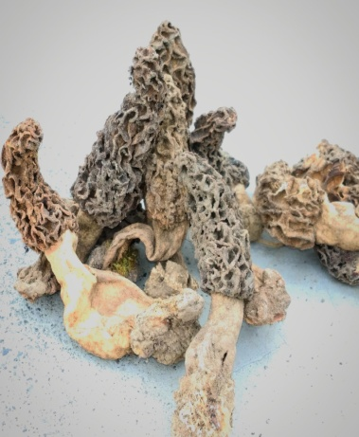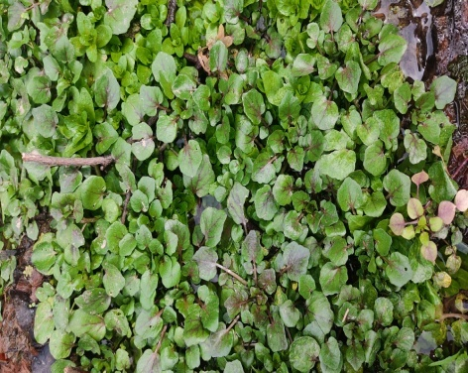
Nasturtium officinale W.T.Aiton
Potentilla indica (Andrews) Th.Wolf
Morchella esculenta Fr.

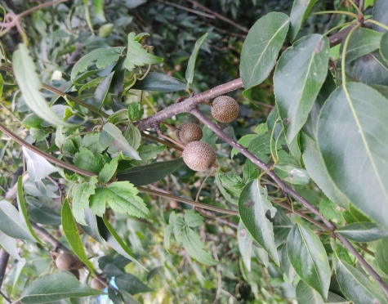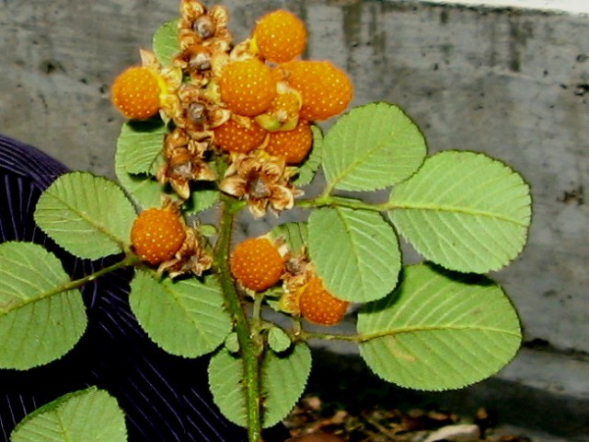
Prunus armeniaca L.
Pyrus pashia Buch.-Ham. Ex D.Don
Rubus ellipticus Smith.

Fig. 5 Photographs of some important wild edible plants of Chamba valley.

References
- Anonymous. (1970-1988). The Wealth of India: Raw Materials, Vol. I-H. (New Delhi: Council of Scientific and Industrial Research (Reprinted))
- Appiah, D.O. (2009) Personifying sustainable rural livelihoods in forests fringe communities in Ghana: a historic rhetoric?. J Food AGRIC. 7(3&4):873-877
- Badhwar, R.L. & Fernandez, R.R. (2011). Edible wild plants of the Himalayas. Delhi: Daya publishing House
- Burlingame, B. (2000). Wild nutrition. J Food Composition Analysis. 13:99–100
- Chowdhery, H.J. & Wadhwa, B.M. (1984) Flora of Himachal Pradesh. Vol. 1-3.India, Calcutta, Bot. Sur.
- Kargioglu, M., Cenkci, S., Serteser, A., Evliyaoglu, N., Konuk, M., Kok, M.S., Bagci Y. (2008). An Ethnobotanical Survey of InnerWest Anatolia, Turkey. Hum. Ecol. 36:763-777
- Kirtikar, K.R. and Basu, B.D. (1984). Indian Medicinal Plants. Vol. I-IV. (Dehradun: Bishen Singh Mahendra Pal Singh (2nd edition))
- Levetin, E. & McMahon, K. (2008). Plant and society. 5. New York: McGraw-Hill.
- Mzid, M., ben Khedir, S., ben Salem, M., Regaieg, W., and Rebai, T. (2017). Antioxidant and Antimicrobial Activities of Ethanol and Aqueous Extracts from Urticaurens. Pharmaceutical Biology. 55: 775–781.
- Ogle, B. M. (2001). Wild vegetables and micronutrient nutrition: Studies on the significance of wild vegetables in women's diets in Vietnam (Doctoral dissertation, Acta Universitatis Upsaliensis).
- Pal, R.S., Kumar, R.A., Kant, L., Bhatt, J.C. (2014). Kilmora, a wild edible potential nutraceutical fruit in Indian Himalayan Region. Popular Kheti. 2(3):199-203.
- Pooja & Samant S.S. (2022). DIVERSITY, INDIGENOUS USES AND UTILIZATION PATTERN OF WILD EDIBLE PLANTS OF CENTRAL HIMACHAL PRADESH, NORTH WESTERN HIMALAYA. World Journal of Pharmaceutical and Life Sciences. 8(3): 131 – 140.
- Ray, A., Ray, R., and Sreevidya, E. A. (2020). How Many Wild Edible Plants Do We Eat—Their Diversity, Use, and Implications for Sustainable Food System: An Exploratory Analysis in India. Front. Sustain. Food Syst. 4:56
- Reddy, K. N., Pattanaik C., Reddy C. S. and Raju V. S. (2007).Traditional knowledge on wild food plants in Andhra Pradesh. Indian J. Trad. Knowl. 6(1):223-229
- Samant, S.S., & Dhar, U. (1997). Diversity, endemism and economic potential of wild edible plants of Indian Himalaya. International Journal of Sustainable Development and World Ecology. 4: 179-191
- Singh, H.B. & Arora, R.K. (1978). Edible wild plants of India. (New Delhi: ICAR)
- Singh, H. & Sharma, M. (2006). Flora of Chamba District (Himachal Pradesh). Bishen Singh Mahender Pal Singh, Dehradun.
- Saha, D., Sundriyal, M. & Sundriyal, R.C. (2014). Diversity of food composition and nutritive analysis of edible wild plants in a multi-ethnic tribal land, Northest India: an important facet for food supply. Indian J Tradit Knowl. 13(4):0975–1068
- Thakur, D., Sharma, A., & Uniyal, S. K. (2017). Why they eat, what they eat: patterns of wild edible plants consumption in a tribal area of Western Himalaya. Journal of ethnobiology and ethnomedicine.13(1): 1-12

