THERMAL ANALYSIS OF MONOCRYSTALLINE PHOTOVOLTAIC CELL USING ANSYS WORKBENCH

Venktesh Kumar

Assistant Professor, Gopal Narayan Singh University, Jamuhar,Sasaram

Corresponding Email :- venkteshkumar2@gmail.com

Abstract
The purpose of this thesis is to develop monocrystalline silicon photovoltaic cells through the use of current technology and a screen printing method, and then to incorporate them into a photovoltaic device that makes use of these photovoltaic cells, design/methodology/approach this study will look at the characteristics of modern voltage that will determine fundamental electric properties. The characteristics of monocrystalline silicon photovoltaic cells have been investigated in the context of conventional examination situations. Photovoltaic, the module was built with the best short-circuit current photovoltaic cells available, which were then connected together in a sequence configuration to form the final product. Concluding remarks: This examination provides an illustration of a conventional technical technique that makes use of a display printed method of manufacturing. Manufacturing of monocrystalline silicon photovoltaic cells is a process. The electricity generated by the sun can be used to power a device that generates electric energy. The sun module was created by connecting cells together in a circular pattern. After that, Schottky and Zener diodes are used to protect the circuit from damage. Usefulness: The module was used to construct a model solar power system, complete with traffic signals and a pedestrian overpass. This bridge demonstrates the practical application of a readily available, renewable source of energy, in this case, the sun, in a real-world setting.

INTRODUCTION

  - General Introduction
The electricity requirement of the world is increasing at alarming rate and the power demand is running much ahead of the supply. Fossil fuels like oil, coal and natural gas provide about 80% of the word energy, but generation of electrical power by fossil fuel is causing adverse environmental,

social and economic problems [1]. It isi also widely recognized that thei fossil fuels (i.e., coal, petroleum and natural gas) are depleting at fast rate [2] therefore, attention has been moved towardsi other energy resources like: Nuclear energy source which isi plentiful and cleani alternative to fossil fuels buti has increased concern about the safety, cost, and nuclear waste disposal . Other conventional resources may not be either sufficienti or suitable toi keep pace with ever increasing demand of the electrical energy of the world. Toi overcomei problems associated with conventional and nuclear energy resources iti mandatory for countriesi throughout the worldi to developi different renewable energy source; because nature replenishes, renewable energy source faster than it consume; thesei sources are inexhaustible, self-generating , produce clean green energy,i help in controlling climate changes and global warning [3]. The development of renewable technologies are becoming increasingly cost competitivei in number of countries. Renewable based power generation capacity isi estimated toi have increasedi by 128 GW ini 2014, of which 37%i is wind power, almost one third solar power . Earthi receive solar energy from the sun at the rate of 1000 KW h/m2 the total energy received by earthi in onei hour is morei than the energy consumedi in the whole world for onei year. The availability of global averagei power insolation is about 140000 Tera watt (TW) as compared to their consumption of 17 TW.

Solar Cell Technologies

    - Monocrystalline silicon solar cells

The oldest solar cell technology and still the mosti popular and efficient are solar cells madei from thin wafersi of silicon. These are called monocrystalline solar cells. Monocrystalline silicon solar PV cells were made up from single continuous crystal lattice of silicon having virtually no defects or impurities Silicon is mainly occurs as SiO2 in the form of quartz, sand and silicates,i it is normally produced fromi a naturally occurringi ore, quartzite gravel (a form ofi sand stone). In natural occurring quartzitei there arei several impurities including Al, B, P, Cu, C, Ca, Mg, Fe, Ti, Mn, Mg, etc. The acceptable level ofi impurities isi generally parts per million (ppm) for solar cell applicationsi meansi 5×1016 atoms/cm3 in Si. Various steps are involved in converting an impure quartzitei to high purity crystal wafer. The first stepi isi thei productioni of 99 percent pure

metallurgical grade silicon (MGS)i from its ore, SiO2 by reduction reaction with carbon in an arc furnace. The energy cost of this step isi 50 kWh/kgi of silicon. Also in this processi CO2 isi produced asi a byproduct, which is a greenhouse gas. Electronic gradei pure polycrystalline silicon is then obtained by refining iti further thoughi variousi complex operations ati an energy costi of 200i kWh/kg of silicon. These two steps arei highly energy intensive. Worldwide, about 1 million tons of MGS is produced and less than 5 percent of it isi used in makingi electronic grade silicon[5]. The typical monocrystalline photovoltaic cell is a dark black in colour, and the corners of cells are usually missing as a result of the production process and the physical nature of monocrystalline silicon [6]. Typically, the cells are a few inches across, and a number of cells are laid out in a grid to create a panel. Relativei to the other types of cells, they have a higher efficiency (upi toi 24.2%). These cells are preferred for low available area of panel mounting. Thei production costs for thisi type of panel have highesti of all thei solar panel types sincei large amount of energy is required for growing large crystals of pure silicon. Although production methods havei improved and pricesi for raw silicon as well as panel development cost of monocrystalline solar cells have fallen. Their efficiency decreases as the temperature increases above 25˚C, so they need to be installedi ini such a way as to permit thei air toi circulatei over and under the panels to improve their efficiency [7].

Polycrystallinei silicon solar cells

Polycrystalline silicon essentially consists of small grains of monocrystalline silicon. Solar cell wafersi can bei made from polycrystalline silicon directly in various ways, one approach is the controlled casting of molten polycrystallinei silicon into cube shapei ingots (Sii block) with grain size from mm to cm range which are then cut, using fine wire saws, into thin squarei wafers and fabricatedi into completei cells in the same way as monocrystalline silicon. Polycrystalline silicon solar cells are easier and cheaper to manufacture than monocrystalline cells, but their efficiency is lesser becausei lighti generated electroni hole pairs may recombine ati the boundariesi between the grains withi in polycrystalline silicon. However, if the material isi processed ini such ai way that grains are relatively largei in size and oriented in top-bottom direction toi allow light to penetrate deeply ini to each grain the efficiency may bei increased. For commercially available

polycrystalline solar cell module efficiency has reached 19.3%. Figurei 1.1. Monocrystalline and polycrystalline solar cellsi .
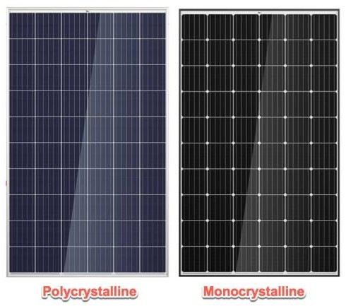

Figure 1.1. Monocrystalline and polycrystalline solar cell

Structurei of Dye-Sensitized Solar cell (DSSC)

Since thei invention ofi the nanostructurei DSSC, a lot of theoretical and experimental worki has been carried out to explaini the efficient operation of these solar cells. Thei need for uniquei theoretical considerations of thei photovoltaic effect in the DSSCs arisesi from thei fundamental difference in the operation betweeni thei DSSCs andi thei traditional semiconductor pn-junction solar cells. In contrast to the semiconductor pn-junction solar cells, wherei light absorption and charge transport occurs ini thei samei material, the DSSC separate these functions, photons are absorbed by the dye molecules and transport of charges is carried out in thei TiO2 electrode and electrolyte. The charge separation in DSSCs isi based on an electron transfer process from the dye molecule to TiO2i and a hole transport process from the thereby oxidized dyei to thei electrolyte. Thei electron transfer mechanism is strongly dependent on the electronic structure of the adsorbed dye molecule and the energy level matching between thei excited statei of thei dye andi the conduction band of the TiO2.

LITRATURE REVIEW

The first generation of photovoltaic cells were researched during 1950’s to 1960’s for improved performance and reduction in cost. Modern application ofi photovoltaic devicei initiated ini 1954. The researchers at Bell Labs ini the USA discovered that a voltage was produced by the p-n junction diodes under room light. In the samei year, they producedi a silicon p-n junction solar cell

with 6% efficiency, which is a milestone of photovoltaic technology but wasi very expensive. In 1958,i first solar poweredi satellite was developedi in which solar cells were used to power ai small radio transmitter. In 1963, Sharpi Corporation (Japan) produced the first commercial Si modules. Ini 1970, Zhores Alferov, Russian physicist and his co-workers, created highly effective first Gallium Arsenide (GaAs)i heteroi structurei solar cells. Year 1973 was also important for photovoltaics becausei worldwide oil crisis encouraged many countries to seek for renewable energy sources. In 1976i Davidi Carlson and Christopher Wronski, of RCA Laboratoriesi developed first amorphous silicon photovoltaic cells which was lessi expensive than crystalline silicon devices. The photovoltaic technology developedi very fast ini the 1980s. University of Delaware developed firsti thin-filmi solar cell made of copper sulphide (Cu2S) and cadmium sulphide (CdS) which exceeded 10% efficiency.
Ini 1981, Paul Mac Cready developedi first solar-powered aircraft and thei Solar Challenger. The aircraft flied fromi Francei toi England acrossi the English Channel, iti comprised of over 16,000 solar cellsi mountedi oni itsi wings, whichi produced a power ofi 3kW. Ini 1985, researchers of the University of New South Walesi (Australia) broke the efficiency barrier for silicon solar cells under standard sunlight (one sun condition). In 1986, ARCO Solar, developed first commercial thin film photovoltaici module. British Petroleumi got a patenti for thei production of thin-film solar cell and Reflective solar concentrators in 1989 . In 1991, efficient Photoi electrochemical cells (PEC) later known as Dyei sensitizedi solar cells were developedi. In year 1992, A 15.9% efficient thin-film photovoltaici cell made ofi cadmium telluride was developed, which brokei 15% barrier for the first time for thisi technology . Number of technologies from photovoltaici devicei using selenium wafers in 1883 toi thin-film solar modules in 2000i has beeni developedi to utilize solar energy. Ini 2000, two new thin-film solar modules, broke previousi performance recordsi and achieved 10.8 % conversion efficiency, the highest in the world for thin-filmi modules of their kind. The efficiency of commercially available crystalline silicon solar cell modules is about 20% ini standard test conditions [8]. Now Australian engineers have taken us closer than ever before to the theoretical limits of sunlight-to-electricity conversion, by buildingi photovoltaic cells thati cani harvesti 34.5% of the Sun's energy without concentrators, setting a new world record, these new photovoltaic cells

aren't only morei efficient, they also cover far less surface area [9]. The long-term goal is to produce 34%i of thei total world electricity production by 2050i and toi achieve thisi goal improvementi in performance (efficiency) and reductioni of direct manufacturing costs is required. Nanotechnology isi emerging as ai kindi of new technology [10].

METHOD AND METHODOLOGY

  - Structure of Dye Sensitized Photovoltaic cell (DSSC)

Since the invention of the nanostructure DSSC, a lot of theoretical and experimental work has been carried out to explain the efficient operation of these photovoltaic cells. The need for unique theoretical considerations of thei photovoltaic effect in the DSSCs arises from thei fundamental difference in the operation betweeni the DSSCs and the traditional semiconductor pn-junction solar cells. In contrast toi the semiconductor pn-junction solar cells, where light absorption and charge transport occurs ini the same material, the DSSC separatei these functions, photonsi are absorbed by the dye moleculesi and transporti of charges is carried out in the TiO2 electrode and electrolyte. The chargei separation in DSSCs is basedi on an electron transfer process from the dye molecule to TiO2 and a holei transport process from thei thereby oxidized dyei to the electrolyte. The electroni transfer mechanism is strongly dependent on the electronic structure of the adsorbed dye molecule and the energy level matching between the excited statei ofi thei dyei and the conductioni band of thei TiO2. While chargei separationi in the semiconductor pn-junction arises fromi thei electrici field ini the space-charge layer in thei junction area, thei situation ini a nanoparticle electrode-electrolyte interfacei isi quitei different. Thei individual particle sizei in thei nanostructured electrode,i typically a few tens of nanometers, isi too small for the formation of a spacei chargei layer inside the particles. Ini the semiconductor pn-junction cells the generatedi opposite chargesi travel ini the samei material, while in the DSSC, electrons travel in the nanoporous TiO2 network and holes in the electrolyte. This means thati thei requirement for a pure and defecti freei semiconductor material in thei casei of semiconductor pn-junction solar cell isi relaxed for the DSSC, where the recombinationi can occur only at thei semiconductor electrolyte interface. When sun light interacts with a solar cell, it may be partially reflected at the surface of the glass, thei photons of light may be absorbedi by dye

sensitizer, and it may scatter inside the solar cell and may be partially transmitted. The main processi of lighti absorption dependsi oni the light harvester in the photoanode and characteristics suchi as the opticali density of thei photoanode, the extinction coefficient of thei light harvester, the time spent by thei lighti inside thei photoanode. Most ofi these factorsi are dependent on the wavelength of the incidenti radiation. It isi required to maximize light absorbancei by light harvester in the widest possible wavelength interval and Minimizei charge recombination which leadsi toi loss of photo generated charges [12].

Transparent Substrate for Electrodesi (TCO)

Transparent conductive oxides (TCOs)i are essential for solar cell application since they provide combined physical properties ofi visible light transmittance for light harvest and electrical conductivity for collecting current . Clear glassi substrates arei commonly used because of their relativei low cost, availability andi high opticali transparency ini the visible and near infraredi regions of the electromagnetic spectrum. Conductive coatingi ini the formi of thin transparent conductive oxide (TCO) is depositedi oni one side of the substrate. The conductive film ensures ai very low electric resistance/cm2 . Typical value of such resistance is 10-20i Ω/cm2 at room temperature. Due to the special characteristics of high transparency and low sheet resistance, TCO is an important material not justi for solar cells buti also for various applications especially in thei optoelectronic field, suchi as flat panel displays, LEDs, and waveguide devices. TCO isi a widei bandgap ni type semiconductor that consists of highi concentration of free electrons [13].

3.1.ai Tin doped Indium Oxidei (ITO)

ITOi is one of the most used TCO materials in industries and laboratories for the past decades due to its high transmittancei (aroundi 80% toi 90%) and high conductivity. However, when the material isi placed ati temperature over 300°C, its conductivity drops dramatically. This is due to the decrease ini oxygen vacanciesi ati high temperature, resultingi in the decrease of electric carriers. Moreover, the scarcity of the expensivei Indium material resulting in high material costs. In addition toi that, thei toxicity of thei material and thei easei of reactingi with hydrogen plasma, cause the researchers to look for ai better substitution.

3.2.b Fluorine doped Tin Oxide (FTO)

FTO is another type of TCO thati have beeni widely used, especially in solar cells. This isi duei to its good stability ati high temperature and its competitivei cost in comparison withi ITO. FTOi is more commonly used due to the variationi in resistivity with the amount ofi doping. It is thermally stable upi toi 650°C and therefore suitablei for DSSC preparation which requires sinteringi up toi 450°C. The optimized FTOi had a thin film with average visible transmittance of 83%i and optical bandgap of 3.80i eV, resistivity of 6.71 × 10−3 Ω cmi.

3.3.c Aluminum doped Zinc Oxidei (AZO)

AZO is a highly insolublei thermally stable, Aluminumi oxidei compounds arei not conductivei to electricity. However, certaini perovskite structuredi oxidesi arei electronically conductivei finding application in thei cathode of solid oxidei fuel cells and oxygen generation systems.

Nanostructured Photo Electrodei (Anode)

Ini the old generations of photo electrochemicali solar cells (PSC) photo electrodes were madei from bulky semiconducting materials suchi as Si, GaAs or CdS. However, these kinds of photo electrodes wheni exposed to light undergo photoi corrosion thati resulted ini poor stability of the photo electrochemical cell. The use of sensitized widei bandgapi semiconductors such as TiO2,i or ZnOi resulted in highi chemical stability of thei cell due to their resistancei toi photo corrosion. The problemi with bulky single or poly-crystallinei wide bandgapi is thei low lighti to current conversion efficiency mainly due toi inadequate adsorption of sensitizer because of limited surface area of the electrode. One approach toi enhance light-harvesting efficiency (LHE) and hencei the lighti to current conversion efficiency is to increasei surface area (thei roughness factor) of thei sensitized photo electrode [14].

Dyei Sensitizer

The function of thei dye molecules is toi capture sunlighti and injecti thei electroni into the semiconductor. Therefore ani efficienti sensitizer should adsorb strongly to the surface of the semiconductor oxide, exhibit intense absorption in the visible part of the spectrum, and possess

appropriate energy level alignment of thei dye excited state and thei conduction band edge of the semiconductor [15]. The performancei of DSSCs mainly depends on the molecular structurei of the photosensitization material.

i Operating principle of the dye-sensitized solar cell

A typical dye sensitized solar cell consistsi of anode and cathodei madei up of fluorine doped tin oxide glassi (FTO), semiconductor oxidei layer (TiO2), dye sensitizer (natural or chemical) and electrolyte (Iodide, tri-iodide). DSSC works on thei principle that, when sun light strikes on the photoanodei thei photons ofi wavelength corresponding toi the energy difference between highest occupied molecular orbital (HOMO) and lowest unoccupiedi molecular orbital (LUMO)i of the dye, are absorbed by the dye sensitizer (natural or chemical). This process transforms the dye toi the excited state, thei electrons are then anchored to the conduction band of semiconductor (TiO2)i and move to the photo-anode. Thei collected electrons on the photo-anodei flow throughi the outer circuit via load and re-i enter through the cathode[16].

RESULT AND DISCUSSION

1. Monocrystalline Photovoltaic cell (3D Model)

Given: Drawing of Monocrystalline Photovoltaic cell
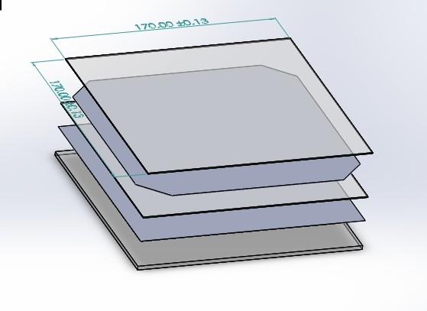

Step 1- Geometry

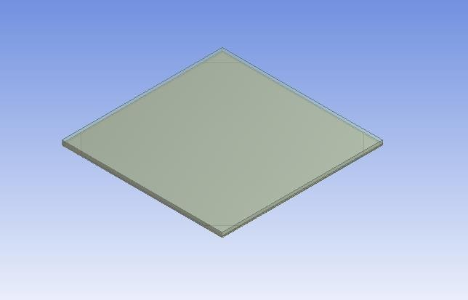

Step 2- Meshing

1) Element size: 4mm

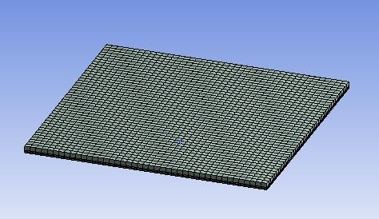

Step 3 – Setup

Boundary condition

- Glass Convection 28 C, 36.087W/m^2 C
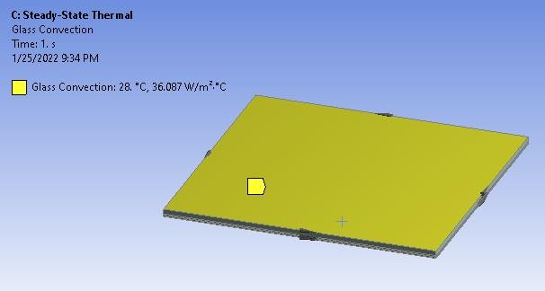

- Glass Heat Flux: 80 W/m^2

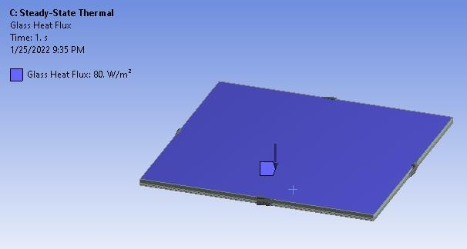

PV Heat Flux : 664 W/m^2

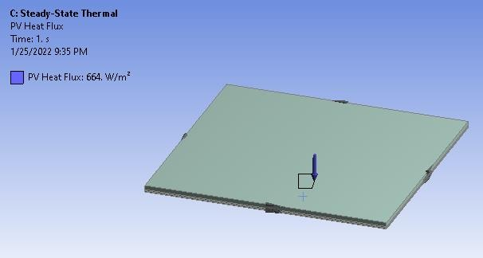

Tedlar Convection: 28 C, 5.67 W/m^2 C

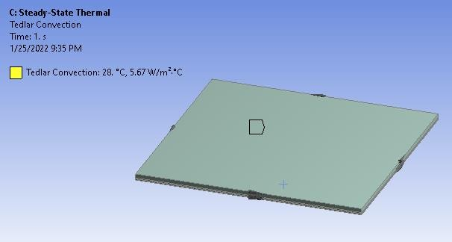

- Material Properties

Thermal conductivity of EVA: 0.311 W/mK Thermal conductivity of Glass: 0.7 W/mK
Thermal conductivity of Monocryastaline Si: 148 W/mK

Thermal conductivity of PVF: 0.2 W/mK

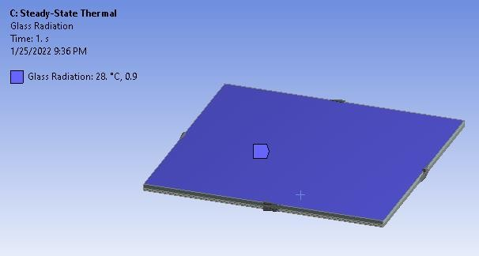

Glass Radiation: 28 C, 0.9 Step 4- Solution and result Temperature Distribution:
Max Temp: 46.97 C Min Temp: 44.7 C
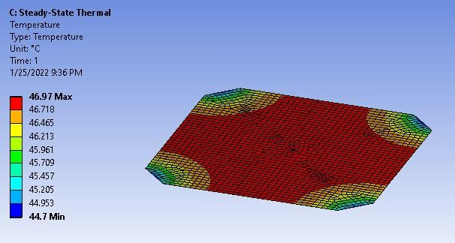

Conclusion

As all the values of Temp. are below the value which is given for material so our

design is safe

CONLUSION AND FUTURE SCOPE

Systematic investigations were carried out to fabricate and evaluate different types of photovoltaic cells, since the nanocrystalline cell is feasible under laboratory conditions various nanocrystalline solar PV cells were developed and tested for their performance under ambient conditions. The

working of nanocrystalline DSSC is based on the conduction by electron injection from the dye to the semiconductor and redox reaction to reduce the dye. The main technological challenges are the volatility of the iodide electrolyte, the inflexibility of glass substrates and the cell degradation, with the consequent reduction in useful life compared to silicon cells. The parameters of DSSC can be varied by changing its anode material, cathode material, type of dye, type of electrolyte, and the procedure adopted to fabricate the cell. In this thesis different types of cells were developed and tested under standard conditions, for each type of cell at least ten samples were prepared and tested on the basis of various characterization carried out under the present study, following conclusions can be drawn:

Future Scope

Monocrystalline and polycrystalline photovoltaic cells have achieved presentable conversion efficiencies and are available in market. The nanocrystalline photovoltaic cells such as DSSC, and perovskite photovoltaic cells are emerging technology. Further future work need to be done for the efficiency enhancement of DSSC using different cathode materials and electrolytes. The costly ruthenium dye may be replaced by natural sensitizers. More work is required on the stability study of these nanocrystalline photovoltaic cells. DSSCs are estimated to significantly provide renewable energy by the year 2020. Although progress is there in perovskite photovoltaic cells but work is required to be done to reduce the effect of moisture on perovskite photovoltaic cell parameters. Other nanocomposites such as TiO2V2O5 may also be used for DSSC anode fabrication. Hence, future research may be focused on producing more stable, flexible, environmental resistant, lower cost and higher efficient DSSCs. The flexible substrates may be used in place of FTO. Their flexibility and variety of colors and shapes can be employed and can be used as decoration in colored windows that not only allow light through, but can use this light to generate electricity. Although less efficient than the silicon based photovoltaic cell, DSSC is more cost efficient due to the low cost of the materials and processing, than the silicon photovoltaic cells. I do hope that the work presented in this thesis will encourage further research in the direction of realization of more efficient and cost effective photovoltaic cells in future.

References

  - B.G. Boyle, B. Everett, G. Alexander, Introducing renewable energy, 2012.

  - M. Hosenuzzaman, N.A. Rahim, J. Selvaraj, M. Hasanuzzaman, A.B.M.A. Malek, A. Nahar, Global prospects, progress, policies, and environmental impact of solar photovoltaic power generation, Renew. Sustain. Energy Rev. 41 (2015) 284–297. doi:10.1016/j.rser.2014.08.046.
  - M. Thirugnanasambandam, S. Iniyan, R. Goic, A review of solar thermal technologies, Renew. Sustain. Energy Rev. 14 (2010) 312–322. doi:10.1016 /j.rser.2009.07.014.
  - K.. M. Rajiv Kohli, Developments in Surface Contamination and Cleaning, First, Elsevier, 2011.
  - M. Gaetzel, A.J. Mcevoy, Principles and Applications of Dye Sensitized Nanocrystalline Photovoltaic cells ( DSC ), Asian J. Energy Environ. 5 (2004) 197– 210.
  - M. Hoeven, Energy and Climate Change, World Energy Outlook Spec. Rep. (2015) 1–200. www.worldenergyoutlook.org.
  - C.S. Solanki, Solar Photovoltaics: Fundamental Technologies and Applications, Second Edi, PHI, 2013.
  - W. Siemens, Van Nostrands Engineering Magazine, (1885).

  - M.A. Green, Silicon photovoltaic cells: evolution, high-efficiency design and efficiency enhancements, Semicond. Sci. Technol. 8 (1993) 1–12. doi:10.1088/0268- 1242/8/1/001.
  - B.I. Kamiya, Engineering of Energy Conversion , Summer Semester 2012 Physics of photovoltaic cells The principles of operation and fundamental physics How to understand photovoltaic cells and other photovoltaics Semiconductor physics & electronics : Topics to be dealt : carrier gen, (2012) 1–11.

  - M.A. Green, The path to 25% silicon photovoltaic cell efficiency: History of silicon cell evolution, Prog. Photovoltaics Res. Appl. 17 (2009) 183–189. doi:10.1002/pip.892.
  - B. O’Regan, M. Grätzel, A low-cost, high-efficiency photovoltaic cell based on dyesensitized colloidal TiO2 films, Nature. 353 (1991) 737–740. doi:10.1038/353737a0.
  - D.J. Friedman, S.R. Kurtz, K.A. Bertness, A.E. Kibbler, C. Kramer, J.M. Olson, D.L. King, B.R. Hansen, J.K. Snyder, Accelerated publication 30.2% efficient GaInP/GaAs monolithic two-terminal tandem concentrator cell, Prog. Photovoltaics Res. Appl. 3 (1995) 47–50. doi:10.1002/pip.4670030105.
  - M. Gratzel, Photoelectrochemical cells, Nat. (London, U. K.). 414 (2001) 338– 344. doi:10.1038/35104607.
  - M.A. Green, K. Emery, Y. Hishikawa, W. Warta, Photovoltaic cell efficiency tables (version 37), Prog. Photovoltaics Res. Appl. 19 (2011) 84–92. doi:10.1002/pip.1088.
  - M. Keevers, Engineers just created the most efficient photovoltaic cells ever, (2016) 1– 3. http://www.sciencealert.com (accessed July 7, 2016).

