IRCTC -CHANGING FACE OF INDIAN RAILWAY
BY: DR.NIKHIL.S
ABSTRACT.
Today is the world of digitalization, that has been seen in every field especially in commerce sector. Every commerce sector using digital platform for distributing their products and services. The main objective of adopting digitalization is ensuring time saving, easy usage and access, avoiding the obstacles in trade and providing maximum satisfaction to their valuable customers. Now all service sector industries like Banking, insurance, hospitality etc. using digital platforms for their marketing. In transportation, Indian Railway, the largest service sector providing valuable online services to their customers through their subsidiary “IRCTC”. It was established in 1999 as a govt owned enterprise under the ministry of Indian railway. The company offers online ticketing, catering services, travel and tourism etc. to rail passengers. most of the customers are using IRCTC website for their train journey needs. The objective of this study aims to reveal the challenges and opportunities faced by users while using IRCTC digital platform.
Keywords: IRCTC,E-commerce, digital services.

INTRODUCTION:
IRCTC, registered as a mini ratna central public sector enterprise under the ministry of Railway. The company was incorporated on 27th September 1999 to professionalize their various services. The company have 5 zonal offices at New Delhi, Mumbai, Kolkata, Chennai and Secundrabad. As per the result of July 2018, India has about 475 million internet users after China. The digital platform act as a gateway. Millions of customers use IRCTC website .Every minute, thousands of tickets can be booked. IRCTC has changed the brand image of Indian railway by professionalizing their services.
Objectives of the study:
1.Identifying the various services of IRCTC.
2.Finding the opportunities of customers while using IRCTC digital platform.
3. Finding the challenges of customers while using IRCTC digital platform.

Indian Railway Catering and Tourism Corporation (IRCTC) Ltd is formed to modernize and professionalize the various services that are beneficial to Indian rail customers. The operational segment of IRCTC has broadly classified into the following divisions.
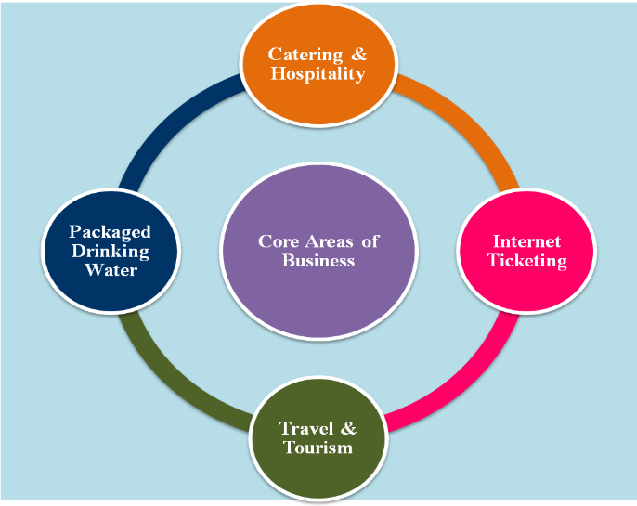

I. online ticket Booking and Enquiry system: it includes the services like Train Ticket booking ,Air ticket booking, Foreign Tourist Booking, Vikalp option, PNR system ,Rail Drishti, Tatkal ticket etc.
2.Catering and hospitality: E-catering, IRCTC hotels, retiring rooms, lounge, jan ahaar, budget hotels, rail yathri nivasees, event catering and management ,E-wheelchair etc.
3.Travel and tourism : Tourist train, maharaja express, customized tour packages, Bharath darsan tourist train ,semi lexury tourist train, state special tourist train, hill charters, educational tour packages, domestic air packages, helicopter packages, ltc facility etc.
4.E-wallet and loyalty : IRCTC SBI platinum card, IRCTC UBI Rupay prepaid card, IRCTC I Mudra E-Wallet etc.

IRCTC plays a vital role in the development of Indian Railway by providing valuable services in their digital platform. online ticket booking is available to customers for 24 hrs a day,365 days a year. It saves the valuable time of customers without their physical presence. Various tour packages, catering services etc ,plays a significant role at this time.
Overview of Ticket Booking Services of IRCTC
The IRCTC is having significant revenues realized from the ticket booking services. The ticket booking services is having significant patronage from the passengers which is reflected from the year on year increase in the enterprise in this area. The following table explains the number of tickets booked and passengers benefitted due to the online train ticket booking services of the IRCTC

E-Ticket Services (in Lakhs)

Year number of tickets Number of Passenger
2014-2015 1,830 3,288
2015-2016 1,993 3,596
2016-2017 2,093 3,731
2017-2018 2,466 4,3400

2018-2019 2,842 4,950

2019-2020 3,190 5,23
Source of data: Annual Reports of IRCTC, 2019-2020

The ticket booking services of the IRCTC is playing a vital role in the income generation of the enterprises. The table gives the complete details about the number of tickets and passengers travelled over the past six year. The trend of e-ticket services and also number of passengers travelled using the tickets have been consistently on the rise over the period that is inspected. The total number of tickets that are booked during the six year period was 14,414 lakhs tickets which have benefitted the travel of nearly 58,865 lakhs of passengers. The e-ticketing services are of great help for the passengers in booking the train tickets and it is generating significant income for the IRCTC. The Compound Annual Growth Rate of the number of tickets booked reveal 34.86 percent growth and number of passengers travelled has seen a growth of 31.81percent during the six year period

- Opportunities in Usage of IRCTC E-commerce portal.
The users to have varied opportunities in relation to services of availability of Diversified payment options, Usage of IRCTC e-commerce portal saves lot of time, Searching and booking Train& Air tickets via IRCTC e-commerce portal is very effective, Getting e-ticket & PNR instantly through SMS is time and paper saving, Usage of IRCTC e-commerce portal saves money in-terms of travelling charges, on-line discounts etc, Personal email accounts are useful for tracking online transactions, All transactions are protected by a secured OTP number which is sent via SMS, Easy & Fast menu driven processes ensure faster checkout, Instant SMS confirmation of transactions brings, Immediate receipt of E-tickets on your email, Proper Refund Facility, Availability of Accurate and sufficient Information, Convenience in usage, Handling Customer Grievances effectively and Any time access.
- Challenges in Using IRCTC E-Commerce Portal The challenges faced by the users are inter-related in the areas of Complications with the ticket cancellation, Poor website infrastructure, Uncomfortable to use, Poor Network connectivity, Repeated session Time out, Delay in Refund of money, Poor customer grievance mechanism and service, High Rate of Failed Transactions, Better Facilities Provided by the Competitors like Make My Trip, Yathra , Travega etc., Presence of disturbing advertisements on the website Interface, Payment related issues, Failures to meet customers’ demands on time and Absence of bulk booking facility.
CONCLUSION.
If the IRCTC is willing to solve the above said challenges that are faced by customers properly and using the opportunities effectively and efficiently, that helps to develop Indian Railway System asper the changing needs of customers. IRCTC ,the digital platform providing distinct services in different angles. but unfortunately most of the customers are still unaware about those vibrant services. In this perspective IRCTC must adopt and implement various promotional schemes to promote these services to attain users attention

References
Agarwal, R. (2008). Public Transportation And Customer Satisfaction: The Case Of Indian Railways. Global Business Review, 9(2), 257-272.
Basu, M., & Mukherjee, K. E-Catering Services An Accolade For Digital India: A Study On The IRCTC E-Catering Services (East Zone). Editorial Board, 45, 22.
Basu, M., & Mukherjee, K. Emergence Of E-Catering Services Revolutionizing The Indian Railways: A Study On The IRCTC E-Catering Services (East Zone).
Chatterjee, P., & Nath, A. (2014). Smart Computing Applications In Railway Systems-A Case Study In Indian Railways Passenger Reservation System. International Journal, 3(4), 61-66.
Dalvi, M. Q., & Sriraman, S. (1997). Indian Railways Tariff Policy. Indian Economic Journal, 45(2), 1.
Dandotiya, R., Aggarwal, P., & Gopal, R. (2020). Impact Of Food And Beverage Quality On Passenger Satisfaction In Indian Railways. International Journal of Customer Relationship Marketing and Management (IJCRMM), 11(2), 37-52.
Gupta, R. (2014). An Empirical Study Appraising Travellers’ Resistance To Online Tourism Services Of Indian Railway. Abhigyan, 32(3), 42-56.
Jain, S., Bhardwaj, S., & Jain, V. (2015). A Study Of E-Commerce With Special Reference To Indian Railway. International Journal in Management & Social Science, 3(12), 420-430.
Kapoor, K. K., Dwivedi, Y. K., & Williams, M. D. (2015). Empirical Examination Of The Role Of Three Sets Of Innovation Attributes For Determining Adoption Of IRCTC Mobile Ticketing Service. Information Systems Management, 32(2), 153-173.

