INFLAMMATION IS RELATIVELY LINKED TO CANCER AND PLAYS A SIGNIFICANT ROLE IN TUMOR FORMATION AND PROGRESSION

Nilanjan Pahari*¹, Mrityunjay Banerjee², Akash Koley¹, Biprojit Bhowmick¹, Saikat Polley¹, Koyel Mandal¹
¹Department of Pharmacology, Calcutta Institute of Pharmaceutical Technology and Allied Health Sciences, Banitabla, Uluberia, Howrah, West Bengal, India – 711316
²Department of Pharmaceutical Chemistry, Institute of Pharmacy and Technology, Salipur, Cuttack, Odisha

Address for correspondence :
Nilanjan Pahari
Associate Professor,
Department of Pharmacology,
Calcutta Institute of Pharmaceutical Technology and Allied Health Sciences, Banitabla, Uluberia, Howrah, West Bengal, India-711316
Email ID : paharinilanjan@gmail.com

INTRODUCTION
Inflammation, is relatively linked to cancer and it has a significant aspect in tumor formation and its progression. Chronic inflamm leads to carcinogenesis by the stimulation of tumor cell proliferation, angiogenesis, and metastasis while diminishing responsiveness to the immune system as well as anti-cancer agents (Balkwill et al., 2001). A microenvironment highly rich in inflammatory cells, growth factors, and chemicals that promotes DNA damage, leads to long-term and enhances cell proliferation and its survival, increasing the risk of cancer. Several epidemiological studies have indicated a significant relationship between inflamm and cancer. Tumor cells grow similarly to inflammatory cells in terms of phenotype because they produce cytokines, chemokines, and their receptors. Chronic synthesis of these inflammatory mediators can induce tissue and DNA damage, resulting in the accumulation of mutations in Ep while accelerating their proliferation. Mutated cells extend to release cytokines and attract inflammatory cells, contributing to angiogenesis, migration, and metastasis by creating a cancer inflammatory microenvironment. Tumors were shown to have higher levels of inflammatory mediators than normal tissues (Philip et al., 2004). Many anti-inflammatory medicines, particularly NSAIDs, can impair the tumour microenvironment by decreasing cell migration and increasing apoptosis and chemosensitivity. Long-term NSAID medication was associated with a low risk of initial or recurring malignancies. Furthermore, mortality in cancer patients was dramatically decreased following NSAID combination therapy (Rayburn et al., 2009).
INFLAMMATION
Inflamm is a natural response to microbial pathogen infection and wound healing. Activated endothelium, macrophages, and mast cells located in the tissues recruit neutrophils to inflammatory regions by releasing appropriate mediators in response to tissue damage. Neutrophils are the first effectors of inflammation, and they are recruited via a four-step process that includes activation of P-, L-, and E-selectins to promote cell rolling along the vascular endothelium, activation of leukocyte integrins, neutrophil freezing on the vascular endothelium, and transmigration to the inflammatory sites.
[ABBREVIATIONS : Inflamm - INFLAMMATION ; Ep - EPITHELIAL CELLS]
NOMENCLATURE

The suffix 'itis' is commonly used to signify the nomenclature of an inflammatory lesion. Thus, inflamm of the appendix is referred to as appendicitis.

ETIOLOGY
There are many factors responsible for inflamm in an individual: (Krishnaiah et al., 2009)

NON-INFECTIOUS FACTORS

- Physical: Physical injury, ionizing radiation, trauma, Burn, foreign bodies,
- Chemical: Alcohol, fatty acids, glucose, chemical irritants, toxins
- Biological: Cell injury
- Psychological: Exhilaration

INFECTIOUS FACTORS

Viruses, Bacteria and other microbes.

CLASSIFICATION OF INFLAMMATION

Inflamm may be classified as- 1. Acute and 2. Chronic (Fred et al., 2006)

ACUTE INFLAMMATION

Acute inflammation is the body's initial response to harmful stimuli, and it is characterised by an increase in the flow of plasma and leukocytes (especially granulocytes) from the circulation into the injured tissues.

PROLONGED INFLAMMATION

Chronic inflammation is long-term inflammation. This causes a progressive shift in the kind of cells present at the site of inflammation, such as mononuclear cells, and is characterised by the inflammatory process's simultaneous destruction and repair of tissue. Moving leukocytes from the circulation into tissue boosts the inflammatory response.

SYMPTOMS

Inflammation symptoms differ depending on whether the reaction is immediate or persistent. The abbreviation "PRISH" summarises the consequences of acute inflammation. They are as follows:

- Pain : Chemicals that stimulate nerve endings are produced, increasing the sensitivity of the region.
- Swelling : This is due to a fluid build-up.
- Redness : This occurs because the capillaries in the area are filled with more blood than usual.
- Heat : More blood rushes to the afflicted region, making it warm to the touch.
- Immobility : There may be some loss of function in the inflamed area.

These five acute inflamm markers only apply to skin inflamms. Chronic inflammatory symptoms can be beneficial in a variety of ways. Examples include fatigue, fever, mouth sores, rash, chest discomfort, joint and stomach pain.

PATHOPHYSIOLOGY AND MOLECULAR MECHANISM OF INFLAMMATION

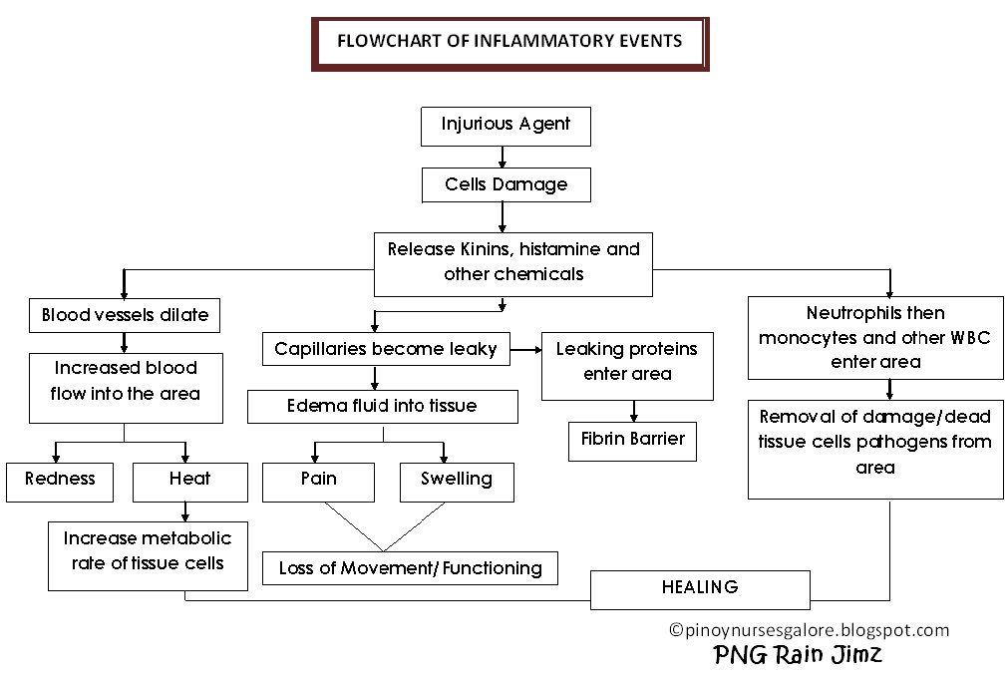
FIG – 1: PATHOPHYSIOLOGY OF INFLAMMATION

Initially, host cells detect inflamm through transmembrane receptors called pattern-receptors, which are produced by both innate and adaptive immune cells.

They do this by identifying structures conserved in microorganisms known as pathogen-associated molecular patterns (PAMPs) and endogenous chemicals derived from internal damage known as hazard-associated molecular patterns (DAMPs). . The second step involves maturation of IL-1 by caspase-1-mediated cleavage of pro-IL-1. This requires a 'caspase-1-activating' high-molecular-weight complex known as the inflammasome.

Members of the NK-κB family share structural similarity with the retroviral oncoprotein v-Rel at the N-terminus known as the Rel homology region (RHR), forming stable homodimers and heterodimers. It promotes the generation of amomers. In response to stimulation, NK-κB dimers are released into her IB cytoplasm and translocate to the nucleus, where they trigger specific gene expression. In addition to NK-κB, several other transcription factors play important roles in selective activation of inflammatory genes. Activator protein-1 (AP-1), to name a few, is a heterodimer of the basic leucine zipper proteins c-Jun and c-Fos. Cyclic-AMP (cAMP) Response Element Binding Protein (CREB), cAMP inducer. E2F, a transcription factor activated by the adenoviral E1A protein in adenovirus-infected cells. Serum response factor (SRF) and related ternary complex factor (TCF) involved in serum induction of Fos transcription (Dalton et al., 1992). “Figure - 1” shows a schematic diagram of the pathophysiology of inflammation.

INFLAMMATION AND CANCER
Several epidemiological and clinical studies have shown associations between inflammation and cancer. For example, ulcerative colitis and Crohn's disease (Seril et al., 2003) may increase tumor risk, whereas anti-colitis drugs may minimize this process (Qiu et al. 2017). Additionally, microbial agents or chemical irritants often cause inflammation. For example, Helicobacter pylori infection or Hepatitis B and viruses can predispose to cancer (Van Tong et al., 2017).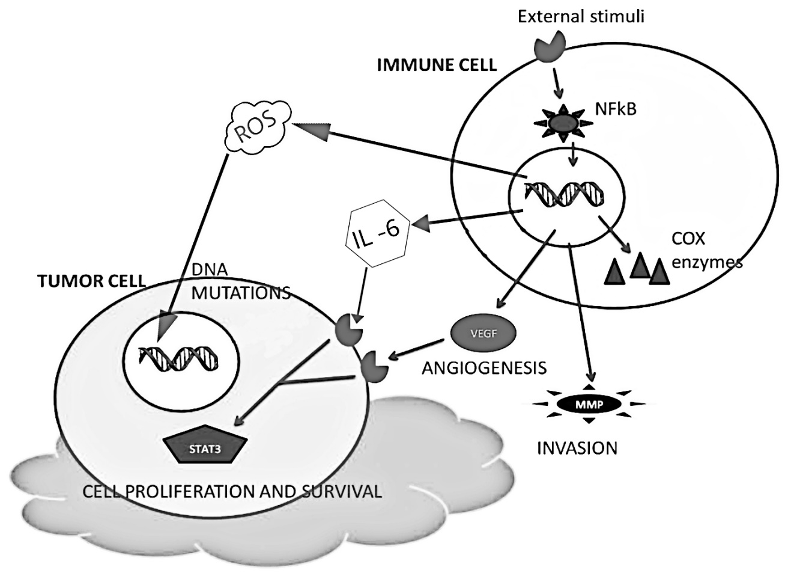
FIG – 2: INFLAMMATION AND CANCER

A variety of inflammatory and carcinogenic agents can activate the transcription factor NF-kB. IL-6 and growth factors induce STAT3 activation leading to cell proliferation and survival, whereas metalloproteases degrade membrane substrates and promote cell invasion. In addition, macrophages secrete numerous reactive oxygen species (ROS) and antimicrobial mutagens. They cause DNA alterations that induce persistent tissue damage and contribute to tumorigenesis. These cytokines released at the tumor site are intrinsic signals for lymphocyte recruitment, but their importance in tumor progression is unknown mutant cells can create a tumor inflammatory environment enriched with macrophages, neutrophils, eosinophils, dendritic cells, mast cells and lymphocytes, all of which play important roles in inflammatory malignancies. increase. Tumor-associated macrophages (particularly TAMs) contribute to angiogenesis and promote tumor growth by secreting specific factors such as cytokines and growth factors, endothelin-2, and urokinase-type plasminogen activator that suppress immune responses. can facilitate progress. “Figure - 2” shows a schematic diagram of inflammation and cancer.

THE ORIGINS AND TYPES OF INFLAMMATION IN CANCER

Inflammation may play an important role in cancer, from the onset of the malignant phenotype to metastatic progression "Figure - 3" and metastases in distant places "Figure - 4".

INFLAMMATION ARISING FROM INFECTION, AUTOIMMUNITY OR THE ENVIRONMENT

There are many examples of inflammation that contribute to the onset of cancer, including (1) infectious agents that directly cause cancer, e.g. feline leukemia virus, or inflammatory viruses, eg. : Helicobacter pylori causes mucosal-associated lymphoma (MALT) or gastric carcinoma in humans (De Falco et al., 2015); (2) immune-mediated diseases that promote chronic inflammation, e.g. inflammatory bowel disease IBD and colon cancer; (3) subclinical inflammation, for example: obesity causes inflammation and leads to liver cancer; (4) environmental carcinogens, e.g. smoke pollution (Cohen et al., 1995).
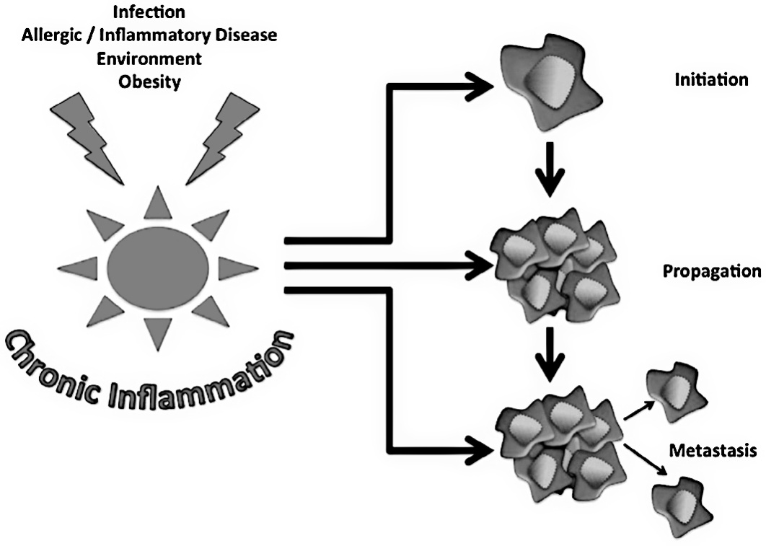
FIG – 3: ROLE OF INFLAMMATION IN CANCER
INFLAMMATION ARISING FROM TUMOURS

The microenvironment maintains a persistent inflammatory state once tumors are established. Tumors elicit an innate inflammatory response and proto-tumoral microenvironment supported by macrophage infiltration and regulated by chemical mediators such as interleukins IL-8 and IL-10. Cell Infiltration, Cytokines, Chemokines : (1) It is proangiogenic and promotes angiogenesis in cancer ; (2) act as a growth factor for tumor cells ; (3) promotes epithelial-to-mesenchymal transition (EMT).

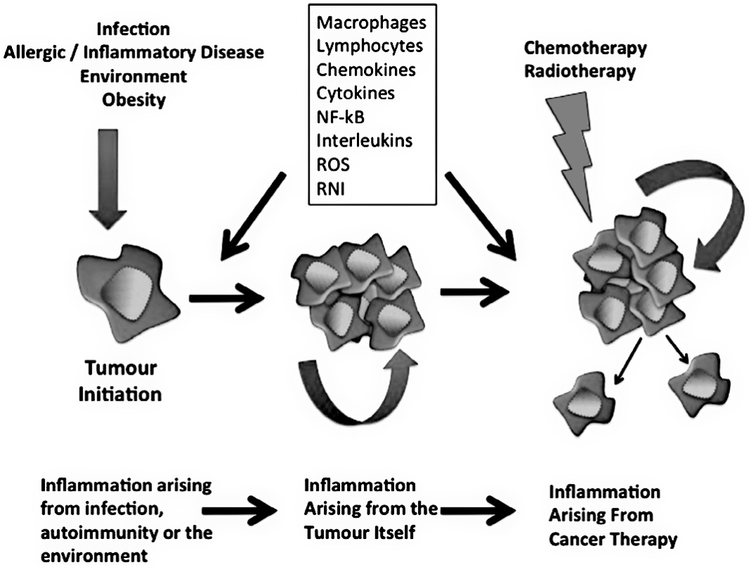
FIG – 4: ORIGIN OF CANCER RELATED INFLAMMATION

INFLAMMATION ARISING FROM CANCER THERAPY
Contrary to popular belief, standard cancer treatments (chemotherapy and radiation therapy) may promote tumor development by increasing inflammation. Chemotherapy and radiation can damage cells and cause inflammation-inducing necrosis (Vakkila et al., 2004). “Figure - 5” shows a schematic diagram of tumour initiation through the effects on DNA.

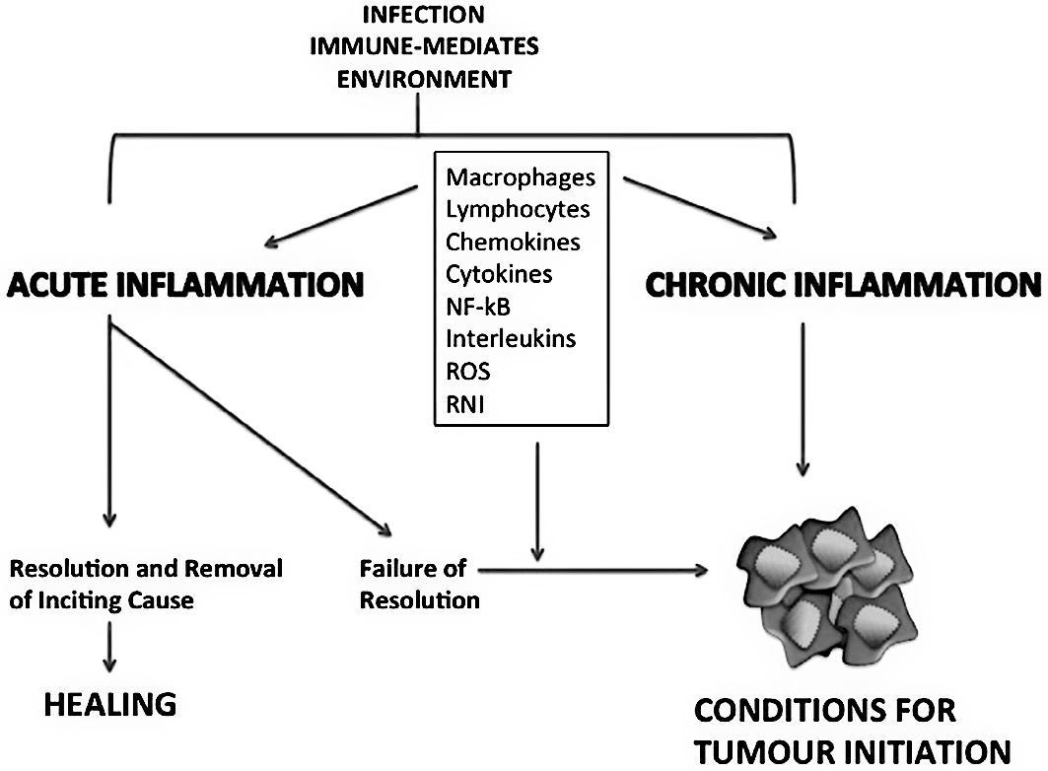
FIG – 5: TUMOUR INITIATION THROUGH THE EFFECTS ON DNA

THE KEY MEDIATORS OF INFLAMMATION

There are two mechanisms that link inflammation and cancer.
Exogenous and endogenous ("Figure - 6"). Upon activation, NF-kB secretes inflammatory mediators, growth factors, and metalloproteases that contribute to the establishment of the inflammatory tumor microenvironment (Sebiomo et al., 2011). For example, cytokines, growth factors, and differentiation factors involved in regulating immune cell proliferation and differentiation contribute to cancer by activating cell proliferation and inhibiting and inhibiting apoptosis of damaged cells (Lee et al. , 1986; Penna et al., 2003) through different molecular signaling cascades.
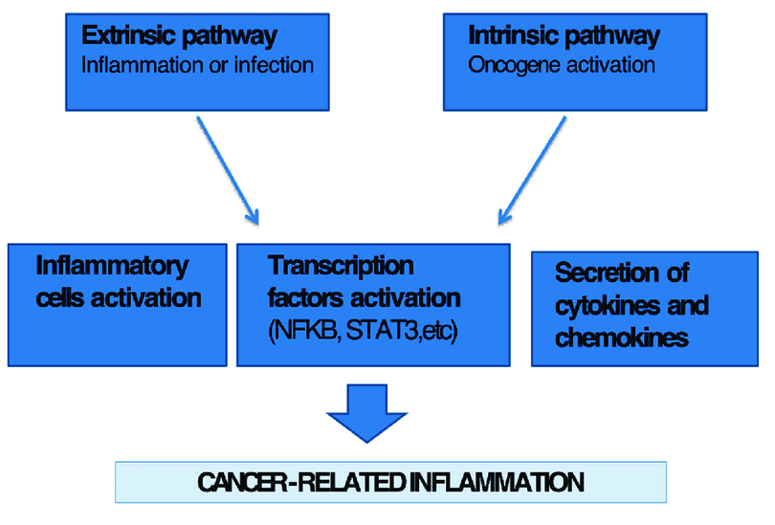
FIG – 6 : LINK BETWEEN INFLAMMATION AND CANCER

TUMOR NECROSIS FACTOR ALPHA (TNF-ALPHA)

It can also suppress the expression of adiponectin, glute-4, PPAR-, and perilipin in adipocytes. Studies have shown that TNF-α produces additional pro-inflammatory cytokines such as IL-1 and IL-8 in her Caco-2 or HT-29 cell lines.

- HISTAMINE

Histamine is a vasodilator, smooth muscle constrictor, and stimulator of vascular permeability, respiratory mucus, and stomach acid production.
- LEUKOTRIENES

The biologic combination, also known as the anaphylactic slow-reacting substance, is made up of leukotriene (LT) C4 and its derivatives, LTD4 and LTE4.

- PROSTAGLANDINS

Prostaglandins are another type of arachidonic acid-derived molecule that mediates allergic responses. Human mast cells produce PGD2 after being triggered by the Ig-E receptor or a calcium ionophore.

- CYTOKINES AND CHEMOKINES

Cytokines such as IL-1, -2, -4, -5, -6, and GM-CSF impact the development of allergic inflamm by influencing the activity of inflammatory cells such as eosinophils, macrophages, B cells and T cells.

- iNOS AND NO SECRETION

iNOS is an enzyme that interferes with NO production and is overexpressed in variations of chronic inflammatory and cancer processes. Activation of iNOS by proinflammatory cytokines or NFkB causes DNA damage, reduces DNA repair, and promotes cancer development (Hussain et al., 2004).

- LOX AND COX PATHWAYS

5-LOX has been detected in human or animal cancer cell lines such as brain, breast, colon, kidney, mesothelium, esophageal mucosa, pancreas, and prostate, and most of these investigations also increased 5-LOX products. I'm here. A recent study (Kummer et al., 2012) shows that 5-LOX expression in papillary thyroid carcinoma (PTC) promotes carcinogenesis through induction of metalloproteinases (MMPs). These enzymes are of two types:
• COX-1, is constitutively expressed in many cells and is primarily involved in the physiological production of prostanoids.
• COX-2, Its expression is often induced in cells in inflammatory conditions.

- JAK/STAT PATHWAY

The STAT3 (signal transducer and activator of transcription 3) protein is a constitutive transcription factor present in a variety of human cancers, including multiple myeloma, leukemia, lymphoma, breast cancer, prostate cancer, and squamous cell carcinoma of the head and neck (Hodge et al., 2005).

- CREB SIGNALING PATHWAY

Cell survival, neuron growth, and metabolism all rely on CREB. For example, CREB-mediated gene expression is necessary for nerve growth factor (NGF)-induced cell survival, which improves sympathomimetic neuron survival by activating downstream target genes (Salojin et al., 2007).

THE ROLE OF INFLAMMATION IN TUMOUR INITIATION AND MAINTENANCE

Tumor products have an impact on inflammatory conditions; immunosuppressive cytokines allow immune evasion and the recruitment of tumor-promoting inflammatory cells such as myeloid-derived suppressor cells, regulatory T cells, and tumor-promoting (M2) macrophages "Figure -7". The tumour microenvironment is a complex network of interactions between tumour cells, supporting stroma, and inflammatory cells that collaborate to maintain the malignant phenotype "Figure - 8". Cancer and inflammation are intricately linked (“Table - 1”).

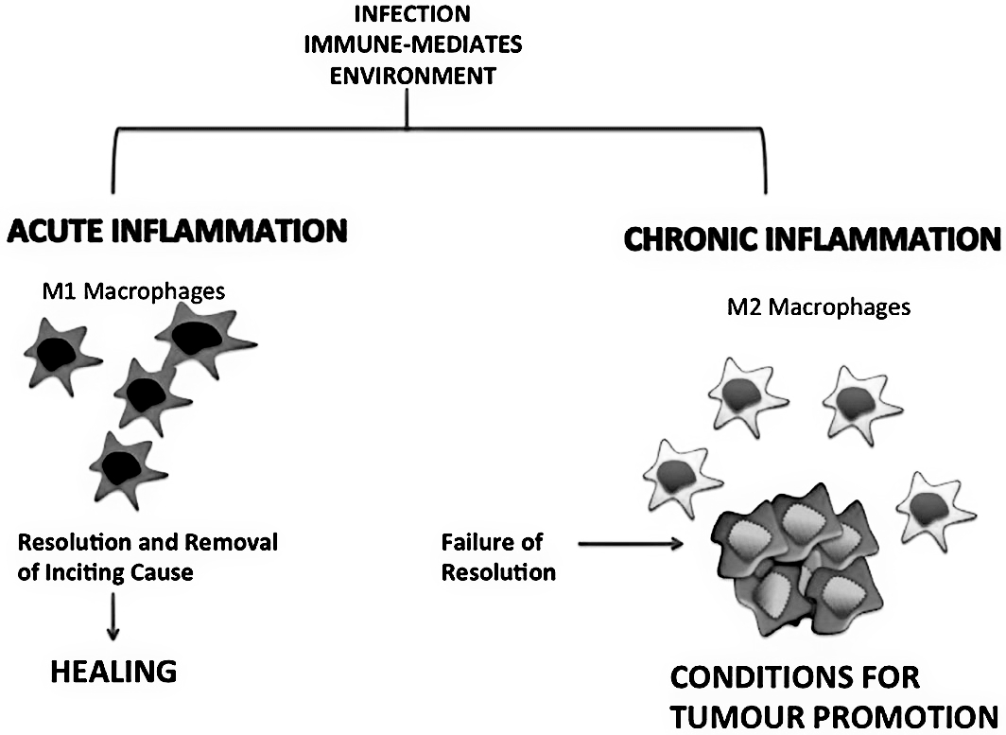
FIG – 7 : TWO ENDS OF A PHENOTYPIC SPECTRUM OF MACROPHAGES

BRIDGING CANCER AND INFLAMMATION
After exposure to pathogens, innate and specific immune responses can work together to eliminate the source of infection and avoid additional tissue damage during acute inflammation. This not only prolongs immune cell infiltration, but also leads to the formation of reactive oxygen species (ROS), reactive nitrogen species (RNA), and macrophage migration inhibitory factor (MIF), all of which can cause DNA damage.
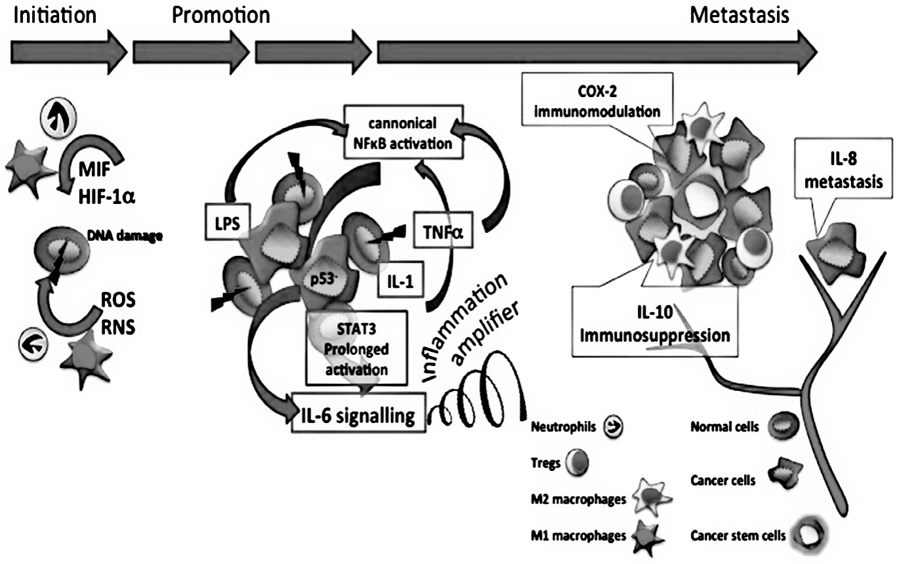
FIG – 8 : SUMMARY OF THE CELLS AND MEDIATORS WITHIN THE TUMOUR MICROENVIRONMENT

- CENTRAL ROLE OF NF-$κ$B

NF-κB is important in regulation of the immune response to infection, and its dysregulation has related to illnesses such as autoimmunity and cancer. This molecule's critical involvement in cancer may be summarised as follows : (1) constitutive NF-κB expression has been identified in many cancer types, supporting its role in promoting the cancer phenotype ; (2) dysregulation of the NF-κB pathway has documented in haematological malignancies and lymphoma; these lymphoid malignancies feature aberrant NF-κB activation, which promotes tumorigenic cell survival, protects against apoptosis and favours oncogenesis ; (3) Constitutive NF-κB activation is a characteristic of chronic inflammatory illness, which is connected to an elevated risk of cancer. ; (4) The primary cause of dysregulation of the NF-κB signalling pathway in human non-lymphoma Hodgkin's (NHL) includes chromosomal abnormalities (e.g. Epstein Barr virus, human T-cell leukaemia virus-1) ; (5) Up-regulation of anti-apoptotic Bcl-2 family proteins as a result of persistent activation of the NF-κB pathway ; (6) The development of resistance in the cytotoxic effects of chemotherapeutic drugs is a serious barrier to current cancer therapy. Many chemotherapeutic drugs that induce p53-mediated apoptosis also activate NF-κB.
NF-κB inhibition increases the effectiveness of anticancer drugs and decrease the incidence of resistance to these treatments in numerous in vivo and in vitro models, making NF-κB a prospective therapeutic target in oncology. Thus, the NF-κB signaling pathway is involved in complex interactions with many cancer signaling pathways (protein kinases, c-Jun N-terminal kinase, STAT3, and transcription factors such as p53), potentially Concerns have been raised about its use. Use of NF-κB inhibitors for cancer treatment with unforeseen side effects.

INFLAMMATION AS TARGET FOR CANCER PREVENTION

Since inflammation can predispose to tumorigenesis, targeting inflammation and molecules involved in inflammatory processes (COX-2 cyclooxygenase 2, NF-kB, VEGF) may be beneficial for cancer prevention and treatment method (“Table – 1”).

  - NSAIDs

Cancer prevention by NSAIDs works by interfering with the eicosanoid system. NSAIDs are less toxic than conventional chemotherapy, have non-specific effects, and can reduce tumorigenesis by interacting with the tumor's inflammatory microenvironment.
Several studies have shown that anti-inflammatory drugs can improve apoptosis and sensitivity to standard treatments while reducing invasion and metastasis (Ma et al., 2016; Saito et al., 2015; Yang et al., 2008), leading them to promising alternatives. for cancer treatment.

  - CORTICOSTEROIDS

Corticosteroids are effective in reducing the side effects of chemotherapy and radiation therapy, and some studies have shown significant benefits in fighting cancer, either alone or in combination. Dexamethasone therapy enhanced the antitumor efficacy of conventional drugs in various animal cancer models (Zhang et al., 2008).

TABLE – 1 : PREVENTIVE AND ANTICANCER EFFECTS OF ANTI-INFLAMMATORY DRUGS

SL NO. | DRUG | EFFECT
1 | ASPIRIN | Induced activation of NF-kB pathway in colon cancer cells,  Preventive effect on bladder cancer, breast cancer,  colorectal cancer, esophageal cancer, lung cancer
2 | COLECOXIB | Induced apoptosis in prostate cancer cells,  Preventive effect on bladder cancer, breast cancer,  colorectal cancer, esophageal cancer, lung cancer, cervix cancer, neuroblastoma
3 | DEXAMETHASONE | Induced cell death in multiple myeloma mediated by miR-125b expression  Preventive effect on breast cancer, rectal cancer, multiple myeloma
4 | IBUPROFEN | Inhibited activation of nuclear β-catenin in human colon adenomas,  Preventive effect on breast cancer
5 | PIROXICAM | Prevented colon carcinogenesis by inhibition of membrane fluidity and canonical Wnt/β-catenin signaling,  Preventive effect on colorectal cancer
6 | SULINDAC | Induced activation of NF-kB pathway in colon cancer cells,  Preventive effect on breast cancer

ANTI-CANCER EFFECTS OF ANTI-INFLAMMATORY AGENTS

Several preclinical and clinical studies have shown that a combination of chemotherapeutic and anti-inflammatory agents improves patient prognosis. Although the mechanism of action behind the anti-cancer effects of anti-inflammatory drugs is unknown, three major possible processes have been characterized.

- CHEMOPROTECTION

The side effect profile of standard anticancer therapies is one of the difficulties. Chemotherapy often causes toxicity to both the tumor and various normal tissues, reducing the patient's quality of life. Some studies have shown that combining conventional treatments with anti-inflammatory drugs can reduce the side effects of chemotherapy. For example, in patients with metastatic prostate cancer, combined treatment with celecoxib and docetaxel reduced myelotoxicity (Calaluce et al., 2000), whereas celecoxib combined with FOLFIRI (folinic acid, fluorouracil, and irinotecan) or capecitabine diarrhea (Baron et al., 2003). The GECO (gemcitabine-coxib) study evaluated the effect of celecoxib in combination with gemcitabine in patients with NSCLC and found that 3 months of celecoxib treatment improved quality of life. Another glucocorticoid, budesonide, has been used in combination with irinotecan to reduce episodes of diarrhea (Zhao et al., 2017).

- ALTERATIONS IN PHARMACOKINETICS OR METABOLISM

Anti-inflammatory drugs can alter the pharmacokinetics of other drugs. Glucocorticoids do not affect plasma pharmacokinetics, but alter the absorption of gemcitabine or carboplatin from the spleen and bone marrow, increasing the number of drugs reaching the tumor.
In addition, anti-inflammatory drugs may affect chemotherapy metabolism. For example, rofecoxib acts as a CYP1A2 inhibitor (Wang et al., 2004), causing changes in the concentration, half-life, and clearance of other drugs metabolized by CYP1A2. Dexamethasone increases her CYP2D6 activity, which celecoxib decreases (Yano et al., 2006), impairing the efficacy of the CYP2D6 substrate tamoxifen. Diclofenac inhibits DMXAA glucuronidation by inhibiting its metabolism and increasing plasma concentrations (Freshney et al., 1986).

- CHEMOSENSITIZATION

In addition to the ability of anti-inflammatory agents to reduce the toxicity of conventional treatments by altering metabolism, the beneficial anticancer effects of combinations of anti-inflammatory and chemotherapeutic agents are likely due to chemo-sensitization of anti-inflammatory agents. Thing. Several preclinical studies have shown that celecoxib is additive or synergistic in vitro when combined with etoposide, doxorubicin, vincristine, or irinotecan. Notably, celecoxib in combination with irinotecan or doxorubicin suppressed tumor development in a neuroblastoma rat model. Furthermore, celecoxib sensitized prostate cancer cells to docetaxel in vitro and in vivo and sensitized gliomas to radiation (Gerber et al., 1998).
Multiple studies have shown that NSAIDs promote apoptosis in multiple tumor types by directly acting on the NF-kB pathway. Aspirin and sulindac can bind to NF-kB in the nucleolus and inhibit transcription of NF-kB targets such as cytokines, growth factors and adhesion molecules. Celecoxib enhanced the antitumor effect of doxorubicin by increasing IkB expression and decreasing NF-kB activity (Gerber et al., 1998). Dexamethasone also inhibits the NF-kB pathway (Xiao et al., 2011).

Anti-inflammatory drugs can kill cancer cells by interfering with proteins involved in programmed cell death. For example, celecoxib enhanced the efficacy of docetaxel by activating caspases and PARP while reducing XIAP activity. Aspirin reduces NF-kB activity by inhibiting caspases and pro-apoptotic proteins, possibly interfering with the proteasome. According to Dittmann et al. Cancer cells can be exposed to radiation by suppressing EGFR in a COX-2-independent manner (Liang et al., 2007).

NOVEL ANTI-INFLAMMATORY DRUGS WITH ANTI-CANCER ACTIVITY

Several clinical studies have been conducted evaluating the use of anti-inflammatory drugs in combination with chemotherapy regimens for cancer prevention and treatment, and anti-inflammatory drugs have shown promising efficacy and toxicity results.

- ANTI-CANCER AGENTS BASED ON COX-2 INHIBITORS

Several studies evaluating the use of COX-2 inhibitors in cancer therapy have shown that the antitumor effects of these agents are independent of their ability to inhibit COX-2. (Rose-John et al. al., 2006).

- NO-DONATING NSAIDS

NO-donating NSAIDs are NSAID analogues with fewer side effects. These drugs retain the active ingredient that produces the anti-inflammatory effect and are attached to NO via a spacer. NO-NSAIDs containing aromatic spacers were more potent than those containing aliphatic spacers. Once produced, NO protects the gastrointestinal tract from damage caused by active drugs by reducing gastrointestinal toxicity (Stetler-Stevenson et al., 1999). NO-donating compounds were made by modifying diclofenac, naproxen, aspirin, sulindac, and ibuprofen (Lau et al., 2017). Several NO-donating NSAIDs caused apoptosis, growth inhibition, or cell cycle arrest in various forms of cancer in vitro and in vivo (Scotton et al., 2002; Kulbe et al., 2005). All preclinical studies of NO-donating NSAIDs have shown higher efficacy than NSAIDs, but further studies are needed to fully realize their potential in cancer prevention (Kim et al., 2016). NO-ASA (NO-acetylsalicylic acid) showed synergistic or additive benefits in combination with oxaliplatin or 5-fluorouracil in colon cancer models and reduced cancer risk in induced pancreatic cancer models. Furthermore, the NO-ASA ortho- and para-isomers were more effective than the meta-isomers in reducing colon cancer cell proliferation and survival. The use of NCX4016 (NO-acetylsalicylic acid) for colorectal cancer prevention was investigated in phase I, but the study was terminated prematurely due to the suspected genotoxicity of the compound (Wang et al., 2010).
- NATURAL PRODUCTS
Grapes/red wine (resveratrol), garlic (various chemicals), and curry powder are all anti-inflammatory foods or natural products (curcumin). Produced anticancer effects on cancer cells or xenografts. These chemicals act as anti-inflammatory agents by inhibiting VEGF or COX enzymes or by targeting NFKB, MAPK, and JNK signaling pathways, and their activity contributes to their anticancer activity. It is possible (Yung et al., 2018; Cuello et al., 2001). .
Garlic compounds have been shown to enhance the anticancer effects of cytarabine and fludarabine in myeloid leukemia cells (Song et al., 2009) and improve the sensitivity of prostate cancer cells and xenograft tumors to docetaxel with fewer side effects. (Putilnik et al., 1999).

4. LOX INHIBITORS
Many researchers have proposed 5-LOX inhibitors (Zileuton, ZYflo, ABT-761) (Liu et al., 1998; Yeung et al., 2013), FLAP inhibitors (MK-886) (Frankel et al., 1996) used pharmacological tools such as Gao et al., 2015) or LTA4 hydrolase (Hu et al., 2001) and LTs antagonists (zafirlukast and montelukast) (Forsythe et al., 1996; Tan et al., 2006) block cell proliferation. Anti-LTs therapies that increase and induce apoptosis show promise for cancer prevention and treatment, but few clinical studies have been conducted to evaluate the efficacy of 5-LOX inhibitors in antitumor therapy. Treatment with LOX inhibitors dramatically inhibited cell proliferation in several pancreatic cell lines. In vivo experiments using athymic mice showed that LOX inhibitors suppress tumor growth and have potential applications in the prevention and treatment of pancreatic cancer.
Gosh found that inhibition of his 5-LOX by her MKAP1, a FLAP inhibitor, caused apoptosis in LNCaP and PC3 cell lines. 5-LOX inhibitors induced apoptosis in esophageal cancer cells, whereas 12-LOX inhibitors showed anti-proliferative and pro-apoptotic effects on gastric cancer cells. Finally, several experiments with hematopoietic cells showed that the inhibitor 5-LOX AA861 caused apoptosis in the leukemia cell line P388.

- EMBELIN AND ITS DERIVATIVES
Embelin is a benzoquinone derivative that can impair arachidonic acid metabolism. Its structure consists of a 2,5-dihydroxy-1,4-benzoquinone polar core linked at the 3-position to a long hydrophobic alkyl chain that confers solubility in polar phases and allows the molecule to cross cell barriers. It has been. Collaborative research with professor Oliver Werz (University of Jena, Germany) showed that this molecule can inhibit both 5-LOX and mPGES-1 activity with IC50 values ​​of 0.06 and 0.2 μM, respectively. Chronic structure of the membrane is important for inhibitory effects. This molecule has been shown to be able to block enzymes without going through the hydroquinone reduction pathway. Docking experiments showed that embelin does not behave like an iron chelator, but fits with its non-decylated chain into the hydrophobic channel where the iron-catalyzed oxygenation process of AA normally takes place. The benzoquinone ring forms hydrogen bonds with three amino acids (Gln363, Gln557, and Tyr181) to maintain contact between enzyme molecules. Two water molecules that co-crystallize with the complex and form hydrogen bonds with two amino acids, Asn425 and Thr364, facilitate the interaction between embelin and 5-LOX. Recent studies have shown that emberin and its derivatives have antioxidant properties. “Figure - 9” shows a schematic diagram of anticancer effects of embelin.
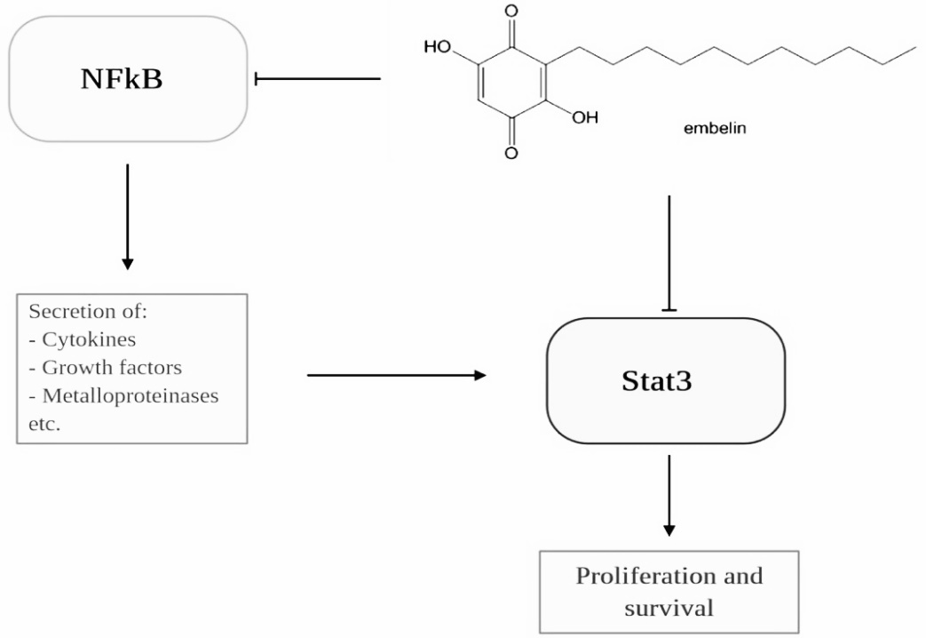
FIG – 9: ANTICANCER EFFECTS OF EMBELIN
CONCLUSION

Inflammation is closely associated with cancer and plays an important role in tumor growth and progression. Therefore, there is a need to target inflammation alone or in combination with chemotherapeutic agents for cancer prevention and treatment. Many anti-inflammatory drugs can be used as adjuncts to conventional therapy, but further research is needed to fully exploit the potential of anticancer agents. Early detection and treatment of chronic inflammation can help prevent cancer from developing. Widespread off-target effects and toxicity limit the use of FDA-approved anti-inflammatory drugs in cancer therapy. A better understanding of the critical role of inflammation in cancer is needed to develop more effective alternative therapies.

REFERENCES

- Balkwill, F.; Mantovani, A. Inflamm and cancer: Back to Virchow? Lancet 2001, 357, 539–545.
- Philip, M.; Rowley, D.A.; Schreiber, H. Inflamm as a tumor promoter in cancer induction. Semin. Cancer Biol. 2004, 14, 433–439.
- Rayburn, E.R.; Ezell, S.J.; Zhang, R. Anti-inflammatory agents for cancer therapy. Mol. Cell Pharm. 2009, 1, 29–43.
- Hoepelman, A. Inflamm. Basic Principles and Clinical Correlates, 3rd ed.; Gallin, J.I., Snyderman, R., Eds.; Lippincott Williams & Wilkins Publishers: Philadelphia, PA, USA, 2001; Volume 58, p. 1335.
- Krishnaiah D, Sarbatly R, Nithyanandam R. A review of the antioxidant potential of medicinal plant species. Food Bioprod Process, 2011; 89: 217-33.
- Fred C. Tenover, American Journal of Infection Control, 2006; 34: S3-10.
- Akira S, Uematsu S, Takeuchi O (2006). Pathogen recognition and innate immunity. Cell, 124(4): 783–801.
- Sen R, Baltimore D (1986). Inducibility of kappa immunoglobulin enhancer-binding protein Nf-kappa B by a posttranslational mechan- ism. Cell, 47(6): 921–928.
- Dalton S, Treisman R (1992). Characterization of SAP-1, a protein recruited by serum response factor to the c-fos serum response element. Cell, 68(3): 597–612.
- Barnes P J (2009). Targeting the epigenome in the treatment of asthma and chronic obstructive pulmonary disease. Proc Am Thorac Soc, 6 (8): 693–696.
- Liu G, Friggeri A, Yang Y, Park Y J, Tsuruta Y, Abraham E (2009). miR-147, a microRNA that is induced upon Toll-like receptor stimulation, regulates murine macrophage inflammatory responses. Proc Natl Acad Sci USA, 106(37): 15819–15824.
- Lai D, Wan M, Wu J, Preston-Hurlburt P, Kushwaha R, Grundström T, Imbalzano A N, Chi T (2009). Induction of TLR4-target genes entails calcium/calmodulin-dependent regulation of chromatin remodeling. Proc Natl Acad Sci USA, 106(4): 1169–1174.
- Seril, D.N. Oxidative stress and ulcerative colitis-associated carcinogenesis: Studies in humans and animal models. Carcinogenesis 2003, 24, 353–362.
- Qiu, X.; Ma, J.; Wang, K.; Zhang, H. Chemo preventive effects of 5-aminosalicylic acid on inflammatory bowel disease-associated colorectal cancer and dysplasia: A systematic review with meta-analysis. Oncotarget 2017, 8, 1031–1045.
- Van Tong, H.; Brindley, P.J.; Meyer, C.G.; Velavan, T.P. Parasite infection, carcinogenesis and human malignancy. E Bio Medicine 2017, 15, 12–23.
- Guo, Y.; Nie, Q.; MacLean, A.L.; Li, Y.; Lei, J.; Li, S. Multiscale modeling of inflamm-induced tumorigenesis reveals competing oncogenic and onco protective roles for inflamm. Cancer Res. 2017, 77, 6429–6441.
- Kawanishi, S.; Ohnishi, S.; Ma, N.; Hiraku, Y.; Murata, M. Crosstalk between DNA damage and inflamm in the multiple steps of carcinogenesis. Int. J. Mol. Sci. 2017, 18, 1808.
- Zhao, H.; Liu, J.; Song, L.; Liu, Z.; Han, G.; Yuan, D.; Wang, T.; Dun, Y.; Zhou, Z.; Liu, Z.; et al. Oleanolic acid rejuvenates testicular function through attenuating germ cell DNA damage and apoptosis via deactivation of NF-κB, p53 and p38 signalling pathways. J. Pharm. Pharmacol. 2016, 69, 295–304.
- Petrenko, O.; Moll, U.M. Macrophage migration inhibitory factor MIF interferes with the Rb-E2F pathway. Mol. Cell 2005, 17, 225–236.
- Riabov, V.; Gudima, A.; Wang, N.; Mickley, A.; Orekhov, A.; Kzhyshkowska, J. Role of tumor associated macrophages in tumor angiogenesis and lymphangiogenesis. Front. Physiol. 2014, 5, 75.
- Lin, E.Y.; Pollard, J.W. Role of infiltrated leucocytes in tumour growth and spread. Br. J. Cancer 2004, 90, 2053–2058.
- Canna, K.; McArdle, P.A.; McMillan, D.C.; McNicol, A.M.; Smith, G.W.; McKee, R.F.; McArdle, C.S. The relationship between tumour T-lymphocyte infiltration, the systemic inflammatory response and survival in patients undergoing curative resection for colorectal cancer. Br. J. Cancer 2005, 92, 651–654.
- De Falco, M., Lucariello, A., Iaquinto, S., Esposito, V., Guerra, G., De Luca, A., 2015. Molecular mechanisms of Helicobacter pylori pathogenesis. Journal of Cell Physiology.
- Francescone, R., Hou, V., Grivennikov, S.I., 2015. Cytokines, IBD, and colitis-associated cancer. Inflammatory Bowel Disease 21, 409–418.
- Calle, E.E., Kaaks, R., 2004. Overweight, obesity and cancer: Epidemiological evidence and proposed mechanisms. Nature Reviews. Cancer 4, 579–591.
- Cohen, A.J., Pope, C.A., 1995. Lung cancer and air pollution. Environmental Health Perspectives 103, 219–224.
- Ohnishi, S., Ma, N., Thanan, R., Pinlaor, S., Hammam, O., Murata, M., Kawanishi, S., 2013. DNA damage in inflamm-related carcinogenesis and cancer stem cells. Oxidative Medicine and Cellular Longevity 2013, 387014
- Vakkila, J., Lotze, M.T., 2004. Inflamm and necrosis promote tumour growth. Nature Reviews Immunology 4, 641–648.
- Sebiomo A, Awofodu AD, Awosanya AO, Awotona FE, Ajayi AJ. Comparative studies of antibacterial effect of some antibiotics and ginger (Zingiber officinale) on two pathogenic bacteria. Journal of Microbiology and Antimicrobials. 2011; 3: 18-22.
- Lee YB, Kim YS, Ahmore CR. Antioxidant property in ginger rhizoma and its application to mate products. Journal of Food Science. 1986; 51: 20-23.
- Penna SC, Medeiros MV, Aimbire FS, Faria-Neto HC, Sertié JA, et al. Anti-inflammatory effect of the hydralcoholic extract of Zingiber officinale rhizomes on rat paws and skin edema. Phytomedicine 2003; 10: 381-385.
- Kadnur SV, Goyal RK. Beneficial effects of Zingiber officinale Roscoe on fructose induced hyperlipidemia and hyperinsulinemia in rats. Indian J Exp Biol, 2005; 43: 1161-1164.
- Islam MS, Choi H. Comparative effects of dietary ginger (Zingiber officinale) and garlic (Allium sativum) investigated in a type 2 diabetes model of rats. J Med Food, 2008; 11: 152-159.
- Kashfi, K. Anti-inflammatory agents as cancer therapeutics. In Advances in Pharmacology; Elsevier: Cambridge, MA, USA, 2009; pp. 31–89.
- Dranoff, G. Cytokines in cancer pathogenesis and cancer therapy. Nat. Rev. Cancer 2004, 4, 11–22.
- Bando, H.; Toi, M. Tumor angiogenesis, macrophages, and cytokines. In Advances in Experimental Medicine and Biology; Springer: Boston, MA, USA, 2000; pp. 267–284.
- Viatour, P.; Merville, M.-P.; Bours, V.; Chariot, A. Phosphorylation of NF-κB and IκB proteins: Implications in cancer and inflamm. Trends Biochem. Sci. 2005, 30, 43–52.
- Tergaonkar, V.; Bottero, V.; Ikawa, M.; Li, Q.; Verma, I.M. IkappaB kinase-independent IkappaBalpha degradation pathway: Functional NF-kappaB activity and implications for cancer therapy. Mol. Cell. Biol. 2003, 23, 8070–8083.
- Guttridge, D.C.; Albanese, C.; Reuther, J.Y.; Pestell, R.G.; Baldwin, A.S., Jr. NF-kappaB controls cell growth and differentiation through transcriptional regulation of cyclin D1. Mol. Cell. Biol. 1999, 19, 5785–5799.
- Hussain, S.P.; Trivers, G.E.; Hofseth, L.J.; He, P.; Shaikh, I.; Mechanic, L.E.; Doja, S.; Jiang, W.; Subleski, J.; Shorts, L.; et al. Nitric oxide, a mediator of inflamm, suppresses tumorigenesis. Cancer Res. 2004, 64, 6849–6853.
- Williams, C.S.; Mann, M.; DuBois, R.N. The role of cyclooxygenases in inflamm, cancer, and development. Oncogene 1999, 18, 7908–7916.
- Werz, O. 5-lipoxygenase: Cellular biology and molecular pharmacology. Curr. Drug Target. Inflamm. Allergy 2002, 1, 23–44.
- Boado, R.J.; Pardridge, W.M.; Vinters, H.V.; Black, K.L. Differential expression of arachidonate 5-lipoxygenase transcripts in human brain tumors: Evidence for the expression of a multitranscript family. Proc. Natl. Acad. Sci. USA 1992, 89, 9044–9048.
- Przylipiak, A.; Hafner, J.; Przylipiak, J.; Köhn, F.M.; Runnebaum, B.; Rabe, T. Influence of 5-lipoxygenase on in vitro growth of human mammary carcinoma cell line MCF-7. Gynecol. Obstet. Investig. 1998, 46, 61–64.
- Wächtershäuser, A.; Steinhilber, D.; Loitsch, S.M.; Stein, J. Expression of 5-lipoxygenase by human colorectal carcinoma Caco-2 cells during butyrate-induced cell differentiation. Biochem. Biophys. Res. Commun. 2000, 268, 778–783.
- Matsuyama, M.; Yoshimura, R.; Mitsuhashi, M.; Tsuchida, K.; Takemoto, Y.; Kawahito, Y.; Sano, H.; Nakatani, T. 5-Lipoxygenase inhibitors attenuate growth of human renal cell carcinoma and induce apoptosis through arachidonic acid pathway. Oncol. Rep. 2005, 14, 73–79.
- Avis, I.M.; Jett, M.; Boyle, T.; Vos, M.D.; Moody, T.; Treston, A.M.; Martínez, A.; Mulshine, J.L. Growth control of lung cancer by interruption of 5-lipoxygenase-mediated growth factor signaling. J. Clin. Investig. 1996, 97, 806–813.
- Hoque, A. Increased 5-lipoxygenase expression and induction of apoptosis by its inhibitors in esophageal cancer: A potential target for prevention. Carcinogenesis 2005, 26, 785–791.
- Knab, L.M.; Grippo, P.J.; Bentrem, D.J. Involvement of eicosanoids in the pathogenesis of pancreatic cancer: The roles of cyclooxygenase-2 and 5-lipoxygenase. World J. Gastroenterol. 2014, 20, 10729–10739.
- Ghosh, J.; Myers, C.E. Central role of arachidonate 5-lipoxygenase in the regulation of cell growth and apoptosis in human prostate cancer cells. In Advances in Experimental Medicine and Biology; Springer: Boston, MA, USA, 1999; pp. 577–582.
- Kummer, N.T.; Nowicki, T.S.; Azzi, J.P.; Reyes, I.; Iacob, C.; Xie, S.; Swati, I.; Darzynkiewicz, Z.; Gotlinger, K.H.; Suslina, N.; et al. Arachidonate 5 lipoxygenase expression in papillary thyroid carcinoma promotes invasion via MMP-9 induction. J. Cell. Biochem. 2012, 113, 1998–2008.
- Hara, S.; Kamei, D.; Sasaki, Y.; Tanemoto, A.; Nakatani, Y.; Murakami, M. Prostaglandin E synthases: Understanding their pathophysiological roles through mouse genetic models. Biochimie 2010, 92, 651–659.
- Hodge, D.R.; Hurt, E.M.; Farrar, W.L. The role of IL-6 and STAT3 in inflamm and cancer. Eur. J. Cancer 2005, 41, 2502–2512.
- Dong, C.; Davis, R.J.; Flavell, R.A. MAP kinases in the immune response. Annu. Rev. Immunol. 2002, 20, 55–72.
- Liu, J.; Dietz, T.; Carpenter, S.R.; Alberti, M.; Folke, C.; Moran, E.; Pell, A.N.; Deadman, P.; Kratz, T.; Lubchenco, J.; et al. Complexity of coupled human and natural systems. Science 2007, 317, 1513–1516.
- Arthur, J.S.; Ley, S.C. Mitogen-activated protein kinases in innate immunity. Nat. Rev. Immunol. 2013, 13, 679–692.
- Owens, D.M.; Keyse, S.M. Differential regulation of MAP kinase signalling by dual-specificity protein phosphatases. Oncogene 2007, 26, 3203–3213.
- Kyriakis, J.M.; Avruch, J. Mammalian MAPK signal transduction pathways activated by stress and inflamm: A 10-year update. Physiol. Rev. 2012, 92, 689–737.
- Kolch, W. Meaningful relationships: The regulation of the Ras/Raf/MEK/ERK pathway by protein interactions. Biochem. J. 2000, 351 Pt 2, 289–305.
- Chambard, J.C.; Lefloch, R.; Pouyssegur, J.; Lenormand, P. ERK implication in cell cycle regulation. Biochim. Biophys. Acta 2007, 1773, 1299–1310.
- Knight, T.; Irving, J.A. Ras/Raf/MEK/ERK pathway activation in childhood acute lymphoblastic leukemia and its therapeutic targeting. Front. Oncol. 2014, 4, 160.
- Johnson, G.L.; Lapadat, R. Mitogen-activated protein kinase pathways mediated by ERK, JNK, and p38 protein kinases. Science 2002, 298, 1911–1912.
- Yang, Y.; Kim, S.C.; Yu, T.; Yi, Y.S.; Rhee, M.H.; Sung, G.H.; Yoo, B.C.; Cho, J.Y. Functional roles of p38 mitogen-activated protein kinase in macrophage-mediated inflammatory responses. Mediat. Inflamm. 2014, 2014, 352371.
- Salojin, K.; Oravecz, T. Regulation of innate immunity by MAPK dual-specificity phosphatases: Knockout models reveal new tricks of old genes. J. Leukoc. Biol. 2007, 81, 860–869.
- Soares-Silva, M.; Diniz, F.F.; Gomes, G.N.; Bahia, D. The mitogen-activated protein kinase (MAPK) pathway: Role in immune evasion by trypanosomatids. Front. Microbiol. 2016, 7, 183.
- Akinleye, A.; Avvaru, P.; Furqan, M.; Song, Y.; Liu, D. Phosphatidylinositol 3-kinase (PI3K) inhibitors as cancer therapeutics. J. Hematol. Oncol. 2013, 6, 88.
- Fruman, D.A.; Chiu, H.; Hopkins, B.D.; Bagrodia, S.; Cantley, L.C.; Abraham, R.T. The PI3K pathway in human disease. Cell 2017, 170, 605–635.
- Brown, K.K.; Toker, A. The phosphoinositide 3-kinase pathway and therapy resistance in cancer. F1000prime Rep. 2015, 7, 13.
- Ebrahimi, S.; Hosseini, M.; Shahidsales, S.; Maftouh, M.; Ferns, G.A.; Ghayour-Mobarhan, M.; Hassanian, S.M.; Avan, A. Targeting the Akt/PI3K signaling pathway as a potential therapeutic strategy for the treatment of pancreatic cancer. Curr. Med. Chem. 2017, 24, 1321–1331.
- Sandoval, S.; Pigazzi, M.; Sakamoto, K.M. CREB: A key regulator of normal and neoplastic hematopoiesis. Adv. Hematol. 2009, 2009, 634292.
- Steven, A.; Seliger, B. Control of CREB expression in tumors: From molecular mechanisms and signal transduction pathways to therapeutic target. Oncotarget 2016, 7, 35454–35465.
- Du, K.; Montminy, M. CREB is a regulatory target for the protein kinase Akt/PKB. J. Biol. Chem. 1998, 273, 32377–32379.
- Johannessen, C.M.; Johnson, L.A.; Piccioni, F.; Townes, A.; Frederick, D.T.; Donahue, M.K.; Narayan, R.; Flaherty, K.T.; Wargo, J.A.; Root, D.E.; et al. A melanocyte lineage program confers resistance to MAP kinase pathway inhibition. Nature 2013, 504, 138–142.
- Phuong, N.T.; Lim, S.C.; Kim, Y.M.; Kang, K.W. Aromatase induction in tamoxifen-resistant breast cancer: Role of phosphoinositide 3-kinase-dependent CREB activation. Cancer Lett 2014, 351, 91–99.
- Cheng, J.C.; Kinjo, K.; Judelson, D.R.; Chang, J.; Wu, W.S.; Schmid, I.; Shankar, D.B.; Kasahara, N.; Stripecke, R.; Bhatia, R.; et al. CREB is a critical regulator of normal hematopoiesis and leukemogenesis. Blood 2008, 111, 1182–1192.
- Antonescu, C.R.; Nafa, K.; Segal, N.H.; Dal Cin, P.; Ladanyi, M. EWS-CREB1: A recurrent variant fusion in clear cell sarcoma—Association with gastrointestinal location and absence of melanocytic differentiation. Clin. Cancer Res. Off. J. Am. Assoc. Cancer Res. 2006, 12, 5356–5362.
- Xia, Y.; Zhan, C.; Feng, M.; Leblanc, M.; Ke, E.; Yeddula, N.; Verma, I.M. Targeting CREB pathway suppresses small cell lung cancer. Mol. Cancer Res. MCR 2018, 16, 825–832.
- Tan, X.; Wang, S.; Yang, B.; Zhu, L.; Yin, B.; Chao, T.; Zhao, J.; Yuan, J.; Qiang, B.; Peng, X. The CREB-miR-9 negative feedback minicircuitry coordinates the migration and proliferation of glioma cells. PLoS ONE 2012, 7, e49570.
- Fan, C.F.; Mao, X.Y.; Wang, E.H. Elevated p-CREB-2 (ser 245) expression is potentially associated with carcinogenesis and development of breast carcinoma. Mol. Med. Rep. 2012, 5, 357–362.
- Jean, D.; Bar-Eli, M. Regulation of tumor growth and metastasis of human melanoma by the CREB transcription factor family. Mol. Cell. Biochem. 2000, 212, 19–28.
- Yamada, T.; Amann, J.M.; Fukuda, K.; Takeuchi, S.; Fujita, N.; Uehara, H.; Iwakiri, S.; Itoi, K.; Shilo, K.; Yano, S.; et al. Akt kinase-interacting protein 1 signals through CREB to drive diffuse malignant mesothelioma. Cancer Res. 2015, 75, 4188–4197.
- Logan, C.Y.; Nusse, R. The Wnt signaling pathway in development and disease. Annu. Rev. Cell Dev. Biol. 2004, 20, 781–810.
- MacDonald, B.T.; Tamai, K.; He, X. Wnt/beta-catenin signaling: Components, mechanisms, and diseases. Dev. Cell 2009, 17, 9–26.
- He, X.; Semenov, M.; Tamai, K.; Zeng, X. LDL receptor-related proteins 5 and 6 in Wnt/beta-catenin signaling: Arrows point the way. Development 2004, 131, 1663–1677.
- Liu, L.J.; Xie, S.X.; Chen, Y.T.; Xue, J.L.; Zhang, C.J.; Zhu, F. Aberrant regulation of Wnt signaling in hepatocellular carcinoma. World J. Gastroenterol. 2016, 22, 7486–7499.
- Zhang, L.; Shay, J.W. Multiple roles of APC and its therapeutic implications in colorectal cancer. J. Natl. Cancer Inst. 2017, 109.
- Le, P.N.; Keysar, S.B.; Miller, B.; Eagles, J.R.; Chimed, T.S.; Reisinger, J.; Gomez, K.E.; Nieto, C.; Jackson, B.C.; Somerset, H.L.; et al. Wnt signaling dynamics in head and neck squamous cell cancer tumor-stroma interactions. Mol. Carcinog. 2019, 58, 398–410.
- Ma, B.; Hottiger, M.O. Crosstalk between Wnt/beta-catenin and NF-kappaB signaling pathway during inflamm. Front. Immunol. 2016, 7, 378.
- Saito, H.; Yamada, Y.; Takaya, S.; Osaki, T.; Ikeguchi, M. Clinical relevance of the number of interleukin-17-producing CD 8+ T cells in patients with gastric cancer. Surg. Today 2015, 45, 1429–1435.
- Yang, J.; Weinberg, R.A. Epithelial-mesenchymal transition: At the crossroads of development and tumor metastasis. Dev. Cell 2008, 14, 818–829.
- Nieman, M.T.; Prudoff, R.S.; Johnson, K.R.; Wheelock, M.J. N-cadherin promotes motility in human breast cancer cells regardless of their E-cadherin expression. J. Cell Biol. 1999, 147, 631–644.
- De Groot, D.J.A.; De Vries, E.G.E.; Groen, H.J.M.; De Jong, S. Non-steroidal anti-inflammatory drugs to potentiate chemotherapy effects: From lab to clinic. Crit. Rev. Oncol. Hematol. 2007, 61, 52–69.
- Harris, R.E.; Chlebowski, R.T.; Jackson, R.D.; Frid, D.J.; Ascenseo, J.L.; Anderson, G.; Loar, A.; Rodabough, R.J.; White, E.; McTiernan, A.; et al. Breast cancer and nonsteroidal anti-inflammatory drugs: Prospective results from the Women’s Health Initiative. Cancer Res. 2003, 63, 6096–6101.
- Waddell,W.R.;Loughry,R.W.Sulindacforpolyposisofthecolon.J.Surg.Oncol.1983,24,83–87.
- Kune,G.A.;Kune,S.;Watson,L.F.Colorectalcancerrisk,chronicillnesses,operationsandmedications:Case control results from the Melbourne Colorectal Cancer Study. Int. J. Epidemiol. 2007, 36, 951–957.
- Wang,D.; Dubois, R.N.Prostaglandins and cancer.Gut 2006,55,115-122.
- Gridelli,C.;Gallo,C.;Ceribelli,A.;Gebbia,V.;Gamucci,T.;Ciardiello,F.;Carozza,F.;Favaretto,A.;Daniele,B.; Galetta, D.; et al. Factorial phase III randomised trial of rofecoxib and prolonged constant infusion of gemcitabine in advanced non-small-cell lung cancer: The GEmcitabine-COxib in NSCLC (GECO) study. Lancet Oncol. 2007, 8, 500–512.
- Zhang,S.M.;Cook,N.R.;Manson,J.E.;Lee,I.M.;Buring, J.E.Low-dose aspirin and breast cancer risk : Results by tumour characteristics from a randomised trial. Br. J. Cancer 2008, 98, 989–991.
- Cruz–Correa, M.; Hylind, L.M.; Romans, K.E.; Booker, S.V.; Giardiello, F.M. Long-term treatment with sulindac in familial adenomatous polyposis: A prospective cohort study. Gastroenterology 2002, 122, 641–645
- Gill, S.; Sinicrope, F.A. Colorectal cancer prevention: Is an ounce of prevention worth a pound of cure? Semin. Oncol. 2005, 32, 24–34.
- Calaluce,R.;Earnest,D.L.;Heddens,D.;Einspahr,J.G.;Roe,D.;Bogert,C.L.;Marshall,J.R.;Alberts,D.S.Effects of piroxicam on prostaglandin E2 levels in rectal mucosa of adenomatous polyp patients: A randomized phase IIb trial. Cancer Epidemiol. Biomark. Prev. Publ. Am. Assoc. Cancer Res. Cosponsored Am. Soc. Prev. Oncol. 2000, 9, 1287–1292.
- Baron,J.A. Epidemiology of non-steroidal anti-inflammatory drugs and cancer. Prog.Exp.TumorRes.2003, 37, 1–24.
- Wang,H.Pretreatmentwithdexamethasoneincreasesantitumoractivityofcarboplatinandgemcitabine in mice bearing human cancer xenografts: In vivo activity, pharmacokinetics, and clinical implications for cancer chemotherapy. Clin. Cancer Res. 2004, 10, 1633–1644.
- Yano,A.;Fujii,Y.;Iwai,A.;Kageyama,Y.;Kihara,K.433:Glucocorticoidssuppresstumorangiogenesisand in vivo growth of prostate cancer cells. J. Urol. 2006, 175, 141.
- Freshney, R.I.; Frame, M.C.; Vaughan, P.F.T.; Graham, D.I. Phenotypic modification of human glioma. In Biology of Brain Tumour; Springer: Boston, MA, USA, 1986; pp. 35–41.
- Burke,B.; Giannoudis,A.; Corke,K.P.; Gill,D.; Wells,M.; Ziegler-Heitbrock,L.; Lewis,C.E. Hypoxia-induced gene expression in human macrophages: Implications for ischemic tissues and hypoxia-regulated gene therapy. Am. J. Pathol. 2003, 163, 1233–1243.
- Murdoch,C.;Muthana,M.;Lewis,C.E. Hypoxia regulates macrophage functions in inflamm. J.Immunol. 2005, 175, 6257–6263. Ferrara, N.; Gerber, H.P.; LeCouter, J. The biology of VEGF and its receptors. Nat. Med. 2003, 9, 669–676.
- Wheeler-Jones, C.; Abu-Ghazaleh, R.; Cospedal, R.; Houliston, R.A.; Martin, J.; Zachary, I. Vascular endothelial growth factor stimulates prostacyclin production and activation of cytosolic phospholipase A2 in endothelial cells via p42/p44 mitogen-activated protein kinase. FEBS Lett. 1997, 420, 28–32.
- Gerber,H.P.;McMurtrey,A.;Kowalski,J.;Yan,M.;Keyt,B.A.;Dixit,V.;Ferrara,N.Vascularendothelial growth factor regulates endothelial cell survival through the phosphatidylinositol 3′-kinase/Akt signal transduction pathway. Requirement for Flk-1/KDR activation. J. Biol. Chem. 1998, 273, 30336–30343.
- Gerber,H.P.;Dixit,V.;Ferrara,N.Vascularendothelialgrowthfactorinducesexpressionoftheantiapoptotic proteins Bcl-2 and A1 in vascular endothelial cells. J. Biol. Chem. 1998, 273, 13313–13316.
- Xiao,Z.;Liu,Q.;Mao,F.;Wu,J.;Lei,T.TNF-α-induced VEGF and MMP-9 expression promotes hemorrhagic transformation in pituitary adenomas. Int. J. Mol. Sci. 2011, 12, 4165–4179.
- Liang,Z.;Brooks,J.;Willard,M.;Liang,K.;Yoon,Y.;Kang,S.;Shim,H.CXCR4/CXCL12axispromotes VEGF-mediated tumor angiogenesis through Akt signaling pathway. Biochem. Biophys. Res. Commun. 2007, 359, 716–722.
- Kryczek, I.; Lange, A.; Mottram, P.; Alvarez, X.; Cheng, P.; Hogan, M.; Moons, L.; Wei, S.; Zou, L.; Machelon, V.; et al. CXCL12 and vascular endothelial growth factor synergistically induce neoangiogenesis in human ovarian cancers. Cancer Res. 2005, 65, 465–472.
- Motro,B.;Itin,A.;Sachs,L.;Keshet,E.Patternofinterleukin6geneexpressioninvivosuggestsarolefor this cytokine in angiogenesis. Proc. Natl. Acad. Sci. USA 1990, 87, 3092–3096.
- Nilsson,M.B.;Langley,R.R.;Fidler,I.J.Interleukin-6,secreted by human ovarian carcinoma cells, is a potent proangiogenic cytokine. Cancer Res. 2005, 65, 10794–10800.
- Rose-John,S.;Scheller,J.;Elson,G.;Jones,S.A.Interleukin-6 biology is coordinated by membrane-boundand soluble receptors: Role in inflamm and cancer. J. Leukocyte Biol. 2006, 80, 227–236.
- Stetler-Stevenson, W.G.Matrix metalloproteinase sinangiogenesis: A moving target for the therapeutic intervention. J. Clin. Investig. 1999, 103, 1237–1241.
- Lau,T.S.;Chan,L.K.;Wong,E.C.;Hui,C.W.;Sneddon,K.;Cheung,T.H.;Yim,S.F.;Lee,J.H.;Yeung,C.S.; Chung, T.K.; et al. A loop of cancer-stroma-cancer interaction promotes peritoneal metastasis of ovarian cancer via TNFα-TGFα-EGFR. Oncogene 2017, 36, 3576–3587.
- Scotton,C.J.;Wilson,J.L.;Scott,K.;Stamp,G.;Wilbanks,G.D.;Fricker,S.;Bridger,G.;Balkwill,F.R.Multiple actions of the chemokine CXCL12 on epithelial tumor cells in human ovarian cancer. Cancer Res. 2002, 62, 5930–5938.
- Kulbe, H.; Hagemann, T.; Szlosarek, P.W.; Balkwill, F.R.; Wilson, J.L. The inflammatory cytokine tumor necrosis factor-α regulates chemokine receptor expression on ovarian cancer cells. Cancer Res. 2005, 65, 10355–10362.
- Kim,S.;Gwak,H.;Kim,H.S.;Kim,B.;Dhanasekaran,D.N.;Song,Y.S.Malignantascitesenhancesmigratory and invasive properties of ovarian cancer cells with membrane bound IL-6R in vitro. Onco target 2016, 7, 83148–83159.
- Wang, Y.; Niu, X.L.; Qu, Y.; Wu, J.; Zhu, Y.Q.; Sun, W.J.; Li, L.Z. Autocrine production of interleukin-6 confers cisplatin and paclitaxel resistance in ovarian cancer cells. Cancer Lett. 2010, 295, 110–123.
- Yung,M.M.;Tang,H.W.;Cai,P.C.;Leung,T.H.;Ngu,S.F.;Chan,K.K.;Xu,D.;Yang,H.;Ngan,H.Y.;Chan,D.W. GRO-α and IL-8 enhance ovarian cancer metastatic potential via the CXCR2-mediated TAK1/NFκB signaling cascade. Theranostics 2018, 8, 1270–1285.
- Cuello,M.;Ettenberg,S.A.;Nau,M.M.;Lipkowitz,S.Synergistic induction of apoptosis by the combination of trail and chemotherapy in chemo resistant ovarian cancer cells. Gynecol. Oncol. 2001, 81, 380–390.
- Song,Y.;Wu,J.;Oyesanya,R.A.;Lee,Z.;Mukherjee,A.;Fang,X.Sp-1andc-Mycmediatelysophosphatidic acid-induced expression of vascular endothelial growth factor in ovarian cancer cells via a hypoxia-inducible factor-1-independent mechanism. Clin. Cancer Res. 2009, 15, 492–501.
- Pustilnik, T.B.; Estrella, V.; Wiener, J.R.; Mao, M.; Eder, A.; Watt, M.A.; Bast, R.C., Jr.; Mills, G.B. Lysophosphatidic acid induces urokinase secretion by ovarian cancer cells. Clin. Cancer Res. 1999, 5, 3704–3710.
- Duffy,M.J.Proteases as prognostic markers in cancer.Clin.CancerRes.1996,2,613–618.
- Masferrer, J.L.; Leahy, K.M.; Koki, A.T.; Zweifel, B.S.; Settle, S.L.; Woerner, B.M.; Edwards, D.A.; Flickinger, A.G.; Moore, R.J.; Seibert, K. Antiangiogenic and antitumor activities of cyclooxygenase-2 inhibitors. Cancer Res. 2000, 60, 1306–1311.
- Liu,X.H.; Yao,S.; Kirschenbaum,A.; Levine,A.C. NS398, as elective cyclooxygenase-2inhibitor,induces apoptosis and down-regulates bcl-2 expression in LNCaP cells. Cancer Res. 1998, 58, 4245–4249.
- Yeung,T.L.;Leung,C.S.;Wong,K.K.;Samimi,G.;Thompson,M.S.;Liu,J.;Zaid,T.M.;Ghosh,S.;Birrer,M.J.; Mok, S.C. TGF-beta modulates ovarian cancer invasion by upregulating CAF-derived versican in the tumor microenvironment. Cancer Res. 2013, 73, 5016–5028.
- Frankel,A.;Mills,G.B.Peptide and lipid growth factors decrease is di-ammine di-chloro platinum-induced cell death in human ovarian cancer cells. Clin. Cancer Res. 1996, 2, 1307–1313.
- Gao, Y.; Shan, N.; Zhao, C.; Wang, Y.; Xu, F.; Li, J.; Yu, X.; Gao, L.; Yi, Z. LY2109761 enhances cisplatin antitumor activity in ovarian cancer cells. Int J. Clin. Exp. Pathol. 2015, 8, 4923–4932.
- Hu,Y.L.;Tee,M.K.;Goetzl,E.J.;Auersperg,N.;Mills,G.B.;Ferrara,N.;Jaffe,R.B.Lysophosphatidicacid induction of vascular endothelial growth factor expression in human ovarian cancer cells. J. Natl. Cancer Inst. 2001, 93, 762–768.
- Forsythe, J.A.; Jiang, B.H.; Iyer, N.V.; Agani, F.; Leung, S.W.; Koos, R.D.; Semenza, G.L. Activation of vascular endothelial growth factor gene transcription by hypoxia-inducible factor 1. Mol. Cell. Biol. 1996, 16, 4604–4613.
- Tan,D.S.;Agarwal,R.;Kaye,S.B. Mechanism soft ranscoelomic metastasisin ovarian cancer. LancetOncol. 2006, 7, 925–934.

