Scope of Industrial Internet of Things in Manufacturing industry: Challenges, Recent Trends and Applications

Nisha Varghese
Department of Computer Science
Christ University
Bangalore, India
nisha.varghese@christuniversity.in

Shafi Shereef
TKDM, GVHSS
Kerala VHSE
Kollam, India
shafishereef@gmail.com

ABSTRACT
The Industrial Internet of Things (IIoT) refers to the network of interconnected industrial devices, machines, sensors, and other equipment that collect, exchange, and analyze data to improve industrial processes and decision-making. The importance of IIoT lies in its transformative potential for various industries and the broader economy. The current article explores through the role of IoT in the Industry, the structure and components of the IoT, distinct features of IIoT, the various layers of the IoT such as Perception Layer, Network Layer, Processing Layer and Application Layer. The perception layer incorporates the various sensors that plays a leading role in data collection. Network layer contains the various technologies in the network connectivity. The processing Layer process the data collected by the sensors and analyze to generate insights and support decision-making and the application layer is responsible for presenting the insights generated by the Processing Layer to end-users in an efficient way. The objective of the article is to elaborate the impact of IoT in the manufacturing sector and various factors associates with Manufacturing sector including various platforms that facilitating the collaborative harmony with human.

Keywords—IoT; IIoT; Manufacturing;

INTRODUCTION

Computer technology has long been present in all industries. It significantly helps us when we are making decisions, picking options, and taking action. Also, the internet has developed into the most important form of communication and a marketplace for products and services. In 2016, the concept of "Industry 4.0" emerges, referring to the fourth industrial revolution driven by IIoT technologies. Industry 4.0's potential has just recently been realised as a result of these developments' penetration of every aspect of daily lives, down to leisure and household goods. Industrial Internet of Things (IIoT) is a part of Industry 4.0, Industry 4.0 is a much larger and more comprehensive concept that includes many other advanced technologies and concepts beyond IIoT. Even though, IIoT is revolutionizing the world in the industry with the help of digital twin.
Digital twin technology is becoming increasingly important in the Industrial Internet of Things (IIoT) because it enables companies to create virtual representations of their physical assets and processes. By creating a digital twin, companies can monitor and optimize their assets and processes in real time, leading to improved efficiency and productivity. Currently, digital twins are used in production, logistics, and after-sales for both hypothetical and real-world scenarios, expanding their prior use in product simulations to help the development of product variants. They are either directly integrated into operations or engaged in platform-wide automated interactions and transactions. This makes it possible for a business to adjust its manufacturing even more closely to the needs of the customer, satisfying unique requests all the way down to a single, fully-custom product, within an achievable price and time frame. On-demand logistics that is focused on providing services is becoming more popular in the logistics industry, and services, after-sales, marketing, and distribution are starting to build their own data-based commercial ecosystems that will support new service models.
In early 2000s, the term "Internet of Things" (IoT) is first coined by Kevin Ashton, a British technology pioneer and in 2008, the term "Industrial Internet" is first used by General Electric (GE) to describe the application of IoT technologies to industrial processes. GE launches its "Industrial Internet" initiative, aimed at developing IIoT applications and solutions and in 2014, the Industrial Internet Consortium (IIC) is formed to promote IIoT standards and best practices. IoT acts as a network and a medium to accelerate the performance of Industry 4.0 /IIoT [1]. It makes industry 4.0 networking more extensive and, as a result, opens up fresh opportunities for process optimization outside of an organization's four walls [2]. It also makes it possible for entirely new business models to emerge, solving issues with centralization, participation, and more intelligent data management.
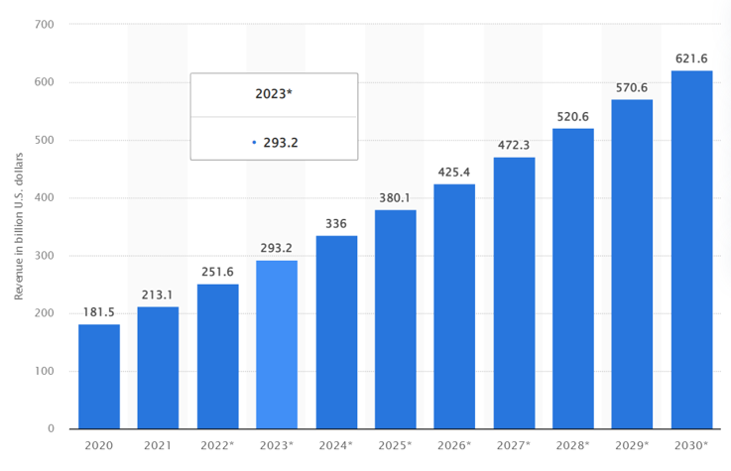

- Worldwide annual revenue of Internet of Things from 2020-2030
According to Statista, the global revenue from the Internet of Things (IoT) is projected to reach approximately 1.6 trillion U.S. dollars in 2025, up from about 389 billion U.S. dollars in 2020 (as shown in Fig.1). This indicates a significant growth in the market as more and more businesses and industries adopt IoT solutions to improve their operations and increase efficiency. It is important to note that revenue from IoT can be generated through various sources, such as hardware sales, software and services, connectivity, and data analytics. The revenue streams may vary depending on the type of industry or application of IoT technology. For example, in the industrial sector, revenue may come primarily from the sale of IoT devices and sensors, while in the healthcare sector, revenue may come primarily from the use of IoT solutions for remote patient monitoring and management.
In 2015, “the global IIoT market is estimated to be worth $151 billion, with predictions for exponential growth over the next decade and in 2017, the IIoT market reaches $170 billion, with growth projected to continue at a compound annual rate of 24.3% over the next five years. The global IIoT (Industrial Internet of Things) market size was valued at USD 77.3 billion in 2020, and it is expected to reach USD 110.6 billion by 2025, growing at a Compound Annual Growth Rate (CAGR) of 7.4% during the forecast period” [10]. The revenue generated from IIoT varies greatly across industries and companies. Some companies may generate millions of dollars from IIoT solutions, while others may generate only a fraction of that amount. This revenue from various domains such as Mining and quarrying, Information and communication, transportation and storage, Manufacturing, Agriculture, Forestry, fishing, water supply, waste management, retail and whole sale, finance and insurance, administrative, electricity, gas, education, health, entertainment and much more.

THE INTERNET OF THINGS VS INDUSTRIAL IOT
Consumer items and how they work together to provide customers with a connected experience are at the heart of the Internet of Things (IoT). Industrial IoT is connected to machinery. Similar to IoT, IIoT emphasize on how hardware and software are networked in a business setting and how technology is used to supply goods and services (Fig. 2) [4].
There is no need to be concerned about potentially fatal events because IoT focuses on generic applications ranging from wearables to robotics and machines and its deployment begins at a small-scale level. IoT deals with small scale networks and offers easy off-site programming. IoT handles very high volume of data and mostly having short product life cycle. IoT requires identity and privacy and moderate requirements. IIoT. IIoT is reliable and having long life cycles based on domain. IIoT uses critical equipment and devices connected over a network which will cause a life-threatening or other emergency situation on failure therefore uses more sensitive and precise sensors with a large-scale network. IIoT facilitates remote on-site programming and requires stringent requirements than IoT.
IIoT makes better use of the data that industrial machines have been creating for years, by utilizing the capabilities of intelligent machines and in-the-moment analysis, The IIoT's primary driver is smart machines for two reasons. The first is that intelligent robots can gather and analyze data in real-time, unlike humans. The second is that smart devices swiftly and clearly convey their findings, enabling business decisions to be made more quickly and accurately. Industrial IoT is a broad enough a term to include all forms of machinery and equipment. They consist of networked IoT sensors, gadgets, equipment, and the software that runs them. IIoT also depends on business intelligence tools including reporting, predictive, and prescriptive analytics. These solutions, which are driven by AI and machine learning, are revolutionary[5]. They make it possible to get deeper understanding and make wiser, quicker decisions, which boosts operational effectiveness on an industrial scale.

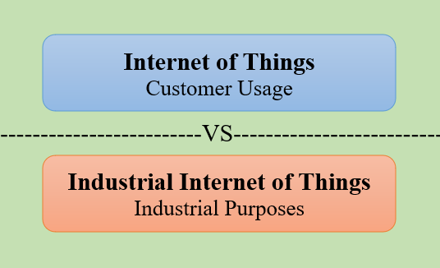
- Internet of Things versus Industrial Internet of Things
The Industrial Internet of Things is the confluence of intelligent technology that enables businesses to address pressing operational issues and solve important business concerns. Organizations can advance by utilising devices and real-time insights on company performance by integrating hardware, software, data aggregation, sophisticated predictive and prescriptive analysis, decision making, and reporting.

STRUCTURE AND COMPONENTS OF IOT/IIOT
The IoT and IIoT embedded with sensors, software, and connectivity to enable them to collect and exchange data over the internet. The components incorporated in the IoT/IIoT work together to create a connected ecosystem that enables real-time monitoring, data analysis, and control of industrial processes. Fig.3 depicts the structure and components of IoT and that can be categorize in to four levels – Perception Layer, Network Layer, Processing Layer and Application Layer and all these layers are associated with some components such as Sensors and Actuators, Connectivity devices, Cloud/Edge computing platforms, framework and applications and visualization, end products and applications.

Perception Layer
The Perception Layer is the first layer of IIoT architecture, which consists of sensors, actuators, and other devices that capture data from the physical world[6]. This layer includes a wide variety of devices such as temperature sensors, pressure sensors, and motion sensors that can collect data about the industrial environment. Sensors are devices that detect changes in the environment and convert them into electrical signals, while actuators are devices that control the physical environment by executing commands based on the input received from sensors. In IIoT, sensors and actuators are used to collect data from machines, equipment, and other devices, and to control their behavior in real-time. Some of the sensors commonly using in IoT/IIoT are the following:
- Temperature Sensors - These sensors measure the temperature of the environment or an object and transmit the data to IoT devices.
- Light Sensors - These sensors detect the presence or absence of light and measure the intensity of light in the environment.
- Proximity/Position Sensors - These sensors detect the presence or absence of an object or a person in the vicinity of the sensor.
- Force/Load/Pressure Sensors - These sensors measure the pressure of a gas or a liquid and transmit the data to IoT devices.
- Motion Sensors - These sensors detect the movement of an object or a person and transmit the data to IoT devices.
- Humidity Sensors - These sensors measure the amount of moisture in the air or in a substance.
- Sound Sensors - These sensors detect the presence or absence of sound and measure the intensity of sound in the environment.
- Chemical/Gas Sensors - These sensors detect the presence of gases and measure their concentration in the environment.
- Image Sensors - These sensors capture images or videos and transmit the data to IoT devices.
- IR Sensors - IR sensors is also termed as infrared sensors, are electronic devices that detect and measure infrared radiation. IR sensors can be found in a variety of forms, including active and passive sensors. Active sensors emit their own IR radiation and measure the reflection or absorption of that radiation. Passive sensors detect the IR radiation emitted by objects in their field of view.
- Ultrasonic Sensors - Ultrasonic sensors are electronic devices that use high-frequency sound waves to detect the presence of objects and measure distances. Ultrasonic sensors are popular in industrial applications because they are resistant to environmental factors such as dust, smoke, and temperature changes.
- Soil Moisture Sensors - Soil moisture sensors are devices used to measure the amount of water content in soil. They are commonly used in agriculture, gardening, and landscaping to ensure that plants receive the appropriate amount of water.
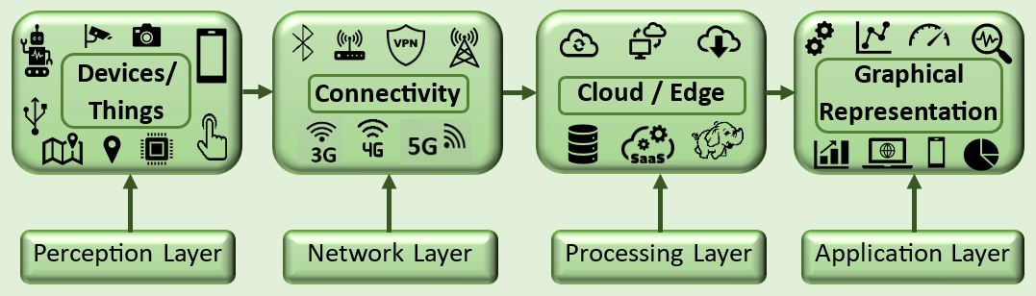
- Flex Sensors - Flex sensors are devices that can detect changes in the curvature or bending of a material. They are typically made of a flexible material such as a polymer or a thin metal foil, which changes its resistance as it is bent.

- Components of IoT/IIoT

Network Layer
The Network Layer is responsible for transmitting the data collected by the sensors and devices in the Perception Layer to the Processing Layer. This layer includes wired and wireless networks, such as Ethernet, Wi-Fi, VPN, Edge Gateway, CDMA, GSM, Satellite, Cellular Networks, Bluetooth, or other wireless protocols, that facilitate data transfer between devices. IoT devices need to be connected to the internet to transmit data[3].
- Wi-Fi: Wi-Fi stands for Wireless Fidelity, it is a technology that uses radio waves to provide wireless high-speed Internet and network connections to devices such as laptops, smartphones, and tablets. Wi-Fi uses a wireless access point or router to create a Local Area Network (LAN) that allows devices to communicate with each other and access the Internet.
- Virtual Private Network (VPN): VPN is a secure and encrypted network connection that allows users to access resources on a remote network as if they were directly connected to that network. VPNs are commonly used to provide remote access to corporate networks, protect online privacy, and bypass geographical restrictions on Internet content.
- Edge Gateway: An edge gateway is a device that provides connectivity and security between different networks. It is typically located at the boundary between a private network and a public network such as the Internet. An edge gateway can be used to route traffic, provide firewall protection, and manage access control.
- CDMA: Code Division Multiple Access (CDMA) is a wireless communication technology that allows multiple users to share the same frequency band by assigning each user a unique code. CDMA is used in some cellular networks to provide voice and data services.
- GSM: Global System for Mobile Communications (GSM) is a cellular network technology that uses digital modulation to provide voice and data services to mobile devices. GSM is the most widely used cellular network technology in the world.
- Satellite: A satellite is an artificial object that is placed in orbit around the Earth to provide communication, navigation, and other services. Satellites can be used to provide wireless connectivity to remote areas where other communication technologies are not available or feasible.
- Cellular Networks: Cellular networks are a type of wireless network that uses cellular technology to provide voice and data services to mobile devices. Cellular networks are made up of a series of interconnected cells that provide coverage over a geographic area.
- Bluetooth: Bluetooth is a wireless technology that allows devices to communicate with each other over short distances. It is commonly used for connecting devices such as smartphones, laptops, and headphones to other devices such as speakers or printers.

Processing Layer
The Processing Layer is where data collected by the sensors is processed and analyzed to generate insights and support decision-making. This layer includes data processing and storage systems, such as cloud servers and edge computing devices, which can perform advanced analytics and machine learning algorithms to extract valuable information from the data[7].
The data collected by IoT devices is stored and processed in the cloud. Cloud computing enables real-time processing of data, as well as the ability to scale and store large amounts of data. Cloud computing is a model for delivering computing resources, such as servers, storage, databases, software, and networking, over the internet[8,14]. It allows users to access and use computing resources on-demand, without having to manage and maintain the underlying infrastructure. Cloud computing is typically based on a centralized architecture, where the computing resources are located in large data centers that are owned and managed by cloud providers, such as Amazon Web Services (AWS), Microsoft Azure, or Google Cloud Platform.
Edge computing devices are used to process data locally, closer to the source, rather than sending it to a centralized cloud-based system for processing. This helps to reduce latency and ensure real-time response in IIoT applications. Edge devices include gateways, routers, and other network devices that can be deployed at the edge of the network. Edge computing, on the other hand, is a model for delivering computing resources and services at the network edge, closer to where data is generated and consumed, rather than in centralized data centers. Edge computing is designed to address the challenges of latency, bandwidth, and security that arise when processing and analyzing large volumes of data in the cloud. Edge computing is typically based on a distributed architecture, where the computing resources are located on the edge of the network, such as in IoT devices, routers, or gateways.

Application Layer
The Application Layer is the top layer of IIoT architecture and is responsible for presenting the insights generated by the Processing Layer to end-users in a meaningful way. This layer includes applications, dashboards, and other user interfaces that provide visualizations and analytics tools to support industrial processes and decision-making. IoT applications and platforms provide a way to interact with IoT devices and manage the data they generate. They allow users to visualize data, control devices, and automate processes. IIoT software applications are used to monitor and control industrial processes, analyze data, and generate insights that can be used to optimize performance. IIoT applications can be used for predictive maintenance, quality control, energy management, and other industrial applications.
The cloud computing plays a key role in IoT by providing a scalable, flexible, and cost-effective infrastructure for storing, processing, and analyzing the vast amounts of data generated by IoT devices and in similar way Edge computing in IIoT by enabling real-time data processing and analysis at the edge of the network. IIoT involves connecting machines, devices, sensors, and other assets in industrial environments to collect and analyze data to improve operations, efficiency, and productivity.

SALIENT FEATURES OF IIOT
The following subsection incorporated various features and that facilitate the efficient collaboration between the components of IIoT[4,5]. IIoT includes some salient features including Connectivity, Data Collection and Analysis, Remote Monitoring and Control, Predictive Maintenance, Improved Safety and Energy Efficiency as depicted in the Fig.4.
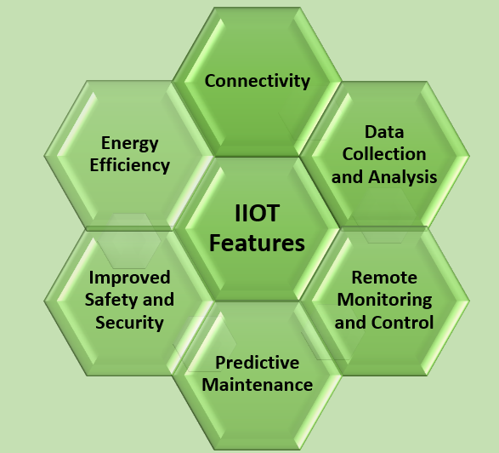

- Features of IIoT

- Connectivity: IIoT devices are connected to the internet and communicate with each other and with the cloud.
- Data Collection and Analysis: IIoT devices collect data from sensors and machines, and this data is analyzed to identify patterns and anomalies that can be used to improve productivity and efficiency.
- Remote Monitoring and Control: IIoT enables remote monitoring and control of industrial equipment, allowing operators to detect and correct issues in real-time.
- Predictive Maintenance: IIoT devices can predict when industrial equipment is likely to fail, allowing for proactive maintenance and reducing downtime.
- Energy Efficiency: IIoT can help to reduce energy consumption by monitoring energy usage and identifying areas for optimization.
- Improved Safety and Security: IIoT can improve safety in industrial settings by monitoring conditions and alerting operators to potential hazards. IoT security is critical to protect the devices and the data they generate from cyber threats. IoT security includes authentication, encryption, and access control to prevent unauthorized access and data breaches.

IIOT IN MANUFACTURING
The IIoT manufacturing approach that leverages the power of IoT technology to optimize and automate the production process in the industrial setting. It involves the use of interconnected devices, machines, sensors, and software to enable real-time data sharing, monitoring, and analysis. The IIoT manufacturing system uses data gathered from sensors and other sources to optimize and automate the production process, resulting in increased efficiency, reduced costs, and improved quality. The system can monitor production processes and equipment, predict equipment failure, and alert maintenance personnel before a breakdown occurs, reducing downtime and increasing overall productivity[9]. IIoT manufacturing is seen as a crucial aspect of Industry 4.0, the fourth industrial revolution, as it allows manufacturers to gain real-time insights into their production processes, and make data-driven decisions to improve efficiency, reduce waste, and optimize production. It is transforming the manufacturing industry, enabling companies to create smarter factories, increase productivity, and improve competitiveness in a rapidly changing market.
The IIoT can be used in a variety of industrial applications, including manufacturing, logistics, transportation, energy, and agriculture. In manufacturing, IIoT devices can monitor equipment and production lines, providing real-time data on performance and maintenance needs. This allows companies to optimize production processes and reduce downtime[11]. The Industrial Internet of Things (IIoT) is transforming the manufacturing industry by enabling real-time data collection, analysis, and decision-making. Here are some of the key roles that IIoT is playing in manufacturing:

Predictive maintenance
IIoT sensors can be placed on machines to collect data about their performance, allowing for predictive maintenance to be performed before a machine fails. This can save manufacturers a significant amount of money on repair costs and downtime. IIoT sensors collect data such as temperature, vibration, and other performance metrics of machinery, which is then analyzed using machine learning algorithms and predictive analytics to identify patterns and anomalies in the data. This analysis allows for the prediction of when maintenance will be needed, enabling maintenance teams to schedule repairs during periods of planned downtime, reducing downtime, and minimizing the risk of unplanned downtime[12]. Predictive maintenance in IIoT also enables companies to move from reactive maintenance, where equipment is only fixed after a failure has occurred, to proactive maintenance, where repairs are made before equipment failure. This can lead to increased productivity, improved safety, and cost savings by reducing the need for emergency repairs and minimizing the impact of equipment downtime.

Quality control
IIoT sensors can be used to monitor the production process in real-time, allowing for quality issues to be detected and addressed before products leave the factory floor. IIoT systems generate massive amounts of data, making it essential to implement effective quality control measures to ensure that the data is reliable and accurate. Here are some steps that can help achieve quality control in IIoT:
- Define quality control metrics: Establish metrics that define the quality of data generated by IIoT systems. Some of these metrics can include accuracy, completeness, consistency, and timeliness.
- Implement data validation: Implement data validation techniques to ensure that data generated by IIoT systems meets the defined quality control metrics. Techniques such as data filtering, outlier detection, and statistical analysis can help identify and eliminate data anomalies.
- Implement real-time monitoring: Real-time monitoring of IIoT systems can help detect and correct quality issues as they arise. Alert mechanisms can be put in place to notify relevant personnel when quality issues are detected.
- Use predictive analytics: Predictive analytics can help identify potential quality issues before they occur. By analyzing historical data, predictive analytics can identify patterns that indicate the likelihood of quality issues and help prevent them from happening.
- Conduct regular audits: Regular audits of IIoT systems can help identify quality control gaps and ensure that quality control measures are being followed. Audits can also help identify areas for improvement and help ensure that IIoT systems are delivering the desired outcomes.

Supply Chain Optimization
IIoT can be used to track materials and products throughout the supply chain, enabling manufacturers to optimize their processes and reduce costs. Supply chain optimization in IIoT involves using the power of connected devices and data analytics to improve efficiency, reduce costs, and increase visibility across the supply chain[13]. IIoT enables the integration of physical and digital systems, resulting in real-time monitoring, data collection, and analysis to optimize the supply chain. Here are some ways in which IIoT can be used to optimize the supply chain:
- Real-time tracking: IIoT devices can be used to track the movement of goods and materials in real-time, allowing businesses to quickly respond to any issues or delays that may arise.
- Predictive maintenance: IIoT devices can monitor the health of machinery and equipment in real-time, allowing businesses to schedule maintenance and repairs before equipment fails, reducing downtime and maintenance costs.
- Demand forecasting: By analyzing customer data and market trends, IIoT can help businesses accurately forecast demand, enabling better planning and inventory management.
- Quality control: IIoT sensors can monitor production processes in real-time, enabling businesses to quickly identify and correct quality issues.
- Optimization of transportation: IIoT can optimize transportation routes and delivery schedules, reducing costs and improving delivery times.
- Collaboration and communication: IIoT enable real-time communication and collaboration between different stakeholders in the supply chain, enabling faster decision-making and problem-solving.

Energy Management
IIoT sensors can be used to monitor energy usage in real-time, allowing manufacturers to identify areas of inefficiency and make improvements to reduce energy consumption and costs.

Process Automation
IIoT can be used to automate repetitive or dangerous tasks, such as machine calibration or material handling, freeing up workers to focus on more complex tasks.

IIOT MANUFATURERS AND PLATFORMS
KUKA Robotics is a German manufacturer of industrial robots and automation solutions. They offer a wide range of robots for various industries, including automotive, aerospace, healthcare, and more. KUKA Robotics is also involved in the Industrial Internet of Things (IIoT) by integrating their robots with various software and communication technologies to enhance the performance and efficiency of their machines. IIoT is the use of connected devices and sensors in industrial settings to gather and analyze data in real-time, enabling better decision-making and optimization of processes. KUKA Robotics has incorporated IIoT capabilities into their machines by adding sensors and communication devices to monitor and analyze data from the robots. This data can then be used to optimize the robot's performance, predict maintenance needs, and improve safety.
KUKA Robotics also offers cloud-based solutions that allow customers to monitor and control their robots remotely. The cloud-based system collects data from the robots, such as machine status, production rates, and energy consumption, to provide insights and analysis that help optimize performance and reduce downtime. KUKA Robotics' integration of IIoT technologies allows them to offer advanced solutions to their customers, improving the performance, safety, and efficiency of their machines. There are many leading companies that are utilizing the Industrial Internet of Things (IIoT) in manufacturing. Here are some examples:
- General Electric (GE) - GE has been a pioneer in the IIoT space for many years. The company has created a suite of IIoT solutions, called Predix, which is specifically designed for the industrial sector. These solutions include predictive maintenance, asset performance management, and operational optimization.
- Siemens - Siemens is another leading company in the IIoT space. The company has developed a platform, called MindSphere, which provides a wide range of IIoT solutions for manufacturing. These solutions include predictive maintenance, energy management, and production optimization.
- IBM - IBM has developed an IIoT platform, called Watson IoT, which provides a range of solutions for manufacturing. These solutions include predictive maintenance, quality control, and supply chain optimization.
- Schneider Electric - Schneider Electric is a leading provider of IIoT solutions for manufacturing. The company's EcoStruxure platform provides a range of solutions for energy management, automation, and safety.
- Honeywell - Honeywell has developed an IIoT platform, called Honeywell Forge, which provides a range of solutions for manufacturing. These solutions include predictive maintenance, asset optimization, and safety management.
- Cisco - Cisco has developed an IIoT platform, called Cisco Kinetic, which provides a range of solutions for manufacturing. These solutions include asset tracking, predictive maintenance, and safety management.
These are just a few examples of the leading companies that are utilizing IIoT in manufacturing. There are many other companies that are also leveraging the power of IIoT to improve their manufacturing processes and drive operational efficiency.

CONCLUSION
The Industrial Internet of Things has revolutionized the manufacturing industry by incorporating advanced technologies to improve efficiency, productivity, and decision-making processes. IIoT refers to the integration of smart devices, sensors, software, and analytics in industrial settings to create a connected ecosystem that enhances automation and data-driven operations. IIoT facilitates the seamless connection of machines, equipment, and processes in the manufacturing environment. IIoT enables predictive maintenance, where equipment health is continuously monitored through sensors. By analyzing data patterns, manufacturers can predict potential failures and perform maintenance proactively, reducing downtime and minimizing unplanned disruptions. IIoT optimizes production processes, enabling manufacturers to identify bottlenecks and inefficiencies and IIoT facilitates stringent quality control measures by monitoring production parameters and identifying defects early in the process. IIoT enables better visibility and traceability across the supply chain and IIoT can improve workplace safety by monitoring and analyzing data from wearable devices or sensors to detect potential hazards, ensuring a safer working environment for employees. Manufacturers can create digital twins of physical assets or processes using IIoT data and IIoT leverages cloud computing and edge computing to process and store massive amounts of data. Integrating AI and machine learning algorithms with IIoT data enables advanced analytics and predictive capabilities. IIoT enables remote monitoring and control of manufacturing processes. IIoT in manufacturing offers immense potential to transform traditional industrial processes into intelligent, data-driven operations. It empowers manufacturers to optimize efficiency, reduce costs, improve quality, and maintain a competitive edge in the fast-evolving global market. However, implementing IIoT requires careful planning, data security measures, and a willingness to adapt to emerging technologies.

References
- Onu Petera, Anup Pradhana, Charles Mbohwa, “Industrial internet of things (IIoT): opportunities, challenges, and requirements in manufacturing businesses in emerging economies”, Procedia Computer Science, 217 (2023), pp. 856–865.
- Sameer Mittal, Muztoba Ahmad Khan, David Romero and Thorsten Wuest, “Smart manufacturing: Characteristics, technologies and enabling factors”, Journal of Engineering Manufacture 2019, Vol. 233(5), pp. 1342–1361.
- Rakshith Badarinath and Vittaldas V. Prabhu, “Advances in Internet of Things (IoT) in Manufacturing”, International Federation for Information Processing, 2017, pp. 111–118.
- Andrew Kusiak, “Smart manufacturing”, International Journal of Production Research, 56:1-2, pp. 508-517, 2018.
- Kevin Shen Hoong Ong, Wenbo Wang, Nguyen Quang Hieu, Dusit Niyato, and Thomas Friedrichs, “Predictive Maintenance Model for IIoT-Based Manufacturing: A Transferable Deep Reinforcement Learning Approach”, 2022, IEEE Internet of Things Journal, VOL. 9, NO. 17, pp. 15725 – 15741.
- Mohd Javaid, Abid Haleem, Ravi Pratap Singh, Shanay Rab, Rajiv Suman, “Upgrading the manufacturing sector via applications of Industrial Internet of Things”, Sensors International, 2021
- Zheng, P., wang, H., Sang, Z. et al. “Smart manufacturing systems for Industry 4.0: Conceptual framework, scenarios, and future perspectives”, Frontiers of Mechanical Engineering, 13, pp.137–150, 2018.
- Jan Zenisek, Norbert Wild, Josef Wolfartsberger, “Investigating the Potential of Smart Manufacturing Technologies”, Procedia Computer Science, 180, pp. 507-516, 2021.
- Morteza Ghobakhloo, “Determinants of information and digital technology implementation for smart manufacturing”, International Journal of Production Research, 58:8, pp. 2384-2405, 2020.
- https://www.statista.com
- Jiafu Wan, Baotong Chen, Muhammad Imran, Fei Tao, Di Li, and Chengliang Liu, and Shafiq Ahmad, “Toward Dynamic Resources Management for IoT-Based Manufacturing”, IEEE Communications Magazine, pp.52-59 2018.
- Peng Zhan, Shaokun Wang, Jun Wang, Leigang Qu, Kun Wang, Yupeng Hu, and Xueqing Li, “Temporal anomaly detection on IIoT-enabled manufacturing”, Journal of Intelligent Manufacturing (2021) 32:1669–1678.
- Tahera Kalsoom, Shehzad Ahmed, Piyya Muhammad Rafi-ul-Shan, Muhammad Azmat, Pervaiz Akhtar, Zeeshan Pervez, Muhammad Ali Imran and Masood Ur-Rehman, “Impact of IoT on Manufacturing Industry 4.0: A New Triangular Systematic Review”, Sustainability 2021, 13, 12506, pp. 1-22.
- Patricia Deflorin, Maike Scherrer, Katrin Schillo, “The influence of IIoT on manufacturing network coordination”, Journal of Manufacturing Technology Management Vol. 32 No. 6, 2021, pp. 1144-1166.

