X RAY PRODUCTION IN DIAGNOSTIC RADIOLOGY
AUTHORS
1* PREETHI.B, DEPARTMENT OF RADIO DIAGNOSIS
SRM MEDICAL COLLEGE HOSPITAL AND RESEARCH CENTRE
MAHATMA GANDHI RD, POTHERI, SRM NAGAR, KATTANKULATHUR, TAMIL NADU 603211, INDIA.
preethibaskar2406@gmail.com
2*VIGNESH. K, DEPARTMENT OF RADIOLOGY AND IMAGING TECHNOLOGY
SCHOOL OF ALLIED HEALTH SCIENCES, VINAYAKA MISSIONS RESEARCH FOUNDATION -DU, CHENNAI, TAMILNADU, INDIA
Vigneshmphy9@gmail.com

Abstract
Electromagnetic waves with wavelengths of 0.01 to 10 nanometers are referred to as X-rays. X-rays have been used to image biological tissues and assist in the diagnosis of disease for a very long time in the field of diagnostic radiology. Simply put, X-rays are created when electrons are accelerated by a potential difference, which results in electromagnetic radiation. The fundamental parts of an X-ray production system consist of a generator and an X-ray tube, each of which parts is enclosed in a vacuum.
I. INTRODUCTION
Roentgen made the discovery of X-rays in 1895 while researching cathode rays, or the electron stream, in a gas discharge tube. This radiation has the ability to ionize a gas, cause fluorescence, irradiate opaque materials, and blacken photographic plates. He gave the new radiation a name such as "x-rays." Following this important discovery, x-rays' nature underwent significant research, and its many other characteristics were revealed. When they were identified as a type of electromagnetic radiation, our knowledge of their nature was significantly improved.
Medical imaging processes in medical diagnostic require the energy utilised to make the figure to be able to travel through tissues. Outside of the radiology department. In all medical specialities, direct visual observation, which also uses visible light, is a common practise. In addition to X-rays, certain diagnostic radiology treatments also use electromagnetic spectrum wavelengths outside of the visible light zone.
II. PRODUCTION OF X RAY
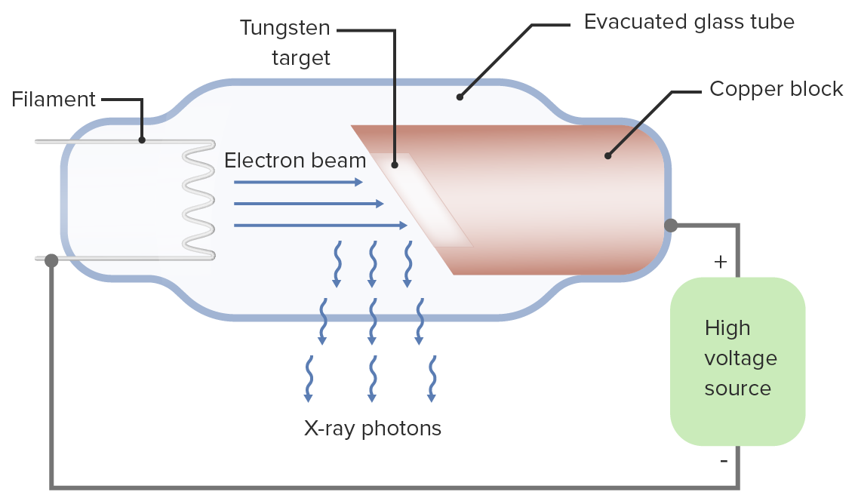
The glass material of a conventional X-ray tube is filled with high vacuum. A cathode (negative electrode) and a positive electrode, both sealed in the tube, are located at either end. Thermionic emission occurs when heat emits an electron from the tungsten plate that serves as the cathode. When extremely energetic electrons contact with materials, they turn their kinetic energy into electromagnetic radiation, producing X-rays.

Figure:1 X Ray Production

An evacuated route vacuum for electron acceleration and an electron source makes up the equipment that brings out the above task. Outside supply of energy to speed up that electron
X-Ray Tube
Cathode:
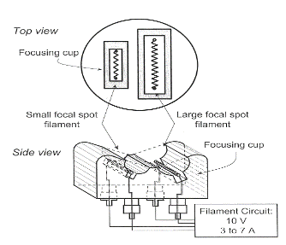
1. A focusing cup surrounds a helical coil of tungsten wire that serves as the cathode.
2. The filament circuits supply a voltage of up to 10 V and up to 7 A of current to the filament.
3. The filaments are heated by electron resistance, which releases electrons.
4.When a positive voltage is given to the anode relative to the cathode, an electron released from the filament flows through the tube's vacuum to the anode.
Focusing cup
Shapes the electron beam's width and surrounds the filaments.
It is possible to bias an insulated focusing cup with a greater negative voltage (about 100V less) than the filament. intensify the electric field surrounding the filament.
1. Limits the beam's spread
2. Produces a narrow focal spot width
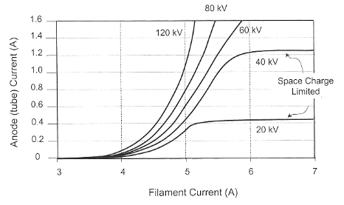
Filament Current
The rate of thermionic electron emission is dependent on filament temperature, which is determined by filament current. A space charge cloud forms around the filament when no voltage is provided between the cathode and the anode.
The electron is accelerated toward the target by the cathode-to-anode voltage, which results in tube current. Relatively substantial changes in tube current can result from small changes in the filament current.
Figure: 2 Filament Current
- The need that the anode have a high atomic number and high melting point is the basis for selecting tungsten as the target material in conventional x-ray tubes.
- Because the atomic number affects the effectiveness of x-ray generation, (W) with Z = 74 makes a good material. which has a melting point of 3,370°C.
- A metal target electrode known as the anode is kept at a positive potential differential with respect to the cathode.
Rotating anode:
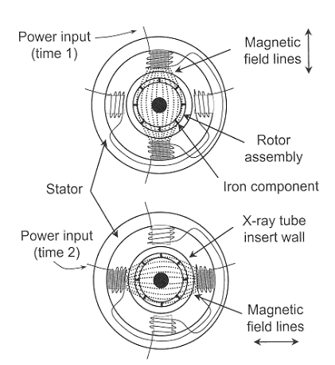
1.Rotating target are used in radio diagnostic radiation energy procedures most frequently.
2. Increased heat loading results in higher -production capabilities
3. nagative e- energy to a revolving object, dispersing heat energy over a sizable area and mass.
Rotor:
The iron core of the rotor's cylindrical shell is surrounded by copper bars. Electromagnets that surround the rotor outside of the x-ray tube make up the stator.
Alternating electricity that travels through the stator windings turns the rotor. Low speed rotation occurs between 3,000 and 3,600 rpm, and high speed rotation occurs between 9,000 and 10,000 rpm.
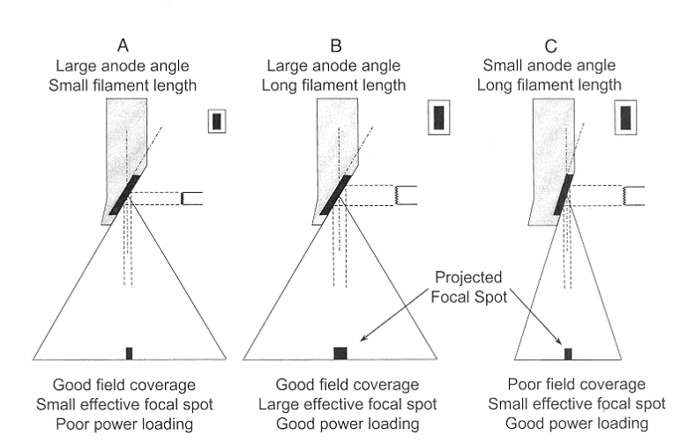
Focal spot size
Actual focal spot width and effective focal spot width are equivalent.
Actual focal length times sine of effective focal length
The line focus principle describes the foreshortening of the focal spot length when seen down the center ray.
Figure:3 Focal Spot Size
Anode angle
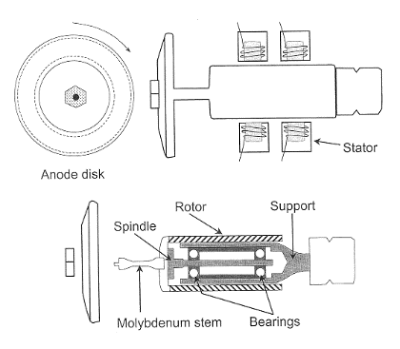
There is a suitable target angle that depends on the clinical imaging application. A modest anode angle is preferred for small field-of-view image receptors, such as those found in cineangiographic and neuroangiographic equipment, whose field coverage is limited by the diameter of the image intensifier. High anode angles are necessary for standard radiography operations in order to achieve large field area coverage at close focal spot-to-image distances.
Effective focused spot length varies with picture plane position in the anode-cathode direction.Position in the picture plane has no discernible effect on the focus point size in the breadth dimension. Specified nominal size at the beam's center ray
Heel effect
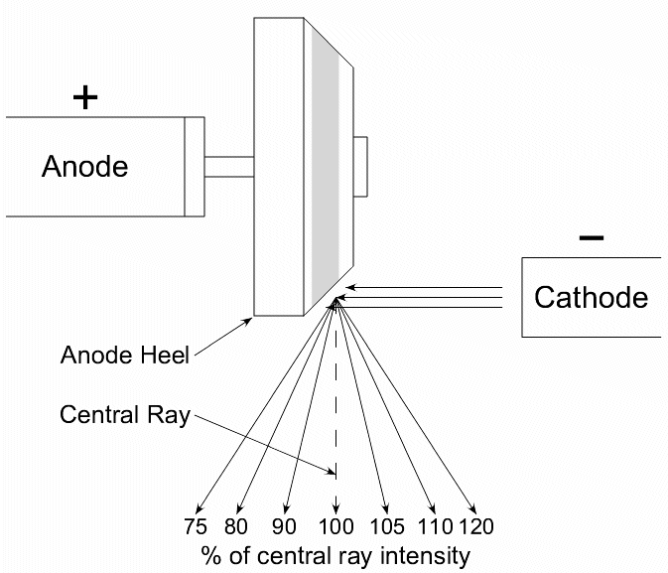
The x-rays experience various degrees of absorbance in the target because they are produced at numerous depths within the target. X-rays that reach deeper inside a target are attenuated more than those that come from the target's surface. As a result, the x-ray beam's intensity diminishes as it moves from the electron source to the anode. The heel effect refers to this change in the x-ray beam. Because of the low energy of x-rays and steep target angles in diagnostic tubes, the effect is particularly obvious. By applying a compensating filter to offer varied reduction across the beam in order to account for the heel effect while improving uniformity, the issue can be reduced to a minimum.

Figure:4 Heel Effect
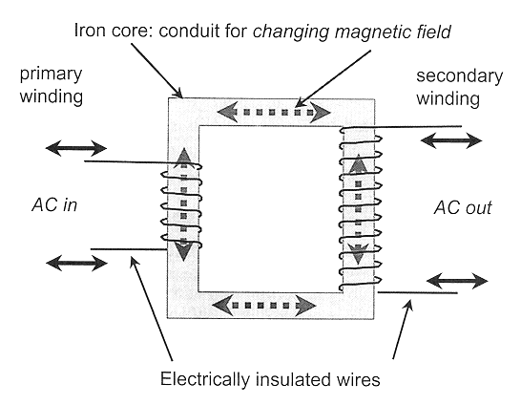
III. Transformers
Utilize electromagnetic induction principles to perform the process of "transforming" opposing input voltage into switching output voltage. Two unique in that electrically isolated wires are wrapped around a single iron core in a generic transformer.

Figure:5 Transformer

Law of Transformers

The ratio of the primary voltage to the secondary voltage is equal to the ratio of the number of coils turns in the primary winding to the number of coil turns in the secondary winding.
VP/VS equals NP/NS
1.Depending on how many turns each coil has, a transformer can isolate a voltage or modify it.
2.A "step-up" that raises the secondary voltage is NS > NP.
3.NS NP: used to "step-down" the secondary voltage
4.Primary voltage and secondary voltage of a "isolation" transformer are equal.

Autotransformer
consists of a single coil of wire wound around an iron core. The Transformers Law continues to apply. operates under the assumption of self-induction rather than mutual induction. The primary circuit and secondary circuit are electrically separated by secondary voltage, which rises or changes gradation more gradually than with traditional transformers.
Diodes
electrical gadgets with two terminals that only allow current to flow in one direction One example of a diode is the x-ray tube itself. A solid-state diode's semiconductor material crystal is "doped" with traces of impurity elements. Conductivity increased when voltage was applied in one direction, but it plummeted to extremely low levels when voltage was applied in the opposite direction.
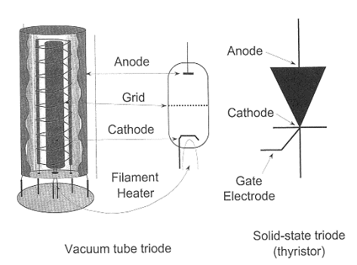
Triodes
A triode is a three-electrode electrical amplifiers vacuum tube (valve) made out of a heated material, a grid and a plate inside an evacuated glass envelope.
The triode valve, sometimes known as the trident vacuum tube, has a number of different functions in electronic circuit designs, including rectifier and amplifier.

Operator Console
The operator sets the focused spot size, exposure duration, kVp, and mA . Peak kilovoltage (kVp) regulates the x-ray beam's quality (penetrability), which affects subject contrast. The x-ray flux is determined by tube current (mA). The mA setting is typically used to determine the focus spot size. Some generators allow the use of preprogrammed processes.
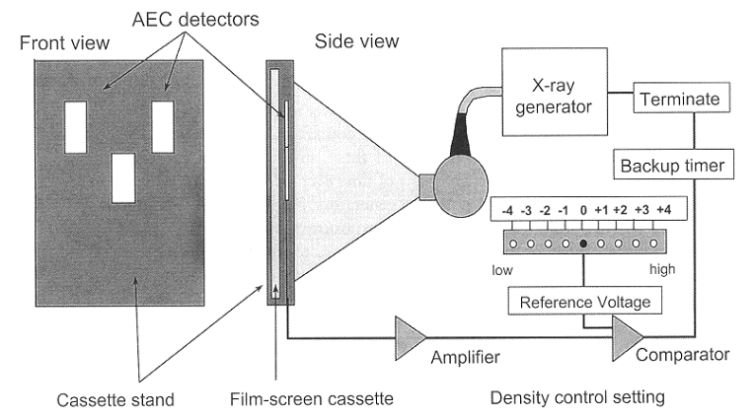
Timing the x-ray exposure
Electronic timers have mostly been supplanted by digital timers because of their superior repeatability and microsecond accuracy. Only single-phase, low-power generators use mechanical switches. employed in three-phase and constant potential circuits are high voltage switches. The initial side of the high-voltage is electrically switched by the higher -frequency inverter.
Photo timers
Check the radiation's actual impact on the image receptor. Stop the x-ray operation after an exact amount has been created. provides a continuous exposure to the image receptor while accounting for patient-specific differences in attenuation and thickness.
Generator for Falling Load
When combined with the photo timing (AEC) subsystem, it provides the highest mA for the chosen kVp while taking into account the characteristics of the instantaneous heat load on the x-ray tube. By gradually lowering the wattage as exposure duration increases, the image receptor (IR) receives the necessary dose of radiation in the shortest amount of time possible.Factors affecting x-ray emission
An x-ray tube's output is described by its quality, quantity, and exposure. An x-ray beam's penetrability is characterized by quality The quantity of the beam's photons is referred to as its size. Since exposure is nearly proportional to the x-ray beam's energy fluence, it possesses features related to both quality and quantity.

Target (anode) material
The energy of the distinctive x-rays are influenced by the target material. Characteristic radiation and bremsstrahlung radiation are influenced by the target material in terms of amount and quality.
Tube voltage (kVp)
determines the bremsstrahlung spectrum's maximum energy and has an impact on the output spectrum's quality
Tube voltage has a direct impact on how well x-rays are produced. exposure that is normally in the diagnostic range equal to the cube of the kVp
$$\text{Exposure}∝\text{kV}{\text{p}}^{2}$$

To maintain the same exposure, increases in kVp must be balanced off by equal variations in mAs.
The patient's x-ray attenuation characteristics are another factor in procedure modification.
The mAs fluctuates with the fifth power of the kVp ratio in order to ensure equal transmitted exposure across a typical patient:

The rate at which electrons move from the cathode to the anode is known as tube current. The relationship between the beam's exposure and tube current for a given kVp and filtration is linear.

Exposure
The traditional unit rad or the SI unit grey (Gy) are used to measure the radiation dose that a person absorbs, or the quantity of energy that radiation deposits in human tissue. The exposure period is the length of time that x-rays are produced. The relationship between exposure time (mAs) and the amount of x-rays produced is straightforward.
The beam optimizer
Beam filtering alters the quantity and quality of the x-ray beam by removing only high-energy photons from the spectrum. An increase in average energy and a decrease in photon number (quantity) improve the quality.

waveform of the power source
For the same kVp, the average potential difference between a three-phase or high-frequency generator and a single-phase generator is smaller. The kVp ratio affects both the amount of x-rays produced and the quality of the x-ray spectra.

References
[1] Diagnostic Radiology Physics: A Handbook for Teachers and Students
[2] J.T. Bushberg, J.A. Seibert, E.M. Leidtholdt, J.M. Boone, 3rd edn. (Lippincott Williams &
Wilkins, 2011)
[3] W.R. Hendee, E.R. Ritenour, Medical Imaging Physics, 4 edn. (Wiley, New York, NY, USA,
2002)
[4] IAEA. (2010). Clinical Training of Medical Physicists Specializing in Diagnostic Radiology.
Training Course Series, 47, International Atomic Energy Agency
[5] Core Curriculum for medical physicists in Radiology, Recommendations from am EFOMP/ESR working group, 2011
[6] International Commission on Radiological Protection,
the 2007 Recommendations of the international commission on Radiological
Protection, ICRP Publication 103, Elsevier (2008)
[7] United nations, sources and effects of ionizing Radiation, Report 2000, Vol.
1: Sources, Scientific Committee on the Effects of Atomic Radiation (UNSCEAR),un, new York (2000)
[8] H. Jones, J. Cunningham, The Physics of Radiology, Fourth Edition (C. Thomas, 1983)

