ANALYTICAL VIEW OF SHIFTING AGE STRUCTURE OF INDIA AND ITS ECONOMIC GROWTH WITH THE HELP OF MIXED METHODS RESEARCH

Dr. Jyoti Badge
Assistant Professor.
VIT University, Bhopal
badge.jyoti@gmail.com

Dr. Priya Dwivedi
Associate Professor
IPER, Bhopal
Priyadwivedi4@gmail.com

Abstract- In the context of structural changes of different countries the two macroeconomic variables like age structure and economic growth are widely discussed terms with respect to there role in furtherance of development process. The present paper tries to analyze the upshots of shifting age structure of India especially working age population on its economic growth by mixed method research. In general, mixed methods research represents research that involves collecting, analyzing, and interpreting quantitative and qualitative data in a single study or in a series of studies that investigate the same underlying phenomenon. Sequential Mixed method design is chosen to gain better insight about the subject matter of the paper. For this attempt major Quantitative analysis- correlation, regression and ANOVA is performed followed by minor qualitative analysis with the help of questionnaire is done to confirm the findings and its validity.

Key words: Working Age Population, Gross Domestic Product, Mixed Method Research

- Introduction

There is a debate about population and its growth which is a very important macroeconomic variable. That may play a very significant role for the development and growth of the country. For the sake of analyzing contribution in the growth of the country, it has to be divided into two categories viz. the dependent population and working age population. Population ages 15-64 is considered as working age population as per the definition of World Bank^{4.} In recent times India is labeled as one of the youngest nations of the world because of increasing size of persons in the working age cohort. Among the range of other macroeconomic factors working age population is one factor that works towards the growth performance of the country. The present paper attempts to analyze the upshots of shifting age structure of India especially working age population on its economic growth by mixed method research. In general, mixed methods research represents research that involves collecting, analyzing, and interpreting quantitative and qualitative data in a single study or in a series of studies that investigate the same underlying phenomenon. Its central premise is that the use of quantitative and qualitative approaches in combination provides a better understanding of research problems that either approach alone². Using Mixed Methods for analyzing economic phenomenon especially variables like population and its linkage with economic growth of a country Further, with the help of qualitative analysis tries to follow up the quantitative analysis.

- Literature Review
Basu et.al (2007), presented the broad macro parameters of the growth of the Indian economy since the nation’s independence and a cross-country evaluation of where India stands, drawing out the patterns discernible in these aggregative statistics. The paper presented an overview of the on-going debate on the components of the Indian growth and the relative importance of the different policies in the 1980s and 1990s.
Agarwal (2014), highlighted some measures to control population explosion so that economic development may not be hindered. Correlation between population growth and economic development could be favorable only when increasing population is proportionate to resources available in country and resources are to be exploited in its full capacity, in effective and efficient manner by the skillful, talented human resources in the countries like India.
Koduru (2016) found the effects of rapid population growth on economic development in India. This paper analyzed the impact of population growth rate on economic development in India by doing the regression analysis of different variables which act as indicators for economic development and the population growth. He found that the relationship between these variables may help the government to consider the effect of population growth on their policies in future.
Peterson (2017), article drawn on historical data to chart the links between population growth, growth in per capita output, and overall economic growth over the past 200 years. Low population growth in high-income countries is likely to create social and economic problems while high population growth in low-income countries may slow their development. International migration could help to adjust these imbalances but is opposed by many. Drawing on economic analyses of inequality, it appears that lower population growth and limited migration may contribute to increased national and global economic inequality.
Kamarudin et.al (2018) examined the effects of population growth on the economic development between the two developed and developing countries. The high population growth creates pressures on limited natural resources, reduces private and public capital formation, and diverts additions to capital resources to maintaining rather than increasing the stock of capital per worker. The positive effects such as economies of scale and specialization, the possible spur to favorable motivation caused by increased dependency. Much of the motivation for human capital policies in developing countries is the possibility of providing economic growth that will raise the levels of incomes in these countries. The focus on alleviating poverty in developing countries relates directly to economic growth because of the realization that simply redistributing incomes and resources will not lead to long run solutions to poverty.
Johnson (2007), With the help of this article author observe the way the approach of mixed approaches is being described and used presently. The authors questioned many of today's experts in mixed research methods how they describe mixed research methods. The writers present the meanings of the members and address the material contained while they were looking for demarcation criteria. The authors have an up-to - date response to the question: What are mixed testing methods? They also briefly summarize the recent history of mixed methods and list a number of issues that need further work as the field continues to move forward. They claim that study using mixed methods is one of three main "analysis paradigms" (quantitative research, qualitative research, and research using mixed methods).
Isabel Leal (2016), Their methodological goal was to investigate variations in clinical results between the diagnosis community and the control group using qualitative data and to clarify incorrect observations within data sets. Using both techniques of data transformation — qualifying and quantizing — within an embedded experimental design comparing and integrating data between data sets and treatment groups allowed us to develop this innovative evaluative approach. Findings explain consistency and differentiation between data sets, investigate the dynamic understanding of cancer among participants and catch aspects and elusive consequences of action through either method alone.
Julie Lucero (2016), This article describes a mixed methods study of community-based participatory research (CBPR) partnership practices and the linkages between those practices and health status changes and outcomes of disparities. This article then offers examples of how an iterative, systematic approach to the study of our mixed approaches provided enhanced understandings of two primary model constructs: confidence and governance. Implications and lessons learned are given when learning CBPR utilizing mixed approaches.

- Research Goal- The present paper aims to measure changes and thein the two variables under current study is Population ages 15-64 (% of total population) and GDP growth (annual %) Inform constituencies.
- Research Question:
What are the factors responsible for effecting age structure and economic growth of India?

- Research Design
- Mixed Methods Designs-Out of given various Mixed Methods Research Designs Sequential Design is used under the study. Under the design major quantitative study that uses qualitative data to gain insight into its findings.

QUANT qual
qual follow-up
Figure 1
- Theoretical Framework

Thomas Robert Malthus pronounced his views about population in his famous book, Essay on the Principle of Population as it affects the Future Improvement of Society, published in 1798.In his theory the relationship between the growth in food supply and in population is explained, stating that population increases faster than food supply and if unchecked leads to vice or misery. In the present context food supply may be synonyms to all the resources of the country or the necessity for living. According to the theory the pace of growth of population as well as resources of living should be matched but the population grows at the geometric progression and food supply at the arithmetic progression leaving the enlarged gap between the two and this situation ends up declaring population as a burden which supports the pessimistic view of population growth.

- Empirical Results

The data of population ages 15-64 (% of total population) and GDP growth (annual %) has been gathered from world bank. Table-1 Shows data of population ages 15-64 (% of total population) and GDP growth (annual %)
Table 1
Year | Population ages 15-64 (% of total population) | GDP growth (annual %) | Year | Population ages 15-64 (% of total population) | GDP growth (annual %) | Year | Population ages 15-64 (% of total population) | GDP growth (annual %)
1961 | 56.18 | 3.72 | 1980 | 57.14 | 6.74 | 1999 | 60.54 | 8.85
1962 | 55.81 | 2.93 | 1981 | 57.18 | 6.01 | 2000 | 60.91 | 3.84
1963 | 55.46 | 5.99 | 1982 | 57.23 | 3.48 | 2001 | 61.19 | 4.82
1964 | 55.25 | 7.45 | 1983 | 57.29 | 7.29 | 2002 | 61.5 | 3.8
1965 | 55.21 | -2.64 | 1984 | 57.39 | 3.82 | 2003 | 61.83 | 7.86
1966 | 55.09 | -0.06 | 1985 | 57.54 | 5.25 | 2004 | 62.17 | 7.92
1967 | 55.16 | 7.83 | 1986 | 57.55 | 4.78 | 2005 | 62.52 | 7.92
1968 | 55.35 | 3.39 | 1987 | 57.65 | 3.97 | 2006 | 62.81 | 8.06
1969 | 55.57 | 6.54 | 1988 | 57.82 | 9.63 | 2007 | 63.1 | 7.66
1970 | 55.78 | 5.16 | 1989 | 58.02 | 5.95 | 2008 | 63.41 | 3.09
1971 | 55.86 | 1.64 | 1990 | 58.23 | 5.53 | 2009 | 63.74 | 7.86
1972 | 55.95 | -0.55 | 1991 | 58.37 | 1.06 | 2010 | 64.11 | 8.5
1973 | 56.07 | 3.3 | 1992 | 58.55 | 5.48 | 2011 | 64.43 | 5.24
1974 | 56.23 | 1.19 | 1993 | 58.76 | 4.75 | 2012 | 64.81 | 5.46
1975 | 56.44 | 9.15 | 1994 | 59.01 | 6.66 | 2013 | 65.21 | 6.39
1976 | 56.5 | 1.66 | 1995 | 59.32 | 7.57 | 2014 | 65.6 | 7.41
1977 | 56.62 | 7.25 | 1996 | 59.57 | 7.55 | 2015 | 65.94 | 8
1978 | 56.79 | 5.71 | 1997 | 59.86 | 4.05 | 2016 | 66.27 | 8.17
1979 | 56.97 | -5.24 | 1998 | 60.19 | 6.18 | 2017 | 66.54 | 7.17
 |  |  |  |  |  | 2018 | 66.77 | 6.81

- Correlation between working age population and GDP growth
- Figure-1 shows scatter diagram of working age population and GDP growth
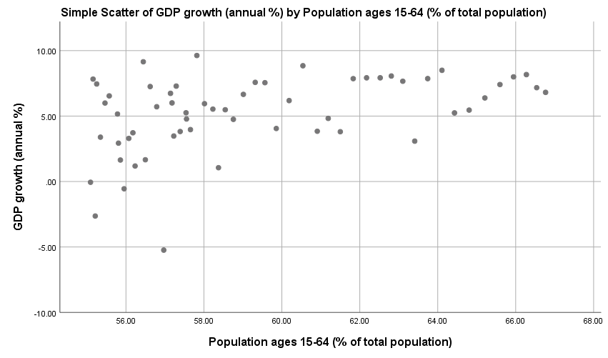
Figure 2
Table 2
Correlations
 |  | Population ages 15-64 (% of total population) | GDP growth (annual %)
Population ages 15-64 (% of total population) | Pearson Correlation | 1 | .431**
 | Sig. (2-tailed) |  | .001
 | N | 58 | 58
GDP growth (annual %) | Pearson Correlation | .431** | 1
 | Sig. (2-tailed) | .001
 | N | 58 | 58
**. Correlation is significant at the 0.01 level (2-tailed).

Table-2 shows correlation between working age population and GDP growth. Its shows that there is weak positive correlation between working age population and GDP growth
b) Regression Analysis of population ages 15-64 (% of total population) and GDP growth (annual %)
Model Summary
Model | R | R Square | Adjusted R Square | Std. Error of the Estimate
1 | .431ª | .186 | .171 | 2.67887
a. Predictors: (Constant), Population ages 15-64 (% of total population)
Figure 3

ANOVAª
Model |  | Sum of Squares | df | Mean Square | F | Sig.
1 | Regression | 91.529 | 1 | 91.529 | 12.754 | .001^{b}
 | Residual | 401.876 | 56 | 7.176
 | Total | 493.405 | 57
a. Dependent Variable: GDP growth (annual %)
b. Predictors: (Constant), Population ages 15-64 (% of total population)
Figure 4

Coefficientsª
Model |  | Unstandardized Coefficients |  | Standardized Coefficients | t | Sig.
 |  | B | Std. Error | Beta
1 | (Constant) | -15.926 | 5.942 |  | -2.680 | .010
 | Population ages 15-64 (% of total population) | .357 | .100 | .431 | 3.571 | .001
a. Dependent Variable: GDP growth (annual %)
Figure 5

- Description of Regression Model

Table 3
R | Correlation Coefficient- .431
R-Square | Coefficient of Determination is .186. It is the ratio of the explained variation to the total variation. It means 1.86% of the total variation in GDP growth can be explained by the linear relationship between working age population and GDP growth. the other 98.14% of the total variation in GDP growth remains unexplained.
Adjusted R Square | 0.171. The "adjustment" in adjusted R-squared is related to the number of variables and the number of observations. It's probably not a concern in our case, since we have a single variate.
Standard error of estimate | 2.67887. The standard error of the estimate is a measure of the accuracy of predictions. The standard error is an estimate of the standard deviation of the coefficient
ANOVA | It tells the story of how the regression equation accounts for variability in the response variable. In our case the total ANOVA model is significant at 5% level of significant.
Regression Equation | GDP Growth = -15.926+0.357(Working age population)

- Validation of Theory- The entire discussion above somewhere indicates the validation of Malthusian theory of Population growth and its impact. If this theory is to be explained in current context of India, it states that the growing population later becomes burden in its later stage because its growth rate outpaces the growth rate of resources required for living.

- Discussion on Methodological Framework-In our current study working age population’s contribution in India’s economic growth is analyzed with the help of statistical tools and the results showed insignificant relationship. Here in the present case if only quantitative analysis would have to be used, thought the quant is justifying its efforts and analysis but it is leaving many important questions unanswered. Therefore, using the mixed methods Research technique and applying Sequential Design ‘qual’ is used in order to get full justification about the research problem.
The gap, that is arising between the two variables under study ie. Working age population and economic growth may because of Employment factor. In the absence of suitable / perfect employment opportunities the gap will become even wider. In order to gain better insight about the situation Qualitative analysis is done on employability and its sustainability. Data collection is done with the help of simple questionnaire filled from 77 respondents. This Sequential Design is helping in tracing the right and complete answer of the research question.
The Details of qualitative analysis is given as under:
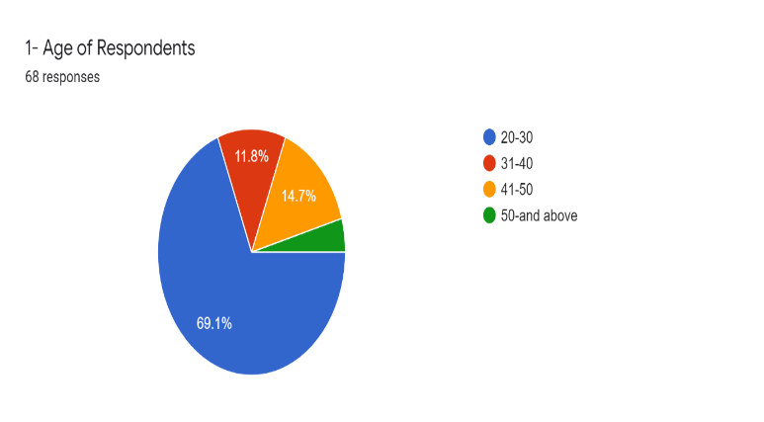
Figure 6
The above figure shows the age of respondents. The highest percentage is 69.1 which belongs to the age group of 20-30 years
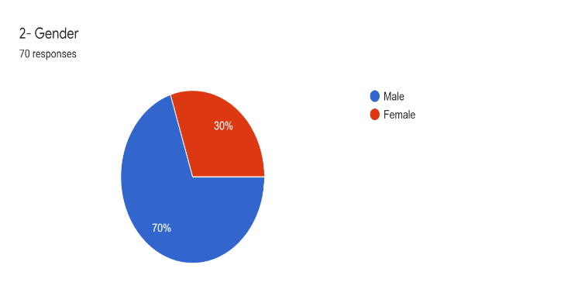
Figure 7
The above figure shows there are 70% male and 30% female respondents
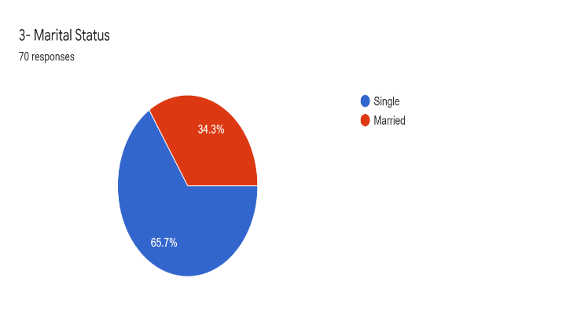
Figure 8
The above figure shows 65.7% are single and 34.3% are married respondents
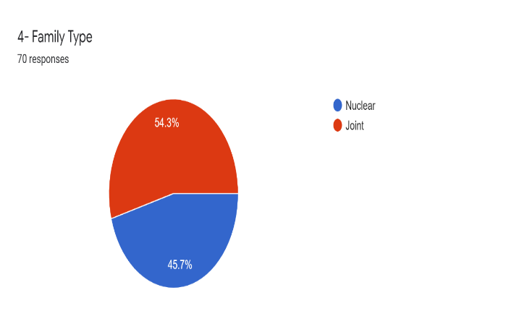
Figure 9
The above figure shows 54.3% are joint and 45.7% are nuclear family

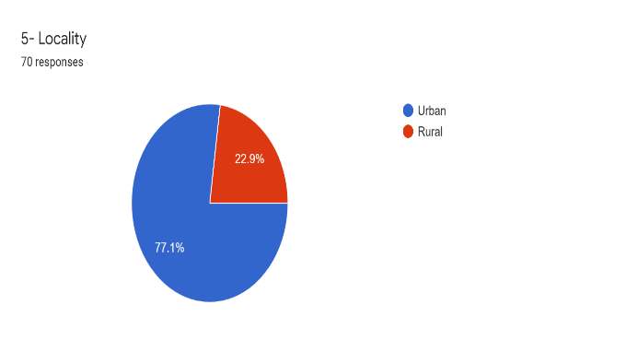
Figure 10
The above figure shows 77.1% are urban and 22.9% are rural
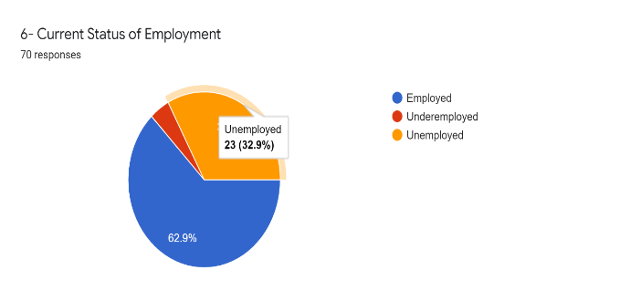
Figure 11
The above figure current status of employment. Under the survey unemployed were 32% and those employed were mainly related with non-technical field
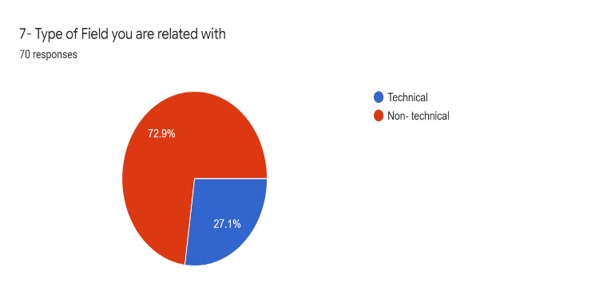
Figure 12

The above figure shows type of field. There are 72.9% are non-technical and 27.1% are related to technical field. .

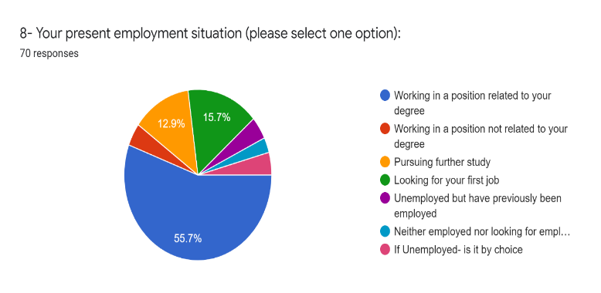
Figure 13
The above figure shows present employment situation. From the survey it is found that the respondents had the clear choice of job field as they have chosen the right course and they got their job there. But greater portion are also of unemployed persons.
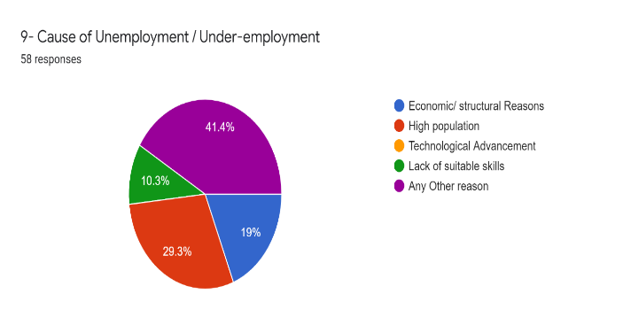
Figure 14
The above figure show cause of unemployment. With respect to unemployment major proportion don’t know the reasons for unemployment but many of them says because of many chasers and few employment availabilities there is unemployment and few says it is lack of suitable skills

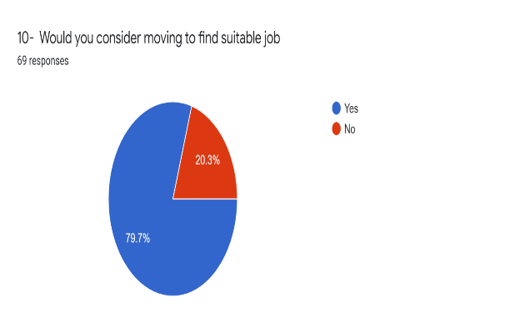
Figure 15

The above figure shows responses of moving to find suitable job. It is interesting to know under survey that majority of respondents want to change their job may be because of dissatisfaction that means they are not getting sustainably. Majority found that it is communication skill that is utmost important for job sustainability and second most Important factor is technological upgradation
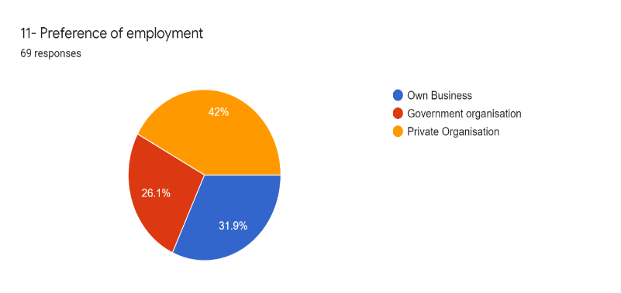
Figure 16
The above figure shows preference of employment. It was found that 42% are in private organization. 31.9% are in their own business and 26.1% are in Government organization.

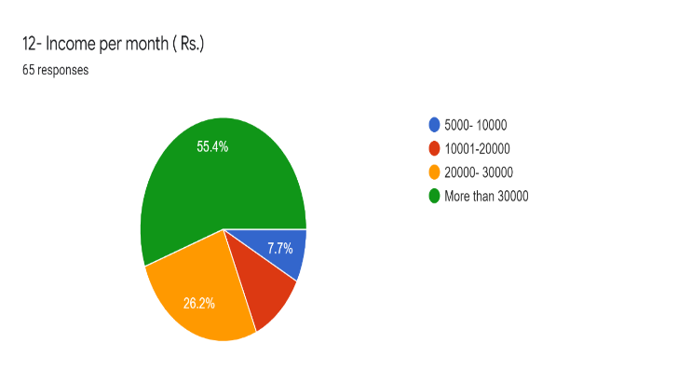
The above figure shows income per month in rupees. 55.4% having more than 30,000 income per month.
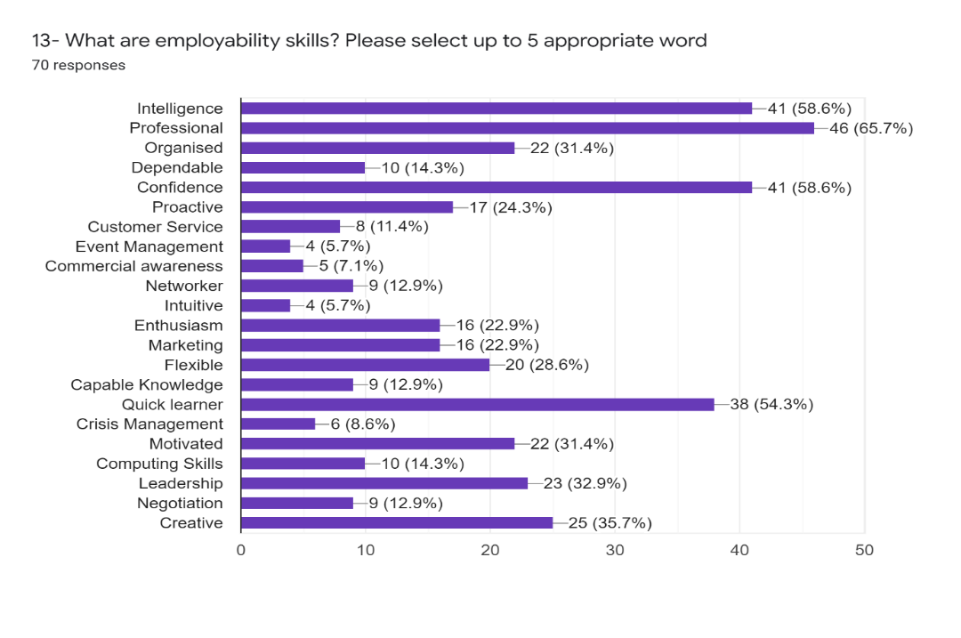

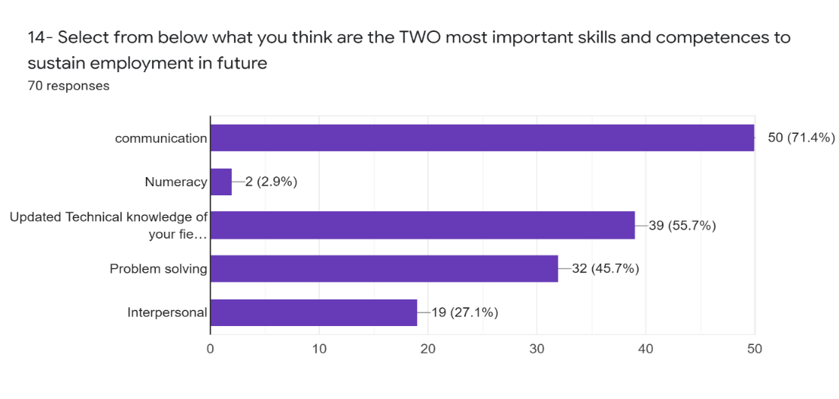

Conclusion
The information gained till question -8 is describing about the characteristics of respondents and their status about the employment, under/un-employment. And the responses from question-9 are actually throwing light on facts of sustainability factors in the respective fields. Updated technological knowledge in the respective fields and communication skills are found as major skill traits for sustainability of job.
In this way with the help of Sequential mixed methods research design not only ‘WHAT’ (Quant) is answered but also ‘HOW’ is addressed properly, and this research design provided the better insight about the scenario.

References:

- Malthus T R(1970) An essay on the principle of population (1798) and A Summary view of the principle of population (1830). Flew A, e. (. (n.d.).
- AGARWAL, S. (Volume : 3 , Issue : 5 ,May 2014). Impact of India’s Population Growth on Economic Development. Indian Journal of Research.
- Bhanu Phani Krishna Koduru, A. T. (n.d.). Effect of Population Growth Rate on Economic Development in India .
- https://data.worldbank.org/indicator/SP.POP.1564.TO.ZS. (n.d.).
- Kamarudin, M. K. (Vol- 7 (2018), 123-127 ). Population Growth and Economic Development in Developing and Developed Countries . International Journal of Engineering & Technology .
- Maertens, K. B. (2007). The pattern and causes of economic growth in India. Oxford Review of Economic Policy, Volume 23, Number 2, , pp.143–167.
- Peterson, E. W. ( 2017: 1 –15 ). The Role of Population in Economic Growth. SAGE Open .

