Knowledge, Perception and Awareness of Renewable Energy (the future trend of energy)
Dr. Hitika Dhingra
University School of Financial Studies, Guru Nanak Dev University, Amritsar.

Sirjan Singh
Student
Department of Computer Science and Engineering,
Thapar Institute of Engineering and Technology, Patiala.

Abstract
Mankind's encounter with environment is as old as the Man himself. Scientists tell us that Man is three million years old. For these three million years Man has survived his profligacy. Though his actions long affected his local environment it is only with the advent of the industrial revolution that the scope of this influence expanded to a global scale. In our generation, Man's competition of his mastery over the whole of the biosphere is threatening to defeat Man's intentions by wrecking the biosphere and extinguishing life, including human life itself.
With growing energy demand and concern for depletion of conventional fuel resources, there is an urgent need to increase awareness regarding usage of green energy. In this paper emphasis has been placed on respondent’s awareness and opinion on ecosystem, global warming, environment pollution, climate change and benefits of renewable energy. The sampling unit consists of different individual respondents of different age and gender from Patiala city. The sample size of the study is two hundred and twenty respondents. Descriptive research using interview schedule was done, whereby the data was collected with the help of a questionnaire. Percentages, graphs and diagrams have been used for analysis of the study.
It has been found that environmental awareness and social acceptance of renewable energy is not adequate. The environment degradation cannot be prevented and renewable energy can’t be adopted until and unless people are enlightened and appraised about the fact that the resources are their own and it is their duty to protect them. It has come to light that lack of awareness can result in a major lag between the time when decision-makers express their interest in going forward with a proposed initiative and the time the proposal wins acceptance by a majority of the public.

Introduction
Mankind's encounter with environment is as old as the Man himself. Scientists tell us that Man is three million years old. For these three million years Man has survived his profligacy. Though his actions long affected his local environment it is only with the advent of the industrial revolution that the scope of this influence expanded to a global scale. In our generation, Man's competition of his mastery over the whole of the biosphere is threatening to defeat Man's intentions by wrecking the biosphere and extinguishing life, including human life itself.
The focus of development must not be on fulfilling economic, social and political goals but on the comprehensive growth of all aspects of human life besides other living organisms. We are using up our environmental capital far faster than we can replace it. Energy is one such area that takes out a lot from nature. Environmentalists have long been admonishing to look for alternate sources of energy to lessen the reliance on conventional sources as well as providing breathing space to nature to heal itself. Governments, both at country and state level, should lead by example in adopting safe environmental practices and inspire others to do the same. The current efforts of the government are inadequate. Some steps have been taken by the Punjab government in harnessing renewable energy sources but more significant action needs to be done.
Objective
• The aim of the study is to analyse the level of awareness among people of Patiala regarding renewable energy;
• In this study emphasis has been placed on respondents’ awareness and opinion on ecosystem, global warming, climate change and factors that attribute to environmental degradation;
• Willingness to pay more for 24hrs of power supply augmented by supply from renewable source and preference of people towards personal or district level generation of power from renewable source has also been studied.

Research Methodology
Sampling Plan: The following are included in the sampling plan for the purpose of present study:
a) Universe of sample:
The sample has been taken from the universe of Patiala city.
b) Sampling unit: The sampling unit consists of different individual respondents of different gender and age from the city of Patiala.
c) Sample size:
The sample size of the study is two hundred and fifty-seven respondents.
d) Sampling procedure and Method:
A convenience sampling technique was used for the survey. The study is based on primary data collection by administering an interview schedule.
e) Collecting the Information:
The data collection is the most expensive and the most prone to error. The interview schedules of 239 were received back and response of 220 respondents was found fit for the purpose of study.
f) Tools of analyses:
Percentages, bar graphs and pie charts have been used for analysis of the study. The tools automatically provide visual representations for a clear understanding of the analyses of the collected data.

Review of Literature
Lovins and the Rocky Mountain Institute (2011) has analyzed the possibility of converting the United States to almost total reliance on renewable energy sources, such as solar energy and wind power. Lovins says that renewable energy is already cheaper than fossil fuels and his analysis predicts further declines in prices for renewable.
Lovins says, “Imagine fuel without fear. No climate change. No oil spills, dead coal miners, dirty air, devastated lands and lost wildlife. No energy poverty. No oil-fed wars, tyrannies, or terrorists. Nothing to run out. Nothing to cut off. Nothing to worry about. Just energy abundance, benign and affordable, for all, forever.”
Lovins discusses everything from how to redesign heavy trucks to make them more fuel efficient to ways to change factory pipes to conserve energy. The book lays out a plan for the U.S. to achieve the following by 2050: cars completely powered by hydrogen fuel cells, electricity, and biofuels; 84 percent of trucks and airplanes running on biomass fuels; 80 percent of the nation's electricity produced by renewable power; $5 trillion in savings; and an economy that has grown by 158 percent.
Mishra S. (October, 2016) in his paper “Renewable energy awareness in India” has aimed to address the issue of energy proliferation. He has mentioned that Awareness is a key factor in promoting renewable energy proliferation. Although a large number of people are aware of the importance of energy and its role in the growth and development of the nation, it is also very much comprehendible that there is a yawning gap which needs to be addressed in the area of energy education and awareness in India. Among Indian audiences, renewable energy and its resources have lower awareness levels. For most, energy is limited to conventional sources. People are familiar but not educated on popular energy issues. Much effort has been showered by government departments and other agencies in India over the past decade in the form of launching various schemes at school, city, and village block levels, but most these have come at abstract timings. Also, the advertising campaigns have been too heavy upon the target audiences leaving them half-baked. The paper proposes a strategic and regimented approach model towards target audiences, preparing them thoroughly before actually disseminating the knowledge package to them.
Fatma Agpak F. and Ozcicek O. (December, 2017) in their paper, “The Role of Education on Renewable Energy Use: Evidence From Poisson Pseudo Maximum Likelihood Estimations” has highlighted the role of education level on the non-hydro renewable energy use and analysed it with regard to two different indicators. According to them, education level of a society is a key determinant of renewable energy demand and supply in that economy. In highly educated societies, environmental awareness and social acceptance of renewable energy is expected to be high and so is renewable energy demand. On the supply side, it has been reported that higher levels of scientific knowledge and know-how facilitate innovation and diffusion of renewable energy technologies. In their study, these theoretical arguments are examined using a sample of 62 countries spanning the period of 1990-2014. To overcome this problem, pseudo-Poisson maximum likelihood technique is applied. The findings suggest that education level is positively related to renewable energy participation at the 1% level. Furthermore, the impact of higher levels of education is found to be stronger than the lower levels.
Nandy J. (2022) in the article, “climate crisis linked to India’s spring heatwave” in Hindustan Times has warned of a severe heatwave in major parts of India over the next few days, stretching from east to west and north west. Dry warm winds have been blowing in north India pretty sooner than usual and therefore raising summer temperatures before time. According to Friederike Otto, leader of World Weather Attribution group and senior lecturer in Climate Science at the Grantham Institute, Imperial College London, the present heatwave in India has been intensified due to climate change which in turn is the outcome of activities by human. Otto has further warned that the heat waves in India will further become more dangerous and hotter if the net greenhouse gas emissions aren’t eliminated. The conditions in India have been in the follow-up of abnormal weather conditions in rest of the world. It has been reported that both the polar regions of Earth encountered heat waves simultaneously, resulting in the average temperature to be 4.8°C higher than the average.

Results and Discussion
The first and second questions were designed to introduce participants to the concepts of the eco-system, climate change, global warming, and renewable and green energy. These questions aimed to raise awareness about the importance of using renewable energy technology for a better environment.

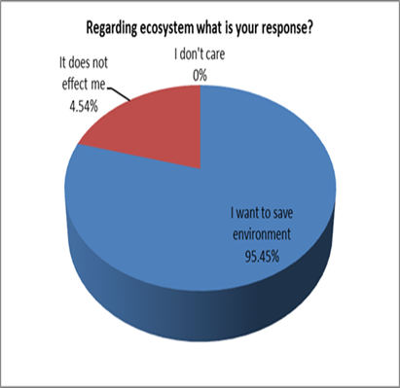
Figure 1
Majority of the respondents (95%) want to save environment, whereas only 4.54% of respondents are of the view that it does not affect them personally. However, no negative response such as ‘I do not care’ was received (Figure 1).
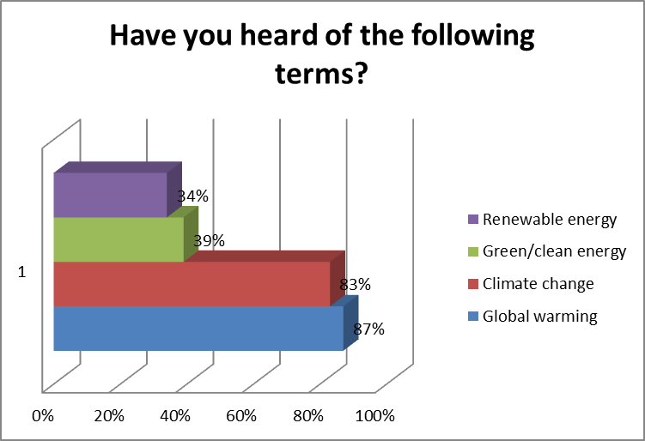
Figure 2
A significant percentage of respondents were aware of terms like "global warming" (87%) and "climate change" (83%), indicating some awareness of environmental issues. However, there was a substantial lack of education and awareness regarding "Renewable Energy," with only 44% having heard of this term (Figure 2).
The findings emphasize the need for more education and awareness-building efforts in the area of renewable and clean energy sources.
The third question in the survey aimed to educate respondents about various sources of renewable energy. The options provided included solar power (78% awareness), hydro power (77% awareness), wind power (57% awareness), biomass (45% awareness), and waste-to-energy (low awareness) (Figure 3).
A varying degree of awareness was found among respondents regarding different renewable energy sources, with solar and hydro power being the most recognized, while waste-to-energy had the lowest awareness.

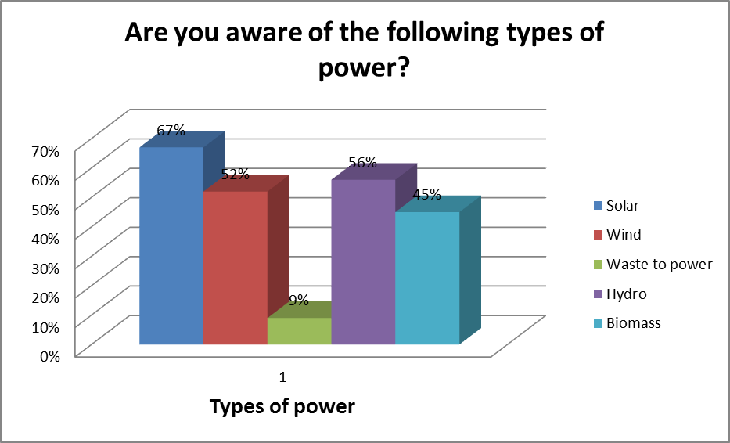
Figure 3

Figure 4
Majority of the respondents identified renewable energy mainly with ‘good for environment’, around 76% agreeing with it. Surprisingly 11% did not even know what are the benefits of renewable energy. 68% of respondents said ‘no power cuts’, 20% said ‘good for businesses as benefits of renewable energy and 16% said ‘less dependence utility’. (Figure 4).
Lack of knowledge and education regarding benefits of renewable energy was predominant. It is important for the government as well as renewable energy agencies to communicate and educate the benefits of renewable to the people as well as adopt intensive marketing to have an advantage of better acceptance of products developed using renewable energy.

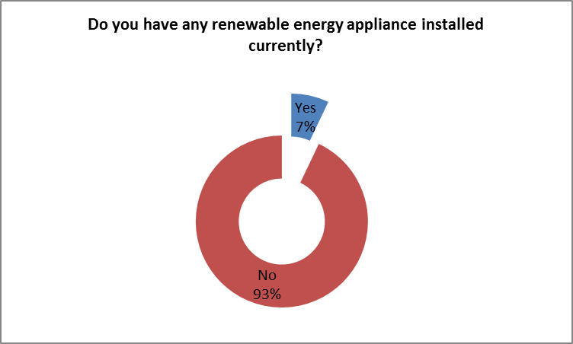
Figure 5

Around 16% of all the respondents had renewable energy appliance installed (Figure 5). Out of these 24 respondents, 9 respondents had solar heaters, 6 had solar panels, 7 had solar lights, and 2 had biomass systems installed. However, the majority, comprising 84% of the respondents, did not have any form of renewable energy installed in their homes or properties.

(Figure 5.1).

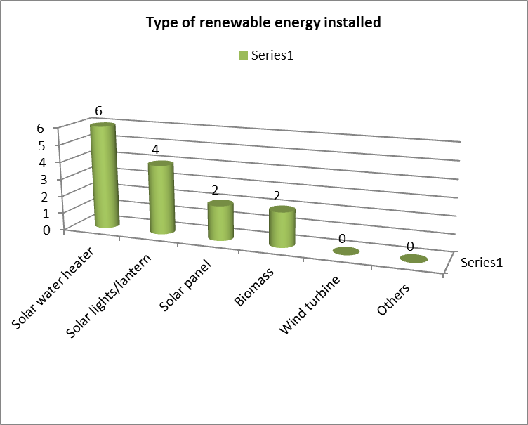
Figure 5.1

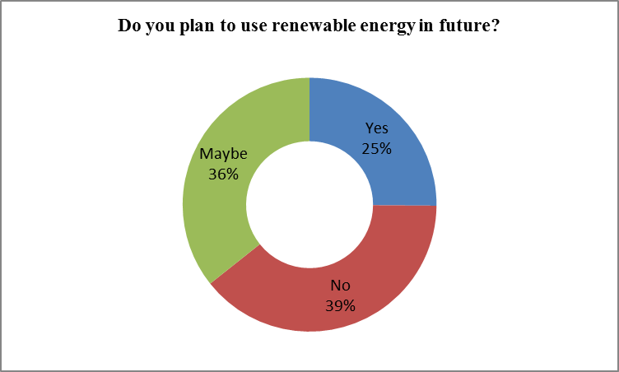
Figure 6
Approximately 36% of the respondents expressed that they are considering the possibility of installing renewable energy systems in the future. About 25% of the respondents stated that they are definite about installing renewable energy in the future. The remaining 39% indicated that they have no intentions of installing any form of renewable energy in the future.
A majority of 97.98% respondents favoured having electricity round the clock (Figure 7).
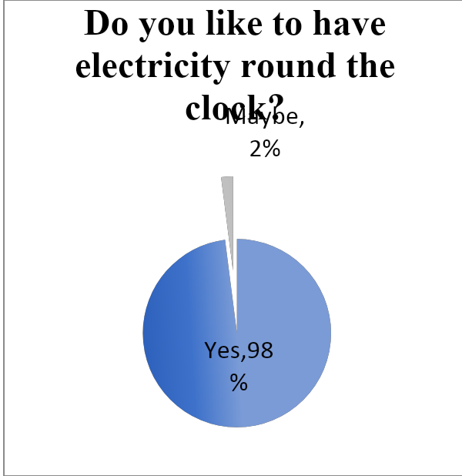
Figure 7

The findings reveal an interesting irony: while a significant portion of respondents are open to paying a slightly higher cost for electricity from renewable sources (55% are willing, 29% are uncertain), a notable 16% outright refuse to do so. Many of these individuals have backup generators.
To potentially shift those who are uncertain ('maybe') towards a positive stance ('yes'), it's crucial to engage in education and communication efforts to highlight the benefits of renewable energy. Additionally, there's an opportunity for the government to reduce the cost of renewable energy generation through investments in research and development.

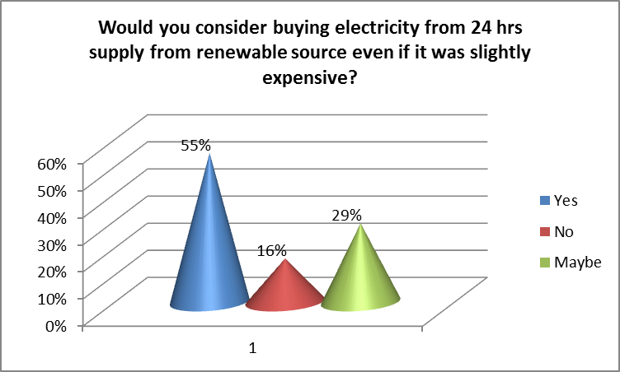
Figure 8
The overwhelming majority of respondents, 96.46%, prefer the generation and distribution of renewable energy at the district level. This preference is attributed to concerns about the visual impact and space occupation of solar panels on rooftops. People are also hesitant because such panels are uncommon in their neighbourhoods. To build confidence among the public, the suggestion is for the government to construct at least one passive house in each region and actively advertise it as a demonstration of renewable energy benefits.

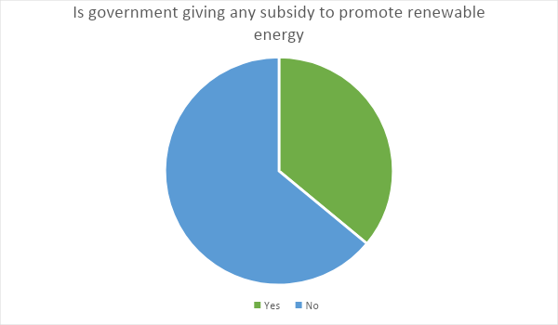
Figure 9

About 64% of respondents had not heard of any subsidy by government for renewable energy. Awareness is quite low among the people. To speed up the installation of renewable energy, education, increasing communication and intensive marketing should be done.

Conclusion

Overall it was found that there was a lack of awareness among people about renewable energy and its benefits. The respondents surveyed were more aware of solar than other renewable sources. It was basically due to awareness of solar water heaters, solar panels and solar lights.
Government has responsibility to educate and communicate about subsidy programs and policies.
It becomes much easier to develop a renewable energy project on a land close to population if they are already communicated and educated about the benefits.
Majority of the people are not willing to pay more even if they get electricity for 24 hours.
There is also need for the government and renewable energy agencies to take the lead and focus investment in Research and Development (R&D) for making cost effective equipments for providing energy from renewable sources at par with conventional sources of energy.
In democratic societies, decision-making should take into account both knowledge of experts and the thoughts and feelings of the public. The lack of awareness and effective marketing strategies can lead to a major delay between when decision-makers express interest in an initiative and when it gains acceptance from the majority of the public. In other words, public awareness and effective communication are critical for aligning public opinion with decision-makers' initiatives in a timely manner.

SUGGESTIONS
In India, every year there is an increase of 8-10 percent in energy requirement in the commercial sector and 20-30 percent increase in residential sector. This is leading to a situation where there are energy deficits. Green Energy is the only answer to overcome this deficit.
Cost reduction, grid management, community acceptance, landscape issues and lack of adequate marketing are the main bottlenecks to awareness and commitment to Green Energy.
India needs to take the lead and develop efficient, hi-tech and cost effective equipments based on Green Energy, not only for industrial and domestic purpose, but also for agricultural and irrigation needs. There is an imperative need for extensive focus and investments in Research and Development (R&D) for making cost effective equipments as well as marketing them to bring about the much-needed GREEN ENERGY REVOLUTION in India.
To advocate the development and acceptance of renewable energy technology, it is crucial to bridge the gap between the general public's perspective and that of energy technologists. This entails educating the public about the importance of prevailing renewable energy technology and fostering greater awareness of its advantages. Essentially, augmenting public knowledge and understanding of renewable energy technology is crucial for its wider adoption and utilization.
References
Bagga, N. (2014, November 16). Solar energy largely untapped. Amritsar Tribune , p. 1.
Bebbington, J. and Thy, C. (1999). Compulsory Environment Reporting in Denmark: An Evaluation. Social and Environmental Accountability Journal, Vol. 19 (2).
Bhalla,G.S. and Khanna, H., (2007). Environment Education. New Delhi: Deep and Deep Publication.
Bhattacharjee, J.B., (1996). Our Environment. Silchar. AU.
Blackstone, W.T., (1974) “Philosophy and Environment Crisis”, University of Georgia Press, Athens.
Dasgupta, P. (2001), "Human Well-Being and the Natural Environment", Oxford University Press, Oxford.
Dhingra, H., & Bhalla, D. G. (2018). need to increase awareness about environment pollution to augment its prevention. Journal of Emerging Technologies and Innovative Research.
India Renewable Energy Awareness Survey (2010), Mercom Capital Group. Retrieved on 24th April, 2014 from www.mercomcapital.com
Jha, P.K. 1998.
Khalid, Fazlam and Joanne O’Brien (eds.), (1992) “Man and Ecology”, Cassell, New York.
Marilyn, A. B. and Sovacool, B.K. (2011), “Climate Change and Global Energy Security: Technology and Policy Options”, MIT Press, Cambridge, USA.
Mark Diesendorf, (2007) “Greenhouse Solutions with Sustainable Energy”, University of New South Wales Press, Sydney.
Moula, E., Johana Maula, Mohamed Hamdy et.al (2013), “Researching social acceptability of renewable energy technologies in Finland”, International Journal of Sustainable Built Environment, UNESCO Commission, Finland, pp. 89-98
Ozcicek, O. and Agpak, F. (2017). The Role of Education on Renewable Energy Use: Evidence From Poisson Pseudo Maximum Likelihood Estimations. Journal of Business & Economic Policy Vol. 4 No.4
Viegas , P. and Menon, G.(1989) "The impact of environmental degradation on people", Indian Social Institute, New Delhi.
10.1007/s40518-016-0055-z
Dear Respondents,
I am pursuing B.Tech. from Thapar Institute. I request you to kindly spare your valuable time to give appropriate responses to the issues addressed in this questionnaire. I shall be highly thankful for your kind cooperation in this regard.

1. Regarding environment what is your response to the following?
(a) I want to save environment
(b) It does not affect me
(c) Don’t care

2. Have you heard of the following terms? (You can tick multiple options)
(a) Global Warming (b) Climate Change
(c) Renewable Energy (d) Green Energy/Clean Energy

3. Have you heard of the following types of power? (You can tick multiple options)
(a) Solar power (d) Hydro power
(b) Wind power (e) Biomass
(c) Waste to power

4. Can you point out the benefits of renewable energy? (You can tick multiple options)
(a) Good for environment (b) Less dependence
(c) Good for business/industry (d) Government subsidy
(e) No power cuts (f) No benefit
(g) Don’t know

5. Do you currently have any renewable energy appliance installed?
(a) Yes (b) No

If yes, which type of renewable energy have you installed? (You can tick multiple options)
(a) Solar water heater (b) Solar panel
(c) Biomass (d) Wind turbine
(e) Any other, please specify_________________________

6. Do you have plans to use renewable energy in near future?
(a) Yes (b) No (c) Maybe

7. Do you like to have electricity round the clock?
(a) Yes (b) No (c) Maybe

8. Would you consider buying electricity for 24 hours supply from a renewable source even if it was slightly
expensive?
(a) Yes (b) No (c) Maybe

9. What will you prefer, renewable energy source generated and distributed at
(a) District level (b) Personal level

10. Are you aware of any government subsidies for renewable energy?
(a) Yes (b) No

